Ong, Oleen Hannah S. 11/25/19

2-ECE-B

Problem 1:

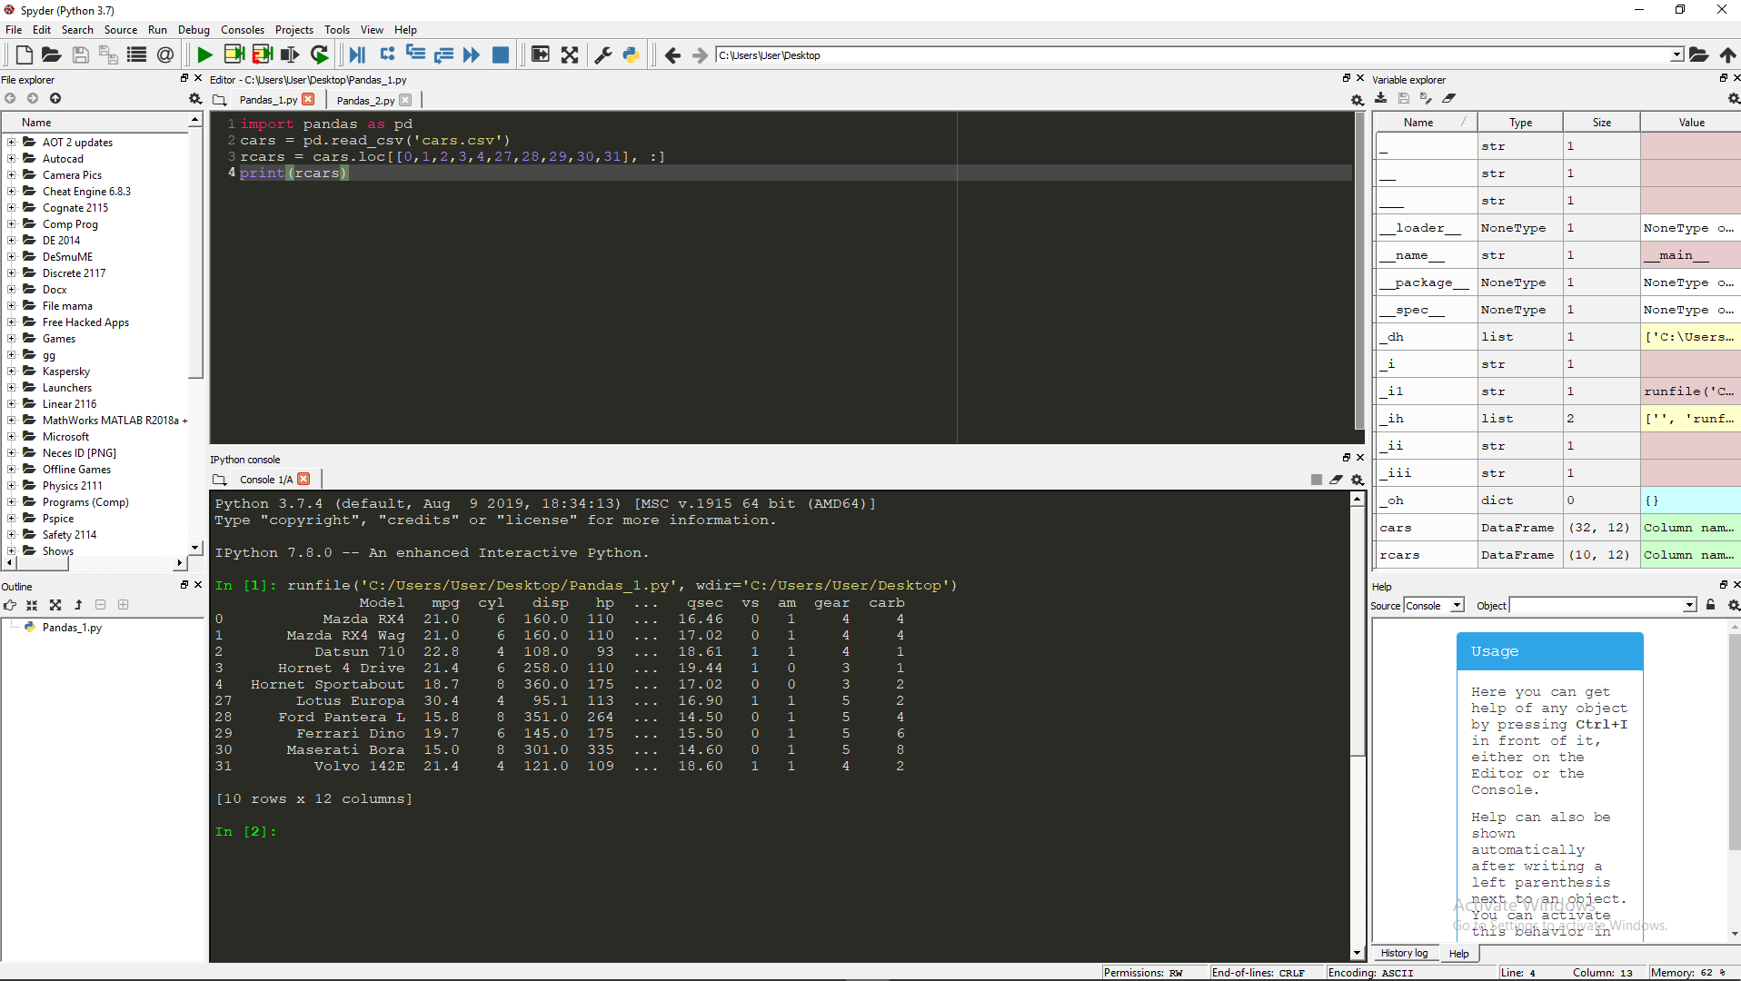

Problem 2:

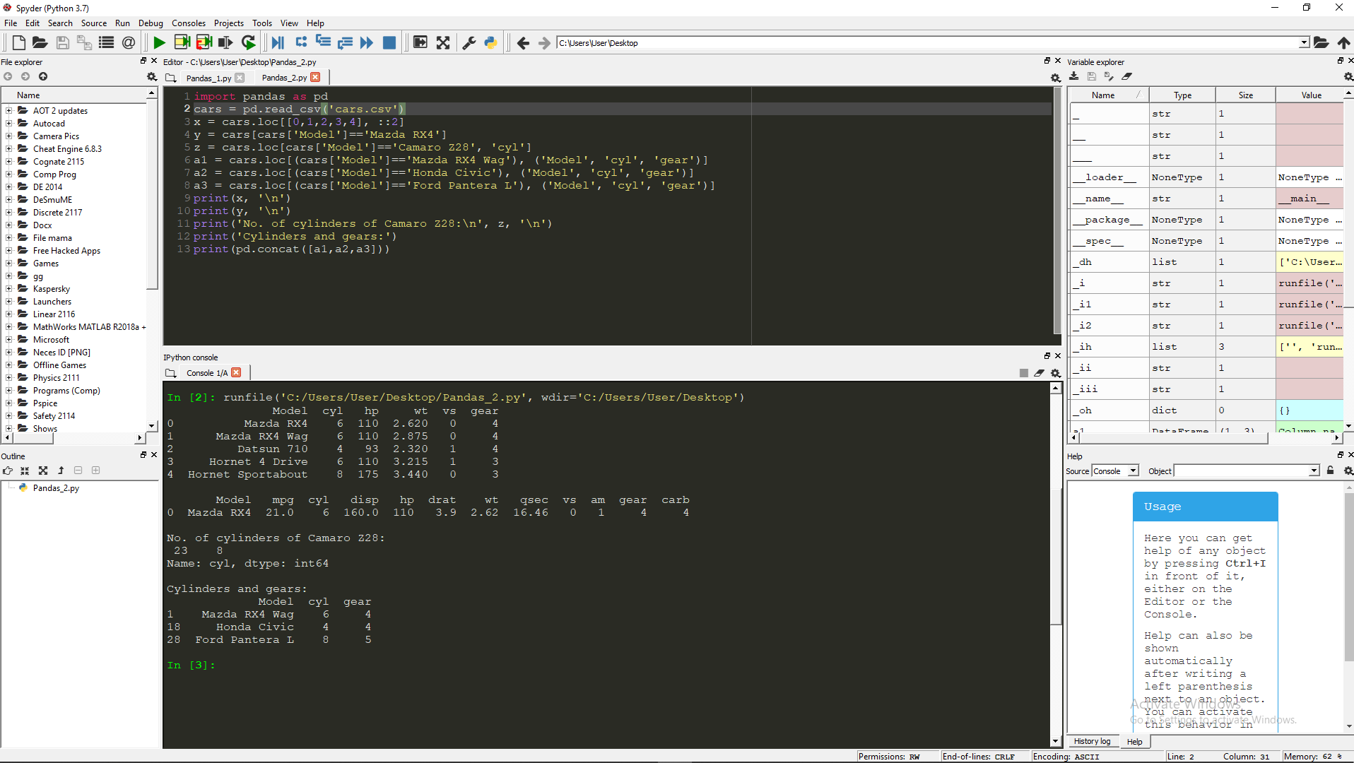

c) How many cylinders (‘cyl’) does the car model ‘Camaro Z28’ have?

* Camaro Z28 = 8 cylinders.

d) Determine how many cylinders (‘cyl’) and what gear type (‘gear’) do the car models ‘Mazda RX4 Wag’, ‘Ford Pantera L’, and ‘Honda Civic’ have.

* Mazda RX4 Wag
  + Number of Cylinders: 6
  + Gear Type: 4
* Ford Pantera L
  + Number of Cylinders: 8
  + Gear Type: 5
* Honda Civic
  + Number of Cylinders: 4
  + Gear Type: 4