ASSUMPTION UNIVERSITY

FACULTY OF ENGINEERING

CE 4221 NETWORK APPLICATION
AND TECHNOLOGY

PROJECT REPORT
VAN SEAT RESERVATION SYSTEM

Submitted to : Sneha Paudel
Submitted by : Chanyapat Saeng-Xuto ID : 6711021
Panupong Jaimethumde ID : 6711038
Putchara Chainiyom ID : 6711164
Group : 2 Section : 641
Date of Submission : 08 / 09 / 2026

Semester 1 / 2026

1. Project Outline and Specifications

1.1 Introduction
Assumption University operates a shared van service between campuses and transport points. Under the current arrangement, a van departs only once every seat is occupied, and no seat can be secured in advance. Consequently, departure times are unpredictable, and students have to arrive earlier than necessary to secure a seat.
This project develops a web-based Van Seat Reservation System that allows passengers to reserve a specific seat on a specific departure in advance. The system also provides a passenger list for each trip.
The central technical requirement is transactional integrity under concurrent access. If two passengers request the same seat at the same time, exactly one confirmed reservation must be created. This guarantee must be enforced at the database level rather than relying only on the user interface.
The system is delivered as a functional prototype rather than a production deployment. Payment processing and QR-code check-in are implemented as interface stubs because a payment gateway and HTTPS-capable deployment are not available within the course environment.

1.2 Overview
A web application for reserving seats on Assumption University shuttle vans. Students reserve seats in advance, drivers check passengers in at boarding, and the transport office schedules trips and assigns drivers.
The system replaces an informal, first-come process with a booking record per trip: passengers see live seat availability and carry an e-ticket; drivers work from a passenger manifest instead of a headcount; the office sees which trips still lack a driver before the day runs.

1.3 Project Objectives
The main objectives of the Van Seat Reservation System are:
- Advance Reservation
Allow registered passengers to search for trips by route.
- Role-Based Access
Separate Passenger, Driver, and Administrator roles using authenticated sessions, with each role restricted to its permitted operations.
- Transport Office Visibility
Allow administrators to manage trips, assign vans and drivers.
- Attendance Tracking
Allow drivers to mark passengers as boarded.
- Payment and Check-in Demonstration
Provide payment and check-in interface stubs. The payment method and status can be recorded, but no real transaction is processed or verified.

2. Scope of the Project

2.1 Passenger Functions
The passenger side of the system includes the following functions:
- Registration and login using phone number with hashed passwords.
- Profile management for editing contact details.
- Trip search filtered by route.
- Selection of payment method between Cards and PromptPay.
- Digital ticket display including a mocked up QR code.
- "My Bookings" page for viewing booking history.

2.2 Driver Functions
The driver side of the system includes:
- Login and access to assigned trips.
- Viewing the passenger manifest for an assigned trip.
- Marking passengers as boarded through manual entry.
- Camera-based QR scanning is represented as a stub.

2.3 Administrator Functions
The administrator side of the system includes:
- Creating, editing, and cancelling trips.
- Assigning vans, routes, drivers, and schedules.
- Managing vans and routes.

2.4 System-Level Technical Scope
The system includes the following technical requirements:
- A relational database schema designed in Boyce-Codd Normal Form (BCNF).
- Session management and role-based authorization.
- Responsive layout suitable for desktop devices.
- A complete UX/UI design set and extracted design tokens.

2.5 Documentation Scope
The project documentation includes:
- Project outline and specifications.
- ER Diagram.
- Page map.
- Test case document.
- Project report.
- Presentation materials.

3. Pages List and Page Map
The following pages are required for the Van Seat Reservation System:

Public (logged out)
File | Page
index.php | Router: sends each role to its home, else login (no UI)
landing.php | Public landing (AU VAN BOOKING intro)
login.php | Login
register.php | Create account
logout.php | Logout: clears session, redirects (no UI)

Passenger
File | Page
trips.php | Route selection (passenger home)
trip-times.php | Time + no. of seats selection for a chosen route
booking-confirm.php | Booking summary + payment (confirmed dialog)
booking-success.php | "Booking confirmed" screen
ticket.php | Booking details / e-ticket
my-bookings.php | Trip history (Upcoming / Completed)
profile.php | Passenger profile

Driver
File | Page
driver-dashboard.php | Today's trips
driver-trip.php | Trip details + manifest
driver-checkin.php | Check-in (mock scan + manual entry)
driver-profile.php | Driver profile

3. Pages List and Page Map (Cont.)

Admin
File | Page
admin-dashboard.php | Admin hub
admin-trips.php | Trip list + create + assign-driver popup
admin-manage.php | Manage data (vans / routes / stops / users tabs)
admin-profile.php | Admin profile

Shared includes (fragments, not pages)

Layout & partials
File | Purpose
header.php | <head>, stylesheet link, <body>, navbar. Page sets $page_title, $user_role, $user_name first
footer.php | Closing tags
navbar.php | Role-aware navigation bar logo + avatar; avatar links to the role's profile
profile-shell.php | Shared profile body (Account / Security / summary + ?edit form), used by all three *-profile.php
van-icon.php | Inline van SVG (route cards)
laptop-mockup.php | Landing hero visual
qrcode-mockup.php | Ticket QR image

Data (functions)
Placeholder data; each becomes a query in the DB phase, keeping the same return shape so no page markup changes.
File | Exposes
routes.php | get_routes(), find_route($id), route_detail($route), get_dropoffs()
schedule.php | get_slots(), find_slot($id)
bookings.php | get_bookings()
driver-today.php | get_todays_trips()
3. Pages List and Page Map (Cont.)

Design label → filename mapping
The Canva mockups use different labels. Map them to filenames here:
Canva label | Filename | Title
landing-page | landing.php | AU VAN
login-page | login.php | AU VAN - Login
registration-page | register.php | AU VAN - Register
route-selection | trips.php | AU VAN - Route
time-selection | trip-times.php | AU VAN - Time
confirm-booking | booking-confirm.php | AU VAN - Booking
booking confirmed | booking-success.php | AU VAN - Confirmed
ticket-page | ticket.php | AU VAN - Ticket
booking history | my-bookings.php | AU VAN - History
profile: passenger | profile.php | AU VAN - Passenger
driver-dashboard | driver-dashboard.php | AU VAN - Dashboard
driver-trip-details | driver-trip.php | AU VAN - Details
driver-trip-checkin | driver-checkin.php | AU VAN - Check-in
profile: driver | driver-profile.php | AU VAN - Driver
admin-dashboard | admin-dashboard.php | AU VAN - Dashboard
admin-trips | admin-trips.php | AU VAN - Trips
admin-manage: * | admin-manage.php | AU VAN - Manage
profile: admin | admin-profile.php | AU VAN - Admin

4. Wireframe User Interface Design of the Pages
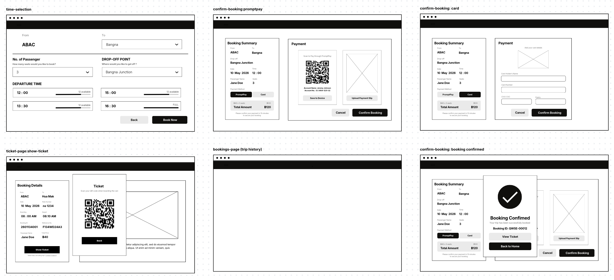
The low-fidelity wireframes were created to define the structure and layout of the pages before implementing the final user interface.The wireframes cover the required pages in the page map, including the passenger, driver, and administrator interfaces.
5. High-Fidelity User Interface of the Pages
The high-fidelity user interface designs represent the final visual appearance of the system before or during front-end implementation. The designs include the required pages and desktop-responsive layouts. The high-fidelity designs were created using Canva.
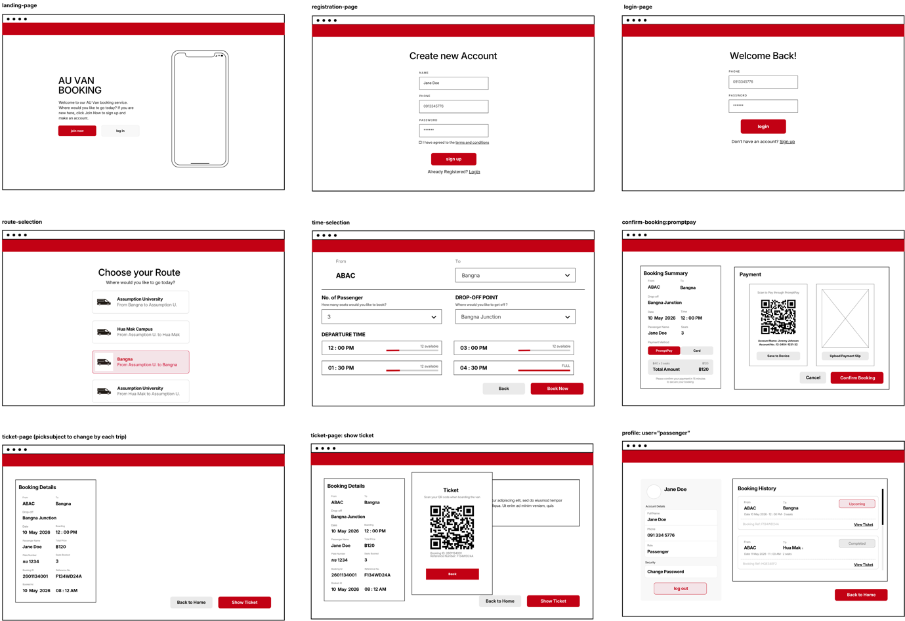

6. Design tokens

Colour
Swatch | Hex | Variable | Role
Red | #c20114 | --brand-primary | Navbar, primary buttons, active/selected accents
Darker red | #9c0110 | --brand-primary-dark | Primary-button hover
Pale red | #f4e4e8 | --brand-tint | Subtle brand background: selected route/tab, "next trip", blocking alert
Yellow | #facc15 | --yellow | Waiting / "needs a driver" accent
Pale yellow | #fef9c3 | --yellow-bg | Waiting badge background
Green | #16a34a | --green | Boarded / success
Pale green | #dcfce7 | --green-bg | Boarded badge background
Off-white | #fdfdfc | --surface | Page and card background
Grey 100 | #eaeaea | --surface-alt | Subtle fills, scanner frame
Grey 200 | #cecece | --border | Borders, dividers, table rules
Grey 400 | #a6a6a6 | --text-muted | Muted / disabled text, chevrons
Grey 600 | #6e6e6e | --text-secondary | Labels, secondary text
Near-black | #100f0d | --text-primary | Primary text
White | #ffffff | --on-primary | Text/icons on the red primary

Type scale
Variable | Value | Use
--text-xs | 12px | Fine print, table headers, pills
--text-sm | 14px | Labels, buttons, nav, secondary text
--text-base | 16px | Body, input values
--text-lg | 18px | Lead paragraph, card title, place names
--text-xl | 24px | h3, profile avatar/name, big numbers
--text-2xl | 32px | h2, stat values
--text-3xl | 48px | h1; landing hero only
6. Design tokens (Cont.)
Weight & leading
Variable | Value | Use
--weight-regular | 400 | Body
--weight-medium | 500 | Values, emphasised cells, buttons
--weight-semibold | 600 | Headings, selected states, names
--leading-tight | 1.15 | Headings, place names
--leading-normal | 1.5 | Body copy

Spacing
Variable | Value | Variable | Value
--space-1 | 4px | --space-5 | 24px
--space-2 | 8px | --space-6 | 32px
--space-3 | 12px | --space-7 | 48px
--space-4 | 16px | --space-8 | 64px

Controls
Buttons and inputs share a height so they line up side by side.
Variable | Value | Use
--control-h | 44px | Default button / input height
--control-h-sm | 36px | Compact controls; tabs, small buttons
--control-pad-x | var(--space-5) (24px) | Horizontal padding inside controls
--btn-min-w | 140px | Minimum button width

6. Design tokens (Cont.)

Layout widths
Container max-widths. Pick the token that matches the page's density.
Variable | Value | Use
--w-narrow | 420px | Login, register
--w-mid | 560px | Route list, profile, booking summary, history
--w-content | 720px | Time selection, tables, detail pages
--w-wide | 1120px | Landing, booking-confirm

Fixed chrome
Variable | Value | Use
--navbar-h | 64px | Sticky navbar height; full-viewport pages subtract this
--avatar-size | 40px | Navbar avatar circle

Radius & border
Variable | Value | Use
--radius | 8px | Cards, inputs, buttons, table cells
--radius-pill | 999px | Pills, badges, avatars
--border-w | 1px | All borders

Font
Variable | Value | Notes
--font-body | 'Inter', 'Noto Sans Thai', sans-serif | Latin + Thai; imported in section 1

7. ER Diagram
The database ER Diagram represents the relationships between the system entities and is designed according to the BCNF database structure.
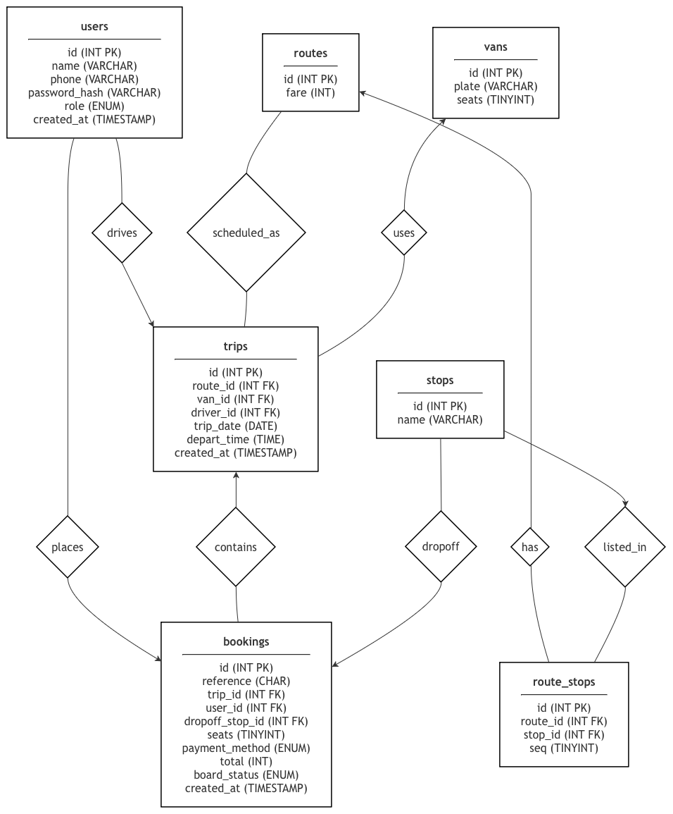

8. Queries and Tables of the Database
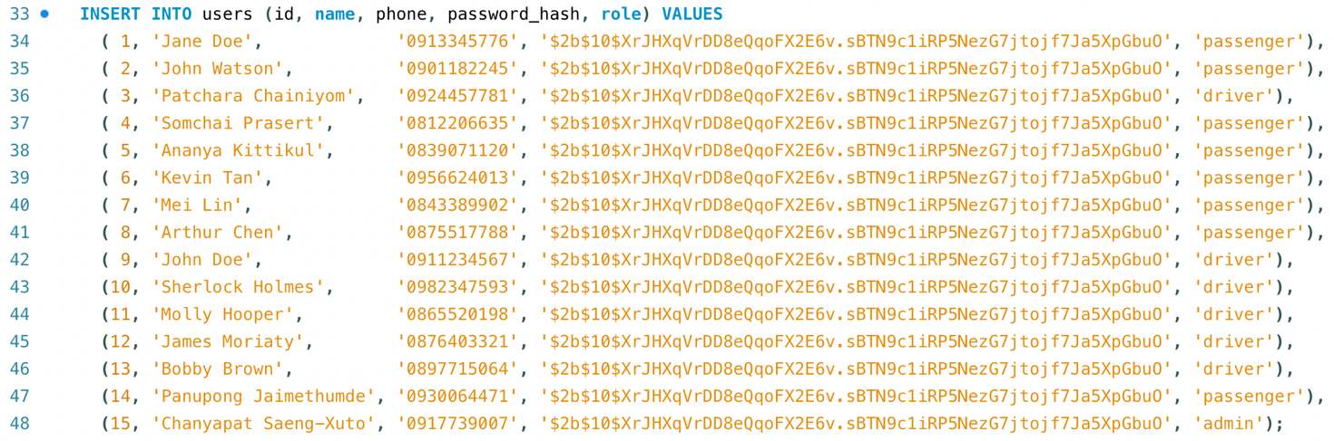
8.1) Users

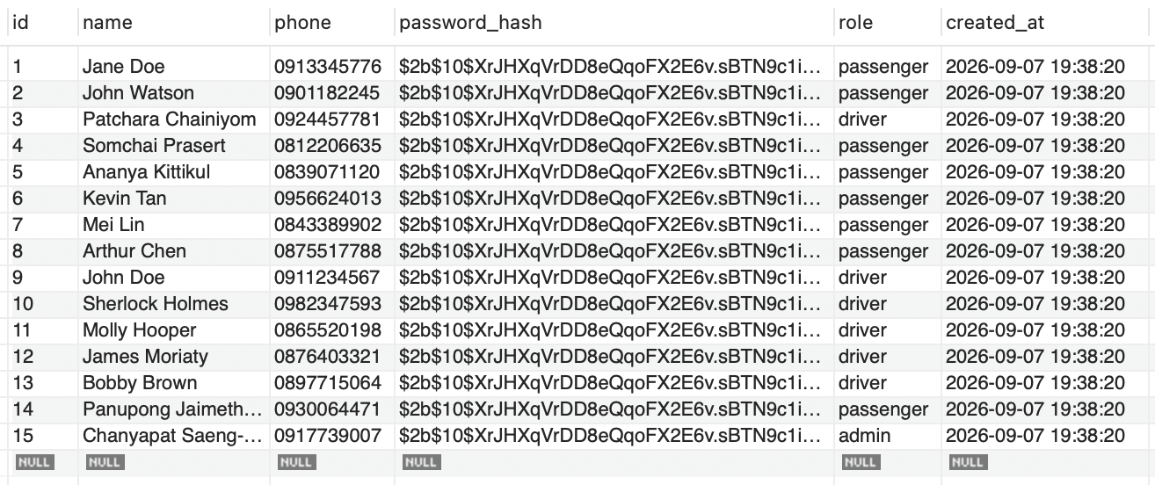

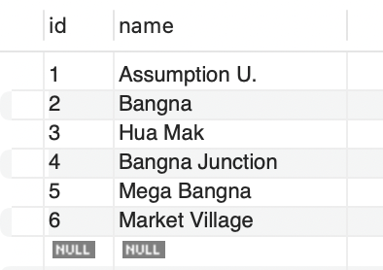
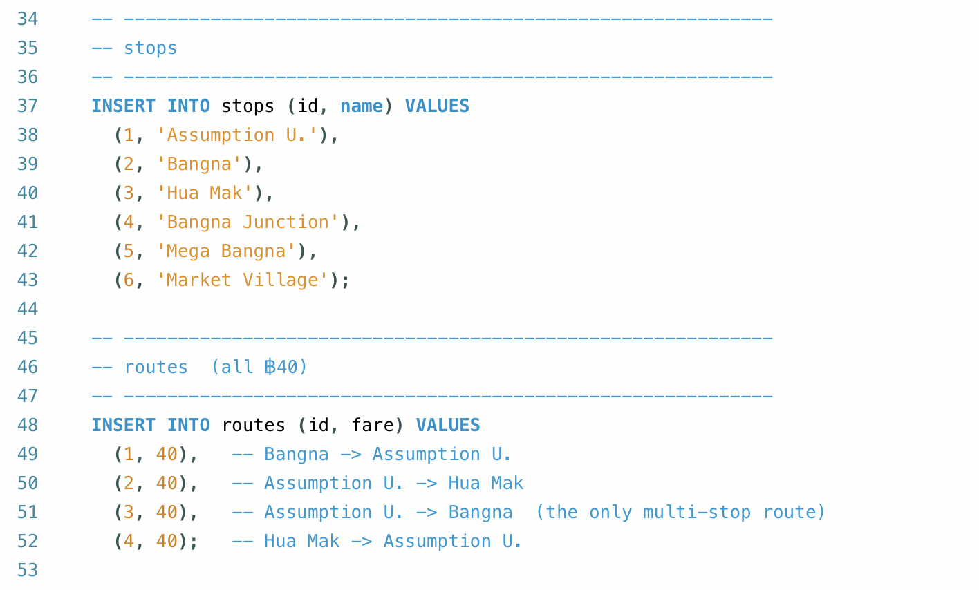
8.2) Stops

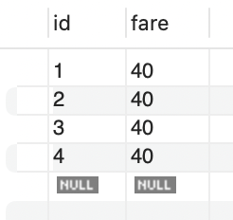
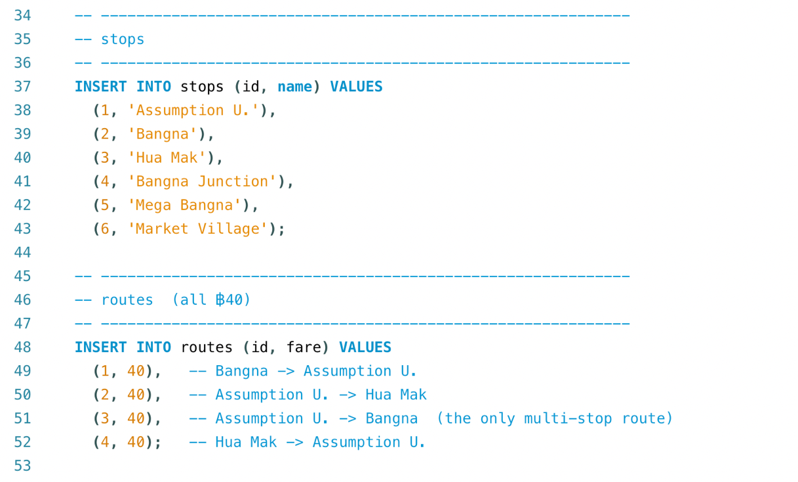
8.3) Routes

8. Queries and Tables of the Database (Cont.)
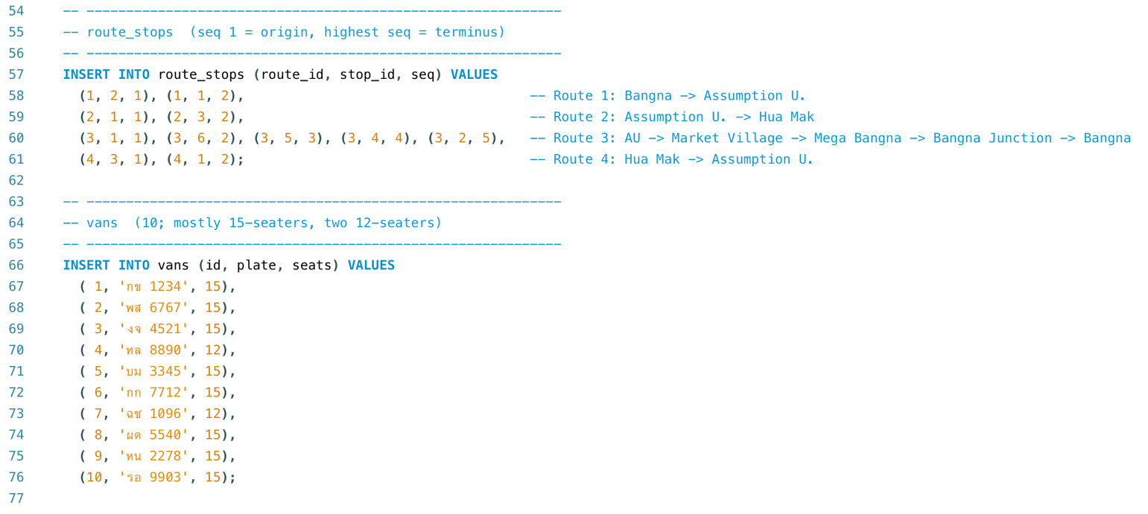
8.4) Vans

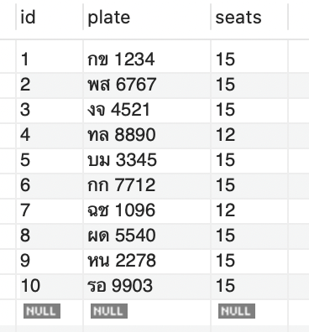

8.5) Route_Stops


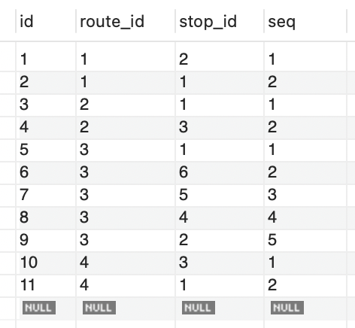

8. Queries and Tables of the Database (Cont.)
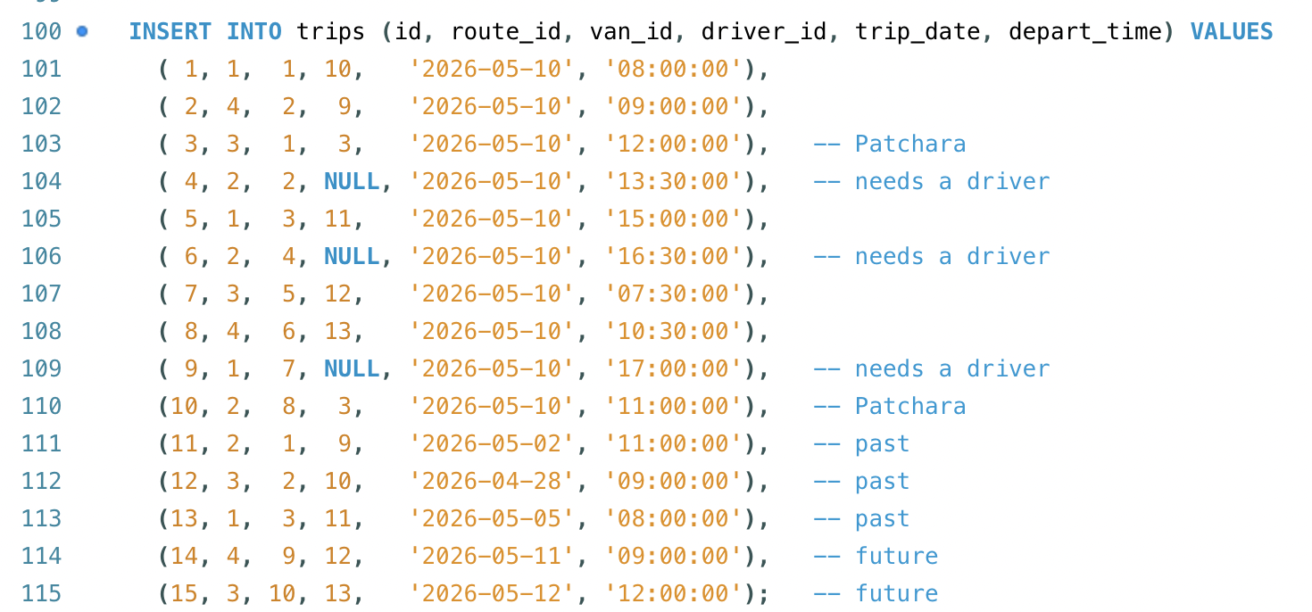
8.6) Trips

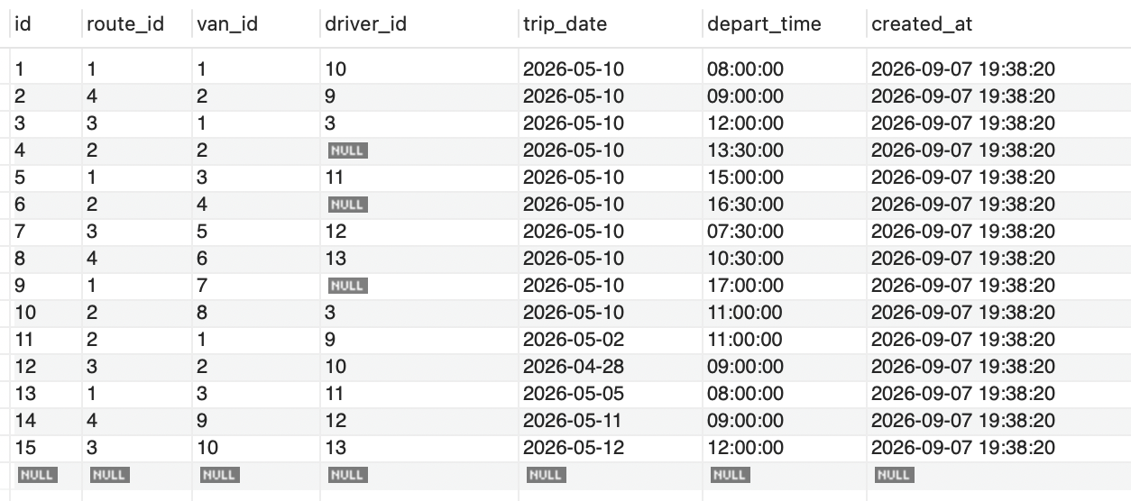

8. Queries and Tables of the Database (Cont.)
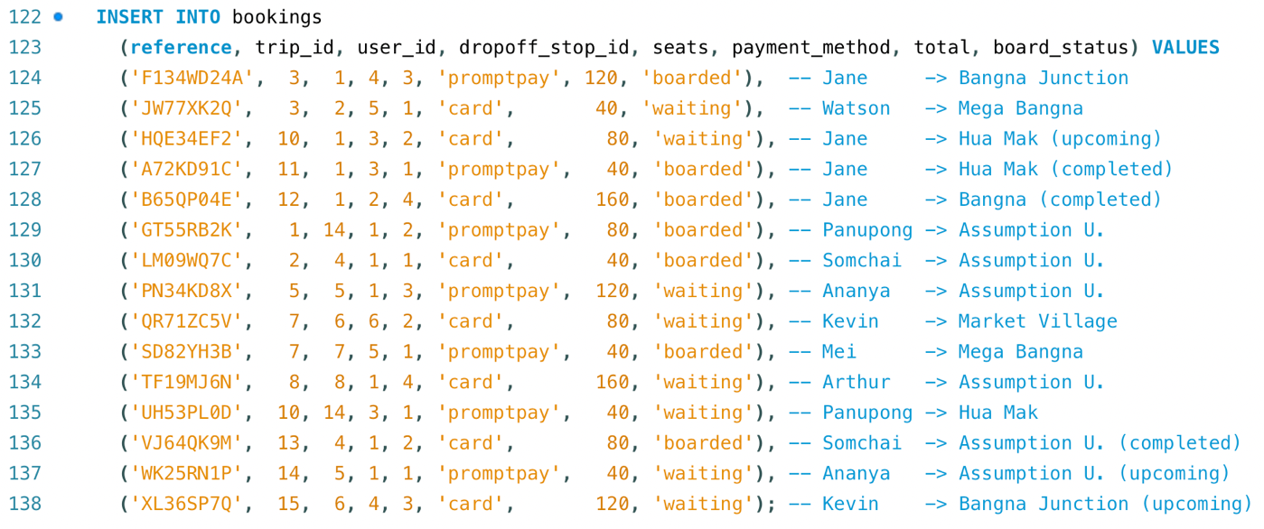
8.7) Bookings

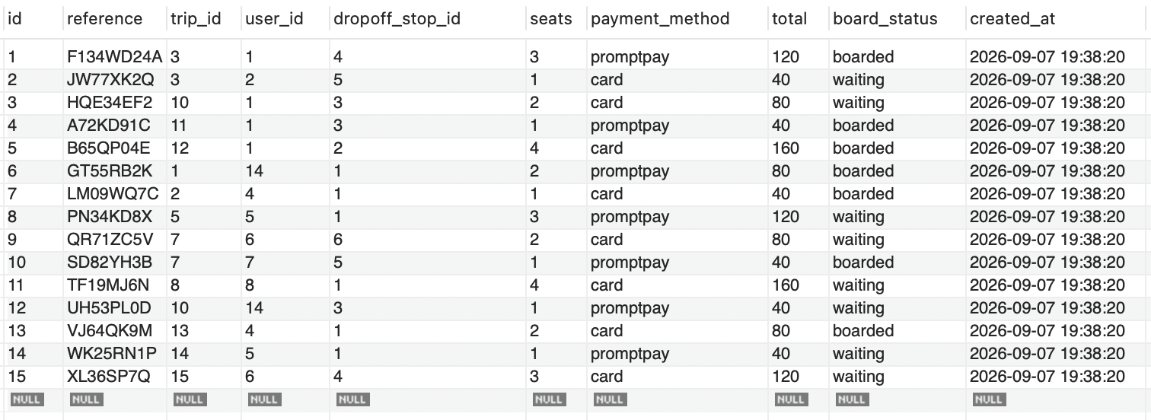

9. Functional Requirement

Accounts & session
ID | Requirement | Pages
G1 | A guest can register with full name, phone, password, and agreement to terms | register.php
G2 | A user can log in with phone + password | login.php
G3 | A user can log out, clearing the session | logout.php
G4 | Visiting the site routes a signed-in user to their role home, else to login | index.php

Passenger
ID | Requirement | Pages
P1 | Browse available routes | trips.php
P2 | For a chosen route, pick a departure time and a seat count (1–4), limited by live availability | trip-times.php
P3 | Choose a drop-off point along the route | trip-times.php
P4 | Review a booking summary and select a payment method (PromptPay or Card) — simulated | booking-confirm.php
P5 | Confirm the booking and receive confirmation | booking-confirm.php (dialog), booking-success.php
P6 | View an e-ticket: booking details and a QR code for boarding | ticket.php
P7 | View booking history, split into Upcoming and Completed | my-bookings.php
P8 | View the account profile and edit it, including changing the password | profile.php

9. Functional Requirement (Cont.)

Driver
ID | Requirement | Pages
D1 | View trips assigned today, with the next trip highlighted | driver-dashboard.php
D2 | View a trip's details and its passenger manifest (name, seats, drop-off, board status) | driver-trip.php
D3 | Check passengers in by mock QR scan or by entering a booking reference | driver-checkin.php
D4 | View and edit the driver profile | driver-profile.php

Admin
ID | Requirement | Pages
M1 | See an operations hub: trips today, seats booked, drivers, and an alert for trips missing a driver | admin-dashboard.php
M2 | List all scheduled trips with time, route, and assigned driver | admin-trips.php
M3 | Create a trip (route, van, date, time, optional driver) | admin-trips.php
M4 | Assign, reassign, or remove a driver on a trip | admin-trips.php
M5 | Manage vans — list and add | admin-manage.php (Vans)
M6 | Manage routes — list and add | admin-manage.php (Routes)
M7 | Manage stops — list and add, ordered per route | admin-manage.php (Stops)
M8 | Manage users — list, search, filter by role, edit | admin-manage.php (Users)
M9 | View and edit the admin profile | admin-profile.php

