1. Business Problem & Project Objective
The accommodation marketplace operates across multiple global cities, each with unique property characteristics and pricing patterns. The primary business problem is understanding how physical property attributes influence advertised listing prices within these specific markets.
This matters because it helps hosts and property managers evaluate their pricing strategies against local competitors, while helping platform operators understand the overall value of their inventory. The intended users of this solution are marketplace stakeholders (hosts, property managers, and market analysts). The findings will support evidence-based decisions regarding property investments, pricing adjustments, and competitive positioning.

2. Research Questions
- Primary Research Problem: How do property characteristics (specifically room type, accommodation capacity, and number of bedrooms) influence advertised listing prices within individual major Airbnb city markets?
- Supporting Question 1: How does the advertised listing price vary across different room types (e.g., Entire home/apt vs. Private room) within each selected city?
- Supporting Question 2: Is there a statistically significant relationship between a property's accommodation capacity (or number of bedrooms) and its advertised price?

3. Required Variables & Expected Outcomes
- Variables Required: price, city, room_type, accommodates, and bedrooms.
- Expected Analytical Outcome: Exploratory data analysis (visualizing price distributions per city) and formal statistical hypothesis testing (e.g., Mann-Whitney U or Kruskal-Wallis tests) to determine if the observed price differences between property sizes and room types are statistically significant.

4. Data Limitations
- Currency Differences: Advertised prices are expressed in local currencies. Prices must be analyzed strictly within their own city and cannot be directly compared across different countries without documented exchange rate standardizations.
- Revenue vs. Advertised Prices: The data reflects advertised prices, which do not establish actual booking revenue, completed stays, or real occupancy rates.
- Data Quality Constraints: Certain fields contain missing values (e.g., district, host response metrics), blank review scores were automatically converted to 0s during database import, and the reviews dataset contains 160 duplicated review_ids. These anomalies must be filtered or handled before formal analysis.

5. Success Criteria
- Methodological Validity: Statistical methods and assumptions (e.g., checking for normal distribution before selecting parametric vs. non-parametric tests) are correctly applied and documented.
- Reproducibility: The Python Jupyter Notebook executes without errors, properly handles missing values, and strictly separates raw local currencies.
- Acurate Interpretation: The final analytical report clearly distinguishes between statistical associations and causal relationships, and does not present advertised prices as actual realized business revenue.

6. Data Inspection & Cleaning Log
- Missing Values & Auto-Conversion: During the database import, blank numeric fields in the review score columns were automatically converted to 0s. Leaving these as 0s would skew the analysis by treating unrated properties as poorly rated. UPDATE queries were executed in MySQL to convert all 0 values back to NULL.
- Duplicate Records: An investigation identified 160 duplicated review_id values in the Reviews dataset. These were documented and excluded from the main pricing analysis.
- Character Encoding: The Listings source file contained "mojibake" (corrupted French accented characters) in the listing names. This was documented as a source-file limitation but did not block the numeric analysis required for this project.

7. Exploratory Data Analysis (EDA) Summary
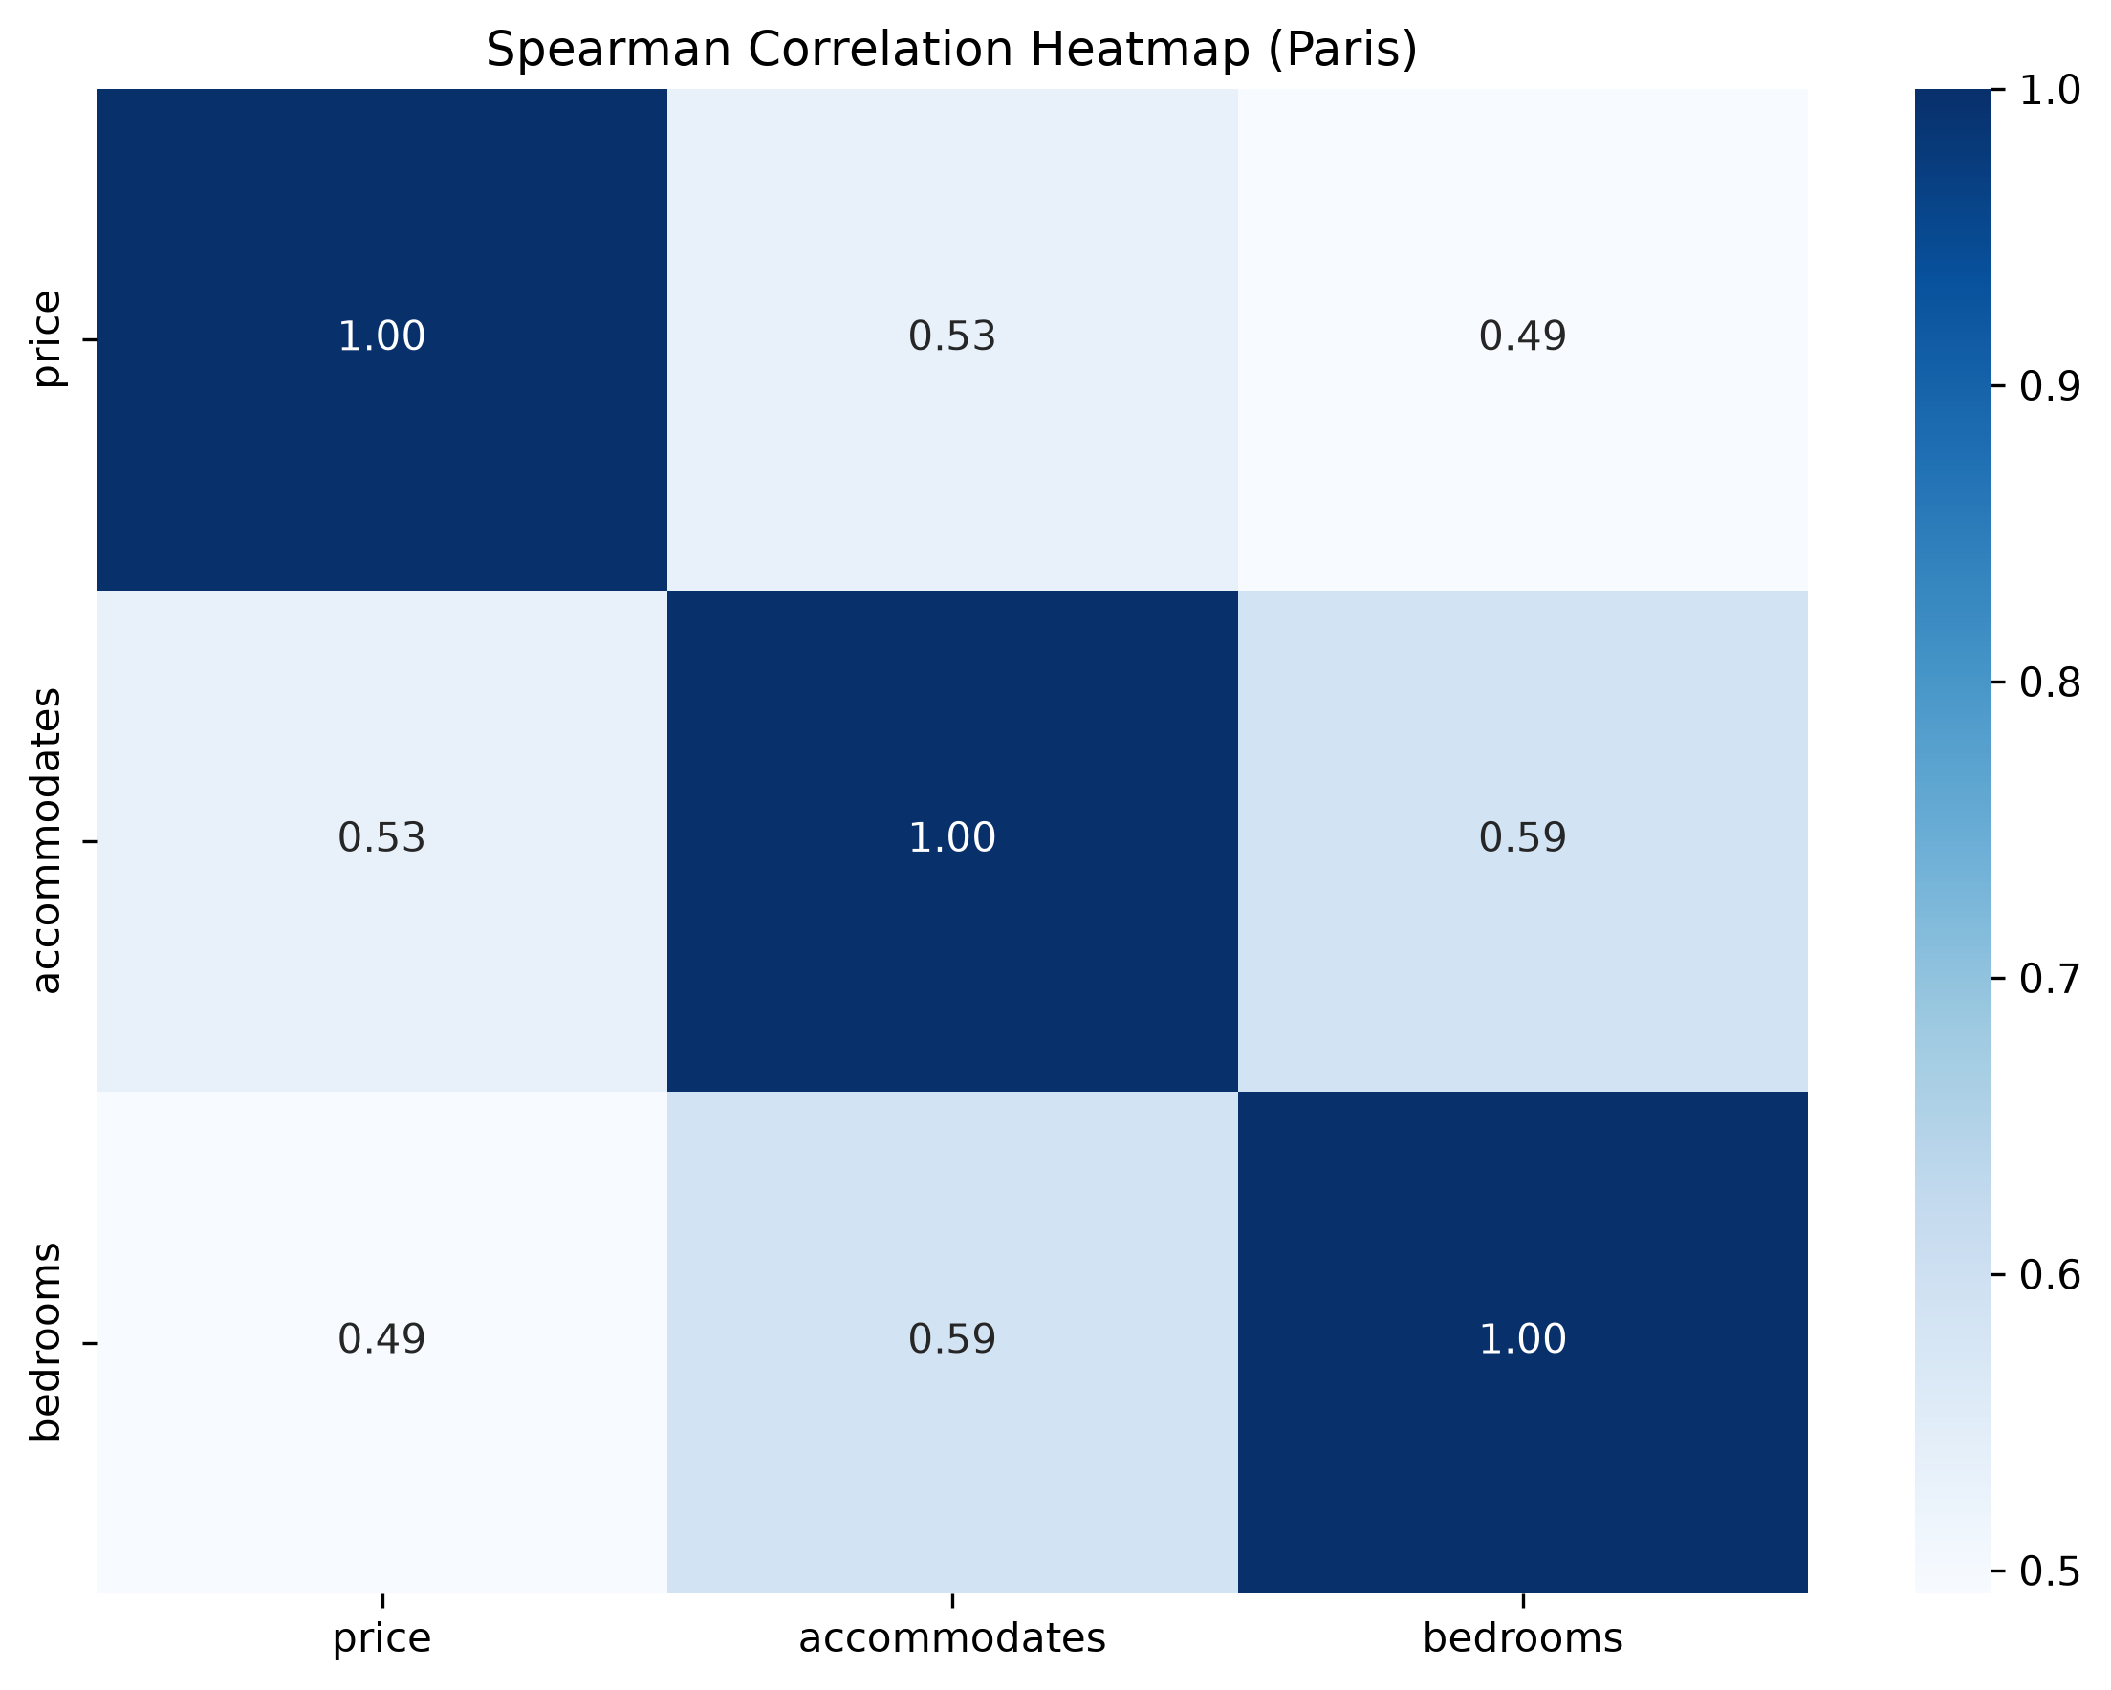
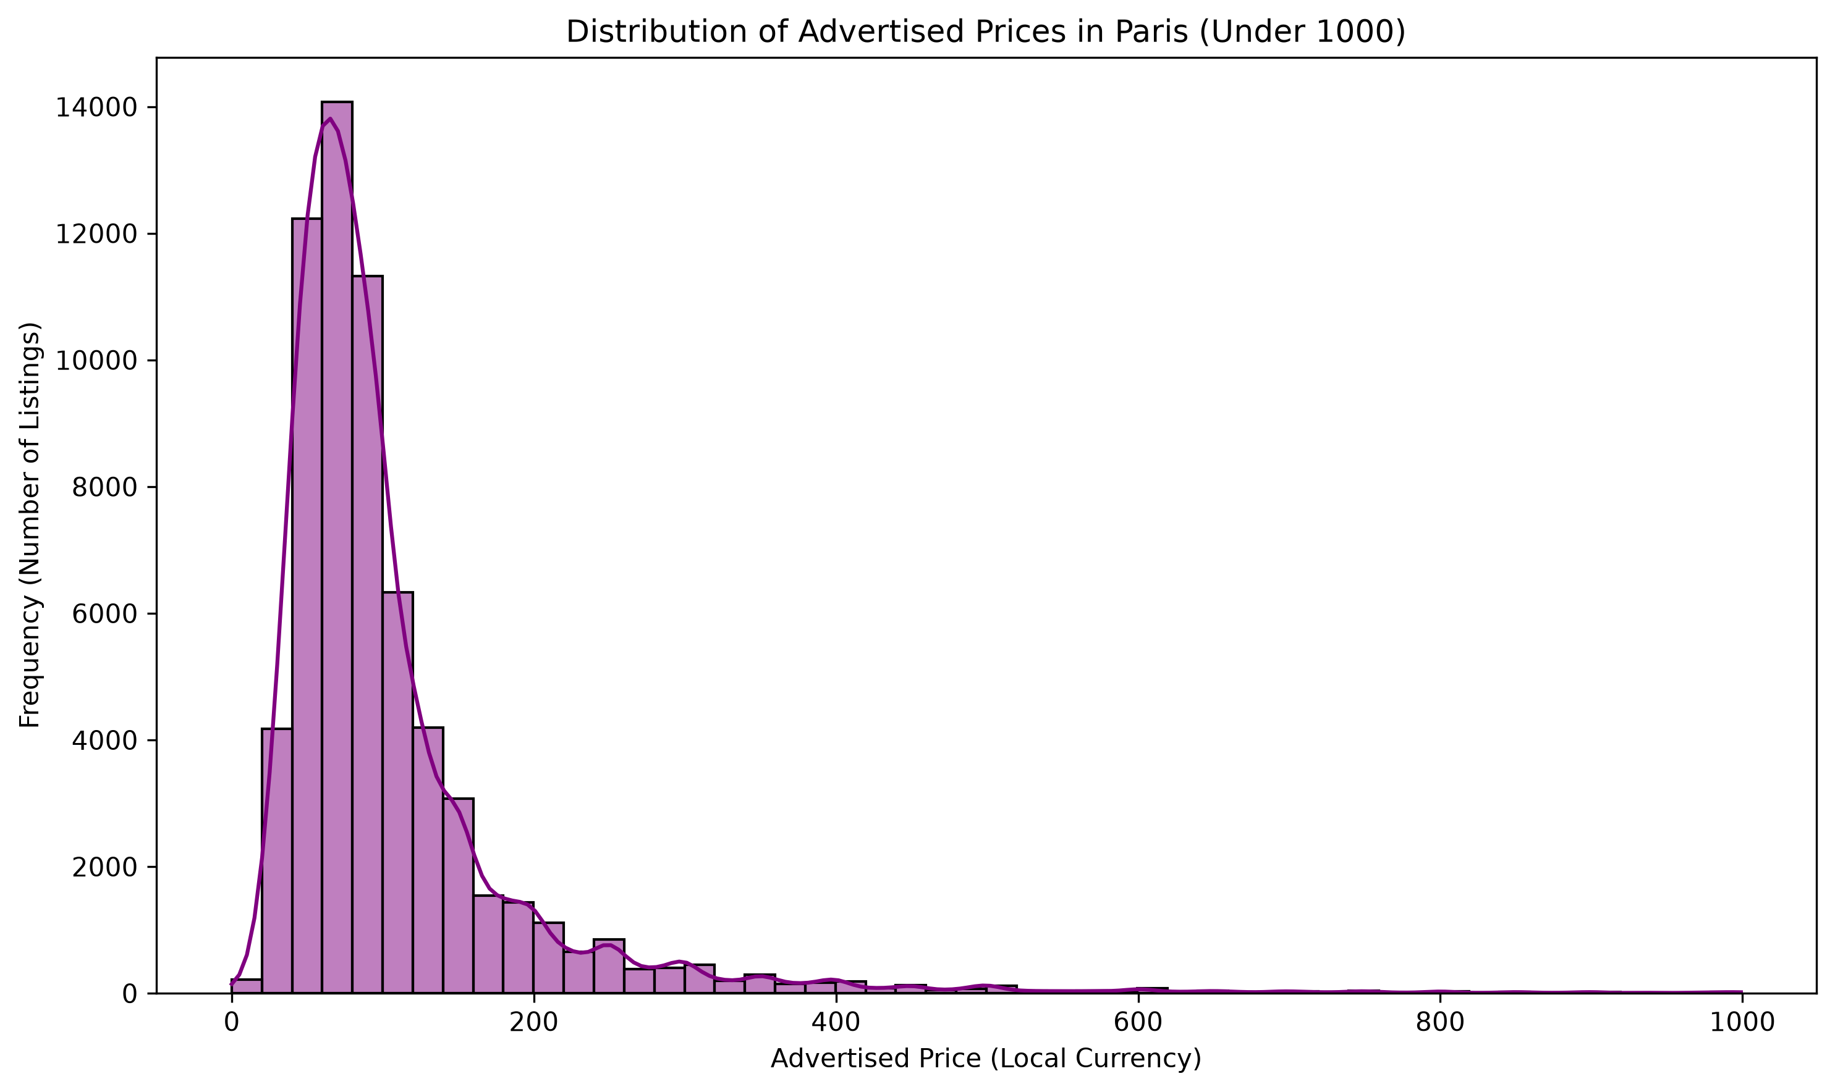
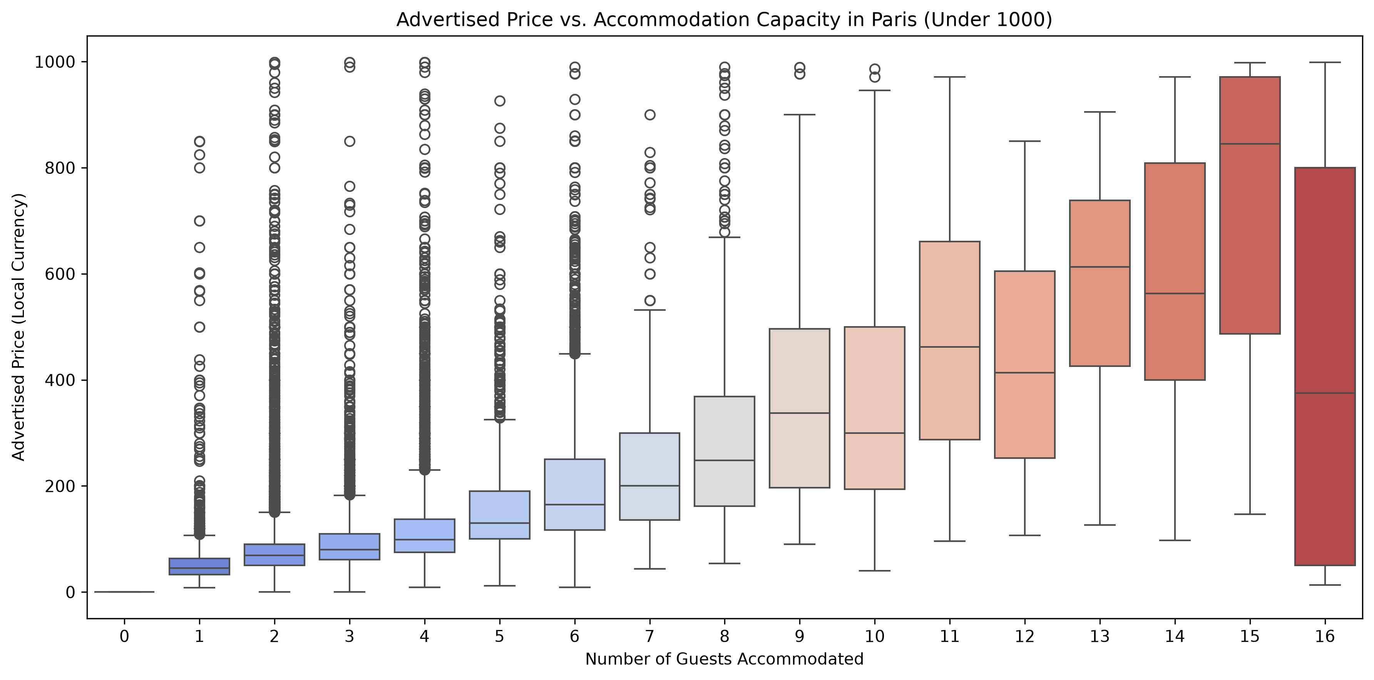
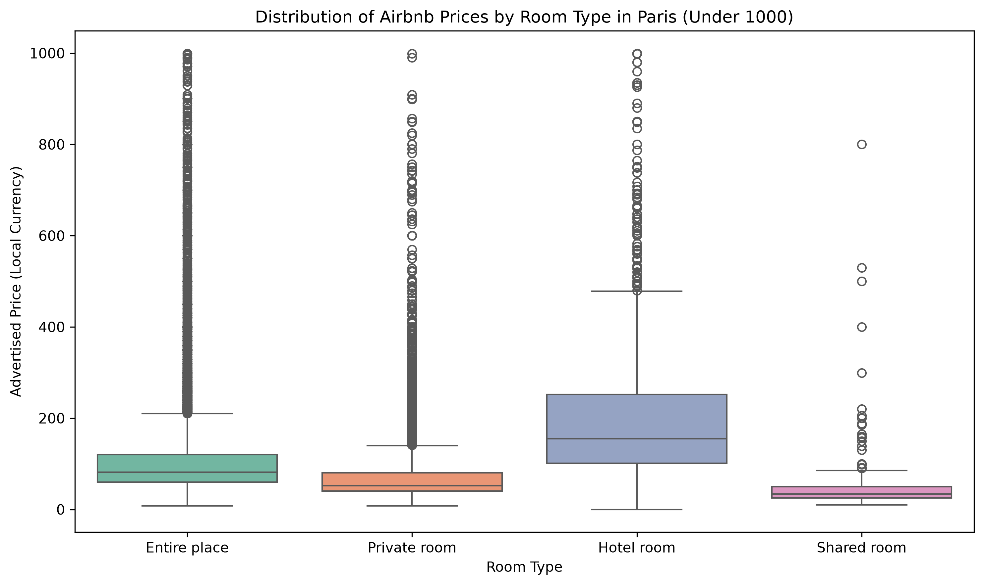
- Price by Room Type: The boxplot analysis reveals clear pricing tiers. Hotel rooms and Entire places command the highest median advertised prices and feature a massive number of high-value outliers. Private and Shared rooms are significantly more budget-friendly with tighter price variances.
- Price by Capacity: There is a clear positive relationship between a property's accommodation capacity and its advertised price. As capacity increases from 1 to 16 guests, the median nightly price steadily rises, though larger properties exhibit much wider pricing variability.
- Price Distribution: The histogram confirms that advertised prices are heavily right-skewed (not normally distributed), justifying the use of non-parametric statistical tests.

8. Statistical Hypothesis Testing
Because the price data is not normally distributed, non-parametric tests were used to evaluate statistical significance.
- Hypothesis 1 (Room Types): A Kruskal-Wallis H-test was conducted to determine if advertised prices differ across room types. The resulting p-value was strictly less than 0.05. Conclusion: We reject the null hypothesis; there is a statistically significant difference in advertised prices across room types.
- Hypotheses 2 & 3 (Property Size): A Spearman Rank Correlation test was conducted to evaluate the relationship between advertised price, accommodation capacity, and the number of bedrooms. Both tests returned p-values less than 0.05 with positive correlation coefficients. Conclusion: We reject the null hypotheses; capacity and bedrooms are significantly and positively correlated with advertised price.

9. Extended Limitations (Association vs. Causation)
While the statistical tests prove that larger capacity is associated with higher prices, they do not prove that capacity alone causes the exact price. Other unmeasured factors in this dataset (such as luxury amenities, exact street location, and property condition) heavily influence the final advertised rate.

10. Business Recommendations
- Host Pricing Strategy: Hosts listing "Entire homes" should scale their pricing models primarily based on their accommodation capacity, as the market data strongly supports capacity-tiered pricing.
- Platform Inventory Focus: The massive density of high-priced outliers in smaller capacities (2 to 4 guests) suggests a highly lucrative market for premium, small-footprint listings (e.g., luxury couples' retreats). The platform should create specific marketing campaigns or search filters highlighting these premium small listings.
- Future Data Collection: To move from estimating "advertised prices" to predicting actual "business revenue," the platform must begin tracking and exporting actual booking conversion rates and calendar occupancy data.

