**This text was added by using code.MongoDb Notes**

1. Do not use Interface types with Mongo Driver!
2. Do not use structs or record structs!

It does not work well.

**Do not use interface types**

The below picture shows 2 different results.

The top shows results of insert using interface types.  
Note the _id:null and the discriminatory type _t:"User"

When using a normal class, no such issue.

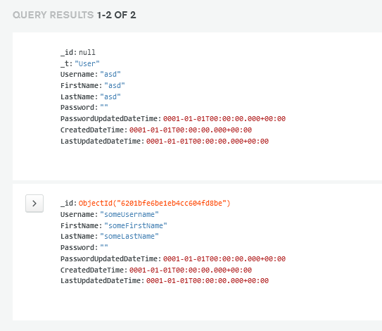

**Do not use struct or record structs**

MongoDb Driver is unablet o set the document using structs or record structs.  
record classes are ok

You will receive an error message:

Message:

Test method Mini.Wms.MongoDbImplementation.Tests.Services.UserServiceTests.AddAsyncTestAsync threw exception:

MongoDB.Bson.BsonSerializationException: SetDocumentId cannot be used with value type Mini.Wms.MongoDbImplementation.Models.User.

