

CSE 6224 Software Requirements Engineering
TRIMESTER 2510

Campus Ride-Sharing Platform with Parking System Integration
Software Requirements Specifications (SRS)

Tutorial Section: TT2L
Group D

Group Members:
William Sim Wee Lian | 243UC245RN
Er Kangming | 243UC247ND
Francis Wong Wei Hou | 243UC245PD

Table of Contents
Table of Contents 2
1 SRS Overview 5
1.1 Purpose 5
1.2 Scope 5
1.3 Product Overview 6
1.3.1 Product Perspective 6
1.3.1.1 Core Functionalities of the Campus Ride-Sharing and Parking Integration System 7
1.3.2 Product Functions 10
1.3.2.1 Student Functions 10
1.3.2.2 Staff Functions 10
1.3.2.3 Guest Functions 11
1.3.2.4 Admin Functions 11
1.3.2.5 Special Functions 12
1.3.3 User Characteristics 12
1.3.4 Limitations 13
1.4 Definitions 14
2 Reference 16
3 Requirements 17
3.1 Functions 17
3.1.1 Use case 17
3.1.1.1 Student 18
3.1.1.2 Staff 20
3.1.1.3 Guest 22
3.1.1.4 Admin 23
3.1.2 Sequence Diagram 24
3.1.2.1 Login and Logout with University Credentials (Student and Staff） 24
3.1.2.2 Guest Login/Logout(Guest) 26
3.1.2.3 Create Ride Offer (Student and Staff) 28
3.1.2.4 Join Ride(Student and Staff） 30
3.1.2.5 View Recommended Matches and Routes(Student and Staff） 31
3.1.2.6 Manage Trip Schedule and History(Student and Staff） 33
3.1.2.7 Report Feature(Student and Staff） 35
3.1.2.8 View Real-time Parking Availability（Except Admin) 37
3.1.2.9 Reserve Parking Spot（Except Admin) 39
3.1.2.10 Check Parking Status （Except Admin) 41
3.1.2.11 Admin Login 43
3.1.2.12 Access Carpooling Data & Review Reports and Complaints (Admin) 45
3.1.2.12 Access Carpooling Data (Admin) 46
3.1.2.14 Manage User Accounts (Admin) 47
3.1.2.15 Access Parking Data (Admin) 49
3.2 Performance Requirements 50
3.3 Usability Requirements 51
3.4 Interface Requirements 53
3.4.1 System Interfaces 53
3.4.2 User Interfaces 54
3.4.3 Hardware Interfaces 55
3.4.4 Software Interfaces 56
3.4.5 Communications Interfaces 58
3.5 Logical Database Requirements 59
3.5.1 User 61
3.5.2 Student 61
3.5.3 Staff 62
3.5.4 Guest 62
3.5.5 Admin 62
3.5.6 RideSharing 63
3.5.7 Report 63
3.5.8 ParkingSpot 64
3.5.9 Reservation 64
3.6 Design Constraints 65
3.7 Software system attributes 67
3.7.1 Accuracy 67
3.7.2 Availability 67
3.7.3 Maintainability 68
3.7.4 Portability 68
3.7.5 Reliability 69
3.7.6 Security 69
3.7.7 Usability 70
3.8 Supporting Information 71
3.8.1 Interview Summary 71
3.8.2 Observation Summary 73
4 Verification 87
4.1 Verification Approach 87
4.1.1 Functional Requirements Verification 87
4.1.2 Performance Requirements Verification 87
4.1.3 Security Requirements Verification 88
4.1.4 Usability Requirements Verification 88
4.1.5 Maintainability Requirements Verification 89
4.1.6 Portability Requirements Verification 89
4.2 Verification Criteria 90
5 Appendices 92
5.1 Assumptions and Dependencies 92
5.2 Acronyms and Abbreviations 93

1 SRS Overview

1.1 Purpose
This project aims to develop a smart and secure Campus Ride-Sharing Platform with Parking Integration to enhance mobility for students, staff, and guests within the university. The platform integrates ride-sharing with real-time parking availability and university authentication to:
- Reduce traffic congestion
- Encourage eco-friendly commuting
- Maximize use of limited parking spaces
Serving as a unified digital platform, it enables users to coordinate carpools, reserve parking spots, and enjoy a safer and more convenient commuting experience.

1.2 Scope
The system is a web-based software solution designed to streamline campus transportation and parking management. It allows users to:
- Coordinate ride-sharing trips (driver-passenger matching based on time and location)
- Track GPS locations in real time
- Reserve parking spots through a centralized interface
Authentication is enforced through university credentials, ensuring role-based access. Guests can use limited features such as viewing rides or booking parking.
Admins have access to a management dashboard for monitoring usage, user activity, incident reports, and transportation analytics.
This project follows software requirements engineering principles and incorporates user interviews and observations to accurately capture stakeholder needs.
Out-of-scope features include:
- Integration with third-party ride-hailing or payment systems
- QR code scanning, license plate recognition, or physical parking sensors
- Mobile app development (web-only access)
This initiative supports the university’s digital transformation goals by providing a scalable, data-driven solution for smarter campus commuting.

1.3 Product Overview

1.3.1 Product Perspective
This section provides an overview of the Campus Ride-Sharing and Parking Integration System, a web-based platform developed to enhance transportation coordination and parking efficiency within the university. The system is part of a digital transformation initiative aimed at improving campus mobility, optimizing parking resources, and promoting sustainable travel practices.
The following architecture outlines the system’s major components and their interactions.
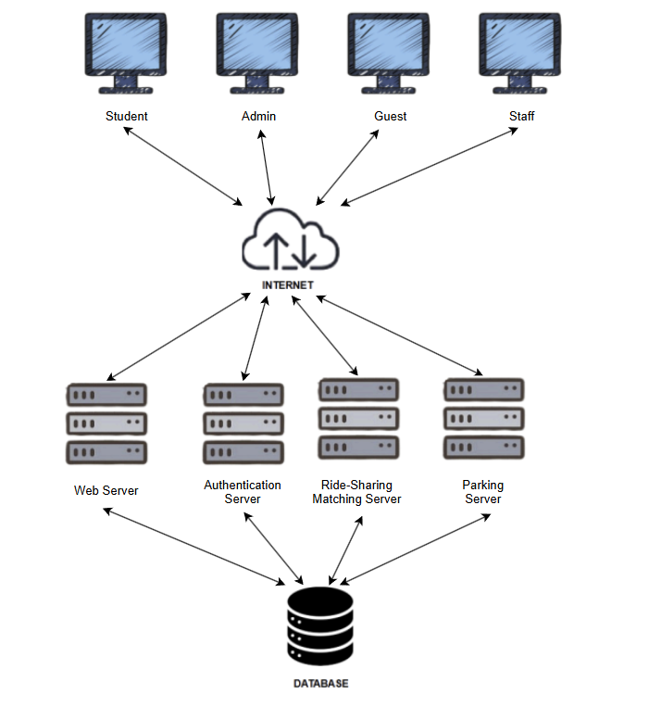
Figure 1.1: System Overview Diagram

The Campus Ride-Sharing and Parking Integration System functions as a web-only extension of the university's digital services. It provides real-time ride coordination, secure authentication through the university’s Digital ID system, and integration with a data-driven parking management module. By connecting students, staff, guests, and administrators through a centralized interface, the platform supports smarter transportation decisions and reduces congestion on campus.
Users access the system via a web browser, without the need for mobile apps or physical sensor integration. Authentication is handled by the university’s Digital ID authentication service, while guests use a simplified login to access limited parking-related features.

1.3.1.1 Core Functionalities of the Campus Ride-Sharing and Parking Integration System
1.Ride Coordination
- Create/join carpools with time and location matching
- Access trip history
2.Authentication
- Secure login via university credentials
- Limited guest access
3.Parking Integration
- Real-time parking availability
- Online reservations
4.User Role Access
- Students/Staff: Full access
- Guests: Parking-only access
- Admins: System oversight
5.Safety & Reporting
- In-ride reporting for incidents
- Activity logs for accountability
6.Data & Analytics
- Ride frequency, parking use, and behavior patterns
- Admin reports for planning and optimization

The following diagram illustrates the system's context diagram, depicting the interactions between system components and external actors.

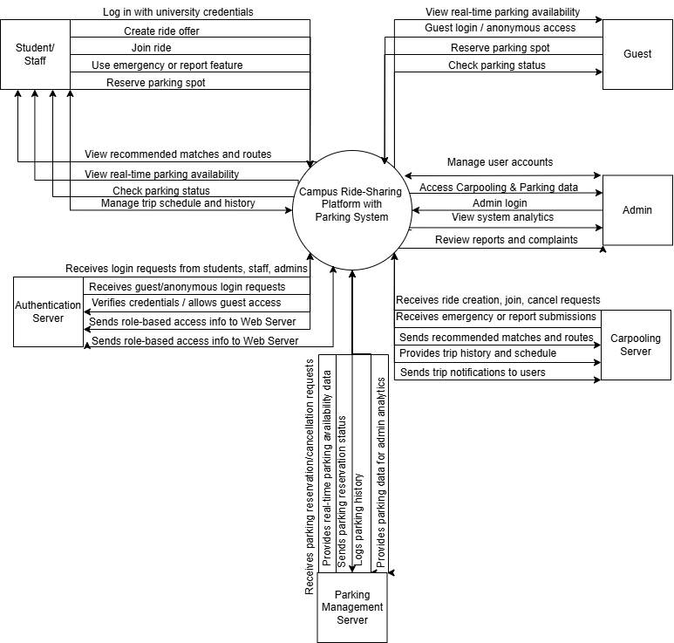
Figure 1.2: System Context Diagram

Aligned with the university's mission of embracing digital transformation and promoting sustainable mobility, the Campus Ride-Sharing and Parking Integration System is designed to fulfill a set of key requirements tailored to the dynamic transportation needs of the university community.
Requirement ID | Goals
REQ_CRPS_001 | The system shall enable users to coordinate ride-sharing trips based on schedules, locations, and preferences.
REQ_CRPS_002 | The system shall provide a real-time display of available parking spots to assist users in making parking decisions.
REQ_CRPS_003 | The system shall allow users to reserve parking spots in advance to reduce search time and avoid congestion.
REQ_CRPS_004 | The system shall authenticate users through secure university credentials to ensure authorized access.
REQ_CRPS_005 | The system shall include GPS-based location tracking to improve matching accuracy and parking navigation.
REQ_CRPS_006 | The system shall provide a centralized web-based interface for ride-sharing and parking services.
REQ_CRPS_007 | The system shall support trip history tracking and real-time notifications for upcoming rides and changes.
REQ_CRPS_008 | The system shall provide reporting and contact features to enhance user safety during trips.
REQ_CRPS_009 | The system shall promote ride-sharing as a sustainable commuting alternative to reduce emissions and traffic.
REQ_CRPS_010 | The system shall include analytics dashboards for administrators to monitor usage and generate actionable insights.
Table 1.1: Goals of the System
By addressing these requirements, the system aims to enhance campus mobility, ensure secure and efficient commuting, and support data-driven transportation management for students, staff, guests, and administrators alike.

1.3.2 Product Functions
This section outlines the normal and special operations performed by different user roles (Students, Staff, Guests, and Admins) in the Campus Ride-Sharing and Parking Integration System. The system supports real-time data interaction, mobile accessibility, authentication integration, and operational automation to ensure smooth and efficient usage.

1.3.2.1 Student Functions
- User Authentication (Login)
  - Students log in using university credentials via the Authentication Server.
  - Upon verification, access is granted to ride-sharing and smart parking modules.
- Create and Join Rides
  - Students can create ride offers with details (origin, destination, time).
  - They may join available rides shared by other users.
  - Notifications are sent upon successful ride creation or joining.
- View Recommended Routes
  - The system suggests optimal carpool routes based on location and time.
- Real-Time Parking
  - Students can view available parking spaces on campus in real time.
  - They may book parking slots in advance or on arrival.
- Reporting
  - Students can trigger report alerts during a ride, notifying admin and security.
- Trip and Booking History
  - A history of past rides, parking usage, and bookings is available for review.

1.3.2.2 Staff Functions
- User Authentication (Login)
  - Staff log in using official university credentials.
- Ride and Parking Access
  - Same access to carpool and parking features as students.
  - May offer staff-only carpool groups or parking areas.
- Priority Parking Access
  - Staff may receive parking priority or reserved zones (configurable by admin).
- Reporting
  - Report features mirror student access, including real-time location sharing.
- Trip Logs
  - Staff can access their own travel and parking logs for commuting analysis.

1.3.2.3 Guest Functions
- Guest Login
  - Guests access the system via guest or anonymous login with limited privileges.
- Smart Parking Access
  - Guests can view and book available parking spaces.
- Check Parking Status
  - Real-time updates on booking status and space availability are provided.
- No Ride-Sharing Access
  - Ride-sharing features are disabled for guest users for security and privacy.

1.3.2.4 Admin Functions
- Admin Authentication
  - Admins securely log in via Authentication Server with elevated privileges.
- User Management
  - Admins can view, add, disable, or manage user roles (students, staff, guests).
- System Monitoring
  - Real-time dashboards for monitoring ride and parking usage statistics.
- Manage Complaints and Reports
  - Admins review complaints, reports, and take necessary actions.
- Route and Parking Optimization
  - Adjust routing algorithms and parking slot availability based on analytics.
- Analytics and Report Generation
  - The system supports generation of detailed reports:
  - User behavior trends
  - Ride utilization and efficiency
  - Parking occupancy rates
  - Report response logs

1.3.2.5 Special Functions
- Centralized Authentication
  - All users authenticate through the centralized Authentication Server.
  - Login failures trigger retry mechanisms or error messages.
- Offline Data Handling
  - In case of network failure, ride and parking data are stored locally and synced upon reconnection.
- Data Backup and Recovery
  - System performs daily automated backups.
  - Recovery mechanisms restore system state in case of failures or data loss.
- Data Security and Logging
  - All transactions (rides, parking, report alerts) are logged for traceability and audit.

1.3.3 User Characteristics
This section describes the end users of the system, their expected familiarity with its features, and how their level of knowledge may impact the usage of the Campus Ride-Sharing and Parking Integration System. The following table summarizes the expected level of knowledge for each user role.
Role | Description | Expected Knowledge
Student | Registered students of the university who use the platform for commuting and parking. | Familiar with mobile/web apps; basic understanding of ride-sharing and parking systems.
Staff | Faculty and administrative staff of the university who commute to campus. | Moderate understanding of the platform features; can use carpooling and parking tools.
Guest | Visitors or external individuals accessing campus with temporary parking needs. | Limited system knowledge; guided access to parking functions through a simplified UI.
Admin | System administrators who oversee operations, analytics, and user management. | High proficiency in backend management, user account handling, and data reporting tools.
Table 1.2: User Characteristics

1.3.4 Limitations
The Campus Ride-Sharing and Parking Integration System faces several limitations that may affect its performance, usability, and scalability. These limitations stem from technical dependencies, real-time data reliability, access restrictions, and adoption challenges. The key limitations are as follows:
- Dependency on Real-Time Data Accuracy
The effectiveness of the ride-sharing and smart parking features heavily relies on the accuracy and timeliness of real-time data (e.g., GPS, parking availability). Any delays or inconsistencies in data feeds can negatively impact user experience and trust.
- Integration Constraints with University Infrastructure
Integration with university authentication systems, campus maps, and databases may be subject to institutional access policies and technical limitations. Incompatibility or restricted access could hinder full functionality.
- Limited Mobile Accessibility
The system is primarily web-based and does not currently support native mobile applications. This may reduce convenience for users who prefer mobile apps for on-the-go commuting and parking interactions.
- User Adoption and Behavioral Change
The success of ride-sharing features depends on user willingness to share rides and coordinate with others. Cultural or personal preferences may limit adoption, requiring awareness campaigns and incentives.
- Scalability for Multi-Campus Deployment
While designed for campus-wide use, scaling the system to additional campuses or institutions may require custom configurations, added infrastructure, and policy alignment, potentially increasing complexity and maintenance effort.
- Privacy and Security Considerations
Handling sensitive user data such as location, vehicle, and trip history demands strict data protection measures. Ensuring privacy and security compliance with university policies and legal standards is critical but challenging.

1.4 Definitions
Below are terms, phrases and words used in the document and their related definitions:
Terms | Definition
Campus Ride-Sharing and Parking Integration System | A web-based platform that enables university students, staff, and guests to coordinate ride-sharing and smart parking activities on campus.
Carpooling | A transportation service where users can offer or join rides with others traveling along the same route.
Smart Parking | A system that allows users to view real-time parking availability, reserve parking spots, and check parking status on campus.
User | Any individual who interacts with the system, including students, staff, guests, and administrators.
Student | An end user enrolled at the university who uses the system to access ride-sharing and parking services.
Staff | University employees who can also access ride-sharing and parking services, similar to students.
Guest | External users who can access limited parking features through guest login.
Admin | A user with administrative rights to manage system users, review reports, and monitor usage analytics.
Authentication Server | An external service used to verify user credentials and manage secure access to the platform.
Real-Time Parking Data | Dynamic data that reflects the current availability of parking spots across campus.
Reporting Feature | A feature that allows users to report incidents or request assistance during carpooling activities.
System Dashboard | The interface used by administrators to view analytics, manage content, and respond to user issues.
Table 1.3: Definition

2 Reference
Alotaibi, E., & Perwej, Y. (2021). A Smart Parking System Using IoT and Cloud-Based Services. International Journal of Advanced Computer Science and Applications (IJACSA), 12(1), 402–409. doi:10.14569/IJACSA.2021.0120152
Abusair, S., Khan, R. Z., & Mian, M. A. (2020). Smart Campus Mobility: A Conceptual Model for Ride-Sharing and Parking Management. 2020 5th International Conference on Computing, Communication and Security (ICCCS), 1–6. doi:10.1109/ICCCS49678.2020.9277569
Raghunandan, N., & Kalaimani, R. (2018). Efficient Parking Management System Using Cloud and IoT. International Journal of Engineering & Technology, 7(2.33), 287–290. doi:10.14419/ijet.v7i2.33.14393
Li, C., & Zheng, S. (2022). Smart Transportation Systems for University Campuses: Integrating Ride-Sharing and Parking Solutions. IEEE Access, 10, 114327–114339. doi:10.1109/ACCESS.2022.3212984
Wang, X., & Wang, S. (2019). Optimization of University Campus Parking Based on Real-Time Data. Journal of Urban Transport, 25(4), 89–97. doi:10.1007/s12469-019-00255-6
OpenAI. (2024). Campus Ride-Sharing & Parking User Survey Form. Retrieved from
https://docs.google.com/forms/d/e/1FAIpQLSeXYZ1234SampleCampusForm

3 Requirements

3.1 Functions

3.1.1 Use case
This is the overall use case diagram that shows all use cases for all actors.
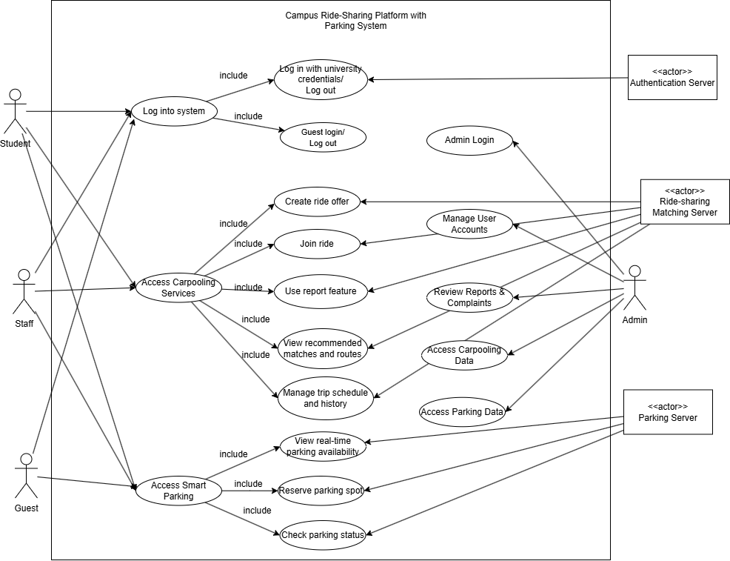
Figure 3.1: Use Case Diagram of Campus Ride-Sharing and Parking Integration System

3.1.1.1 Student
Figure 3.2: Use Case Diagram of Actor (Student)
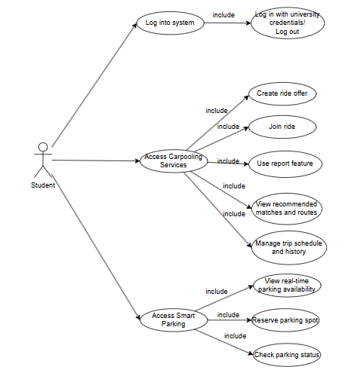

Use Case ID | Use Case Name | Description
REQ_UCS001 | Login and Logout | Allows student to securely log in and out using university credentials
REQ_UCS002 | Create Ride Offer | Allows student to create a carpooling trip offer
REQ_UCS003 | Join Ride | Allows student to join available ride offers
REQ_UCS004 | View Recommended Routes | Shows best-matched carpooling routes based on preferences
REQ_UCS005 | Manage Trip Schedule and History | Enables student to view, edit, or cancel rides and view history
REQ_UCS006 | Report Feature | Allows student to send alerts or reports for security and complaints
REQ_UCS007 | View Real-time Parking | Displays available parking spots in real time
REQ_UCS008 | Reserve Parking Spot | Enables student to book parking space before arrival
REQ_UCS009 | Check Parking Status | Allows student to view parking reservation details
Table 3.1: Use Case Diagram of Actor (Student)

3.1.1.2 Staff
Figure 3.3: Use Case Diagram of Actor (Staff)
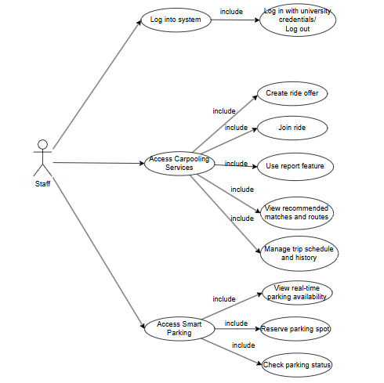

Use Case ID | Use Case Name | Description
REQ_UCT001 | Login and Logout | Allows staff to securely log in and out using university credentials
REQ_UCT002 | Create Ride Offer | Allows staff to create a carpooling trip offer
REQ_UCT003 | Join Ride | Allows staff to join available ride offers
REQ_UCT004 | View Recommended Routes | Shows best-matched carpooling routes based on preferences
REQ_UCT005 | Manage Trip Schedule and History | Enables staff to view, edit, or cancel rides and view history
REQ_UCT006 | Report Feature | Allows staff to send alerts or reports for security and complaints
REQ_UCT007 | View Real-time Parking | Displays available parking spots in real time
REQ_UCT008 | Reserve Parking Spot | Enables staff to book parking space before arrival
REQ_UCT009 | Check Parking Status | Allows staff to view parking reservation details
Table 3.2: Use Case Diagram of Actor (Staff)

3.1.1.3 Guest
Figure 3.4: Use Case Diagram of Actor (Guest)
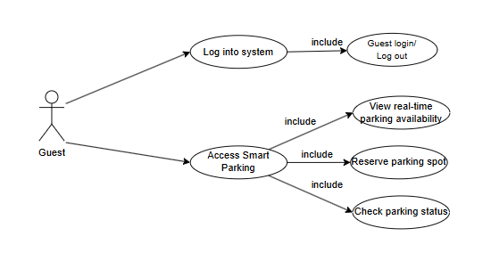

Use Case ID | Use Case Name | Description
REQ_UCG001 | Guest Login/Log Out | Allows guest to log in or log out anonymously or with temporary credentials
REQ_UCG002 | View Real-time Parking | Allows guest to see current available parking spaces
REQ_UCG003 | Reserve Parking Spot | Enables guest to reserve parking space
REQ_UCG004 | Check Parking Status | Allows guest to check status of reserved parking
Table 3.3: Use Case Diagram of Actor (Guest)

3.1.1.4 Admin
Figure 3.5: Use Case Diagram of Actor (Admin)
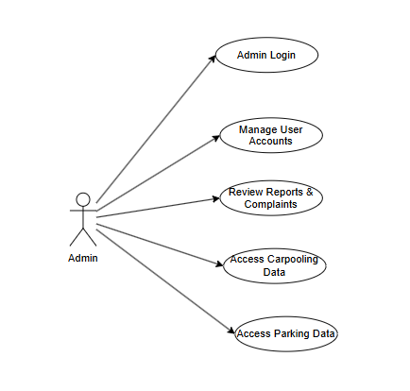
Use Case ID | Use Case Name | Description
REQ_UCA001 | Admin Login/Log out | Allows admin to securely log in or log out to the system
REQ_UCA002 | Manage User Accounts | Enables admin to create, edit, or delete user accounts
REQ_UCA003 | Review Reports & Complaints | Admin reviews submitted complaints
REQ_UCA004 | Access Carpooling Data | Admin views and manages carpooling-related records
REQ_UCA005 | Access Parking Data | Admin views and manages parking-related records
Table 3.4: Use Case Diagram of Actor (Admin)

3.1.2 Sequence Diagram

3.1.2.1 Login and Logout with University Credentials (Student and Staff）
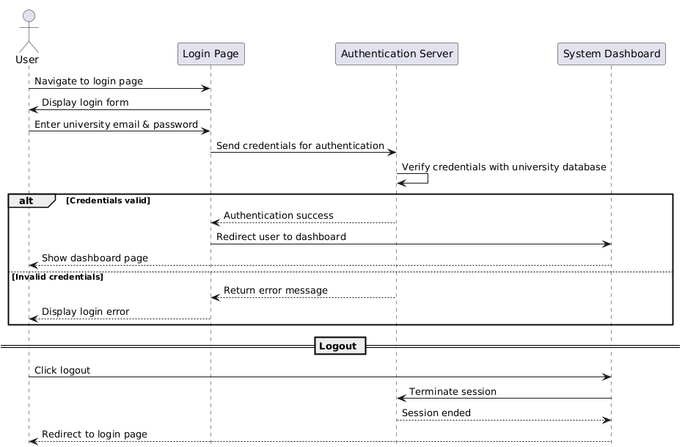
Figure 3.6：Login and Logout with University Credentials

Field | Description
ID | REQSQ001
Feature | Login and Logout with University Credentials
Version | 1.0
Purpose | To allow students, staff, and admins to securely access the system
Actor | Student / Staff
Precondition | User must have valid university credentials
Postcondition | User is authenticated and redirected to the system dashboard
Main Flow | 1. User navigates to login page  2. System displays login form  3. User submits credentials  4. System authenticates credentials  5. On success, user is redirected to dashboard
Alternate Scenario | 1. If credentials are invalid, system displays an error  2. If fields are empty, system prompts for required input
Table 3.5 : Login and Logout with University Credentials

3.1.2.2 Guest Login/Logout(Guest)
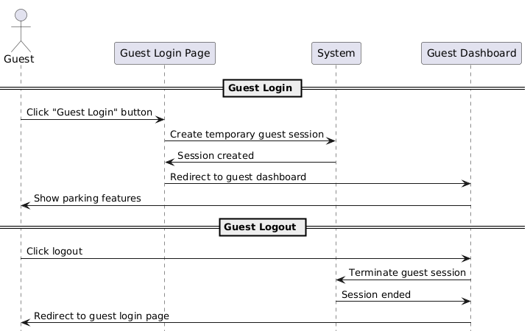
Figure 3.7: Guest Login and Logout

Field | Description
ID | REQSQ002
Feature | Guest Login and Logout
Version | 1.0
Purpose | To allow guests to access parking services without credentials
Actor | Guest
Precondition | Guest navigates to guest login page
Postcondition | Guest is granted temporary access and redirected to the guest dashboard
Main Flow | 1. Guest clicks “Guest Login”  2. System creates guest session  3. System redirects to dashboard
Alternate Scenario | 1. If session creation fails, system displays an error
Table 3.6: Guest Login and Logout

3.1.2.3 Create Ride Offer (Student and Staff)
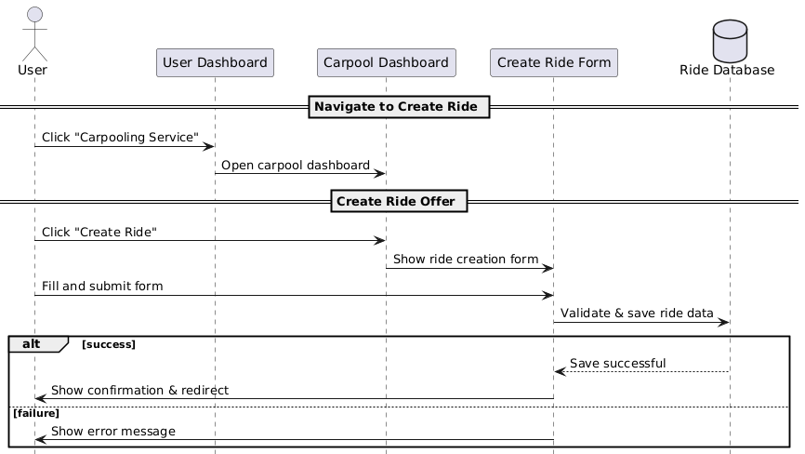
Figure 3.8: Create Ride Offer

Field | Description
ID | REQSQ003
Feature | Create Ride Offer
Version | 1.0
Purpose | To allow users to create and publish a new carpooling ride offer
Actor | Student / Staff
Precondition | User must be logged in
Postcondition | New ride offer is saved and listed in user's trip history
Main Flow | 1. User clicks "Carpooling Service"  2. System opens Carpool Dashboard  3. User clicks "Create Ride"  4. System shows ride creation form  5. User fills and submits  6. System validates and saves  7. System confirms and redirects
Alternate Scenario | 1. If required fields are missing, system prompts user  2. If DB save fails, system shows error
Table 3.7: Create Ride Offer

3.1.2.4 Join Ride(Student and Staff）
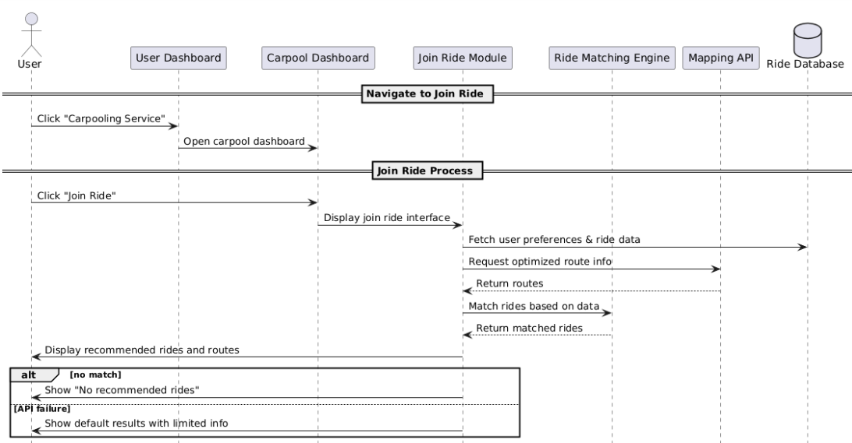
Figure 3.9: Join Ride

Field | Description
ID | REQSQ005
Feature | View Recommended Matches and Routes (as part of Join Ride)
Version | 1.0
Purpose | To provide users with personalized carpool matches and suggested routes
Actor | Student / Staff
Precondition | User is logged in and clicks "Join Ride"
Postcondition | User sees best-matched rides with optimized routes
Main Flow | 1. User clicks "Carpooling Service"  2. System opens Carpool Dashboard  3. User clicks "Join Ride"  4. System fetches ride data and preferences  5. Mapping API is called  6. Results are matched and displayed
Alternate Scenario | 1. If no matches, system shows “No recommended rides”  2. If API fails, system shows default results
Table 3.8: Join Ride

3.1.2.5 View Recommended Matches and Routes(Student and Staff）
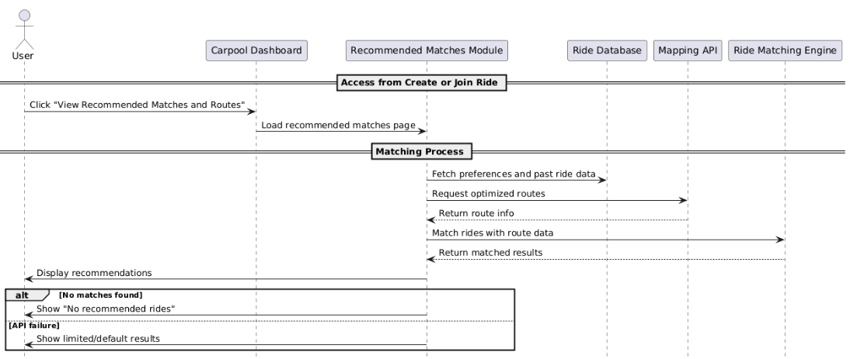
Figure 3.10: View Recommended Matches and Routes

Field | Description
ID | REQSQ005
Feature | View Recommended Matches and Routes
Version | 1.0
Purpose | To provide users with personalized carpool matches and suggested routes
Actor | Student / Staff
Precondition | User must be logged in with stored preferences or past ride data
Postcondition | User views best-matched rides with optimized routes
Main Flow | 1. User opens "Recommended Matches and Routes"  2. System fetches ride data and preferences  3. System calls mapping API  4. System matches results  5. Recommendations displayed
Alternate Scenario | 1. If no matches, system shows “No recommended rides”  2. If route API fails, system shows limited results
Table 3.9: View Recommended Matches and Routes

3.1.2.6 Manage Trip Schedule and History(Student and Staff）
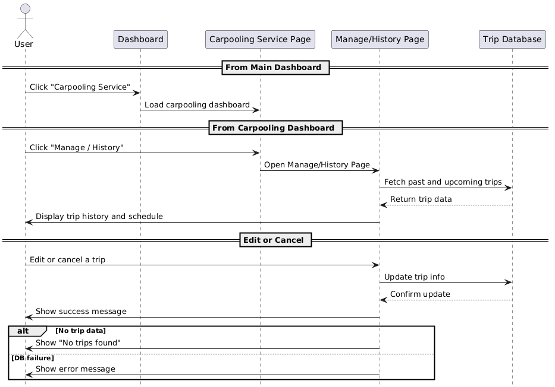
Figure 3.11: Manage Trip Schedule and History

Field | Description
ID | REQSQ006
Feature | Manage Trip Schedule and History
Version | 1.0
Purpose | To allow users to view, edit, or cancel their trips and access trip history
Actor | Student / Staff
Precondition | User must be logged in and have trip data (created via ride offer) in the system
Postcondition | User views trip history or updated future trip details
Main Flow | 1. User logs in  2. Clicks "Carpooling Service"  3. Enters "Manage / History" page  4. System loads trips  5. Trips displayed  6. User edits/cancels  7. System updates and confirms
Alternate Scenario | 1. If DB fails, system shows error  2. If no trips, system shows empty state
Table 3.10: Manage Trip Schedule and History

3.1.2.7 Report Feature(Student and Staff）
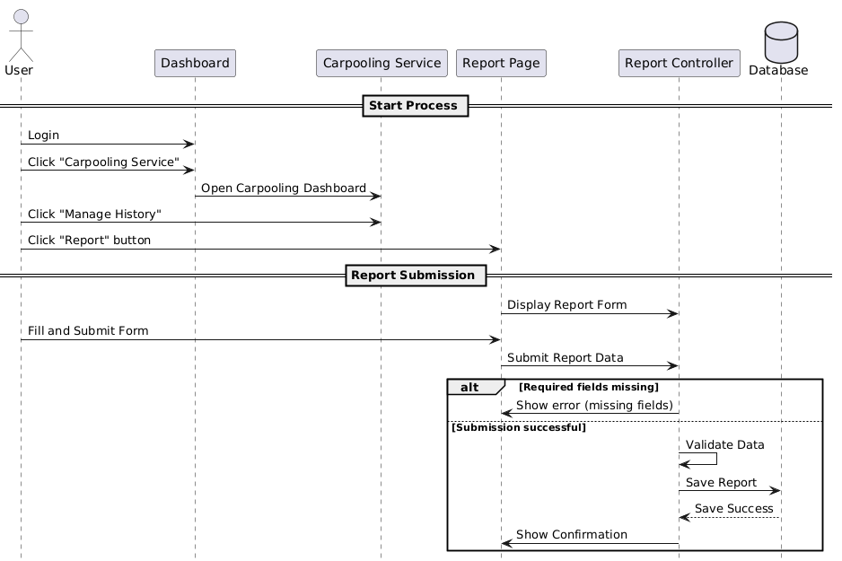
Figure 3.12: Report Feature

Field | Description
ID | REQSQ007
Feature | Report Feature
Version | 1.0
Purpose | To allow users to submit reports regarding issues or complaints
Actor | Student / Staff
Precondition | User is logged in and accesses the Report/Feedback page from Carpooling Dashboard
Postcondition | Report is submitted and stored in the database; user receives confirmation
Main Flow | User logs in  User clicks “Carpooling Service”  User clicks “Manage History”  System displays Report / Feedback page  User clicks “Report” button  System displays the Report form  User fills in the report details and clicks Submit  System validates the input fields  System stores the report in the database  System shows confirmation message to the user
Alternate Scenario | If required fields are empty, the system prompts the user to complete all mandatory fields  If submission fails due to a system error, an error message is displayed to the user
Table 3.7: Report Feature

3.1.2.8 View Real-time Parking Availability（Except Admin)
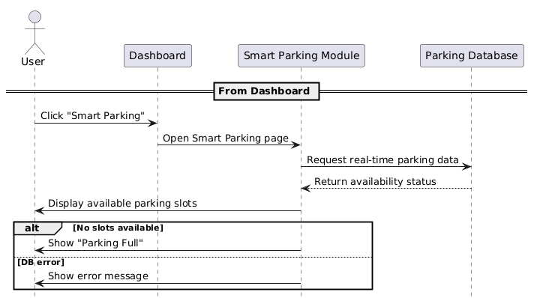
Figure 3.13: View Real-time Parking Availability

Field | Description
ID | REQSQ008
Feature | View Real-time Parking Availability
Version | 1.0
Purpose | To allow users to view current availability of parking slots
Actor | Student / Staff / Guest
Precondition | User is logged in (or guest accessed) and navigates to the Smart Parking page
Postcondition | System displays updated parking availability
Main Flow | 1. User clicks "Smart Parking" on dashboard  2. System requests real-time data  3. Parking DB returns status  4. System displays available slots
Alternate Scenario | 1. If parking DB is unavailable, system shows error  2. If no slots available, system shows "Full" message
Table 3.8: View Real-time Parking Availability

3.1.2.9 Reserve Parking Spot（Except Admin)
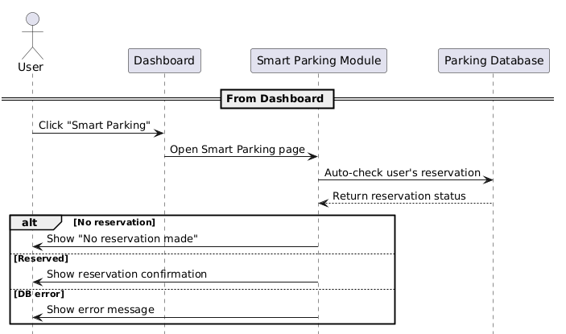
Figure 3.14:Reserve Parking Spot

Field | Description
ID | REQSQ009
Feature | Reserve Parking Spot
Version | 1.0
Purpose | To allow users to check and confirm their reserved parking spot
Actor | Student / Staff / Guest
Precondition | User is logged in (or guest accessed) and has made a reservation
Postcondition | User sees reservation details or system notifies of no reservation
Main Flow | 1. User clicks "Smart Parking"  2. System checks for reservation  3. Reservation status returned  4. System displays confirmation or prompt
Alternate Scenario | 1. If no reservation, system shows "No reservation made"  2. If DB fails, system shows error
Table 3.9: Reserve Parking Spot

3.1.2.10 Check Parking Status （Except Admin)
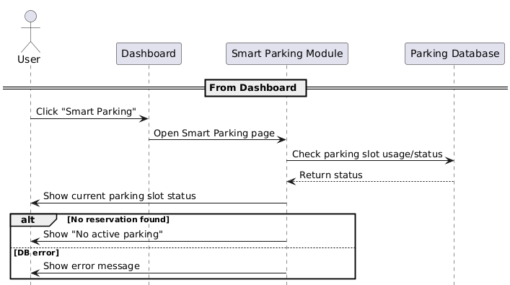
Figure 3.15:Check Parking Status

Field | Description
ID | REQSQ010
Feature | Check Parking Status
Version | 1.0
Purpose | To allow users to check their current parking usage status
Actor | Student / Staff / Guest
Precondition | User is logged in (or guest accessed) and has previously reserved a parking slot
Postcondition | System displays real-time status of the user's parking slot
Main Flow | 1. User clicks "Smart Parking"  2. System checks current status of parking slot  3. Status is returned  4. User views real-time status
Alternate Scenario | 1. If no reservation found, system shows "No active parking"  2. If DB fails, system shows error
Table 3.10: Check Parking Status

3.1.2.11 Admin Login
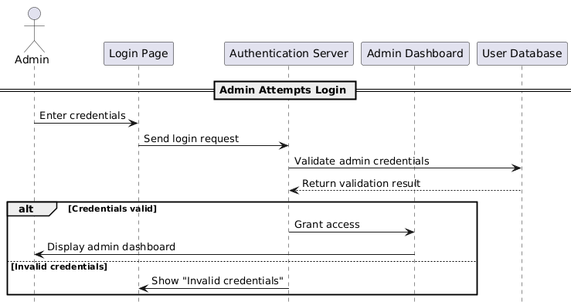
Figure 3.16: Admin Login

Field | Description
ID | REQSQ011
Feature | Admin Login
Version | 1.0
Purpose | To allow administrators to securely access the system via login credentials
Actor | Admin
Precondition | Admin has a valid account and accesses the login page
Postcondition | Admin is redirected to the admin dashboard upon successful login
Main Flow | 1. Admin enters credentials  2. System validates credentials  3. If valid, admin is redirected to dashboard
Alternate Scenario | 1. If credentials are invalid, system shows error message
Table 3.11: Admin Login

3.1.2.12 Access Carpooling Data & Review Reports and Complaints (Admin)
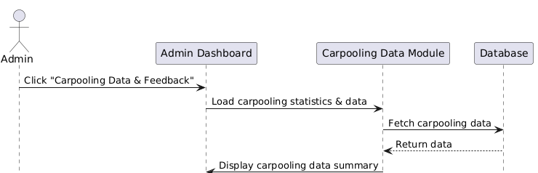
Figure 3.17: Access Carpooling Data & Review Reports and Complaints

Field | Description
ID | REQSQ012
Feature | Access Carpooling Data & Review Reports and Complaints
Version | 1.0
Purpose | To allow admins to view carpooling data and access detailed reports and complaints submitted by users
Actor | Admin
Precondition | Admin must be logged in and access the admin dashboard
Postcondition | Carpooling data is displayed; reports and complaints are accessible after clicking feedback button
Main Flow | 1. Admin clicks "Carpooling Data & Feedback"  2. System loads carpooling data  3. Admin clicks "Feedback" button  4. System loads reports and complaints
Alternate Scenario | 1. If data retrieval fails, system shows error message
Table 3.12: Access Carpooling Data & Review Reports and Complaints

3.1.2.12 Access Carpooling Data (Admin)
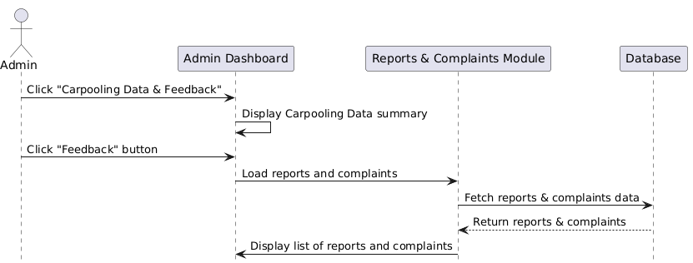
Figure 3.18: Review Reports and Complaints

Field | Description
ID | REQSQ012B
Feature | Review Reports and Complaints
Version | 1.0
Purpose | To allow admins to review user-submitted reports and complaints
Actor | Admin
Precondition | Admin must be logged in and access the admin dashboard
Postcondition | Reports and complaints list is displayed after clicking the feedback button
Main Flow | 1. Admin clicks "Carpooling Data & Feedback"  2. Admin clicks "Feedback" button  3. System loads and displays reports and complaints
Alternate Scenario | 1. If data retrieval fails, system shows error message
Table 3.13: Review Reports and Complaints

3.1.2.14 Manage User Accounts (Admin)
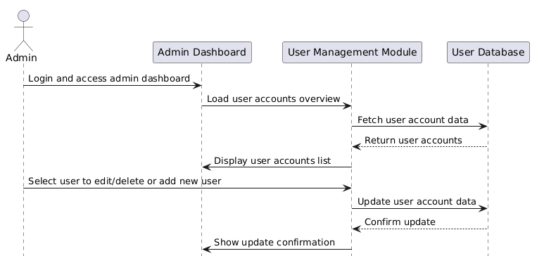
Figure 3.19: Manage User Accounts

Field | Description
ID | REQSQ013
Feature | Manage User Accounts
Version | 1.0
Purpose | To allow admin to view, add, edit, or delete user accounts
Actor | Admin
Precondition | Admin must be logged in and have accessed the admin dashboard
Postcondition | User accounts data is displayed and admin can manage accounts
Main Flow | 1. Admin logs in and enters admin dashboard  2. System loads user accounts  3. Admin edits/adds/deletes user  4. System updates DB and confirms
Alternate Scenario | 1. If database fails, system shows error message
Table 3.14: Manage User Accounts

3.1.2.15 Access Parking Data (Admin)
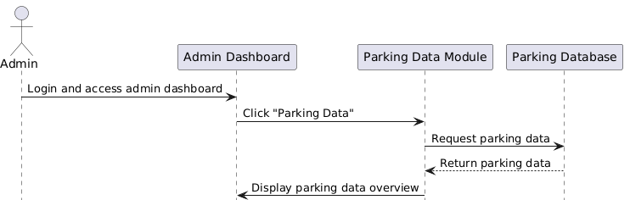
Figure 3.20: Access Parking Data

Field | Description
ID | REQSQ014
Feature | Access Parking Data
Version | 1.0
Purpose | To allow admin to view parking usage data and statistics
Actor | Admin
Precondition | Admin must be logged in and access the admin dashboard
Postcondition | Parking data is displayed to the admin
Main Flow | 1. Admin logs in and accesses admin dashboard  2. Admin clicks "Parking Data"  3. System retrieves parking data  4. Data displayed to admin
Alternate Scenario | 1. If database fails, system shows error message
Table 3.15: Access Parking Data

3.2 Performance Requirements
This section defines the performance and quality expectations for the Campus Ride-Sharing and Parking Integration System. These requirements ensure the system delivers a responsive, stable, and scalable user experience under different load conditions. The table below outlines the desired performance characteristics to meet user needs effectively.
Requirement ID | Description | Priority
REQ_P001 | The system shall respond to user interactions (e.g., booking, joining a ride) within 0 to 3 seconds. | High
REQ_P002 | The platform shall support up to 5,000 concurrent users without performance degradation. | High
REQ_P003 | The system shall ensure 99.9% uptime availability excluding scheduled maintenance periods. | High
REQ_P004 | Real-time parking data shall be retrieved and displayed within 2 seconds. | Medium
REQ_P005 | The system shall process up to 100,000 ride-sharing and parking transactions daily without performance loss. | High
REQ_P006 | User dashboards and trip/parking history shall load within 1 second. | Medium
REQ_P007 | Ride creation, join requests, and parking reservations shall be processed in under 1 second. | High
REQ_P008 | The system shall maintain database transaction latency below 100ms. | Medium
REQ_P009 | The system shall support horizontal scaling to handle growth in users and data. | High
REQ_P010 | The system shall maintain a crash rate of less than 1 crash per 10,000 sessions. | Medium
REQ_P011 | Administrative reports and analytics shall be generated within 5 seconds of request. | Medium
REQ_P012 | The system shall perform automatic backups with a maximum data loss window of 1 hour. | High
REQ_P013 | Real-time ride and parking notifications shall be delivered to users within 1 second. | High
REQ_P014 | The system shall use load balancing techniques to efficiently distribute user requests across servers. | High
REQ_P015 | Secure communications shall use encryption with a processing delay of less than 50ms. | Medium
Table 3.1: Performance Requirements

3.3 Usability Requirements
This section outlines the usability expectations for the Campus Ride-Sharing and Parking Integration System. These requirements aim to enhance user satisfaction by providing a smooth, intuitive, and accessible experience for all types of users, including students, staff, guests, and administrators. The table below details each usability requirement.
Requirement ID | Description | Priority
REQ_UR001 | The system shall provide a seamless login experience using university credentials or guest access. | High
REQ_UR002 | The interface shall display relevant real-time updates such as parking availability and ride offers. | Medium
REQ_UR003 | Users shall be able to share their ride details or parking bookings with others through a unique shareable link. | High
REQ_UR004 | The platform shall include a notification system to alert users of trip changes, new ride matches, or parking status updates. | Medium
REQ_UR005 | The interface shall offer a clean, responsive, and intuitive design to minimize user confusion and cognitive load. | High
REQ_UR006 | The admin dashboard shall provide usage analytics and feedback summaries from users regarding ride and parking experiences. | Medium
REQ_UR007 | The platform shall integrate with campus services (e.g., maps, timetable systems) for enhanced navigation and scheduling. | High
REQ_UR008 | Users shall be able to customize their dashboard to show preferred features such as parking status or trip history. | Low
REQ_UR009 | The platform shall provide onboarding tutorials and tooltips to guide first-time users through core features. | Medium
REQ_UR010 | The platform shall protect user data during all interactions, especially during login and trip/parking sharing. | High
REQ_UR011 | The platform shall be fully mobile-friendly and responsive, ensuring smooth use on smartphones and tablets. | High
REQ_UR012 | The system shall offer a feedback form where users can report issues or suggest improvements for usability. | Medium
REQ_UR013 | Users shall be able to tag co-riders or carpool buddies in ride details for better coordination. | Low
REQ_UR014 | The platform shall include accessibility features such as screen reader compatibility, color contrast, and keyboard navigation. | High
REQ_UR015 | The system shall be regularly updated to maintain compatibility with browsers and device operating systems. | Medium
Table 3.2: Usability Requirements

3.4 Interface Requirements

3.4.1 System Interfaces
The Campus Ride-Sharing and Parking Integration System interfaces with several subsystems and external services to enable seamless operations across authentication, ride-sharing, parking management, and administrative analytics. These interfaces ensure secure data exchange, role-based access control, and real-time system feedback, providing a smooth experience for all users including students, staff, guests, and administrators.
Interface ID | System Name | Description | Details
REQ_SI001 | Authentication Server | Handles login and access control for students, staff, guests, and admins | Supports university SSO and guest login via secure protocols (e.g., OAuth 2.0, JWT)
REQ_SI002 | Carpooling Server | Manages ride creation, joining, scheduling, reporting & admin data access | APIs for ride offer, match recommendations, trip history, and report data
REQ_SI003 | Parking Management Server | Manages smart parking, admin usage logs, and parking analytics | Provides real-time data, reservations, and logs accessible by admin
REQ_SI004 | Notification Service | Sends alerts to users across all roles including report and admin use | API integration with email/SMS (e.g., SendGrid, Twilio)
REQ_SI005 | Map & Route API | Recommends optimal carpool routes | Connects to map services (e.g., Google Maps) for location and routing
Table 3.3: System Interfaces

3.4.2 User Interfaces
The following outlines the user interface design principles for the Campus Ride-Sharing and Parking Integration System. All visual elements, layouts, and user interaction components are designed for clarity, accessibility, and consistency, adhering to the Multimedia University (MMU) branding and the administrative dashboard interface style.
Module ID | Description | Priority
REQ_UI001 | The overall GUI uses a primary white content background, with light gray panels (#D3D3D3) for sidebars and subtle shadowed containers. | High
REQ_UI002 | The left sidebar layout is persistent across all pages, using black icons with dark gray labels (#333333) in Roboto, size 14pt. | High
REQ_UI003 | The system font family is Roboto for all interface text and Roboto Slab for headers or section titles. | Medium
REQ_UI004 | Text colors follow a consistent theme: Dark Gray (#333333) for body text, and White (#FFFFFF) when displayed over colored buttons or bars. | High
REQ_UI005 | Font sizes are structured for readability: 14pt minimum, 16pt standard text, 20pt subtitles, and 32pt section headers. | High
REQ_UI006 | Font weight is medium (500) for general content and bold for headers and actionable elements (e.g., button text, section titles). | High
REQ_UI007 | Buttons are color-coded by function: Bright Blue (#007BFF) for primary actions (e.g., Edit, Logout), Red (#FF4136) for Delete/warnings. | Medium
REQ_UI008 | Buttons use white text, have slightly rounded corners, and consistent padding with hover feedback (slight shade or pointer change). | Medium
REQ_UI009 | Tables are styled with no outer borders, clear column headers, and use padding and spacing to separate content for clean visibility. | High
REQ_UI010 | Icons and labels in navigation menus are vertically aligned, maintain equal spacing, and ensure usability even on mid-sized screens. | Medium
REQ_UI011 | The top navigation bar includes user role display, a Logout button styled in blue (#007BFF), and an icon for intuitive access. | High
REQ_UI012 | All interfaces are designed for desktop resolution first, with flexible layout containers that prevent horizontal scrolling. | Medium
Table 3.4: User Interfaces

3.4.3 Hardware Interfaces
The Campus Ride-Sharing and Parking Integration System is designed to be accessible via a range of devices including desktops, laptops, tablets, and smartphones. To ensure smooth operation and access to all features, the devices should meet the following minimum hardware specifications. Devices that do not meet these requirements may experience degraded performance or limited functionality.
Interface ID | Description
REQ_HI001 | The processor of the device shall be at least a 64-bit processor (e.g., Intel Core i3 or equivalent) for optimal performance
REQ_HI002 | The device shall have a minimum of 4GB RAM to support multitasking and real-time data processing
REQ_HI003 | The device shall have at least 2GB of free storage space to accommodate application data and cache
REQ_HI004 | The device must support internet connectivity via Ethernet, Wi-Fi, or mobile data networks to enable real-time updates and communication
Table 3.5: Hardware Interfaces Requirements

3.4.4 Software Interfaces
The Campus Ride-Sharing and Parking Integration System depends on various software components and platforms to operate effectively. Below is a detailed list of software interfaces required for system functionality:
ID | Category | Name | Version Number | Purpose | Reference
REQ_SI001 | Operating System | Microsoft Windows | Windows 10 or later | Software platform managing device hardware and resources to support system execution | Microsoft Official Page
 |  | macOS | macOS Mojave 10.14 or later |  | Apple Official Page
 |  | Linux | Ubuntu 20.04+, Debian 11+, Fedora 40+ |  | Linux Distribution Pages
 |  | iOS | iOS 15.0 or later |  | Apple Official Page
 |  | Android | Android 10.0 or later |  | Android Official Page
REQ_SI002 | Browser | Google Chrome | 124.0.6367.159 | Used by end users to access the web application and communicate with the server | Chrome Official Page
 |  | Microsoft Edge | 124.0.2478.80 |  | Microsoft Edge Official Page
 |  | Safari | 16.6.1 |  | Safari Official Page
REQ_SI003 | Database | MySQL | 8.0 or later | Database system used to store and manage data for users, trips, parking, and analytics | MySQL Official Page
REQ_SI004 | Backend Server | Node.js | 18.x or later | Server runtime environment for handling API requests and business logic | Node.js Official Page
REQ_SI005 | API Framework | Express.js | 4.x | Framework for building RESTful APIs to support client-server communication | Express Official Page
Table 3.6: Software Interfaces

3.4.5 Communications Interfaces
This section outlines the communication interfaces and protocols used by the Campus Ride-Sharing and Parking Integration System to interact with users, external services, and other systems.
Interface ID | Description | Protocols/  Methods | Priority
REQ_CI001 | The system shall support HTTP/HTTPS protocols for secure web communication | HTTP/HTTPS | High
REQ_CI002 | The system shall integrate with university authentication services for user login (e.g., SAML, OAuth) | SAML, OAuth 2.0 | High
REQ_CI003 | The system shall use WebSocket protocol for real-time updates, notifications, and ride matching | WebSocket | Medium
REQ_CI004 | The system shall support SMTP for sending emails to users for notifications, booking confirmations, and alerts | SMTP | Medium
REQ_CI005 | The system shall support integration with campus LDAP or Active Directory for user authentication and management | LDAP/Active Directory | High
REQ_CI006 | The system shall support secure file transfer protocol (SFTP) for exchanging files with external systems | SFTP | Medium
REQ_CI007 | The system shall ensure response time for ride offer posting and updates to be under 1 second | MQTT | Low
REQ_CI008 | The system shall enable data exchange with external databases through JDBC/ODBC connections | JDBC/ODBC | Medium
REQ_CI009 | The system shall support JSON and XML data formats for data interchange between clients and servers | JSON, XML | High
Table 1.6: Communications Interfaces

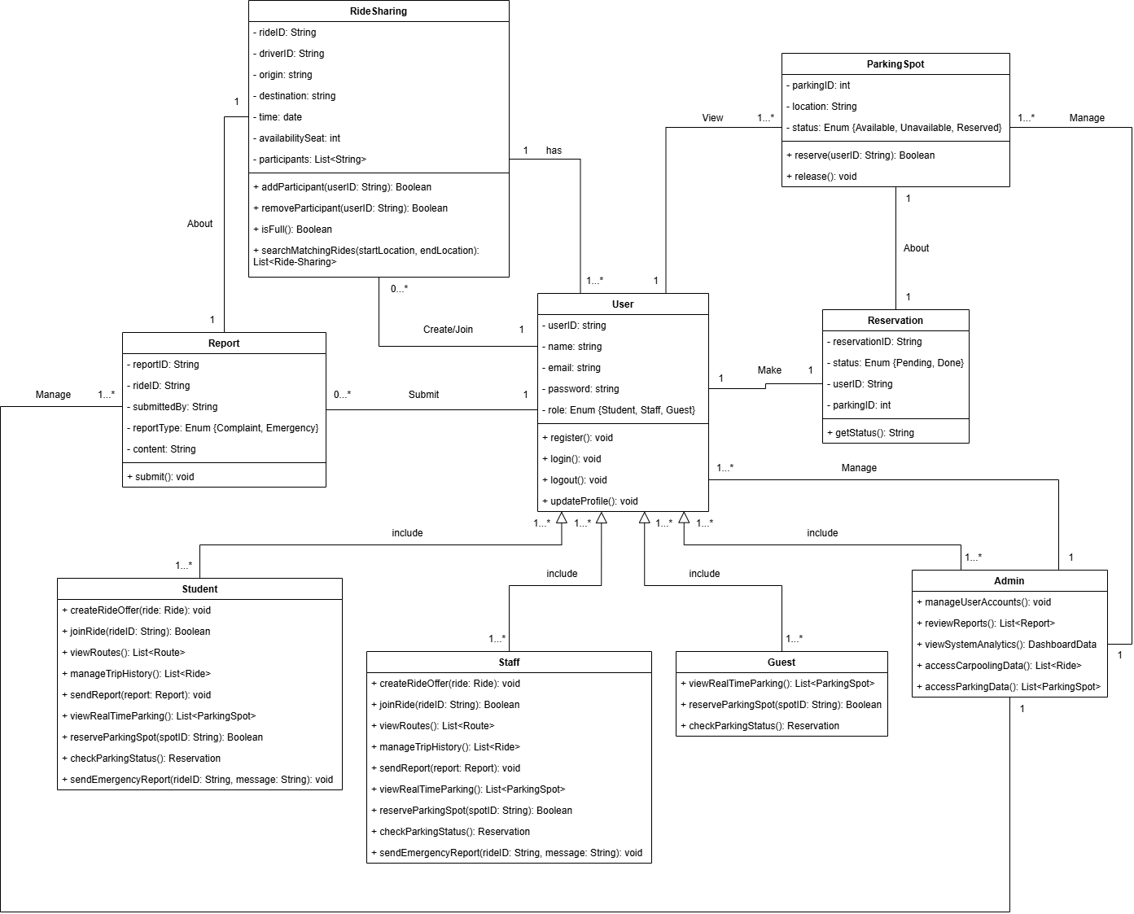
3.5 Logical Database Requirements

Figure 3.1: Class Diagram

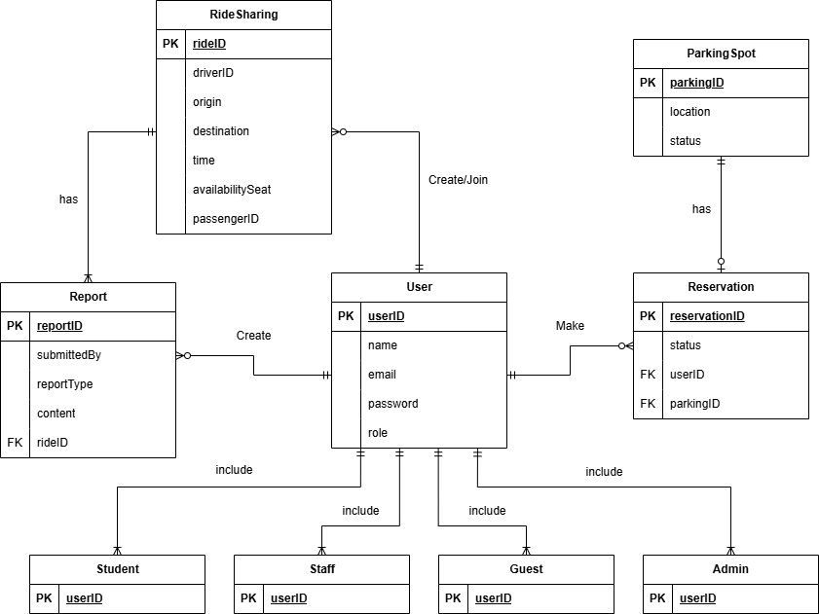

Figure 3.2: Entity Relationship Diagram

The Entity-Relationship Diagram (ERD) represents the structure and relationship between the system entities of Campus Ride-Sharing Platform with Parking Integration System. The primary entities are User, RideSharing, Reservation, Report, and ParkingSpot with user role extensions as Student, Staff, Guest, and Admin. The system maintains the user data integration in the User entity with the general properties of name, email, and password and handles the specialized roles through subtype entities for them. Users can give ride-sharing rides either as drivers or ride on rides by using the RideSharing entity, and trip reports can be given by using the Report entity. Parking is managed by the Reservation entity, where users are referenced within individual ParkingSpot records to reserve their spots. ERD accurately illustrates how each entity enables others in the system to enable operations such as providing rides, accident reporting, and parking reservation, while possessing role-based operations and permissions.

3.5.1 User
Field Name | Description | Data Type | Constraints | Extra Notes
userID | Unique identifier for each user. | Integer (PK) | PK, Not Null | Used as university login credentials
name | Full name of the user. | Varchar (50) | Not Null | Used as guest login credentials
email | Email address of the user. | Varchar (50) | Unique, Not Null | -
password | Encrypted user password. | Varchar (30) | Not Null | Used as login credentials
role | Role of the user (student, staff, admin, guest). | Varchar (10) | Not Null | -
Table 3.4: User Data Dictionary

3.5.2 Student
Field Name | Description | Data Type | Constraints | Extra Notes
studentID | Unique ID for student user. | Integer | PK, FK to User(userID), Not Null | -
Table 3.5: Student Data Dictionary

3.5.3 Staff
Field Name | Description | Data Type | Constraints | Extra Notes
staffID | Unique ID for staff user. | Integer | PK, FK to User(userID), Not Null | -
Table 3.6: Staff Data Dictionary

3.5.4 Guest
Field Name | Description | Data Type | Constraints | Extra Notes
guestID | Unique ID for guest user. | Integer | PK, FK to User(userID), Not Null | -
Table 3.7: Guest Data Dictionary

3.5.5 Admin
Field Name | Description | Data Type | Constraints | Extra Notes
adminID | Unique ID for admin user. | Integer | PK, FK to User(userID), Not Null | -
Table 3.8: Admin Data Dictionary

3.5.6 RideSharing
Field Name | Description | Data Type | Constraints | Extra Notes
rideID | Unique identifier for each ride. | Integer | PK, Not Null | -
driverID | ID of the user offering the ride. | Integer | Not Null | -
origin | Starting location. | Varchar | Not Null | -
destination | Destination location. | Varchar | Not Null | -
time | Departure time. | Datetime | Not Null | -
availabilitySeat | Available seats. | Integer | Not Null | -
userID | References the user offering the ride. | Integer | FK to User(userID), Not Null | Used to record who joined this trips
Table 3.9: RideSharing Data Dictionary

3.5.7 Report
Field Name | Description | Data Type | Constraints | Extra Notes
reportID | Unique report ID. | Integer | PK, Not Null | -
rideID | Associated ride. | Integer | FK to RideSharing (rideID), Not Null | -
submittedBy | Reporting user. | Varchar (50) | Not Null | -
reportType | Type of report. | Varchar (20) | Not Null | -
content | Report details. | Text | Not Null | -
Table 3.10: Report Data Dictionary

3.5.8 ParkingSpot
Field Name | Description | Data Type | Constraints | Extra Notes
parkingID | Unique parking spot ID. | Integer | PK, Not Null | -
location | Spot location. | Varchar (100) | Not Null | -
status | Availability status. | Varchar (10) | Not Null | -
Table 3.11: ParkingSpot Data Dictionary

3.5.9 Reservation
Field Name | Description | Data Type | Constraints | Extra Notes
reservationID | Unique reservation ID. | Integer | PK, Not Null | -
status | Reservation status. | Varchar (10) | Not Null | -
userID | Reserving user. | Integer | FK to User (userID), Not Null | -
parkingID | Reserved parking spot. | Integer | FK to ParkingSpot (parkingID), Not Null | -
Table 3.12: Reservation Data Dictionary

3.6 Design Constraints
This section records the design constraints and limitations that ought to be considered throughout the whole Ride-Sharing and Parking Management System development. The design constraints can be hardware constraints, software constraints, regulatory and standard constraints, social and cultural constraints, and organizational constraints.
Requirement ID | Description | Priority | Author
REQ_DC001 | The system must comply with Web Content Accessibility Guidelines (WCAG) to ensure usability for all users, including those with disabilities. | Medium | Francis Wong Wei Hou
REQ_DC002 | The system must comply with applicable data protection regulations (GDPR) to protect user data like names, emails, and ride/parking details. | High | Francis Wong Wei Hou
REQ_DC003 | The system must be developed within a 1-year period to meet organizational or campus deployment deadlines. | High | Francis Wong Wei Hou
REQ_DC004 | The system must not display or allow any offensive content in ride descriptions, reports, or user profiles. | Medium | Francis Wong Wei Hou
REQ_DC005 | The system must use open-source libraries and frameworks approved by the organization. | Medium | Francis Wong Wei Hou
REQ_DC006 | The system must be compatible with major web browsers (Google Chrome, Firefox, Safari, Microsoft Edge) and support mobile devices (iOS and Android). | High | Francis Wong Wei Hou
REQ_DC007 | The system must enforce strict role-based access control (Guests can only view parking, Admins can manage accounts) to prevent unauthorized access. | High | Francis Wong Wei Hou
REQ_DC008 | The system must integrate with existing campus IT systems (user authentication via SSO, parking databases) without major infrastructure changes. | High | Francis Wong Wei Hou
REQ_DC009 | The system must support real-time updates for parking spot availability and ride-sharing status to ensure accurate information for users. | High | Francis Wong Wei Hou
REQ_DC010 | The system must be designed with a modular architecture to handle an increasing number of users and future feature additions. | High | Francis Wong Wei Hou
REQ_DC011 | The system must incorporate data encryption for sensitive user data (userID, email, ride details) in transit and at rest, per organizational IT security policies. | High | Francis Wong Wei Hou
REQ_DC012 | The system must ensure reports submitted by users are reliably logged and immediately accessible to Admins for quick response. | High | Francis Wong Wei Hou
Table 3.13: Design Constraints

3.7 Software system attributes
In this subsection, the necessary characteristics and traits of the Ride-Sharing and Parking Management System are specified. These traits ensure that the system meets the needs of all user roles (Students, Staff, Guests, Admins) and functions properly when combined with real-time data and capabilities. The system should achieve these traits in order to meet those needs.

3.7.1 Accuracy
Requirement ID | Description | Priority | Author
REQ_SRA001 | The system shall have an error rate of less than 0.0001% in all computational processes | High | Francis Wong Wei Hou
Table 3.14: Accuracy

3.7.2 Availability
Requirement ID | Description | Priority | Author
REQ_SRA002 | The system’s server shall maintain consistent uptime with a maximum of 12 hours of downtime per year. | High | Francis Wong Wei Hou
Table 3.15: Availability

3.7.3 Maintainability
Requirement ID | Description | Priority | Author
REQ_SRA003 | The system shall be designed with modular components to allow updates or bug fixes within 24 hours without affecting other functionalities. | High | Francis Wong Wei Hou
REQ_SRA004 | The system shall include detailed documentation for all code and processes to facilitate future maintenance by developers. | Medium | Francis Wong Wei Hou
Table 3.16: Maintainability

3.7.4 Portability
Requirement ID | Description | Priority | Author
REQ_SRA005 | The system shall operate on multiple platforms (Windows, macOS, Linux for servers; iOS, Android for mobile) without requiring significant changes. | High | Francis Wong Wei Hou
REQ_SRA006 | The system shall use platform-  independent technologies (web-based frontend, REST APIs) to ensure compatibility across environments. | High | Francis Wong Wei Hou
Table 3.17: Portability

3.7.5 Reliability
Requirement ID | Description | Priority | Author
REQ_SRA007 | The system shall handle a high volume of transactions and concurrent users without crashing. | High | Francis Wong Wei Hou
REQ_SRA008 | All transactions shall be recorded accurately, ensuring no data loss or corruption. | High | Francis Wong Wei Hou
REQ_SRA009 | The system shall receive notifications for the success or failure of their actions within the platform. | High | Francis Wong Wei Hou
Table 3.18: Reliability

3.7.6 Security
Requirement ID | Description | Priority | Author
REQ_SRA010 | The system shall use encryption  (HTTPS, AES-256) for all data transmission to protect user information (userID, email, ride details). | High | Francis Wong Wei Hou
REQ_SRA011 | The system shall implement secure user authentication to prevent unauthorized access. | High | Francis Wong Wei Hou
Table 3.19: Security

3.7.7 Usability
Requirement ID | Description | Priority | Author
REQ_SRA012 | The system shall provide an intuitive interface, allowing users to complete tasks (reserving a parking spot, joining a ride) in fewer than 5 clicks. | High | Francis Wong Wei Hou
REQ_SRA013 | The system shall include a help section or tooltips to assist users in understanding functionalities. | Medium | Francis Wong Wei Hou
Table 3.20: Usability

3.8 Supporting Information
This section provides additional information that supports the system requirements, referencing data collected during the requirements elicitation phase.
During the elicitation phase, we applied multiple methods to gain a thorough understanding of the overall system and to validate and refine its requirements. The key elicitation techniques employed include:
- Interviews – We conducted structured interviews with key stakeholders to gather in-depth insights on their needs, expectations, and challenges. This qualitative method enabled us to clarify ambiguous requirements and explore stakeholder perspectives in detail.
- Observation – By observing stakeholders in their real working environment, we identified implicit needs and current workflow challenges related to alumni engagement and social media activities. This method revealed requirements that may not surface through direct questioning.
- Prototyping – We developed interactive prototypes and involved relevant stakeholders in reviewing them. This iterative process allowed stakeholders to visualize proposed features, provide immediate feedback, and helped us capture detailed functional and non-functional requirements for the Alumni Engagement Platform integration with social media platforms.

3.8.1 Interview Summary
Participant Profile:
  - Gender: Male
  - Occupation: Student at a private local university
- Project Vision and Scope Understanding
  - Question: After reading the vision and scope of this application, please rate 1 to 5 of how much you understand the project objective.
  - Response: Rating 4
- Expected Functionalities for ride-sharing system (Satisfier)
  - Question: What specific functionalities do you expect the ride-sharing system to provide?
  - Response: User can view the current location of the driver of the trips in order to meet.
- Necessity of ride-sharing history feature (Delighter)
  - Question: Do you think ride-sharing history is needed for this application?
  - Response: Yes. For example, the user can find the specific driver again if he/she wants from ride-sharing history.
- Expected Functionalities for parking system (Satisfier)
  - Question: What specific functionalities do you expect the parking system to provide?
  - Response: System will navigate the driver to available parking slots of the setted faculty parking.
- Necessity of real-time parking availability data (Dissatisfier)
  - Question: Do you think real-time parking availability data is necessary for this parking system?
  - Response: Yes. Otherwise it will waste users time if the system shows the parking slot is available but when users arrive it actually is not.

Interview Summary (Developer Perspective)
Participant Profile:
- Gender: Male
- Occupation: part-time developer
- Project Vision, Scope, and Goals Understanding
  - Question: Can you rate 1 to 5 of how much you understand the objectives of the project by looking at the vision, scope and goals?
  - Response: Rating 4
- Anticipated Challenges
  - Question: What challenges will be facing while implementing the features?
  - Response: Parking system integrate with the sensors and need a server to real-time tracking all parking availability. The Parking system needs an observer to observe the server to get new parking availability information and update the UI.
- Enhancing User Engagement (Delighter)
  - Question: What features can be implemented to enhance the user engagement within the Ride-Sharing Application (RSA)?
  - Response: Driver benefit feature to encourage people to be the driver, otherwise no one will become a driver.
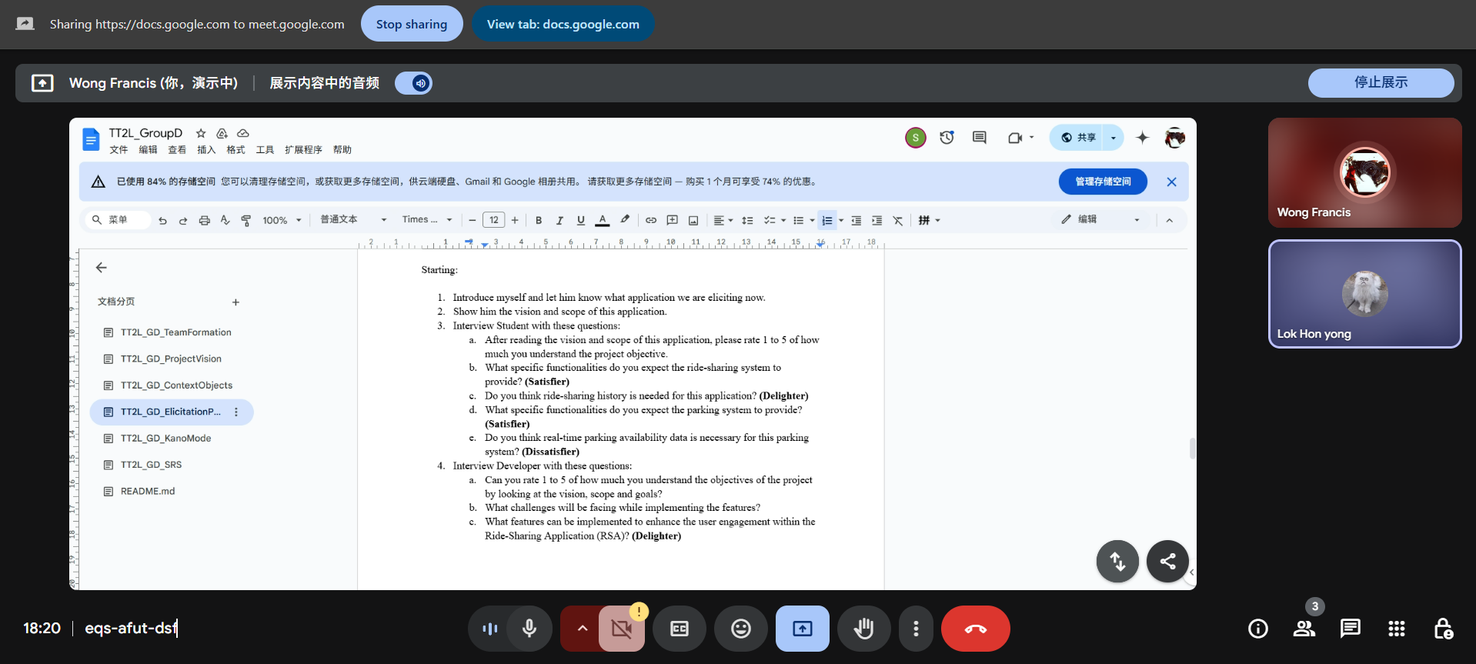
Figure 3.8.1 Screenshot of Francis Wong Wei Hou interviewing

3.8.2 Observation Summary
Based on the elicitation plan
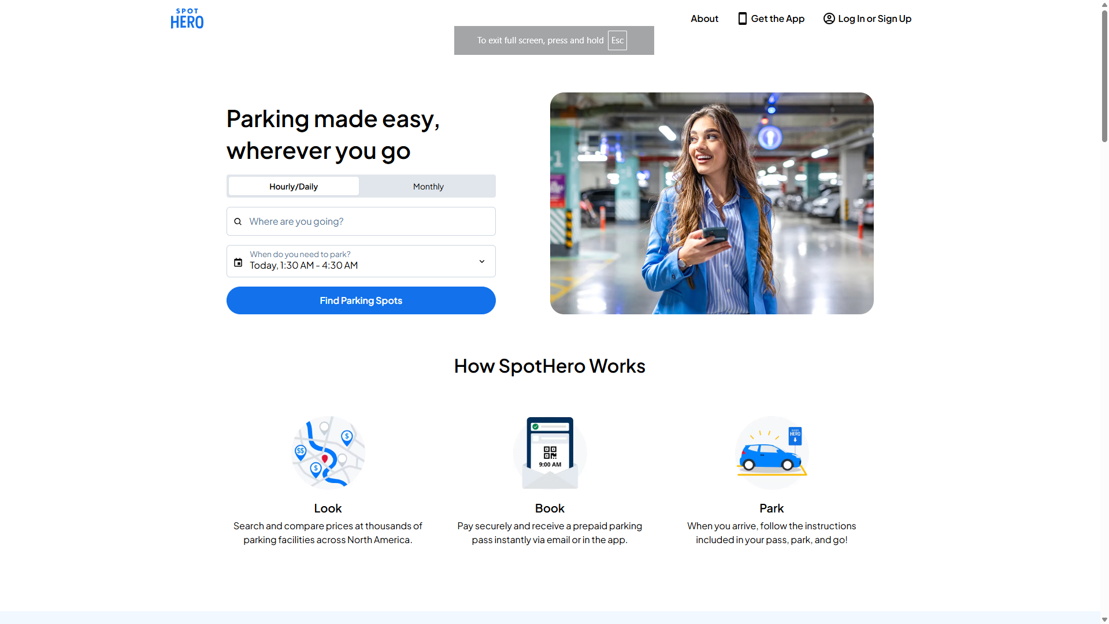
Figure 3.8.2 Screenshot of SpotHero Website

- Overview
This observation was conducted to evaluate the interface and features of a competitor parking reservation platform — SpotHero. The goal was to identify potential dissatisfiers in the design and functionality that, if addressed properly, can improve the user experience of our own Campus Ride-Sharing and Parking Integration System. This analysis focused on usability, convenience, data presentation, and the efficiency of key workflows.

- User Interface Design
Navigation & Layout:
SpotHero’s homepage is professionally designed, with a minimalist layout and clear navigation. Users can easily search for parking spots based on location and time. However, for first-time users, the absence of step-by-step guidance or onboarding may be disorienting. In our system, adding guided user tours or instructional overlays can help new users navigate more confidently. Also, offering campus-specific navigation categories (e.g., by faculty, block, or building) can better serve the university context.
Data Visualization:
Parking availability is shown through a mix of map-based views and list results, which is effective. However, the lack of interactive heat maps, capacity color indicators, or zone congestion metrics may limit quick comprehension during peak hours. For our platform, we could introduce dynamic zone indicators (e.g., red/yellow/green areas) to represent parking density more intuitively.
Responsiveness:
The website adapts well to different screen sizes and devices. However, for users on slower connections or older devices, some features like map zooming can lag slightly. Our system can prioritize lightweight map layers and preloaded common locations to enhance mobile performance on-campus.
- Functionality
Parking Search & Reservation:
The core functionality—searching and reserving parking—is straightforward and effective. Filters like time, location, and price are useful. However, it lacks support for academic zone-specific searches, which would be more relevant in a university environment. In our system, filtering based on building proximity, faculty zone, or event-based parking could offer better utility.
Authentication & Access Control:
SpotHero uses standard email/password login, which is fine for public users. However, it lacks role-based access or institutional authentication. Our system will leverage university credential login (SSO), enabling secure role-specific access for students, staff, and administrators, ensuring proper system governance.
Calendar & Reminders:
There’s no built-in event or class calendar linking feature in SpotHero. In contrast, integrating university timetables, parking reservations, and ride schedules within a centralized calendar module will significantly enhance convenience in our platform. Adding automated reminders for bookings is also highly recommended.
- Performance Indicators
Availability Indicators:
SpotHero displays real-time availability of parking spots, which is a strong feature. However, it does not include historical data trends or forecast-based availability. For our project, introducing parking trend analytics (e.g., full capacity hours, peak times) and usage-based suggestions would aid decision-making for users and administrators alike.
Ride-Sharing Integration:
SpotHero focuses solely on parking, with no ride-sharing functionality. Our platform’s unique offering lies in integrating carpool coordination and parking. Observing this gap reinforces the value of driver-passenger matching, estimated travel time, and eco-score tracking as features that can set us apart.
Safety & Incident Reporting:
There is no built-in incident or reporting mechanism. In a campus setting, trust and safety are crucial. Our system should include features such as in-ride SOS, ride history tracking, report buttons, and trusted user badges to address this concern.

- Recommendations
Area | Recommendation
Custom Campus Filters | Implement parking search by building name, faculty zone, or event
User Authentication | Replace public login with secure university SSO login
Ride-Sharing Coordination | Introduce carpool matching with driver-passenger preferences
Data Analytics | Use usage heatmaps, trend graphs and admin reports to optimize planning

b. Prototyping
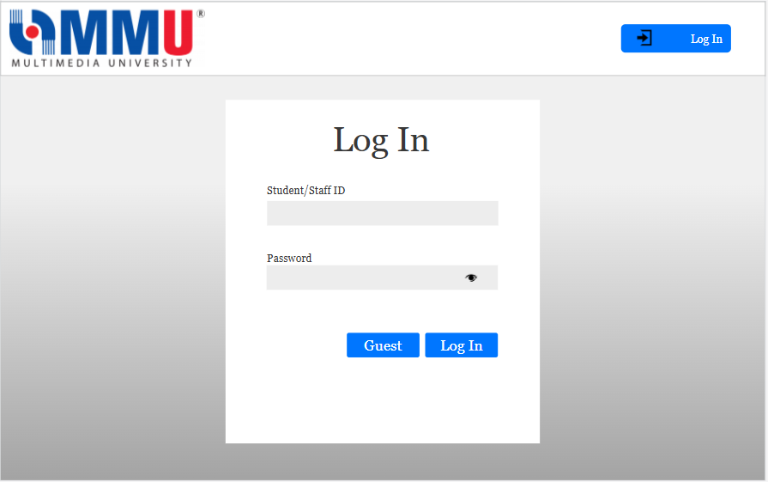
Figure 3.8.3 Screenshot of Prototype Log In Page

This is the login page where both student and staff may log in using their ID and Password, where as guest can press the guest button to log in. As for the admin, they can insert their ID and Password into the same log in page but will be brought over a admin specific dashboard which is not accessible to staff, student and guests.

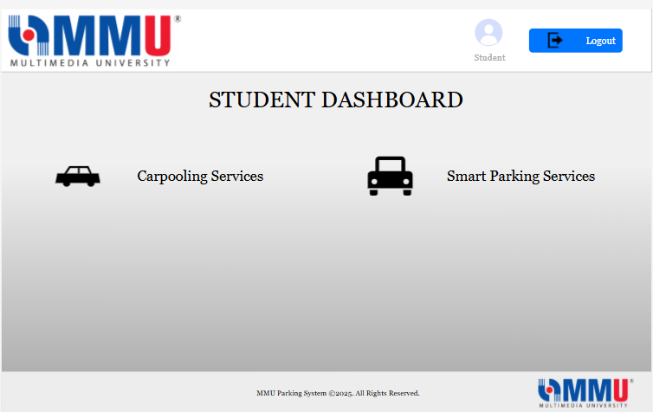
Figure 3.8.4 Screenshot of Prototype Student Dashboard

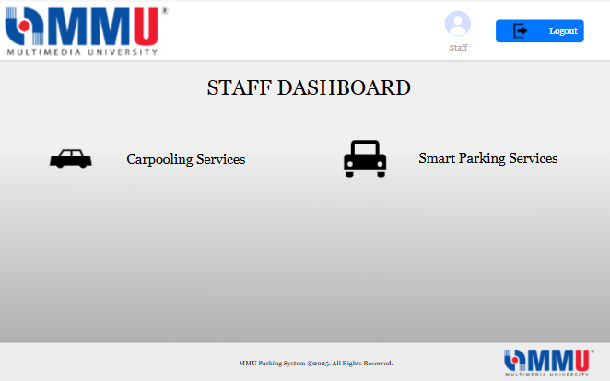
Figure 3.8.5 Screenshot of Prototype Staff Dashboard
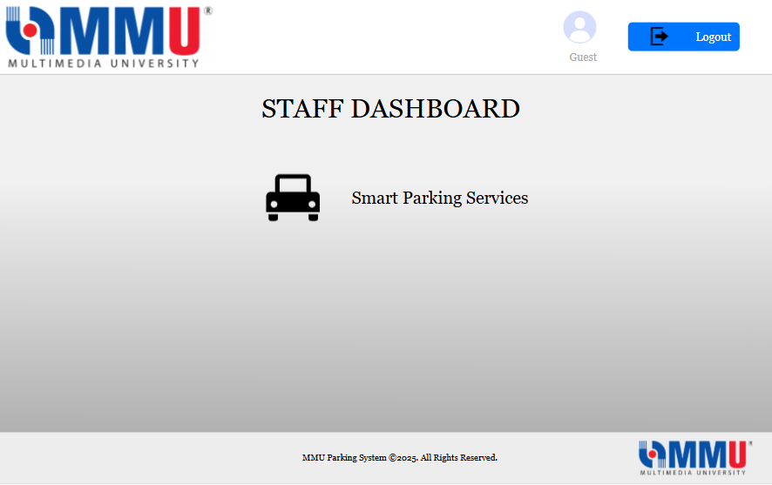
Figure 3.8.6 Screenshot of Prototype Guest Dashboard

These are the dashboard page for both the staff and student, where they can access both carpooling and the smart parking services. Whereas for guests, they can only access the smart parking service in their dashboard.

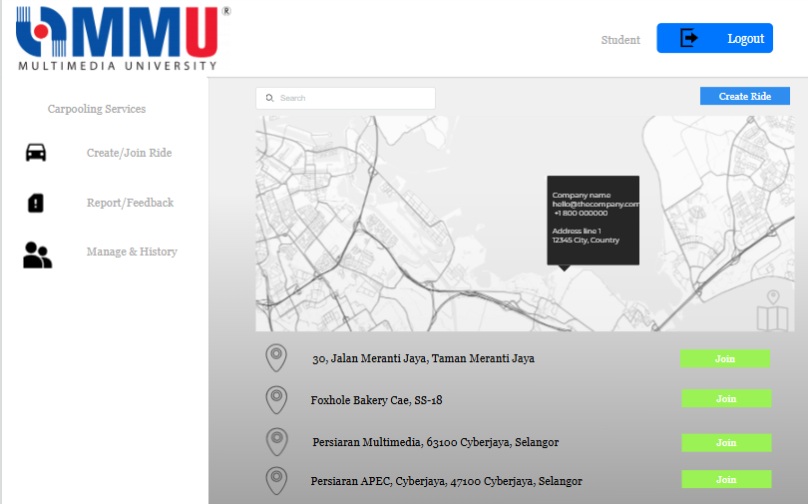
Figure 3.8.7 Screenshot of Prototype Student Carpooling services


Figure 3.8.8 Screenshot of Prototype Staff Carpooling services

This is the page that both staff and student will be brought to when they press on the carpooling services button. In this page you will see that there is a create&join ride section where they can either create a ride and set their destination for others to see or they can join a ride to the destination in common.

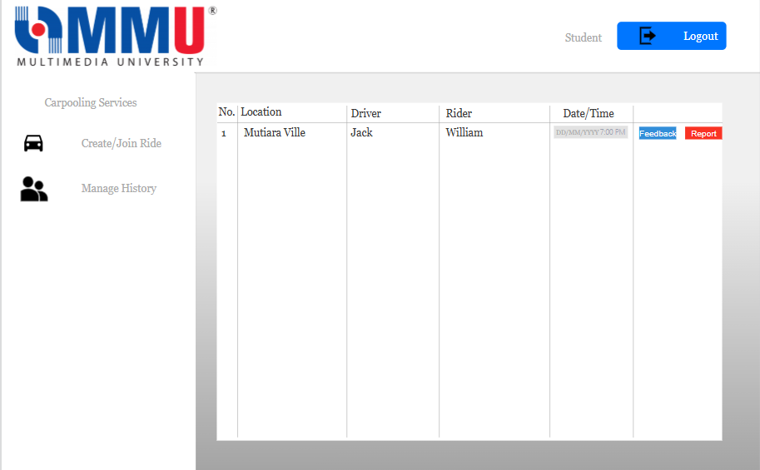
Figure 3.8.9 Screenshot of Prototype Student Carpooling Manage History

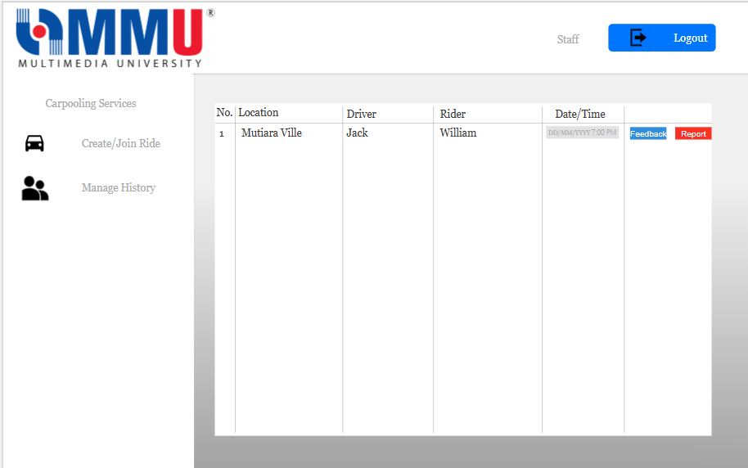
Figure 3.8.10 Screenshot of Prototype Staff Carpooling Manage History
This is the page where both student and staff are able to see their carpooling history and also for them to be able to give feedback or report on that particular drive.

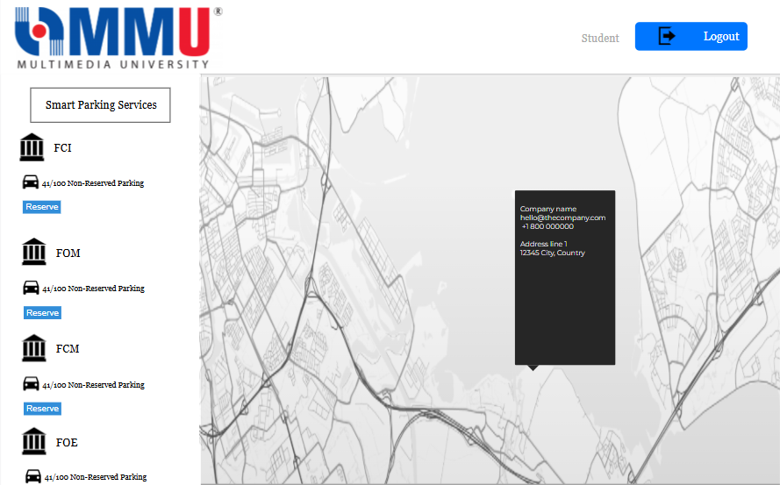
Figure 3.8.11 Screenshot of Prototype Student Smart Parking Services

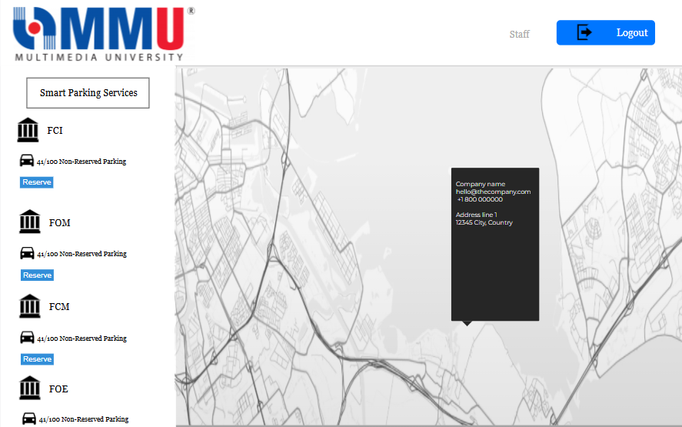
Figure 3.8.12 Screenshot of Prototype Staff Smart Parking Services
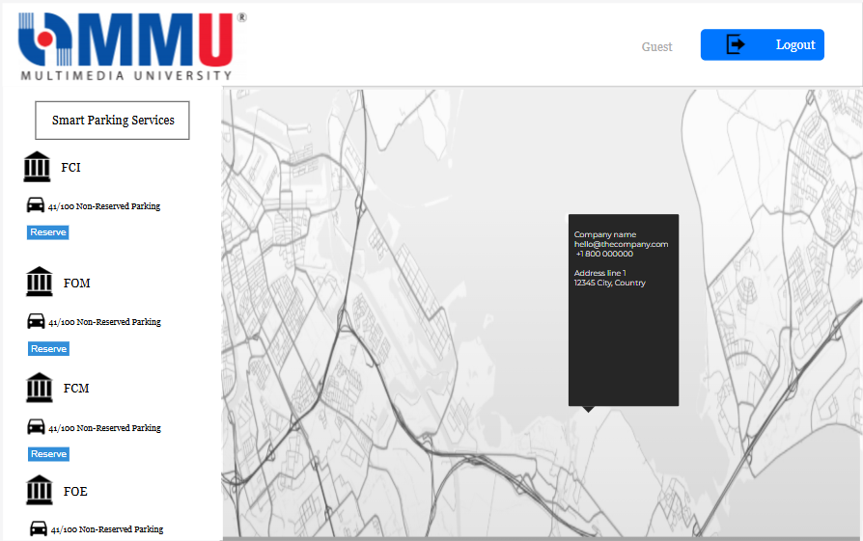
Figure 3.8.13 Screenshot of Prototype Guest Smart Parking Services

This page is for both students, staffs and guests alike to access the smart parking services where they can see which faculty has how many parkings left and decide if they want to reserve or not.

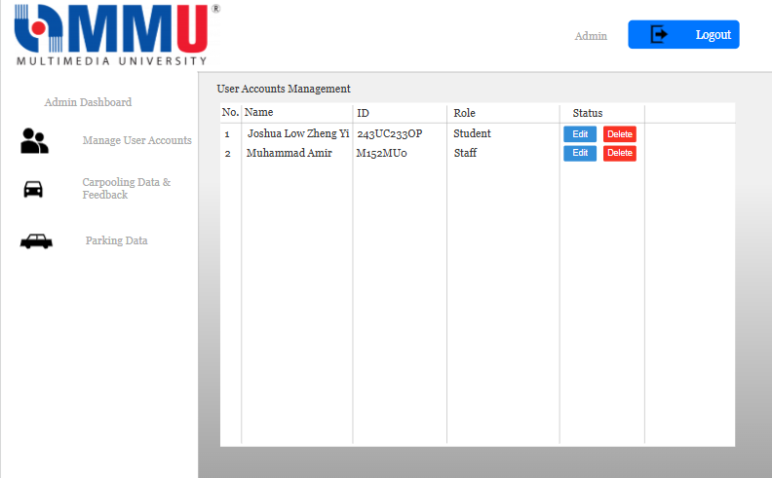
Figure 3.8.14 Screenshot of Prototype Admin Manage User Accounts

This the page where Admins can access and manage all user accounts for both student and staff. They can both edit the information within the account of both student and staff or delete the account in its entirety.

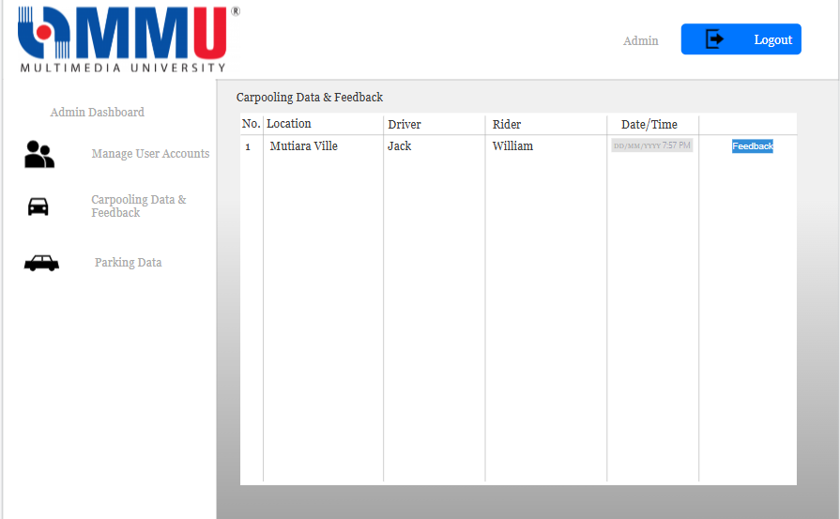
Figure 3.8.15 Screenshot of Prototype Admin Manage User Accounts

This is the page where Admins can view all the carpooling data and feedbacks from the driver and rider.
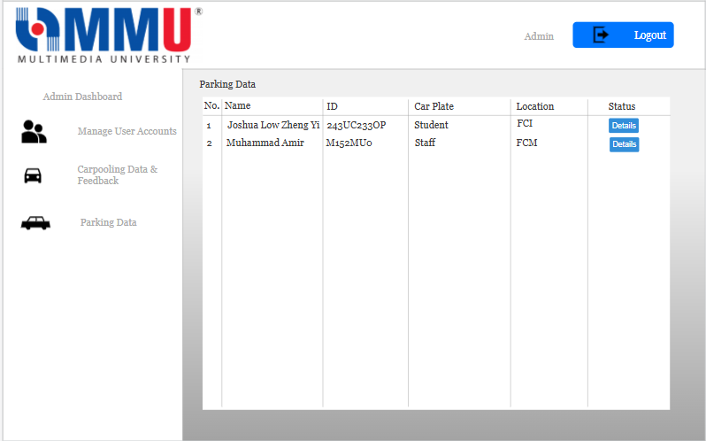
Figure 3.8.16 Screenshot of Prototype Admin Manage User Accounts

This is the page where Admins can view all the parking data which were made reserved by who and at which faculty. Admin can choose to delete the reserved parking data as they see fit.

3.8.3 Validation Session
Session ID | Date and Time | Technique | Section Reviewed | Participant & Role | No. of Defect
VS-01 | 22/6/2025; 10am-2pm | Inspection | 1.1, 1.2, 1.3, 1.4, 3.1, 3.2, 3.3, 3.4 | Fahad Bin Jahed (Inspector),  Chin Jing Xuan (Inspector),  Quek Jing Xiang (Inspector)  Ong Zi Xuan (Moderator) | 23
VS-02 | 23/6/2025; 2pm-6pm | Inspection | 3.5, 3.6, 3.7, 3.8, 4.1, 4.2, 4.3, 4.4, Agreement Defect, Conflict Analysis | Ong Zi Xuan (Inspector),  Chin Jing Xuan (Inspector),  Quek Jing Xiang (Inspector)  Fahad Bin Jahed (Moderator) | 12

3.8.4 Defect Summary

Severity Table
Severity | Description
1 | Minor issue; does not impact understanding or implementation (e.g., grammar)
2 | Low impact; small ambiguity that can be inferred easily
3 | Medium impact; causes moderate ambiguity or requires clarification to avoid misimplementation
4 | High impact; significantly affects requirement clarity or testability
5 | Critical defect; renders requirement unusable or leads to major system issues if unresolved

Content Defect
Req ID | Validation and Defect Description | Detected By | Comment/Suggested Fix | Session ID | Severity (1–5)
REQ_P002 | Ambiguous term "performance degradation" | Quek Jing Xiang | Added "max latency of 500ms" as a measurable performance loss metric | VS-01
REQ_P005 | Ambiguous term "performance loss" | Quek Jing Xiang | Added "max latency of 500ms" as a measurable performance loss metric | VS-01 | 3
REQ_P006 | Did not specify conditions and infeasible requirement | Quek Jing Xiang | Added condition and its respective requirement and increased max load time. "Dashboard shall load within 2 seconds under typical network conditions (< 150ms latency) and backend response time not exceeding 800ms under typical traffic condition." | VS-01 | 3
REQ_P013 | Unclear description | Quek Jing Xiang | Added "max update period of 1s under all conditions" for all notifications | VS-01 | 2
REQ_UR002 | Missing max update period | Quek Jing Xiang | Added "max update period of 1s under all conditions" | VS-01 | 3
REQ_UR005 | Non-verifiable requirement | Quek Jing Xiang | Added "User tasks shall have no more than 2 support tickets during beta testing" | VS-01 | 3
REQ_SI004 | Unclear description | Quek Jing Xiang | Changed description to "Enables admins to create notifications for all roles. Enables riders to send report alerts to admins" | VS-01 | 2
REQ_CI001 | Did not specify minimum version required | Quek Jing Xiang | Added "Minimum version of TLS1.2 required for HTTPS" | VS-01 | 3
REQ_SRA007 | Ambiguous term "high volume of transactions" | Quek Jing Xiang | Changed description to "System shall handle up to 5000 concurrent users and up to 100 transactions per second without crashing" | VS-02 | 3
REQ_SRA009 | Unclear description | Quek Jing Xiang | Changed description to "Users shall be notified whether their action succeeded or failed" | VS-02 | 2
REQ_SRA011 | Did not specify specific protocol | Quek Jing Xiang | Added "...using protocols OAuth2.0 and JWT" | VS-02 | 3
REQ_CRPS_004 | Goal “authenticate users through secure university credentials” applies to all, yet Guest Functions (1.3.2.3) allow anonymous/temporary login without those creds. | Ong Zi Xuan | In REQ_CRPS_004, clarify on which user categories require secure credentials vs guest access. | VS-01 | 5
REQ_UR001 | User requirement “login via university credentials or guest access” contradicts goal REQ_CRPS_004 mandating only secure credentials. | Ong Zi Xuan | In REQ_CRPS_004, clarify on which user categories require secure credentials vs guest access. | VS-01 | 5
REQ_CRPS_005 | Goal “include GPS-based location tracking” has no corresponding use case, interface, or sequence diagram in Section 3.1. | Ong Zi Xuan | - Add REQ_UCS010 to Student use-case table (Table 3.1)  - Add REQ_UCT010 to Teacher use-case table (Table 3.2)  - Add sequence diagram table for Real-Time GPS Tracking (REQSQ013) | VS-01 | 4
REQ_CRPS_007 | Goal “trip history tracking and real-time notifications” is stated system-wide, yet Guest Functions disable ride-sharing (no history) and use-cases omit notifications. | Ong Zi Xuan | - Specify in Table 1.1 that guests are excluded from real-time notifications (addresses agreement defect)  - Add use case REQ_UCS011 “Receive Trip Notifications” to Table 3.1  - Add use case REQ_UCT011 “Receive Trip Notifications” to Table 3.2  - Add sequence diagram REQSQ016 for trip notifications in Section 3.1.2 | VS-01 | 4
REQ_UR007 | User requirement to “integrate with campus services (timetables)” is absent from all Section 3 use cases and interfaces. | Ong Zi Xuan | refine REQ_UR007 to remove timetable integration, keep map integration | VS-01 | 4

Documentation Defect
Page No. | Validation and Defect Description | Detected By | Comment/Suggested Fix | Session ID | Severity (1–5)
Pg 13, 16, 20, 22, 23, 24, 28, 30, 32, 33, 35, 37, 39, 41, 43, 45, 46, 47, 49, 50, 52, 53, 54, 56, 58, 59, 62, 63, 64, 65, 67, 68, 69, 70, 71, 89, 90, 91, 93, 95 | Incorrect table label placement,Table label below instead of above (ISO) | Chin Jing Xuan | Move table label above table | VS-01 | 2
Pg 19,21,23 | Incorrect figure label placement,Figure label above instead of below (ISO) | Chin Jing Xuan | Move figure label below figure | VS-01 | 2
Pg 37,52,62 | Table label numbering shrink instead of ascending order | Chin Jing Xuan | Renumber table label to match ascending order | VS-01 | 2
Pg 60 | Figure label numbering shrink instead of ascending order | Chin Jing Xuan | Renumber figure label to match ascending order | VS-01 | 2
Pg 59 | Incorrect chapter from Table 3.6 to 1.6 | Chin Jing Xuan | Rename table label to match the chapter & ascending order | VS-01 | 2
Pg 95 | Missing title for table 5.1. Require every table to have a title above the table (ISO) | Chin Jing Xuan | Add title as: "Table 5.1: Acronyms and Abbreviations" | VS-01 | 2
Pg 74, 75, 80, 81, 82, 83, 84, 85, 86, 87,88 | Inconsistent figure label numbering format (flat 3.X vs nested 3.X.X) | Chin Jing Xuan | Unify figure label numbering style (flat 3.X) | VS-01 | 2
Pg 8, 9 | Use of bullet list without consistent punctuation as some of the list items are sentences and others are phrases. | Fahad Bin Jahed | Normalize list punctuation (e.g., completing the sentence with periods) | VS-01 | 1
pg 11, 12, 13 | Repetition of similar function descriptions across user roles without clear distinction (e.g., login, view parking, reserve spot, etc.). | Fahad Bin Jahed | Use shared function references or a comparative table | VS-01 | 2
pg 48,91 | Informal use of words across the document(e.g., "admin can manage accounts..." | Fahad Bin Jahed | "Can" should be replaced with "shall be able to" to align with formal requirement style. | VS-01 | 1
pg 61, 62, 63, 64, 65, 66 | The logical Database Requirements did not follow the specific requiements of ISO | Fahad Bin Jahed | Should be documented according to the defined documentation and specifcation guideline. | VS-02 | 3
pg 73,74 | Interview responses have inconsistent structure (no respondent ID, unclear who answered what). | Fahad Bin Jahed | Use clear formatting with participant codes | VS-02 | 2
pg 93 | Verification Criteria table includes inconsistent verb tense (“must be” vs “shall”). | Fahad Bin Jahed | Standardize using “shall” throughout | VS-02 | 1
pg 96 | Acronyms list missing of the acronyms used in the document and some used abbreviations also (e.g., ERD, DBMS). | Fahad Bin Jahed | Ensure all abbreviations have been inputted and the acronyms used are defined as well (e.g., JSON, LINUX, REST etc). | VS-02 | 2

Agreement Defect
Conflict ID | Validation Description/Stakeholder Concern | Mismatch | Detected By | Session ID | Severity (1–5)
CF-01 | Performance vs Cost: QA & Dev teams demand high system performance; PO insists on minimizing infrastructure costs. | QA/Dev expect < 2s response times under load, but PO’s cost-cutting target caps hardware budget, which would degrade performance. | Fahad Bin Jahed | VS-02 | 4
CF-02 | Dev team wants advanced “delighter” features; PM enforces early launch. | Dev team plans to include extra features, but PM has committed to a fixed early‐launch date | Fahad Bin Jahed | VS-02 | 4
CF-03 | Creativity vs Feasibility: UX designers propose complex custom UI components; Dev team requires simpler, standard widgets. | Designer’s custom animations and widgets require extensive coding effort (often 15–20 hrs per component), which conflicts with the Dev team’s need to reuse existing libraries for rapid delivery and maintainability. | Fahad Bin Jahed | VS-02 | 3
CF-04 | Desirability vs. Capability: PO wants advanced route prediction; the team finds it hard to build. | Building a reliable route-prediction system is very complex and may cause big delays. | Fahad Bin Jahed | VS-02 | 4
CF-05 | Sprint goal is unclear and ambiguous, so developers interpret it differently. | Because of this miscommunication, team members work on different things and the sprint may get delayed. | Fahad Bin Jahed | VS-02 | 3

3.8.5 Conflict Analysis
Conflict ID | Conflict Description | Conflict Analysis | Stakeholders Involved | Session ID
CF-01 | Performance vs cost | Interest conflict - the dev team prioritized high performance, while the Product Owner (PO) emphasized minimizing costs. Dev team aims to ensure system runs smoothly and is scalable, whereas PO is driven by budget constraints. If this conflict is unresolved, could delay delivery or compromise quality. | PO, Dev Team | VS-02
CF-02 | Features vs time tradeoff | Interest conflict - the Development teams preferred implementing more delighter features to make the product more functionally more complete, while the project manager emphasized quicker roll out time. This is due to the promise on completion time made by the project manager to the investors in investor meetings, whereas the dev team wants to create a more complete and quality software. It could lead to loss of trust by the investors or product of below expectations quality. | Project manager, dev team | VS-02
CF-03 | Creativity vs feasibility | Interest conflict - the designer team preferred to be creative in their designs by designing components that are difficult to implement, while the dev team preferred using simpler components to implement. This is because the designer team aims to make their interfaces visually appealing, whereas the dev team preferred to balance implementation complexity with visual appeal. It could lead to overcomplicated designs or less visually appealing interfaces. | dev team and designer | VS-02
CF-04 | Feasibility vs desirability | Interest conflict - The product owner wants to implement complex features into the software, but the features might be infeasible to implement by the dev team due to lack of knowledge. This is because the product owner might overpromise on certain features with the investors to implement the features within the deadline, but the dev team is unable to implement all of them as they lack the expertise. This might cause loss of trust by investors, or the features might not be of expected qualities. | dev team, investors and product owner | VS-02
CF-05 | Miscommunication | It happens when the dev team interprets the sprint goal differently due to unclear and ambiguous sprint goal. It might lead to misalignment between the team members and leading to delay in development time. | scrum team | VS-02

3.8.6 Conflict Analysis and Resolution
Conflict ID | Conflict Resolution Strategy | Resolved  (Y/N) | Outcome (If Resolved) | Justification
CF-01 | Organise a face-to-face meeting between Dev team and Product Owner (PO) to talk over and agree a reasonable balance between performance and cost. | Y | Everyone agreed with the expected performance level within the budgets. | Ensure everyone have a clear goal and expectation, reduce the risk of future disagreements.
CF-02 | Organise a face-to-face meeting between Dev team and project manager, to get an agreement on which part need to be prioritise first which can be delay. | Y | Important and require features will be prioritized first, while other enhancements features will be implement when free time available. | Ensure the project can be finish by the delivery time while maintain the project quality to obtain customer trust.
CF-03 | Organize a face-to-face meeting between the designers and developers to discuss and find designs that look good and are easy to implement in code. | Y | Develop the project with a simpler design that still looks visually appealing. | Find the sweet spot between creativity and feasibility, so the design are creative enough to attract stakeholders to return and collaborate again.
CF-04 | The Dev team showed the Product Owner which features were too difficult or not possible to implement, and worked together to reach an agreement with the investors about excluding those features. | Y | Only feasible features will be kept, while the more difficult ones will be removed or postponed for future implementation. | Avoid wasting time trying to implement overly complicated features that could prevent the project from being delivered before the deadline.
CF-05 | The team needs to list down clear sprint goals and discuss what is achievable. | Y | Everyone understands the goal better and works smoothly. | Prevents goal confusion and save development time so it can be deliver in time.

3.8.7 Changelog
Change ID | Page No / Req ID(s) | Summary of Change | Proposed By | Date | Session ID
CH-01 | Pg 13, 16, 20, 22, 23, 24, 28, 30, 32, 33, 35, 37, 39, 41, 43, 45, 46, 47, 49, 50, 52, 53, 54, 56, 58, 59, 62, 63, 64, 65, 67, 68, 69, 70, 71, 89, 90, 91, 93, 95 | Move table label above table | Chin Jing Xuan | 22-6-2025 | VS-01
CH-02 | Pg 19, 21, 23 | Incorrect figure label placement,Figure label above instead of below (ISO) | Chin Jing Xuan | 22-6-2025 | VS-01
CH-03 | REQ_P005, REQ_P006, REQ_P013 | REQ_P005: Added more information on performance loss criteria.  REQ_P006: Added details  REQ_P013: Rephrased description | Quek Jing Xiang | 23-6-2025 | VS-01
CH-04 | REQ_UR002, REQ_UR005 | REQ_UR002: Added details on update period  REQ_UR005: Added verification details | Quek Jing Xiang | 23-6-2025 | VS-01
CH-05 | REQ_SI004, REQ_CI001 | REQ_SI004: Rephrased description  REQ_CI001: Added additional details on minimum version required | Quek Jing Xiang | 23-6-2025 | VS-01
CH-06 | REQ_SRA007, REQ_SRA009, REQ_SRA011 | REQ_SRA007: Added additional details on requirement  REQ_SRA009: Rephrased description  REQ_SRA011: Added details on protocols used | Quek Jing Xiang | 23-6-2025 | VS-02
CH-07 | REQ_CRPS_004 | Clarify on which user categories require secure credentials vs guest access. | Ong Zi Xuan | 23-6-2025 | VS-01
CH-08 | REQ_UCS010, REQ_UCT010, REQSQ013 | - Add REQ_UCS010 to Student use-case table (Table 3.1)  - Add REQ_UCT010 to Teacher use-case table (Table 3.2)  - Add sequence diagram table for Real-Time GPS Tracking (REQSQ013) | Ong Zi Xuan | 23-6-2025 | VS-01
CH-09 | Table 1.1, Table 3.1, Table 3.2, REQSQ016 | - Specify in Table 1.1 that guests are excluded from real-time notifications (addresses agreement defect)  - Add use case REQ_UCS011 “Receive Trip Notifications” to Table 3.1  - Add use case REQ_UCT011 “Receive Trip Notifications” to Table 3.2  - Add sequence diagram REQSQ016 for trip notifications in Section 3.1.2 | Ong Zi Xuan | 23-6-2025 | VS-01
CH-10 | REQ_UR007 | refine REQ_UR007 to remove timetable integration, keep map integration | Ong Zi Xuan | 23-6-2025 | VS-01
CH-11 | Pg 37, 52, 62 | Renumber table label to match ascending order | Chin Jing Xuan | 23-6-2025 | VS-02
CH-12 | Pg 60 | Renumber figure label to match ascending order | Chin Jing Xuan | 23-6-2025 | VS-02
CH-13 | Pg 59 | Rename table label to match the chapter & ascending order | Chin Jing Xuan | 23-6-2025 | VS-02
CH-14 | Pg 95 | Add title as: "Table 5.1: Acronyms and Abbreviations" | Chin Jing Xuan | 23-6-2025 | VS-02
CH-15 | Pg 74, 75, 80, 81, 82, 83, 84, 85, 86, 87, 88 | Unify figure label numbering style (flat 3.X) | Chin Jing Xuan | 23-6-2025 | VS-02
CH-16 | REQ_P001 | align REQ_P001 performance SLA to approved budget with PO–QA sign-off (CF-01) | Fahad Bin Jahed | 23-6-2025 | VS-01
CH-17 | REQ_UI013 | add REQ_UI013 for joint UX–Dev feasibility review of custom UI (CF-03) | Fahad Bin Jahed | 23-6-2025 | VS-01
CH-18 | REQ_CRPS_011 | add REQ_CRPS_011 to gate advanced route-prediction behind Dev feasibility report (CF-04) | Fahad Bin Jahed | 23-6-2025 | VS-01
CH-19 | Section 3.1.2.14, 3.8.2 | Replace informal use of words accross document | Fahad Bin Jahed | 23-6-2025 | VS-02
CH-20 | Section 4.2 | Replace inconsistent verb tenses in the Verification Criteria table | Fahad Bin Jahed | 23-6-2025 | VS-02
CH-21 | Section 5.2 | Add acronyms in the Acronyms and Abbreviations table | Fahad Bin Jahed | 23-6-2025 | VS-02

3.8.8 Requirement Traceability Matrix

Traceability Score
Traceability Score | Description
1 | Linked to only 1 artifact (e.g., just a goal, or just a use case)
2 | Linked to 2 artifacts (e.g., goal + feature)
3 | Linked to 3 artifacts, but links may be basic or unverified
4 | Linked to 3 artifacts with high confidence, correctness, and completeness (e.g., validated relationships, clear traceability)

Req ID | Requirement Description | Linked Goal(s) | Feature(s) | Use Case(s) | Traceability Score (1-4)
REQSQ001 | To allow students, staff, and admins to securely access the system | REQ_CRPS_004 | F01 : User Authentication | REQ_UCS001, REQ_UCT001, REQ_UCA001 | 4
REQSQ002 | To allow guests to access parking services without credentials | REQ_CRPS_003 | F02 : Guest Authentication | REQ_UCG001 | 4
REQSQ003 | To allow users to create and publish a new carpooling ride offer | REQ_CRPS_003 | F03 : Create Ride Offer | REQ_UCS001, REQ_UCT001 | 4
REQSQ005 | To provide users with personalized carpool matches and suggested routes | REQ_CRPS_003 | F04 : View Recommended Matches & Routes | REQ_UCS001, REQ_UCT001 | 4
REQSQ006 | To allow users to view, edit, or cancel their trips and access trip history | REQ_CRPS_003 | F05 : Manage Trip Schedule & History | REQ_UCS001, REQ_UCT001 | 4
REQSQ007 | To allow users to submit reports regarding issues or complaints | REQ_CRPS_003 | F06 : Report Feature | REQ_UCS001, REQ_UCT001 | 4
REQSQ008 | To allow users to view current availability of parking slots | REQ_CRPS_002 | F07 : View Real-time Parking Availability | REQ_UCS001, REQ_UCT001, REQ_UCG001 | 4
REQSQ009 | To allow users to reserve and confirm a parking spot | REQ_CRPS_002 | F08 : Reserve Parking Spot | REQ_UCS001, REQ_UCT001, REQ_UCG001 | 4
REQSQ010 | To allow users to check their current parking usage status | REQ_CRPS_002 | F09 : Check Parking Status | REQ_UCS001, REQ_UCT001, REQ_UCG001 | 4
REQSQ011 | To allow administrators to securely log in and access management functions | REQ_CRPS_004 | F10 : Admin Authentication | REQ_UCA001 | 4
REQSQ012 | To allow admins to view and analyze carpooling data, reports, and complaints | REQ_CRPS_004 | F11 : Access Carpooling Data & Review Reports/Complaints | REQ_UCA001 | 4
REQSQ012B | To allow admins to query raw carpooling data for export or deeper analysis | REQ_CRPS_004 | F12 : Access Carpooling Data | REQ_UCA001 | 4
REQSQ013 | To allow admins to add, edit, or delete user accounts | REQ_CRPS_004 | F13 : Manage User Accounts | REQ_UCA001 | 4
REQSQ014 | To allow admins to view parking reservation logs and statistics | REQ_CRPS_004 | F14 : Access Parking Data | REQ_UCA001 | 4
REQSQ015 | To enable live tracking of rides on a map interface | REQ_CRPS_003 | F15 : Real-Time GPS Tracking | REQ_UCS001, REQ_UCT001 | 4
REQSQ016 | To deliver real-time trip updates and allow viewing of past trip records | REQ_CRPS_003 | F16 : Receive Trip Notifications | REQ_UCS001, REQ_UCT001 | 4

3.8.9 Role in Requirements Validation, Negotiation, and Validation
Student Name | Primary Responsibility | No. of Session Participated
Ong Zi Xuan | Content validation, GitHub Version Control, Changelog Maintenance, Traceability Matrix Updates | 4
Fahad Bin Jahed | Agreement Defect, Documentation review, Defect Classification | 3
Quek Jing Xiang Jing Xiang | Content Validation, stakeholder concern tracking, Conflict Analysis, Changelog Maintenance | 4
Chin Jing Xuan | Documentation review, Defect Classification, Conflict Analysis and Resolution | 3

3.8.10 Version Control & Configuration Summary
Repository Branch: project-part-2
Key Files:
SRS.md: Working version of updated SRS
TT2L_GD_SRS.doc: Final version
changelog.md: Record of all requirement-related changes

4 Verification

4.1 Verification Approach
This section provides the verification approaches and methods planned to qualify the software of the Ride-Sharing Platform with Parking System Integration. The verification actions are organized in parallel with the functional requirements, performance requirements, security requirements, usability requirements, maintainability requirements, and portability requirements. Each action includes details on how, who, when, and where.

4.1.1 Functional Requirements Verification
Requirement ID | Method | Responsibility | Event-based Timing | Venue/  Environment
REQ_V001 | Unit Testing | Developers | During implementation phase | Developer Environment / IDE
REQ_V002 | System Integration Testing | QA Team | After integrating system modules | Testing Lab
Table 4.1: Functional Requirements Verification

4.1.2 Performance Requirements Verification
Requirement ID | Method | Responsibility | Event-based Timing | Venue/  Environment
REQ_V003 | Load Testing | QA Team | After system completion | Performance Testing Tools
REQ_V004 | Stress Testing | QA Engineers | Before deployment under peak load scenarios | Performance Lab
Table 4.2: Performance Requirements Verification

4.1.3 Security Requirements Verification
Requirement ID | Method | Responsibility | Event-based Timing | Venue/  Environment
REQ_V005 | Authentication Testing | Security Analyst, QA | After login & role-based access are implemented | Secure Testing Environment
REQ_V006 | Vulnerability Scanning | Security Team | Before production release | Security Testing Tools / Cloud Lab
Table 4.3: Security Requirements Verification

4.1.4 Usability Requirements Verification
Requirement ID | Method | Responsibility | Event-based Timing | Venue/  Environment
REQ_V007 | User Interface Evaluation | UX Designers, End Users | After prototype or beta version development | Usability Lab
REQ_V008 | User Feedback Session | UX Team | During user testing or pilot launch | Online Surveys / Interview Session
Table 4.4: Usability Requirements Verification

4.1.5 Maintainability Requirements Verification
Requirement ID | Method | Responsibility | Event-based Timing | Venue/  Environment
REQ_V009 | Code Review | Development Team Lead | After each development sprint | Code Repository / Review Tools
REQ_V010 | Design Documentation Review | Developers, Analysts | During design validation meetings | Meeting Room / Online Documentation
Table 4.5: Maintainability Requirements Verification

4.1.6 Portability Requirements Verification
Requirement ID | Method | Responsibility | Event-based Timing | Venue/  Environment
REQ_V011 | Cross-Platform Testing | QA Engineers | Before deploying to multiple OS/devices | Device Lab / Emulator Tools
REQ_V012 | Browser Compatibility Testing | QA Team | During front-end testing phase | BrowserStack / Cloud Tools
Table 4.6: Portability Requirements Verification

4.2 Verification Criteria
This section shows that the system will be verified based on the following criteria to ensure it meets the defined functional and quality requirements:
Requirement ID | Requirement/Feature | Verification Criteria
REQ_VC001 | Ride offer creation | The system shall allow a user to create a ride offer with details like origin, destination, time, and available seats. A successful message is displayed upon valid submission.
REQ_VC002 | Route matching | When a user searches for a trip, the system must display matched ride offers within a 5 km radius of the user's specified route.
REQ_VC003 | Parking reservation | A user must be able to reserve a parking spot only if it is marked as available in the system.
REQ_VC004 | View parking availability | The system must update and display current parking spot status in real-time.
REQ_VC005 | Report submission | Users must be able to submit an report while in an active ride, and the system shall record the report linked to the ride ID.
REQ_VC006 | User authentication | Login attempts with correct credentials must be authenticated, and users should be redirected based on their roles.
REQ_VC007 | Access control | Guests can access only parking-related features; they must not be allowed to view or create ride-sharing offers.
REQ_VC008 | Performance | The system shall return search results for ride offers or parking availability within 3 seconds under normal load.
REQ_VC009 | Usability | All primary actions (view parking availability, reserve parking, search ride, join ride, report) must be accessible within 3 clicks from the dashboard.
REQ_VC010 | Data Integrity | A ride offer must not be created without mandatory fields such as origin, destination, time, and seat count.
Table 4.7: Verification Criteria

5 Appendices

5.1 Assumptions and Dependencies
Assumptions:
- Users (students and staff) have access to a stable internet connection when using the system.
- Users are familiar with basic web applications and can navigate the system without extensive training.
- The system will be accessed primarily via modern desktop or mobile web browsers.
- All registered university users have valid credentials stored in the university authentication system.
- Campus facilities such as parking lots have IoT sensors or manual updates to provide real-time parking data.
Dependencies:
- The system depends on the university's authentication server for verifying student and staff logins.
- Real-time parking data depends on integration with campus parking management infrastructure or sensors.
- Accurate GPS functionality depends on the device's built-in location services and browser support.
- Reporting functionality may rely on integration with campus security systems or alert services.
- Continuous server uptime and hosting infrastructure are required to ensure uninterrupted system access.
- System updates and maintenance depend on cooperation from university IT departments.

5.2 Acronyms and Abbreviations
Acronym / Abbreviation | Definition
CRPIS | Campus Ride-Sharing and Parking Integration System
UI | User Interface
UX | User Experience
GPS | Global Positioning System
DB | Database
API | Application Programming Interface
OTP | One-Time Password
SSO | Single Sign-On
HTTPS | Hypertext Transfer Protocol Secure
RTD | Real-Time Parking Data
ERF | Reporting Feature
ASD | Authentication Server
SD | System Dashboard
Table 5.1

