Math 328 Chapter 7 HW

David Oniani

March 23, 2021

## Setup

library(Stat2Data)  
library(dplyr)

##   
## Attaching package: 'dplyr'

## The following objects are masked from 'package:stats':  
##   
## filter, lag

## The following objects are masked from 'package:base':  
##   
## intersect, setdiff, setequal, union

library (tidyr)  
library(emmeans)  
library(ggplot2)  
  
# I like the minimal theme  
theme_set(theme_minimal())  
  
# Disable warnings (they clutter the document)  
options(warn = -1)

## Exercise 7.14

It is clear that MSAB < MSB < MSA (A has 10s squared, B has 5s squared, and AB has 4s squared) and each of the has 1 degree of freedom. Hence, MSAB < MSB < MSA and we now need to find where MSE fits. SSE here equals to sum of square residuals over the degrees of freedom which is 60 / 4 = 15. Now, since MSAB = 8 * 4^2 = 128, we have that MSE < MSAB. Finally, we have: MSE < MSAB < MSB < MSA.

## Exercise 7.16

It is clear that MSAB < MSA < MSB (B has 3s squared, A has 2s squared, and AB has 1s squared) and each of the has 1 degree of freedom. Hence, MSAB < MSA < MSB and we now need to find where MSE fits. MSE here equals to sum of square residuals over the degrees of freedom which is 60 / 4 = 15. Now, since MSAB = 8 * 1^2 = 8 and MSA = 8 * 2^2 = 32, we have that MSAB < MSE < MSA. Finally, we have: MSAB < MSE < MSA < MSB.

## Exercise 7.34

# Dr. Phil's suggestion:  
# "For 7.34(c), I suggest plotting the data. Fitting a model using lm and  
# examining the parameter estimates could also be informative."  
  
# Load the data  
data("Swahili")  
  
# (a)  
modela = aov(Attitude.Score ~ factor(Province) * factor(Sex), data = Swahili)  
summary(modela)

## Df Sum Sq Mean Sq F value Pr(>F)   
## factor(Province) 1 32275 32275 349.82 < 2e-16 ***  
## factor(Sex) 1 11021 11021 119.45 < 2e-16 ***  
## factor(Province):factor(Sex) 1 5320 5320 57.66 1.66e-13 ***  
## Residuals 476 43917 92   
## ---  
## Signif. codes: 0 '***' 0.001 '**' 0.01 '*' 0.05 '.' 0.1 ' ' 1

# (b)  
par(mfrow = c(1 : 2))  
plot(modela, which = c(1 : 2))

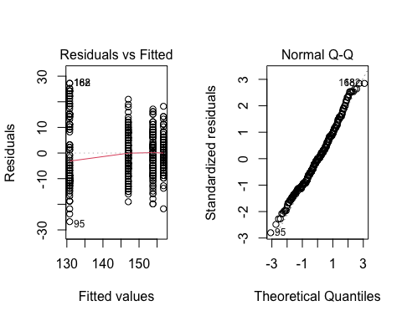

# (c)  
modelc = lm(Attitude.Score ~ factor(School) * factor(Province), data = Swahili)  
plot(modelc, which = c(1 : 2))

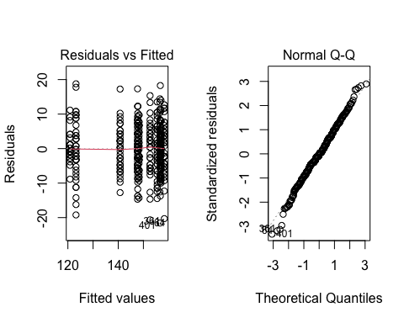

summary(modelc)

##   
## Call:  
## lm(formula = Attitude.Score ~ factor(School) * factor(Province),   
## data = Swahili)  
##   
## Residuals:  
## Min 1Q Median 3Q Max   
## -21.575 -3.888 -0.225 4.275 18.775   
##   
## Coefficients: (12 not defined because of singularities)  
## Estimate Std. Error t value Pr(>|t|)   
## (Intercept) 120.850 1.039 116.341 <2e-16 ***  
## factor(School)B 31.800 1.469 21.647 <2e-16 ***  
## factor(School)C 2.375 1.469 1.617 0.107   
## factor(School)D 19.900 1.469 13.546 <2e-16 ***  
## factor(School)E 27.425 1.469 18.669 <2e-16 ***  
## factor(School)F 26.825 1.469 18.260 <2e-16 ***  
## factor(School)G 35.875 1.469 24.421 <2e-16 ***  
## factor(School)H 34.625 1.469 23.570 <2e-16 ***  
## factor(School)I 36.150 1.469 24.608 <2e-16 ***  
## factor(School)J 37.450 1.469 25.493 <2e-16 ***  
## factor(School)K 35.725 1.469 24.319 <2e-16 ***  
## factor(School)L 26.900 1.469 18.312 <2e-16 ***  
## factor(Province)PWANI NA NA NA NA   
## factor(School)B:factor(Province)PWANI NA NA NA NA   
## factor(School)C:factor(Province)PWANI NA NA NA NA   
## factor(School)D:factor(Province)PWANI NA NA NA NA   
## factor(School)E:factor(Province)PWANI NA NA NA NA   
## factor(School)F:factor(Province)PWANI NA NA NA NA   
## factor(School)G:factor(Province)PWANI NA NA NA NA   
## factor(School)H:factor(Province)PWANI NA NA NA NA   
## factor(School)I:factor(Province)PWANI NA NA NA NA   
## factor(School)J:factor(Province)PWANI NA NA NA NA   
## factor(School)K:factor(Province)PWANI NA NA NA NA   
## factor(School)L:factor(Province)PWANI NA NA NA NA   
## ---  
## Signif. codes: 0 '***' 0.001 '**' 0.01 '*' 0.05 '.' 0.1 ' ' 1  
##   
## Residual standard error: 6.57 on 468 degrees of freedom  
## Multiple R-squared: 0.7817, Adjusted R-squared: 0.7766   
## F-statistic: 152.4 on 11 and 468 DF, p-value: < 2.2e-16

1. Factors Province and Sex and both significant with the p-value being less than 2e-16. This means that attitudes toward Swahili vary significantly based on Province and Sex. The interaction between Province and Sex is also significant with the p-value of approximately 1.66e-13. This means that attitudes toward Swahili vary based on the interaction/relationship between Province and Sex (e.g., certain provinces have more people of a specific Sex).
2. The normality condition seems to be met. There are some points at the tail of the plot that deviate from the dotted line, but the Normal QQ does look normal overall. It seems like the variation is not constant. Ideally, the plot should show a random scattering of points above and below the reference line at a horizontal 0. This is not the case in Residuals vs Fitted plot where points are stacked across vertical lines. Hence, we conclude that the normality condition is met, while equal variance condition is not met.
3. By just looking at Residuals vs Fitted plot, we can see that the equal variance condition is not met. Therefore, applying a two-way ANOVA is not appropriate in the first place. It is not a complete factorial design since equal sample size from each school is not enough. For the study to be a balanced complete factorial design, equal sample sizes must be taken for each of the possible factor combinations.

## Exercise 7.38

# Dr. Phil's Comment:  
# " For 7.38, use the Oral exam score as the response variable  
# (not Written or Combine)."  
  
# Load the data  
data(Ricci)  
  
# (a)  
lra = lm(Oral ~ Position, data = Ricci)  
sa = summary(emmeans(lra, pairwise ~ Position), infer = c(T, T))  
sa$contrasts

## contrast estimate SE df lower.CL upper.CL t.ratio p.value  
## Captain - Lieutenant 6.02 2.35 116 1.38 10.7 2.568 0.0115   
##   
## Confidence level used: 0.95

# (b)  
par(mfrow = c(1, 1))  
with(Ricci, interaction.plot(Position, Race, Oral))

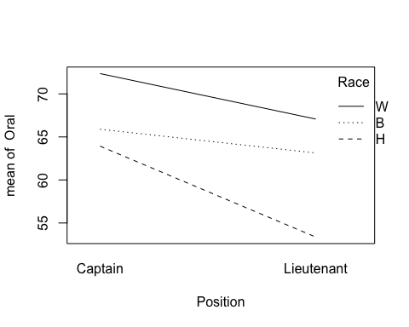

# (c)  
lrc = lm(Oral ~ factor(Position) * factor(Race), data = Ricci)  
par(mfrow = c(1, 3))  
plot(lrc, which = c(1 : 3))

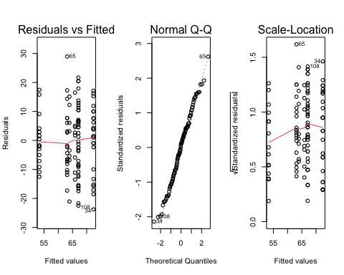

summary(aov(Oral ~ factor(Position) * factor(Race), data = Ricci))

## Df Sum Sq Mean Sq F value Pr(>F)   
## factor(Position) 1 971 970.8 7.534 0.007056 **   
## factor(Race) 2 2475 1237.7 9.605 0.000141 ***  
## factor(Position):factor(Race) 2 175 87.4 0.678 0.509519   
## Residuals 112 14433 128.9   
## ---  
## Signif. codes: 0 '***' 0.001 '**' 0.01 '*' 0.05 '.' 0.1 ' ' 1

1. The difference between the means of Captain and Lieutenant is 6.02 with the p-value of approximately 0.012. Hence, the difference is not significant.
2. Analyzing the interaction plot, the more nonparallel the lines are, the greater the strength of the interaction. In our case, there seems to be some interaction between Position and Race as the lines are not parallel. If we extend these lines in both sides (left and right), every pair of lines will cross each other. Hence, there could be a potential interaction between Position and Race variables.
3. By just looking Residuals vs Fitted, we can conclude that the equal variance condition is not met. The red line has a noticeable skew in the left tail and deviates from the dotted line. The normality condition also does not seem to be met since the left part of the Normal QQ seems to show a significant deviation from the dotted line. The Scale-Location also seems to show a decreasing trend. Hence, we conclude that fitting a two-way ANOVA model is not appropriate (it might be appropriate after a response transformation however, but the book does not ask for this).
4. We concluded that the two-way ANOVA model is not appropriate, but we will still comment on the results. Position and Race are both significant with p-values of approximately 0.0071 and 0.0001 respectively. Interaction between Position and Race, however, is not significant with the p-value of approximately 0.5095.