ONI EMMANUEL AYOMIKUN

MATRIC NO: 241205006

DEPARTMENT OF INFORMATICS AND INFORMATION SYSTEMS

FACULTY OF COMPUTING

COURSE CODE: COS202

TITLE: COMPUTER PROGRAMMING II (PYTHON)

ASSIGNMENT REPORT

1. PROJECT OBJECTIVES
The objective of this project was to design and implement two functional Python programs to solve everyday computational tasks:

Mathematical Calculator (MC): A lightweight, terminal-based application capable of evaluating direct arithmetic expressions using standard operations (+, -, *, /, \, ^, %) along with explicit Clear (C) and exit (OFF) commands.

Personal Pocket CGPA Calculator (PPC): A portable grading tool allowing students to calculate their cumulative grade point average locally, reducing the reliance on external portals.

- DESIGN & SOURCE CODE MECHANICS

2.1 The Mathematical Calculator (MC)
Instead of relying on single-line shorthand shortcuts, the calculator uses modular programming. Individual core functions are declared for each operation:

Addition / Subtraction / Multiplication: Handled by add(), subtract(), and multiply().

Division Control: Standard division is executed via divide(), while floor division (\) is processed through floor_divide().

Advanced Modifiers: Exponentiation (^) utilizes power(), and remainders are computed with modulo().

An if-elif-else control ladder reads the user's input string, identifies the operation symbol, splits the numbers, and matches it directly to the right formula module. The program includes a history list array to store previous equations, which prints whenever the user clears (C) the display window. Here is the output result;
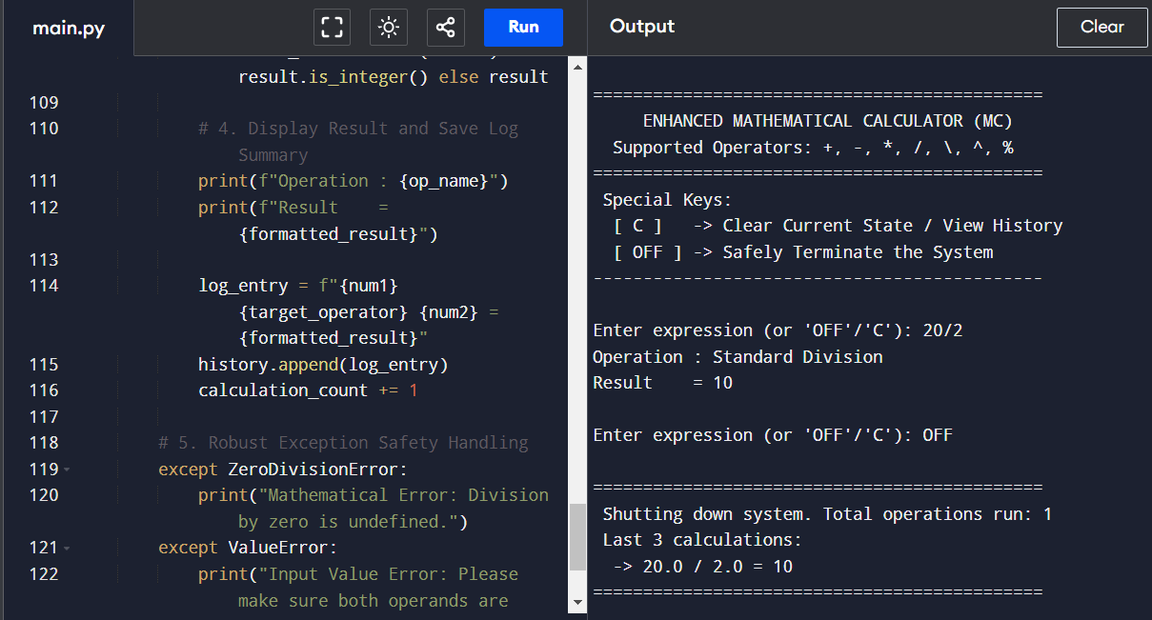

2.2 The Pocket CGPA Calculator (PPC)
The core requirement of the CGPA calculator is the implementation of selection control statements to map letter grades to a standard 5-point academic scale.
A tracking loop collects data for a user-specified number of courses. For each course, an explicit conditional hierarchy processes the input grade:

if grade == 'A': grade_point = 5

elif grade == 'B': grade_point = 4

elif grade == 'C': grade_point = 3

elif grade == 'D': grade_point = 2

elif grade == 'E': grade_point = 1

elif grade == 'F': grade_point = 0

Mathematical Formulation: The total Quality Points (QP) are compiled by multiplying each course's credit units by its mapped grade point. The final running CGPA is derived dynamically using the formula:
$$\text{CGPA} = \frac{\sum(\text{Credit Units} \times \text{Grade Point})}{\sum\text{Total Credit Units}}$$. Here is the output result;
.

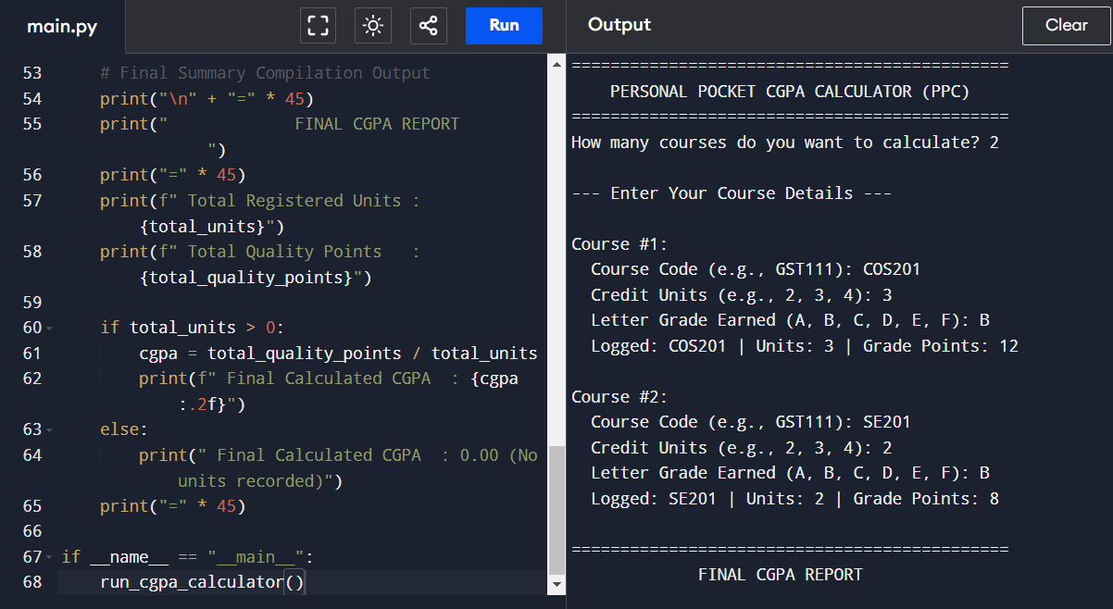

3. PERFORMANCE SUMMARY
Both systems were successfully tested using a standard terminal input stream. The applications parse text effectively, catch input errors safely (such as preventing crashes when dividing by zero), and output precise results immediately without demanding heavy graphical dependencies or system configurations.

