Individual Project-Propeller activation

1. Project Description

The idea behind this project is basically to activate a propeller using a sensor. I originally thought of a smart cooling device that activates once a condition is met. Theoretically, because I was thinking about a cooling device, it seemed obvious that I needed a temperature sensor to activate the propeller, but because it is harder to simulate a temperature change, I chose to use a ultrasonic sensor instead. So, the end result is a propeller (fan connected to a motor) that activates when an object is within 15 cm of the sensor and deactivates otherwise. Also, to be able to manage the propeller, I created a code in the Arduino IDE to constantly read the data from the sensor and correctly manage the actions of the propeller.

1. Schematics

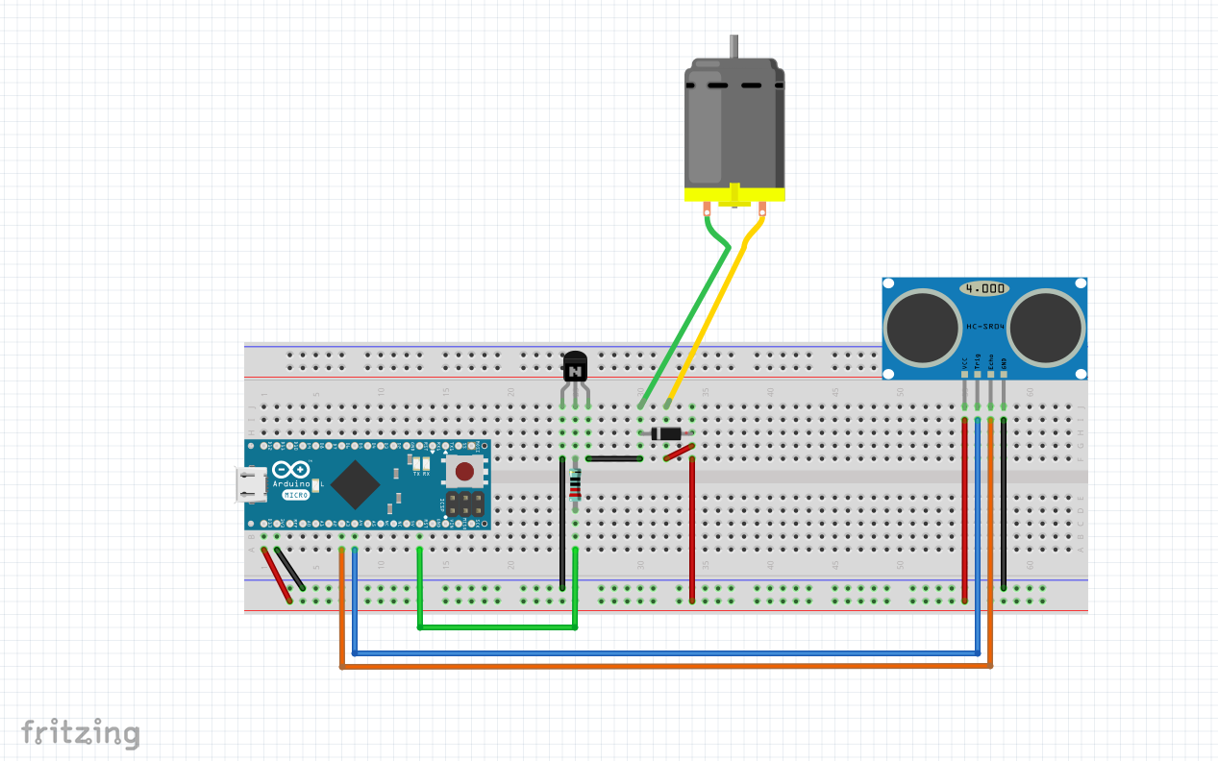

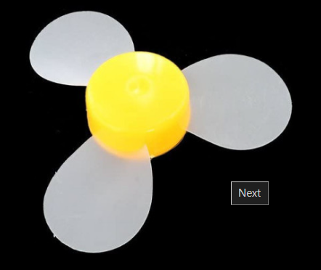Some observations:

* I could not find/create the board I used for the project, so a chose a similar one (one with a micro port)
* The ultrasonic sensor is mirrored, I could not place it in the scheme as I did on the breadboard, so the wires connected to the sensor are in opposite order
* I did not find a fan to add to the scheme, but in the project, it is connected to the motor
* I did not have an orange wire long enough, so I used a black one in my project
* Regarding the board we have: 3V3-red wire, GND-black wire, D6-Echo, D5-Trig, D2-a25 (resistor) (Echo, Trig sensor pins)

Besides what I previously mentioned, the scheme follows the project I made (colors and pin positions)

1. Pre-requisites

* Arduino IDE 2.3.2 - <https://www.arduino.cc/en/software>
* Android Things compatible board (Plusivo ESP8266)- <https://www.plusivo.ph/wifi-boards/135-plusivo-micro-wifi-development-board-with-esp8266-and-ch340g.html>
* Ultrasonic sensor HC-SR04 - <https://www.plusivo.ph/ultrasonic-sensors/61-hc-sr04-ultrasonic-sensor.html?search_query=HC-SR04&results=2>
* N20-10170 Miniature Motor (10000 RPM at 3 V) with Wire (no other specification)
* Toy fan - <https://www.plusivo.ph/others/668-toy-fan.html>
* 1 diode 1N4007 - <https://www.plusivo.ph/diodes/609-diode-1n4007.html>
* 1 transistor NPN2N2222 - <https://www.plusivo.ph/transistors/603-transistor-npn-2n2222-to-92.html>
* 1 resistor 1K
* Jumper wires
* 1 breadboard - <https://www.plusivo.ph/breadboards/20-breadboard-hq-830-points.html>

1. Setup and Build

To setup, we have to add the board in the Arduino IDE environment, following these steps:

* Open Arduino IDE.
* Go to FILE> PREFERENCES.
* Copy the following link to "Additional Boards Manager URLs": http://arduino.esp8266.com/stable/package_esp8266com_index.json
* Open TOOLS> BOARDS> BOARDS MANAGER.
* Download and install ESP8266.
* Restart the Arduino IDE.

1. Running

To run the app module on an Android Things board:

* Connect the ultrasonic sensor and propeller pins to the board according to the schematics
* Deploy and run the app module
* Put an object within 15cm of the sensor
* Check if the propeller activates
* Take the object farther than 15cm of the sensor
* Check if the propeller deactivates

1. Demo-video capture

The video can be found in the github repository, I could not attach it here.

<https://github.com/onigaandreea/Individual-Project-Android-Things> - github repo link