Prithvi Narayan Campus Institute Of Science and Technology

Department Of Computer Science and Information Technology

Tribhuvan University



Project Report On

System Analysis and Design (CSC-315)

Submitted to: Mr. Surya Poudel

Submitted by:

|  |  |
| --- | --- |
| Student Name | Exam Roll Number |
| Aayush Paudel | 27550/077 |
| Subash Rijal | 27577/077 |
| Sujan Sigdel | 27579/077 |
| Sulav Lamsal | 27580/077 |
|  |  |

CONTENTS

1. INTRODUCTION 
   1. Statement of the problem
   2. Objectives
   3. Scope of the project
   4. Limitations
2. STUDY OF EXISTING SYSTEM 
   1. Data Collection
   2. System Requirement
   3. Feasibility Analysis
   4. System Planning
   5. Project Methodology
3. SYSTEM ARCHITECTURE 
   1. Context Diagram
   2. ER Diagram
4. TESTING 
   1. Testing Objective
   2. White Box Testing
   3. Black Box Testing
5. SUPPORT AND MAINTENANCE

# Future Scope

* 1. Backup and Recovery

# Security

1. CONCLUSION

# REFERENCES

# 1 INTRODUCTION

Gym Management System allows us to browse through endless possibilities, and access their customer’s details. Say 'goodbye' to the days when you use to maintain a register, log book and bill. This system can store the payment history, generate bill, and store the details of the customers who have taken admission into the gym and also the exercise routine the respective member is following from their joining date. Payment records can be added and stored. Various plans of payments can be added with respective validity. The member enroll to the specific plan are displayed and their respective date of ending of their plan is also accessible which is fully controlled by the gym owner or the administrator

# 1.1 Statement of the problem

**GYM Management System** is the process whereby records of members are directly stored and can be accessed by the admin interactively in real-time without an intermediary service. Gym Management System is the process of storing member’s details including health status, payment records, exercise routines etc. who have taken admission to the gym. Since the emergence of the World Wide Web, owners have sought to stored their user details in a digital system for easy access and find out every detail when needed.

# 1.2 Objectives

The primary goal of the gym management system is to automate the current manual processes involved in maintaining records of member activities, equipment usage, scheduling, and membership details. The project aims to achieve the following objectives:

* To efficiently store and manage records of members, health status, plans and exercise routines.
* To design an intuitive and user-friendly graphical interface tailored to the needs of staff.
* To streamline processes and save time in managing membership registrations, renewals etc.
* To create a cost-effective solution that optimizes resource utilization, reducing manual efforts and paperwork.
* To incorporate features for tracking and analyzing members' fitness progress, including workout routines, and goals.

# 1.3 Scope of the project

The main scope and deliverables of the project would be to:

* Understand and prepare detailed requirement and specifications
* Prepare high level and detailed design specifications of the system
* Prepare Test Plan and Test cases
* Develop the system and coding
* Perform unit testing, integration and system testing
* Demonstrate a bug free application after suitable modification if needed.

# 1.4 Achievements

By successfully implementing the project, a substantial knowledge has been acquired on the implementation of a database system using .net technologies. This knowledge will be useful in the future in creating any type of desktop application or online database systems.

# STUDY OF EXISTING SYSTEM

To develop this project, 'Dream Gym' has been chosen for analysis, revealing a blend of conventional and contemporary record-keeping methods in operation. The gym manages member activities, equipment usage, scheduling, and membership details manually. Members need to register their workout details using a paper-based system, which can be time-consuming. Staff members also face the challenge of not having the convenience to log into the system for efficient management.

2.1 Data Collection

Data collection is a critical phase encompassing the gathering and organization of relevant information in the context of developing the gym management system. The objective of this data collection process is to acquire essential details, including member information, equipment inventory, and class schedules. To formulate the foundation of this project, an interview session was conducted with key staff members, including gym managers, to understand the current operational system, the responsibilities of staff, and the intricacies of managing member activities. This process of gathering requirements and information serves as a crucial step in the development of our gym management system.

2.2 System Requirements

System requirements are expressed in a software requirement document. The Software requirement specification (SRS) is the official statement of what is required of the system developers. This requirement document includes the requirements definition and the requirement specification. The software requirement document is not a design document. It should set out what the system should do without specifying how it should be done. The requirement set out in this document is complete and consistent.

* The software specification document satisfies the following: -
* It specifies the external system behaviors.
* It specifies constraints on the implementation.
* It is easy to change.
* It serves as reference tool for system maintainers.
* It records forethought about the life cycle of the system.
* It characterizes acceptable response to undesired events

User Class and Characteristics:

* Administrators can add, edit & delete member, plan, schedule and make payment update of the respective member.
* Administrator can view the monthly income of the member.
* Administrator can update the health status of the members.
* Administrator will have a overview of the total plan available total member join per year and month.
* Administrator can change admin password admin user profile and the secure key when the changes are required.
* Administrator can view the expire date of a specific member enrolled to the particular plan.

Functional Requirements:

* The System must provide following functionalities—
* Keeping records of registration of members.
* Keeping the records of payments.
* Keeping the monthly income.
* Storing the health status of the customer.

Non Functional Requirements:

Following Non-functional requirements will be there in the online portal.

* + - Secure access of confidential data (customer’s details).
    - 24 X 7 availability.
    - Better component design to get better performance at peak time.

Flexible service based architecture will be highly desirable for future extension Nonfunctional requirements define system properties and constraints It arise through user needs, because of budget constraints or organizational policies, or due to the external factors such as safety regulations, privacy registration and so on.

Various other Non-functional requirements are:

1. Security

2. Reliability

3. Maintainability

4. Portability

5. Extensibility

6. Reusability

7. Application Affinity/Compatibility

8. Resource Utilization

* 1. Feasibility Analysis

Feasibility study is made to see if the project on completion will serve the purpose of the organization for the amount of work, effort and the time that spend on it. Feasibility study lets the developer foresee the future of the project and the usefulness. A feasibility study of a system proposal is according to its workability, which is the impact on the organization, ability to meet their user needs and effective use of resources. The key components of feasibility analysis are: -

1. Technical Feasibility:

The system must be evaluated from the technical point of view first. The assessment of this feasibility must be based on an outline design of the system requirement in the terms of input, output, programs and procedures. Having Identified an outline system, the investigation must go on to suggest the type of equipment, required method developing the system, of running the system once it has been designed.

1. Economical Feasibility:

The developing system must be justified by cost and benefit. Criteria to ensure that effort is concentrated on project, which will give best, return at the earliest. One of the factors, which affect the development of a new system, is the cost it would require. The following are some of the important financial questions asked during preliminary investigation:

* The costs conduct a full system investigation.
* The cost of the hardware and software.
* The benefits in the form of reduced costs or fewer costly errors.

Since the system is developed as part of project work, there is no manual cost to spend for the proposed system. Also all the resources are already available, it give an indication of the system is economically possible for development.

1. Operational Feasibility:

This application is easy to operate as it is made user-friendly and students of different ages and classes can readily use it. Little training is required to learn it and it will provide services and access to different information that may be required for some decision making.

1. Schedule Feasibility:

Schedule feasibility refers to the ability to complete a project within the required timeframe.

2.4 System Planning

System planning is a pivotal phase in the development or enhancement of any information system, including the gym management system. It encompasses a thorough analysis and decision-making process to define the goals, objectives, resources, and strategies necessary for the efficient design, implementation, and maintenance of the system. The primary objective of system analysis is to identify and address potential issues within the system. This entails breaking down the system into distinct components for analysis, understanding project goals, and engaging with users to ensure specific objectives are achieved during the requirements gathering phase conducted by individuals or teams from the client or interviewer.

In the context of building a gym management project, planning serves as a roadmap to ensure seamless progress. We meticulously outline the project's functionalities, select appropriate tools and technologies, and design the integration of various components. Our team adheres to coding standards, employs collaborative tools, and rigorously tests every aspect to ensure optimal performance. Consideration is given to security measures, scalability for accommodating a substantial user base, and anticipating potential challenges. Once the project is prepared, we develop comprehensive materials to facilitate user understanding and usage, adhere to relevant rules and regulations, and continually seek avenues for improvement. Analogous to constructing a house, our approach involves meticulous planning, utilizing the right materials, thorough checks, and ensuring safety and usability for all users.

2.5 Project methodology

Project methodology is a systematic approach or framework utilized to plan, execute, and manage projects, and in the context of software engineering, a system development methodology structures, plans, and controls the information system development process. Various models or methods are employed during the Software Development Life Cycle (SDLC), such as the waterfall model, prototyping model, spiral model, and others, chosen based on the software's nature or objective.

For the development of our gym management system, we adopted the Waterfall Model. Despite being an older model, we deemed it the most suitable for our system, particularly for projects characterized by their small scale and well-defined requirements. The entire system is constructed in alignment with the principles of the Waterfall Model.

The Waterfall Model, being the first Process Model introduced, is known as a linear-sequential life cycle model. Its simplicity in understanding and application makes it an ideal choice. In the waterfall model, each phase must be completed before the next one commences, ensuring a clear sequential progression without overlapping. The sequential phases in the Waterfall model are as follows:

1. Requirement Gathering and analysis:

All possible requirements of the system to be developed are captured in this phase and documented in a requirement specification document.

1. System Design:

The requirement specifications from the first phase are studied in this phase and the system design is prepared. This system design helps in specifying hardware and system requirements and helps in defining the overall system architecture.

1. Implementation:

With inputs from the system design, the system is first developed in small programs called units, which are integrated into the next phase. Each unit is developed and tested for its functionality, which is referred to as Unit Testing.

1. Integration and Testing:

All the units developed in the implementation phase are integrated into a system after the testing of each unit. Post integration the entire system is tested for any faults and failures.

1. Deployment of system:

Once the functional and non-functional testing is done; the product is deployed in the customer environment or released into the market.

1. Maintenance:

There are some issues that come up in the client environment. To fix those issues, patches are released. Also to enhance the product some better versions are released. Maintenance is done to deliver these changes in the customer environment.

# 3. SYSTEM ARCHITECTURE

System architecture refers to the high-level structure of a complex system, which includes the components or modules, their relationships, and the principles and guidelines governing their design and evolution over time. The architecture of a system serves as a blueprint for both the system's development and its ongoing maintenance. A three-layer architecture has been implemented in the system development. It is a very common architecture that is typically split into a presentation or GUI layer, an application logic layer and data layer.

Presentation layer

Application(Logic) Layer

Data layer

First layer

Second layer

Third Layer

Fig : System Architecture

Presentation Layer:

This layer is the top level of the application and contains the user interface of the application.

Application Layer:

This layer is the second layer of the system architecture. In this layer, Business logic is implemented. This layer reads and stores data in data layer.

Data layer:

This layer is third layer of the system architecture. The data layer can store data securely, perform transactions and search through huge chunks of data quickly. MySQL, SQL, MongoDB have been used to store data

# Data Flow Diagram (DFD)

DFDs show the flow of data from external entities into the system, showed how the data moved from one process to another, as well as its logical storage.

* Squares representing external entities, which are sources or destinations of data.
* Rounded rectangles representing processes, which take data as input, do something to it, and output it.
* Arrows representing the data flows, which can either, be electronic data or physical items.
* Open-ended rectangles representing data stores, including electronic stores such as databases or XML files and physical stores such as or filing cabinets or stacks of paper.

There are four basic symbols that are used to represent a data flow diagram.

Fig: Process

Fig: Database/Data Store

Fig :External Entity

Fig: Data flow

From above figure, we can use one of the figure to show the process, database/data Store and external entities. Here, we discuss Context-level diagram and level -1 DFD diagram of Library Management System.

# Context-level diagram/ Level - 0 DFD

A context diagram gives an overview and it is the highest level in a data flow diagram, containing only one process representing the entire system. It should be split into major processes which give greater detail and each major process may further split to give more detail.

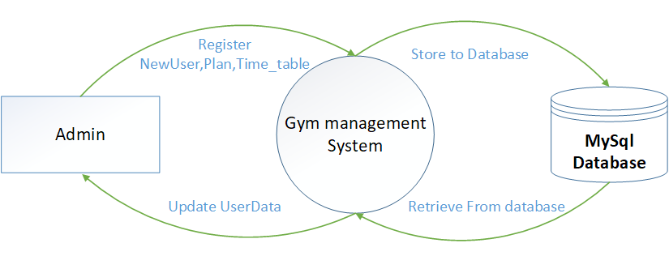

Fig: Level – 0 DFD

Here we illustrate the flow of data when either the gym staff or the member requests information. The primary system is accessible to gym staff for record maintenance, depicting the various components of a gym management system and their interconnections. The arrows in the diagram depict the interactions among these components. The key components include:

* + 1. Library Management System:

This is the software system exclusively accessible to gym staff, responsible for overseeing all gym operations. It manages tasks such as cataloging equipment and materials, facilitating their circulation to gym members, and generating comprehensive reports

* RegisterNewUser:

This is the process of registering a new user in the gym management system, providing them access to various facilities and services.

* Plan:

This represents the different membership plans available in the gym, outlining the features and benefits associated with each plan.

* Store to Database:

This is the procedure of saving essential data, such as user information, membership plans, and health status, into the gym management system's database.

* Retrieve from Database:

This is the process of fetching stored data from the gym management system's database when needed, ensuring accurate and up-to-date information.

* Update Userdata:

This is the process of modifying and refreshing user-related information in the gym management system, such as personal details, membership status.

# Level -1 DFD

A Level-1 Data Flow Diagram (DFD) is a visual representation of the data flow within a system at a higher level than a Level-0 DFD. It provides a more detailed view of the system, breaking down the processes and data flows identified in the Level-0 DFD into sub- processes and data stores. Each process in a Level-1 DFD can be further decomposed into more detailed processes until the desired level of detail is reached.

**1st level DFD for Admin Processes**

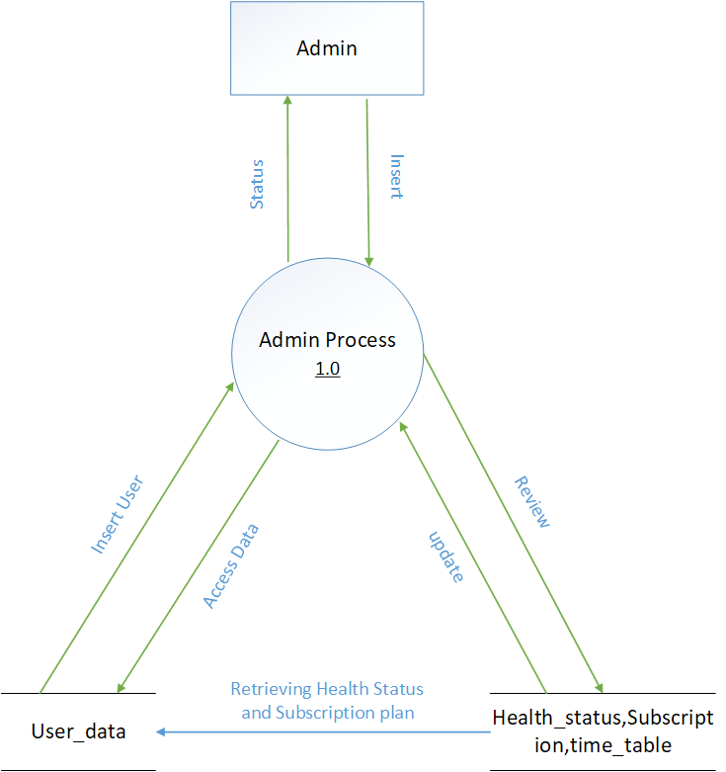

**DFD For User Registration and Profile Update**

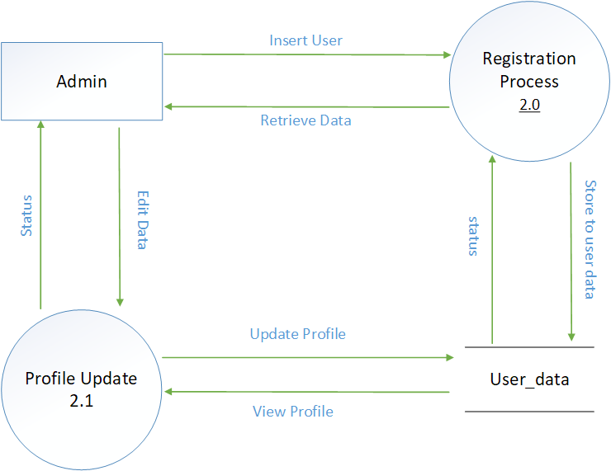

# Entity Relationship Diagram

Simply stated the ER model is a conceptual data model that views the real world as entities and relationships. A basic component of the model is the Entity-Relationship diagram which is used to visually represent data objects. The ER Diagram for this Gym Management System is shown in Figure.

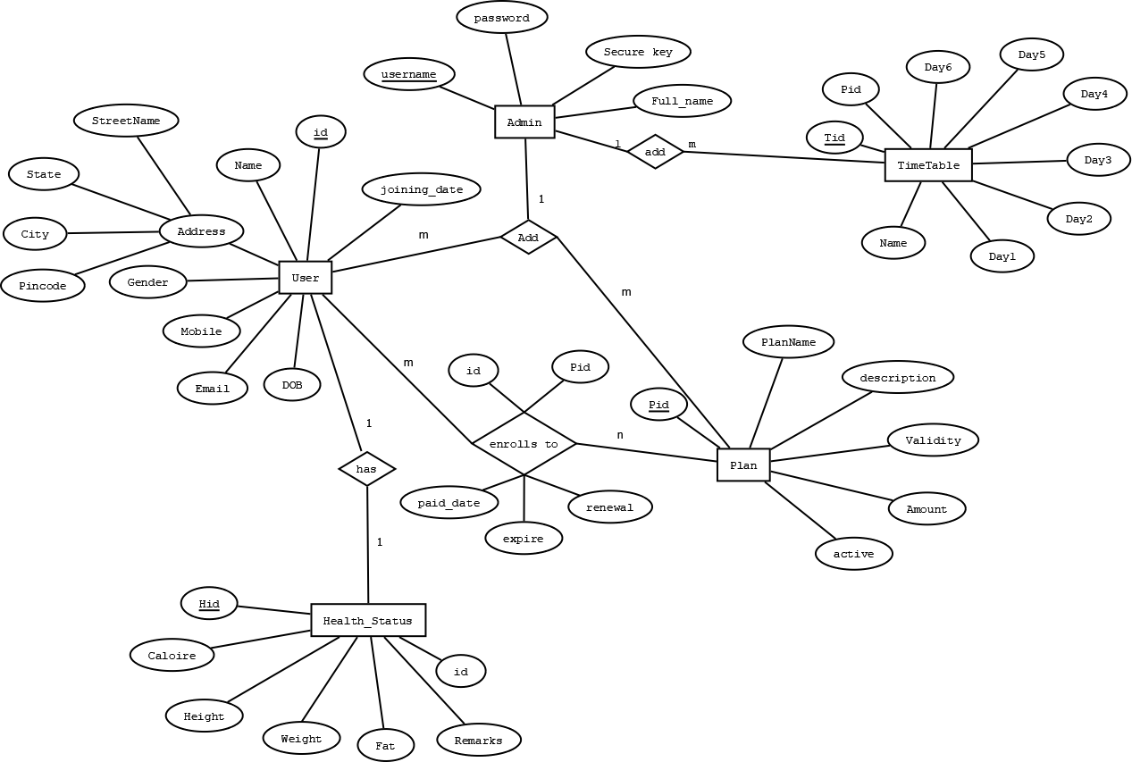

Here's a brief explanation of each entity and their relationships:

*User*: Represents a user of the system with attributes like name, address, mobile, etc.

*Admin*: User with administrative privileges.

*Health Status*: Stores health-related attributes for a user, like calorie intake and weight.

*Plan*: A type of subscription or plan that a user can enroll in, with details like plan name, validity, and amount.

*Timetable*: Represents a schedule or set of plans with daily details.

**Relationships:**

*User to Admin*: A one-to-many relationship, indicating that a user can be an admin, and there can be multiple admins.

*User to Health Status*: A one-to-one relationship, suggesting that each user has a unique health status record.

*User to Plan*: A many-to-many relationship, shown as 'User' connects to 'Plan' through 'enrolls to', meaning a user can enroll in many plans and a plan can have many users.

*Plan to TimeTable*: A one-to-many relationship, indicating each plan has one timetable, but a timetable can belong to multiple plans. Each line and letter ('m', 'n', '1') near the lines denotes the cardinality of the relationship: 'm' or 'n' means many. '1' means one. For example, 'm' to 'n' between 'User' and 'Plan' means many users can enroll in many plans, whereas '1' to 'm' between 'Admin' and 'User' means one admin can be associated with many users but a user is associated with only one admin.

# TESTING

4.1 Testing Objective

Testing is a crucial aspect of ensuring the success of the gym management system. The testing phase operates on the logical assumption that with correct functioning of all system components, the intended goals will be achieved successfully. It serves as a critical component of quality assurance for software and signifies the ultimate evaluation of specifications, design, and coding. The testing process involves running the gym management system under various circumstances and conditions to identify errors and bugs.

This phase involves comprehensive testing using diverse sets of data, evaluating system operations under controlled conditions, and assessing the results. Controlled conditions encompass both normal and abnormal scenarios. Software testing, in the context of the gym management system, can be defined as the process of verifying and validating that the software meets technical requirements outlined in its design and development. It ensures the system is free of errors, effectively and efficiently meets user requirements, and handles all exceptional and boundary cases.

* Unit Testing
* Integration Testing
* System Testing
* User Acceptance Testing

Validation

Data validation is an essential part of any data handling task whether you're in the field collecting information, analyzing data, or preparing to present data to stakeholders. If data isn't accurate from the start, your results definitely won't be accurate either. That's why it's necessary to verify and validate data before it is used.

Mandatory

We can mark a field as Mandatory, which means that a particular field cannot be left blank. Fields marked as mandatory will be represented by an asterisk (*) sign that will appear beside the field name. Content managers will not be able to save entries if

"Mandatory" fields are left blank.

Number of Characters

Setting a character limit will ensure that users enter content within the maximum or minimum number of characters set to a field. For example, you want to create a "Password" field in your website and you want to set a minimum and maximum limit to the cell. In this case, the Number of Characters validation rule comes in handy.

Security Testing of the Project

Testing is vital for the success of any software. no system design is ever perfect. Testing is also carried in two phases. first phase is during the software engineering that is during the module creation. second phase is after the completion of software. this is system testing which verifies that the whole set of programs hanged together.

4.2 White Box Testing:

In this technique, the close examination of the logical parts through

the software is tested by cases that exercise species sets of

conditions or loops. Errors that can be corrected using this technique are typographical errors, logical expressions which should be executed once may be getting executed more than once and error resulting by using wrong controls and loops. When the box testing tests all the independent part within a module a logical decision on their true and the false side are exercised, all loops and bounds within their operational bounds were exercised and internal data structure to ensure their validity were exercised once.

4.3 Black Box Testing:

This method enables the software engineer to device sets of input techniques that fully exercise all functional requirements for a program. black box testing tests the input, the output and the external data. it checks whether the input data is correct and whether we are getting the desired output.

Alpha Testing:

Acceptance testing is also sometimes called alpha testing. Be spoke systems are developed for a single customer. The alpha testing proceeds until the system developer and the customer agree that the provided system is an acceptable implementation of the system requirements.

Beta Testing:

On the other hand, when a system is to be marked as a software product, another process called beta testing is often conducted. During beta testing, a system is delivered among a number of potential users who agree to use it. The customers then report problems to the developers. This provides the product for real use and detects errors which may not have been anticipated by the system developers.

Unit Testing:

Each module is considered independently. it focuses on each unit of software as implemented in the source code. it is white box testing.

Integration Testing:

Integration testing aims at constructing the program structure while at the same constructing tests to uncover errors associated with interfacing the modules. modules are integrated by using the top down approach.

Validation Testing:

Validation testing was performed to ensure that all the functional and performance requirements are met.

System Testing:

It is executing programs to check logical changes made in it with intention of finding errors. a system is tested for online response, volume of transaction, recovery from failure etc. System testing is done to ensure that the system satisfies all the user requirements.

# SUPPORT AND MAINTENANCE

Support and maintenance stand as critical elements within the gym management system's development life cycle, emphasizing the continuous effective, efficient, and secure operation of the system beyond its initial implementation. These activities encompass addressing issues, implementing updates, and providing user assistance to ensure the system's sustained functionality and adaptability.

Maintenance is an integral requirement for all systems, including software, as it addresses residual errors or bugs that may surface after the system has been in operation for an extended period. When these errors are identified, they necessitate removal, leading to modifications in the software. Maintenance involves a thorough understanding of the effects of change, making necessary adjustments to both the code and documentation, testing new components, and retesting existing ones. Ongoing support and maintenance for the gym management system are paramount to its continuous improvement and seamless operation.

* 1. Future Scope

Software development is never –ending process and continues the life of the software as per the changing needs of the user from time to time. The project is no doubt has been developed keeping in mind easy modification and enhancement that may be required from time to time.

However, there are many scopes to modify this software. As because due to shortage of time, we here become unable to include many things. We are trying to cover all their existing system for keeping records of the members enrolls but due to shortage of time we become unable to include many things. Due to lake of time I here include none of them and a future scope one can develop these returns which are so much essential. Only with a little more doing it is possible to design the formats for those returns. Moreover, an on-line system will be more helpful to the organization. With almost the same data with only a little modification an on-line system can be designed to fulfill their demands. All these can be considered to be future scope for this project.

* 1. Backup and Recovery

Administrators have the privilege of backing-up and recovery. An admin is able to make a backup of the database and restore it in case of a system crash or any other need for a reinstall.

* 1. Security

To protect the system, Security measures can be taken at the following levels:

* Physical:

The sites containing computer systems must be physically secured against armed and malicious intruders. The workstations must be carefully protected.

* Human:

Only appropriate users must have the authorization to access the system. Phishing (collecting confidential information) and Dumpster Diving (collecting basic information so as to gain unauthorized access) must be avoided.

* Operating system:

The system must protect itself from accidental or purposeful security breaches.

* Networking System:

Almost all of the information is shared between different systems via a network.

# **CONCLUSION**

After implementing the application, it will contain the advantages were incomparable to the present contemporary systems used by company. The most admirable feature founded was its simplicity in terms of application to the user but its highly beneficial outputs can’t be ignored. The users will be highly benefited after using the system.

It is hoped that this project will help the future developers to modify and implement the system. After modifying some techniques of the programs, it will give us the best performance as our requirements. The project will be very useful for the users.

# REFERENCES

1. <https://studylib.net/doc/25661677/gym-management-system-project-report--1->
2. <https://www.researchgate.net/publication/372124307_Design_and_Implementation_of_Gym_Management_System_Based_on_Web>
3. <https://www.practitest.com/resource-center/article/black-box-vs-white-box-testing/>
4. Kenneth E. Kendall and Julie E. Kendall, System Analysis and Design, 9th Edition, Pearson
5. KEC Publishers & Distributers PVT LTD (System Analysis and Design)