Colors used:

Leave out formal charges!

Chemicals not used:

1. [noble gases](https://en.wikipedia.org/wiki/Noble_gas) ([He](https://en.wikipedia.org/wiki/Helium), [Ne](https://en.wikipedia.org/wiki/Neon), [Ar](https://en.wikipedia.org/wiki/Argon" \o "Argon), [Xe](https://en.wikipedia.org/wiki/Xenon" \o "Xenon), [Kr](https://en.wikipedia.org/wiki/Krypton))
2. [alkaline earth metals](https://en.wikipedia.org/wiki/Alkaline_earth_metal) ([Be](https://en.wikipedia.org/wiki/Beryllium), [Mg](https://en.wikipedia.org/wiki/Magnesium), [Ca](https://en.wikipedia.org/wiki/Calcium), [Sr](https://en.wikipedia.org/wiki/Strontium" \o "Strontium), [Ba](https://en.wikipedia.org/wiki/Barium), [Ra](https://en.wikipedia.org/wiki/Radium))
3. [iron](https://en.wikipedia.org/wiki/Iron) (Fe)
4. other elements
5. CCl4 Carbon tetrachloride 5 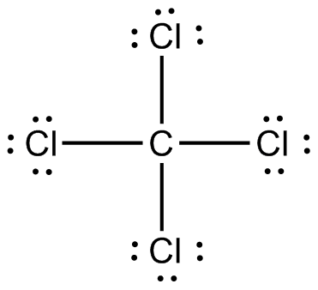
6. C2H6 Ethane 8 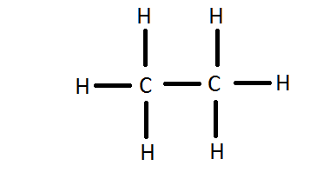
7. HCl Hydrogen Chloride 2 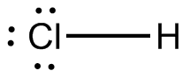
8. C2H2 Ethyne 4 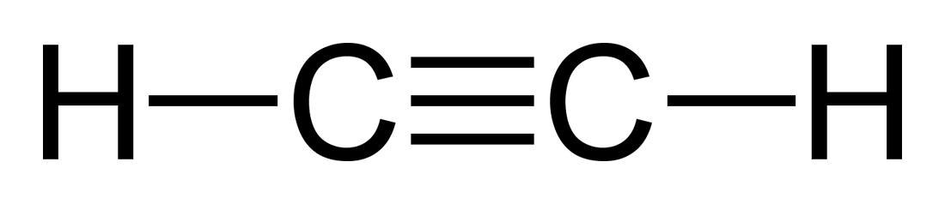
9. LiH Lithium Hydride 2 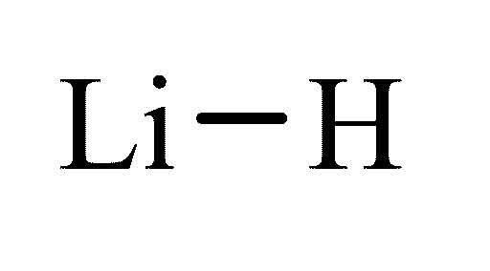
10. H2SO4 Sulfuric Acid 7 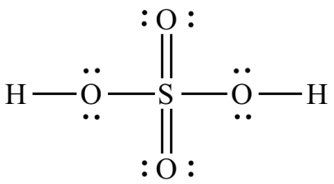
11. CO3^2- carbonate 4 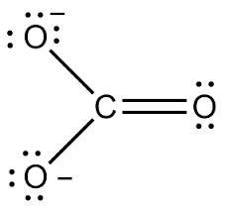
12. CH3NO2 nitromethane 7 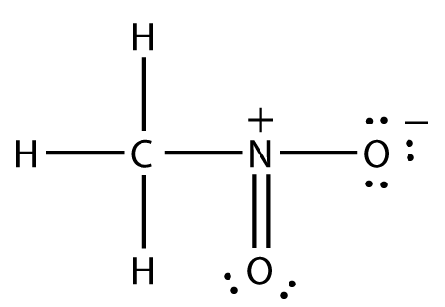
13. C3H6 Propene 9 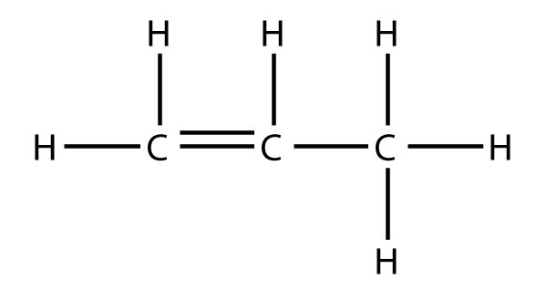
14. OF2 Oxygen Difluoride 3 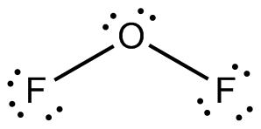
15. Br2 Bromine 2 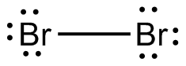
16. Cl2 Chlorine 2 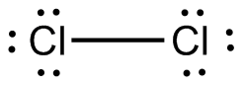
17. F2 Fluorine 2 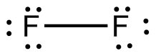
18. N2 Nitrogen 2 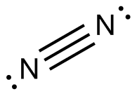
19. BH3 Boron Hydride 4 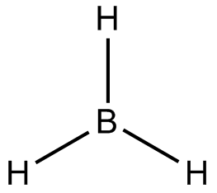
20. H2 Hydrogen 2 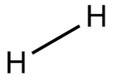
21. HBrO3 Bromic Acid 5 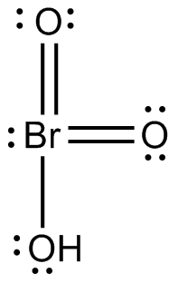
22. N2O3 Dinitrogen Trioxide 5 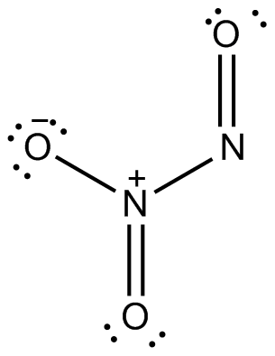
23. NF3 Nitrogen Trifluoride 4 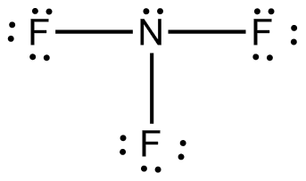
24. PF3 Phosphorus Trifluoride 4 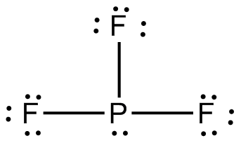
25. PF5 Phosphorus Pentafluoride 6 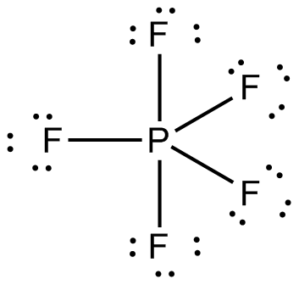
26. PH3 Phosphine 4 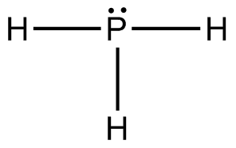
27. Cl2O Dichlorine oxide 3 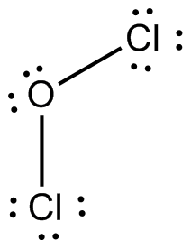
28. HNO Hyponitrous Acid 3 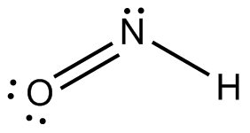
29. N2O Nitrous Oxide 3 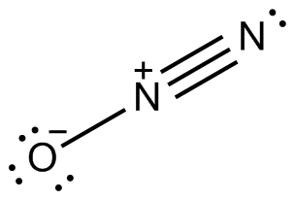
30. PCl3 Phosphorus Trichloride 4 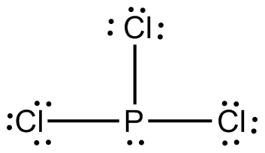
31. PCl5 Phosphorus Pentachloride 6 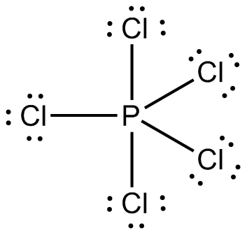
32. BrF5 Bromine Pentafluoride 6 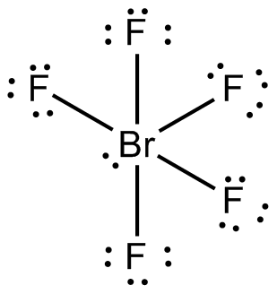
33. ClF3 Chlorine Trifluoride 4 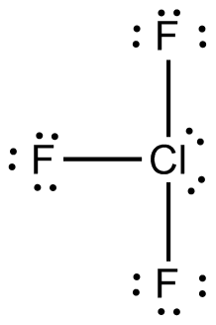
34. ClO Chlorine Monoxide 2 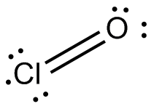
35. HF Hydrogen Fluoride 2 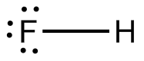
36. N2O4 Dinitrogen Tetraoxide 6 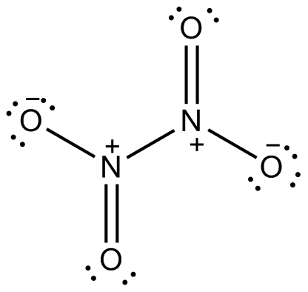
37. NO2 Nitrogen Dioxide 3 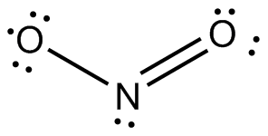
38. SF4 Sulfur Tetrafluoride 5 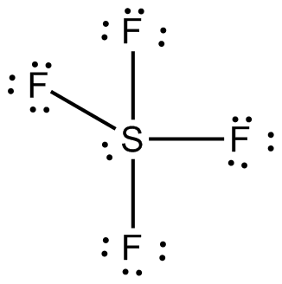
39. SF6 Sulfur Hexafluoride 7 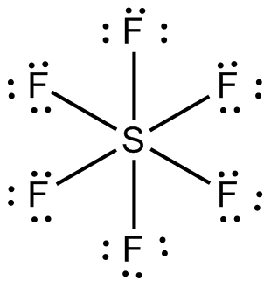
40. H2O2 Hydrogen Peroxide 4 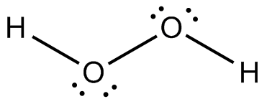
41. HBr Hydrogen Bromide 2 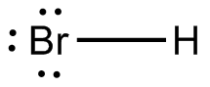
42. HCN Hydrogen Cyanide 3 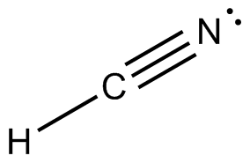
43. HI Hydrogen Iodide 2 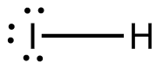
44. PO4^-3 Phosphate 5 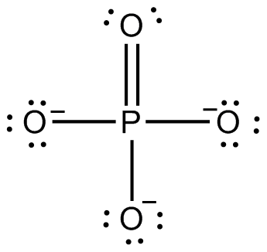
45. SO2 Sulfur Dioxide 3 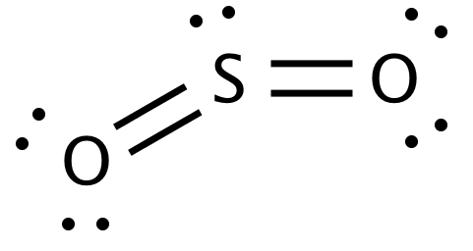
46. O2 Oxygen 2 