Data Cleaning and Imputation Pipeline Report
Retail Store Sales Dataset
Onika Bevny
2026-05-15
Table of Contents

1 Introduction
This report presents the design, implementation, and execution of a fully reproducible data cleaning and imputation pipeline developed for the retail_store_sales dataset.
The pipeline was created in R using a structured and modular workflow that incorporated multiple stages, including data ingestion, diagnostics, cleaning, imputation, validation, export generation, and automated reporting.
The primary objective of the pipeline was to identify, assess, and address data quality issues while maintaining transparency, consistency, and reproducibility throughout the entire analytical process.
Key areas addressed within the pipeline included:
- Detection and handling of missing values
- Identification of cross-field inconsistencies
- Validation of important numeric relationships
- Recovery of logically recoverable values
- Application of basic imputation techniques
- Generation of reproducible multi-format outputs
- Automated creation of analytical summaries and reports

2 Dataset Overview
The dataset assigned for this project was the retail_store_sales dataset. The analysis and pipeline development were limited to a predefined set of variables provided within the assignment scope.
The variables included in the project were:
- Transaction ID
- Customer ID
- Category
- Item
- Quantity
- Price Per Unit
- Total Spent
- Payment Method
- Location
- Transaction Date
- Discount Applied
The pipeline was developed as a structured end-to-end workflow designed to process the dataset systematically while maintaining reproducibility and consistency across all stages of the project.
The workflow consisted of the following stages:
- Data ingestion
- Data diagnostics
- Data cleaning
- Missing value imputation
- Validation and consistency checks
- Data dictionary generation
- Multi-format dataset export
- Automated report generation
Each stage was implemented as an independent script within the pipeline to support modularity, traceability, and ease of maintenance.
Pipeline Diagnostics Overview
metric | value
Rows | 12,575
Columns | 11
Duplicate Transaction IDs | 0
Exact Duplicate Rows | 0
Date Parse Issues | 12,575
Numeric Logic Issues | 0
Spending Mismatches | 0
Potentially Recoverable Cross-Field Rows | 609

3 Data Quality Diagnostics Before Cleaning
Initial diagnostics were conducted to evaluate the quality of the dataset prior to cleaning and transformation.
The diagnostics stage focused on:
- Missingness analysis
- Sentinel value detection
- Duplicate checks
- Date parsing validation
- Numeric range validation
- Spending logic validation
- Cross-field recoverability assessment
Missingness Summary Before Cleaning
variable | missing_count | missing_percent
transaction_id | 0 | 0.00
customer_id | 0 | 0.00
category | 0 | 0.00
item | 1,213 | 9.65
price_per_unit | 609 | 4.84
quantity | 604 | 4.80
total_spent | 604 | 4.80
payment_method | 0 | 0.00
location | 0 | 0.00
transaction_date | 0 | 0.00
discount_applied | 4,199 | 33.39

3.1 Missingness Visualization
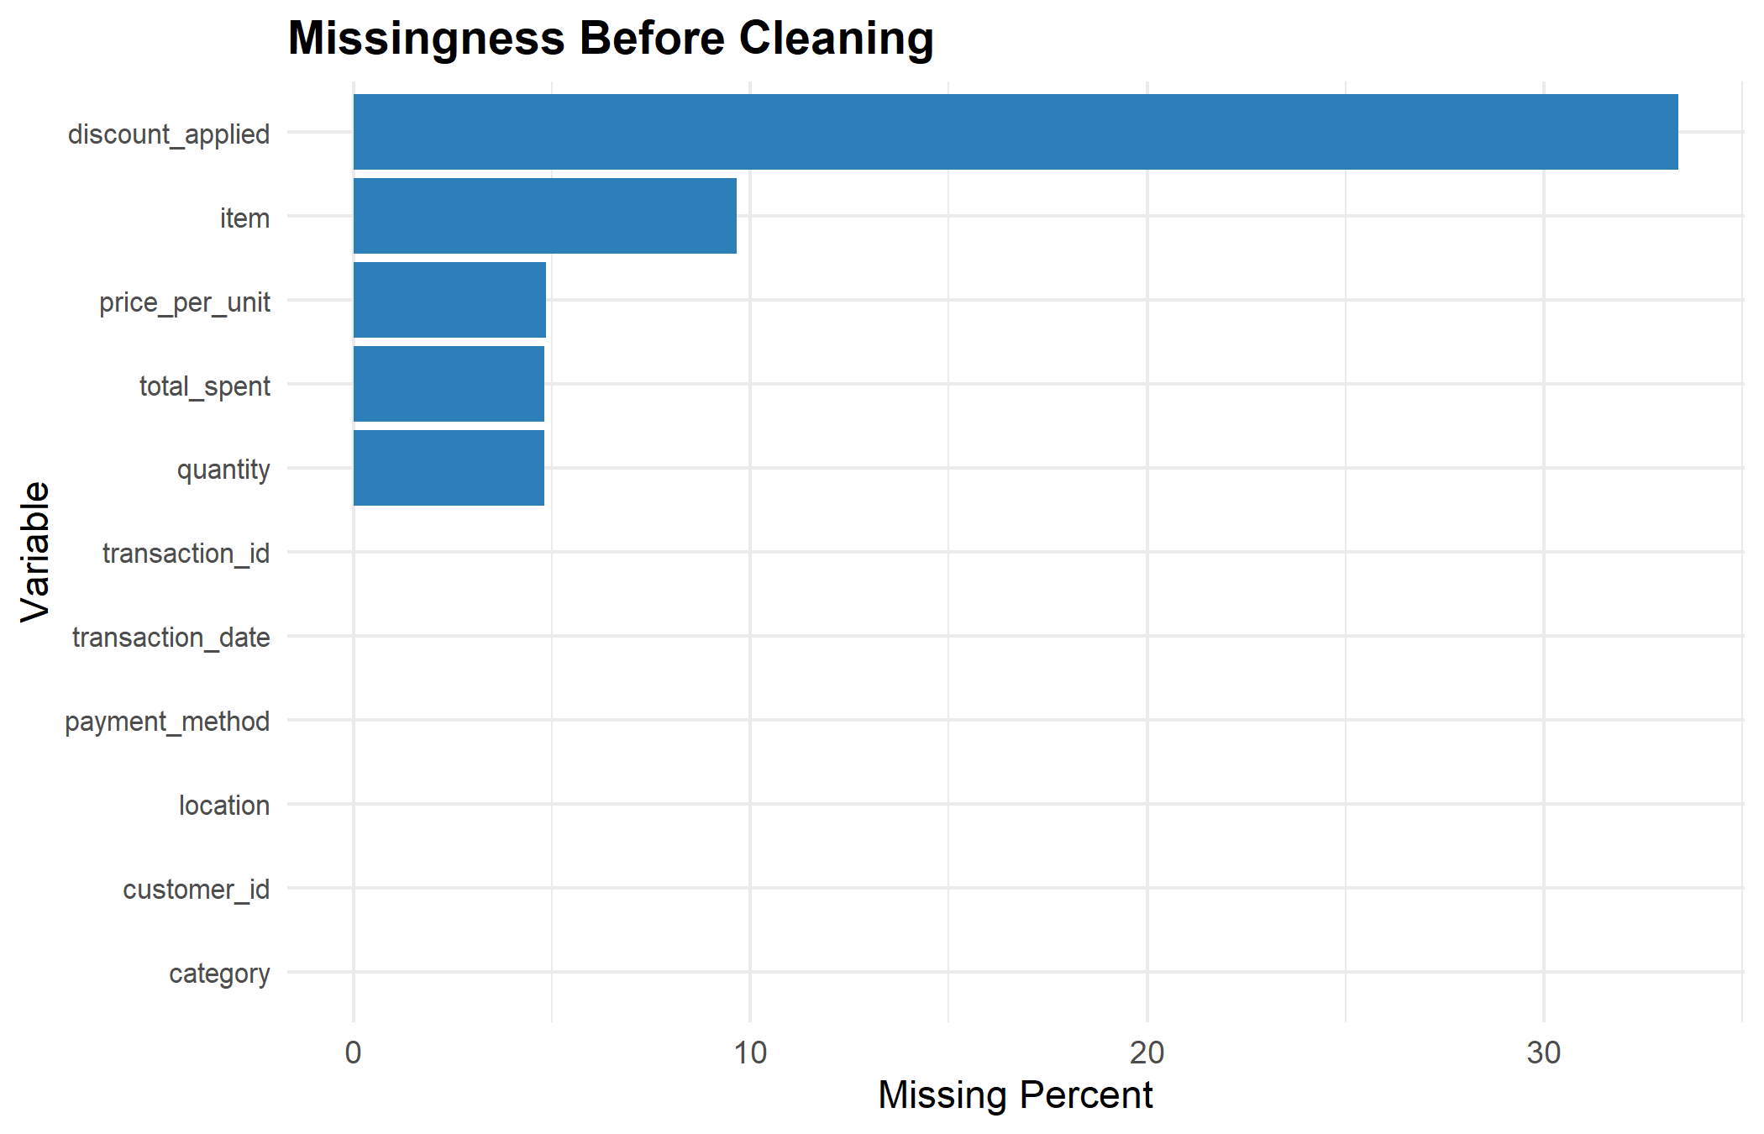

4 Cleaning Decisions and Transformations
The cleaning stage focused on correcting recoverable inconsistencies while preserving the integrity of the original dataset.

4.1 Cross-Field Recovery
Cross-field recovery was implemented using the deterministic relationship:
Total Spent = Quantity × Price Per Unit
Missing price_per_unit values were recovered where both quantity and total_spent were available.
Rows that could not be logically recovered were preserved for the imputation stage.
Missingness Before and After Cleaning
variable | missing_count_before | missing_count_after | recovered
category | 0 | 0 | 0
customer_id | 0 | 0 | 0
discount_applied | 4,199 | 4,199 | 0
item | 1,213 | 1,213 | 0
location | 0 | 0 | 0
payment_method | 0 | 0 | 0
price_per_unit | 609 | 0 | 609
quantity | 604 | 604 | 0
total_spent | 604 | 604 | 0
transaction_date | 0 | 0 | 0
transaction_id | 0 | 0 | 0

4.2 Recovery Visualization
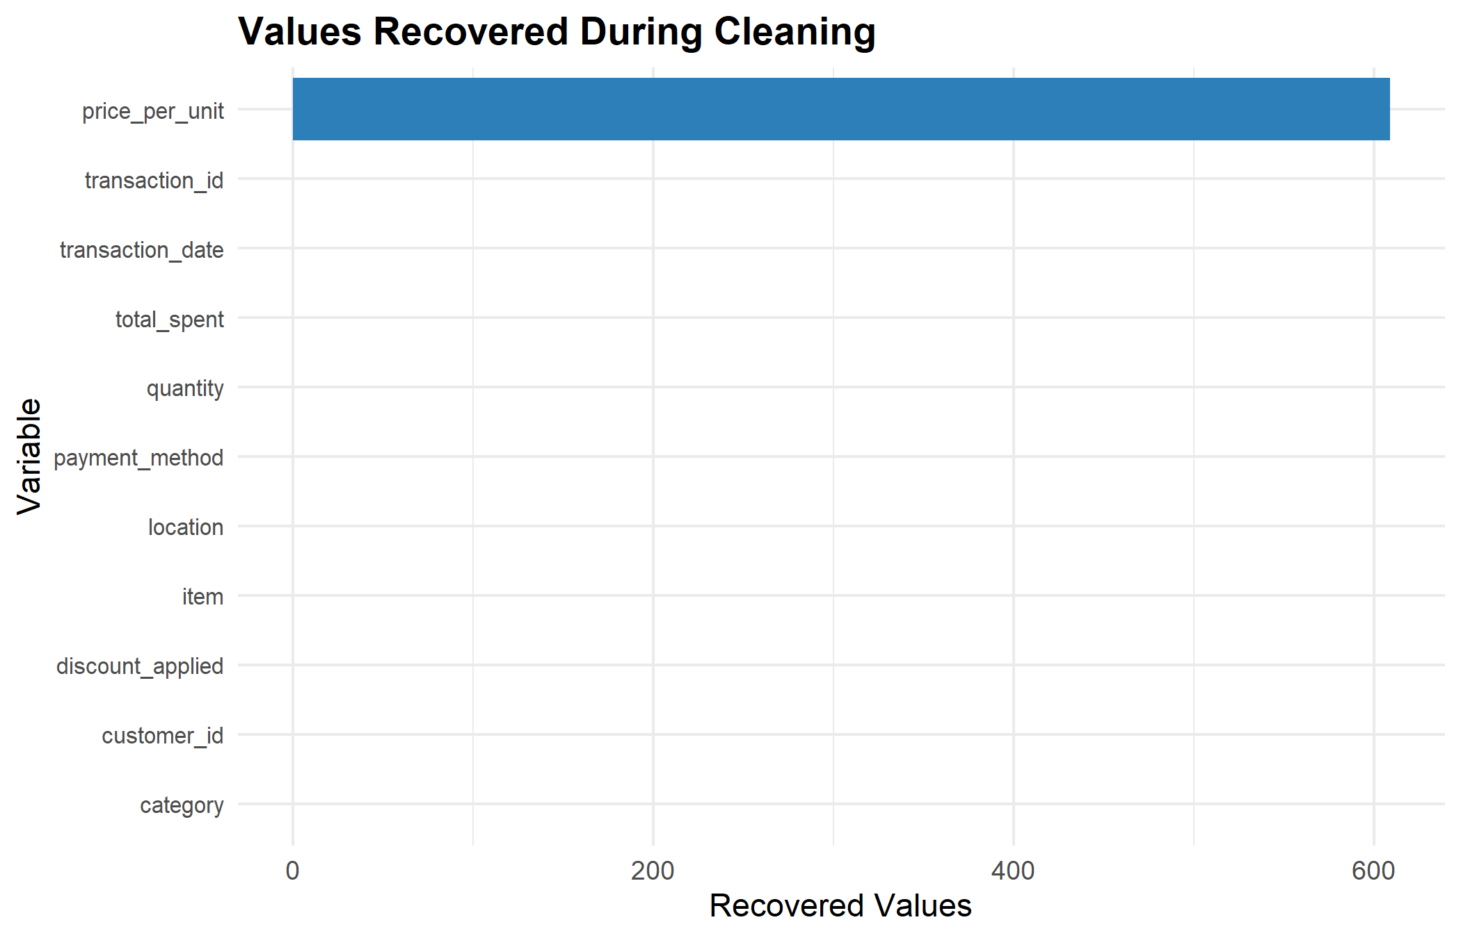

5 Imputation Methods Applied
The imputation stage addressed unresolved missing values remaining after cleaning.

5.1 Median Imputation
Median imputation was applied to the following numeric variables:
- quantity
- total_spent
Median values were calculated using observed non-missing data only.

5.2 Hot-Deck Imputation
A simple category-based hot-deck approach was applied to the item variable.
Missing item values were replaced using the most frequently observed item within the same product category.

5.3 Preserved Missingness
Missing values in discount_applied were intentionally retained because there was insufficient information to reliably determine whether a discount had been applied.
A missingness indicator variable was created to preserve this information for downstream analysis.
Missingness Before and After Imputation
variable | missing_count_before | missing_count_after | imputed_or_resolved
category | 0 | 0 | 0
customer_id | 0 | 0 | 0
discount_applied | 4,199 | 4,199 | 0
item | 1,213 | 0 | 1,213
location | 0 | 0 | 0
payment_method | 0 | 0 | 0
price_per_unit | 0 | 0 | 0
quantity | 604 | 0 | 604
total_spent | 604 | 0 | 604
transaction_date | 0 | 0 | 0
transaction_id | 0 | 0 | 0

5.4 Imputation Visualization
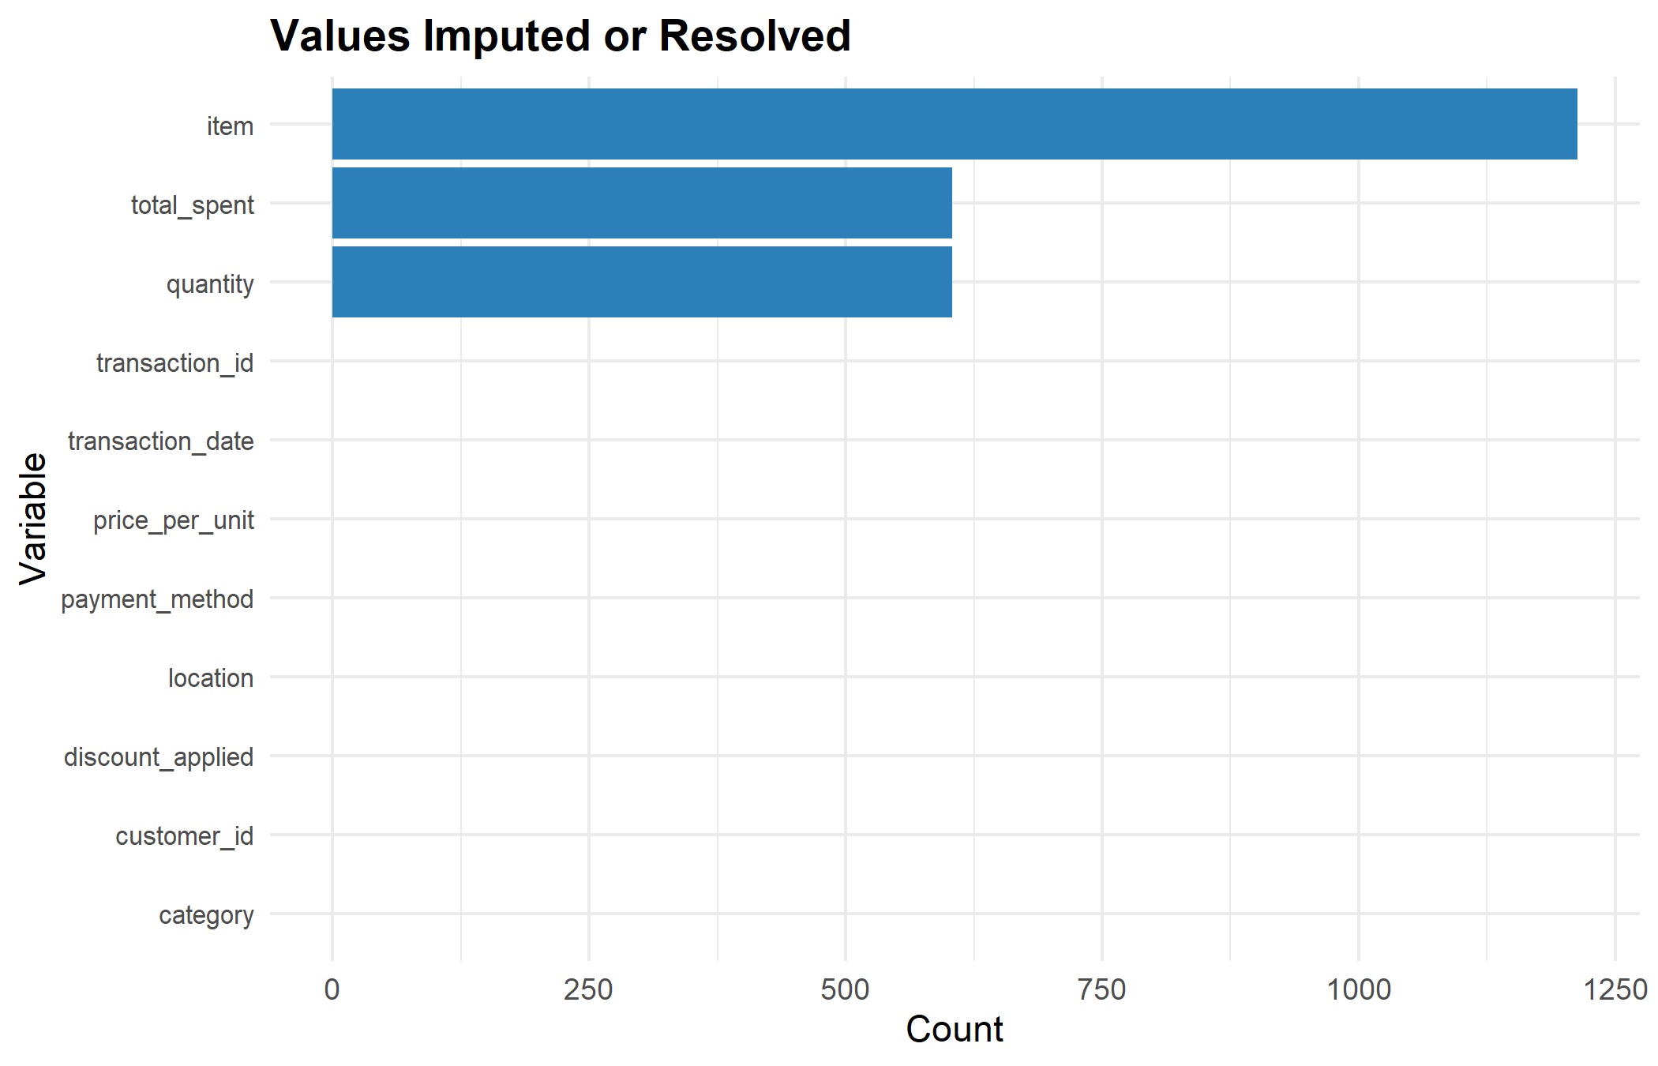

6 Post-Cleaning and Post-Imputation Summary
The following section summarizes the final missingness structure of the dataset after all cleaning and imputation procedures were completed.
Final Missingness Summary
variable | missing_count_final | missing_percent_final
transaction_id | 0 | 0.00
customer_id | 0 | 0.00
category | 0 | 0.00
item | 0 | 0.00
price_per_unit | 0 | 0.00
quantity | 0 | 0.00
total_spent | 0 | 0.00
payment_method | 0 | 0.00
location | 0 | 0.00
transaction_date | 0 | 0.00
discount_applied | 4,199 | 33.39
item_missing_flag | 0 | 0.00
discount_applied_missing_flag | 0 | 0.00

6.1 Final Missingness Visualization
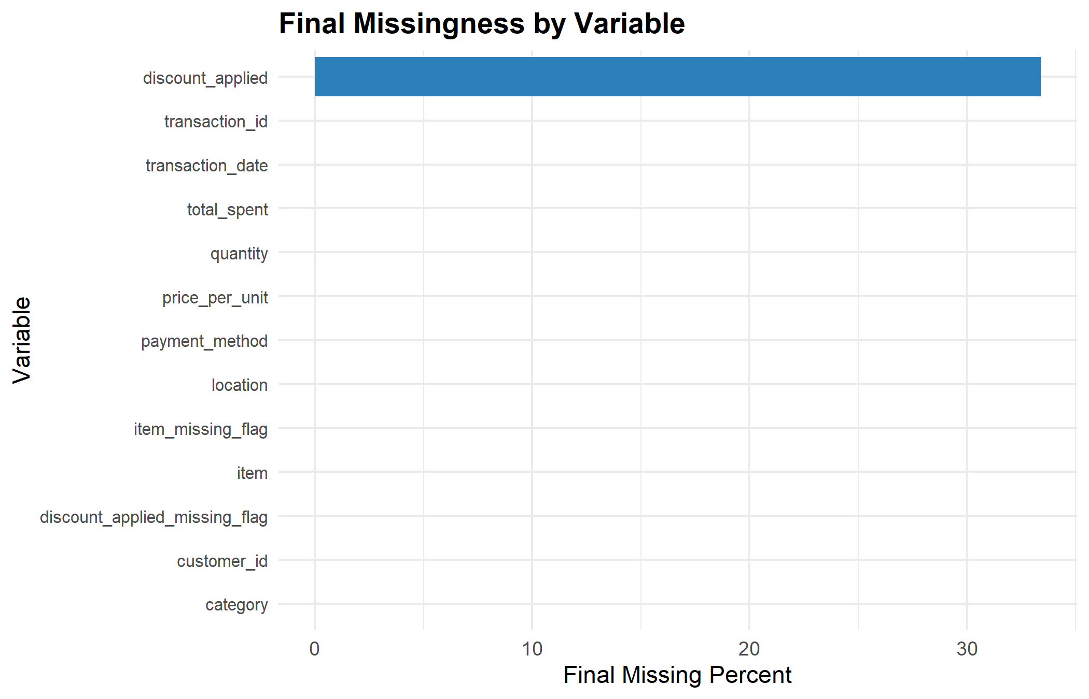

7 Numeric Variable Distributions
The following visualizations summarize the distributions of key numeric variables in the finalized dataset.
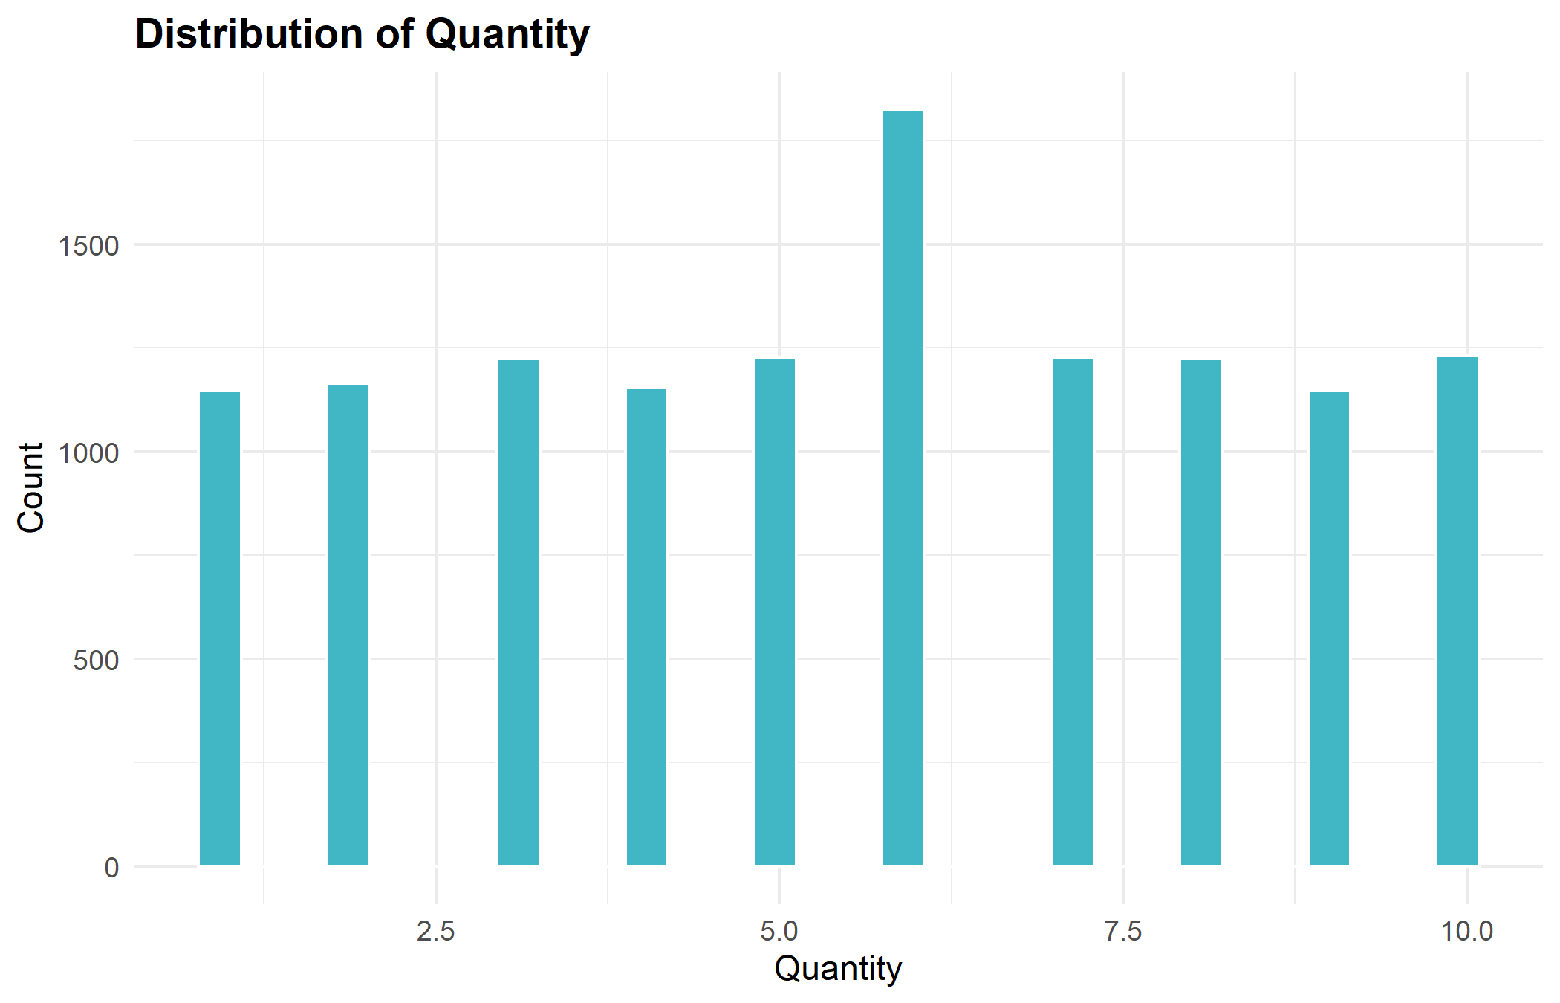
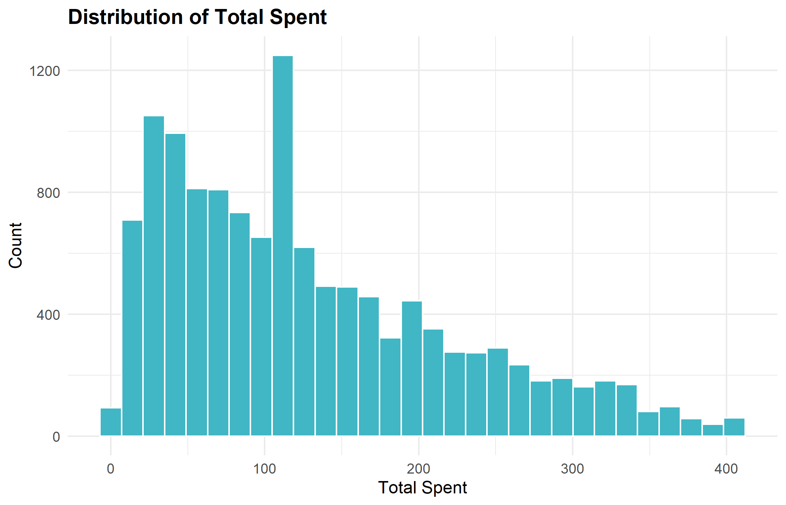

8 Validation Summary
Final validation checks were conducted after imputation to ensure that cleaning and imputation procedures did not introduce inconsistencies or invalid values.
Validation focused on:
- Remaining total spent mismatches
- Invalid quantity values
- Invalid price values
- Invalid total spent values
Validation Summary After Imputation
check | count
Remaining total_spent mismatches | 604
Invalid quantity values | 0
Invalid price_per_unit values | 0
Invalid total_spent values | 0

9 Limitations and Known Risks
Despite the successful implementation of the pipeline, several limitations should be considered:
- Some missing values in discount_applied were intentionally retained because there was insufficient information to accurately determine whether a discount had originally been applied.
- The use of median imputation for numeric variables may reduce the natural variability present within the dataset.
- The hot-deck imputation approach assigned missing item values using the most frequently observed item within each category, which may not always reflect the original missing value.
- More advanced predictive or machine learning-based imputation methods were not implemented in order to remain consistent with the scope and requirements of the assignment.

10 Conclusion
This project successfully developed a fully reproducible data cleaning and imputation pipeline for the assigned dataset. The pipeline automated the complete workflow, including data ingestion, diagnostics, cleaning, imputation, validation, documentation, export generation, and automated reporting.
Major outcomes of the project included:
- Recovery of missing values through cross-field logical relationships
- Application of multiple basic imputation techniques, including median and hot-deck imputation
- Verification of numeric and logical consistency rules throughout the pipeline
- Generation of automated diagnostics, summaries, and validation outputs
- Export of finalized datasets into multiple reproducible formats
- Automated generation of a structured Word report summarizing the full analytical workflow
Overall, the pipeline provides a transparent, organized, and reproducible framework for managing data quality issues while remaining aligned with the scope and requirements of the assignment.

