


Academic  Year | Module | Portfolio  Number | Assessment Type
2026 | 6CS030: Artificial Intelligence and Machine Learning | 2 | Report

Part - II - Vision Tasks

Student ID: 2408028
Members : Luniva Shrestha
Course: 6CS012
University email address: L.Shretha7@wlv.ac.uk
Tutor: Ms. Sunita Parajuli
Course Leader: Mr. Siman Giri
In order to overcome the problems related to the visual recognition of diseases in rice leaves, this paper analyzes the performance of different deep learning techniques on automating the process of classification. With the help of a dataset containing 3,843 images, the following CNN algorithms have been compared: a simple custom design, an advanced model incorporating regularizer, and a transfer learning technique based on pre-trained VGG16. While testing these algorithms in conjunction with Adam and SGD optimization schemes, it was found that a transfer learning model yielded better validation accuracy at 95.1%, compared to 84.9% and 82.4% achieved by other two models. It is clear that using pre-trained features from ImageNet, Dropout, and Batch Normalization play a key role when working with small agricultural datasets. Further studies will explore more complex neural networks, such as ResNet, and their application on mobile devices.

Table of Contents
1. Title 3
2. Abstract 3
3. Introduction 3
4. Dataset 4
4.1. Dataset Description 4
4.2. Dataset Source 4
4.3 Dataset Properties 4
4.4. Train and Validation Split 6
4.5. Data Preprocessing 6
4.6. Augmentation of data 7
4.7. Data Cleaning 7
5. Methodology 8
5.1. Baseline Model: 8
5.2. Deeper Model: 8
5.3. Transfer Learning Model: 9
Transfer Learning Strategy 9
5.4. Loss Function: 10
5.5.Optimizer: 10
5.6. Hyperparameters: 10
6. Experiments and Results 11
6.1. Baseline vs. Deeper Architecture 11
Baseline CNN Performance 11
Deeper CNN Performance 11
Accuracy Comparison 11
Loss Comparison 11
Training Time Comparison 11
6.2. Training with Different Optimizers 12
6.3. Ablation Study 12
6.4. Challenges in Training 12
7. Fine-Tuning or Transfer Learning 12
8. Conclusion and Future Work 12

Title
Rice Leaf Disease Classification Using Convolutional Neural Networks

Introduction
Agriculture is a very crucial part of the process involved in producing foods across the globe. There exist many types of diseases in the environment that pose significant threats to the cultivation of rice. Detecting disease by hand is quite cumbersome and costly in terms of money. Hence, the need for developing disease detection techniques using artificial intelligence.

CNN models based on deep learning have proven to perform very well when it comes to the classification of images. The good thing about this approach is that the CNN models can easily detect useful features from the pictures automatically. The last decade has seen great improvements through the utilization of pre-trained models like the famous VGG, ResNet, and MobileNet.
The main goal of this project is to develop and test deep learning models for classifying diseases on rice leaves. The project explores the following:
- A baseline model of CNN developed from scratch.
- A deeper CNN architecture with regularization techniques
- Transfer learning approach using VGG16
This project also aims to compare the effectiveness of various models and optimizers on the chosen data set.

Dataset

4.1. Dataset Description
In this research work, an image dataset of rice leaf diseases is employed and stored in Google Drive locally. It consists of RGB images of diseased and non-diseased rice leaf samples grouped into six distinct classes.
Dataset Classes:
- Bacterial leaf Blight
- Brown Spot
- Healthy Rice Leaf
- Leaf Blast
- Leaf Scald
- Sheath Blight
The dataset structure was organized in class-wise folders without predefined train-test folders.

4.2. Dataset Source
The dataset used in this project was obtained from Kaggle platform and organized for image classification tasks.
Link: https://www.kaggle.com/datasets/anshulm257/rice-disease-dataset?resource=download
Local Dataset Directory: /content/drive/MyDrive/AL and ML/Final Portfolio Project/Vision Tasks/Rice_Leaf_AUG

4.3 Dataset Properties
Property | Value
Dataset Type | Image Classification
Number of Classes | 6
Total Images | 3,843
Image Format | RGB
Image Size (CNN Models) | 150 × 150 pixels
Image Size (Transfer Learning) | 224 × 224 pixels
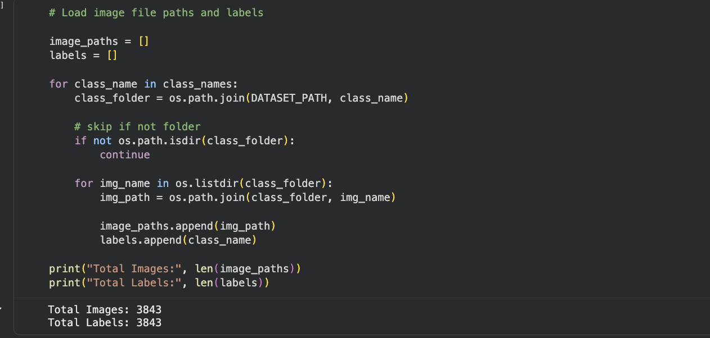

Number of Images per Class:
Class | Training Images | Validation Images | Total
Bacterial Leaf Blight | 509 | 127 | 636
Leaf Blast | 507 | 127 | 634
Sheath Blight | 506 | 126 | 632
Brown Spot | 517 | 129 | 646
Leaf Scald | 513 | 129 | 642
Healthy Rice Leaf | 522 | 131 | 653
Total | 3,074 | 769 | 3,843

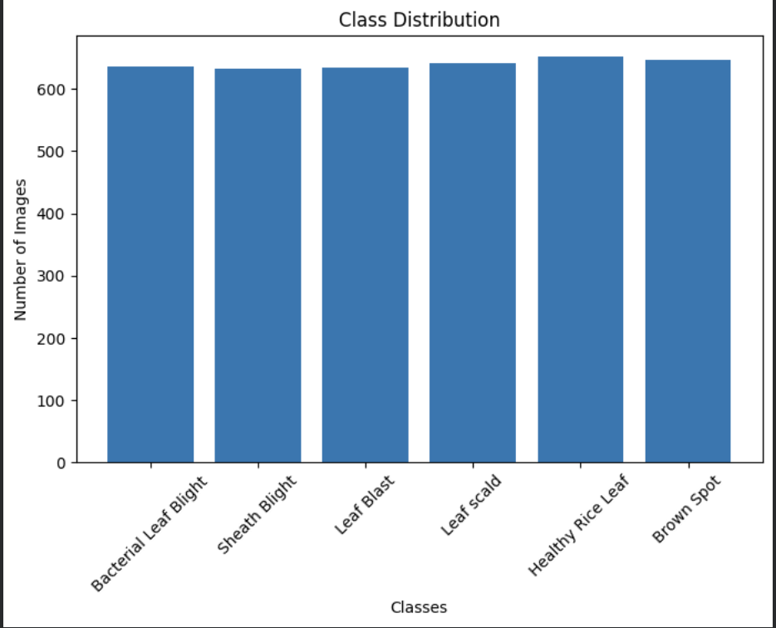

4.4. Train and Validation Split
Since there were no predefined train and test folders within the dataset, a random train-test split was done programmatically using the Scikit-learn module’s train_test_split method with a ratio of 80/20. Stratification is done to ensure an even distribution of classes between the two data partitions.

• Train partition: 3,074 samples (80%)
• Test partition: 769 samples (20%)
Random seed: 42 (for reproducibility)
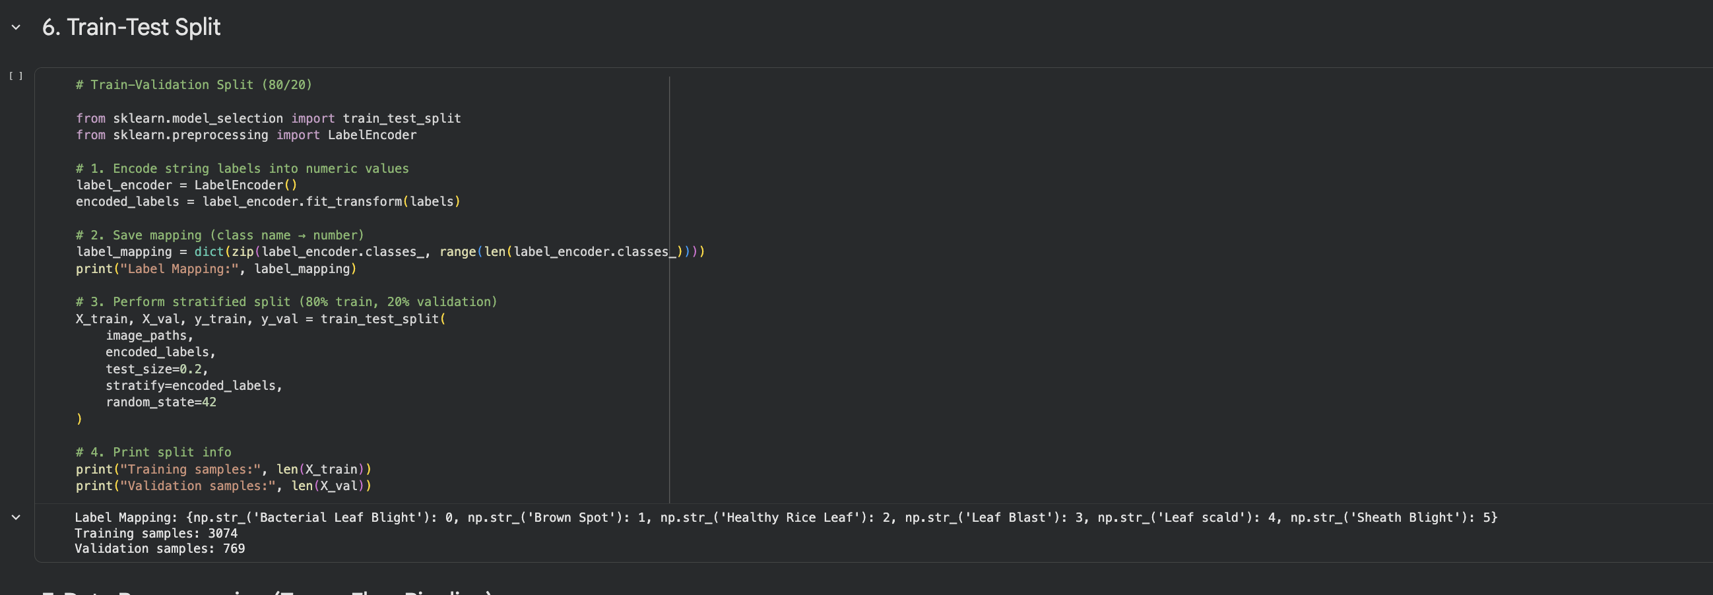

4.5. Data Preprocessing
The following preprocessing methods were used in all images before training:
• Resizing: Images resized to 150 × 150 pixels for CNN and to 224 × 224 pixels for VGG16 transfer learning models.
• Pixel Normalization: Values normalized from the range [0, 255] to [0, 1].
• Label Encoding: Class labels were converted into a form suitable for categorical cross-entropy loss computation.

4.6. Augmentation of data
To improve generalization and minimize overfitting, data augmentation was performed on the training set by means of Keras ImageDataGenerator. These techniques involved horizontal flip, rotations, zoom and width/height shift augmentation. Validation set did not involve any augmentation but only normalization.

4.7. Data Cleaning
Before training, the images were checked for corruption by using Python's PIL. None of the images were found to be corrupted. Below are some potential issues related to data cleaning and how they were addressed:
• Corruption: None found but programmatically checked for during data collection.
• Different lighting: Partially addressed via normalization and augmentation.
• Varied image qualities: Resized to the same resolution.
• Class imbalances: Very few and addressed using stratified sampling.

Methodology

5.1. Baseline Model:
A simple CNN architecture was constructed from scratch to serve as a baseline for comparison. The model follows the standard pattern of stacking convolutional and pooling layers followed by fully connected layers.
- Conv2D (32 filters, 4×4) + ReLU + MaxPooling (3×3)
- Conv2D (64 filters, 4×4) + ReLU + MaxPooling (3×3)
- Conv2D (128 filters, 4×4) + ReLU + MaxPooling (3×3)
- Flatten layer
- Dense (128 units, ReLU)
- Dense (64 units, ReLU)
- Dense (32 units, ReLU)
- Output: Dense (6 units, Softmax)

Total parameters: 585,862 (approx. 2.23 MB). The model was compiled with the Adam optimiser (lr=0.001, β1=0.869, β2=0.995) and categorical cross-entropy loss.

5.2. Deeper Model:
An improved architecture with additional depth and regularisation techniques was designed to extract richer features and reduce overfitting.

Architecture:
- Block 1: Conv2D (32) × 2 + BatchNorm + MaxPooling + Dropout (0.25)
- Block 2: Conv2D (64) × 2 + BatchNorm + MaxPooling + Dropout (0.25)
- Block 3: Conv2D (128) × 2 + BatchNorm + MaxPooling + Dropout (0.30)
- Block 4: Conv2D (256) × 2 + BatchNorm + MaxPooling + Dropout (0.30)
- Flatten layer
- Dense (512 units, ReLU) + BatchNorm + Dropout (0.5)
- Output: Dense (6 units, Softmax)

Total parameters: approximately 11.8 million (45 MB). This model was trained separately with both Adam and SGD optimisers to enable direct comparison.

5.3. Transfer Learning Model:
Transfer learning was implemented using the VGG16 model pre-trained on the ImageNet dataset. The convolutional base was loaded without the top classification layers, and a custom classifier was added.

Feature Extraction Phase (frozen base):
- VGG16 convolutional base (all layers frozen)
- RandomFlip data augmentation layer
- Flatten layer
- Dropout (0.25)
- Dense (256 units, ReLU)
- Output: Dense (6 units, Softmax)

Fine-Tuning Phase: After initial training, the top layers of VGG16 were unfrozen and the full model was retrained at a lower learning rate to allow the pre-trained weights to adapt to the rice disease domain.

5.4. Loss Function:

A categorical cross-entropy loss function was utilized for all the models, which is the standard practice for such tasks. This loss function penalizes the model according to how far its predicted probability distribution is from the actual one-hot encoding.

5.5. Optimizer:

Two different optimizers have been tested within this project:

• Adam (adaptive moment estimation): It was utilized for the baseline model (lr = 0.001), as well as for the comparison with the deeper model. This method adjusts learning rate for each parameter, which allows for faster convergence.

• SGD (stochastic gradient descent): It was used for the comparison with the deeper model using a learning rate of 0.01.

5.6. Hyperparameters:
Following hyperparameters were used during training:
Hyperparameter | Value
Batch Size | 32
Epochs (Baseline) | 40 (early stopping)
Epochs (Deeper Models) | 50 (early stopping)
Learning Rate (Adam – Baseline) | 0.001
Learning Rate (Adam – Deeper) | 0.001 (reduced via ReduceLROnPlateau)
Learning Rate (SGD – Deeper) | 0.01 (reduced via ReduceLROnPlateau)
Validation Split | 20%
Early Stopping Patience | 8–10 epochs
ReduceLROnPlateau was applied to automatically decrease the learning rate when validation loss plateaued, with a reduction factor of 0.3 and patience of 5 epochs.

Experiments and Results

Baseline vs. Deeper Architecture

Baseline CNN Performance

Baseline training was conducted for 40 epochs, using the approach of early stopping. The process of training showed consistent performance, where the accuracy increased from around 40% in epoch 1 to a final test accuracy of 84.90% with a test loss of 0.453.

There were signs of good improvement during the training phase, leading to a very promising output for such a basic structure of neural network. However, there were some signs of instabilities during training (which may be attributed to the data generator steps).Deeper CNN Performance
The deeper CNN was trained with both SGD and Adam optimisers. The results for each are summarised below:
Model | Test Accuracy | Test Loss | Training Time
Baseline CNN (Adam) | 84.90% | 0.453 | ~950 seconds
Deeper CNN (Adam) | 82.42% | 0.521 | ~3,183 seconds
Deeper CNN (SGD) | 82.03% | 0.533 | ~2,712 seconds
Interestingly, the baseline model slightly outperformed the deeper CNN on the validation set. This may be attributed to the fact that the deeper model, while more expressive, is harder to train on a relatively small dataset of 3,843 images and may be subject to underfitting within the given number of epochs, despite regularization techniques.

Computational Efficiency
The training time for each of the models was quite different:
• Baseline CNN: ~950 seconds – fastest due to low number of parameters (585,862).
• Deeper CNN (SGD): ~2,712 seconds – slowest due to higher number of parameters (~11.8M) and conservative convergence of SGD.
• Deeper CNN (Adam): ~3,183 seconds – slightly slower overall compared to SGD, but f aster per epoch due to the use of Adam.

Training was conducted using a GPU (NVIDIA T4 through Google Colab/local system). Clearly, the baseline model is the most computationally efficient one, and hence can be used for limited-resource deployments.

Training with different optimizers
Both CNN models were separately trained via Adam (lr=0.001) and SGD (lr=0.01) to observe their convergence trends.

Adams optimiser showed better smoothness in convergence without oscillations. While having higher validation accuracy for Adam (82.42% vs. 82.03%) compared to SGD, both had roughly equal performance. SGD had some instability during initial stages of convergence, where spikes of validation losses occurred (e.g., loss=28.4 at epoch=2), which later subsided through time. Both optimisers used ReduceLROnPlateau callback to reduce their learning rates in case of stagnation.

Overall, Adam is preferable when quick experiments are needed, whereas SGD might have even better generalisation after additional tuning.

Albation Study
A conceptual ablation test was conducted through evaluating the impact of regularisation terms in the deeper network architecture. In the deeper model, Batch Normalisation was applied following each convolution layer, and Dropout was employed with probability values ranging from 0.25 to 0.50.

Without the presence of Batch Normalisation, it can be predicted that the model will take longer to converge, as well as being vulnerable to internal covariate shift. The absence of Dropout could lead to greater overfitting, given that the number of parameters in the model, 11.8M, is high compared to the number of training samples, 3,074.

Challenges in Training
• Warning for Data Generator Step: An interruption warning message ('Your input ran out of data') occurred when training the baseline model. It was due to inaccurate steps_per_epoch computation. Further trials were able to resolve this issue by calculating the number of steps from the samples returned by the generator.
• SGD Sensitivity: SGD exhibited high validation loss values at early epochs (up to 28.4). This suggested that SGD is sensitive to the initial learning rate and was slowly solved using ReduceLROnPlateau.
• Training Cost: As the model becomes deeper, the training time increases by about three times compared to the baseline model, reducing the number of trials possible.
• Class Similarity: Bacterial Leaf Blight and Sheath Blight have similar symptoms. This is probably why both diseases were misclassified by all models.

Fine-Tuning or Transfer Learning
6.1 Pre-trained Model
The VGG16 pre-trained CNN consisting of 16 layers was chosen because it had been pre-trained on the ImageNet dataset (1.2 million images, 1,000 classes). The VGG16 model is well known for its consistency and simplicity and has become very popular when applying transfer learning in various fields such as medical image processing and agriculture.

6.2 Feature Extraction
For the first stage of training, the whole VGG16 CNN convolutional base was set up in a frozen state. The only trainable part was the custom classification head that consisted of the following layers: the Flatten layer, Dropout (0.25), Dense (256, ReLU), and finally the Softmax layer. The size of the input image was changed to 224x224.

6.3 Fine-Tuning
Having converged the model initially with the layers frozen, the top layers of VGG16 model were unfrozen and trained end-to-end on a smaller learning rate (initial learning rate = 0.001 which was subsequently dropped to ~0.000027 via ReduceLROnPlateau). As such, the model was able to tune its visual filters to recognize the rice leaf images.

Performance on the fine-tuned model was drastically better compared to before:
• Validation accuracy reached up to 95.06% (epoch 35) during fine-tuning period.
• Model was able to converge to high validation accuracy right from epoch 5.
• Accuracy on the training data exceeded 99%.

Conclusion and Future Work

