# ACA Assignment3 Compute Key

Team 念中林 胡臻 柳煜辰

* A. Pitch Chroma
  1. Given a STFT matrix X, we can compute pitch chroma by mapping energy at each pitch frequency range (one semitone) into an octave for each observed frame.
  2. To test this function, we generate a sine wave with frequency at 262HZ and the excepted result of each time stamp should indicate it’s at pitch C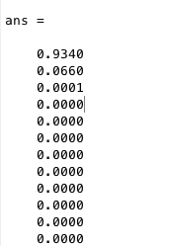
  3. The value in first slot is the largest, which the pitch in this time stamp is C.

B. Key detection

As required in document, we evaluate the key detection module with country genre audios, the accuracy is 0.55 with blocksize=16384 and hopsize=8192. The confusion matrix is plot as following: 