# **Loubby Recruiter Dashboard Navigation Documentation**

This document is designed to serve as a comprehensive guide for recruiters. Every FAQ entry provides explicit instructions—from logging in and scrolling to clicking specific buttons—to help you easily navigate and use each tool on the dashboard.

]

## **General Access & Navigation**

### **Q1: What is the Loubby Recruiter Dashboard and how do I get started?**

**A:** The Recruiter Dashboard is your central hub for managing candidate applications, communications, job postings, and scheduling interviews.

**How to Access:**

1. **Open your web browser** and go to<https://app.loubby.ai/dashboard>.
2. As a first-time user, when trying to login to loubby ai, you have to sign up.

**Sign Up Steps:**

* Scroll down to the bottom right of the app on the landing page, just below the Login with Google option, and click on the sign up button.
* Wait for the next page to pop out, then navigate to create an account.
* Click on the radio button right close to **“Iam an Employer” ,**it instantly takes you to another page.
* 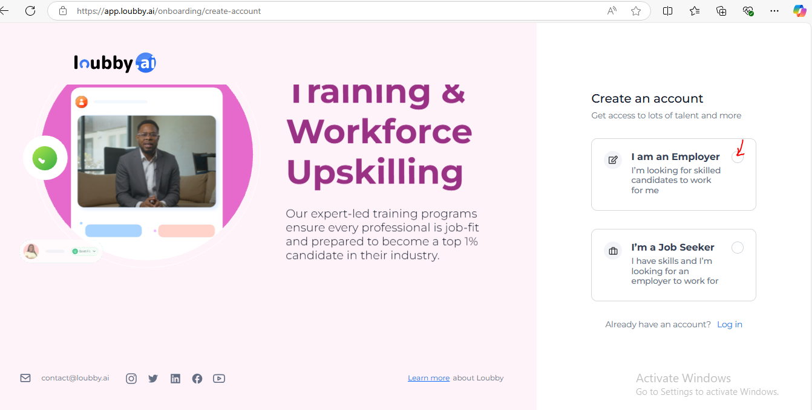
* Click on the check box by “**I am a partner; I manage other companies.**”
* Next, input the company name.
* Input your email
* Your First Name
* Last Name
* Select your country code by clicking on the drop-down button below the phone number with the US flag by the side.
* Input a phone number.
* Proceed to input a password you can remember.
* Confirm the password.
* Click on terms of service and privacy policy, read, and review.
* Click on Create Account.

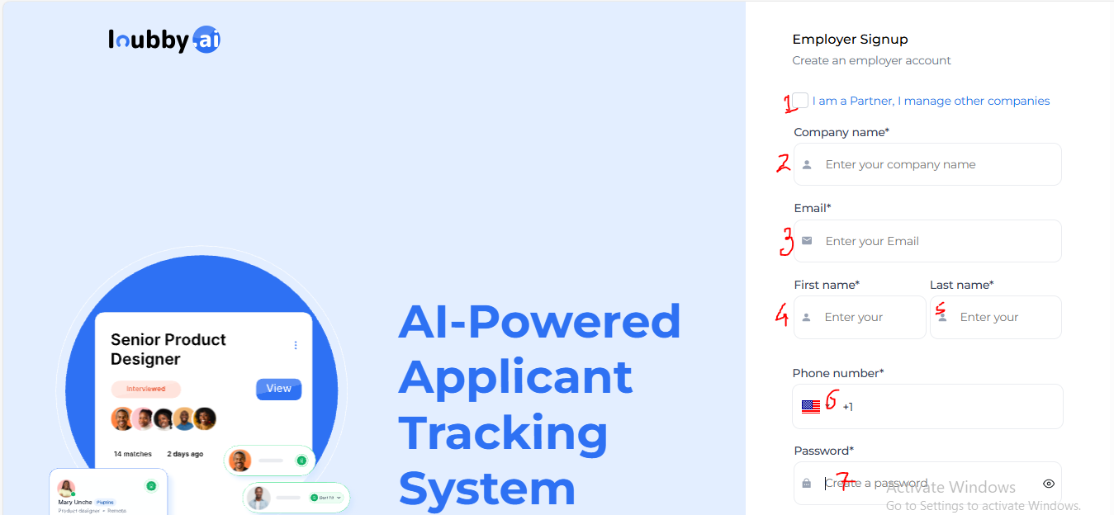

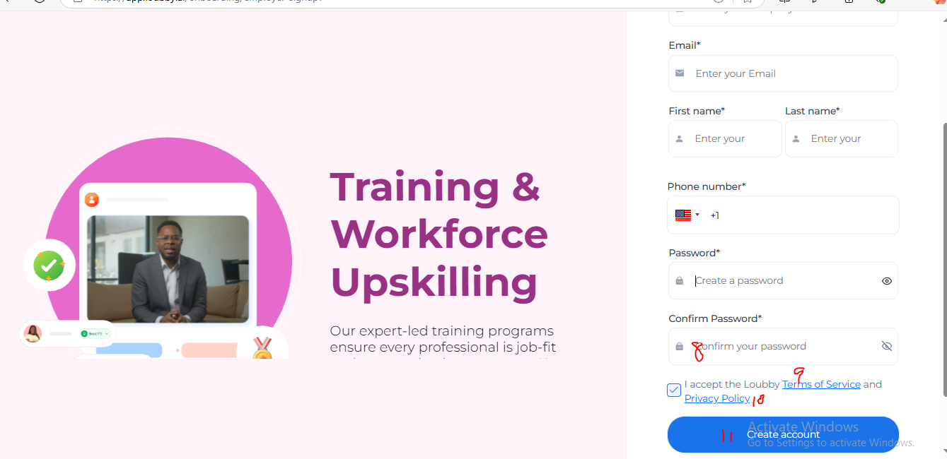

On successfully signing up, a pop-up notification displays on the top right of your screen, indicating that the account was successfully created.

**Email Verification**

This is followed by an email in your inbox.

* Click on verify email.
* You will be redirected to the Loubby app where you will see a confirmation of your email verification.
* You can click on the redirect to sign in button to navigate to the loubby sign in page.
* 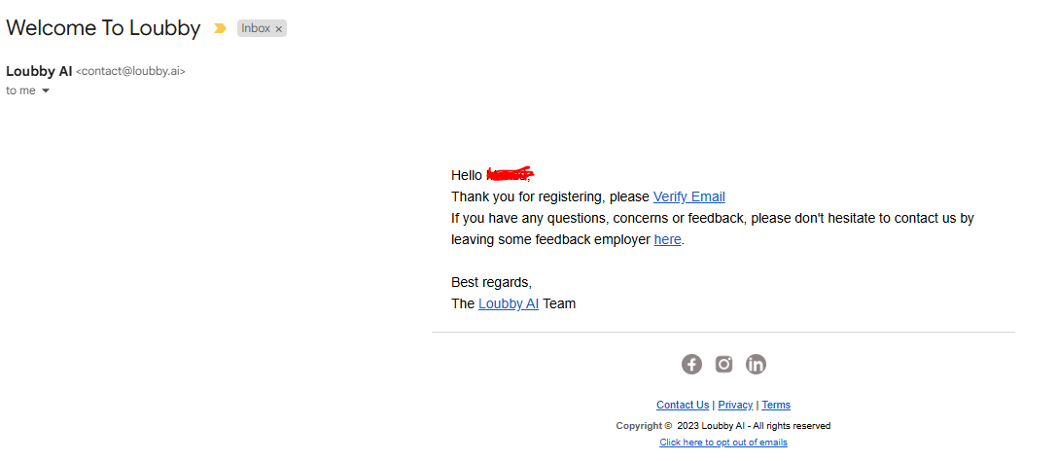

1. **Login:**
   * **Step 1:** Input your email
   * **Step 2:** Input password.
   * **Step 3:** Click on **“Log in”**
2. Once logged in, you’ll see a pop up on the main dashboard with the name of your company close to a radio button, 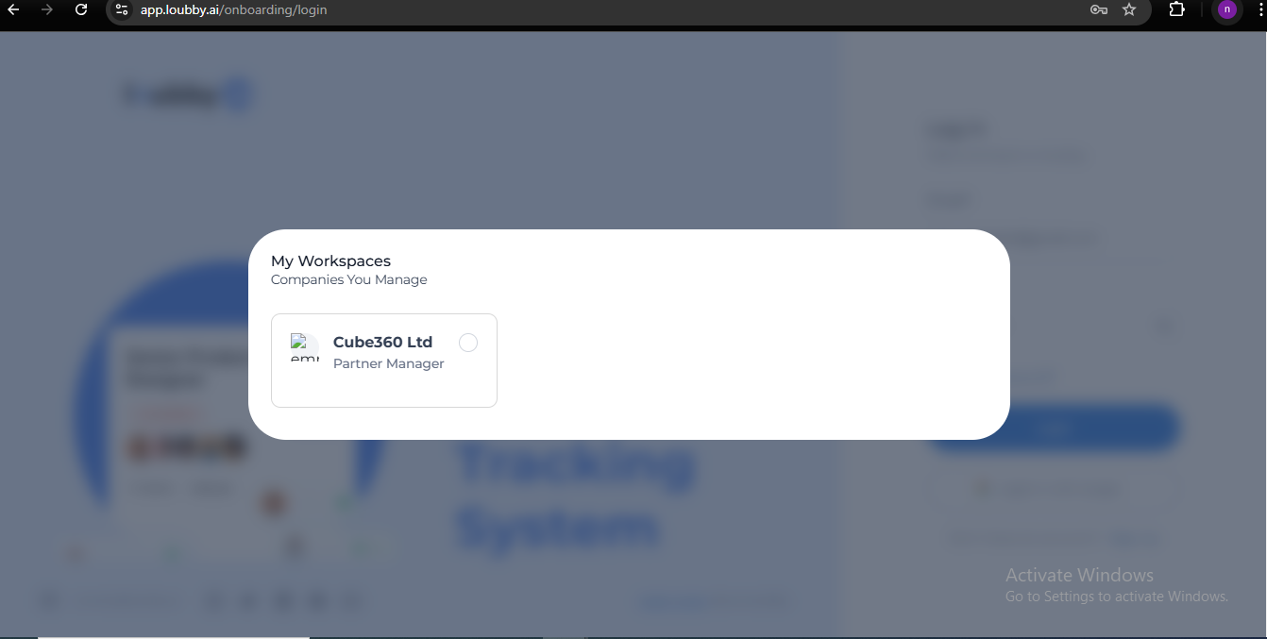This takes you to the next page to update your company profile details. Input the following details:

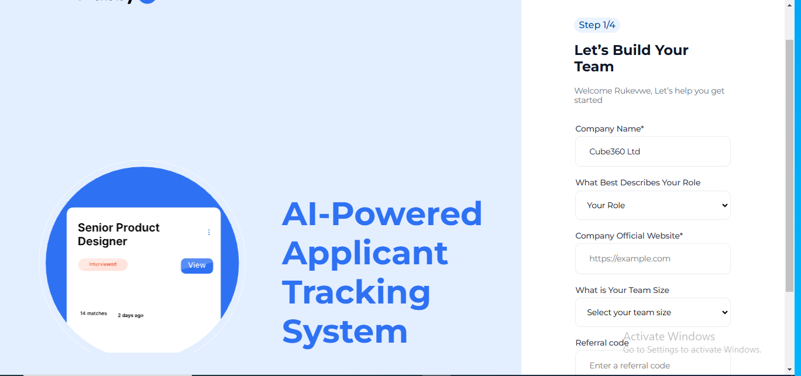

* **Company Name**
* **What best describes your role**:
* **Options**
* Accountant
* Administrative assistant
* Chief executive officer
* Chief Operating officer
* Chief marketing officer
* Chief Technology officer
* Customer service representative, Executive
* Manager
* Marketing Manager
* Sales representative

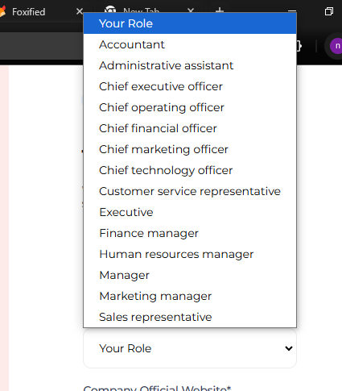

* Proceed to **what is your team size** and select the appropriate size.

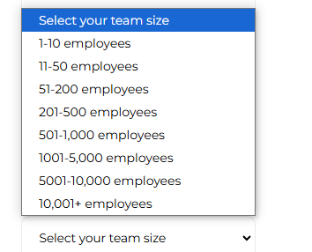

* If you have referral code, input it in the “**Referral code**” input box

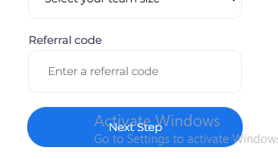

Verify your details are complete, then click on “**next step.".**

**Proceed to “Tell Us A Bit About Your Company ” .**

Navigate to company Logo.

**1.Click to upload:** Ensure your logo is in either of these format, SVG,PNG,JPG or GIF and the size is 800x400 px

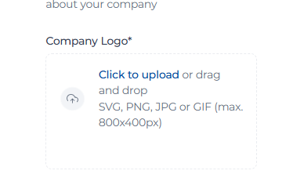

**2.** Navigate to “**Tell us about your company”**:

Describe your company in not less than 80 characters.

3. Click on “**Next Step**”.

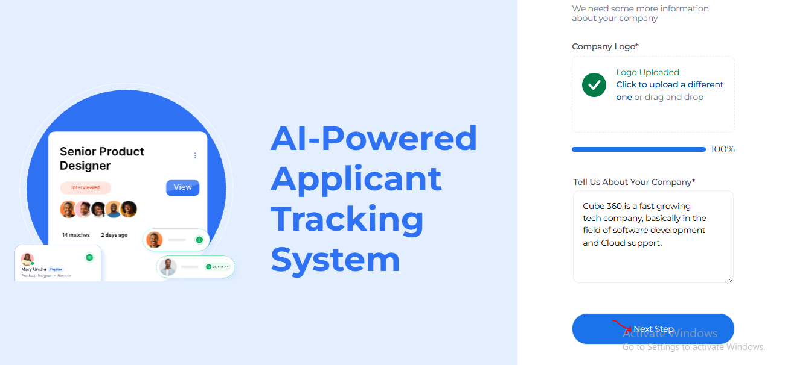

3. Navigate to **Company Socials (Optional)**

Input your company’s public social media profile in the following input boxes.

Facebook profile url, twitter Username, Instagram Username, Youtube Channel Url, linkedin Profile Url.

Click on “**Next Step** ”.

**Step 4** :**Invite Your Team Members (Optional)**

I. Input the answer to :Where is your Headquarters*

2. Year Company was founded

3. Select Your industry from:Transport, Agriculture, Internet, telecommunication, education, construction, electronics, manufacturing, energy, pharmaceutical , healthcare, food, entertainment, music, hospitality, technology, human resources, recruiting ,oil and gas, Others.

4. Invite Teammates;

Input emails of teammates

5. Click on Submit and you will be directed to the recruiter dashboard.

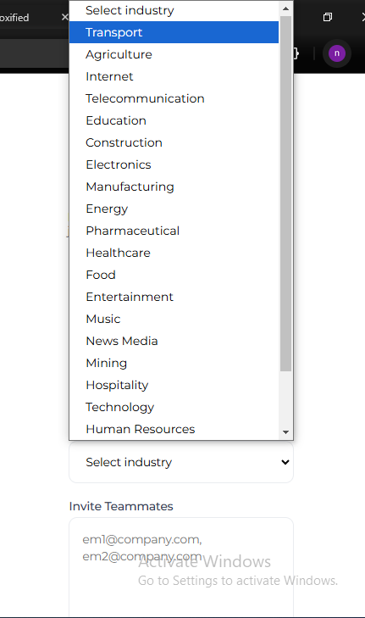

**RECRUITER DASHBOARD**

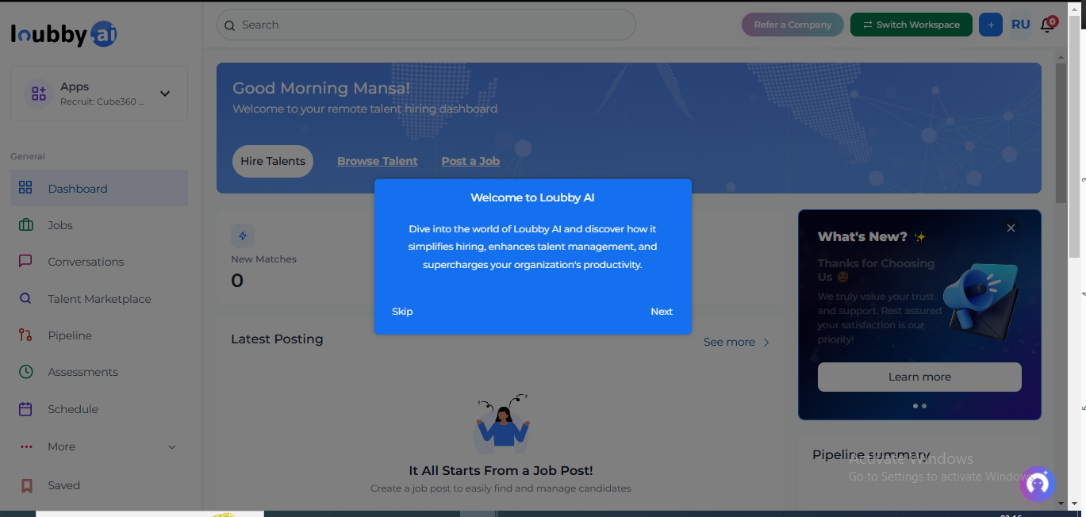

**Navigating the dashboard**

Right on the interface of the dashboard, you will see a pop up with “**Welcome to Loubby Ai**”, you can use this as a pipeline to

### **Q2: How do I maintain a secure session on the dashboard?**

**A:** Your session remains active until you manually log out or until the system times out due to inactivity.  
 **Instructions:**

1. **Secure Login:** Always log in through the official URL.
2. **Session Persistence:** Avoid leaving your browser idle; if you’re away, consider logging out for security.
3. **Logout:** When finished, scroll to the top right and click your **profile icon**, then select **“Logout”** from the dropdown menu.

### **Q3: How do I confirm if I am on the recruiter page** **Instructions:**

1. **Locate the Apps Icon: Click** on the inverted v sign, a drop down will be displayed.
2. **Select your company name with Prefix Recruit right in front of your company name.**
3. Right below the Manage option on the list, there is a check box, you can check or uncheck to make your company name display as the default company whenever you log in.

## **Applications**

### **Q4: How do I hire talents?**

**Instructions:**

1. Access the hire talents button
2. It pops out an oval like box with question “Have you created a job post for this role”?
3. **Select ‘YES’ only if you have created a job post for the role.If not select “NO”.**

**NO**

You will be redirected to create New Job listing page.

There are 2 options displayed on the dashboard to enter details of the job DESCRIPTION, which are as follows ;

1. Generate with AI.

2. Import from External ATS

**Generate with AI**

On selecting this option, an Iframe page will display with the following for you to update so the Ai can generate the Job description for you.

1. Job Title
2. Select Experience Level
3. Search Location
4. Additional info (optional)

Proceed to click on **Generate with AI**

**Navigate** to click to upload job details or auto-fill form by uploading document.

If this option is chosen , the following fields will be auto populated

1. Job description
2. Location
3. Select Preference-Remote, hybrid and Onsite
4. Job type: Full time, part time, contract, intership
5. Category eg software developers
6. Experience Level* Entry, junior, middle, Senior,Director, VP and above
7. Number of open positions.
8. Application deadline
9. Additional information
10. Skills: press enter to add multiple options
11. Toggle on or off **Make the perks public.** Candidate will get to enjoy these benefits when they apply
12. Currency- **USD$ OR NGN**
13. Frequency - **Hourly , biweekly,Monthly and yearly**
14. Rate-Negotiable, **$0-500, 500-1000, 1000-2000, 2000-5000, 5000-15000, 150000-Above**
15. Bonus target, 401k, vision insurance, medical insurance, disability insurance, stock options.

12. Other perks: Type into the input box

13. Click on **save** to draft or **Next**

14 On clicking **Next,** you will access **Candidate Application Page.**

**What are the modes of application ?**

1. **Standard Loubby Application**: Users can register for this job with only their Loubby account. No extra info required.
2. **Custom Application Form**: Create your form fields, candidates will fill when applying. This pops out a template for you to choose an modify how the form should be displayed. It contains the following fields, Label, type required enabled action. First Name, Last Name, Headline, email address, phone number, location.

Navigate to additional Settings, Click check box to **Restrict Applications to specific partners. If clicked**

Select partner(s) by clicking the drop down with a list of partners to choose from. If not, proceed to Next.

Click **Next**

**You will be directed to Reference Page**

*Toggle enable reference for this role

* Select number of reference per candidate

* Customize reference field for reference messages

Click next

**Note* You can toggle off reference so you will be directed to the scorecard page**

**ScoreCard Page**

On this page , you can add or delete collaborators for interview sessions.

This can done by scrolling into the search input box, type first name or email of the collaborator, then select role to assign to the collaborator. The roles includes, collaborator, interviewers, reviewers , and approver.

Click the toggle button by **Enable approval task for this role:** With this option you can enable stakeholders to review and approve the job before it is published.

**Add assignes**

Type approver email into the search box

**Click the check box to activate any or both these options below.**

**Only one approval is required to complete the task**

**Post must be approved in order of assignees.**

Message (optional), due date (optional)

Click on **Next**

**INTERVIEW PIPELINE**

### Interview Pipeline

##### We've provided pre-filled default interview stages which should is good to go. Please feel free to make any necessary edits or modifications as you see fit.

##### The interview pipeline establishes the sequential stages that candidates applying for this role will undergo, outlining the expected steps and duration for candidate selection.

Navigate to interview stages

Interview stages

## **Stage 1**

**Select Interview type**, **by clicking** on the drop down and selecting one of these options, Shortlisted,Phone Interview, Pre Screening, First Round ,Second Round, Third Round, Hiring Manager OnsiteRecruiter Interview, Final RoundInterview Feedback.

## **Type of interview**

**Select an interview type by clicking** Live Video One Way VideoCalendarAI Interview

## **Stage 2**

Select Interview typeShortlisted Phone Interview Pre ScreeningFirst RoundSecond Round Third Round Hiring Manager OnsiteRecruiter Interview Final RoundInterview Feedback

## **Type of interview**

**Select an interview type Live** Video One Way Video Calendar AI Interview

## **Stage 3**

**Select Interview type** Shortlisted Phone Interview Pre Screening First Round Second RoundThird RoundHiring Manager OnsiteRecruiter Interview Final RoundInterview Feedback

## **Type of interview**

**Select an interview type Live** VideoOne Way VideoCalendarAI Interview

Click **+ to add another.**

**\*Input Number of interviews**

**\*Average time to hire** Select average time to hire 3 days 1 week 2 weeks 3 weeks 1 month 3 months 6 months

**We encourage the max hire not exceed 3 days**

**Upload or enter prep materials:**type into the input box or click on upload image then click **create Job**

**HOW TO BROWSE FOR TALENTS**

From the dashboard page, click on **Browse talent** and you will be directed to talent page.

You can filter from the left pane using

### 1. **Job Type**

Full Time Job

Part Time Job

Contract Job

Internship Job

Remote

### 2. Professional Level

Internship

Entry Level

Junior Level

Middle Level

Senior Level

Director Level

VP & Above

### 3. Experience Years

0 experience years

0-2 experience years

2-5 experience years

5-10 experience years

10-15 experience years

15-20 experience years

20+ experience years

### 4. Education

High School

Associate Degree

Bachelor's Degree

Master's Degree

Doctoral Degree

### 5. State (based on country)

All states

**You can search from the three search icons based on skills, roles and country.**

Results will be displayed if the matchthe filter and search options

### **Q5: How do I update or manage an application?**

**A:** You can update a candidate’s application status and add notes directly from their detailed view.  
 **Instructions:**

1. **Open Application Detail:**
   * Click on a candidate’s application from the list.
   * The detail view opens in a new panel or page.
2. **Change Status:**
   * Look for action buttons (e.g., **“Shortlist”**, **“Reject”**). Click the appropriate button to update the status.
3. **Add Notes:**
   * Scroll down to the **“Notes”** section.
   * Click in the text box and type your note, then press **“Save”**.
4. **Navigation:** Use the **“Back”** button at the top left to return to the list.

## **Conversations**

### **Q6: How do I manage conversations with candidates?**

**A:** The Conversations section enables you to chat with candidates, share documents, and view past communications.  
 **Instructions:**

1. **Access Conversations:**
   * From the navigation menu, click **“Conversations”**.
2. **New Conversation:**
   * Click the **“New Conversation”** button at the top right.
   * Type the candidate’s name in the search field, then click on the candidate’s profile to start a chat.
3. **Using the Chat Interface:**
   * Scroll down within the conversation pane to see older messages.
   * To reply, click into the text box at the bottom, type your message, and press **“Send”**.
4. **Attachment Handling:**
   * To attach a file, click the **paperclip icon** in the message box, select your file, and then click **“Upload”**.

### **Q7: How do I retrieve or archive old conversations?**

**A:** You can search for and archive conversations for better organization.  
 **Instructions:**

1. **Search Bar:** At the top of the Conversations page, type keywords or candidate names.
2. **Filtering:** Use the **“Sort”** dropdown to filter by date or status.
3. **Archive Conversation:** Click on a conversation to open it, then click the **“Archive”** icon (usually a folder with an arrow) at the top right.
4. **Restore Archive:** To restore, navigate to the **“Archived”** tab and click **“Restore”** next to the desired conversation.

## **Connections**

### **Q8: What is the Connections section and how do I use it?**

**A:** Connections is a dedicated space to save and manage candidate profiles that you want to keep for future opportunities.  
 **Instructions:**

1. **Navigate to Connections:**
   * From the left menu, click **“Connections”**.
2. **Adding a Connection:**
   * Click **“Add Connection”** at the top right.
   * Fill in the candidate’s details in the form that appears.
   * Click **“Save”** to add the candidate.
3. **Managing Connections:**
   * Use the tags and filters at the top to sort your connections.
   * Click on any candidate to view detailed information or update their status.
4. **Follow-Up:**
   * Click the **“Message”** button next to a candidate to initiate follow-up communication.

## **Assessments**

### **Q9: How do I assign and manage candidate assessments?**

**A:** Assessments allow you to evaluate candidate skills through tests and surveys.  
 **Instructions:**

1. **Access Assessments:**
   * Click **“Assessments”** from the main menu.
2. **Assign an Assessment:**
   * Open a candidate’s profile from Applications or Connections.
   * Click the **“Assign Assessment”** button, usually located at the top of the candidate profile.
   * Select the appropriate test from the dropdown list.
   * Click **“Assign”**.
3. **Review Assessment Results:**
   * Return to the Assessments page.
   * Click on a candidate’s assessment result to view a detailed breakdown with charts and scores.
4. **Provide Feedback:**
   * In the assessment detail view, type feedback in the designated text area and click **“Submit Feedback”**.

## **Schedule**

### **Q10: How do I schedule interviews or meetings with candidates?**

**A:** The Schedule section helps you plan interviews, calls, or meetings using an integrated calendar.  
 **Instructions:**

1. **Open Schedule:**
   * Click **“Schedule”** in the navigation menu.
2. **View Calendar:**
   * The calendar displays your scheduled events.
   * Scroll through the calendar by using the mouse wheel or the arrow buttons on the side.
3. **Create an Event:**
   * Click the **“New Schedule”** button at the top right.
   * In the pop-up form, enter the event title, candidate name, date, and time.
   * Click **“Save”**.
4. **Edit or Reschedule:**
   * Click on an existing event.
   * Modify the details as needed and click **“Update”**.
   * A conflict alert may appear if there is an overlapping event.

## **Candidate Save**

### **Q11: How do I save candidate profiles for later review?**

**A:** The Candidate Save feature allows you to bookmark candidates for future consideration without altering their application status.  
 **Instructions:**

1. **Navigate to Candidate Save:**
   * Click **“Candidate Save”** from the navigation menu.
2. **Save a Candidate:**
   * From any candidate’s profile (accessible in Applications), click the **“Save Candidate”** button.
   * The candidate is immediately added to your saved list.
3. **Manage Saved Candidates:**
   * On the Candidate Save page, use the filter and tag options at the top.
   * Click a candidate’s profile to view details, or click the **“Remove”** icon to unsave.
4. **Search Saved Candidates:**
   * Use the search bar to find candidates by name or tag.

## **Job-Board**

### **Q12: How do I create and manage job postings?**

**A:** The Job-Board section is where you can create new job postings, edit existing ones, and track their performance.  
 **Instructions:**

1. **Access the Job-Board:**
   * From the main navigation, click **“Job-Board”**.
2. **Create a New Posting:**
   * Click the **“Create Job”** button, usually found at the top right.
   * A form will appear where you must enter job title, description, requirements, and application deadlines.
   * Click **“Preview”** to see how the job post will appear.
   * If all details are correct, click **“Publish”**.
3. **Manage Existing Postings:**
   * Click on any job posting from the list to open its details.
   * Edit fields as needed, then click **“Update”**.
   * To archive a job posting, click the **“Archive”** button.
4. **View Engagement:**
   * Scroll down to see candidate engagement metrics (views, applications, etc.) displayed in real-time.

## **Advanced Workflows & Integration**

### **Q13: How do different sections integrate to streamline my workflow?**

**A:** All sections of the dashboard are interconnected to ensure a smooth flow of information between applications, assessments, scheduling, and communications.  
 **Instructions:**

1. **Data Consistency:**
   * When you update a candidate’s status in Applications, the change reflects in Assessments, Conversations, and Candidate Save automatically.
2. **Integrated Actions:**
   * For example, when scheduling an interview from a candidate profile, the event is added to both the Schedule page and your external calendar (if synced).
3. **Unified Analytics:**
   * Click the **“Analytics”** button on the top navigation to view combined reports that aggregate data from all modules.

## **Support, Troubleshooting & Accessibility**

### **Q14: What should I do if I encounter a technical issue?**

**A:** The platform includes built‑in troubleshooting guides and access to live support to help you resolve any issues.  
 **Instructions:**

1. **Access Help:**
   * Click the **“Help”** icon (usually a question mark) in the top right corner.
   * Browse FAQs or use the search bar for your specific issue.
2. **Live Support:**
   * Click **“Chat Now”** within the Help section to start a live support session.
3. **Error Messages:**
   * When an error occurs (e.g., session timeout), a pop-up will appear with troubleshooting steps. Follow the instructions or click **“Contact Support”**.

### **Q15: How do I provide feedback on my experience?**

**A:** Your feedback helps improve the system.  
 **Instructions:**

1. **Submit Feedback:**
   * At the bottom of every page, click the **“Submit Feedback”** link.
   * Fill out the form with your comments, suggestions, or any issues encountered.
   * Click **“Send”** to submit.
2. **Feedback Follow-Up:**
   * You may receive follow‑up emails if further details are needed.

### **Q16: What accessibility features are available and how do I activate them?**

**A:** The dashboard is designed with accessibility in mind, ensuring an inclusive experience for all users.  
 **Instructions:**

1. **Activate High‑Contrast Mode:**
   * Click the **“Settings”** gear icon in the upper left.
   * Scroll down to **“Accessibility Options”**.
   * Toggle **“High‑Contrast Mode”** on.
2. **Keyboard Navigation:**
   * Use the **Tab** key to move through interactive elements.
   * Press **Enter** to activate buttons or links.
3. **Screen Reader Compatibility:**
   * The interface includes ARIA labels for screen readers. For optimal use, ensure your screen reader software is updated.

## **Future Enhancements & Roadmap**

### **Q17: What new features are planned for the Recruiter Dashboard?**

**A:** Planned updates aim to further streamline your workflow and enhance communication.  
 **Examples:**

1. **Voice & Video Integration:**
   * Future updates will allow you to start a video call directly from the Conversations section.
2. **Enhanced Automation:**
   * Automated candidate follow‑ups and more predictive analytics will be integrated into the dashboard.
3. **Beta Testing:**
   * You may be invited to test new features via a beta program, with detailed instructions provided on how to opt‑in.

## **Final Summary & Best Practices**

### **Q18: What are the best practices for using the dashboard effectively?**

**A:**

* **Regularly Monitor:** Frequently check notifications, applications, and analytics to stay updated.
* **Follow Detailed Steps:** Use the explicit click and navigation instructions provided in this FAQ.
* **Secure Your Session:** Log out after each session and use strong passwords.
* **Provide Feedback:** Regularly submit feedback to help refine the system.

### **Q19: Who do I contact if I need further assistance?**

**A:**

* **Internal Support:** Contact your internal IT or HR support team.
* **Loubby Support:** Use the in‑dashboard chat or email support feature by clicking **“Help”** in the top right corner.
* **Community Resources:** Join webinars or user forums for additional tips and shared experiences.

This extended FAQ is designed to be a detailed, step‑by‑step guide that covers every aspect of navigating the Loubby Recruiter Dashboard. By following the explicit instructions—such as clicking specific buttons, scrolling to view more options, and using on‑screen prompts—you’ll be able to access and effectively use every tool on the platform.

If you require further detail or additional topics to be covered, please let me know!