This report comprises 22 clusters, significantly exceeding the maximum character limit for issue bodies. Consequently, later clusters and their descriptions will be moved to an external repository that will remain unmodified post-submission. Please note that each cluster in this report is independent, with its own unique description and arguments. Ideally, each cluster would be addressed in a separate issue, but this approach is unfeasible due to the risk of my account being flagged for spam by GitHub.

**Detailed Methodology & Walkthrough**

We collected as many Centralized Exchange (CEX) hot wallets and gas suppliers as possible from explorers (Binance, Coinbase, Kucoin, Bybit, OKX). Using a simple Dune SQL query, approximately 2.5 million CEX deposit addresses (addresses where users send assets to deposit into a CEX) were gathered. From these, we filtered CEX deposit addresses that received funds from at least seven addresses regularly interacting with Layer Zero, using an unofficial Dune Dashboard.

Clusters ranging from 7 to 300 active Layer Zero addresses sharing the same CEX deposit address were formed. A script then created larger clusters by linking addresses interacting with cluster addresses but not with the CEX deposit address. To minimize false positives, an address needed to be directly connected to at least four other addresses within the cluster. Clusters with fewer than 20 addresses (including the CEX deposit address) were discarded.

This initial detection/proof layer ensures that each cluster contains a significant number of addresses sharing the same CEX deposit address, with each address connected to at least four others. Although automated, this layer has a lower false-positive rate due to the multiple interactions and shared CEX deposit address.

For the second detection/proof layer, each address in every cluster was manually reviewed to remove false positives and add on-chain arguments to the cluster description. These on-chain arguments include synchronized transactions, similar transaction patterns for Layer Zero activities, etc. Various resources were utilized, such as LayerZero Scan, Dune, Debank, Arkham, and Etherscan.

This manual review, though not time-efficient, ensures the clusters' sybil nature and minimizes false positives. It also demonstrates that the report is not just a list of addresses but a thoroughly investigated document.

Combining the two detection layers—clusters sharing the same CEX deposit address and similar on-chain activities—provides robust detection with minimal false positives. Activity predating the snapshot was examined across 14 blockchains: Ethereum (endblock 19757726), Optimism (endblock 119326917), BSC (endblock 38236464), Polygon (endblock 56379454), Arbitrum (endblock 205653169), Gnosis (endblock 33677943), Linea (endblock 4059728), Scroll (endblock 5184468), Zksync (endblock 32656745), Moonbeam (endblock 6045324), Moonriver (endblock 6637617), FTM (endblock 80127182), Base (endblock 13709885), and Celo (endblock 25273962).

Please note that links to Arkham diagrams in this report are often missing, as Arkham supports only 7 of the 14 blockchains.

**Reward Address (If Eligible)**

A faire

**Table of Contents**

Since the clusters are independent and each has its own description, the following sections have been combined. The subsequent section includes a list of cluster addresses and their descriptions, the CEX deposit address some of the addresses share, an Arkham diagram, and the second layer of detection.

**Reported Addresses & Description**

**CLUSTER 26**

The first 8 addresses of the cluster share the same Binance deposit address: 0x96c167D92bE4068940e8036f8CeAf91d0b6AAEF8. The remaining addresses are linked to numerous other addresses within the cluster multiple times.

0xf086748cfcdccd1efa72f8b12e50547cfe174913

0xd4648afa05071c7e2c3e74e64b017bf0291be3a6

0x6bb9e127e0a68f1644a873208097258157bae49d

0x8f9fe2408a3715bcb8f59fe0c4fcac186399f7bd

0xb54defad873c1df316fd61d0ed85974585c11795

0xc0aac4ec8335d78dd049ec5d99178106d7d654fc

0x646e3bd22b9d2c40de855dc467af1528307ae4d5

0x6b47a326f049f0c7c7666f05631106daf967d64f

0xbf022b19a5d389b0129bc6d0856051ad4838f986  
0x0229a3d4fab214ac8ae4fe6a5bb1b7279592ac9d  
0xd0be5393d1a423e2761225cabb62a6fa81d5fdc0  
0xd95417aa3023043931328d5a3baa6afd80379510  
0x4060c69936e04075dc6170c4d5b1fe3e35a4baab  
0xa343330f1e2848f02d09ad0f197be4f75ecdfb3c  
0xc3f7debf793001d97badbd056e038fc5d9424689  
0x052321f8fd145e193243e18986abfbc411c0d0d5  
0xce50bb4b0364804bf06e98b4ba41553f50df0d72  
0xdefd213b17192e57eeb77da9ae1c22a2fbd96bee  
0x7bfbcb4e840ac0ff776b2076b1059bd97e991259  
0x601ae641d4db4dc5f13dc06f5cab0b767071ba33  
0x646e3bd22b9d2c40de855dc467af1528307ae4d5  
0xfe0d44e5cb1d0ac5e75657f57da993edd67ee618  
0x6ae4c746a66f8d41564ecc34159e83c2ca5ea0d2  
0x2492faede662f1a23bba2a3e271d4b4a52e39a85  
0x8b39225eab9c463e0b00c61acf1d489def2ccca7

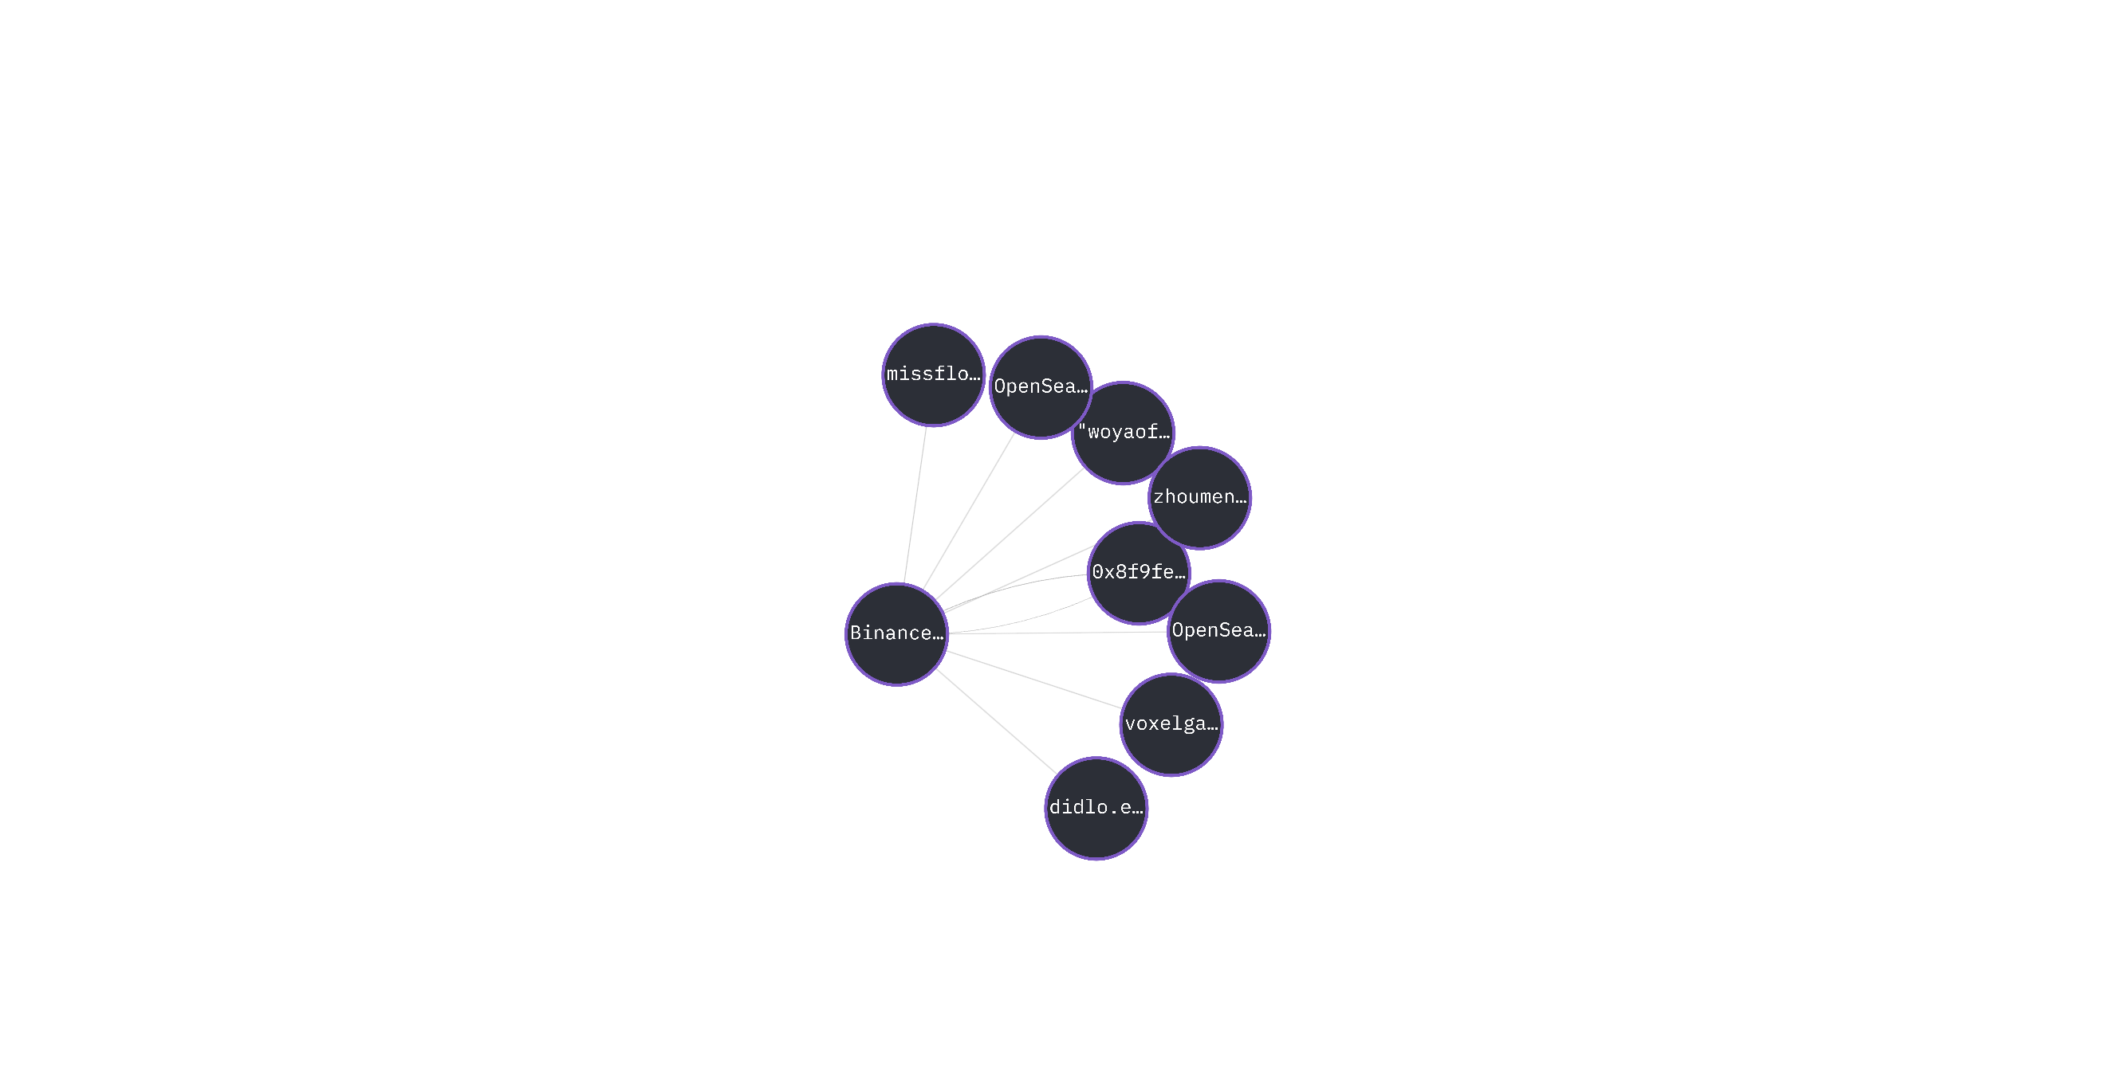

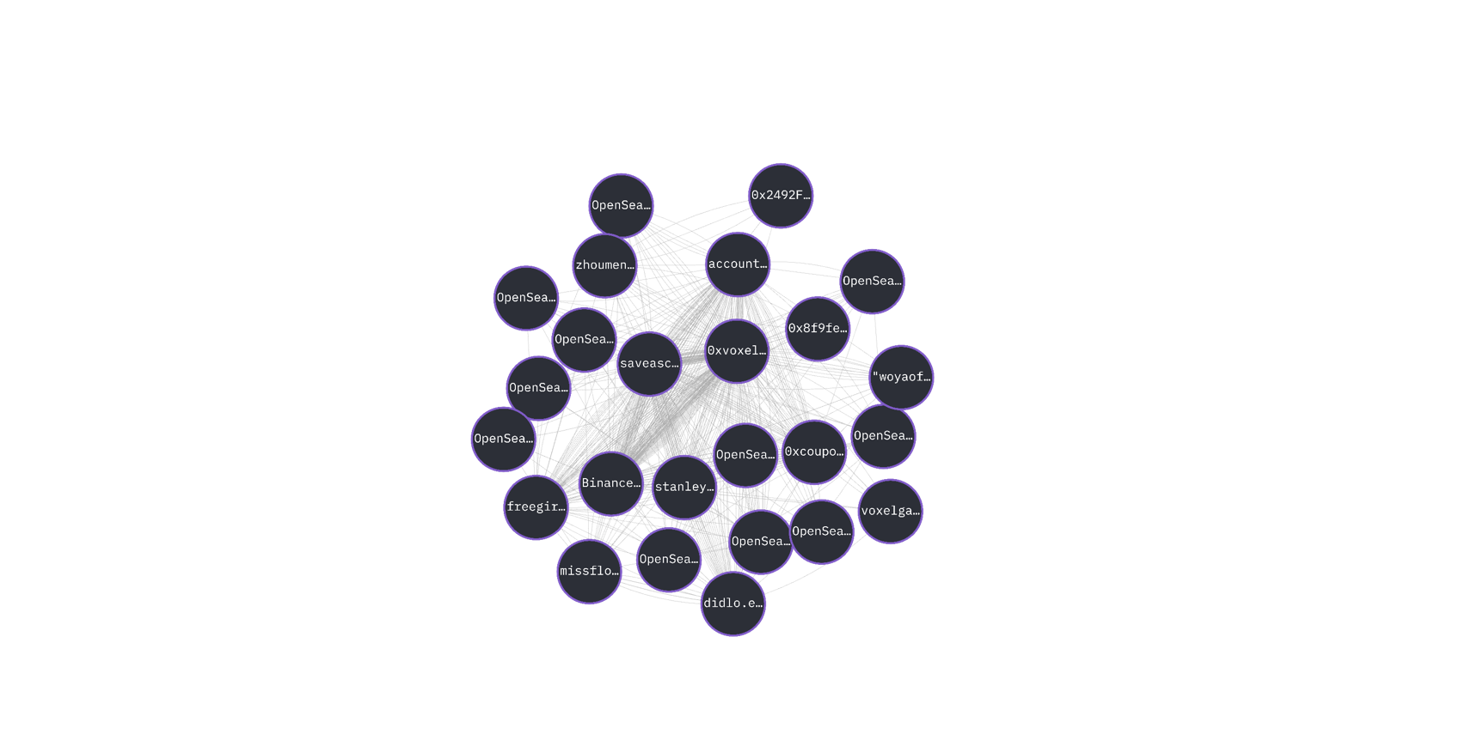

All these addresses exhibit the same on-chain activity.

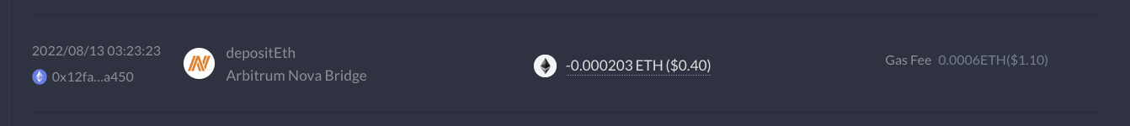

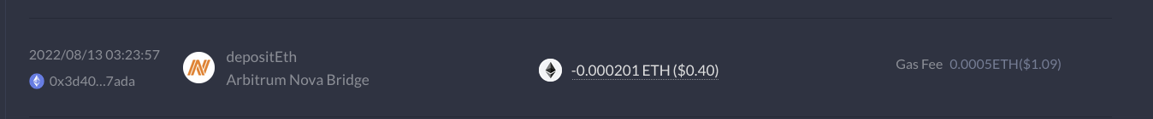

For example, their most recent Layer Zero interactions are the same, with the same dapps used at the same time in the same order: Stargate 6 months ago, Maverick 2 months ago, Stargate 9 months ago. The addresses also have similar ENS names.

These addresses share the same CEX deposit address, are part of a cluster with multiple internal links, and exhibit the same on-chain behavior. This suggests a large-scale sybil operation, likely automated by scripts.

**CLUSTER 50**

The first 5 addresses of the cluster share the same OKX deposit address: 0xD82b6ec56B76D5cA43D7826dce4e3d2Ff9C173DE. The remaining addresses are linked to numerous other addresses within the cluster multiple times.

0xb087e0033db8c075d9267e543c9e3b9f19bcc7f9

0x2caaa9c911de5990b474eb5c7679b8662d931eb2

0xe21b36ebede73eb8acc7e15e13407d629240cfbf

0xbb3a0ceeea78fc630ea6ac4c97eecd106aefa16e

0x0b61e8ce1efc73078db28b8dc9ae6e635efe67dd

0x227fbcb2931d501a31f29b1a356e12f71c6deb8d

0x68db90264b5f95032110965e2b4ca7353d67f9f5

0x8cb50b46e0708dc0b2b34e6077b876eb95a057af

0xe2709b901d6ea39ffca044679b4e268f65c68661

0xf59a93cf770eb6e2b4344387ce835c58ff8b363d

0x2d232c211c80c8ce716b884b8fcd784bb55e6053

0x4f2dc64360ebbe78c968338ed4baae1d14144340

0xa69bde39bafa75534befd12a5f36ec8f95248009

0xad8a954fab2e71f3865a8272c4042e10d83e3d5f

0x0941f8f756e890b2d81f7f16970a872ce0ae4001

0x9aa1575e60d33cd8e750f3193bdfa7d5540fe136

0x3485f5b66360022b56382cb7f37424f5f8f76ee7

0x45b0c219918c42f0ca946bdb91b517275a8c9cca

0xe0735dc521947f398d26184df05ca3803474eefd

0xb339297171670de477002e1e3bd429b87d2da263

0x8d8979ba8c18e0591f08cdefa54980a13b71df1b

0xdb520b6769df9df5911e5969d570ea12850dac69

0x48996d180fda73c5d44ac0b92cae7022b84a9acb

0xfc03f894465e2b43be15a56918c4e298e2ee4be5

0x50270d3eea45820a33e7b57072e49c37f0fbf40e

0xfd0041184f9387a822216be34da1f4893ea7b426

0xf3b5f18add21b6578e679d0de8ac7597d0095b73

0x6a643bcc171e12448aa4202db2bfd4b008108a5a

0xd12c62dea4f5c705b38f4b034c3561ca65be71d5

0x897aaceb5620805a04b561c076ca49667d663238

0x1d639c172c474d56ef85dae0431295466734c197

0xc6cbb0774096f5309dcea918b30b32e194cbebc1

0xa050e41f634170149c3b151729260df037a0f946

0x76fc58dd26ed16baf40a893faef7920afd679036

0x6fbca37a3d4933f1ec9419a4c3da5d5329cddfc2

0x2a89216e0135be6cae98fb207cb024b96de980c3

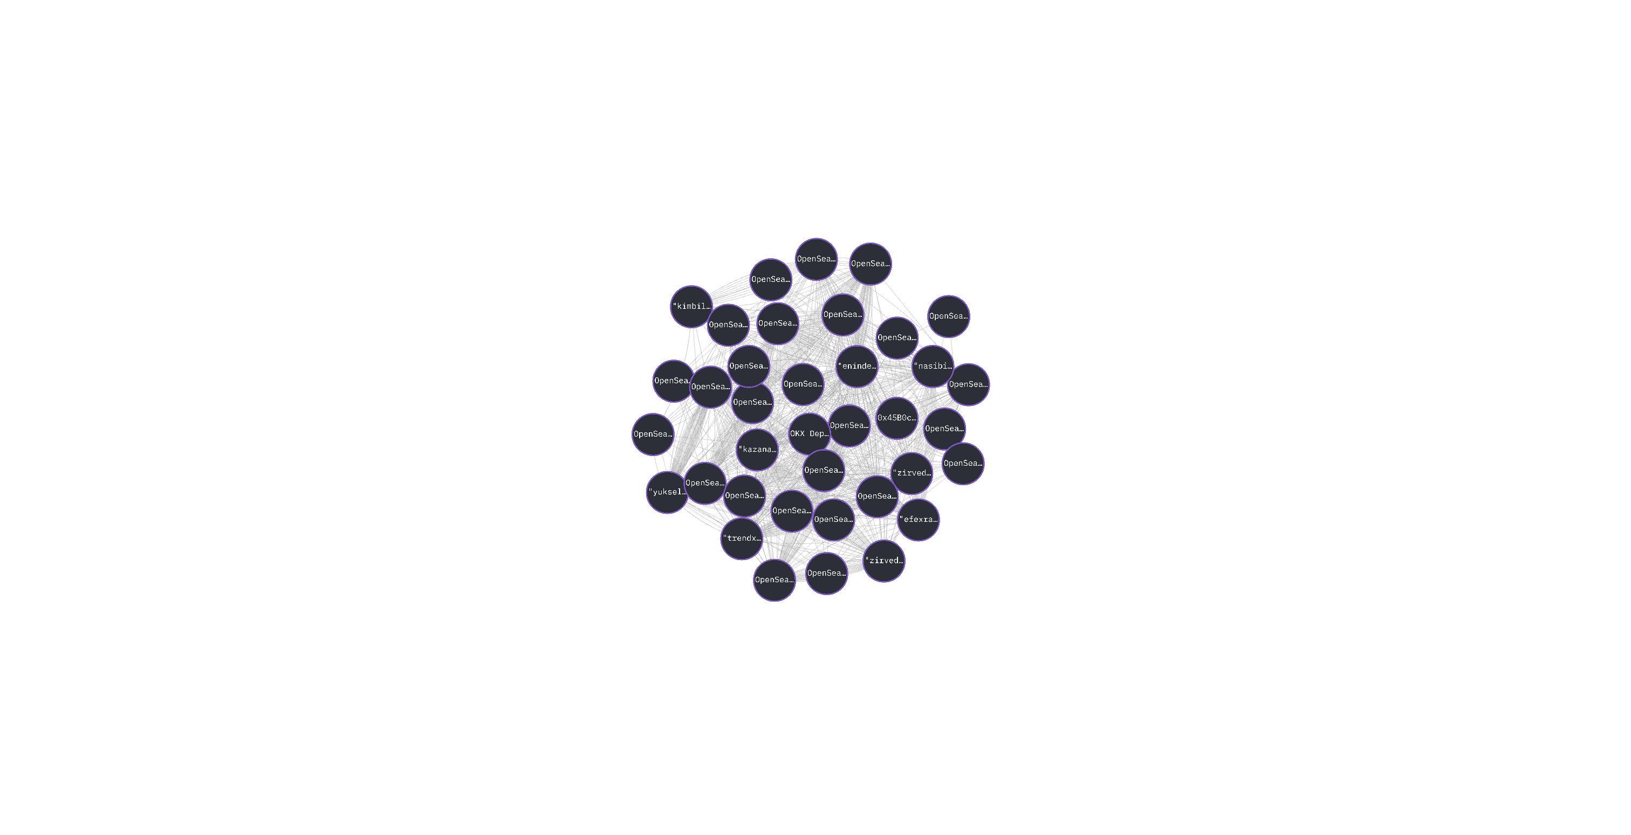

These addresses exhibit the same on-chain activity.



For example, their most recent Layer Zero interactions are the same, with the same dapps used at the same time in the same order: Merkly 18 days ago, Stargate 4 months ago, Merkly 6 months ago. The addresses also have similar ENS names.

These addresses share the same CEX deposit address, are part of a cluster with multiple internal links, and exhibit the same on-chain behavior. This suggests a large-scale sybil operation, likely automated by scripts.

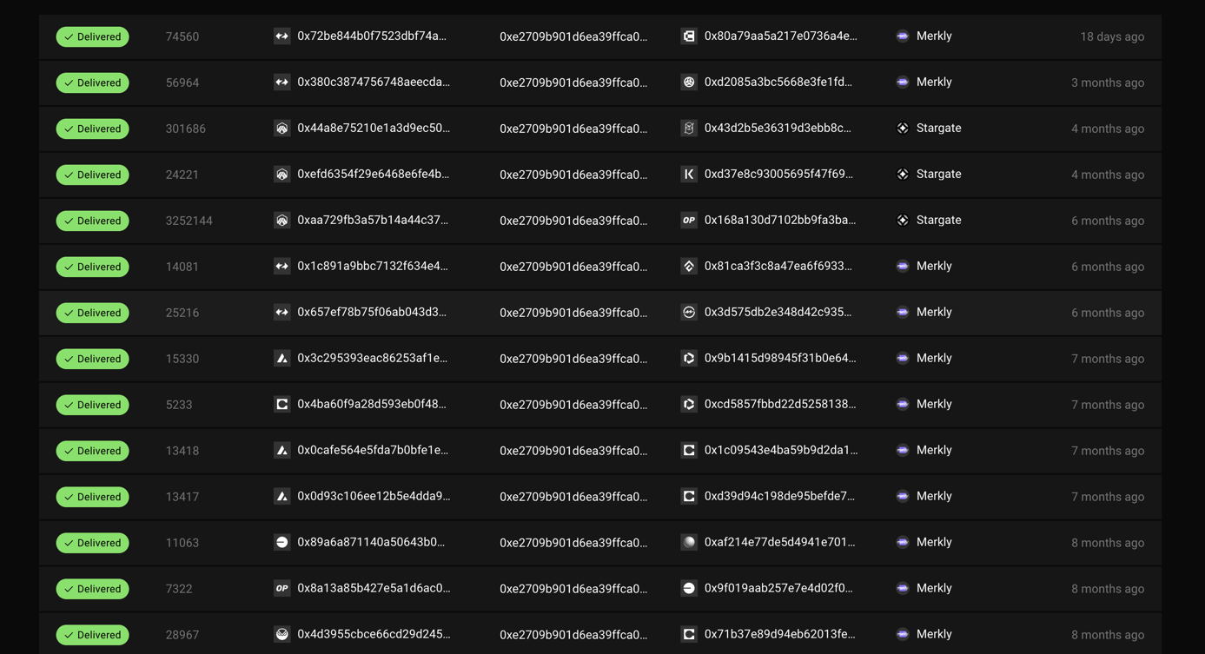

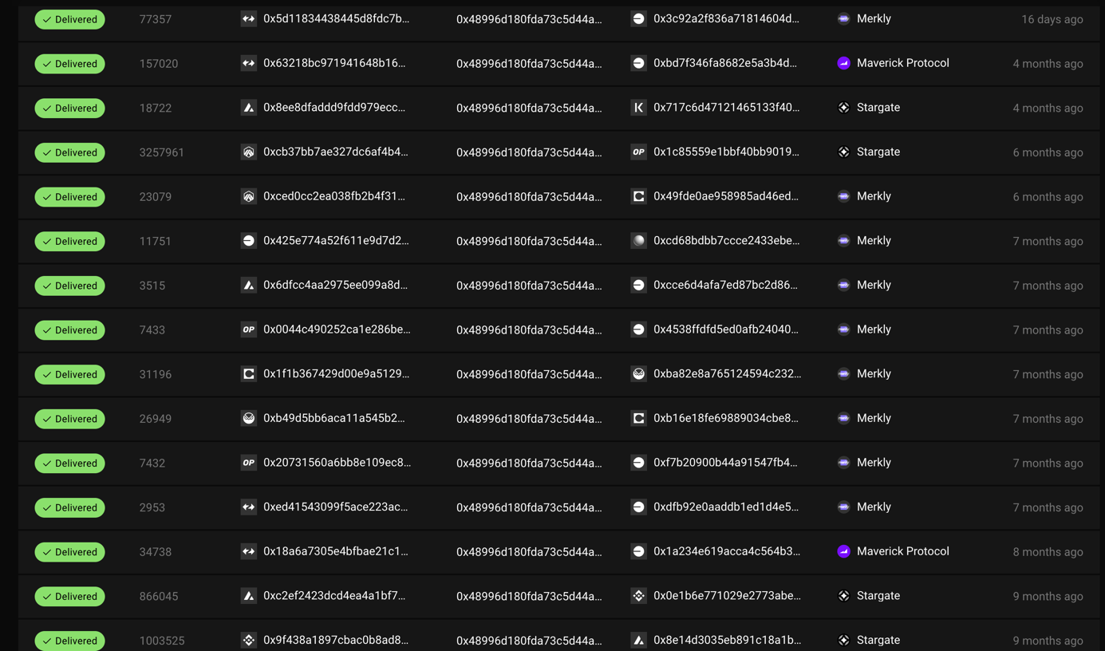

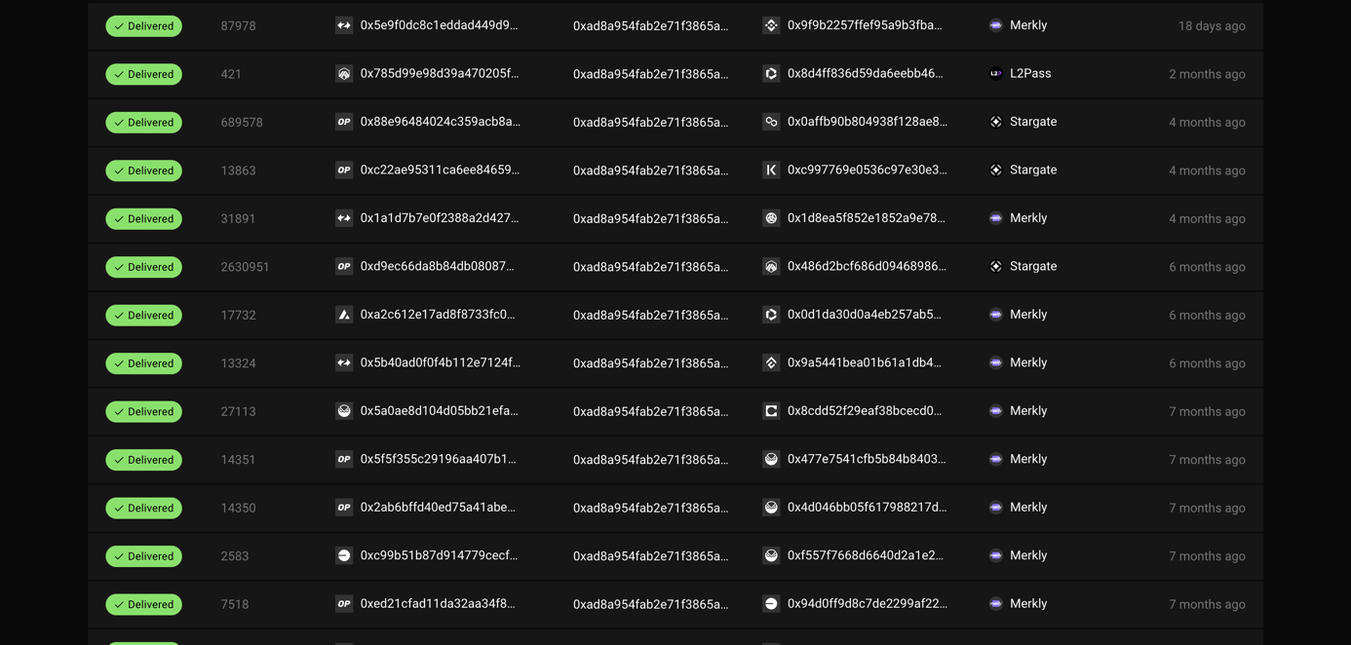

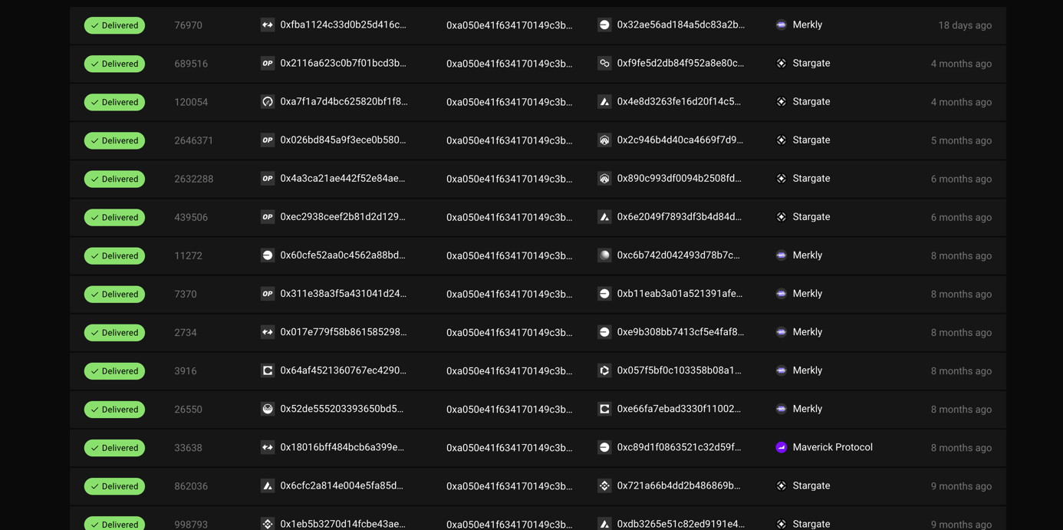

Add argu lzd et date screen tableau dune

**CLUSTER 51**

The first 7 addresses of the cluster share the same Binance deposit address: 0xDEa00B50ef00397c585a4A571585A3cecdCC8f5f. The remaining addresses are linked to numerous other addresses within the cluster multiple times.

0x80e82eabe9661b8486c87fed697c2151fdfe2bb1

0xfcffc4bae29e75f108e2496afdfa8ac150a6985a

0xebdd26127ae02a4e01ce45ef7df2fb4cb2749de6

0xf3ff1be41319aa44a759fc59d7be1be3c8b34bd5

0xcae03f27fbefef8d209b4424fae8aa9012079170

0x8d8c74bef923b63c393ae4b7bbf249442ce0fd59

0x20a9e5517c5c9a464da5a0750d2b5d381f373ebc

0x68ee33a5491259acb20a280f74b6858315f8bae1

0xb519d7664d1b862bb8f118d138bd43123c7b4b07

0x034fed0e84e250cccf5dc21a14511b212a54bddb

0x8e2da4a20777a22b2c6c4f159ea265a4b15fefdd

0x387f49fdae110c14c3503e4cc2e72d9ab8f4dab9

0x6891e9536f1fb44a7f6bcfa4d910b95147d137e0

0x0c0ce68d7bd507f5ffe4fbff00b5476d2477ff11

0x62b285bf4e04077da564cd4ba999a605668c6c8e

0x2be4644510db08a8c885e36e524dfa3b2d363d3c

0x2e645e4ee4609dc5e2e3c090cf61bf40e910139c

0x2761d36894600153c5e5e780a059eecbdda66679

0x09bc739bfa9f0a101f5f92a0f16ffc729b97211a

0x7966f650354e716c165381f2cad5d63cef665d31

0xb939db6e80aab2ef86299fc8a20a1c93d03fb0dd

0x7df50c90e392e05736db7f047b50d2f422a062f7

0x750f0efc0a9cce35ba61f23a7dcb678a1b1442b3

0xab81bde2361c9a2564603da7d0315c967aff7ee1

0xae65e17160178833be9c263599486e430dbed510

0xe464168a2318f326d396c67c2549bf54c2749566

0x23db79360ede7fa797d44bfc860f78114a9a67cc

0xed0abfa70b9b9b0d148422584aab8bb48590eeea

0xae20a0eb750bc707ec56e0a48537548a544014c1

0xa7c9e4463043f73af8819dc224104216c4969790

0x592a77f3b94244addfe497ca96769f93e07433df

0xf00e95842c62c938e7f4f0f21e7ce253c7011b97

0xd445b5e58dad7a05c57fda2e3a994a4e7556837b

0xca3d40c72fa7a54a400ddc081ab4440eedd69795

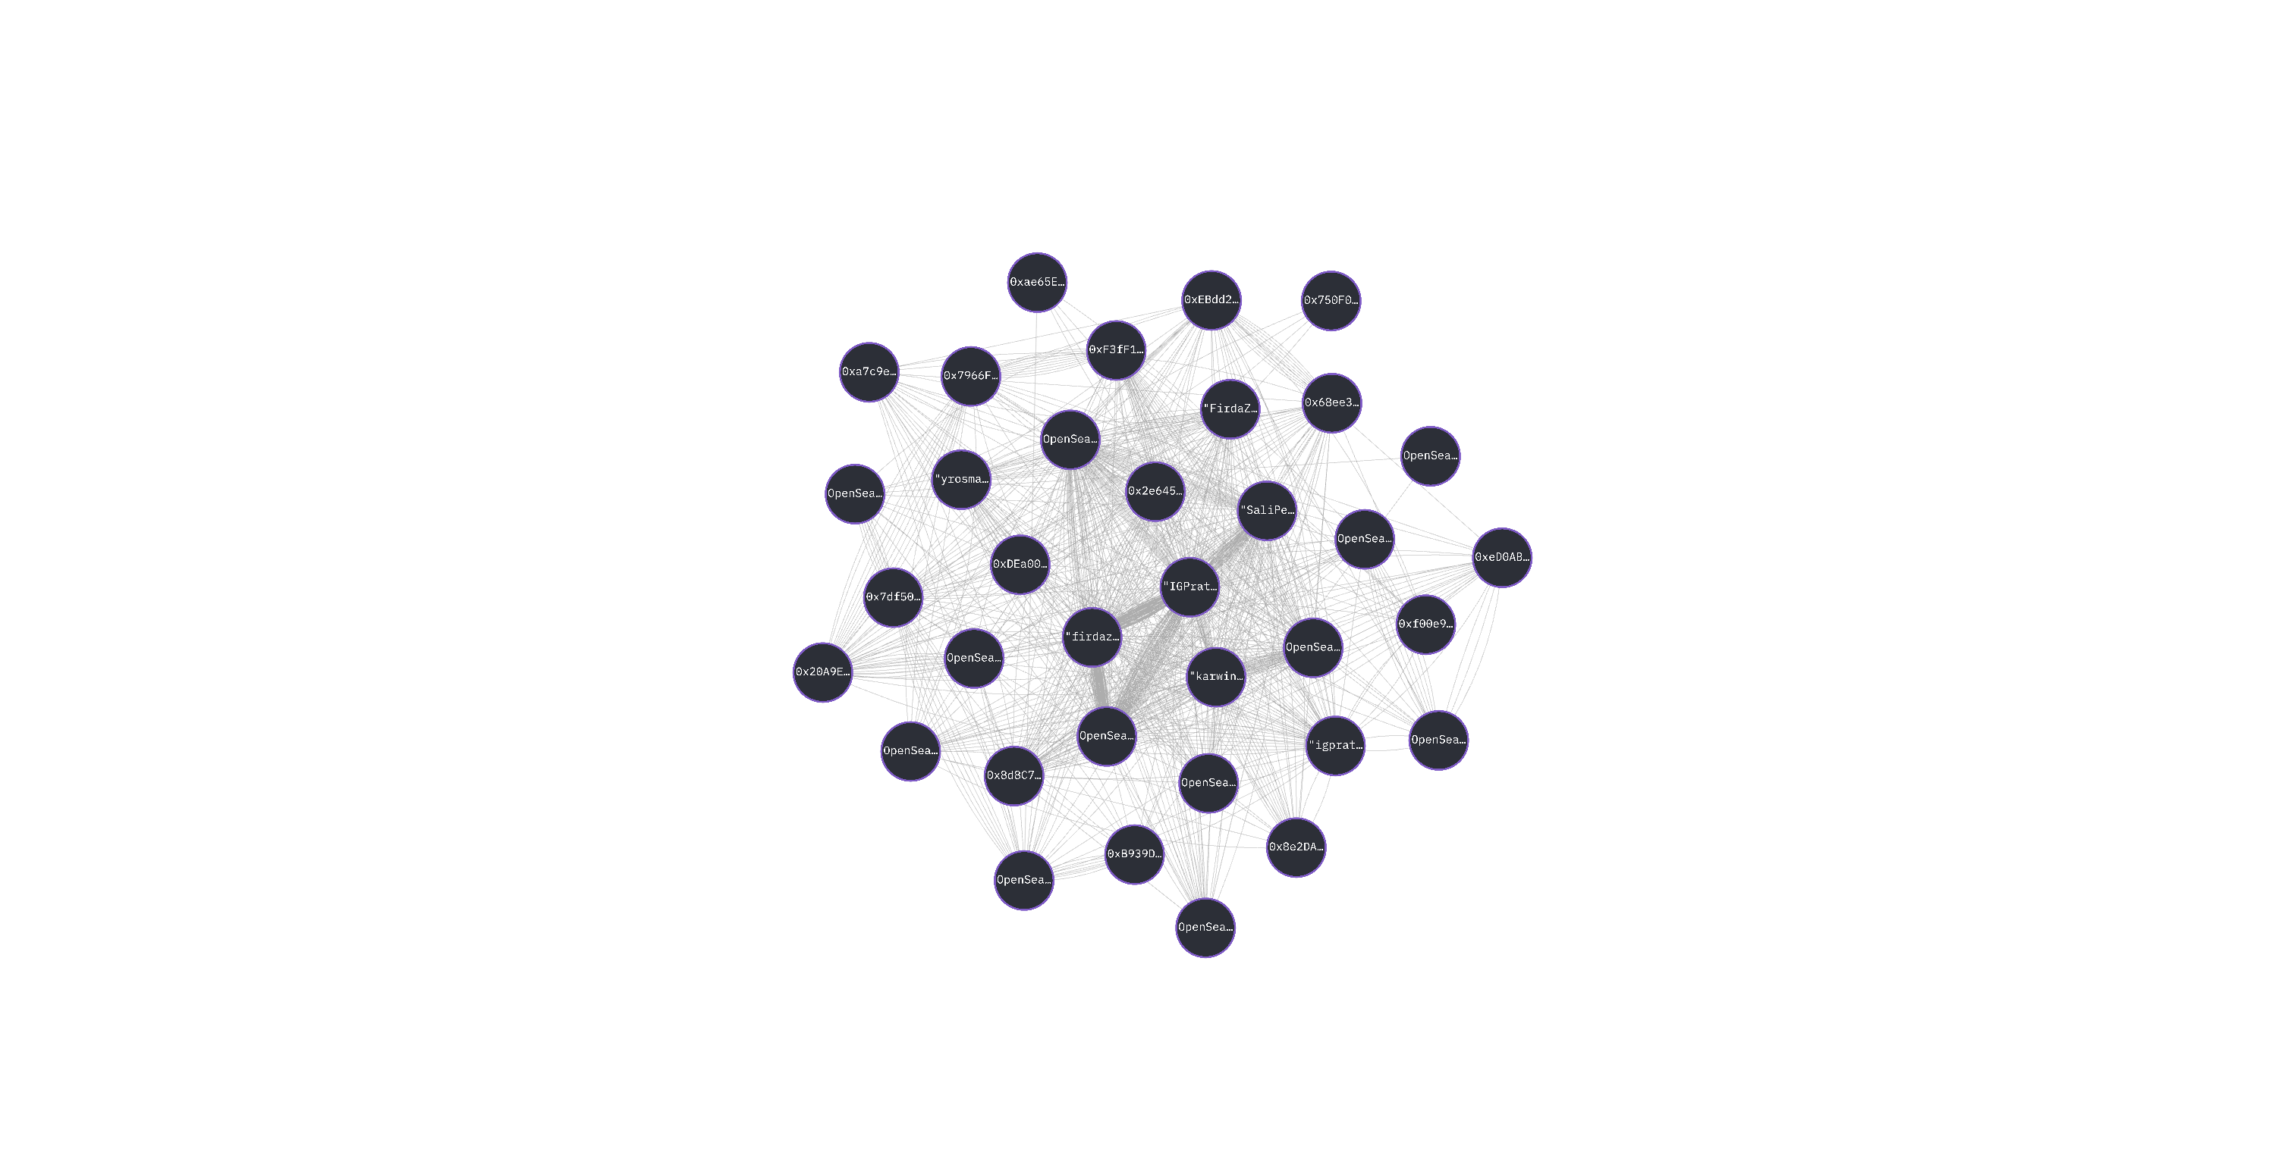

These addresses exhibit the same on-chain activity.

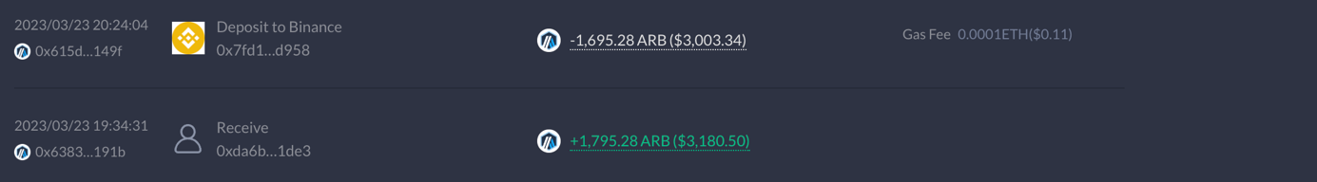



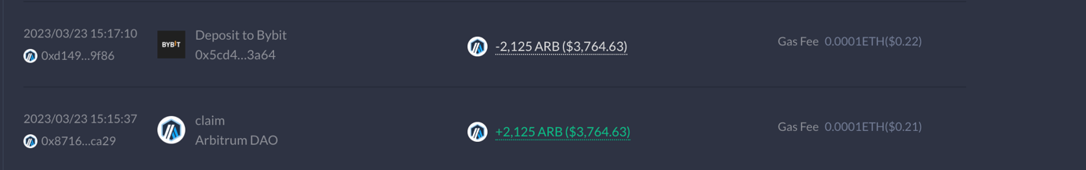



For example, their most recent Layer Zero interactions are the same, with the same dapps used at the same time in the same order: Maverick 9 days ago, Stargate 28 days ago, Angle 7 months ago. The addresses also have similar ENS names.

These addresses share the same CEX deposit address, are part of a cluster with multiple internal links, and exhibit the same on-chain behavior. This suggests a large-scale sybil operation, likely automated by scripts.

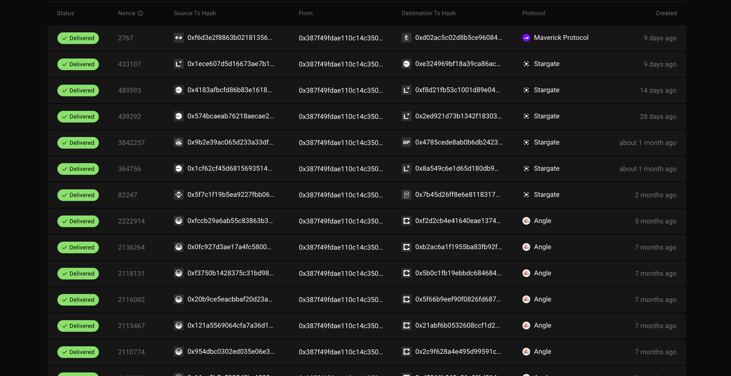

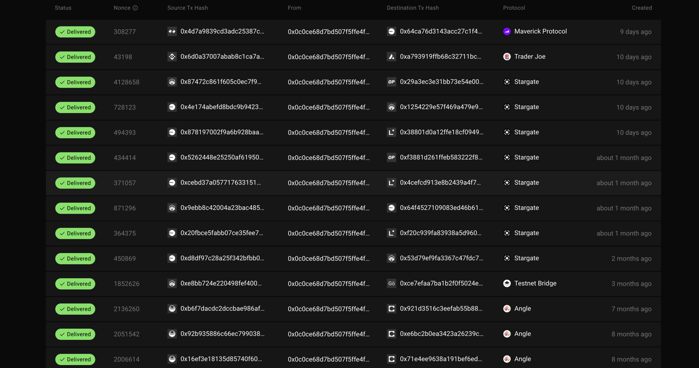

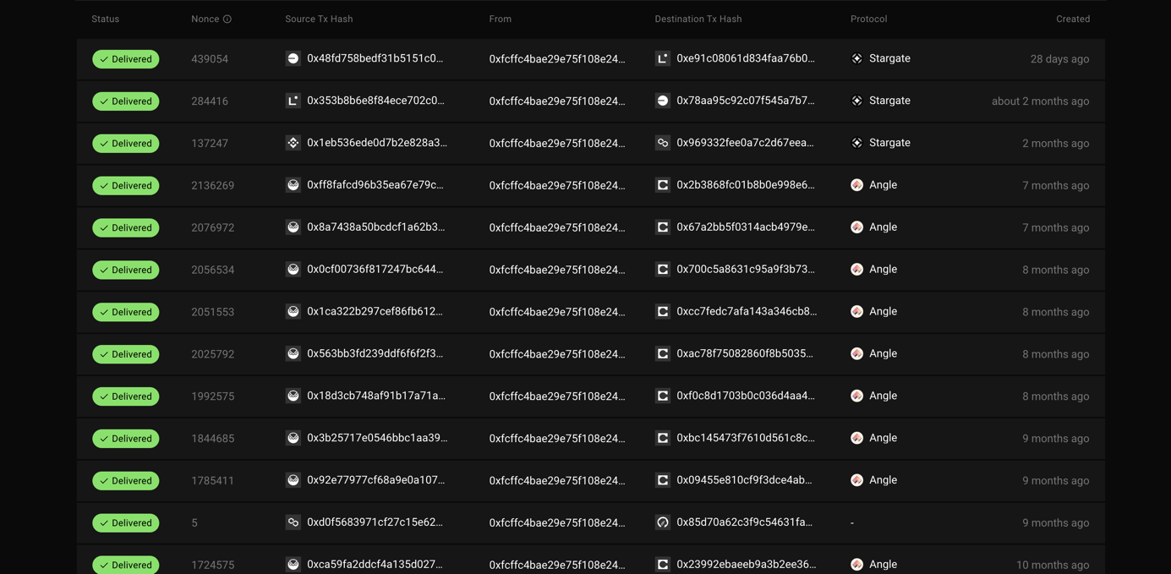

Add argu lzd et date screen tableau dune

**CLUSTER 54**

The first 9 addresses of the cluster share the same OKX deposit address: 0xE7d9306fbB0e6331E98D8CDf5A63D2c2D9eaA855. The remaining addresses are linked to numerous other addresses within the cluster multiple times.

0x7ff630219db6bc7ace11946dce8465f814f0c293

0x8308081db7d66ff56d76d224157a1e1d545aa6d6

0x71075f4e836670e0b6ea7f7834d6f7addd536421

0xa9a4e3a351ace513e9ac3d0df3f9146220bca9ef

0x64ad047d7e1d1077525e7396093e640c159de52c

0xf39a557a1fdb4fd1d03b291259d9f4fa585f9c8c

0xd65b4226a3d72a11297dc332603705b0792d0764

0x3f9d1a094deb889aa46d9aedc5f6a101d92a24ab

0x437130539bcf3155a9f1614e9789697845b83516

0x1adf17f665fbf879c75767ecc87f938abc776682

0x3a5688ba86331c4668fef062ccf4bfd6ad2a0d5d

0x18e6293edf7b32830e7d3452e7ccda0029788a90

0xcb547ec878d93cfefd4be94abe0da9b576f81d85

0x758091a94b7904d982ee5b6d85bae5ae4afde404

0xd81bd5ca852f1caf838795fa0669eb761bfeba71

0xd3047e64519d9826918a6ca997fd9171eddaa0f4

0x10435d35d76a227c67a54342796f707af9571db9

0x609f5678ca2b10aa12e1f7153a39d099b0e7ecc0

0xe5b457317c42e2cf7173c33fc85188fccf75e926

0xf0d7fce7c6e83d704c045162d19669f600b2b5a8

0x9d0e4a7d3de79236528c76ef1f6d95141b4a4dae

0x0fa7d8f0e7e458bbb78aa2a2c6c3627433076724

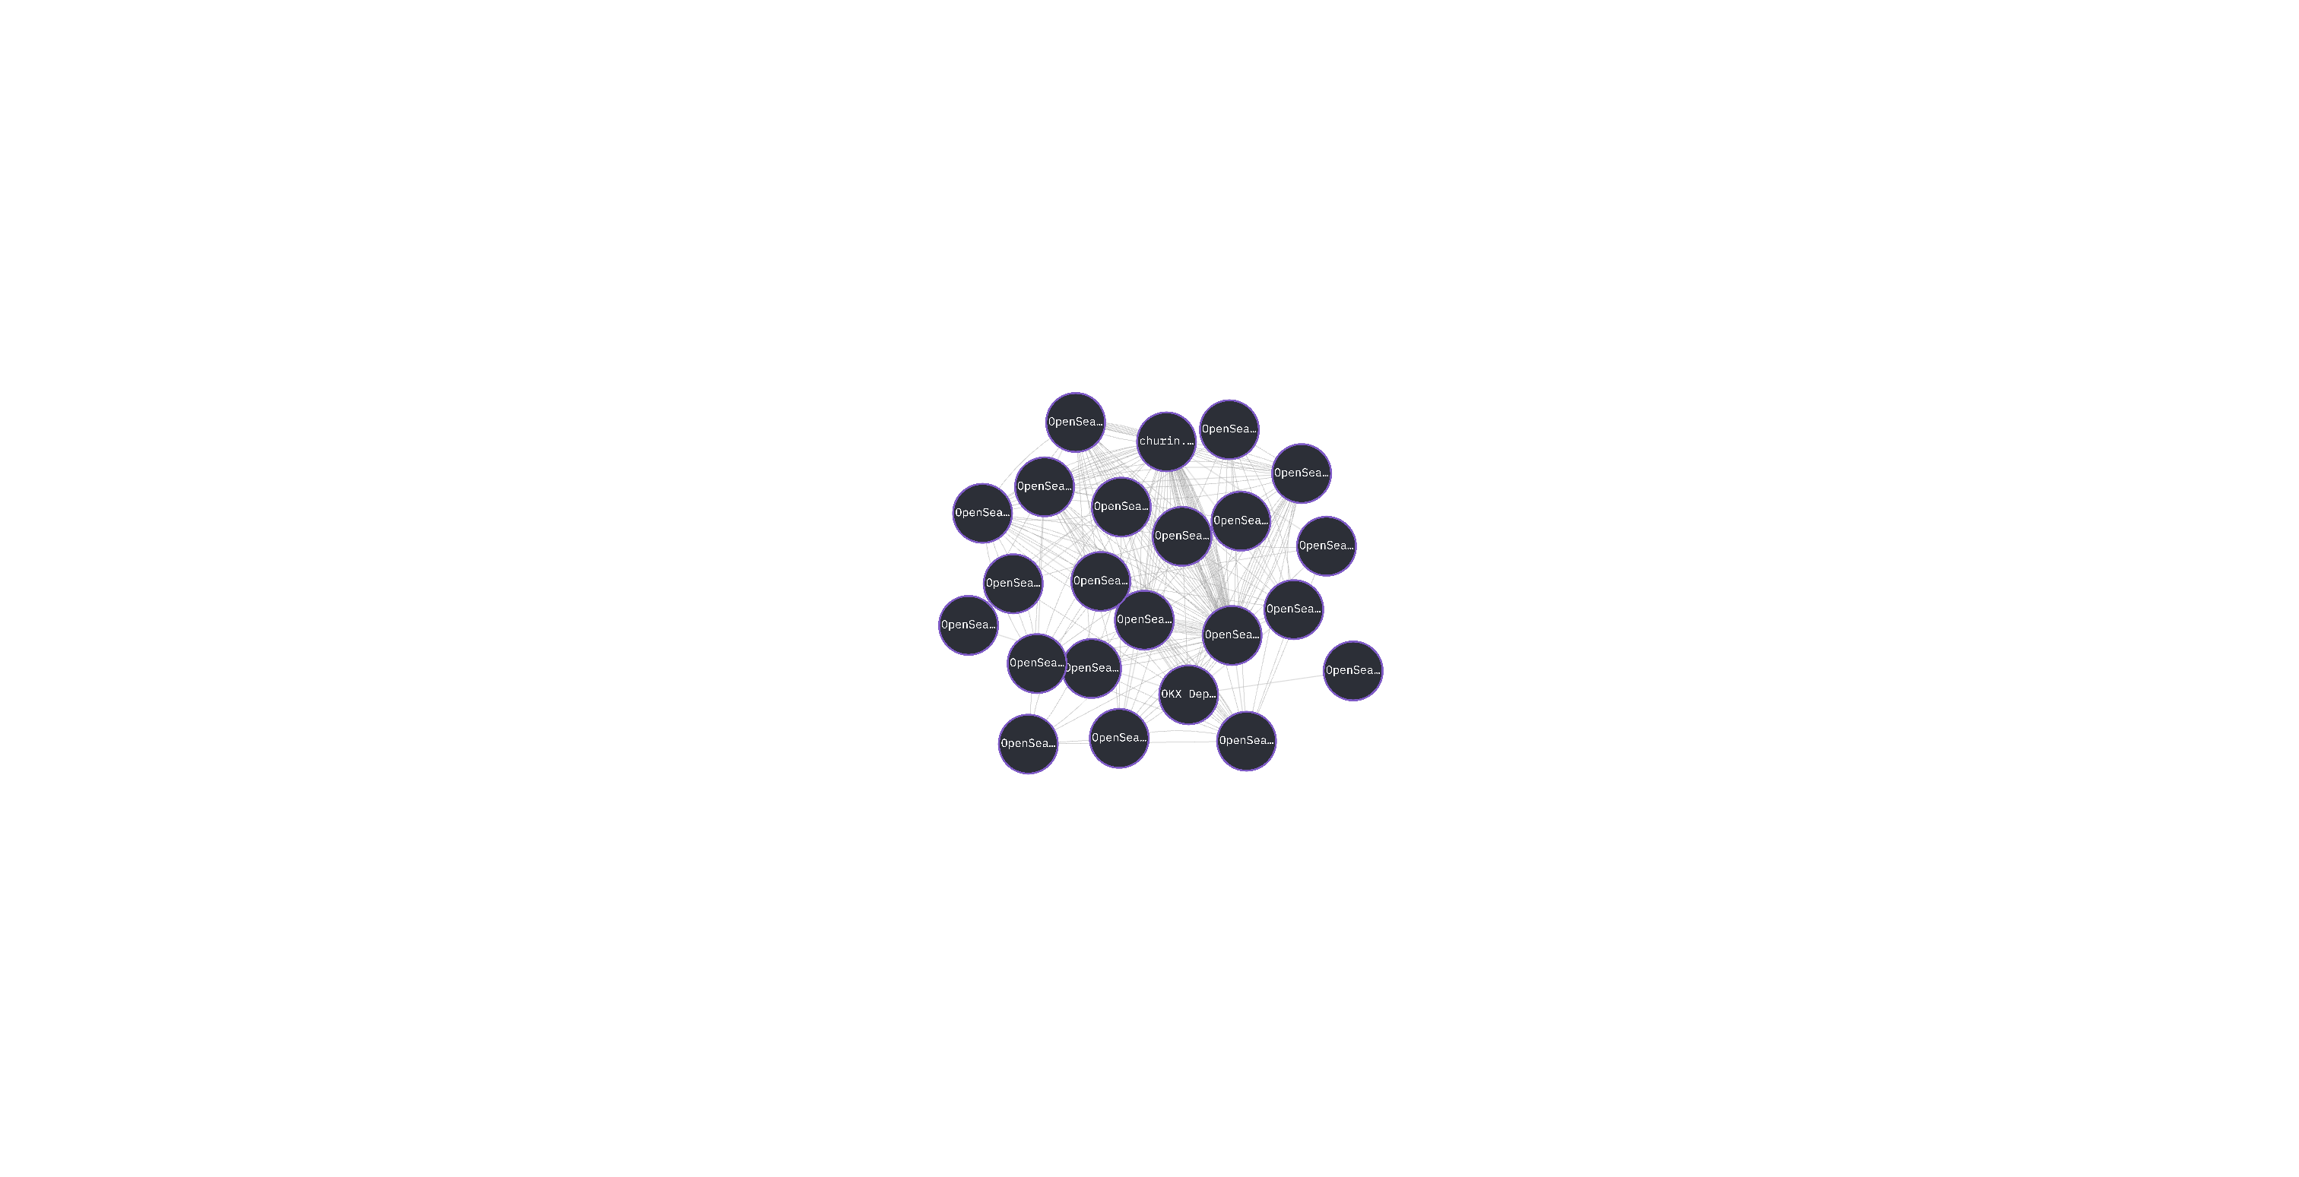

These addresses exhibit the same on-chain activity.









For example, their most recent Layer Zero interactions are the same, with the same dapps used at the same time in the same order: Stargate 7 months ago. The addresses also have similar ENS names.

These addresses share the same CEX deposit address, are part of a cluster with multiple internal links, and exhibit the same on-chain behavior. This suggests a large-scale sybil operation, likely automated by scripts.







Add argu lzd et date screen tableau dune