CASE STUDY REPORT
Waste, E-Waste and Circular Economy: 10 Case Studies (TE)
Prepared for Mid-Semester Examination 2 (MSE 2)
Student Name | Onkar shelke
Roll No. | 25102C2002
Course | TE (Case Studies)
Class / Division | CMPN C
Faculty | Aniket Kundu
Submission Date | 4 October 2026
Report Structure (for each case)
Executive Summary | Background | Strategy | Impact & Results | SWOT | Comparison with India | Recommendations | Conclusion | References | Revision Sheet

Index of Case Studies
No. | Case Study | Region
1 | Why Japan Recycles More Than Most Countries: Lessons for India | Japan
2 | Switzerland's E-Waste Success Story | Switzerland
3 | India's E-Waste Management Rules 2022 | India
4 | India's Extended Producer Responsibility (EPR): Success or Paper Compliance? | India
5 | Bengaluru: India's E-Waste Capital? | Bengaluru, Karnataka
6 | Mumbai's E-Waste Ecosystem | Mumbai, Maharashtra
7 | Kerala's Clean Kerala Company | Kerala
8 | Pune's SWaCH Model | Pune, Maharashtra
9 | Dharavi Recycling Ecosystem | Dharavi, Mumbai
10 | Dell's Circular Economy Strategy | Global corporation (with India operations)

Note on data: figures in this report are rounded or indicative and drawn from the cited public sources; please verify exact values and citations against the original documents before final submission.

Case Study 1: Why Japan Recycles More Than Most Countries: Lessons for India
Region: Japan Theme: Legal framework, segregation culture, product-stream recycling

1. Executive Summary
Japan is widely cited as a model 'sound material-cycle society'. With little land for landfills and almost no natural resources, it built a layered legal system: one basic Act plus separate recycling laws for packaging, home appliances, food, construction waste, vehicles and small electronics. Households segregate meticulously, municipalities collect, and producers are responsible for recycling. The result is very high recovery in specific streams (for example PET bottles and large appliances). Overall, however, Japan still incinerates most municipal waste, so its strength is stream-wise material recovery and behavioural discipline rather than a 'zero-incineration' system.

2. Background
Japan has about 125 million people on a small, mountainous land area. Landfill capacity became a crisis in the 1990s, pushing the state to move from disposal to the 3Rs (Reduce, Reuse, Recycle).
Key laws: Basic Act for Establishing a Sound Material-Cycle Society (2000); Containers and Packaging Recycling Law (1995, in force 1997); Home Appliance Recycling Law (in force 2001); Food Recycling Law (2000); Automobile Recycling Law (2005); Small Home Appliance Recycling Act (2013); Plastic Resource Circulation Act (2022).

3. Strategy / Initiative
- Layered legislation: a fundamental Act sets the hierarchy, product-specific laws set duties for each stream.
- Shared responsibility: consumers segregate and (for appliances) pay a recycling fee at disposal; municipalities collect; manufacturers and importers recycle.
- Fine-grained segregation with fixed collection calendars; extreme example: Kamikatsu town sorts waste into 40+ categories and declared a zero-waste goal in 2003.
- Traceability: a manifest / recycling-ticket system tracks appliances from consumer to recycler.
- Social norms and education: neighbourhood associations, school programmes and visible community pressure sustain compliance.
- Tokyo 2020 Medal Project: donated phones and small electronics supplied the metals for all Olympic and Paralympic medals.
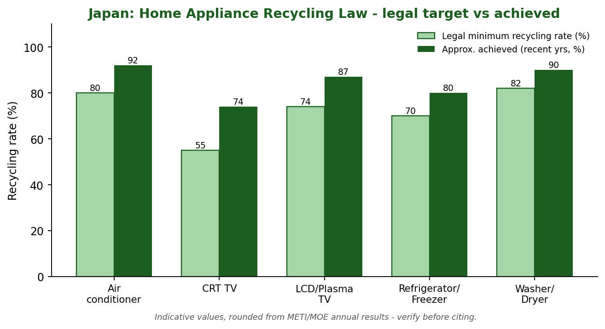
Figure 1: Legal minimum vs achieved recycling rate under Japan's Home Appliance Recycling Law

4. Impact and Results
Indicator | Data / Result | Significance
PET bottle recycling rate | Roughly 85-88% in recent years | Among the highest in the world
Large home appliances | Achieved rates exceed legal minimums (approx. 74-92% by category) | Producer duty is actually met
Landfill (final disposal) | Fell by roughly two-thirds between 2000 and ~2019 | Landfill crisis largely eased
Overall municipal waste recycling | About 20%; most of the rest is incinerated with energy recovery | Honest limit of the model
Tokyo 2020 medals | About 79,000 t of small devices collected; ~5,000 medals made from e-waste metals | Shows public participation at scale
Figures are rounded/indicative; verify against the cited sources before quoting in an exam or report.

5. SWOT Analysis
Strengths  - Strong legal architecture, stream by stream  - High citizen discipline and trust in rules  - Producer responsibility built in and monitored | Weaknesses  - Heavy reliance on incineration  - High cost of collection and sorting  - Low overall MSW recycling rate (~20%)
Opportunities  - Plastic Resource Circulation Act (2022) can lift plastics  - Advanced sorting technology, chemical recycling  - Export of know-how and standards to Asia | Threats  - Ageing, shrinking population lowers labour for collection  - Global plastic-waste export restrictions  - Rising energy and compliance costs

6. Comparison with India
Parameter | This case | India / benchmark
Legal design | Product-specific recycling laws | SWM Rules 2016; EPR under E-waste, Plastic and Battery rules
Segregation at source | Universal, culturally enforced | Mandated but weak compliance, mixed waste common
Informal sector | Minimal | Large; carries much of actual recycling
Disposal pattern | Incineration + high stream recycling | Dumpsites/landfills still dominant for residual waste
Enforcement | Fines, manifests, social pressure | Uneven across urban local bodies

7. Recommendations
- Adopt stream-wise rules with clear, measurable targets and audits, not only broad rules.
- Enforce door-to-door source segregation with a fixed calendar, incentives and graded penalties.
- Integrate waste pickers as paid partners in collection, as Japan integrates municipal crews.
- Add visible, easy take-back for small electronics and batteries through retailers.
- Invest in school and community behaviour campaigns before punitive measures.

8. Conclusion
Japan's lesson for India is that high recycling is the product of law, infrastructure and habit working together. India cannot copy Japan's incineration-heavy path or its cost structure, but it can copy the discipline of segregation, stream-specific rules and verified producer responsibility, while building on its informal recycling strength.

9. References
- Ministry of the Environment, Japan - Sound Material-Cycle Society and Annual Report on the Environment.
- Council for PET Bottle Recycling - Annual Report.
- METI / MOE - Home Appliance Recycling Law annual implementation results.
- Tokyo 2020 Medal Project official documentation.
- MoHUA, Solid Waste Management Rules 2016; CPCB Annual Report on SWM.

Case Study 2: Switzerland's E-Waste Success Story
Region: Switzerland Theme: Advance Recycling Fee, producer responsibility organisations

1. Executive Summary
Switzerland introduced one of the world's first formal e-waste systems. Manufacturers and importers finance recycling through a visible Advance Recycling Fee (ARF) paid by the buyer at the point of sale, managed by industry-run producer responsibility organisations (PROs). Retailers must take back old devices free of charge and consumers are legally bound to return them. The system delivers high collection per person, transparent financing and traceable, audited recycling.

2. Background
Until the late 1980s, appliances were landfilled or incinerated, releasing hazardous substances such as mercury, lead and CFCs. Industry launched voluntary schemes: S.EN.S (household appliances) and SWICO (ICT, office and consumer electronics), later joined by SLRS for lighting.
In 1998 the Ordinance on the Return, Taking Back and Disposal of Electrical and Electronic Equipment (ORDEO/VREG) made take-back and recycling legally binding, building on the existing industry systems.

3. Strategy / Initiative
- Three PROs cover product families and run the system for members.
- Advance Recycling Fee shown on the invoice, from a few centimes to several francs depending on the product; it funds the entire end-of-life chain.
- Legal duties: consumers return, sellers take back free, producers/importers ensure recycling.
- Dense free take-back network: retailers and municipal points across the country.
- Certified, audited recyclers with technical standards and traceability; hazardous fractions handled in approved facilities.
- Reserves are built from fees to stabilise costs when commodity prices fall.
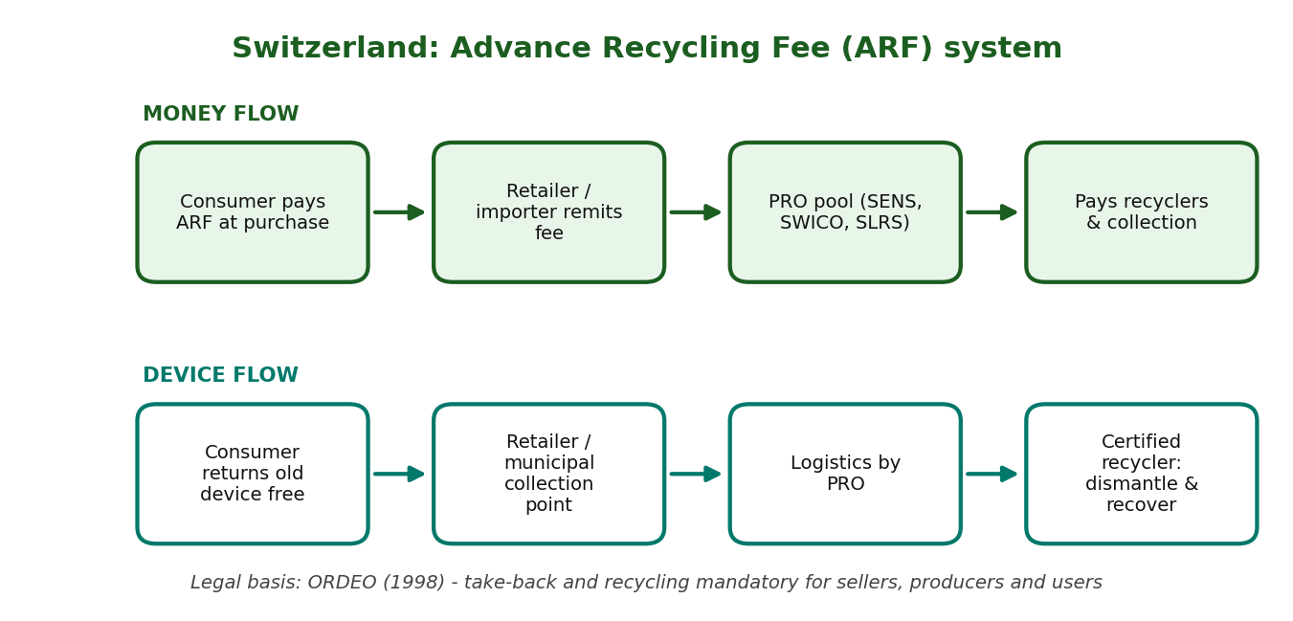
Figure 2: Money flow and device flow in the Swiss ARF system

4. Impact and Results
Indicator | Data / Result | Significance
E-waste generated (per person) | About 23 kg per year (Global E-waste Monitor 2020, 2019 data) | Very high consumption level
Formal collection (per person) | Roughly 15-16 kg per year | Among the world's highest
Total collected | Well over 100,000 tonnes annually | National coverage
Material recovery | Most of collected mass recycled (about 75-90% by weight, varies by category) | Metals and glass recovered; hazardous parts safely treated
Financing | Self-funded by consumers via ARF, no tax money | Polluter-pays principle applied transparently
Figures are rounded/indicative; verify against the cited sources before quoting.

5. SWOT Analysis
Strengths  - Transparent, self-financing ARF  - Industry-run PROs with legal backing  - Convenient free take-back, strong civic habit | Weaknesses  - High wealth makes the model costly to copy directly  - Fee-setting needs constant updating  - Hoarding of old devices at home
Opportunities  - Extend to new products (solar, e-bikes, batteries)  - Repair and reuse channels  - Export standards to other countries | Threats  - Falling commodity prices reduce recovery revenue  - Illegal e-waste exports  - Rapid product miniaturisation and lithium batteries

6. Comparison with India
Parameter | This case | India / benchmark
Finance model | Visible ARF at purchase | EPR costs hidden in price; certificate trading
Take-back | Free at every seller | Limited; consumers often sell to kabadiwalas
Collection (per person, approx.) | 15-16 kg | Below 1 kg formally (est.)
Informal sector | Negligible | Dominant
Oversight | Audited PROs and recyclers | Portal-based; verification gaps

7. Recommendations
- Pilot a visible, product-wise recycling fee ring-fenced for e-waste.
- Make retailer take-back mandatory and easy for at least large and small appliances.
- Create PRO-like bodies with transparent accounts and independent audits.
- Link informal collectors to PROs with payments per verified kilogram.
- Run public awareness on why e-waste must not go to scrap dealers.

8. Conclusion
Switzerland shows that clear legal duties, shared financing and convenience produce results. India's lesson is not to copy the fee exactly but to make financing visible, take-back convenient and reporting auditable.

9. References
- SENS eRecycling, SWICO and SLRS annual reports.
- Federal Office for the Environment (FOEN), Switzerland - ORDEO.
- Global E-waste Monitor 2020, UNU/ITU/ISWA.
- CPCB / MoEFCC - E-Waste (Management) Rules.

Case Study 3: India's E-Waste Management Rules 2022
Region: India Theme: Regulation, EPR certificates, scope expansion

1. Executive Summary
The E-Waste (Management) Rules 2022, notified in November 2022 and in force from 1 April 2023, replaced the 2016 Rules. They broaden coverage to over 100 categories of electrical and electronic equipment, create a central EPR portal run by CPCB, introduce tradable EPR certificates with a floor price, set rising recycling targets, and bring refurbishers and solar photovoltaic items into the framework. The rules move India from a producer-pays declaration towards a monitored, market-based EPR system, but success depends on verification and on including the informal sector.

2. Background
India is among the world's largest e-waste generators. Earlier rules (2011 and 2016) introduced EPR but suffered from low collection targets, weak monitoring and dominance of informal recyclers.
The 2016 Rules covered about 21 categories of equipment. Policy gaps and evidence of poor compliance led to the redesign in 2022.

3. Strategy / Initiative
- Wider scope: about 106 EEE items listed in the schedule, including newer product categories.
- Central online portal: registration of producers, manufacturers, refurbishers and recyclers; all EPR transactions recorded digitally.
- EPR certificates: producers meet obligations by buying certificates generated only when recyclers process e-waste.
- Rising targets: about 60% in 2023-24, 70% in 2024-25 and 80% from 2025-26 onwards, calculated on past sales.
- Floor and ceiling prices for certificates to protect recyclers and avoid under-pricing.
- Environmental compensation for non-compliance and requirement of minimum metal-recovery standards.
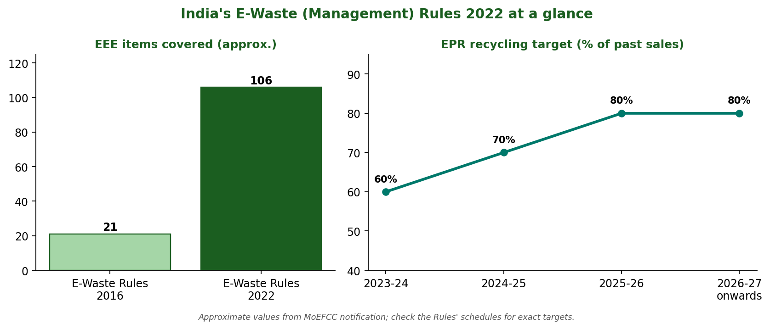
Figure 3: Scope expansion and EPR targets under the 2022 Rules

4. Impact and Results
Indicator | Data / Result | Significance
Products covered | 21 categories (2016) to about 106 items (2022) | Far broader legal reach
Institutional design | Central CPCB portal, digital certificates | Improved traceability in principle
Recycling targets | 60% rising to 80% of past sales | Higher ambition than earlier rules
Actors covered | Producers, manufacturers, refurbishers, recyclers | Refurbishing formally recognised
Ground reality | Formal processing still a small share of estimated generation (CPCB ~1.6 Mt in 2021-22) | Implementation gap remains
Values are approximate; check the notified Rules and CPCB reports for exact numbers.

5. SWOT Analysis
Strengths  - Broad scope and digital tracking  - Market-based certificates with price bounds  - Refurbishers recognised | Weaknesses  - Informal sector not explicitly integrated  - Certificate fraud risk  - Data gaps on actual generation
Opportunities  - Growth of authorised recyclers and urban mining  - Green jobs, critical-mineral recovery  - Better data through the portal | Threats  - Continued leakage to informal recyclers  - Low consumer awareness  - Enforcement capacity of SPCBs

6. Comparison with India
Parameter | This case | India / benchmark
Approach | Certificate-based EPR with targets | Switzerland: fee + PRO; Japan: law + fee at disposal
Coverage | ~106 items | EU: broad categories with collection targets per capita
Verification | Portal + audits (improving) | Swiss PROs are audited and traceable
Informal sector | Marginal role | Often dominant in India in practice
Consumer role | Weak duty, low awareness | Mandatory return in Switzerland

7. Recommendations
- Strengthen audits, GPS/weighbridge data and third-party verification of certificates.
- Formalise informal collectors through registration and per-kg payments.
- Set collection targets per capita alongside EPR targets.
- Publish portal data openly for public scrutiny.
- Run mass awareness and easy take-back points via retailers.

8. Conclusion
The 2022 Rules are a substantial upgrade in design. Their impact will be judged by verified tonnage recycled, not by certificates issued.

9. References
- MoEFCC, E-Waste (Management) Rules 2022 (Gazette notification, Nov 2022).
- CPCB, EPR portal and annual reports on e-waste.
- Global E-waste Monitor 2020 and 2024, UNU/ITU.
- CSE and TERI policy briefs on e-waste EPR.

Case Study 4: India's Extended Producer Responsibility (EPR): Success or Paper Compliance?
Region: India Theme: EPR design, verification, fraud risk

1. Executive Summary
EPR makes producers responsible for the end-of-life of their products. India has adopted EPR for e-waste, plastic packaging, batteries and other streams, with a central portal and certificates. The legal architecture is strong, but evidence and regulator actions point to weak physical verification, certificate trading detached from recycling, and risk of 'paper compliance'. The fair verdict: a strong design with uneven implementation, i.e. a partial success that needs tougher, data-driven enforcement.

2. Background
EPR entered Indian law through the E-Waste Rules 2011, then the Plastic Waste Management Rules 2016 and later the Battery Waste Management Rules 2022 and 2022 guidelines on plastic packaging EPR.
Under the certificate model, a producer buys certificates from recyclers or processors. If the certificate is not tied to verified physical processing, the producer's target can be 'met' without waste actually being recycled.

3. Strategy / Initiative
- Central EPR portals under CPCB for registration, targets and certificates.
- Targets set on past sales or quantity placed on the market.
- Certificate trading between producers and recyclers, with price signals.
- Third-party audits, environmental compensation and penalties for non-compliance.
- Increasing digital tracking (invoices, weighbridge data, quantity reconciliation).
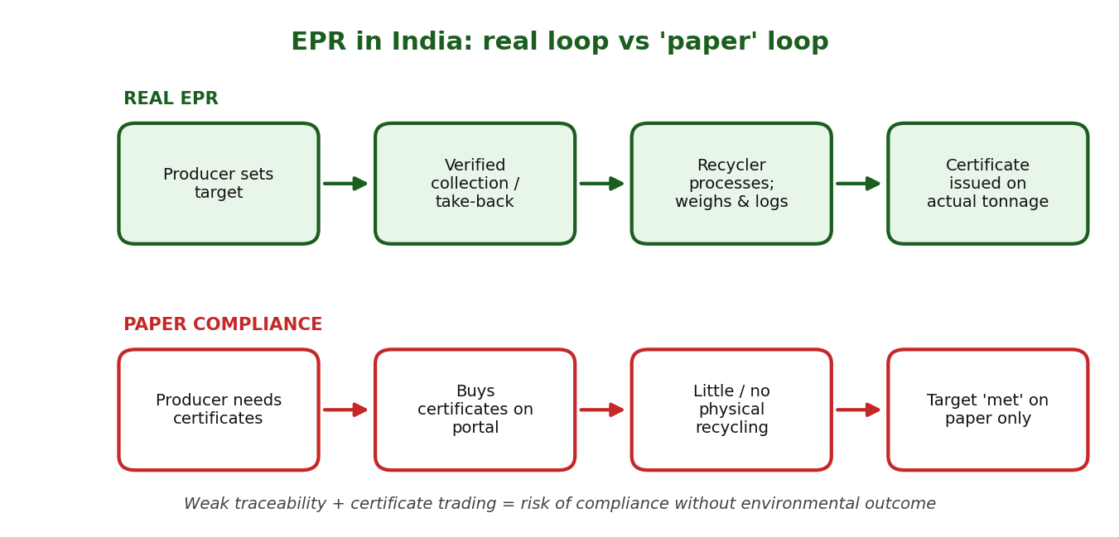
Figure 4: Real EPR loop versus paper compliance

4. Impact and Results
Indicator | Data / Result | Significance
Regulatory reach | EPR now covers e-waste, plastic packaging, batteries and more | Wide policy coverage
Digitisation | Registration and certificates on central portals | Better visibility than before
Compliance quality | Regulators and researchers have flagged inflated or irregular certificates (2023-25, verify latest CPCB notices) | Risk of paper compliance
Recycling outcomes | Formal recycling still limited compared with waste generated | Gap between target and tonnage
Informal sector | Not systematically integrated | Leakage and exclusion
Qualitative evidence table: confirm recent enforcement actions from CPCB/MoEFCC notices before citing specific cases.

5. SWOT Analysis
Strengths  - Comprehensive legal framework  - Central portal and digital records  - Polluter-pays principle embedded | Weaknesses  - Weak physical verification  - Certificate trading without proof of processing  - Capacity gaps in regulators
Opportunities  - AI/IoT-based tracking and reconciliation  - Integration of waste pickers  - Global market access (green procurement) | Threats  - Fraud damages trust  - Industry lobbying against stricter targets  - Unequal state-level enforcement

6. Comparison with India
Parameter | This case | India / benchmark
Financing | Producers buy certificates | Switzerland: ARF collected upfront; EU: PRO fees with collection targets
Verification | Improving but uneven | Audited PROs in Europe/Switzerland
Consumer role | Limited | Mandatory return abroad
Informal sector | Not integrated | Not central abroad, but central in India
Transparency | Portal data partly public | Annual PRO reports in Switzerland

7. Recommendations
- Link every certificate to weighed, geo-tagged, audited processing records.
- Independent third-party audits with penalties for fake certificates.
- Publish producer-wise data for public scrutiny.
- Include the informal sector through registration and payments per kg.
- Add collection-based targets so that EPR reflects real take-back.

8. Conclusion
India's EPR is more than paper, but not yet fully real. It will be a success only when compliance is measured by verified physical recycling and consumer take-back.

9. References
- CPCB, EPR portal and guidelines (E-waste, Plastic, Battery).
- MoEFCC, Plastic Waste Management Rules 2016 and amendments; Battery Waste Management Rules 2022.
- CSE, State of India's Environment reports on EPR.
- OECD, Extended Producer Responsibility: Updated Guidance.

Case Study 5: Bengaluru: India's E-Waste Capital?
Region: Bengaluru, Karnataka Theme: IT hub, formal recyclers, bulk generators

1. Executive Summary
Bengaluru, India's IT and start-up hub, generates large volumes of e-waste from campuses, offices and households, and hosts one of the more developed formal recycling ecosystems in the country, with early authorised recyclers such as e-Parisara. Whether it deserves the label 'e-waste capital' depends on how it is measured: it is a leader in generation and formal infrastructure, yet a substantial share still flows through informal channels.

2. Background
Bengaluru's technology industry (IT/ITeS, electronics, start-ups) creates constant device turnover. Karnataka State Pollution Control Board (KSPCB) authorises collectors, dismantlers and recyclers under the E-Waste Rules.
Bengaluru Solid Waste Management Ltd (BSWML, 2019) and the municipal corporation handle city waste; e-waste is dealt with through drives, authorised collection centres and corporate buy-back.

3. Strategy / Initiative
- Authorised dismantling and recycling units located around the city, licensed by KSPCB.
- Bulk generators (IT companies, institutions) tie up with authorised recyclers for asset disposal and certified data destruction.
- Collection drives and drop-off centres for households.
- Corporate CSR and sustainability programmes promoting responsible disposal.
- Awareness through resident associations and NGOs.
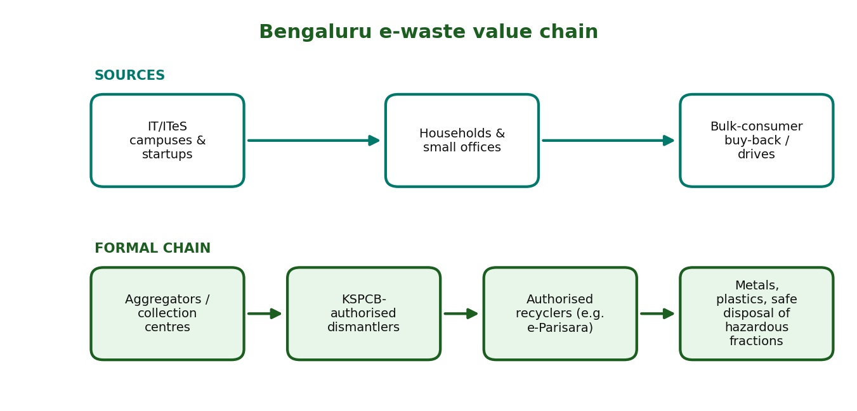
Figure 5: Bengaluru's e-waste value chain

4. Impact and Results
Indicator | Data / Result | Significance
Generation | Estimated in the tens of thousands of tonnes per year (estimates vary) | Among India's largest city generators
Formal capacity | One of the larger networks of authorised recyclers in a single state | Strength of the ecosystem
Bulk-generator flow | Corporate disposal largely via authorised recyclers | Cleaner, traceable stream
Household flow | Considerable share still to kabadiwalas / informal channels | Leakage remains
Innovation | Start-ups and recyclers pilot urban mining and refurbishing | Job and skill creation
City-level e-waste numbers are estimates; use KSPCB or CPCB figures for exact values in your submission.

5. SWOT Analysis
Strengths  - Large formal recycler base  - IT sector with corporate compliance capacity  - Skilled workforce and start-up ecosystem | Weaknesses  - Household e-waste leakage to informal  - Low public awareness  - Pressure on urban land for recycling units
Opportunities  - Urban mining and rare-metal recovery  - Refurbishing and reuse markets  - Model for other cities | Threats  - Rapid growth in devices  - Illegal dumping and burning on city outskirts  - Certificate/EPR compliance gaps

6. Comparison with India
Parameter | This case | India / benchmark
Formal recycling infrastructure | Relatively strong | India overall: limited and concentrated in a few states
Bulk generator compliance | High for IT firms | Low among SMEs and households nationally
Household collection | Drives and drop-offs, patchy | Switzerland: free retailer take-back everywhere
Informal sector | Still significant | Dominant nationally

7. Recommendations
- Set up ward-level e-waste drop boxes and retailer take-back.
- Mandate audit trails for corporate asset disposal.
- Register and train informal collectors to feed authorised recyclers.
- Use BSWML and resident associations for scheduled household collection.
- Publish city e-waste data annually.

8. Conclusion
Bengaluru is India's e-waste capital in generation and in formal infrastructure, but a true capital of good practice would also close the household leakage. The city is a useful pilot for scaling national systems.

9. References
- KSPCB - authorisation lists and annual reports.
- CPCB - Inventory of e-waste and annual reports.
- BBMP / BSWML - solid waste management documents.
- Company sustainability disclosures (e-Parisara, IT majors).

Case Study 6: Mumbai's E-Waste Ecosystem
Region: Mumbai, Maharashtra Theme: Formal vs informal chains, market hubs

1. Executive Summary
Mumbai, in Maharashtra (a leading e-waste generating state), combines a huge consumer base, dense electronics markets and a large informal recycling economy alongside a smaller network of authorised recyclers such as Ecoreco. The city illustrates India's central challenge: most e-waste is handled informally, cheaply and often unsafely, while formal recyclers struggle to secure enough volume.

2. Background
Mumbai is a financial capital with high device ownership, big corporate offices and famous electronics markets such as Lamington Road. Estimates of e-waste generation are large (industry estimates commonly exceed a lakh tonnes per year for the metropolitan region) though data differ.
Maharashtra Pollution Control Board (MPCB) authorises collectors and recyclers. Informal hubs in and around Dharavi and other parts of the city dismantle and trade scrap.

3. Strategy / Initiative
- Authorised recyclers with MPCB consent handle bulk and corporate e-waste.
- BMC and NGO collection drives for households.
- Producer take-back and buy-back programmes.
- Informal dismantlers and kabadiwalas offer doorstep cash purchase.
- Emerging efforts to connect informal collectors with formal recyclers.
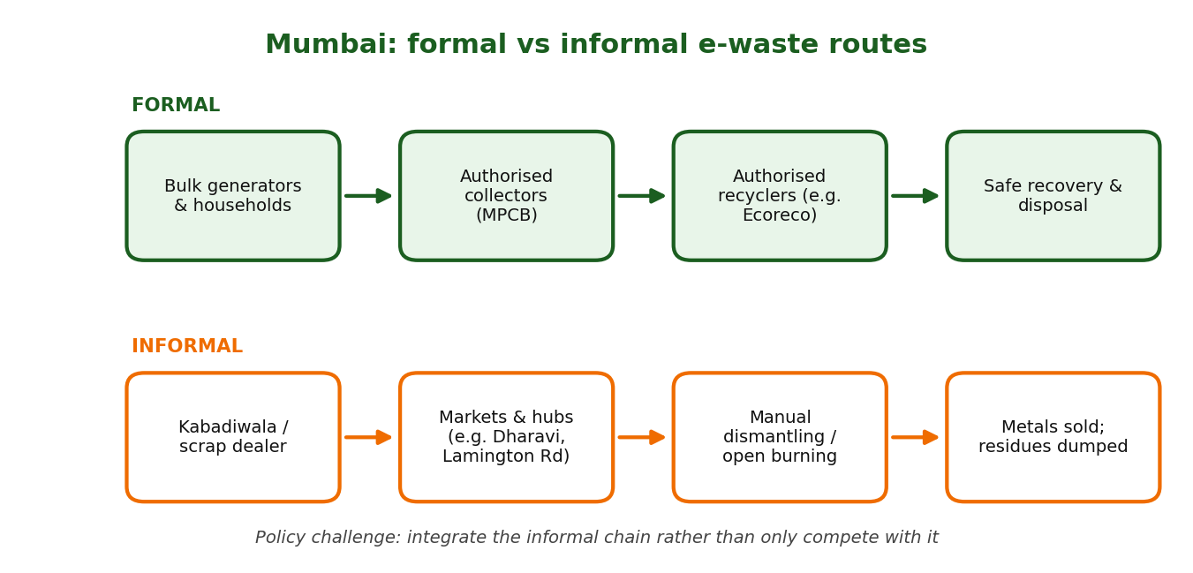
Figure 6: Formal and informal e-waste routes in Mumbai

4. Impact and Results
Indicator | Data / Result | Significance
Formal recycling | Concentrated in bulk and corporate streams | Traceable but limited volume
Informal recycling | Handles a large share of household and small business e-waste | Cheap, fast; unsafe practices
Employment | Many livelihoods depend on scrap trade | Social importance
Environmental risk | Open burning and acid leaching in unregulated units | Pollution and health hazards
Recovery | Formal recyclers recover metals more completely | Higher yield and safety
Qualitative summary; confirm numbers with MPCB / CPCB before quoting.

5. SWOT Analysis
Strengths  - Huge volume and market density  - Established formal recyclers  - Strong scrap-trade skills | Weaknesses  - Informal dominance  - Weak household take-back  - Poor working conditions
Opportunities  - Formal-informal partnerships  - Take-back at electronics markets  - Job upgrading and safety training | Threats  - Toxic exposure  - Land pressure  - Competition between formal and informal for scarce e-waste

6. Comparison with India
Parameter | This case | India / benchmark
Generation | Very high, city-level | India: ~1.6 Mt (CPCB 2021-22, all states)
Formal share | Low-moderate | Switzerland: nearly all e-waste formal
Collection convenience | Doorstep informal wins | Swiss: free take-back at retailers
Regulation | MPCB authorisation, EPR portal | Same national law, differing enforcement

7. Recommendations
- Create formal-informal linkages with registered collectors and fair per-kg rates.
- Establish take-back kiosks in electronics markets and malls.
- Provide PPE, training and safe dismantling hubs for informal workers.
- Increase penalties for open burning and illegal recycling.
- Incentivise households through buy-back and vouchers.

8. Conclusion
Mumbai's ecosystem shows that policy must work with existing informal networks, not just beside them. Convenience, price and safety together decide where e-waste goes.

9. References
- MPCB - list of authorised e-waste collectors and recyclers.
- CPCB - Inventory and annual reports on e-waste.
- Ecoreco / industry documents; ASSOCHAM and industry reports.
- Global E-waste Monitor, UNU/ITU.

Case Study 7: Kerala's Clean Kerala Company
Region: Kerala Theme: Local-body led non-biodegradable waste management

1. Executive Summary
Clean Kerala Company Ltd (CKCL) was set up by the Government of Kerala's Local Self-Government Department to manage non-biodegradable (and later e-) waste. Working with local bodies, Haritha Karma Sena (HKS) groups collect door-to-door for a user fee and hand waste to Material Collection Facilities, from where CKCL arranges transport and recycling. The model shows how decentralised institutions can build a functioning collection network.

2. Background
Kerala has high population density, limited land and a strong tradition of local self-government and women's self-help groups (Kudumbashree). Under the Suchitwa Mission and Haritha Keralam Mission, waste management was decentralised.
CKCL was registered in 2019 as a government company to link local bodies with recyclers and manage plastics, other non-bio waste and e-waste.

3. Strategy / Initiative
- Haritha Karma Sena (women's groups) collect segregated non-bio waste door-to-door for a nominal monthly user fee.
- Material Collection Facilities (MCFs) at ward level and Resource Recovery Facilities for baling and grading.
- CKCL organises transport, contracts with recyclers and manages e-waste drives.
- Plastic shredding for road construction and cement co-processing.
- Digital monitoring (for example the Smart Garbage app) and local body oversight.
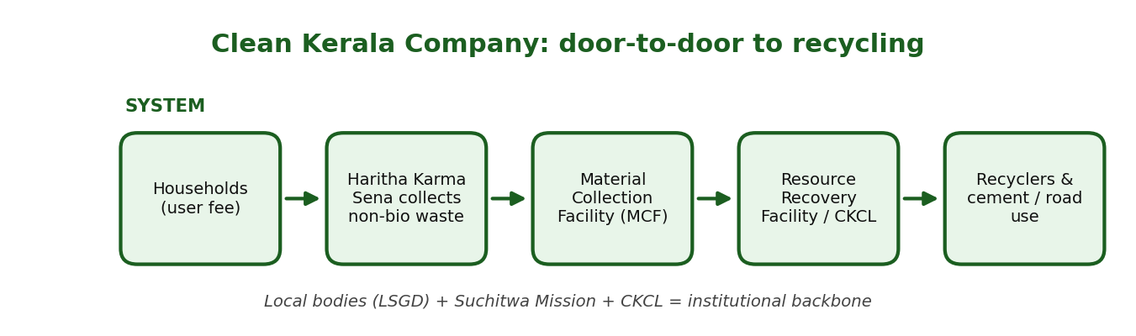
Figure 7: Waste flow in the Clean Kerala Company system

4. Impact and Results
Indicator | Data / Result | Significance
Collection coverage | HKS present in most local bodies (reported) | Wide network
Livelihood | Tens of thousands of women employed as HKS members (reported) | Social benefit
Recycling routes | Plastic to recyclers, roads, cement kilns; e-waste to authorised recyclers | Diversion from dumping
Financing | User fee + sale of recyclables + local body support | Partial cost recovery
Reach of e-waste drives | Periodic campaigns collect tonnes of e-waste | Growing formal channel
Programme figures are reported values that change yearly; verify with Suchitwa Mission / CKCL reports.

5. SWOT Analysis
Strengths  - Strong local-body and women's-group network  - Formal institutional backbone  - User-fee based, decentralised | Weaknesses  - Uneven performance across panchayats  - Dependence on subsidy and grants  - Limited recycling capacity within state
Opportunities  - Scale to e-waste, textiles, sanitary waste  - Data-driven monitoring  - Replicable model for other states | Threats  - Low user-fee compliance  - Market price swings for plastics  - Land constraints for MCFs

6. Comparison with India
Parameter | This case | India / benchmark
Institution | State company + local bodies + HKS | India: often municipal contractors
Informal integration | Women's groups formalised | Informal often unregistered
Financing | User fee + sale | Often municipal budget only
Take-back for e-waste | Drives + collection points | Switzerland: full retailer take-back

7. Recommendations
- Strengthen recycling capacity and market linkages inside the state.
- Use dynamic user fee plus performance-linked support.
- Expand digital tracking of collection and sales.
- Integrate e-waste and other EPR streams systematically.
- Share the model with other states through training.

8. Conclusion
Kerala shows that a decentralised, community-based, institutionally supported system can deliver door-to-door collection and linkage to recyclers. Its long-term test is financial sustainability and recycling capacity.

9. References
- Clean Kerala Company Ltd - official website and reports.
- Suchitwa Mission, Government of Kerala.
- Haritha Keralam Mission documents.
- Local Self-Government Department, Kerala.

Case Study 8: Pune's SWaCH Model
Region: Pune, Maharashtra Theme: Waste-picker cooperative, inclusive solid waste management

1. Executive Summary
SWaCH Seva Sahakari Sanstha Maryadit is a wholly owned cooperative of waste pickers formed in 2008 by the Kagad Kach Patra Kashtakari Panchayat (KKPKP) with Pune Municipal Corporation (PMC). Members collect segregated waste door-to-door for a household user fee, sort recyclables and earn income directly. It is one of India's best-known examples of turning informal waste pickers into recognised service providers.

2. Background
KKPKP, a union of waste pickers, began organising in the 1990s and won ID cards and recognition from PMC. SWaCH was created to move from unrecognised scavenging to formal service delivery.
Households pay a user fee (revised periodically) directly to the waste pickers; PMC provides space, equipment support and integration in its systems.

3. Strategy / Initiative
- Door-to-door collection by cooperative members with ID cards and uniforms.
- User fee paid by households; members keep collection fees plus sale of recyclables.
- Sorting into wet and dry, dry waste to scrap dealers, wet to composting/PMC systems.
- Training, health and safety support, insurance and social security.
- Public awareness on segregation and waste-picker dignity.
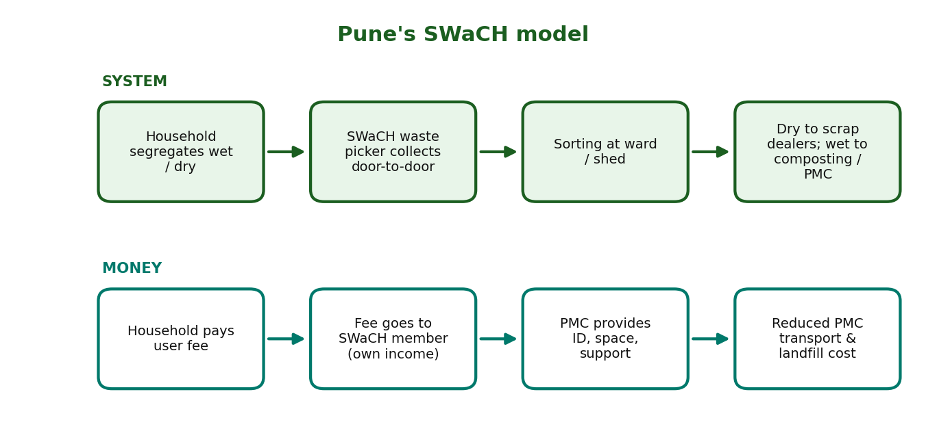
Figure 8: Service and money flow in the SWaCH model

4. Impact and Results
Indicator | Data / Result | Significance
Members | Several thousand waste-picker members (approx. 3,000-4,000) | Large formal workforce
Households served | Roughly a million households (approx.) | City-scale coverage
Income | More stable and higher than unorganised picking | Dignity and security
Landfill diversion | Substantial reduction in waste reaching dumps | Savings for PMC
Recognition | Widely cited as a global good-practice model | Replicable framework
Values are approximate; verify with SWaCH and KKPKP annual reports.

5. SWOT Analysis
Strengths  - Worker-owned cooperative  - Strong community trust and door-to-door reach  - Increases segregation quality | Weaknesses  - Dependence on PMC contracts  - User-fee collection challenges  - Physical hardship of work
Opportunities  - Add e-waste, bulk generator and EPR services  - Scale to other cities  - Better sorting infrastructure | Threats  - Privatisation of collection contracts  - Contract renewal uncertainty  - Rising formal competition

6. Comparison with India
Parameter | This case | India / benchmark
Waste-picker role | Owners of a cooperative | India: mostly unrecognised
Financing | User fee + recyclables sale | Often only municipal payments
Segregation | Improved by direct contact | Poor in most cities
Governance | Partnership with municipal body | Often contractor-driven

7. Recommendations
- Replicate cooperative models with legal recognition in all urban local bodies.
- Guarantee stable contracts and fair fee revision.
- Provide sorting sheds, PPE and social security.
- Link cooperatives to EPR obligations for payments per kg.
- Digitise data for transparency.

8. Conclusion
SWaCH proves that inclusion improves both efficiency and equity. Its future depends on secure contracts and integration with EPR financing.

9. References
- SWaCH Seva Sahakari Sanstha Maryadit - annual reports.
- KKPKP - documentation on waste picker organising.
- Pune Municipal Corporation - SWM reports.
- WIEGO and Global Alliance of Waste Pickers publications.

Case Study 9: Dharavi Recycling Ecosystem
Region: Dharavi, Mumbai Theme: Informal circular economy, redevelopment risk

1. Executive Summary
Dharavi, one of Asia's largest informal settlements, hosts a dense recycling economy of thousands of micro-enterprises that sort, wash, shred, melt and trade plastics, metals, paper, cloth and e-waste. Widely quoted estimates suggest it processes a very large share of Mumbai's plastic waste and generates annual turnover of hundreds of millions of dollars. It is a strong example of low-cost circularity, but also of unsafe conditions and vulnerability to redevelopment.

2. Background
Dharavi covers a few square kilometres in central Mumbai with a population commonly estimated in the several-lakh range. Migrant communities built specialised clusters for plastics, leather, pottery, garments and scrap.
The Dharavi Redevelopment Project (developer selected in 2022) plans large-scale rehabilitation, raising concerns about relocation of businesses and the future of the recycling clusters.

3. Strategy / Initiative
- Networks of ragpickers and kabadiwalas gather waste from across the city.
- Specialised units sort by polymer or metal grade, wash, shred, melt and pelletise.
- Flakes and granules are sold to manufacturers, creating cheap secondary raw material.
- Community-based finance and informal contracts keep costs very low.
- Recent policy discussion on providing designated spaces for recycling in redevelopment plans.
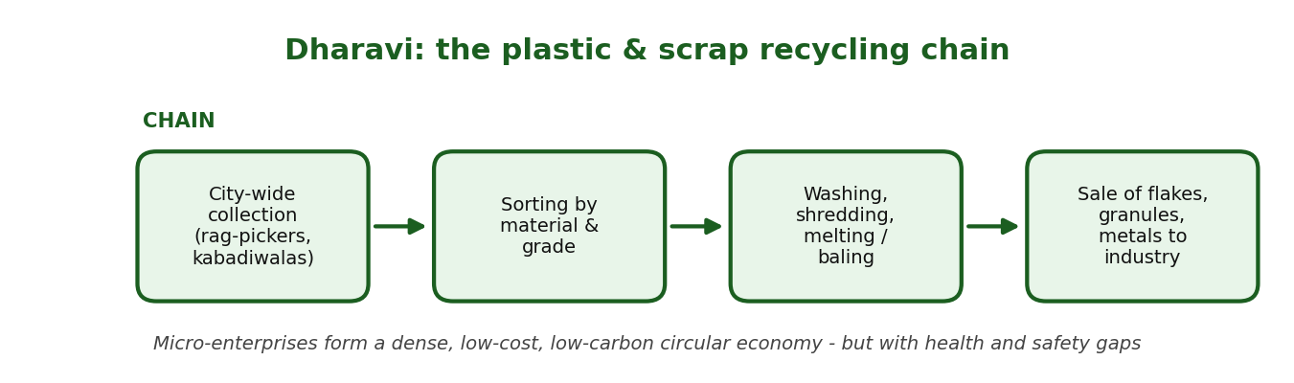
Figure 9: The plastic and scrap recycling chain in Dharavi

4. Impact and Results
Indicator | Data / Result | Significance
Micro-enterprises | Thousands of small units (widely quoted 10,000+) | Vast informal industrial base
Employment | Large workforce (often quoted in the tens of thousands or more) | Livelihood engine
Plastic recycling | Commonly cited as handling a majority of Mumbai's recyclable plastic | Major landfill diversion
Turnover | Widely quoted as hundreds of millions of US dollars per year | Economic significance
Risks | Fire, toxic exposure, poor sanitation | Need for safer processes
Dharavi statistics vary widely across sources; treat as indicative and cite the specific study you use.

5. SWOT Analysis
Strengths  - Low-cost and low-carbon recycling  - Deep skills and networks  - High recovery of recyclable material | Weaknesses  - Unsafe working conditions  - No formal recognition or social security  - Pollution from unregulated processes
Opportunities  - Formalise clusters with safe industrial spaces  - Link to EPR compliance and brands  - Training and technology upgrades | Threats  - Redevelopment displacing businesses  - Regulatory crackdowns without alternatives  - Competition from large formal plants

6. Comparison with India
Parameter | This case | India / benchmark
Recycling model | Dense micro-enterprises | Japan/Switzerland: industrial plants with strict standards
Cost | Very low | Formal recycling more costly
Safety | Poor | High standards abroad
Policy status | Unrecognised | EPR systems formalise actors abroad

7. Recommendations
- Protect and integrate recycling clusters in redevelopment plans with dedicated, safe spaces.
- Provide PPE, safety norms and healthcare access.
- Register units and connect them to EPR buyers and brands.
- Offer micro-credit and technology support for cleaner processing.
- Involve residents in planning.

8. Conclusion
Dharavi demonstrates that circular economy already exists in Indian cities. The policy task is to formalise and upgrade it, rather than erase it.

9. References
- Government of Maharashtra / SRA - Dharavi Redevelopment documents.
- Academic studies on Dharavi's recycling economy (e.g. published field surveys).
- WIEGO reports on informal waste workers.
- News and policy analyses on Dharavi Redevelopment Project.

Case Study 10: Dell's Circular Economy Strategy
Region: Global corporation (with India operations) Theme: Corporate circularity, closed-loop materials, take-back

1. Executive Summary
Dell Technologies has set corporate goals to make its products and packaging circular: use recycled, renewable or lower-carbon materials, reuse or recycle an equivalent amount of product for every product sold, and use packaging that is fully recycled or renewable and recyclable by 2030. It supports these with take-back programmes, closed-loop plastics from used electronics, recovered gold from motherboards and ocean-bound plastic in packaging. It shows how a manufacturer can turn EPR into strategy.

2. Background
As a major PC and server maker, Dell faces EPR obligations and rising e-waste. It has run take-back and recycling programmes for many years, including Dell Reconnect with Goodwill, and reports having recovered billions of pounds of used electronics.
Its sustainability strategy sets 2030 targets and reports progress annually.

3. Strategy / Initiative
- Design: increase recycled and renewable content, design for repair, upgrade and disassembly.
- Closed loop: use recycled plastics from returned electronics and recovered gold in new devices.
- Take-back: mail-back, trade-in and partnerships (such as Reconnect) for old equipment.
- Packaging: use recycled, renewable and ocean-bound plastic materials with recyclable design.
- Reporting: publish targets and progress; comply with EPR rules such as India's.
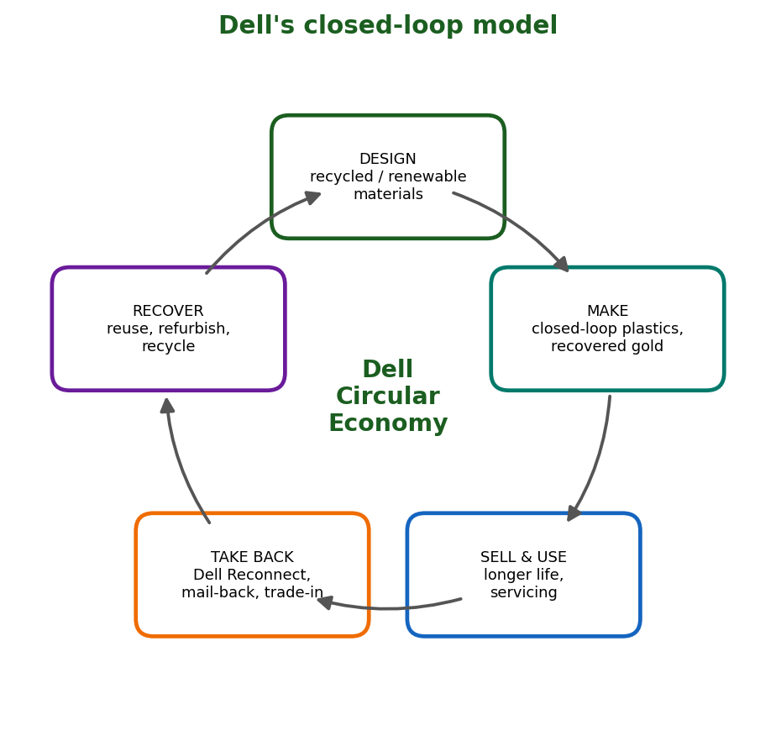
Figure 10: Dell's closed-loop circular model

4. Impact and Results
Indicator | Data / Result | Significance
Product goal | Over half of product content from recycled/renewable/reduced-carbon material by 2030 | Design-led circularity
Take-back goal | Reuse or recycle an equivalent product for every one sold (by 2030) | Full-lifecycle responsibility
Packaging goal | 100% recycled or renewable packaging by 2030 | Waste reduction upstream
Recovery to date | Billions of pounds of used electronics recovered since 2007 (company-reported) | Scale of take-back
Innovations | Closed-loop plastics, recovered gold, ocean-bound plastic | Circular design in practice
Company-reported figures change annually; verify with Dell's latest ESG / sustainability report.

5. SWOT Analysis
Strengths  - Scale and supply-chain leverage  - Established take-back and recycling partners  - Transparent public goals | Weaknesses  - Reliance on company-reported data  - Recycled content still a fraction of total  - Product complexity limits repairability
Opportunities  - Growth of refurbished/'as-a-service' models  - Regulation (EPR, right-to-repair) favouring circular firms  - Customer demand for green IT | Threats  - Volatile recycled-material prices  - Consumer reluctance to return devices  - Greenwashing scrutiny

6. Comparison with India
Parameter | This case | India / benchmark
Take-back | Global programmes, EPR-linked in India | India: limited consumer return; informal sale dominates
Materials | Recycled and closed-loop | India: recyclers recover metals mostly; less closed-loop use
Reporting | Annual ESG report | Few Indian producers publish detailed data
Role of EPR | Strategic | Often compliance-driven

7. Recommendations
- Indian producers should set public circularity goals like Dell.
- Expand mail-back and trade-in programmes with easy consumer access.
- Partner with authorised recyclers and integrate informal collectors.
- Design for repair, reuse and recycled content, supported by right-to-repair rules.
- Independent verification of ESG claims.

8. Conclusion
Dell illustrates that circularity can be embedded in design, supply chain and take-back. For India, the lesson is that EPR should become a business strategy, not just a compliance cost.

9. References
- Dell Technologies - ESG / Sustainability Report and 2030 goals.
- Dell Reconnect programme documentation.
- MoEFCC - E-Waste Rules 2022 (producer obligations).
- Ellen MacArthur Foundation - Circular Economy resources.

10. Exam Revision Sheets (one per case)
Case 1: Why Japan Recycles More Than Most Countries: Lessons for India
Must-remember facts  - Basic Act 2000 sets 3R hierarchy  - Packaging law 1995/97; Appliance law 2001; Auto 2005; Small appliance 2013; Plastics Act 2022  - Consumer pays fee at disposal for appliances  - Kamikatsu: 40+ categories, zero-waste 2003  - PET recycling ~85%+; MSW recycling only ~20% | Likely exam questions  - Explain how legal design drives Japan's recycling success.  - Critically evaluate: 'Japan should be India's model.'  - Suggest 4 policy transfers from Japan to India.
Key terms: 3R, Sound Material-Cycle Society, EPR, manifest system, Kamikatsu, thermal recovery | Hook: Japan = Law + Segregation + Shared responsibility.

Case 2: Switzerland's E-Waste Success Story
Must-remember facts  - ORDEO 1998; PROs: SENS, SWICO, SLRS  - ARF paid by buyer at purchase  - Free take-back by every seller  - Collection ~15-16 kg/person  - Audited, certified recyclers | Likely exam questions  - Explain the ARF mechanism with a diagram.  - Compare Swiss and Indian e-waste systems.  - Can India adopt ARF? Discuss.
Key terms: ARF, PRO, ORDEO, take-back, polluter pays, traceability | Hook: Swiss = Pay upfront, return free, recycle audited.

Case 3: India's E-Waste Management Rules 2022
Must-remember facts  - Notified Nov 2022; effective 1 Apr 2023; replaces 2016 Rules  - ~106 EEE items (was 21)  - CPCB EPR portal; certificates with floor/ceiling price  - Targets ~60/70/80%  - Refurbishers and recyclers registered | Likely exam questions  - Explain the key features of E-Waste Rules 2022.  - How do the 2022 Rules differ from 2016?  - Evaluate the certificate system.
Key terms: EPR, EPR certificate, refurbisher, CPCB portal, floor price, environmental compensation | Hook: 2022 = Wider scope + Digital portal + Tradable certificates.

Case 4: India's Extended Producer Responsibility (EPR): Success or Paper Compliance?
Must-remember facts  - EPR: 2011 e-waste rules; PWM 2016; Battery 2022  - Certificate model + CPCB portals  - Main risk: paper compliance / fake certificates  - Verdict: strong design, uneven implementation | Likely exam questions  - 'EPR in India is paper compliance.' Discuss.  - Suggest reforms to make EPR verifiable.  - Compare Indian EPR with Swiss ARF.
Key terms: EPR, PRO, certificate trading, traceability, paper compliance, polluter pays | Hook: EPR works only when certificate = verified tonnage.

Case 5: Bengaluru: India's E-Waste Capital?
Must-remember facts  - IT hub; KSPCB authorises recyclers  - e-Parisara: early authorised recycler  - BSWML formed 2019  - Strong formal chain for bulk generators  - Household leakage remains | Likely exam questions  - Is Bengaluru India's e-waste capital? Argue.  - How can Bengaluru fix household leakage?  - Compare Bengaluru with Mumbai.
Key terms: KSPCB, bulk generator, authorised recycler, urban mining, informal leakage | Hook: Bengaluru = IT hub + formal recyclers + household gap.

Case 6: Mumbai's E-Waste Ecosystem
Must-remember facts  - Maharashtra is a top e-waste state; MPCB regulates  - Informal hubs incl. Dharavi; Lamington Road market  - Ecoreco: authorised recycler  - Main issue: informal dominance | Likely exam questions  - Discuss formal vs informal e-waste in Mumbai.  - How can Mumbai formalise scrap trade?  - Compare with Bengaluru.
Key terms: MPCB, informal sector, kabadiwala, authorised recycler, open burning | Hook: Mumbai = High volume + informal dominance.

Case 7: Kerala's Clean Kerala Company
Must-remember facts  - CKCL: govt company (LSGD), 2019  - Haritha Karma Sena: women door-to-door collectors, user fee  - MCF and RRF network  - Plastic to roads and cement; e-waste drives | Likely exam questions  - Describe the CKCL model.  - Evaluate strengths and limits of HKS.  - What can other states learn?
Key terms: CKCL, HKS, MCF, RRF, Suchitwa Mission, Kudumbashree, user fee | Hook: CKCL = Local body + Women's groups + Recyclers.

Case 8: Pune's SWaCH Model
Must-remember facts  - SWaCH formed 2008 with KKPKP and PMC  - Worker-owned cooperative of waste pickers  - Household user fee; door-to-door  - Recognised as global best practice | Likely exam questions  - Explain the SWaCH model.  - How does SWaCH benefit PMC?  - Suggest scale-up strategies.
Key terms: SWaCH, KKPKP, PMC, cooperative, user fee, inclusive SWM | Hook: SWaCH = Waste pickers as owners, not scavengers.

Case 9: Dharavi Recycling Ecosystem
Must-remember facts  - Informal recycling hub in Mumbai  - Thousands of micro-enterprises; hundreds of millions USD turnover (quoted)  - Plastic, metal, paper, cloth, e-waste  - Redevelopment risk to recycling units | Likely exam questions  - Explain Dharavi's recycling chain.  - Pros and cons of informal recycling.  - How to protect Dharavi's recyclers in redevelopment?
Key terms: informal circular economy, micro-enterprise, redevelopment, formalisation, kabadiwala | Hook: Dharavi = Circular by necessity, unsafe by neglect.

Case 10: Dell's Circular Economy Strategy
Must-remember facts  - 2030 goals: >50% recycled/renewable content; reuse or recycle equivalent product per sale; packaging 100% recycled/renewable  - Closed-loop plastics and recovered gold  - Dell Reconnect (with Goodwill)  - Company-reported data | Likely exam questions  - Explain Dell's circular economy strategy.  - How can Indian firms adopt such strategies?  - Evaluate risk of greenwashing.
Key terms: circular economy, closed loop, take-back, EPR, ocean-bound plastic, ESG | Hook: Dell = Design, recover, reuse, report.

