

**e-Yantra Robotics Competition 2016**

**Theme - Launch a Module**

**Theme and Implementation Analysis**

**LM-1224**

|  |  |
| --- | --- |
| **Team leader name** | Hrushikesh Naresh Budhale |
| **College** | Walchand College of Engg., Sangli |
| **Email** | hruhnb@gmail.com |
| **Theme assigned** | Launch a Module |
| **Date** | 05/02/2017 |

**Arena Setup (5) Q1. Insert pictures of the fully assembled arena as instructed in the Rulebook.**

< Prepare the arena as per instructions given in Section 3 of Rulebook. Refer to the Sample_Arena_Configuration.pdf provided with this document and set up the arena according to the configuration. You must insert two images: (i) image of the arena with all the Objects, Obstacles and Color Markers clearly visible and (ii) image of the Overhead Camera Setup (you may refer to the sample image Figure 8, in the rulebook). Insert the images below. >

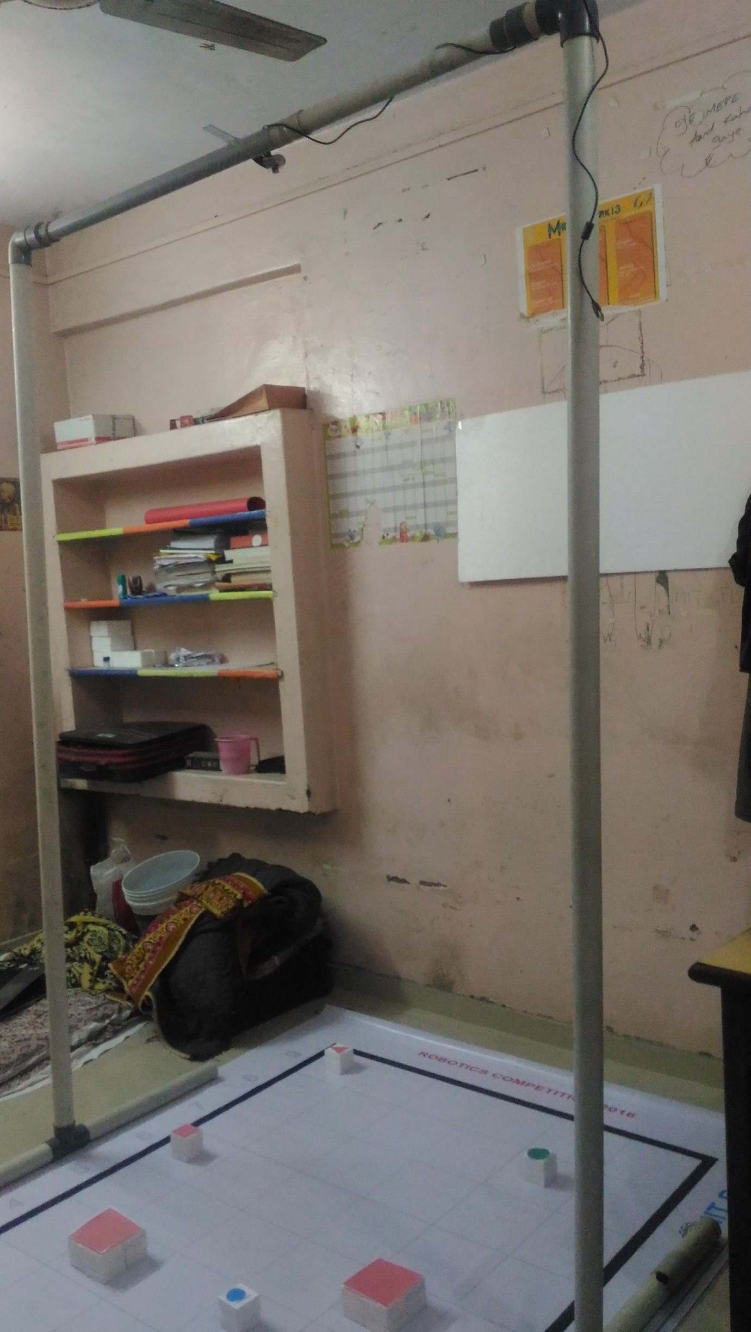

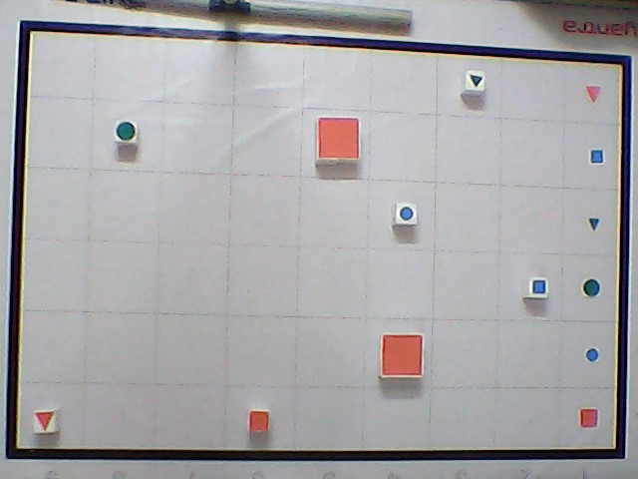

**Scope (5) Q2. State the scope of the theme assigned to you.**

< Teams should briefly explain the assigned theme in their own words. What in your opinion is the purpose of such an application? You may use figures / diagrams to support your answer.

Answer format: Text - limit: 50-100 words>

The theme ‘Launch a Module’ Deals with the stages that take place during a launch. In this theme we are preparing for stage 2 of rocket. In an actual rocket, the stage 1 of the rocket has to ignite the stage 2 motor. Then the first stage gets separated. These are the critical operations during stage separation. Our robot has to correctly place the objects in the door area in order to complete these critical operations. Here objects resemble the key. When the keys are appropriately placed in the door area the first stage unlocks from the main rocket.

**BuildingModules (5)**

**Q3. Identify the major components required for designing the robotic system for the solution of the theme assigned to you.**

< Teams should classify the components into various categories: mechanical systems, electronic systems etc. and mention how these will be used in the theme. You may draw diagrams/figures to illustrate your answer.

Answer format: Bulleted form

1. Component 1

2. Component 2

3. Component ….etc.

* Mechanical Systems
  + Drive
    - Wheels
    - Motors
    - Encoding disc
  + Robotic Arm
    - Servo motors
    - Arm frame
  + Camera stand
    - Using PVC pipes.
* Electronics Systems
  + Atmega2650
  + LCD Display
  + Buzzer
  + Camera
  + Xbee and Xbee adapter
  + Rotary encoder for distance measurement
  + Sharp distance sensor
* Software
  + Robot Controller Code on Atmega 2560(Embedded C)
  + Image processing and Path finding code(Python)

**Actuators (15)**

**Q4. List all the actuators present on Firebird V robot. Besides the existing actuators, please mention any additional actuators that may be required for designing the robot system in your theme. Mention and justify the use of additional components. (5)**

< Team should list all types of actuators they will need for making the complete system. Teams have to mention: (i) actuators that are already present on Firebird V robot and (ii) actuators that they need to interface with the Firebird V robot.

You can also draw some diagrams/figures to illustrate your answer.

Answer format: Bulleted form

1. Actuator1

2. Actuator2

3. Actuator3…. etc.

>

Actuators present on the Firebird V robot are:

1. Two 60 rpm motors with position encoders.

Additional actuators required:

2. Two servo motor for grabbing and positioning of the arm in pick and place action.

**Q5. Explain the design and working of the mechanism used to pick up Objects and how it is mounted on the Robot. (10)**

<

Explain and draw figure(s) of your mechanism and show how you are planning to mount the mechanism on the robot.

>

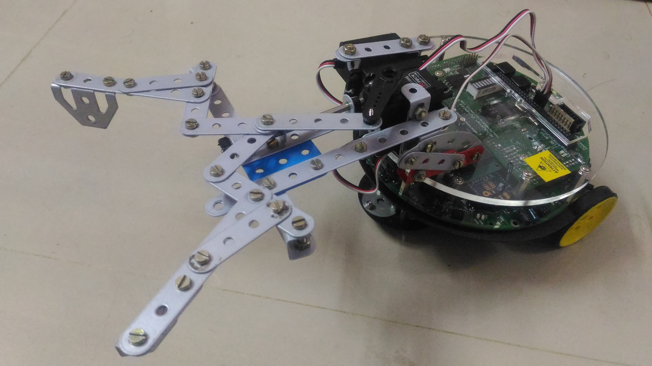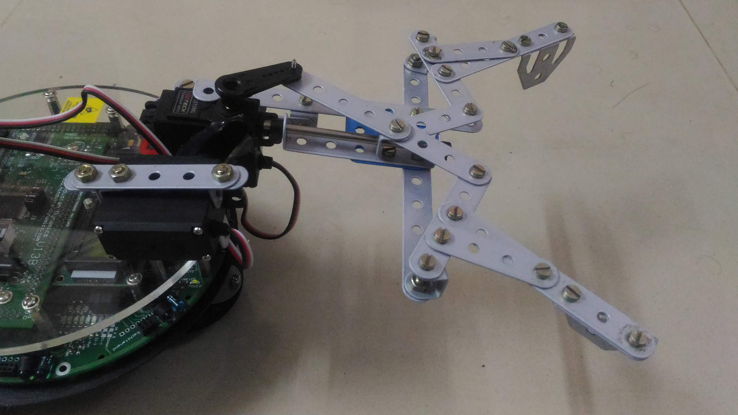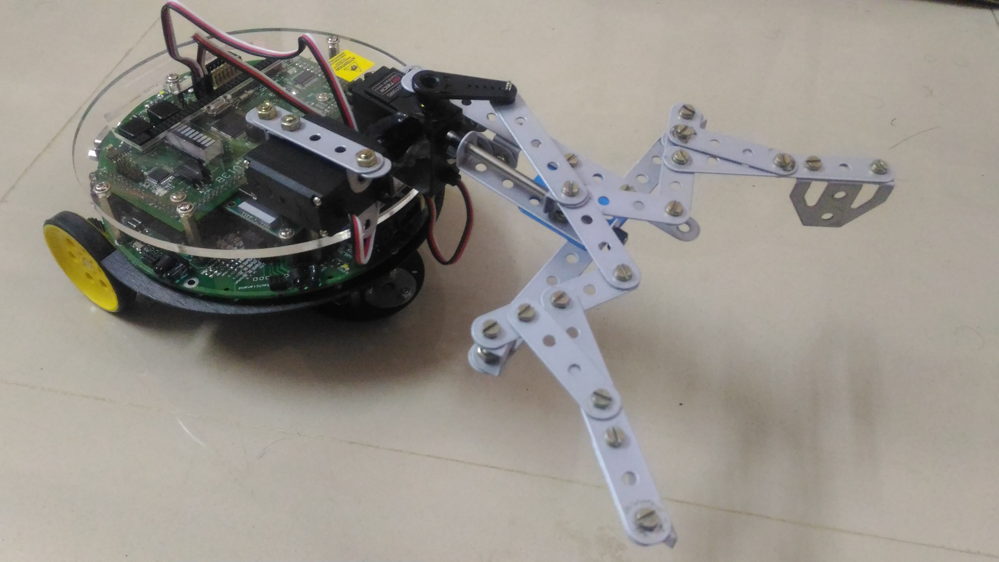

**Testingyour knowledge (related to rule-book)(10)**

**Q6. What is the difference between an Object and an Obstacle? (5)**

< Please explain the answer in your own words. The answers copied directly from rulebook will not be considered for evaluation. You can also draw some diagrams/figures to illustrate your answer.

Answer format: Text/Bullets

Word-limit: 50 words

>

1. Objects are of size 6x6x6 cm in size and can be of any shape (4sided, Triangle, Circle) and color (Red, Blue and Green) on the other hand obstacles are 12x12x6 cm in LxBxH respectively and having only 4-sides and Red color.
2. Considering rules, objects are to be picked up by robot and placed in appropriate section of door area according to its pair by the robot on the other hand robot should avoid obstacles.

**Q7. What will the robot do (according to your algorithm) if a {Red, Square, Large} colour marker is present in the Door Area and two {Red, Square, Large} Objects are present in the Working Area.(5)**

< Please explain the answer in your own words. You can also draw some diagrams/figures to illustrate your answer.

Answer format: Text/Bullets

Word-limit: 100 words

>

1. According to our current algorithm we are going to find the distance of the object from the robot as well as distance of that object from the respective marker and add both distances.
2. Similarly we are going to find the sum of distances from other object to marker and robot.
3. We are assigning additional weight to the turns in the path since a little bit longer path with minimum turns is better than the shortest path with many turns for a robot to complete the task in minimum possible time.
4. And will choose the one with least weight.

**Camera and Image Processing (15)**

**Q8. How will you detect the Position and Orientation of the robot in the arena using the Overhead Camera? What kind of Image processing technique would you use? (10)**

<

Explain in detail the process you will adopt in order to detect the position and orientation of robot. You can also draw some diagrams/figures to illustrate your answer.

Answer format: Text/Bullets

Word-limit: 150 words

>

1. For detecting position and orientation we are going to place a **Black colored Marker** on the robot since black colored objects are not present on the arena.
2. The marker will be an image as shown in the following figure.
3. The image acquired by overhead camera will be processed to get the black colored object’s (which is our marker) contour.
4. Here we are going make use of points generated by using different properties of same shape as follows.
5. The image shown above is having such shape that it will generate a point A (shown in red) by using function cv2.moments() for centroid. And will generate another point B (shown in blue) by using function cv2.minEnclosingCircle() for minimum enclosing circle.
6. After getting these 2 points we will find angle made by the vector formed joining points A and B (A head and B tail) with respect to an arbitrarily considered vector joining center of cell F1(tail) and A1(head).

**Q9. How will you differentiate between an Obstacle and a Red coloured Object ? (5)**

<

Explain in detail the process you will adopt in order to differentiate between the two. You can also draw some diagrams/figures to illustrate your answer.

Answer format: Text/Bullets

Word-limit: 100 words

>

1. Before detecting we are going to measure size of region inside the black border(in number of pixels) and compare it with actual size of grid and make scale (scale = actual size/ grid size) which will help to convert and compare size of block(which can be a obstacle or object) irrespective of the distance of camera from the ground.

1. After acquiring each block (which can be a obstacle or object) we are going to differentiate between their color and shape which will eliminate shapes and colors other than 4-sided and red respectively.
2. To differentiate between their size we are going to use the scale with some percentage of tolerance (in area of contour) to tackle noise or discrepancy in detection.

**Navigation Scheme (5)**

**Q10. How will you navigate the robot in the arena using the Overhead Camera? (5)**

<

Explain in detail the process you will adopt for navigating the robot in the arena. You can also draw some diagrams/figures/flowcharts to illustrate your answer.

Answer format: Text/Bullets

Word-limit: 100 words

>

1. The program is going to send an integer value through Xbee packets to the robot when robot has executed its previous command .
2. We have designed a protocol for communication of robot and program such that the most significant number in the integer will address the command number which is to be executed and the 3 successive least significant numbers will address the value required for that function to execute.

e.g.-

Consider a robot is to be moved “forward” by “120”mm.

The program will send the integer value “4120” where 4 is number of command arbitrarily assigned for forward motion and 120 will tell the robot how much distance to be moved.

1. After complete execution of command the robot is going to send a value which is arbitrarily fixed to tell the program that process is executed.

**Communication (5)**

**Q11. Describe how you plan to implement communication between the computer and the robot. Will this communication be uni-directional or bi-directional ? Justify your answer. (5)**

<

Mention the kind of data you will be transmitting to the robot to/from the computer.

Answer format: Text/Bullets

Word-limit: 100 words

>

* We are going to make use of module serial in library pyserial (which is open source)

for communication with robot through python program.

* The communication is going to be **2 way communication** for the reasons mentioned below.
* In our algorithm the python program (computer) is going to send instructions of some predefined type e.g.- move x mm forward, pick the obj. , place the obj., turn x degree to right/left etc.
* Even though program is able to detect the motion of robot; It is unable to detect whether root has completed the given instruction and can lead to make robot follow two instructions simultaneously. This can cause either leaving the previous one partially completed or acting unnecessary movement.
* Hence we are going to make the robot to tell the program if it has completed the instruction by sending a message to program.
* The program is going to halt (stop) till it receive the instruction from the robot. And will resume sending next command or process after getting the message of complete execution from the bot.

**Algorithm Analysis (25)**

**Q12. Draw a flowchart to explain the algorithm you propose to use to complete the given task. (25)**

< The flowchart should elaborate the major functions that they will be using for completing the assigned theme.

Follow the standard pictorial representation used to draw the flowchart.

>

Acquire image

Identify ROI and detect objects and obstacles

Mark object as obstacle which does not have matching marker

Graph Construction

Find nearby object to robot using BFS

Find its shortest path and convert it to discrete points

Find angle between robot’s orientation and the line joining robot and nearest point in neighbouring cell on the path and the distance from it.

Send command to turn the robot to turn by that angle

Wait for response

If correct send command to move forward by that distance

Confirm the orientation using camera

Else correct and repeat

Again repeat till the bot reaches to object

Send command to pick object

Find shortest path from object position to matching marker and convert it to discrete points

Send command to turn the robot to turn by that angle

Wait for response

Find angle between robot’s orientation and the line joining robot and nearest point in neighbouring cell on the path and the distance from it.

Find angle between robot’s orientation and the line joining robot and nearest point in neighbouring cell on the path and the distance from it.

Send command to turn the robot to turn by that angle

Confirm the orientation using camera

If correct send command to move forward by that distance

Else correct and repeat

Again repeat till the bot reaches to object

Wait for response

Send command to place object

If all markers are covered

Exit

Else

repeat

**Challenges (10)**

**Q13. What are the major challenges that you anticipate in addressing this theme? How do you plan to overcome these challenges? (10)**

< Answer format: Bulleted form

1. Challenge 1

2. Challenge 2

3. Challenge 3, etc.

Processes which we consider as major challenges are as follows:

1. As given task is kind of a linear programming problem where shortest path for completing the task can be found its quite challenging to make generalized program considering all possibilities to shorten the distance on which robot has to travel throughout the task making wise selection of priority of objects.
2. Another major challenge is to make a mechanism for pick and place movement of the object using 2 servo motors.
3. Detecting Region of interest (in this case region inside border) and perfectly identifying the type of object.
4. Detecting position and orientation of robot and designing a communication system for proper co-ordination between computer program and hardware program.
5. Learning language used for programming robot and communication using Xbee module.