Distributed Generation System

Ben Ofodile, FaezYahya, Gerardo Caicedo, Joshua Meduoye, Ankit Bhatia

Purdue School of Engineering and Technology, Indianapolis

***Abstract- Model a 3-phase power plant which contains steam turbine and distributed system. The the system generates 100KW power keeping the power factor to unity. Distributed system is represented by 3-phase photovoltaic system to reduce gas emission. Both systems have been designed to operate individually and combined to supply 100KW at the load. Input torque to synchronous generator and DC voltage to distributed system change depend on the output power capacity generated by each system. Both systems maintain constant voltage at the load.***

***Index Term- synchronous generatorpulse width modulation (PWM), and low pass filter (LPF).***

1. INTRODUCTION

As conventional source of energy is disappearing and demand of energy is bumping with exponential rate, for the available source it is challenging to meet expectations. So this project focus on combing traditional generation with distributed generation, which can be used as well individually. Here, the schematics of distributed system is explained as complete alternative or part of the existing energy system so that wastage and pollutant is less. The combination of different source of energy provider makes us to cope up with our demand in convenient way. Here the source of mechanical power for synchronous comes from steam turbine. However, the source power for disturbed system is the sun. It is converted from DC voltage to AC voltage through an inverter that is driven with PWM signal. Line voltages are obtained as output for voltage controlled source. These line voltages are filtered using three individual RC low pass filters. Specifications are considered while designing as per requirements (50 KW at synchronous generator output and 50 KW at the output of low pass filter) to generate power of 100 KW at the resistive load.

1. SYNCHRONOUS GENERATOR

A synchronous machine is an ac rotating in case of steady state operation speed should be proportional to frequency of the armature current.. The magnetic field created by the armature currents rotates at the same speed as that created by the field current

on the rotor,. which is rotating at the synchronous speed, and a steady torque results.

Synchronous machines are commonly used as generators especially for large power systems, such as turbine generators and hydroelectric generators in the grid power supply. Because the rotor speed is proportional to the frequency of excitation, synchronous motors can be used in situations where constant speed drive is required. Since the reactive power generated by a synchronous machine can be adjusted by controlling the magnitude of the rotor field current, unloaded synchronous machines are also often installed in power systems solely for power factor correction or for control of reactive kVA flow. Such machines, known as ***synchronous condensers***, may be more economical in the large sizes than static capacitors.

With power electronic variable voltage variable frequency (VVVF) power supplies, synchronous motors, especially those with permanent magnet rotors, are widely used for variable speed drives. If

the stator excitation of a permanent magnet motor is controlled by

its rotor position such that. the stator field is always 90o (***electrical***) ahead of the rotor, the motor performance can be very close to the conventional brushed dc motors, which is very much favored for variable speed drives. The rotor position can be either detected by using rotor position sensors or deduced from the induced *emf*in the stator windings. Since this type of motors do not need brushes, they are known as brushless dc motors.

MACHINE STRUCTURE

The armature winding of a conventional synchronous machine is almost invariably on the stator and is usually a three phase winding. The field winding is usually on the rotor and excited by dc current, or permanent magnets. The dc power supply required for

excitation usually is supplied through a dc generator known as exciter, which is often mounted on the same shaft as the synchronous machine. Various excitation systems using ac exciter and solid state rectifiers are used with large turbine generators.

There are two types of rotor structures: round or cylindrical rotor and salient pole rotor.Generally, round rotor structure is usedfor high speed synchronous machines, such as steam turbine generators, while salient polestructure is used for low speed applications, such as hydroelectric generators

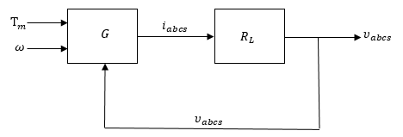

Fig. 1. Block Diagram of Synchronous Generator

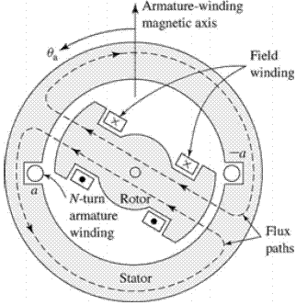

Fig. 2. Two-pole, 3-phase, wye-connected, salient pole synchronous machine windings

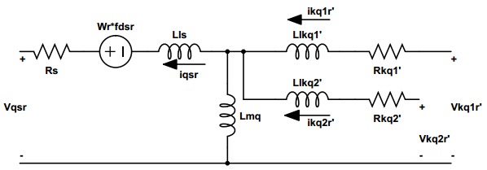

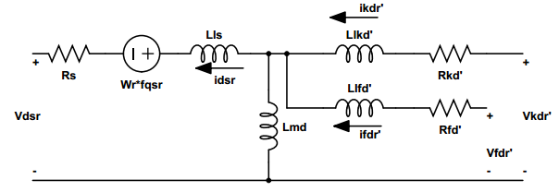

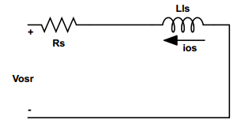

Fig. 3. Equivalent Circuit of Synchronous Generator

Equations

With help Park’s equation we obtain the following equations. Here the torque and speed from windmill system is input to synchronous. Current is output of it. The stator windings are identical with phase shift of 120 degree.

Stator voltage:

(1)

(2)

(3)

Rotor voltage:

(4)

(5)

(6)

(7)

Stator flux:

(8)

(9)

(10)

Rotor flux:

(11)

(12)

(13)

(14)

Mechanical torque equation:

(15)

Since Jm is constant the derivative of it will be equal to zero.

(16)

(17)

And we know

(18)

We can derive from Eq (2-18). Since our system is equal to 2 pole therefore hence:

(19)

(20)

(21)

Since our synchronous machine is equipped with only field winding we will be assuming,, , , , , , and . Therefore Eq (2-13) becomes:

(22)

And if we solve for

(23)

Also if we solve from Eq (2-6)

(24)

From Eq (2-13) if we solve for

(25)

(26)

Using the transformation for 3 phase from arbitrary reference frame from stationary reference frame:

(27)

Where

Once we obtained we can obtain from Ohm’s law.

(28)

Controlled voltage source is a three leg converter constituting six power switches,, , , , respectively. The upper switches q1, q2, q3 and ,, are complementary, which means = (1 -). The state of switches are represented. The conduction state of switches can be represented using binary variable as =1 for a closed switch and =0 for an open switch (where x=1, 2, 3). The pole voltages are given as,, can be defined as a function of the state of switches as:

(29)

(30)

(31)

And their respective output voltages,,are defined as:

(32)

(33)

(34)

Where Vno is the neutral voltage and is given as:

(35)

The state of switches is defined based on the input voltage ()

(36)

(37)

Here for a balanced three phase system sum of output voltages will be zero.

(38)

By simple back substitution of in equations, they can be written in the form of a matrix as shown below:

= * (39)

This low pass filter equation is for only one of them:

Where we take our input voltage equal to output of the control voltage source ()

By circuit analysis we obtain below equations:

(40)

(41)

(42)

By taking the euler we get as;

(43)

+ (8)+ (9) + (11)+ (12)+(13+ (14) MATLAB Simulation

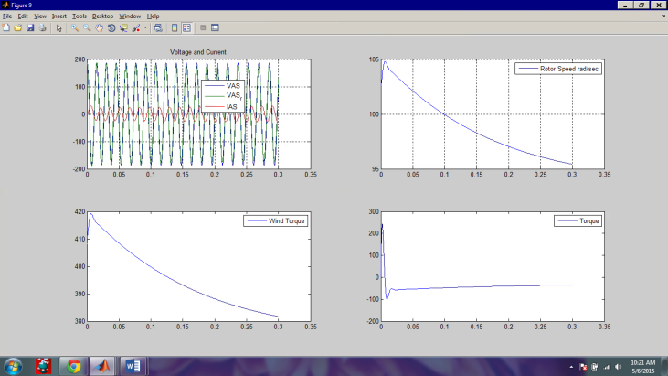

Fig. 4. Input Rotor Speed, Wind Torque and output Torque

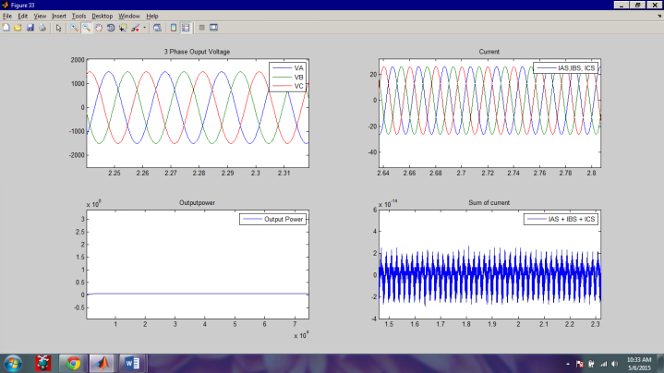Fig. 5. Output Voltage, Current and Power

1. Distributed system

3-Phase photovoltaic system is used for distributed system. Sunlight is available almost everywhere and the generated energy is emission-free. Solar panels are used to convert sunlight intensity to DC voltage. This voltage is fed into a 3-Phase DC-AC inverter to generate 3-Phase AC voltages. The inverter is driven by PWM signals to obtain 5 levels of modulated line to neutral voltages. These voltages then are filtered using low pass filter to produce a smooth sinusoidal voltage. Next section will discuss each step in details.

PULSE WIDTH MODULATION (PWM)

PWM is a technique used to generate pulse signals with varied duty cycles. Duty cycle is percentage of on time to period of one cycle. The average value of voltage is depending on the duty cycle. A 100% duty cycle means output voltage is always on and 50% duty cycle means average voltage is 50% of source voltage. Below is a figure shows different duty cycle. Switching frequency of PWM has to be much greater than the operating frequency to result with a smooth waveform.

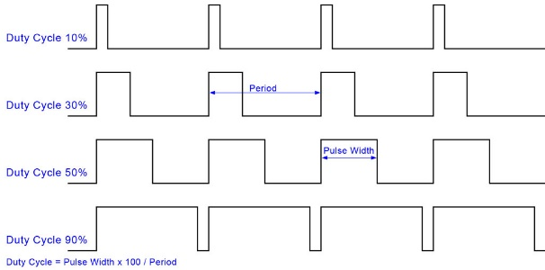

Fig. 6. Duty cycle

The basic principle behind PWM as it is pictured below, it employs two signals; one is a sinusoidal waveform with operating frequency of reference signal and the other one is a triangular waveform with much higher frequency. These two signals feed into a comparator and the comparator outputs modulated signal as pictured in figure 8.

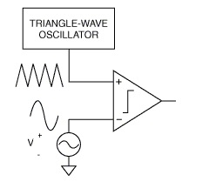

Fig. 7. PWM Circuit

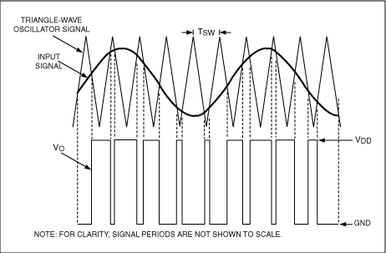

Fig. 8. Output Waveform

The biggest advantage of using PWM is, the load will dissipate less heat due to switching frequency reduces power loss. Another advantage is the odd harmonics can be placed far away from fundamental frequency which minimize the cost of designing a low pass filter.

In this project, 3 PWM circuits have been modeled to generated 3 signals and their inverted versions with 120 degree offset as pictured in figure 9. Each circuit is driving one leg of the DC-AC inverter to control two switches as pictured in figure 10.

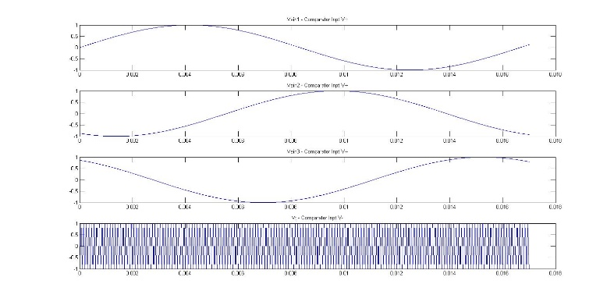

Fig. 9. PWM Comparator inputs

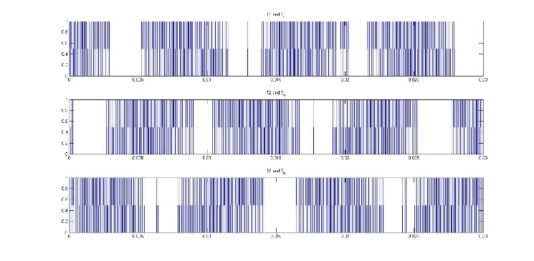

Fig. 10. DC-AC inverter switches states

The modulation index chosen for PWM is 127 which from switching frequency of 7740 Hz and operating frequency of 60 Hz. This modulation index is a multiple of 3 to suppress even harmonic and push the first odd harmonic back to switching frequency region to easily eliminate it through a simple low pass filter. Figure 11 shows frequency domain representation of line to neutral voltage for phase a. The fundamental frequency is at 60 Hz, and the first odd harmonic is at the switching frequency of ~7.74KHz.

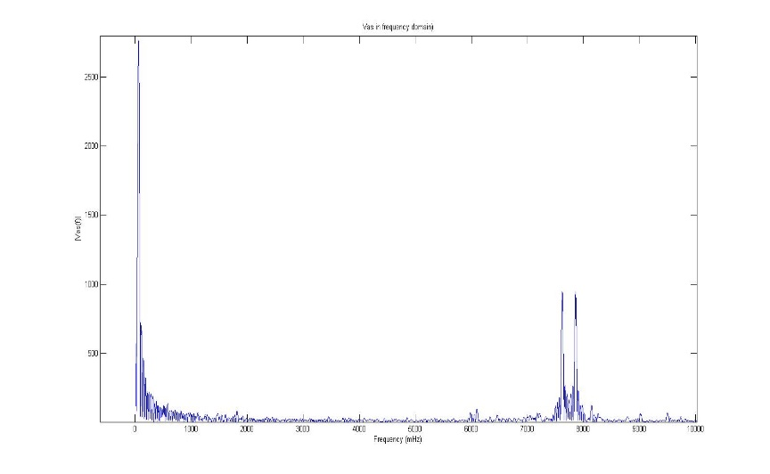

Fig. 11. Vas in frequency domain

1. 3-PHASE DC-to-AC INVERTER

To simulate dc to ac inverter, an ideal MOSFET will be implemented such as in figure 12; to simplify simulation, devices will be operated in the saturated (ON) and cut-off (OFF) regions.

The advantage of this strategy is that analysis will ignore both voltage across and current through each switch. Hence, if switch is ON, voltage across is zero and there will be current through the device. On the other hand, when switch is OFF, there will be no voltage.

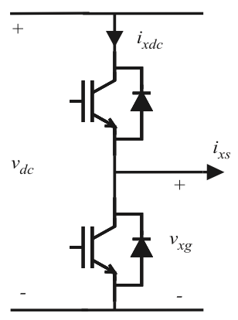

Fig. 12. One phase leg. Bottom switch has opposite state to Top switch.

Table 1

One phase leg circuit analysis.

|  |  |  |  |
| --- | --- | --- | --- |
| TOP SWICTH STATE | Ixdc | Ixs | Vxg |
| ON | Ixs | Ixs>0 | Vdc |
| OFF | 0 | Ixs=<0 | 0 |

Inverter Circuit Analysis

The project scope requested an R load (100 KW – power factor equal to 1). Hence, the equivalent impedance (Zeq) has zero imaginary components. Therefore, Zeq = R. In the 3-phase wye-connected load, each phase will have same exact load (R, in ohms). Also, it is assumed this to be a balanced system, where zero sequence Voltage is zero. This wye-connected load will be tied to the 3-phase inverter shown in Figure 11.

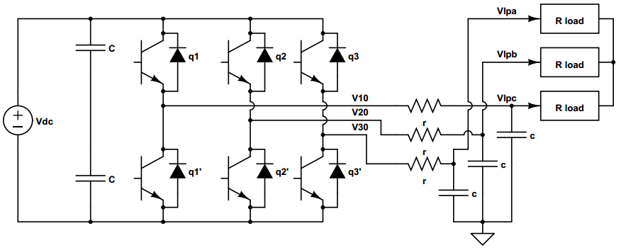

Fig. 13. Three-phase Inverter Topology

Switch state (Tx) uses logic levels (0 or 1) to turn ON/OFF the switch. Top switch state of each leg is provided by the output of comparator (Ideal Op amp). Since top and bottom switch state of each leg must opposite, an inverter is connected in parallel to the output of each comparator (Tx) to generate inverse signal T(x+3), where x=1, 2, 3 correspond to the top switches. See figure 14.

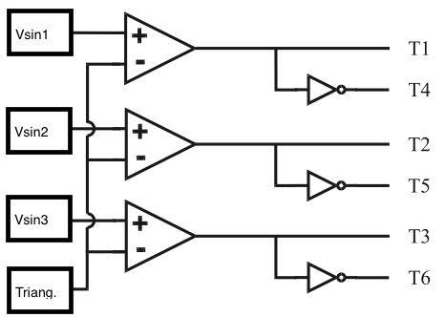

Fig. 14. Comparator topology for PWM Modulation

Equation Set1 - Line to ground voltage generation:

Vag = Vdc*T1 (44)

Vbg = Vdc*T2 (45)

Vcg = Vdc*T3 (46)

From equation set 1 and switch states in figure 10, we derive line-to-ground voltages. See figure 15.

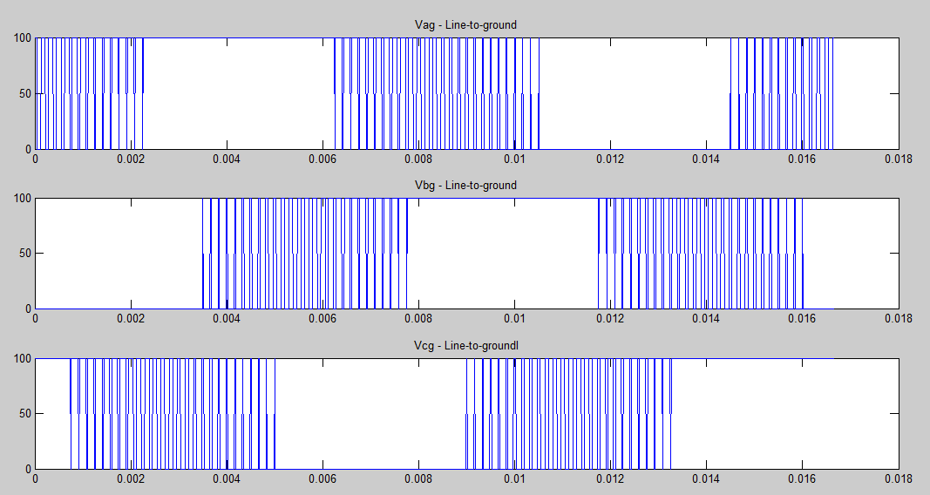

Fig. 15. Three-phase line-to-ground voltages

Equation set 2 - Line to neutral (Phase) voltage generation:

Vas = ((2*Vag)-Vbg-Vcg)/3 (47)

Vbs = ((2*Vbg)-Vag-Vcg)/3 (48)

Vcs = ((2*Vcg)-Vag-Vbg)/3 (49)

Vng = (Vag+Vbg+Vcg)/3 (50)

Since the Rload is the same for all phases, phase voltages can be derived from line to ground voltages and neutral to ground voltage value. See equation set 2 and figure 16 and 17.

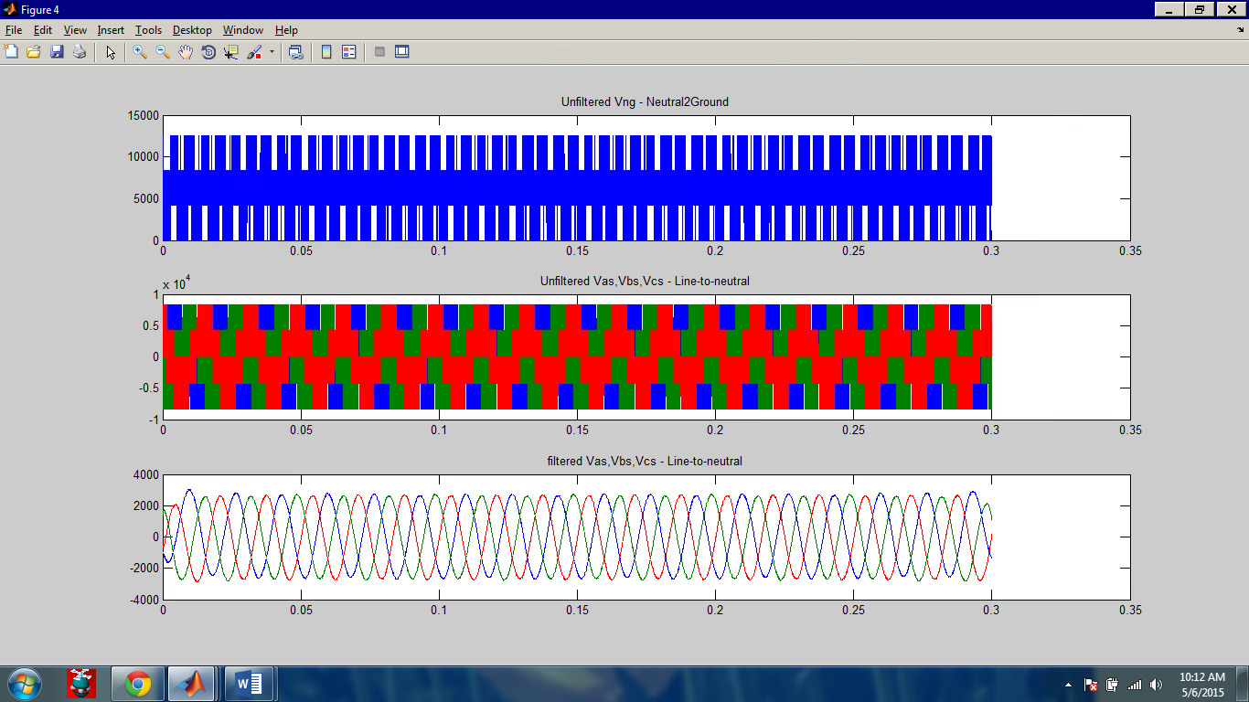

Fig. 16. Phase voltages and neutral-to-ground voltage

Equation set 3 - Switch states:

T1 = Vout_comp_a;

T4 = 1 - Vout_comp_a (51)

T2 = Vout_comp_b;

T5 = 1 - Vout_comp_b (52)

T3 = Vout_comp_c;

T6 = 1 - Vout_comp_c (53)

Table 2

Current v/s Switch State

|  |  |  |  |  |  |
| --- | --- | --- | --- | --- | --- |
| **T1** | **T2** | **T3** | **Ias** | **Ibs** | **Ics** |
| 0 | 0 | 0 | 0 | 0 | 0 |
| 0 | 0 | 1 | -Vdc/3R | -Vdc/3R | 2Vdc/3R |
| 0 | 1 | 0 | -Vdc/3R | 2Vdc/3R | -Vdc/3R |
| 0 | 1 | 1 | -2Vdc/3R | Vdc/3R | Vdc/3R |
| 1 | 0 | 0 | 2Vdc/3R | -Vdc/3R | -Vdc/3R |
| 1 | 0 | 1 | Vdc/3R | -2Vdc/3R | Vdc/3R |
| 1 | 1 | 0 | Vdc/3R | Vdc/3R | -2Vdc/3R |
| 1 | 1 | 1 | 0 | 0 | 0 |

MATLAB Simulation

1. Load: 100KW

2. Power factor: 1

3. DC Source: 8.5KV



Fig. 17. Inverter Output – Vxs Filtered

LOW PASS FILTER DESIGN

A **low**-**pass filter** is a **filter** that passes signals with a frequency lower than a certain cutoff frequency and attenuates signals with frequencies higher than the cutoff frequency.

The low pass filter in this project is used to filter out high frequency components of all the three phase voltages Vas, Vbs, and Vcs of the distributed generation system

STEPS

The following steps are carried out during the filtering of the unfiltered signals (Vas,Vbs,Vcs)

* This is done by applying a fast Fourier transform of the unfiltered signals (Vas, Vbs, Vcs) to transform from time domain space to frequency domain space. The output includes the frequency of the harmonics of the unfiltered signals
* Based on our cuttoff frequency of 100Hz we are able to cut off high frequency components of the signal using RC circuit.
* After cutting off the high frequency components of the signal, the signal is thenreconstructed from frequency domain back to time domain. Below figures show before and after filtering for Vas.

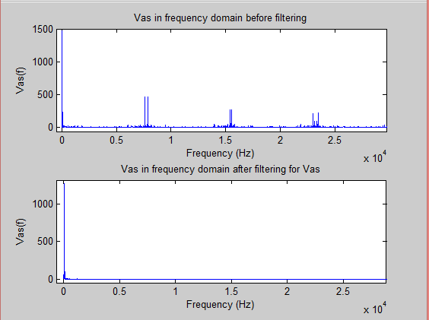

* Fig. 18. Vas before and after Filtering

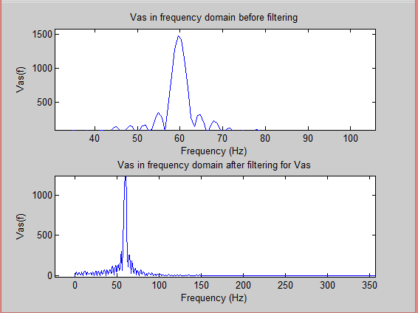

* Fig. 19. Zoomed in Fig 18

During the analysis of the unfiltered phase voltage signals (see top figures of 18 and 19) and the filtered phase voltage signals, the low pass filter was successfully in filtering unwanted harmonics in the unfiltered signals. The output was measured to make sure we had the right frequency for the phase voltages.

It was also found that as a result of the filtering (see bottom figures of 18 and 19), the output of our filtered signal lost some amplitude(power) in the process as compared to the original unfiltered signal. This is as a result of the amplitude of the higher frequency harmonics being filtered out that reduced the resulting amplitude of the filtered signal.

1. Combined System and conclusion

After proper working of individual system, next task is to combine all subsystem to get desired power across the load. Here we intended to get ~100 KW power, from which 50 KW is provided by synchronous and rest 50 KW is obtained from distributed. Both systems have the same phase shift for each voltage phase. Current from both systems is added together to achieve this power. Below first two figures show the output power of each system.

Ptotal= Psm + Pds= ~100 KW

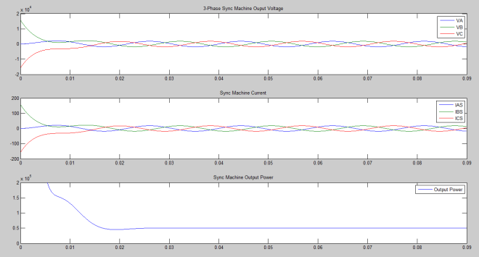

Fig 20: Synchronous Generator Output

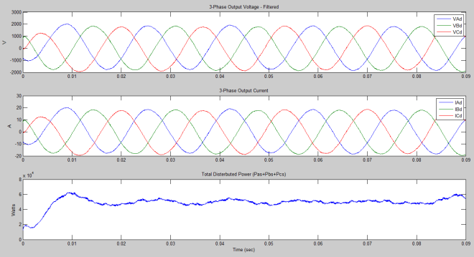

Figure 21: Distributed Generator Output

Below figure shows the combined power of both systems. The high power in the first few mille seconds is due to the start of synchronous machine. Power stabilizes once machine reaches steady state.

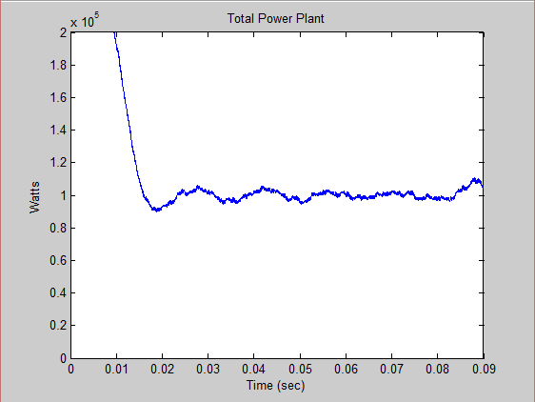

Figure 22: Total Power output

References

[1] Paul Krause, Oleg Wasynczuk, Scott Sudhoff, Steven Pekarek, “Analysis of Electrical Machinery and Drive Systems,” edition third John Wiley & Sons, Inc., Hoboken, New Jersey, 2013

[2] Mathworksuser manul for MATLAB and Simulink-2005

[3]E. C. dos Santos Jr, “Advanced Power Electronics Converters: PWM Converters Processing AC Voltages,” ISBN: 978-1-118-88094-4, 384 pages, Wiley-IEEE Press.

[4] E. C. dos Santos Jr, “Hydroelectricity and Power Electronics,” Environmental Impacts, Emerging Technologies and Challenges. NOVA Science Publishers, Inc. ISBN: 978-1-63321-728-7. Chapter 7: Parallel Three-phase Back-to-Back Converters.