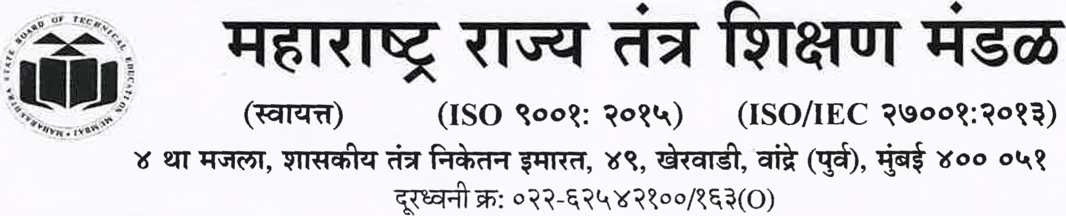
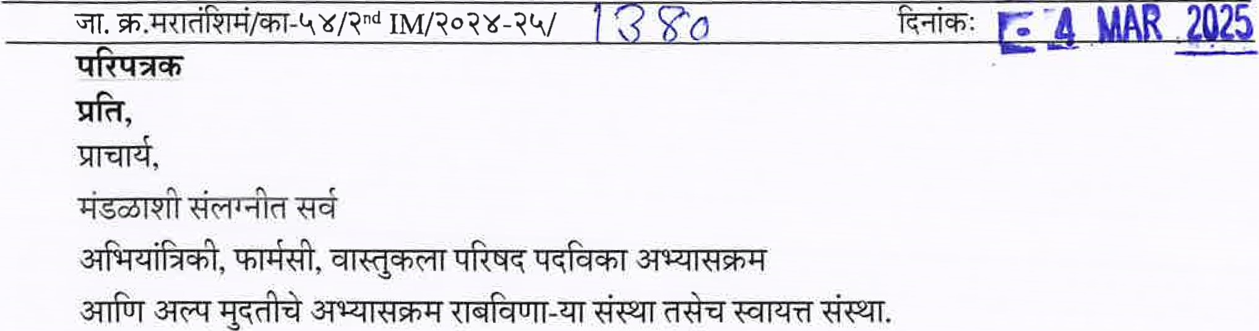
director@msbte.com
www.msbte.ac.in
(External Institute Monitoring) Evaluation Sheet (KPI
Norms) 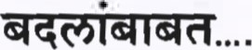
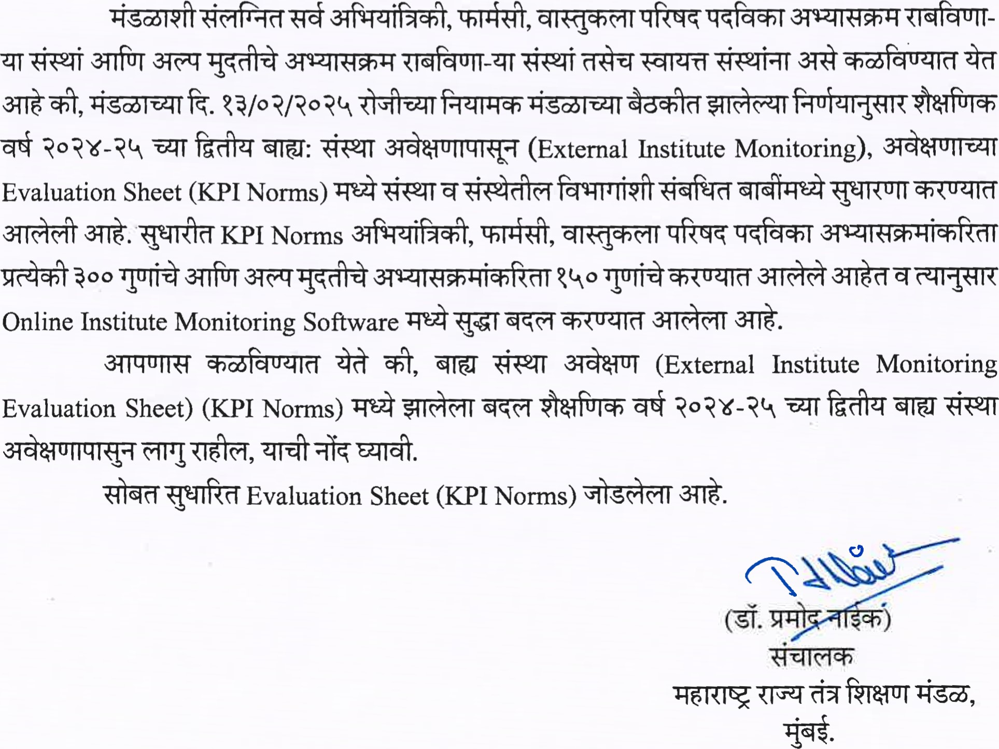


Criteria for Institute Monitoring for All India Council of Technical Education (AICTE) approved Diploma courses affiliated to MSBTE:-

Sr.  No |  | Criteria & Sub-criteria | Institute Level |  | Dept. Level |  | Total
 |  | Criteria & Sub-criteria | No. of categories  & Subcategories | Weightage | No. of categories  & Subcategories | Weightage | No. of categories  & Subcategories | Weighta ge
I |  | Affiliation, Governance &  Administration | 53 |  | 09 | 30 | 62 | 126
A |  | Compliance to the provision of Section 250) of MSBTE Act, 1997 regarding condition of affiliation | 33 | 74 | 08 | 28 | 41 | 102
B |  | Governance and  Administrative Criteria | 05 | 06 | 01 | 02 | 06 | 08
c |  | Redressal and Medical Care System | 12 | 12 |  |  | 12 | 12
D |  | Facilities available | 03 | 04 |  |  | 03 | 04
II |  | Academic criteria | 16 | 38 | 38 | 129 | 52 | 167
A |  | Accreditation |  |  | 02 | 06 | 02 | 06
B |  | Learning Resources |  |  | 04 | 07 | 04 | 07
C |  | Curriculum Coverage |  |  | 12 | 46 |  | 46
D |  | Professional Output | 10 | 25 | 02 | 07 | 12 | 32
E |  | Efforts for faculty development and industry involvement |  |  | 07 | 18 | 07 | 18
F |  | Result and Placements | 02 | 03 | 09 | 41 |  | 44
G |  | Co-Curricular Activities | 04 | 10 | 02 | 04 | 06 | 14
 | Il | Socio Economic criteria | 04 | 05 | 01 | 02 | 05 | 07
A |  | Alumni | 03 | 03 |  |  | 03 | 03
B |  | Socio-Industry Involvement | 01 | 02 | 01 | 02 | 02 | 04
 |  | Total | 73 | 139 | 48 | 161 | 119 | 300
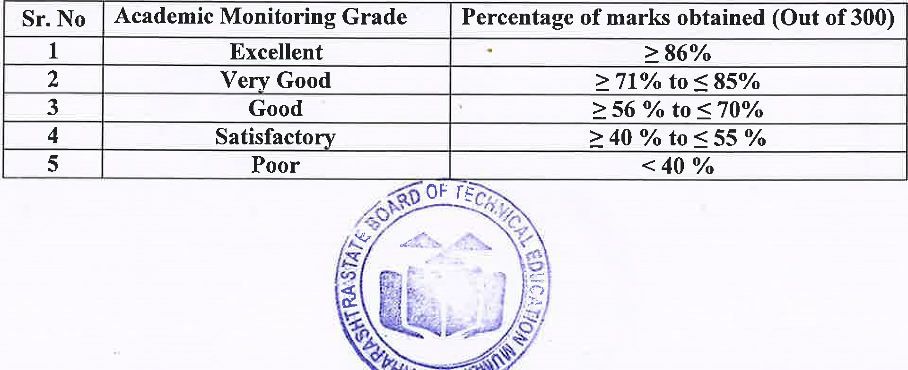
1
Criteria for Institute Monitoring for Pharmacy Council of India (PCI) approved Diploma courses affiliated to MSBTE:-
Sr.  No | Criteria & Sub-criteria |  |  | Institute Level |  |  | Dept. Level |  | Total
Sr.  No |  |  |  | No. of categories  & Subcategories | Weightage |  | No. of categories  & Subcategories | Weightage | No. of categories  & Subcategories | Weighta
I | Affiliation, Governance &  Administration |  |  | 51 | 93 |  | 07 | 26 | 61 | 119
A | Compliance to the provision of Section 25(1) of MSBTE Act, 1997 regarding condition of affiliation |  |  | 31 | 71 |  | 07 | 26 | 41 | 97
B | Governance and  Administrative Criteria |  |  | 05 | 06 |  |  |  | 05 | 06
C | Redressal and Medical Care System |  |  | 12 | 12 |  |  |  | 12 | 12
D | Facilities available |  |  | 03 | 04 |  |  |  | 03 | 04
II | Academic criteria |  |  | 15 | 36 |  | 36 | 138 | 52 | 174
A | Accreditation |  |  |  |  |  | 02 | 06 | 02 | 06
B | Learning Resources |  |  |  |  |  | 04 | 07 | 04 | 07
C | Curriculum Coverage |  |  |  |  |  | 11 | 55 | 11
D | Professional Output |  |  | 09 | 23 |  | 02 | 07 | 11 | 30
E | Efforts for faculty development and industry involvement |  |  |  |  |  | 07 | 18 | 07 | 18
F | Result and Placements |  |  | 02 | 03 |  | 09 | 41 | 11 | 44
G | Co-Curricular Activities |  |  | 04 | 10 |  | 02 | 04 | 06 | 14
III | Socio Economic criteria |  |  | 04 | 05 |  | 01 | 02 | 05 | 07
A | Alumni |  |  | 03 | 03 |  |  |  | 03 | 03
B | Socio-Industry Involvement |  |  | 01 | 02 |  | 01 | 02 |  | 04
 | Total |  |  | 70 | 134 |  | 44 | 166 | 115 | 300
 |  | Sr. No | Academic Monitoring Grade |  |  | Percentage of marks obtained (Out of 300)
 |  | 1 | Excellent |  |  | 86%
 |  | 2 | Verv Good |  |  | 271% to
 |  | 3 | Good |  |  | 56 % to
 |  | 4 | Satisfactory |  |  | 240 % to %
 |  | 5 | Poor

Council of Architecture (COA) approved Diploma courses affiliated to MSBTE:-
Sr. | Criteria & Sub-criteria | Institute Level |  | Dept. Level |  | Total
Sr. | Criteria & Sub-criteria | No. of categories  & Subcategories | Weightage | No. of categories  & Subcategories | Weightage | No. of categories  & Subcategories | Weighta ge
1 | Affiliation, Governance  & Administration | 52 | 97 | 09 | 30 | 61 | 127
A | Compliance to the provision of Section 25(1) of MSBTE Act, 1997 regarding condition of affiliation | 32 | 75 | 08 | 28 | 40 | 103
 | Governance and  Administrative Criteria | 05 | 06 | 01 | 02 | 06 | 08
c | Redressal and Medical Care System | 12 | 12 |  |  | 12 | 12
D | Facilities available | 03 | 04 |  |  | 03 | 04
Il | Academic criteria | 14 | 35 | 38 | 131 | 52 | 166
A | Accreditation |  |  | 02 | 6 | 02 | 06
B | Learning Resources |  |  | 04 | 7 | 04 | 07
C | Curriculum Coverage |  |  | 12 | 48 | 12 | 48
D | Professional Output | 08 | 22 | 02 | 7 | 10 | 29
E | Efforts for faculty development and industry involvement |  |  | 07 | 18 | 07 | 18
F | Result and Placements | 02 | 03 | 09 | 41 | 11 | 44
G | Co-Curricular Activities | 04 | 10 | 02 |  | 06 | 14
111 | Socio Economic criteria | 04 | 05 | 01 | 02 | 05 | 07
A | Alumni | 03 | 03 |  |  | 03 | 03
 | Socio-Industry Involvement | 01 | 02 | 01 | 02 | 04 | 04
 | Total | 70 | 137 | 48 | 163 | 118 | 300
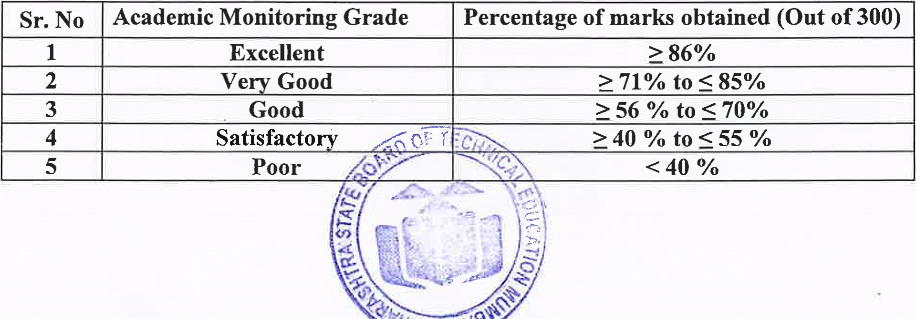
3

Evaluation Criteria :-

I | Affiliation, Governance & Administration
S.N | Criteria & Sub-criteria | Documents to be  Verified | Observations | Marks | (M)
A | Compliance to the provision of Section 25 (1) of MSBTE Act, 1997 and MSBTE (Amendment) Act,2023 regarding condition of affiliation
a
b
C
d

 | 6) | Number of Laboratories as per AICTE/ PCI /COA norms and Area as per Norms | Physical Verification (As per deficiency report generated by  AICTE/COA for that particular A.Y) | 4 & above for AICTE  (5 & above for  Pharmacy/Architecture) | 5 | D(5)
 |  |  |  | Less than 4  ( Less than 5for Pharmacy  /Architecture) | 0 | D(5)

 | 17) Library:- No. of National  [International/ Technical journals subscribed [Hard copies] per branch | Physical Verification (As per deficiency report generated by  AICTE/COA for that particular A.Y) | 3 or More for NCTE  (6 or morefor Pharmacy /  Architecture) | 2 | D(2)
 |  |  | Less than 3 for AICTE  (Less than 6 for Pharmacy /  Architecture) |  | D(2)

e
f

 |  | .
 | 2) Head of the department  (As Per current  AICTE/COA Norms) | Appointment order, Mode of any appointment, approval by Competent Authority. | Regular | 5 | D(5)
 | 2) Head of the department  (As Per current  AICTE/COA Norms) |  | In charge with required Qualification | 2 | D(5)
 | 2) Head of the department  (As Per current  AICTE/COA Norms) |  | In charge without required Qualification |  | D(5)
 | 3) Faculty to Student ratio based on approved intake: Minimum 80% should be regular/full time faculty and remaining may be adjunct faculty/ Resource persons industry |  | 1:25  (for PH - 1:20) | 5 | D(5)
 |  |  | 1:26 to 1:30 | 3 | D(5)
 |  |  | Below 1:30  (for PH - Below 1:20) | 0 | D(5)
 | 4) Percentage faculty approved by State Govt./DTE/COA MSBTE or proposals sent to  State Govt./DTE/COA/ MSBTE for approval & awaited; out of total required faculty (committee to verify details) | Physical Verification | 50% or more | 5 | D(5)
 |  | Physical Verification | To 49 % | 3 | D(5)
 |  | Physical Verification | Less than 20% | 0 | D(5)
 | 6) M. E. /M. Tech/ M  Pharm/M Arch qualified (Completed) faculty out of required posts as per AICTE/COA norms | Marks sheet / PG  Certificate  (As per deficiency report generated by AICTE/ COA for that particular A.Y) | 50% or more | 3 | D(3)
 |  |  | 35% To | 2 | D(3)
 |  |  | Less Than 35% | 0 | D(3)
 | 7) No. of Faculties completed Ph.D. study / M. Arch for  Architecture only  (M for Pharmacy) | Award Certificate  Provisional or Final | 1 or More | 2 | D  (2)
 |  | Award Certificate  Provisional or Final | Nil |  | D  (2)

 | 9) Availability of supporting staff as per the  Government Norms. | Related document verification  (0.9 * No. of lecturers in dept.)  - as per Govt. Norms (As per deficiency report generated by  AICTE/COA for that particular A.Y) | Yes | 1 | D  (1)
 |  |  | No | 0 | D  (1)
B | Governance and Administrative Criteria
2 | Vision & Mission of  Department (As approved in  Governing / Board Meeting/  CDC Meeting/ Stake Holders)  (NA for Pharmacy) |  | Yes | 2 | D(2)

C | Redressal and Medical Care System
 | The institute Inust have various committees in place, for conducting meetings at least twice a year. For all committees -Board containing names & contact details of members of the constituted committee be displayed at the prominent places of the Institute.

d
 |  |  | Yes | 1
 |  |  | No
g | Arrangement of workshop and other related programmes for tension free health of the students.  A counsellor should be appointed for the above purpose by the Institute. | Document  Verification &  Student Feedback | Yes | 1
g |  | Document  Verification &  Student Feedback | No
D | Facilities available
1 | Internet facility for Students | Paid Bills for last three months duration of internet facility.  (Internet band width required as per  AICTE/COA Norms | Yes | 2 | 1  (2)
1 | Internet facility for Students |  | No | 0 | 1  (2)
2 | Cooperative /Central Store Facility | Physical Verification | Yes | 1 | 1  (1)
2 | Cooperative /Central Store Facility | Physical Verification | No | 0 | 1  (1)
3 | Availability of Digital Payment | Digital Wallet/ POS Machine | Yes | 1 | 1  (1)
3 | Availability of Digital Payment | Digital Wallet/ POS Machine | No | 0 | 1  (1)
Il | Academic Criteria | 

 |  | POS Machine
Il | Academic Criteria
 | Criteria & Sub-criteria | Documents to be Verified |  | Observations | Marks | (M)
A | Accreditation
 | Accreditation by NBA | NBA Application form |  | Applied | 5 | (5)
 | Accreditation by NBA |  |  | Not Applied | O | (5)
2 | Internal Academic Audit (Once in 6 Months) | Audit Records |  | Yes | 1 | (1)
2 | Internal Academic Audit (Once in 6 Months) |  |  | No | 0 | (1)
B | Learning Resources
 | LCD/ Smart Screen Projector in dept. | Dead  Stock/Physical  Verification |  | One | 1 | (1)
 | LCD/ Smart Screen Projector in dept. |  |  | Nil |  | (1)
2 | Faculties using self -developed  Power Point [Flash presentations/Readymade presentations as a teaching aid during imparting the instructions. | Physical Verification |  | 50% or more | 2 | (2)
2 |  |  |  | 25% To 49% | 1 | (2)
2 |  |  |  | Less Than 25% | 0 | (2)
3 | Availability of Smart Classroom (at least one) | Physical Verification |  | Yes | 2 | D  (2)
3 | Availability of Smart Classroom (at least one) |  |  | No | 0 | D  (2)
4 | Use of Video Lectures published on MSBTE Portal for Teaching —Learning by faculties & students. | Based on feedback from faculty & students & its  Verification |  | 100% | 2 | (2)
4 |  |  |  | More than 50% | 1 | (2)
4 |  |  |  | less than 50% |  | (2)
C | Curriculum Coverage as per MSBTE/PCI
1 | Curriculum covered as per MSBTE/PCI norms : Number  of Lectures/Practical covered as per norms till date of Monitoring only | Faculty Teaching plan & execution Record, Student Feedback Formats, etc.   |  | 100% | 5 | (5)
1 |  |  |  | 90% To 99% | 3 | (5)
1 |  |  |  | 80% To 89% | 2 | (5)
1 |  |  |  | Less Than | 0 | (5)
2 | Curriculum covered as per MSBTE/PCI norms : Theory subject lesson plan prepared & followed till date of Monitoring only |  |  | 100% | 5 | D  (5)
2 |  |  |  | 90% To 99% | 3 | D  (5)
2 |  |  |  | 80% To 89% | 2 | D  (5)
2 |  |  |  | Less Than | 0 | D  (5)
 |  | 

_3 | Curriculum covered as per MSBTE/PCI norms : Practical plan prepared & followed ti l l date of Mon itoring on ly |  |  |  |  | 5 | D  (5)
_3 |  |  |  | To 99% |  | 4 | D  (5)
_3 |  |  |  |  |  | 2 | D  (5)
_3 |  |  |  | Less Than |  | 0 | D  (5)
4 | Curriculum covered as per MSBTE/PCI norms : Student feedback about satisfactory coverage of curriculum till date of Monitoring only |  |  | IOO% |  | 5 | (5)
4 |  |  |  | To 99% |  | 4 | (5)
4 |  |  |  | To 89% |  | 2 | (5)
4 |  |  |  | Less Than |  | 0 | (5)
5 | Attendance :  a) Whether Biometric attendance facility is available | Physical verification |  | Yes |  | 2 | (2)
5 |  |  |  | No |  |  | (2)
5 | b) Average attendance of theory Subject, Practical subject, Average attendance of all Progressive assessment for all Theory &  Practical should be considered till date of monitoring | Attendance verification |  | 90% or more |  | 5 | (5)
5 |  |  |  |  |  | 4 | (5)
5 |  |  |  | Less Than 75% |  |  | (5)
6 | Remedial lectures conducted for weaker students. | Verification of  l) Remedial time table  - Attendance sheet  - Result |  | Implemented |  | 1 | (l)
6 | Remedial lectures conducted for weaker students. |  |  | Not Implemented |  | 0 | (l)
7 | Availability of equipment jn working condition for conduct of experiments / jobs as per  MSBTE / PCI/ COA norms | Dead stock register,  Record of use,  Student Feedback,  Physical Verification |  | 91% To 100% |  | 5 | (5)
7 |  |  |  | To 90% |  | 3 | (5)
7 |  |  |  | 75% To 85% |  | 1 | (5)
7 |  |  |  | Less Than 75% |  |  | (5)
8 | Conduct of refresher courses for direct 2nd year admitted students for acquiring prerequisite technical knowledge to cater requirement of direct 2nd year subjects (NAfor  Pharmacv/Architecture) | Documents certified by Principal,  Student feedback |  | Yes |  | 3 | (3)
8 |  |  |  | No |  | O | (3)
9 | Final year projects of the students : Industry sponsored /  Application oriented / Academic  (NA for Pharmacy) | Physical Verification   |  | Industry Sponsored (Min 2) |  | 4 | D  (4)
9 |  |  |  | Application Oriented (Min 2) |  | 3 | D  (4)
9 |  |  |  | Study Based |  |  | D  (4)

1 0 | Documentation of any contemporary building heritage building by students  (Onlyfor Arch itecture) | Document  Verification | 100% | 5 | (5)
1 0 |  | Document  Verification | Less than 90% | 3 | (5)
1 0 |  | Document  Verification | Less than 80% |  | (5)
I l | Budget allocation and utilisation  (Recurring, Non-Recurring &  Maintenance) For Govt. and Aided institutions budget demanded, allocated and utilised | Physical verification of finance documents | Demanded, Allocated and 80%  Utilized | 4 | (4)
I l |  | Physical verification of finance documents | Demanded, Allocated and utilization is between 40% to 80%. | 2 | (4)
I l |  | Physical verification of finance documents | Demanded, Allocated and utilization is less than 40% | 0 | (4)
12 | Assessment ofStudents ' Practical Training Exant conduction as per PCI norms.  (Applicable only to Pharmacy) | Evaluation,  Examination  Documentation,  Project Report, Oral records etc. | Evaluation & Examination Conducted | 16 | (16)  PH
12 |  |  | Not conducted | 0 | (16)  PH
13 | Assessment of Students eligible for Industrial Training /  Internship | Evaluation,  Examination  Documentation,  Industrial training Report, Oral records  etc.  (Eligible &  Completed as per  MSBTE Norms) | 100% eligible students | 2 | (2)
13 |  |  | Less than 100% eligible students |  | (2)
D | Professional Output
1 | Number of papers presented by the faculties in National / International Journals/ conference in last/ current* Academic Year | Letter of acceptance, Copy Published | 3 or More Papers from Institute | 4 | 1  (4)
 |  | Letter of acceptance, Copy Published | 2 Papers from Institute | 2 | 1  (4)
 |  | Letter of acceptance, Copy Published | Less Than 2 |  | 1  (4)
2 | a) Proposals submitted to  MODROBS/FDP/  RPS/ISRO/DST etc. during last/ current* Academic Year (NA for Architecture) | Documentation,  Copies of the submission of proposal with acknowledgment proof. | 2 or more | 4 | 1  (4)
2 |  |  |  | 2 | 1  (4)
2 |  |  | No | 0 | 1  (4)
2 | b) Workshop, Seminars conducted in association with IIA/ Architecture Engineers  Associations (Only for  Architecture) | Documentation,  Copies of the submission,  Photographs | 2 or More | 4 | 1  (4)
2 |  | Documentation,  Copies of the submission,  Photographs | 1 | 2 | 1  (4)
2 |  | Documentation,  Copies of the submission,  Photographs | No | 0 | 1  (4)
3 | Number of consultancy / testing / patient counselling projects |  | 2 or More | 2 | 1  (2)

 | undeftaken during last/ Current * year. (NAfor Pharmacy) | Documentation,  Work Orders &  Copy of agreement  (MoU)
 | undeftaken during last/ Current * year. (NAfor Pharmacy) | Documentation,  Work Orders &  Copy of agreement  (MoU) | No
4 | Whether Institute working as Examination Center/Deputing faculty to Exam Center for MSBTE in immediately concluded exam. | MSBTE Orders | Yes |  | 1
4 |  | MSBTE Orders | No |  | 1
5 | Whether Institute Involved in RAC/ RRAC/ DC/PCDC activities of MSBTE in Last / current * academic year (RAC/RRAC/DC/PCDC has been given to the deserving Institutes as per need by MSBTE). | MSBTE Orders | 2 or More than 2 Activities | 3 | (3)
5 |  | MSBTE Orders | One Activity | 2 | (3)
5 |  | MSBTE Orders | Faculty Deputed | 1 | (3)
5 |  | MSBTE Orders | No Activity | O | (3)
6 | Whether Institute is working as 'Project institute for Model answers or Lab Manual Development' for MSBTE in last / current * academic year. | MSBTE Orders | Development Center | 2 | 1  (2)
6 |  | MSBTE Orders | Services rendered |  | 1  (2)
6 |  | MSBTE Orders | No | 0 | 1  (2)
7 | Professional Activities  (Magazine/ Technical  Magazine/ Exhibition of Student work)) | Physical Verification | Yes | 2 | D  (2)
7 |  | Physical Verification | No |  | D  (2)
8 | Institutional Membership of professional societies/ students chapters. (NAfor Architecture) | Physical Verification | Yes | 2 | 1  (2)
8 |  | Physical Verification | No |  | 1  (2)
9 | Mechanism of Student  Feedback, Analysis and  Corrective Action is adopted. | Student Feedback, Documentation,  Suggestion Box etc. | Yes |  | D  (5)
9 |  | Student Feedback, Documentation,  Suggestion Box etc. | No |  | D  (5)
10 | Adoption of Performance  Appraisal and Development System (PADS) for Faculty and Supporting Staff. | Physical Verification | Yes | 2 | 1  (2)
10 |  | Physical Verification | No |  | 1  (2)
I l | Implementation of Career  Advancement Scheme (CAS) (NA for Architecture) | CAS Documents verification | Yes | 1 | 1  (1)
I l |  | CAS Documents verification | No | 0 | 1  (1)
12 | Deputation of faculty for  MSBTE Activities RAC /Confr011er/MSCIT Vigilance/ University Exams., etc. | Deputation/Office  Orders | 35% or more | 4 | 1  (4)
12 |  | Deputation/Office  Orders | To 34 % | 2 | 1  (4)
12 |  | Deputation/Office  Orders | Less Than 15% | 0 | 1  (4)
E | fFC  Efforts for faculty development and Indu nvol me

F | Result and Placements
 | No. of Students passed in 1 ^{st} Division in final year. | Documentation:  Result Analysis | 60% or more | 6 | (6)
 | No. of Students passed in 1 ^{st} Division in final year. | Documentation:  Result Analysis | to 59% | 4 | (6)
 | No. of Students passed in 1 ^{st} Division in final year. | Documentation:  Result Analysis | Less than 30% |  | (6)
2 | Average result of final year of last 3 years | Documentation:  Result Analysis | 90% or more | 5 | (5)
2 | Average result of final year of last 3 years | Documentation:  Result Analysis | to 89% | 3 | (5)
2 | Average result of final year of last 3 years | Documentation:  Result Analysis | Less than 60% | 0 | (5)
3 |  |  | Attainment Level Target set by Program | 2
 | I | Faculties deputed/sponsored for the improve:ncnt of acadeno ic qualification/Higher Education | Relieving Letter, Pernnission letter | Inore | 2 | (2)
 |  |  |  | Nil |  | (2)
 | 2 | MOUs with Professional organization  /IndustryNendors/Academician /Hospital/Community Pharmacy for the participation in academic development of the Department | Documents ofjoint activities performed under active MOU in current academic year | 4 or Inore | 3 | (3)
 |  |  |  | 2 to 4 | 2 | (3)
 |  |  |  | Less Than 2 | 0 | (3)
 | 3 | Industry/Professional expert's lectures involved in academic activities of institute during last / current* academic year. | Invitation Letter,  Photographs, Video Shooting | 3 or more | 3 | (3)
 |  |  |  | I to 2 | 2 | (3)
 |  |  |  | Nil |  | (3)
 | 4 | Number of Industrial/  Construction Site/Case Study visits /Hospital Visits organised during last/ current* academic year. | Permission letter from industry, Photographs, Copy of circular for students. Students'  Feedback | 2 or More | 3 | (3)
 |  |  |  | 1 | 2 | (3)
 |  |  |  | Nil | 0 | (3)
 | 5 | Faculties attended trainings for  Soft skills, Content updation,  Industrial trainings, COA TRC, Orientation Workshops etc. in last/ current* academic year. | Certificate of Participation | 30% or more | 3 | (3)
 |  |  |  | to 29% | 2 | (3)
 |  |  |  | Less Than 10% |  | (3)
 | 6 | Establishment of Center of  Excellence/Start up/lncubation  Centre in collaboration with industries | Physical verification | Yes | 2 | (2)
 |  |  |  | No |  | (2)
 | 7 | Completion of UNICEF's  "Youth Engagement and  Stewardship for Climate Change and Water Conservation" by Faculties ( by March -2024) | Certificate  Verification | All Faculties | 2 | (2)
 |  |  |  | Faculties more than 50% | 1 | (2)
 |  |  |  | Faculties less than 50% | 0 | (2)

 | aspects | Mapping table | Mapping of CO-PO with  Curricular and Co-curricular activities | 2
 |  | Calculation chart | Attainment level calculated | 2
 |  | Justification table | Attainment level achieved | 2
 |  | Action Taken  Report(ATR) of last academic session | Action taken report w.r.t. GAP Analysis | 2
4 | Programs conducted for personality development during last/current* year | Documentation, Photographs, expenditure vouchers  (if applicable) | 2 or more | 3 | (3)
4 |  |  | 1 | 2 | (3)
4 |  |  | Nil | 0 | (3)
5 | Participation/Organization Sports | Document,  Certificates, Photographs  Verification | Zonal Sports | 3 | D  (3)
5 | Participation/Organization Sports | Document,  Certificates, Photographs  Verification | Inter Zonal Sports | 2 | D  (3)
5 | Participation/Organization Sports | Document,  Certificates, Photographs  Verification | Institute Level | 1 | D  (3)
6 | Campus Placement | Placement Record,  Appointment Letters,  Joining Letters / approved admitted list etc. | 50% or more | 3 | D  (3)
6 | Campus Placement |  |  | 2 | D  (3)
6 | Campus Placement |  | Less Than | 0 | D  (3)
7 | Entrepreneurship Development  Cell established | Physical verification | Yes | 1
7 | Entrepreneurship Development  Cell established | Physical verification | No | 0
8 | Students Mentoring system (Professional guidance/ Career advancement /AII -round development/ Course/Lab work specific, mentoring programs conducted) frequency of mentoring (Excluding Personality  Development Programs) | Physical Verification | 2 or more activities / year | 2 | 1  (2)
8 |  | Physical Verification | 1 activity / year | 1 | 1  (2)
8 |  | Physical Verification | No activities |  | 1  (2)
9 | Final Year pass outs going for selfemployment | Alumni Record  Details | 10% or Above | 2 | (2)
9 | Final Year pass outs going for selfemployment | Alumni Record  Details | 5% To 9% | 1 | (2)
9 | Final Year pass outs going for selfemployment | Alumni Record  Details | Less than 5% |  | (2)
10 | Students completing diploma program within stipulated period | Result analysis | More than 60% | 5 | D  (5)
10 | Students completing diploma program within stipulated period | Result analysis | 30% To 59% | 3 | D  (5)
10 | Students completing diploma program within stipulated period | Result analysis | Less than 30% |  | D  (5)
11 | Percentage of Students Appeared for ESE (End Semester Exam) with respect to the actual enrollment. | Verification of  Enrollment records & result analysis.   | Above | 4 | (4)
11 |  |  | 75% To 89% | 2 | (4)
11 |  |  | Less than 75% | 0 | (4)

111 | Socio- Economic Criteria
A | Alumni
 | Whether alumni association registered or not? If Yes give No. of past students registered. | Formation of  for  Records | Yes | 1 | 1  (1)
 |  |  | No | 0 | 1  (1)
12 | Mass Copy Case | MSBTE punishment  order in Institute login/ Show cause to students/ MSBTE RAC Malpractice  letter | Unsafe for Academics due to proved incidence of Inass copy at Institute Level |  | leading to  "Poor"
G | Co-curricular Activities
1 | Organizing Technical Quiz /  Seminar / Paper Presentation  /Project Competition event last  /current* year | Event Leaflets,  Expenditure details, Photographs, participant feedback,  etc. | State Level Activity in association with Govt. /  MSBTE/1ndustry | 2 | D  (2)
1 |  |  | Any other | 1 | D  (2)
1 |  |  | No Activity | 0 | D  (2)
2 | Number of state/ national / international level awards won by the Institute in workshop /seminar/ conference/ project competitions Research organized in association with industry/ Universities / MSBTE/ Government body during  Last 2 years. | Certificates | 2 or more Awards | 4 | 1  (4)
2 |  | Certificates | I Award | 2 | 1  (4)
2 |  | Certificates | No | 0 | 1  (4)
3 | Awards won by the Institute's student in workshop /seminar/ conference/ project competitions Organized by any other organizations during last 2 years. | Certificates | 2 or more Awards | 2 | 1  (2)
3 |  | Certificates | I Award | 1 | 1  (2)
3 |  | Certificates | No | 0 | 1  (2)
4 | Conduction of Induction Training program for newly admitted students | Related document verification | Yes | 1 | 1  (2)
4 |  | Related document verification | No | o | 1  (2)
5 | Facility to watch MOOCS Courses through SWAYAWSpoken  Tutorials | Related Documents | Yes | 2 | (2)
5 |  | Related Documents | No |  | (2)
6 | Contribution in MSBTE Newslette | Related Documents | Sent at least one Activity for eve issue of the Newsletter | 1
6 | Contribution in MSBTE Newslette | Related Documents | The Activity of the issue is printed in MSBTE Newsletter | 2

2 | Alumni meet Conducted once in a year? | Alumni, Relevant Documents | Yes
3 | Contribution by Alumni (Expen lectures/Placement/suppoW Funding/Sponsorship etc.) | Alumni, Relevant Documents | Yes |  | ( l )
3 |  | Alumni, Relevant Documents | No | 0 | ( l )
B | Socio-Industry Involvement
4 | Activities with respect to CEP programs /  NSS/ Community Development Through Polytechnics (CDTP), PMKVY, CSR organized during last / current * year. | Event Leaflets,  Expenditure details,  Photographs, participant feedback, etc. | 2 or more | 2 | 1  (2)
4 |  |  | 1 | 1 | 1  (2)
4 |  |  | No |  | 1  (2)
5 | Any other social activities — Earn and learn/ NSS/ NCC/ Community services/Student welfare etc. |  | 2 or more | 2 | (2)
5 |  |  | 1 |  | (2)
5 |  |  | No | 0 | (2)
*-- Last year is considered for FIRST monitoring and Current year is considered for SECOND monitoring of the respective year.

Note: 1. For Pharmacy & COA Institutes, Criteria & Sub-criteria, observations & marks are highlighted in Italics respectively. All other Parameters remain same.
- This revised pro-forma is applicable for Institute Monitoring for all Diploma courses.
- Compliance Report should be asked for all the institutions & action taken report (ATR) to be inspected by the Inspection Committee.


Category wise Academic Monitoring Marking System for Non-AICTE diploma courses
Sr.  No | Criteria & Sub-criteria | Institute Level |  | Dept Level |  | Total
Sr.  No | Criteria & Sub-criteria | No. of categories  & Subcategories | Weightage | No. of categories  & Subcategories | Weightage | No. of categories  & Subcategories | Weightage
I | Governance, Policy  Making &  Infrastructure criteria | 8 | 17 | 2 | 10 | 10 | 27
 | Governing Board for policy and planning | 3 | 4 |  | 0 | 3 | 4
B | Infrastructure | 5 | 13 | 2 | 10 | 7 | 23
Il | Administrative criteria | 9 | 11 |  |  | 9 | 11
A | Office automation |  | 1 |  |  |  | 1
 | Redresser and Medical Care System | 7 | 7 | 0 | 0 | 7 | 7
C | Facilities Available | 1 | 3 |  |  |  | 3
111 | Academic criteria | 3 | 11 | 15 | 101 | 18 | 112
A | Human Resource | 2 | 9 | 2 | 4 | 4 | 13
B | Curriculum Coverage |  |  | 4 | 57 | 4 | 57
C | Efforts for faculty development and industr involvement |  |  | 4 | 8 | 4 | 8
D | Result and Placements | 1 | 2 | 5 | 32 | 6 | 34
 | Total | 15 | 35 | 17 | 115 | 32 | 150

Annexure —I

Category wise Academic Monitoring Marking System for Non-AIC TE diploma courses
I. Governance, Policy Making & Infrastructure Criteria
Sr.  No | Criteria & Sub-criteria | Documents to be verified | Marks | Level  (Inst./Dept.)
A | Governing Board for policy and planning
I | Governing Board in place | Office order-I |  | Institute
2 | dequate representation of industry and cademician on board | Office order-I | 2/0 | Institute
3 | Whether meeting was conducted in last year or not? EIMC shall verify the Minutes of meeting | Meeting register/Minutes of meeting-I |  | Institute
B | Infrastructure
 | Built up area as per Norms of Short term courses at the Postal address of the Institute Committee shall scrupulously verify the required documents; | Plan of built up area-I | 5/0 | Institute
2 | No. of Laboratories | Photo-I |  | Dept.
3 | Library:- No. of books in library | Certificate from librarian |  | Dept.
4 | Percentage of students using library books | Daily use certificate for last 2 days | 3/1/0 | Institute
5 | Student to Computer ratio | Certificate from principal-I | 3/2/1 | Institute
6 | Hygienic & Purified  Drinking Water Facilities | Photo-I |  | Institute
7 | Toilet facility for staff and students | Photo-I | 1/0 | Institute

Il. Administrative Criteria
 | Sr  No | Criteria & Sub-criteria | Documents to be verified | Marks | Level  (Institute / Dept.)
 | A | Office Automation in use
 |  | Computerized MIS system in place / Computerized Accounting System | Screenshot of MIS | 1/0 | Institute
 | B | Redressal and Medical Care System
 | 1 | Students mentoring and grievance cell in place | Appointment order of mentor & session conducted  1 |  | Institute
 |  | Availability of first Aid Comes Sick Room of area Approx. 20 Sq. m. , Availability of first Aid Medical Kit in All the Departments of the institute. | Photo-I | 1/0 | Institute
 | 3 | All the students of the Institute are covered under insurance scheme of Government as per Department of Higher and Technical Education, Government Resolution dated  25.08.2011 and 16.10.2023. | Insurance Documents | 1/0 | Institute
 | 4 | Arrangement of primary medical first aid training for Students and Staff ((minimum 1 per year) should include an Emergency First aid Artificial Respiration., Medical check-up of Students and Staff (minimum I er year) | Training Certificates &  Photographs along with  Medical  Documents | 1/0 | Institute
 | 5 | Display of emergency contact numbers of Government hospital, Govt. PHC and private hospitals nearby institute.  The contact numbers of the Government (108) and public ambulance should be displayed and regularly coordinated with by the Institute. | Physical Verification | 1/0 | Institute
 | 6 | The MOU of the Institute with nearby hospital or the Doctor to make available the On-call medical facility. Availability of vehicle to carry the students in hospital in an emergency situation. | Document Verification |  | Institute
 | 7 | Arrangement of workshop and other related programmes for tension free health of the students.  A counsellor should be appointed for the above purpose by the Institute. | Document Verification & Student Feedback |  | Institute
 | C | Facilities available
 | I | Internet facility for Students | Last three month  bill-I |  | Institute
 | Ill. Academic Criteria
Sr  No | Criteria & Sub-criteria | Documents to be verified | Marks | Level  (Inst/ Dept)
A | Human Resource
 | Principal / Director (As per Norms) | Appointment order-I |  | Institute
2 | Faculty to Student ratio (As per Norms) | List of Faculty-I | 4/2/0 | Institute
3 | Regular Faculty | List & Appointment orders of faculty-I |  | Dept
4 | Lab Assistant | List & Appointment orders |  | Dept
B | Curriculum Coverage
 | Curriculum covered as per MSBTE norms at the time of monitoring :  I . I No. of Lectures covered as per norms I .2. Student feedback about satisfactory coverage of curriculum | Certificate from principal-I | 1.1 20/16/12/0  1.2 5/3/2/0 | Dept.
2 | Attendance of Students  Average attendance of theory Subject/ Practical subject | Attendance record-I | 10/8/0 | Dept.
3 | Availability of equipment's for conduct of experiments/jobs as per MSBTE curriculum | Photo-I  List of equipment's along with cost | 15/10/5/0 | Dept.
4 | Availability of furniture for conduct of theory/ classes/ experiments/ jobs as per MSBTE norms | Photo-I  List of Furniture along with cost | 7/5/3/0 | Dept.
C | Efforts for faculty development and industry involvement
 | Industry experts lectures involved in academic activities of institute during last year | Invitation letters-I | 3/2/0 | Dept.
2 | o. of Industrial visits organised during last ear | Industrial visit permission letter | 3/0 | Dept.
3 | MOU with industry | Doc of MOU |  | Dept
4 | Social activities, like Blood donation camp/ tree plantation etc. | Photo-I |  | Dept

D | Result and Placements
 | Programs conducted for personality development [EDP during previous/ current* year | Doc of conduction of programs-I | 5/3/0 | Dept.
2 | tudents Campus Placement, self-employment and higher education statistics
2.1 | Final year students placed through campus interview | Summary sheet of placement-I | 2/1 | Dept
2.2 | Final year pass outs going for selfemployment | List of Students-I | 2/1 | Dept
 | Final year pass outs opting for higher education | List of students-I | I/O | Dept
3 | Students appeared in immediately concluded MSBTE examination | certificate from principal | 10/8/4/0 | Dept.
4 | Students Passed the examination All students of all Years EIMC to verify result gazettes of MSBTE | Result Analysis-I | 10/8/4/0 | Dept.
5 | Participation of faculty in Paper  Presentation / Workshop / Exhibition /Seminar / Competitions in previous / current* Academic Year | Photo-I Doc-I | 2/0 | Dept.
6 | Faculty participation in answer book assessment of MSBTE exam in immediately concluded exam  Documents to be verified by EAMC | Certificates/orders from MSBTE |  | Institute

*- Previous year is considered for FIRST monitoring and Current year is considered for SECOND monitoring of the respective year.



