Ducklings

H541 Interaction Design Practice

Deepashree Venkatesh Prasad Hanan Alotaibi Onkar Borgaonkar

Contents
I Research Summary and Findings 3
II Problem Statement 4
III Key User Requirements 4
IV Brainstorming Ideas: 5
V Storyboards 5
VI Solution 7
VII Prototype 8
VIII Expert Review 20
IX Validation 21
Usability Study Findings 21
Task Error 21
Post-Task Questionnaire 22
Interview 22
Summary of Product Assessment 22
Problems with the Product 22
Recommendations for Future Development 22
X Appendices 23
Appendix A: Personas 23
Appendix B: Internal Walkthrough Feedback Form 24
Appendix C: Task Error Record Sheet 28
Appendix D: Post-Task Questionnaire 28
Appendix E: High Fidelity Screenshots 28

I Research Summary and Findings

We interviewed four participants, one male and three females. Their age ranging from 30 to 44 years old. The male relies on his wife for most of the documentation which mostly happen on Facebook. He and his wife prefer online documentation because it’s instantaneous even though they don’t prefer to rely on a company to keep “tokens of memories”. On the other hand, one female had baby books for her two boys and shared pics on Facebook as well, but didn’t have privacy concerns at all. As for the other two women, both had major privacy concerns. They had used online services and a website in the past, but they were never satisfied and prefered to store memories offline and use informal journal to record anecdotes, baby schedules in addition to photos and videos. All participants had family members who participate in documentation of memories and all the participants wanted to share those memories with their family members. One participant said that she documented lots of memories for her first baby born and completed his handwritten baby book but didn’t document as many digital photos for the second born, nor completed his purchased baby scrapbook. The other two females prefer to record every single details for their babies’ memories and store them chronologically starting from their ultra sound pics. All participants felt that looking back on the memories of their child with their child would be a “precious bonding experience”. Basically, all participants want help organizing and documenting those moments in a neat beautiful way to share it with the world and their children in the future.
Post the interviews we looked at some options available for parents to virtually document their child. We came across services like Tiny Beans and My Own Little Story which allow users to upload pictures or videos (only Tiny Beans) of their babies. Tiny Beans allows multiple contributors but My Own Little Story allows only one contributor. The photos and videos can be organized by milestone (My Own Little Story) or chronologically (Tiny Beans). But neither of them allow the flexibility to choose the organization method. Some of the services are only available as apps which restricts the platforms on which they can use and they also restrict channel through which artifacts can be shared.

Key findings:
Parents are highly motivated and willing to invest a reasonable amount of time and effort into documenting the growth of their child. Parents want to be able to share memories, not only with the child at a later point but also with their friends and family. Some users want complete control over who they are sharing with and some are not concerned. Most parents aren’t aware of the services available to them to aid them with documentation, but based on secondary research, we believe that these services will not be fully able to cater to their needs.
The artifacts generated by parents are diverse in terms of the medium and platform they use. They use mobiles for video and photos but they also use digital camera to generate the same. Some parent like to use text to document their child.

II Problem Statement

We discovered that documenting the birth and growth of their children has a huge emotional value to their parents. They feel it is important to document it in any format as “Nothing is more special than having a baby.” But rarely do they feel satisfied with how they are documenting their children.
Through affinity diagramming and thematic networking, we noticed themes in problems faced by most parents: Privacy Concerns, Requirement of high time and effort, large number of artifacts, and Disorganization of artifacts.
Our problem statement can be summarized as follows:
“Parents are motivated and excited to document and share the growth of their children. The depth of details and variety of documentation is limitless and the fear of missing out makes them generate a large amount. This leaves them with the daunting task to organize them. In addition, privacy concern plays a vital role in their hesitation to use existing technologies. We want to explore solutions to address these pain points so documentation and sharing of their child’s growth is secure, organized and doesn’t take them away from enjoying the present with their children.”

III Key User Requirements

We identified our key requirements based on our personas (link).

The following are the requirements we have identified:
- Comprehensive Privacy Settings
The solution must accommodate parents requiring different levels of privacy.
- Multiple Views of Memories
The solution must provide users with multiple ways to view their memories, and the ability to save the views.
- Preset Options
The solution must allow the users to set presets for storing and sharing memories.
- Accessible over various platforms
The solution must take into consideration that users may use different ways and platforms to create memories and cater to that need.

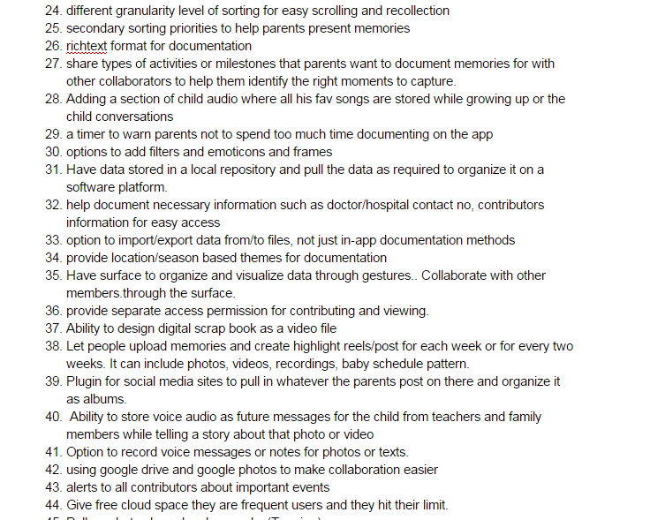
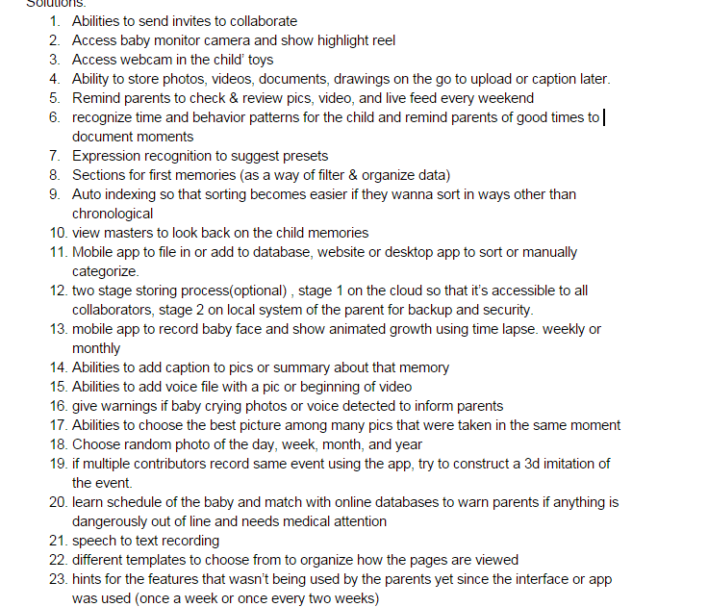
IV Brainstorming Ideas:
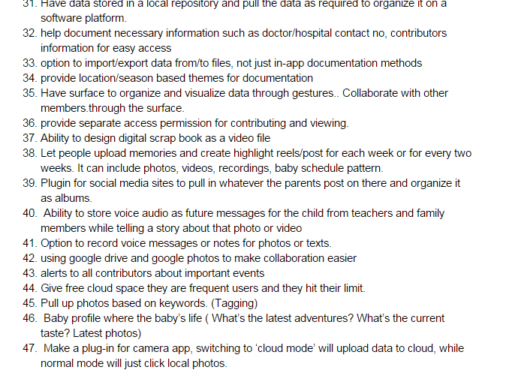

V Storyboards
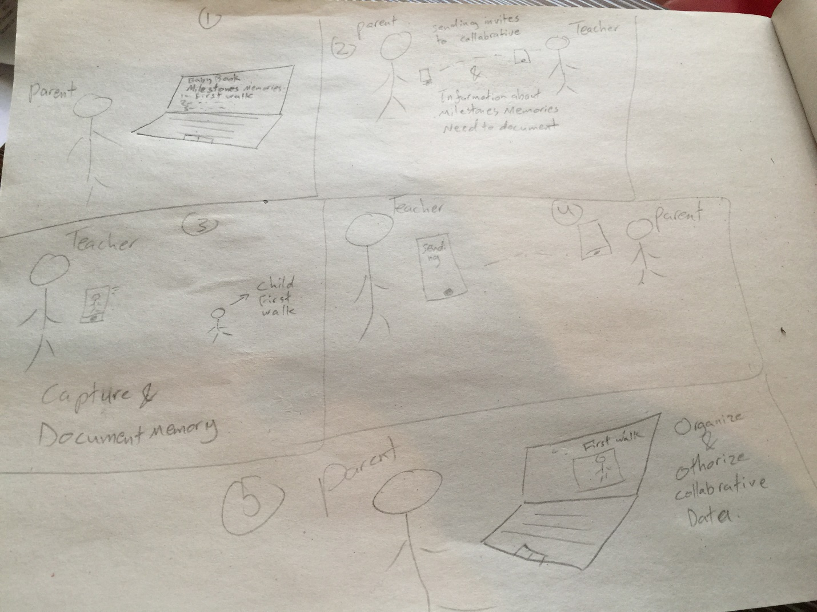

Ashley sends an invite to her daughter's kindergarten teacher to collaborate in documenting milestone memories of her daughter’s life that she is missing due to her long working hours. The teacher accepts the invite. When the teacher notices Ashley child walking for the first time, she captures and documents it and sends it to Ashley who will review it, authorize it, and edit it in a neat way.

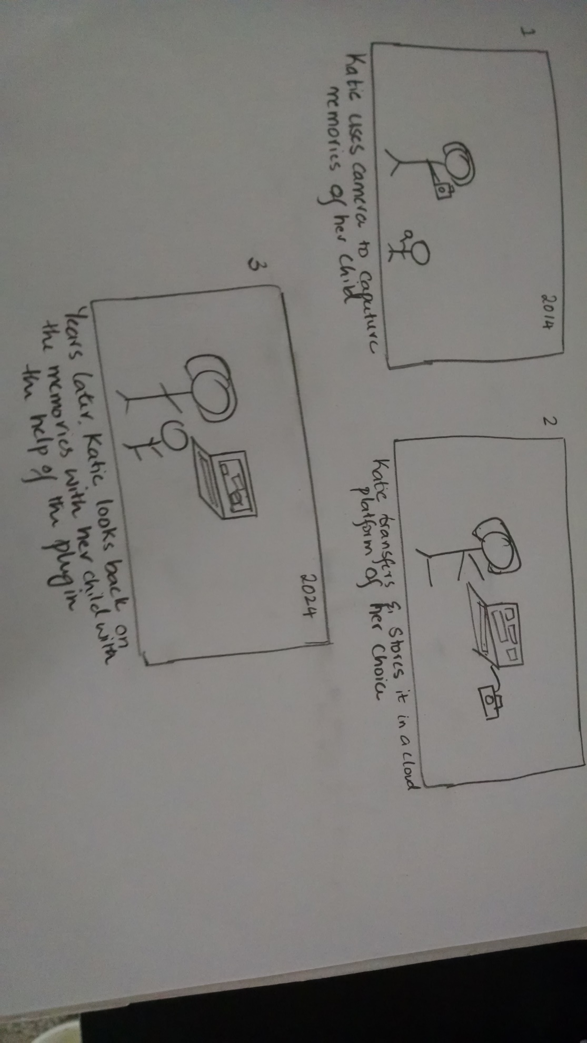
Sharing memories with the child.
The second storyboard show who will benefit from sharing those memories of the child. The parents or one of them can document the child memories and happy events send it in a secure way to family members like grandparents. In addition to saving those memories in organized way as a future message or journal for the child when he/she grew up to make him/her feel loved and connected to his family.

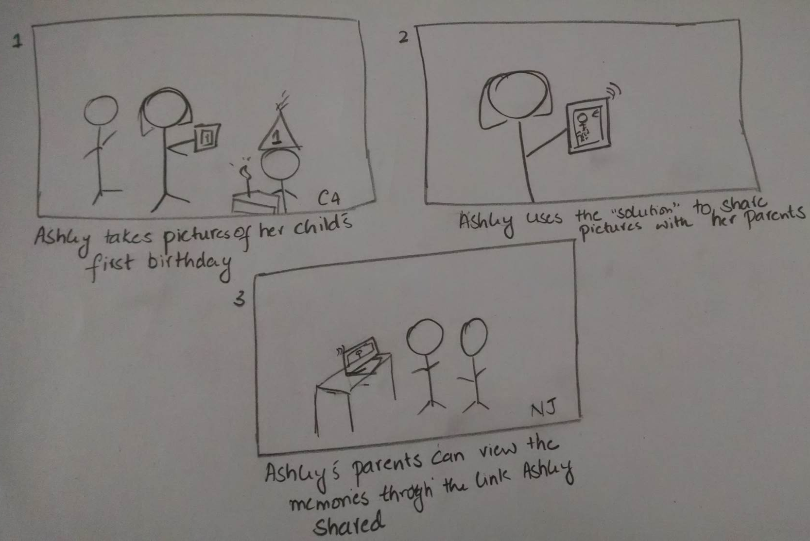
Sharing memories with family

VI Solution

We want to design a plugin which will help users create and view memories of children. We feel that a plugin is a better option than introducing a new application. The users are already spoilt for choice for storage options and introducing a new application might not be as appealing to the users. A plugin, however will be based on a framework the users are comfortable with and also trust to an extent. The plugin will be compatible with Google Drive/iCloud. The solution satisfies our four user requirements.

- Comprehensive Privacy Settings: The design offers a range of setting through which the user can set the level of privacy they are comfortable with. Since it is a plugin, the user already has a sense of security with system.
- Multiple Views of Memories: The design enables the user to search and pull up their memories in multiple ways through keywords, chronologically or by event.
- Preset Options: The design offers preset options for one click creation and sharing of memories.
- Accessible over various platforms: It is a plugin to systems which are accessible across mobile and desktop.

VII Prototype
The team decided first what main pages this add on for baby book project should contain, how it can help the parents documents their children memories and what features does it include as well. We used Balsamiq to prototype the add-on. We focused mainly on the desktop interface since all the features and pages are redundant on both the mobile and the desktop add on. We only sketched two prototypes screens for the mobile interface to explain a feature that is provided differently than what the desktop interface offers.

The main pages or lists are:
Notification Center
My Drive
Shared with me
Children pages
Settings & preferences

In addition there is many features that a user can access in most or some of those pages.

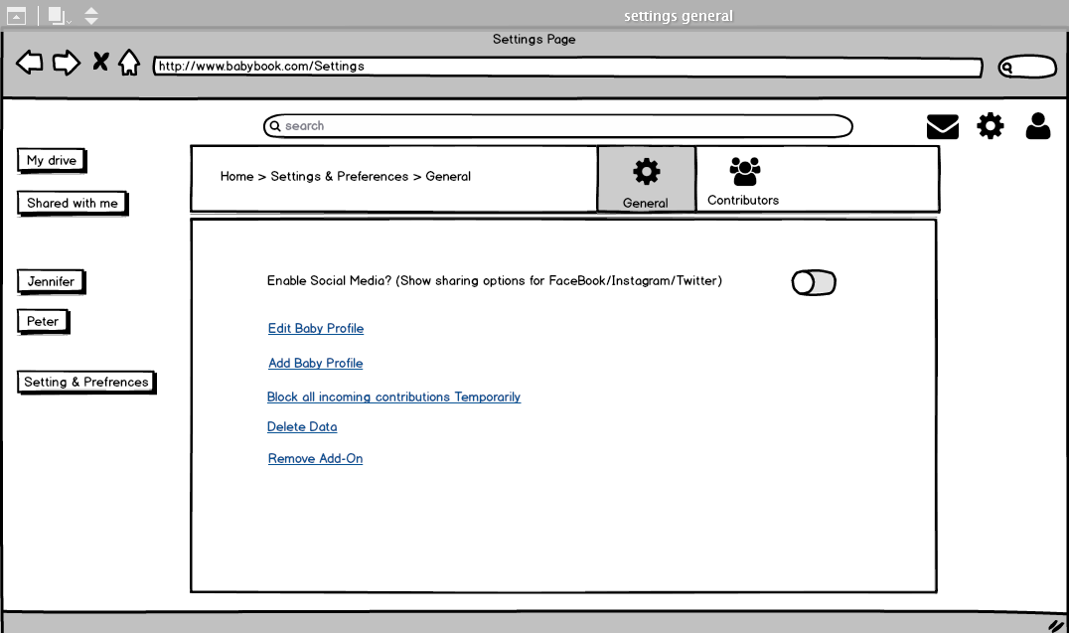
The screenshot above for the Setting & Preferences page and under the general section. Here we gave the option for the parent whether or not they want to share their children documentations via social media, as well as editing existing baby profile, adding a new baby profile, block all incoming contributions temporarily, delete data, and remove Add-On. Those were the features that we saw that can best fit the general settings and make the parent feel that they are in control for their family privacy and data flow when it becomes busier to an extent that the parent cannot view all of the contributions for example then he/she can block it temporarily.

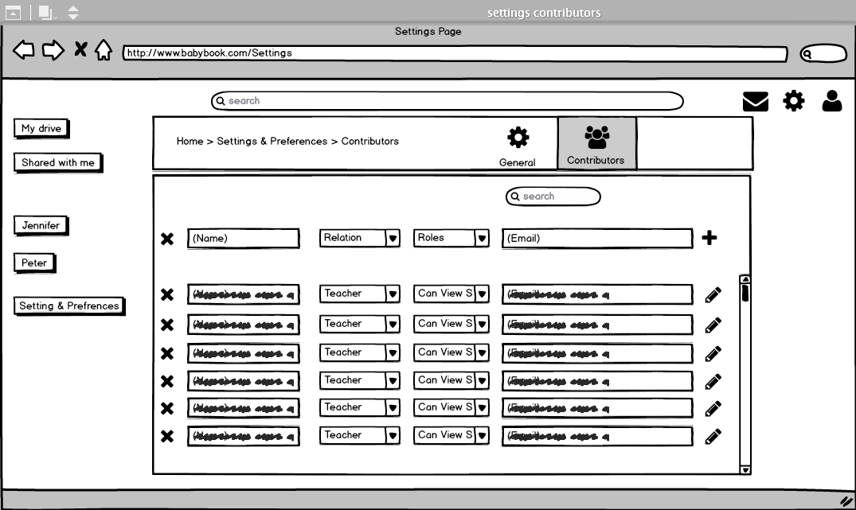
Next in here is the Settings & Preferences and under the contributors section, the parent can add contributors in addition to their relation to the child and their roles and accessibility levels (the role “can edit & share” can be assigned to the other parent or optionally to one other person because editing is a time consuming job and we don't intend to burden the parent with this task). When the parent clicks on the plus icon and add a certain contributor, the system would send an automatic invite to that person with a generated link to download the Add-On as well.

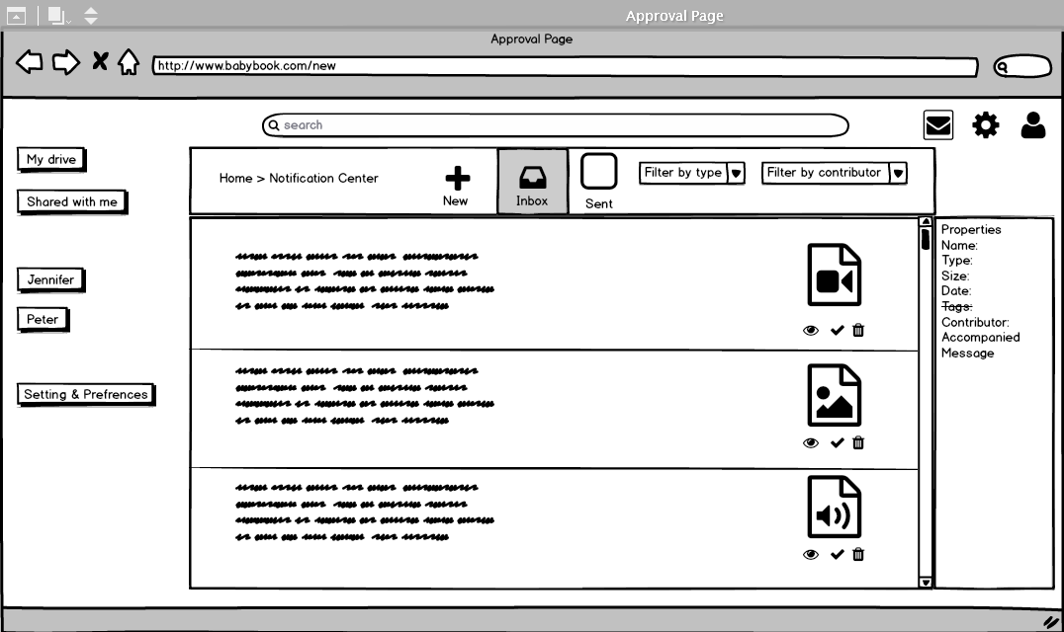
Parents could keep communicate with contributors using the notification center where all new arrival data from other contributors takes place and exist under the inbox section, which is also the notification center’ default page. In this page the parent can view quickly the content of each message and the type of document that it's included in that message. We provided three features for those attachments documents (preview, approve, and delete). Once the document is approved it would go directly to the My Drive page.

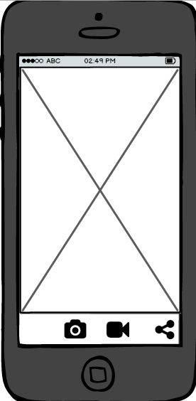
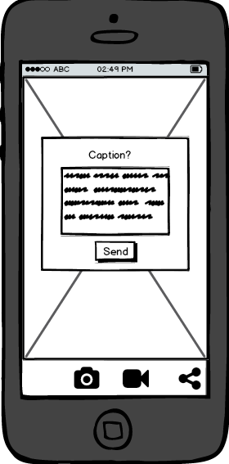

Contributors can document memories by capturing it on their phone and add a caption to the document. Then, they can access the Add-On on the phone as well and send it to the parent via notification center as explained above.

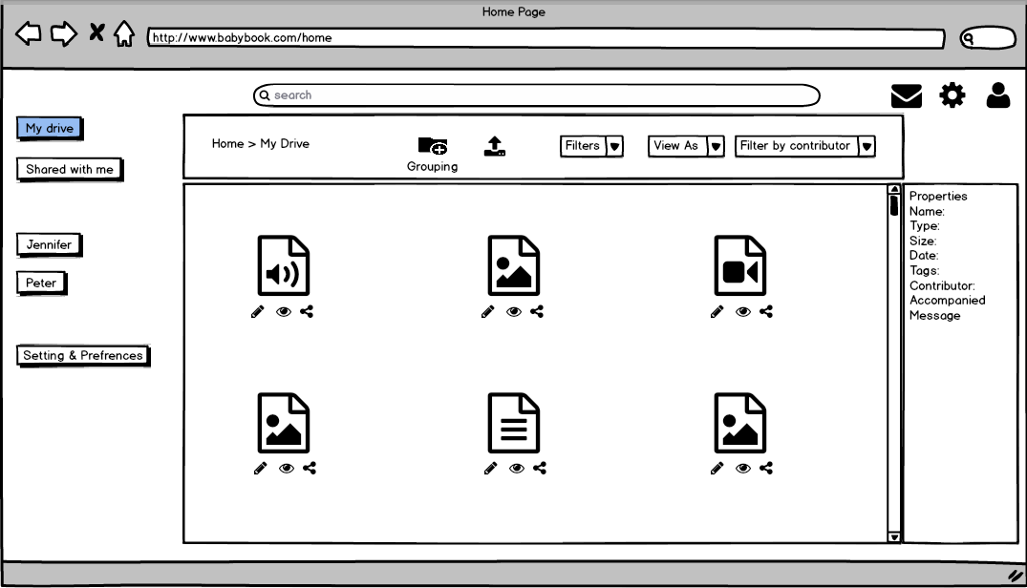
The Add-On is part of Google drive and under Google drive there is a specific storage only for the add on data. My drive here represent the storage where only the approved stored documents after the initial approval in the notification center goes to. Parent are the only user who can access this page and he/she can upload other documents using the upload icon to add previous documents that they have. Also, My drive here represent the default page in the Add-On for the parent. The search box is accessible and can be used to find documents in any page in the Add-On. In addition there is three list that the team created to better help the parent organized and view the documents (Filters, View As, Filter by contributor).

The “Filters” list help the parent view only certain type of documents such as: (Images,
Videos, Audios, and Texts). In addition to (Unorganized and Organized) which means documents that was already customized or not. Also, the same filter provide the option of (Ungrouped and Grouped) for documents that was listed under a certain category or folder or not.

In the “View As” list the parent can view the documents as (Timeline, Carousel, List, Grid). And the third list “Filter by contributor” view the documents that was contributed by a certain person who relate to the child, that person can be (Teacher, Grandparents, Parents, Cousin/sibling). In addition, on the right side of the screen the parent can see the files’ properties that is provided with each document.

We provided three basic features as icons under each document (preview, Edit, and sharing options). There is also a grouping icon on top which will talk about it on one of the next screens.

Deleting a document is only provided in the new arrival documents in the notification center but it can't be access in my drive nor the child main page to prevent deleting documents by mistake. Instead if a parent decided to delete an existing document in one of those two pages. He/She should click on preview first then click the trash icon on the preview popup like it's shown in the next screenshot.

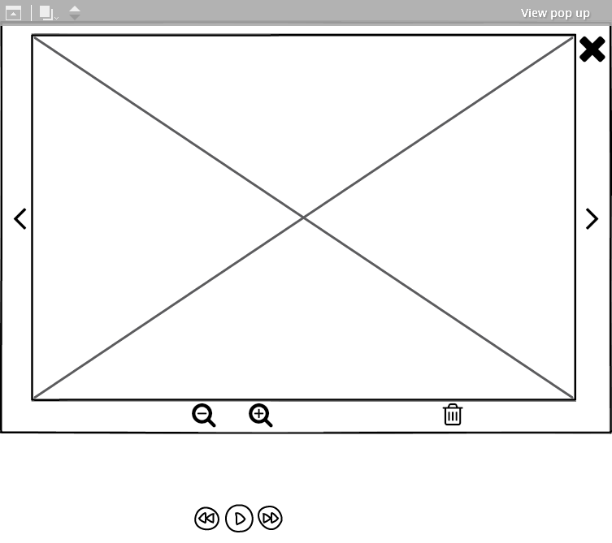
The preview popup feature exist every time there is an eye icon under a document, which is basically in most of the Add-On pages. Depending on the type of the document if it's an image or text the zoom in and out features appears in addition to the trash icon. However, if the document type was video or audio instead of the zoom in and out feature, a playback icon will appears.

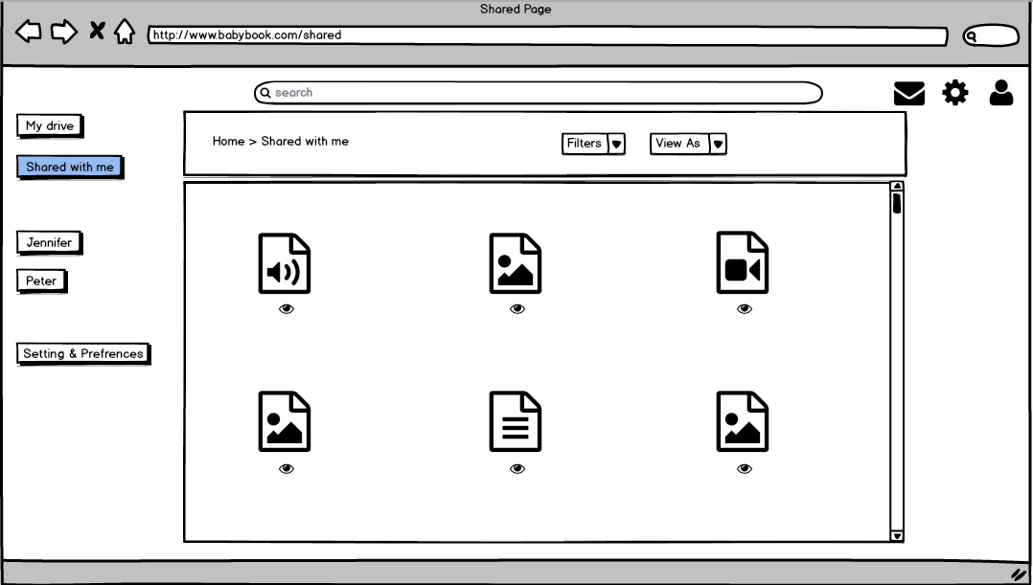

In the shared with me page, the parent here is viewing other parents shared documents for their children. Here the parent role will be different and become only a viewer or a contributor to someone else's children documentation. Here he/she can only preview the documents without editing it or sharing it.

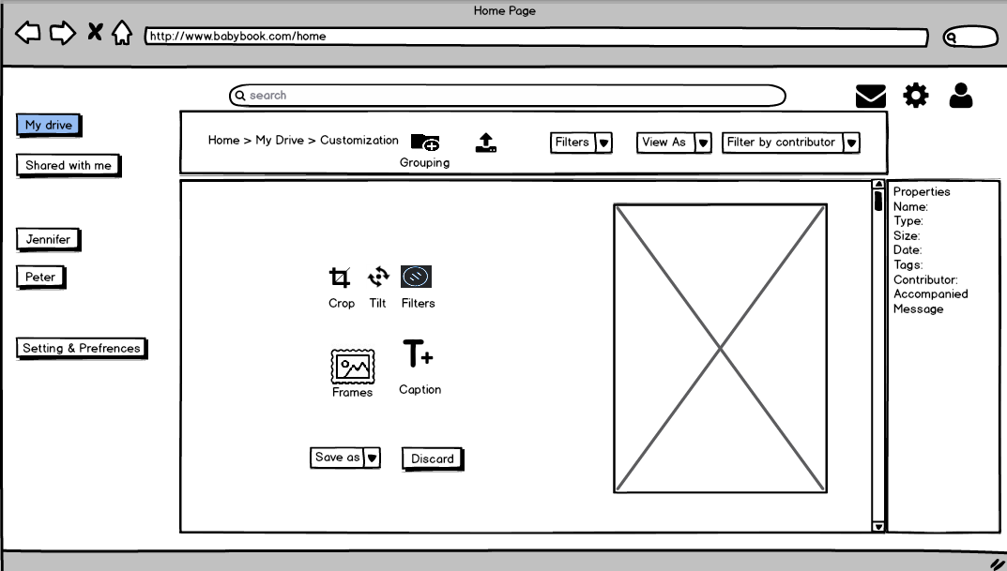

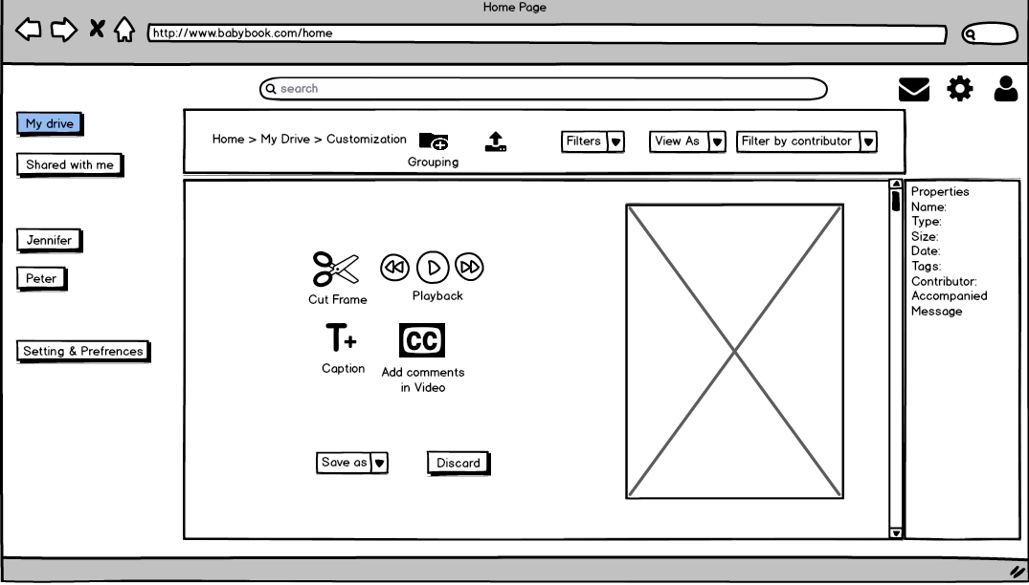

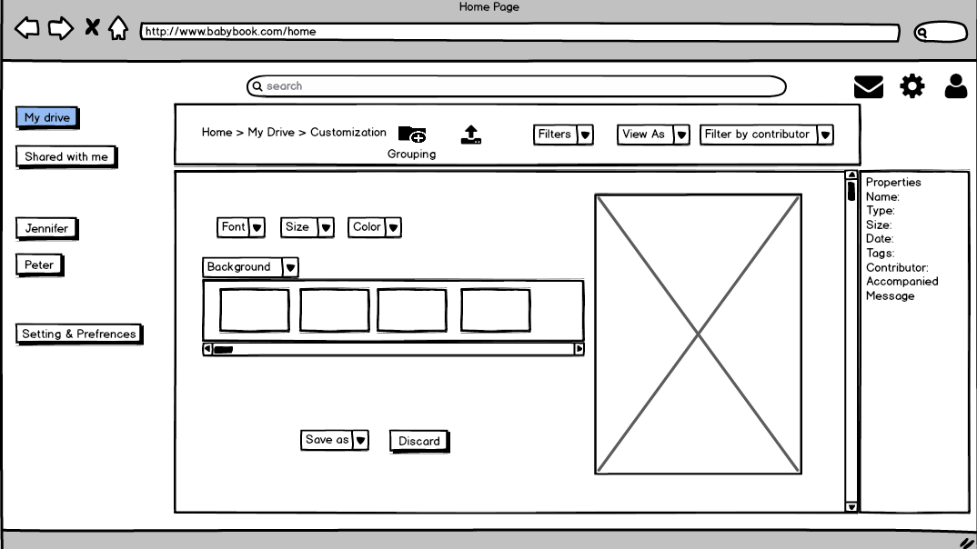

There are three types of customization as provided in the previous three screens (Images Customization, Audio/Video Customization, and Text Customization). The customization feature can be accessed in both My drive and the child page. The team decided to add different features to better fit the different types of documents.
1- For the Image Customization the features are (crop, tilt, image filters, presets frames, and adding caption).
2- For the Audio/Video Customization the features are (cut frame, playback, add caption, and add comments or explaining to video in a form of “subtitle”.
3- For the Text Customization the feature are (font, size, color, and preset background image or shape).
After the customization of a document ends, the parent can save the document as a file or as a workspace if he/she didn’t finish customizing yet. The parent can chose to discard all of the customizing work that the did to the original document at any time.

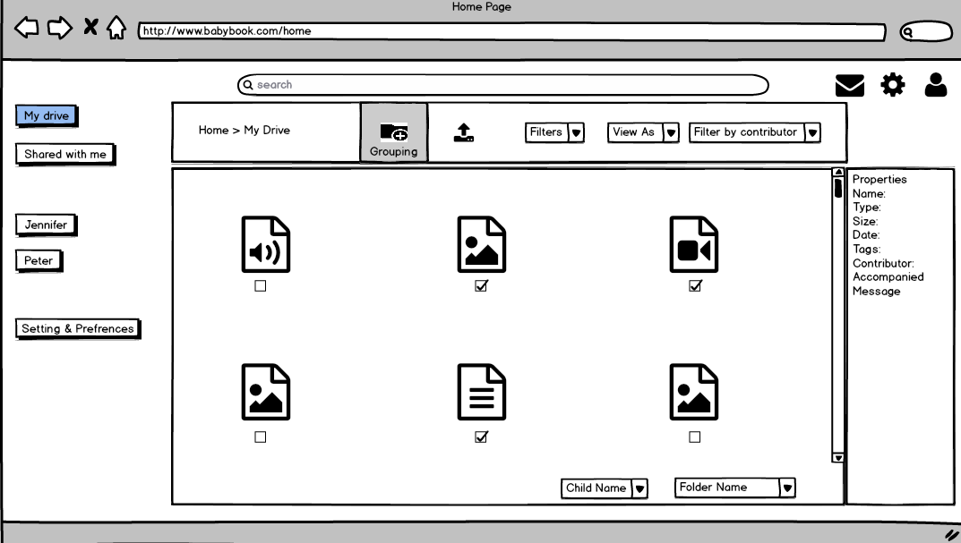
The grouping feature can be accessed from My drive page that we explained earlier as well as the child page. When a parent select the grouping icon all of the features for documents will be replaced with a simple check box. The parent select the preferred documents by clicking on the check boxes for each document. Then, select the child name from the list below to decide under which page a copy from those documents would move to. In addition, the parent can add those copies to a certain folder in that child page. The folder name page in this list includes ( Random, Milestone Events, First times, Accompanying other people, contributed by people, customized group 1, customized group 2, and + New folder).

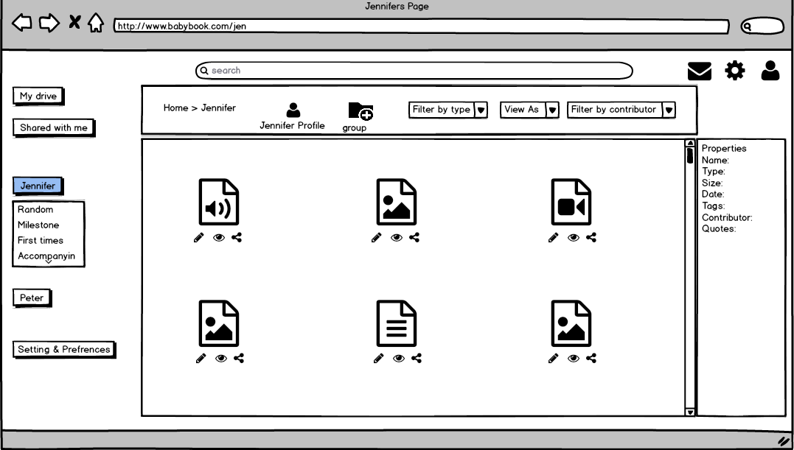
The previous folder name list in the grouping screenshot earlier is provided under the child name as links to that folder which is in this screenshot in Jennifer’ page. Other features, view lists and filters are similar to the lists in My drive page. However, the difference here is that it's only dedicated and focused for documents about Jennifer. Also, from the child page, the parent and/or contributor can access the baby profile which they can access from Jennifer icon that appears right next to the grouping icon.

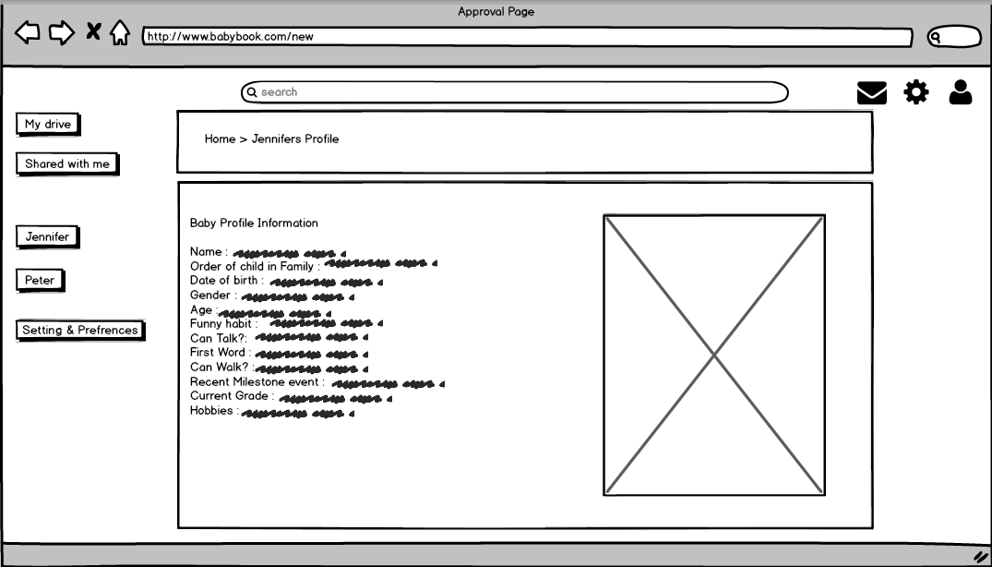
When clicking on the baby profile both a parent and contributor can view information about the baby along with the most recent picture selected by the parent.
In general our team faced some obstacles in the prototyping phase. There was lots of features and lots of things to consider and problems to solve. One of the main issues is that this Add-On is accessible from both mobile and desktop interfaces but if we duplicated all of the pages and features and prototyped screens for them it would be redundant because it would be the same except in a minimized version to fit the mobile screen.

Also, we had an issue with creating New arrival page on top of my drive and making use of the notification center. After many discussions back and forth we decided to combine them in order to make it easier for the user.

VIII Expert Review

Cognitive Walkthrough
The Prototype was well planned but lacks a few easy tweaks which can make the user experience rich.
The iconography, though being consistent overall, needs to be made more visible and explicit. Many of the options do not have icons related to them and might stand out to be inconsistent with the other options. Also a few features such as adding /editing contributors isn’t very visible for a first time user and requires exploration on the user's side. As the main intention of this system is to minimize the time spent on the system, it is crucial that important features be present at the top for easy access.
Adding a few visual cues for completing the task successfully would also help achieve this intent, as it will prevent rechecking and manual confirmation. E.g. the grouping option or the editing a contributor entry feature show no visual confirmation after completion of task.
The prototype does seem to cover many of the major concerns raised during the interview and initial survey sessions and hence does a good job of giving the complete command to the parent while eliminating the overhead of managing every detail of the process. Maintaining Privacy and Security would be easy to achieve as all the security of the cloud get implicitly added to the Add-On.
Heuristic Evaluation
The evaluation revealed that the add-on uses conventions familiar to the user and provides tools for the user to have a certain degree of freedom with the content. However, there were pitfalls to the add-on
The results and recommendations based on the Heuristic Evaluations are:
- Misleading and Unclear labels on Menu items:
The labels like ‘My Drive’, ‘Shared with me’ are misleading and sound similar to the system the add-on is installed on. In addition, just listing out the names of the children is clear.
Recommendation: Re-label ‘My Drive’ and ‘Shared with me’ to ‘All Memories’, ‘Shared Memories’. Nest Jennifer and Peter under a label ‘My Children’s Memories’

- On the customize page, there is no indication as to the current process they are in.
Recommendation: Add ‘Edit’ on top of the workspace.

- The labelling of the group icon is inconsistent.
Recommendation: Rename it to ‘Group’ throughout the system.

- There is no flexibility to directly to add memories to child’s file.
Recommendation: Enable uploading on children’s memory page.

- Using the eye icon to view the picture is rather difficult
Recommendation: Remove eye icon. View image by double clicking on it.

IX Validation

Usability Study Findings

Task Error
Based on the task error record, the most reported issue was with adding memory and saving a snapshot.
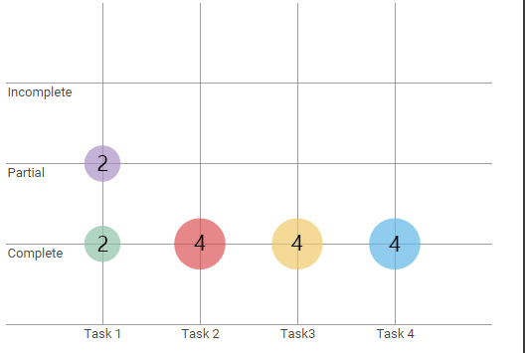
Figure 1 Task Completion Rate
Half of the reviewers were able to add a memory to the timeline but were not able to save as snapshot. They mentioned that they did not understand what saving as a snapshot meant. The other two experts who were able to complete the task mentioned that they found the iconography for snapshot confusing.
They recommended that ‘Add Memory’ button be persistent and easily accessible and adding tool tips for the icons.

Post-Task Questionnaire
The Post-Task Questionnaire asked the experts to rate their experience of using the prototype, specifically focusing on certain features of the prototype. Overall, they found the prototype quite easy to navigate through. The experts were in unanimous agreements that it was difficult to understand terminologies used especially Memory Settings. There was also confusion over what labels ‘Jennifer’ and ‘Peter’ represented. The experts assumed that they were different collaborators.
The Post-Task Questionnaire also revealed that the interactions with the timeline is difficult and lacks interactivity. The experts recommended addition on an edit feature for the images on the timeline and modify the shape of the images on the timeline.

Interview
The interview was conducted after the expert reviewers has filled out the Task Error Record and Post-Task Questionnaire. Based on their responses, we spoke to them about the prototype and their experience with it.
The findings from the interviews can be summarized as follows:
- Finding the collaborators pages was hard as it was under Memory Settings.
- There was no indication whether or not they were successful in saving a snapshot
- They all agreed that a small tutorial was required for first time user.
- Assumed that ‘Jennifer’ and ‘Peter’ were collaborators. Recommended to place ‘Jennifer’ and ‘Peter’ under ‘Memories’ since they would have memories related to a specific child.

Summary of Product Assessment

Problems with the Product
Based on expert reviews and usability evaluations the following are the major issues
- The concept of snapshot is not clear to users/experts
- Lack of interactivity with the Timeline
- Confusion over iconography and children labels (Jennifer and Peter)
- Difficulty in finding collaborators page.
These are the issues on a micro-level, however overarching problem was the unfamiliar interactions and unusual organization of components within the add-on.

Recommendations for Future Development
A few recommendations to improve the interactions are:
- Add tool tips for icons or add labels to the icons to indicate the functionality.
- Add pop-ups for first time users to explain unfamiliar functionalities like snapshots and adding memories.
- Ensure that the prototype is responsive.
The add-on effectively facilitates collaboration, collection and organization of memories in one space, however it fails to successfully provide means for parents and collaborators to collaborate on visualizing memories together and re-creating stories of the child. Before we move forward, we recommend to rethink timeline aspect of the solution and user’s interaction with it.

X Appendices

Appendix A: Personas

Ashley Bennett
Ashley Bennett is a mother of a 4 year old girl, she is married but works full time as a Lawyer in Indianapolis, Indiana. Being in her late 30s, she has a busy job, working Mon-Fri 9-6, sometimes even on weekends. Her husband is also busy with his job.. Ashley loves to document minute details related to her daughter, but due to her job, is not always around to do it. Whenever she get a chance, she clicks photos of her daughter and uploads them on Instagram and/or Facebook to share them. She sometimes considers being a stay at home mom because she hates missing out on crucial moments in her baby’s life, like when her daughter is at kindergarten. She desperately needs a way to help her document her daughter’s memories when she is not around. She needs an app which helps her to documents, organize and easily share photos in a neat and secure manner. She would also like to have an option to let the kindergarten teacher contribute to documenting the important moments of her daughter’s life and send it to her.


Katie Chapman
Katie is a mother of 2 kids, a 4 year old boy and a 6 month old daughter. She is a stay at home mom, living in Fremont, California. Her hobbies in Photography, collecting bottle caps, blogging and she also sometimes volunteers at a local pet shelter. She uses her professional Camera to click photos of her kids instead of her mobile phone. She is meticulous about nutrition intake of herself and her family. When it comes to her kids, she doesn’t trust anyone with their details and photos. She is active on Instagram and shares her photography on it, sometimes even her kids photos, but not on Facebook or Twitter. She loves sharing her kids photos with family and close friends. She finds it hard to manage two kids and maintain an elaborate documentation system, thus requires an automatic or easy to use way to document, so as to be able to pay attention to both her kids. She fears missing out on her 4 year old boys activities in kindergarten. Also, the increasing no of scams and privacy breaches scare her while uploading photos of her kids online. The main feature she looks for while using any system related to her kids is privacy and security. Her husband is usually at work and cannot help in documentation on a regular basis. So she would also like to receive some help from her family or friends who can help her in documenting memories for her children.

Liam Prather

Liam is a father of a 3 year old girl. He works as Marketing Manager in a big firm and has a very busy schedule, due to which he has limited time to spend with his family. He is calm and practical man which helps him in his job. His wife primarily records the memories of their daughter but has to travel occasionally. He takes up the role of recording memories at such times. He wants to make the most out of the time he has with his daughter and is looking for a way to record memories with his daughter without drawing his attention away from his daughter. He enjoys looking back at his memories with his daughter by milestones and events. He likes to share photos and moments with his family members who live in different cities. He is careful about the photos of his daughter that he posts on social media websites as he can't see an easier way to share them with his inner circle of friends.

Appendix B: Internal Walkthrough Feedback Form
Task: Customizing Image from Memories
CW Question | Issue? | Notes
Will the user be trying to achieve the right effect? | Yes
Will the user know that the correct action is available? | No
Will the user know that the correct action will achieve the desired effect? | Yes
If the correct action is taken, will the user see that things are going ok? | Yes
General Notes: | The customize button under every document is one of many options available on screen and even though the iconography is proper, the user might not be able to spot it immediately

Undo a mistake
CW Question | Issue? | Notes
Will the user be trying to achieve the right effect? | No
Will the user know that the correct action is available? | No
Will the user know that the correct action will achieve the desired effect? | No
If the correct action is taken, will the user see that things are going ok? | No
General Notes: | The discard button will discard all changes applied to the document, it will be tedious for the user to redo all but the last changes every time.

Deleting documents
CW Question | Issue? | Notes
Will the user be trying to achieve the right effect? | No
Will the user know that the correct action is available? | No
Will the user know that the correct action will achieve the desired effect? | No
If the correct action is taken, will the user see that things are going ok? | No
General Notes: | Although we don’t want the parents to waste a lot of time choosing which document to keep and which to discard, it would still be necessary to have a delete file button which is missing.

Task: Grouping
CW Question | Issue? | Notes
Will the user be trying to achieve the right effect? | Yes
Will the user know that the correct action is available? | Yes
Will the user know that the correct action will achieve the desired effect? | Yes
If the correct action is taken, will the user see that things are going ok? | No
General Notes: | There are no signs of the user to confirm the grouping took place correctly other than opening the group manually and checking for the newly added documents.

Task: Adding/Editing Contributors
CW Question | Issue? | Notes
Will the user be trying to achieve the right effect? | No
Will the user know that the correct action is available? | No
Will the user know that the correct action will achieve the desired effect? | Yes
If the correct action is taken, will the user see that things are going ok? | Yes
General Notes: | The option to add a contributor is not apparent unless visiting the settings page. The option should be made more prominent and accessible from the other pages.

Confirmation of successful editing
CW Question | Issue? | Notes
Will the user be trying to achieve the right effect? | Yes
Will the user know that the correct action is available? | Yes
Will the user know that the correct action will achieve the desired effect? | Yes
If the correct action is taken, will the user see that things are going ok? | No
General Notes: | After editing an existing entry, there is no visual feedback that the modification of that entry was successful.
Task: Editing Baby profile
CW Question | Issue? | Notes
Will the user be trying to achieve the right effect? | No
Will the user know that the correct action is available? | Yes
Will the user know that the correct action will achieve the desired effect? | Yes
If the correct action is taken, will the user see that things are going ok? | Yes
General Notes: | The option to Edit the Baby profile is not present on the profile page but in the settings. Even though this adds to the security of the system, it makes the task of editing and previewing the changes unnecessarily longer.

Appendix C: Task Error Record Sheet

https://goo.gl/s4hzzU

Appendix D: Post-Task Questionnaire

https://goo.gl/QIBboR

Appendix E: High Fidelity Screenshots
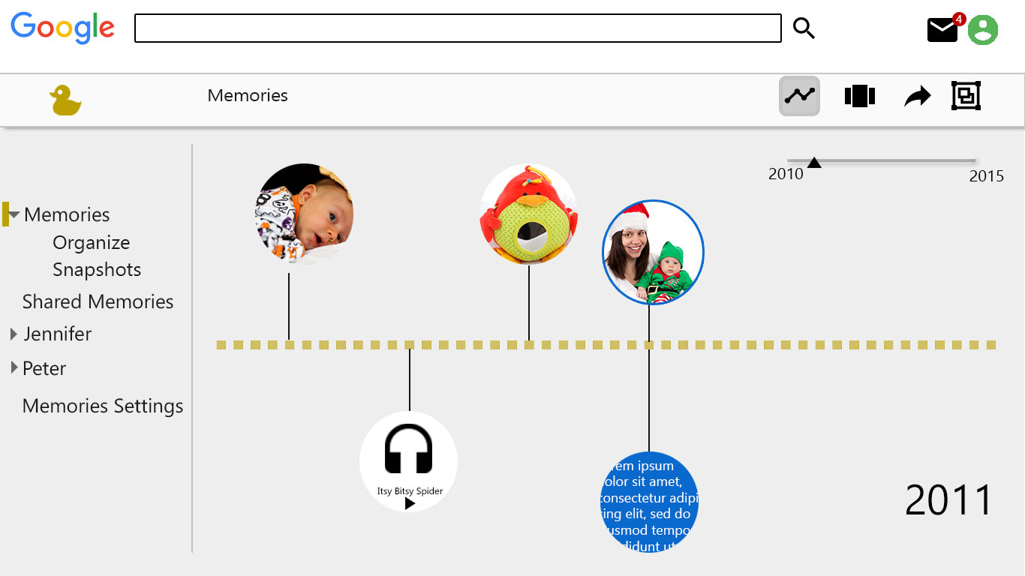
The Timeline Page

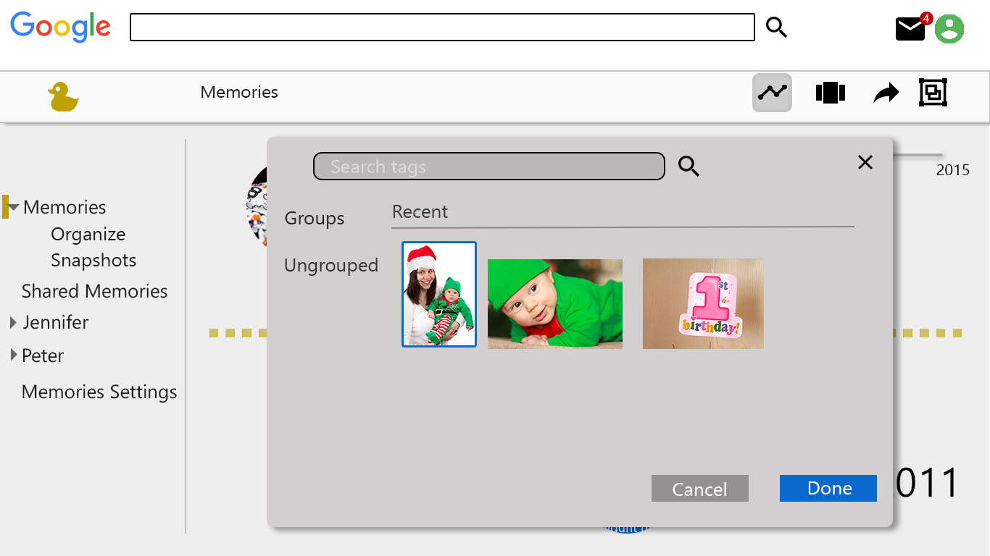
Adding memory
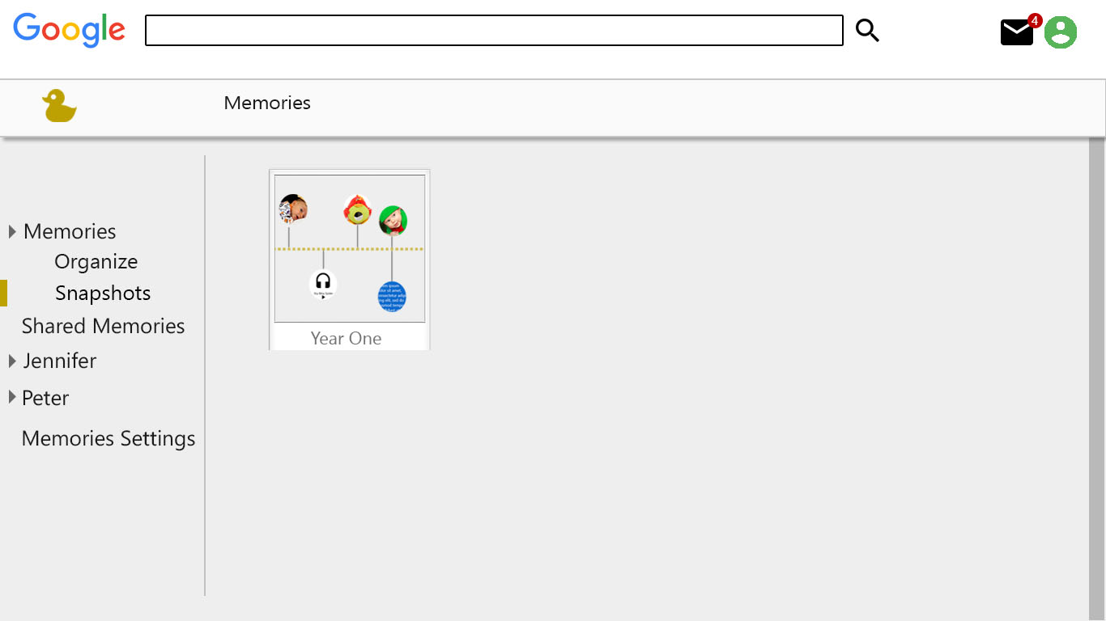
Snapshot page

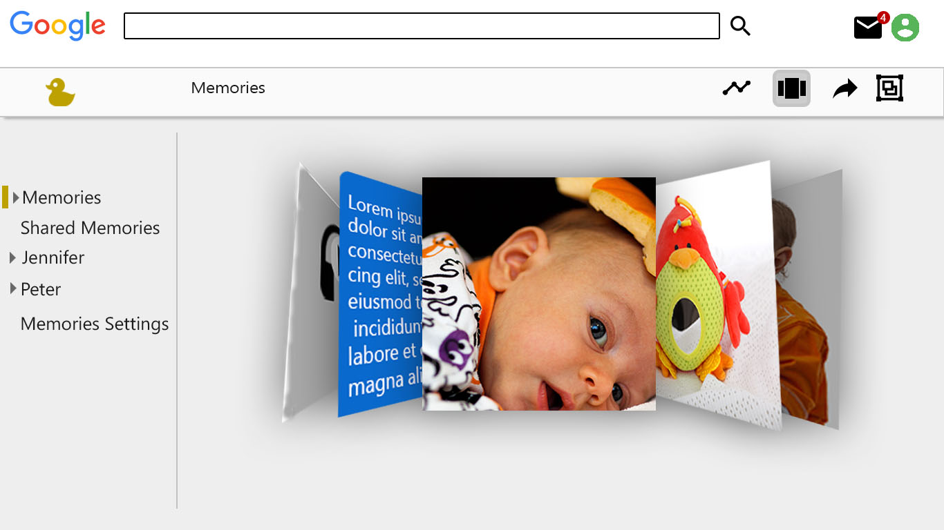
Coverflow visualization

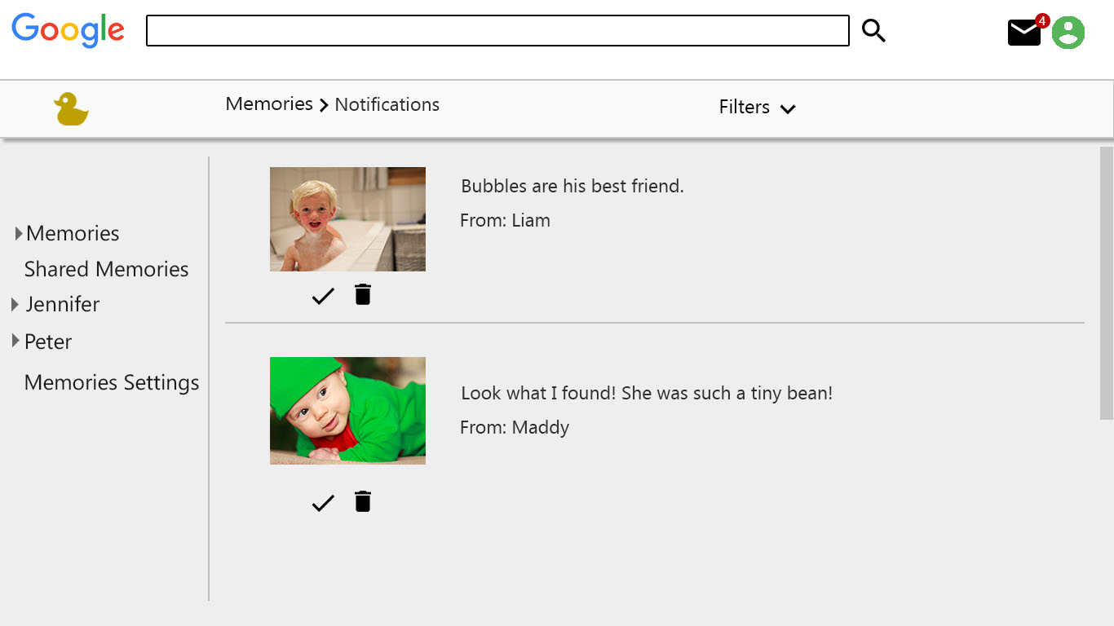
Notification Center
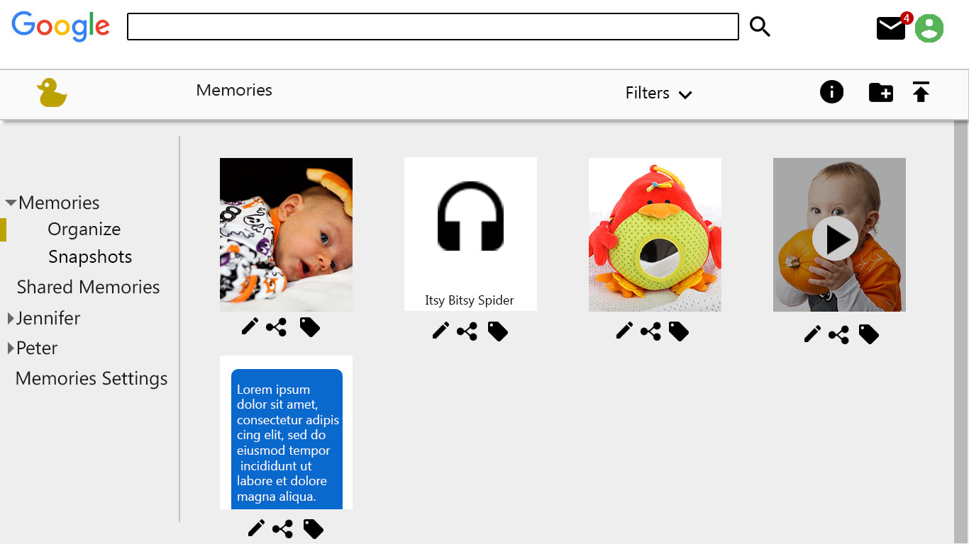
Organize page

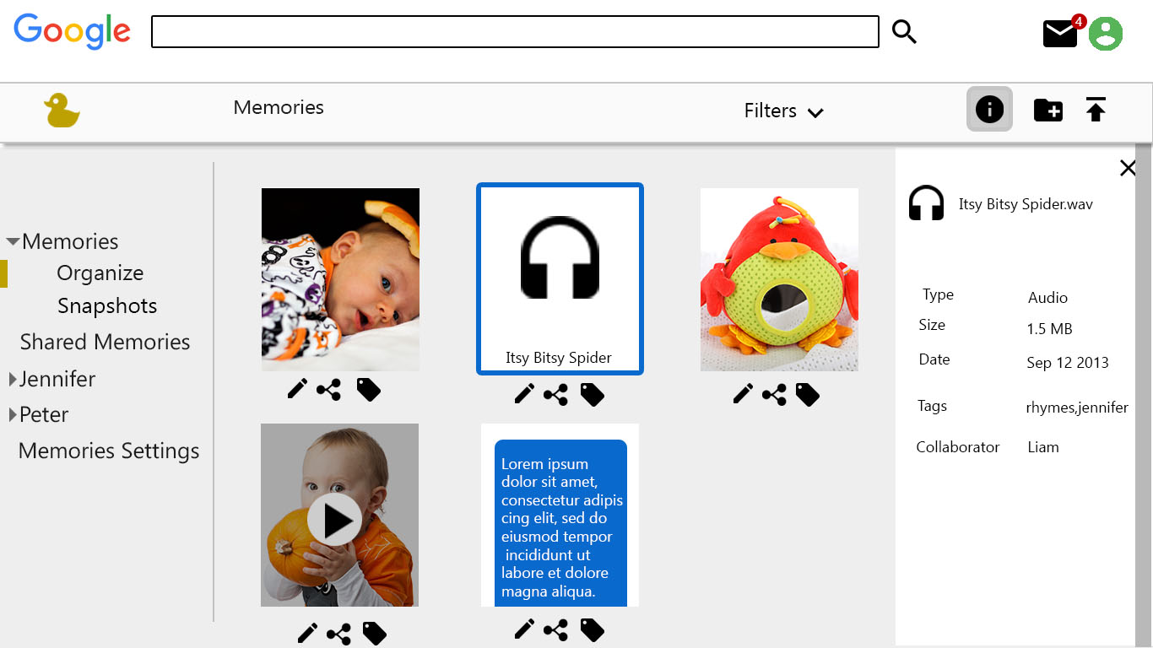
Extra Information page

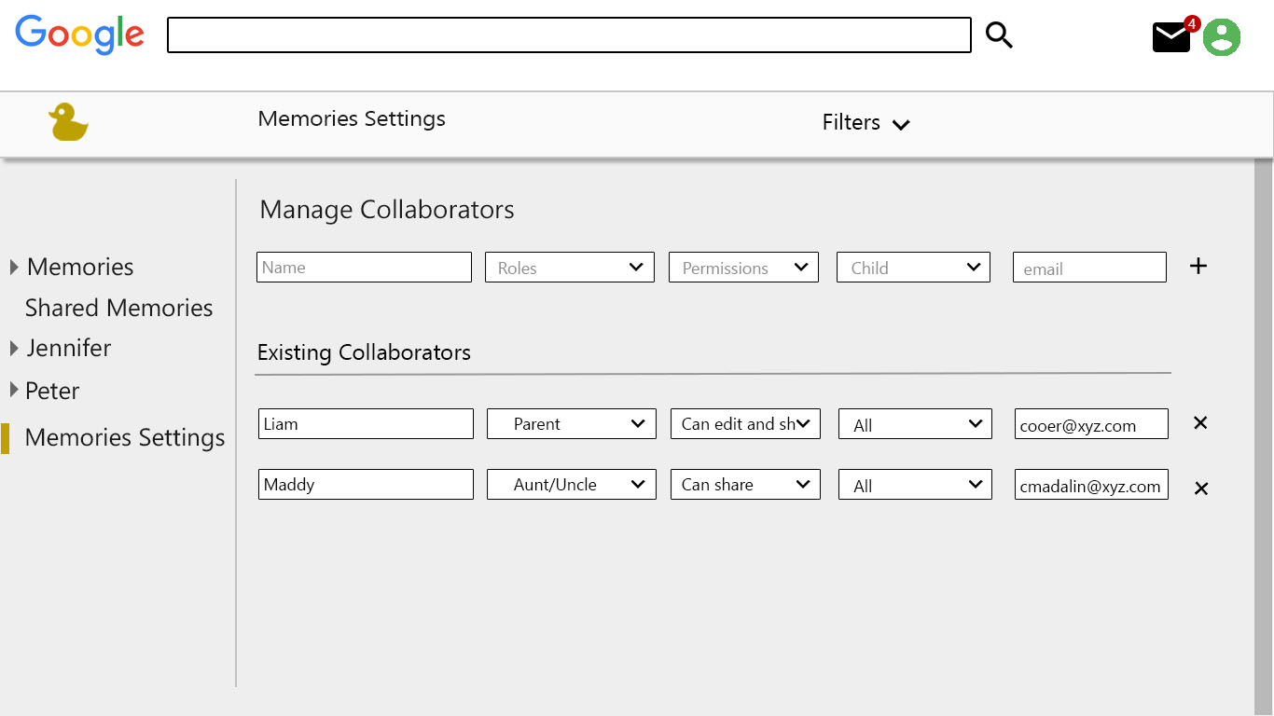
Collaborator settings

