login as: ec2-user
Authenticating with public key "Imported-Openssh-Key"
┌──────────────────────────────────────────────────────────────────────┐
│ • MobaXterm Personal Edition v25.4 • │
│ (SSH client, X server and network tools) │
│ │
│ ⮞ SSH session to ec2-user@43.204.212.31 │
│ • Direct SSH : ✓ │
│ • SSH compression : ✓ │
│ • SSH-browser : ✓ │
│ • X11-forwarding : ✗ (disabled or not supported by server) │
│ │
│ ⮞ For more info, ctrl+click on help or visit our website. │
└──────────────────────────────────────────────────────────────────────┘

, #_
~\_ ####_ Amazon Linux 2023
~~ \_#####\
~~ \###|
~~ \#/ ___ https://aws.amazon.com/linux/amazon-linux-2023
~~ V~' '->
~~~ /
~~._. _/
_/ _/
_/m/'
Last login: Sun May 24 18:24:24 2026 from 103.119.172.167
[ec2-user@ip-172-31-14-138 ~]$ sudo su -
Last login: Sun May 24 18:31:44 UTC 2026 on pts/1

[root@ip-172-31-14-138 ~]# ansible all --list-hosts
hosts (1):
172.31.6.16
[root@ip-172-31-14-138 ~]# history
1 useradd omkar
2 passwd omkar
3 vi /etc/sudoers

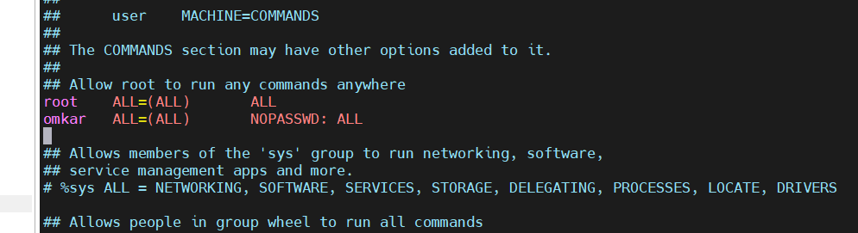

4 vi /etc/ssh/sshd_config

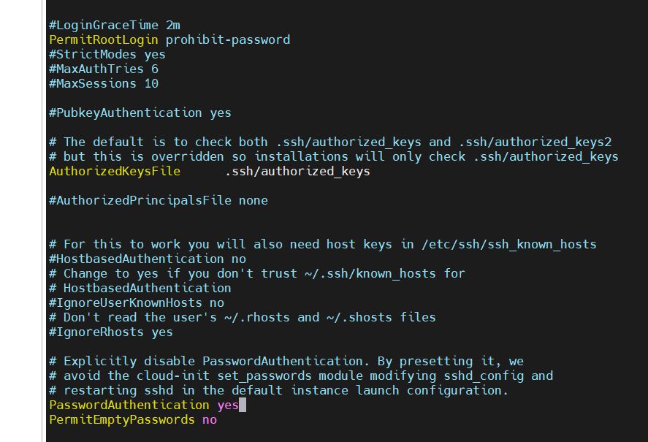

5 service sshd restart
6 exit
7 sudo su - omkar
8 vi /etc/ansible/hosts.yaml
9 sudo su - omkar
10 cd /etc/ansible/
11 ls -ltr
12 rm -rf hosts.yaml
13 vi hosts
14 ansible all --list-hosts
15 sudo su - omkar
16 :
17 exit
18 ls -ltr
19 vi /etc/ansible/deploy.yaml
20 ansible all --list-hosts
21 history

[root@ip-172-31-14-138 ~]# sudo su - omkar
Last login: Sun May 24 18:53:41 UTC 2026 on pts/2

[omkar@ip-172-31-14-138 ~]$ git -v
git version 2.50.1

[omkar@ip-172-31-14-138 ~]$ mkdir gitproject
[omkar@ip-172-31-14-138 ~]$ cd gitproject

[omkar@ip-172-31-14-138 gitproject]$ git clone https://github.com/Shantanumajan6/project.git
Cloning into 'project'...
remote: Enumerating objects: 92, done.
remote: Counting objects: 100% (24/24), done.
remote: Compressing objects: 100% (9/9), done.
remote: Total 92 (delta 21), reused 15 (delta 15), pack-reused 68 (from 1)
Receiving objects: 100% (92/92), 24.47 KiB | 3.50 MiB/s, done.
Resolving deltas: 100% (41/41), done.
[omkar@ip-172-31-14-138 gitproject]$ cd

[omkar@ip-172-31-14-138 ~]$ ls -ltr
total 8
drwxr-xr-x. 3 omkar omkar 21 May 24 18:38 gitproject
-rw-r--r--. 1 omkar omkar 1028 May 24 19:16 deploy.yaml
-rw-r--r--. 1 omkar omkar 514 May 24 19:17 tomcat.yaml
[omkar@ip-172-31-14-138 ~]$ cd gitproject/project/

[omkar@ip-172-31-14-138 project]$ ls -ltr
total 8
drwxr-xr-x. 3 omkar omkar 18 May 24 18:38 src
-rw-r--r--. 1 omkar omkar 949 May 24 18:38 pom.xml
-rw-r--r--. 1 omkar omkar 507 May 24 18:38 Jenkinsfile
drwxr-xr-x. 4 omkar omkar 88 May 24 18:48 target
[omkar@ip-172-31-14-138 project]$ cd target/
[omkar@ip-172-31-14-138 target]$ ls -ltr
total 3844
drwxr-xr-x. 4 omkar omkar 175 May 24 18:46 LoginWebApp
drwxr-xr-x. 2 omkar omkar 28 May 24 18:46 maven-archiver
-rw-r--r--. 1 omkar omkar 3930148 May 24 18:46 LoginWebApp.war
-rw-r--r--. 1 omkar omkar 24 May 24 18:48 hosts.yaml
[omkar@ip-172-31-14-138 target]$ cd

[omkar@ip-172-31-14-138 ~]$ vi deploy.yaml

---
- hosts: devlinux
user: omkar
become: yes
gather_facts: yes

tasks:
- name: install java
yum:
name: java-17-amazon-corretto
state: present

- name: create servers directory
file:
path: /mnt/servers
state: directory
mode: '777'

- name: download tomcat
get_url:
url: https://dlcdn.apache.org/tomcat/tomcat-11/v11.0.22/bin/apache-tomcat-11.0.22.zip
dest: /mnt/servers/apache-tomcat-11.0.22.zip

- name: unzip tomcat
unarchive:
src: /mnt/servers/apache-tomcat-11.0.22.zip
dest: /mnt/servers/
remote_src: yes

- name: give permission to tomcat
file:
path: /mnt/servers/apache-tomcat-11.0.22
mode: '777'
recurse: yes

- name: start tomcat
shell: /mnt/servers/apache-tomcat-11.0.22/bin/startup.sh

- name: deploy war file
copy:
src: /home/omkar/gitproject/project/target/LoginWebApp.war
dest: /mnt/servers/apache-tomcat-11.0.22/webapps/

- name: shutdown tomcat
shell: /mnt/servers/apache-tomcat-11.0.22/bin/shutdown.sh
ignore_errors: yes

- name: restart tomcat
shell: /mnt/servers/apache-tomcat-11.0.22/bin/startup.sh

[omkar@ip-172-31-14-138 ~]$ ansible-playbook deploy.yaml

PLAY [devlinux] **********************************************************************************************************************************************

TASK [Gathering Facts] ***************************************************************************************************************************************
[WARNING]: Platform linux on host 172.31.6.16 is using the discovered Python interpreter at /usr/bin/python3.9, but future installation of another Python
interpreter could change the meaning of that path. See https://docs.ansible.com/ansible-core/2.15/reference_appendices/interpreter_discovery.html for more
information.
ok: [172.31.6.16]

TASK [install java] ******************************************************************************************************************************************
ok: [172.31.6.16]

TASK [install unzip] *****************************************************************************************************************************************
ok: [172.31.6.16]

TASK [create servers directory] ******************************************************************************************************************************
ok: [172.31.6.16]

TASK [download tomcat] ***************************************************************************************************************************************
ok: [172.31.6.16]

TASK [unzip tomcat] ******************************************************************************************************************************************
changed: [172.31.6.16]

TASK [give permission to tomcat] *****************************************************************************************************************************
changed: [172.31.6.16]

TASK [start tomcat] ******************************************************************************************************************************************
changed: [172.31.6.16]

TASK [deploy war file] ***************************************************************************************************************************************
changed: [172.31.6.16]

TASK [shutdown tomcat] ***************************************************************************************************************************************
changed: [172.31.6.16]

TASK [restart tomcat] ****************************************************************************************************************************************
changed: [172.31.6.16]

PLAY RECAP ***************************************************************************************************************************************************
172.31.6.16 : ok=11 changed=6 unreachable=0 failed=0 skipped=0 rescued=0 ignored=0

logout

─────────────────────────────────────────────────────────────────────────────────────

Output :



login as: ec2-user
Authenticating with public key "Imported-Openssh-Key"
┌──────────────────────────────────────────────────────────────────────┐
│ • MobaXterm Personal Edition v25.4 • │
│ (SSH client, X server and network tools) │
│ │
│ ⮞ SSH session to ec2-user@43.204.233.148 │
│ • Direct SSH : ✓ │
│ • SSH compression : ✓ │
│ • SSH-browser : ✓ │
│ • X11-forwarding : ✗ (disabled or not supported by server) │
│ │
│ ⮞ For more info, ctrl+click on help or visit our website. │
└──────────────────────────────────────────────────────────────────────┘

, #_
~\_ ####_ Amazon Linux 2023
~~ \_#####\
~~ \###|
~~ \#/ ___ https://aws.amazon.com/linux/amazon-linux-2023
~~ V~' '->
~~~ /
~~._. _/
_/ _/
_/m/'
[ec2-user@ip-172-31-6-16 ~]$ sudo su -
[root@ip-172-31-6-16 ~]# useradd omkar
[root@ip-172-31-6-16 ~]# passwd omkar
Changing password for user omkar.
New password:
BAD PASSWORD: The password is shorter than 8 characters
Retype new password:
passwd: all authentication tokens updated successfully.
[root@ip-172-31-6-16 ~]# vi /etc/sudoers
[root@ip-172-31-6-16 ~]# vi /etc/ssh/sshd_config
[root@ip-172-31-6-16 ~]# service sshd restart
Redirecting to /bin/systemctl restart sshd.service
[root@ip-172-31-6-16 ~]# exit
logout
[ec2-user@ip-172-31-6-16 ~]$ sudo su -
Last login: Sun May 24 18:25:03 UTC 2026 on pts/1
[root@ip-172-31-6-16 ~]# sudo su - omkar
[omkar@ip-172-31-6-16 ~]$ ls -ltr
total 0
[omkar@ip-172-31-6-16 ~]$ cd /mnt/
[omkar@ip-172-31-6-16 mnt]$ ls -ltr
total 0
drwxrwxrwx. 3 root root 68 May 24 19:24 servers
[omkar@ip-172-31-6-16 mnt]$ cd servers/
[omkar@ip-172-31-6-16 servers]$ ls -ltr
total 14588
drwxrwxrwx. 9 root root 16384 May 1 18:29 apache-tomcat-11.0.22
-rw-r--r--. 1 root root 14919127 May 24 19:24 apache-tomcat-11.0.22.zip
[omkar@ip-172-31-6-16 servers]$ cd apache-tomcat-11.0.22/
[omkar@ip-172-31-6-16 apache-tomcat-11.0.22]$ ls -ltr
total 188
drwxrwxrwx. 7 root root 81 May 1 18:29 webapps
drwxrwxrwx. 2 root root 30 May 1 18:29 temp
drwxrwxrwx. 2 root root 16384 May 1 18:29 lib
drwxrwxrwx. 2 root root 16384 May 1 18:29 bin
-rwxrwxrwx. 1 root root 16582 May 1 18:29 RUNNING.txt
-rwxrwxrwx. 1 root root 6632 May 1 18:29 RELEASE-NOTES
-rwxrwxrwx. 1 root root 3301 May 1 18:29 README.md
-rwxrwxrwx. 1 root root 2401 May 1 18:29 NOTICE
-rwxrwxrwx. 1 root root 61666 May 1 18:29 LICENSE
-rwxrwxrwx. 1 root root 8851 May 1 18:29 CONTRIBUTING.md
-rwxrwxrwx. 1 root root 27577 May 1 18:29 BUILDING.txt
drwxrwxrwx. 3 root root 16384 May 24 19:24 conf
drwxrwxrwx. 3 root root 22 May 24 19:24 work
drwxrwxrwx. 2 root root 132 May 24 19:24 logs

[omkar@ip-172-31-6-16 apache-tomcat-11.0.22]$ cd
[omkar@ip-172-31-6-16 ~]$ ls -ltr /mnt/servers/apache-tomcat-11.0.22/webapps/
total 3872
drwxrwxrwx. 3 root root 16384 May 24 19:37 ROOT
drwxrwxrwx. 16 root root 16384 May 24 19:37 docs
drwxrwxrwx. 7 root root 99 May 24 19:37 examples
drwxrwxrwx. 6 root root 79 May 24 19:37 host-manager
drwxrwxrwx. 6 root root 114 May 24 19:37 manager
-rw-r--r--. 1 root root 3930148 May 24 19:37 LoginWebApp.war
drwxr-x---. 4 root root 175 May 24 19:37 LoginWebApp

logout

──────────────────────────────────────────────────────────────────────────────────────────────────────────────────────────────────────────────────────────────

Session stopped
- Press <Return> to exit tab
- Press R to restart session
- Press S to save terminal output to file

