Docker Assignment 2.1

Subject : One repo -- three branches -- master, Q1, Q2 -- all three have index.html files in them.
JM -- use jenkins declarative pipeline
Create three containers.
JM -- SSH to slaves
JM -- Slave 1(deploy master) -- slave 2(deploy Q1) -- slave 3 (deploy Q2)

= = = = = = = = = = = = = = = = = = = = = = = = = = = = = = = = = = = = = = = = = = = = = = = =
Jenkins New Job :
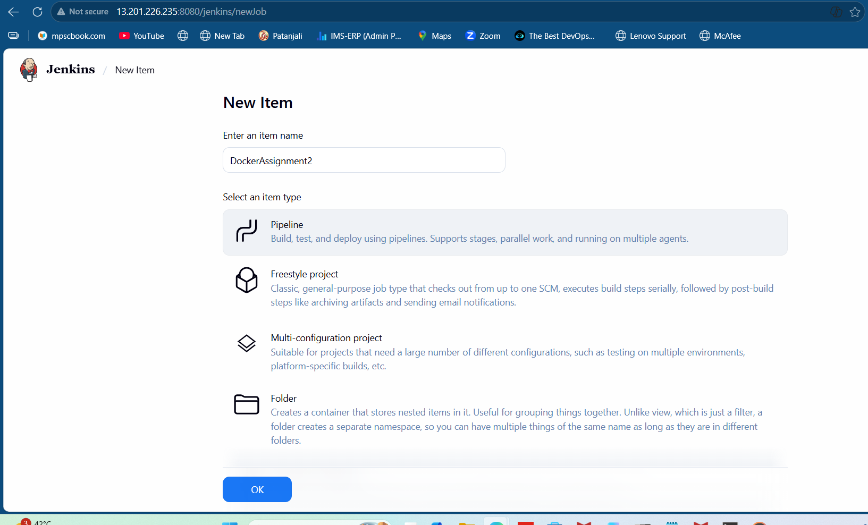

Jenkins Slave 1 :
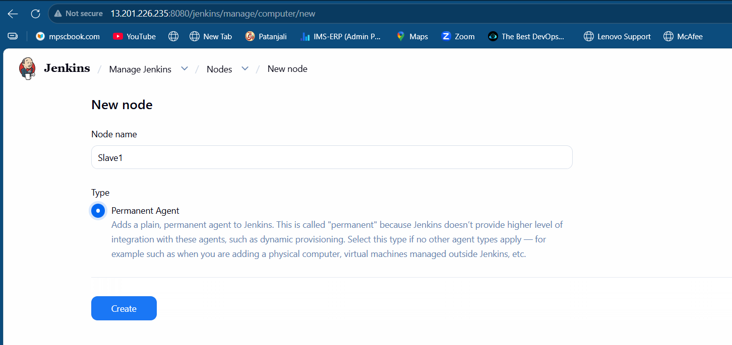

Jenkins Slave 1 Credentials :
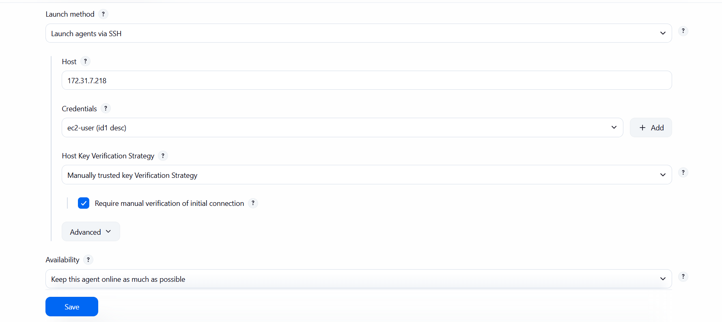

Jenkins Build Steps :
pipeline {
agent none
stages {
stage('Deploy Master Branch') {
agent {
label 'slave1'
}
steps {
git branch: 'master',
url: 'https://github.com/onkarjadhao12/dock1.git'
sh '''
docker rm -f c1 || true
docker run -itd --name c1 -p 8081:80 httpd
docker cp index.html c1:/usr/local/apache2/htdocs/index.html
'''
}
}

stage('Deploy Q1 Branch') {
agent {
label 'slave2'
}
steps {
git branch: 'Q1',
url: 'https://github.com/onkarjadhao12/dock1.git'
sh '''
docker rm -f c2 || true
docker run -itd --name c2 -p 8082:80 httpd
docker cp index.html c2:/usr/local/apache2/htdocs/index.html
'''
}
}

stage('Deploy Q2 Branch') {
agent {
label 'slave3'
}
steps {
git branch: 'Q2',
url: 'https://github.com/onkarjadhao12/dock1.git'
sh '''
docker rm -f c3 || true
docker run -itd --name c3 -p 8083:80 httpd
docker cp index.html c3:/usr/local/apache2/htdocs/index.html
'''
}
}
}

post {
success {
echo 'Deployment Successful'
}
failure {
echo 'Deployment Failed'
}
}
}

Container 1 on Slave 1 :
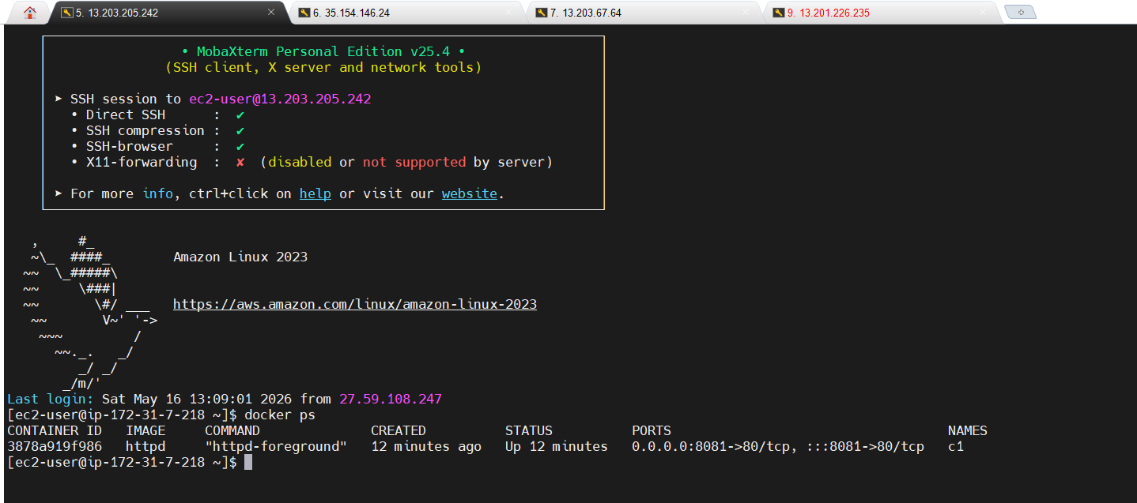
Container 2 on Slave 2 :
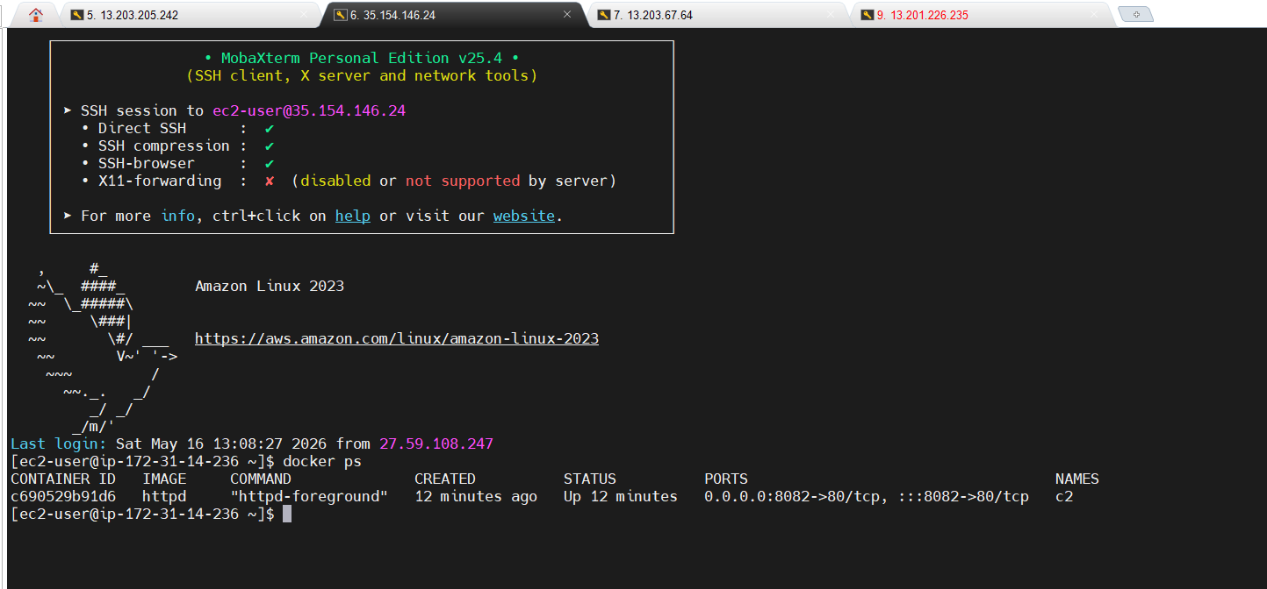

Container 3 on Slave 3 :
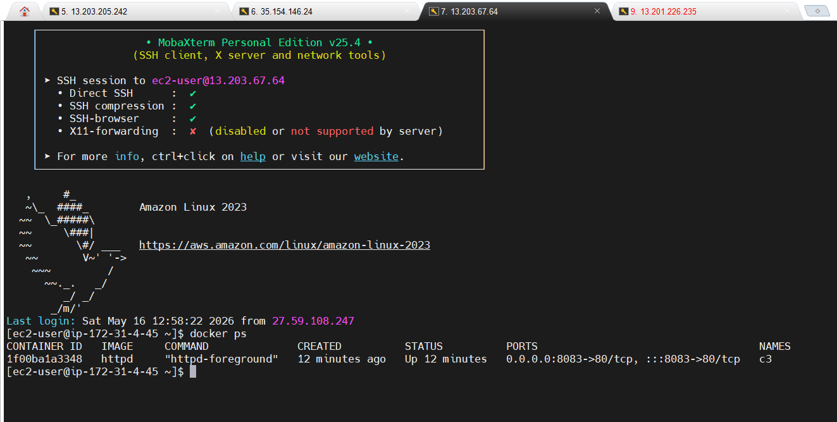

Jenkins index.html :
1. master branch
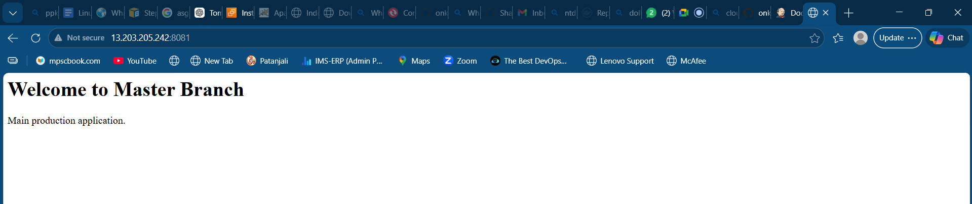

2. Q1 branch
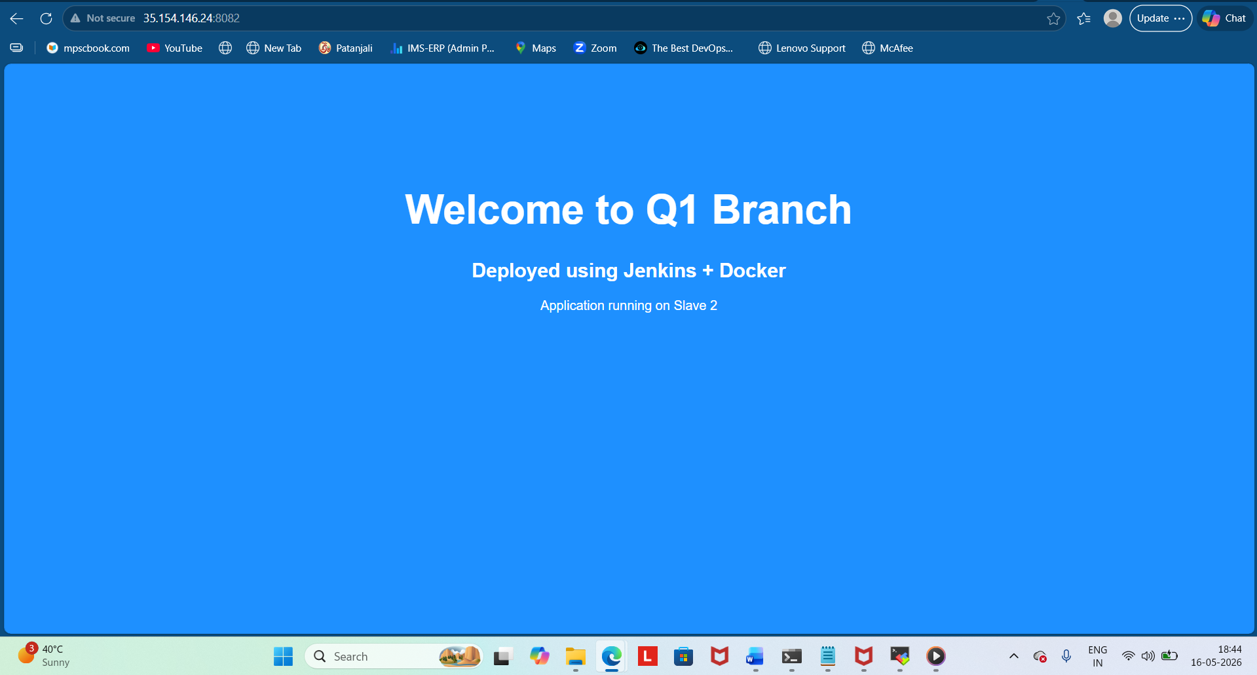

3.Q2 Branch
