Docker Assignment 2.3

Subject : One repo -- three branches -- master, Q1, Q2 -- all three have index.html files in them.
JM -- use jenkins declarative pipeline
Create three containers.
JM -- SSH to slaves
JM -- Slave 1(deploy master) -- slave 2(deploy Q1) -- slave 3 (deploy Q2)
Using Bind Mount

= = = = = = = = = = = = = = = = = = = = = = = = = = = = = = = = = = = = = = = = = = = = = = = =
Jenkins New Job : DockerAssignment2.3
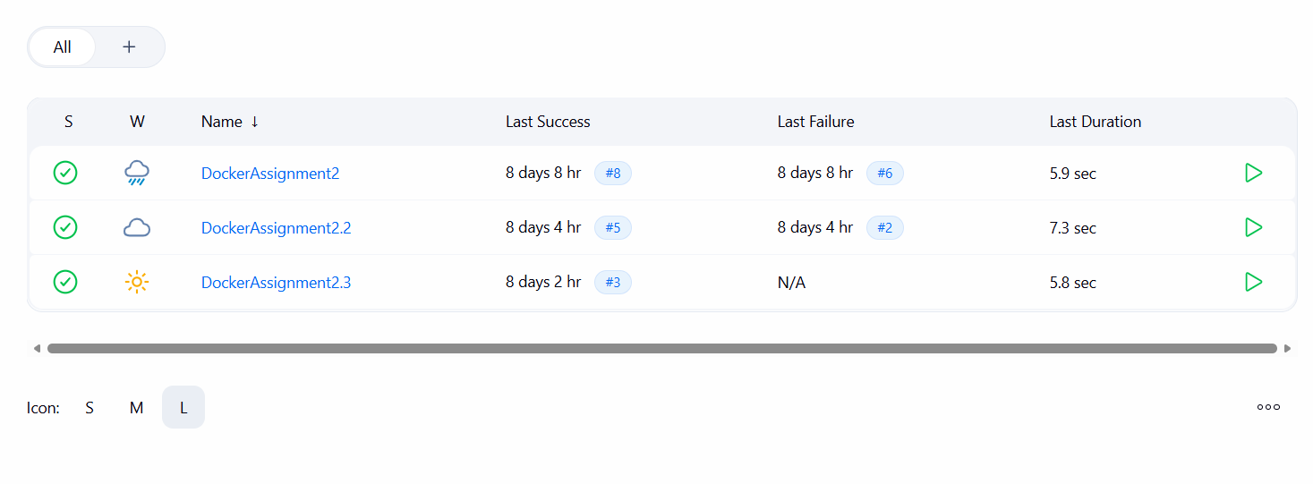

Jenkins Slave 1 :
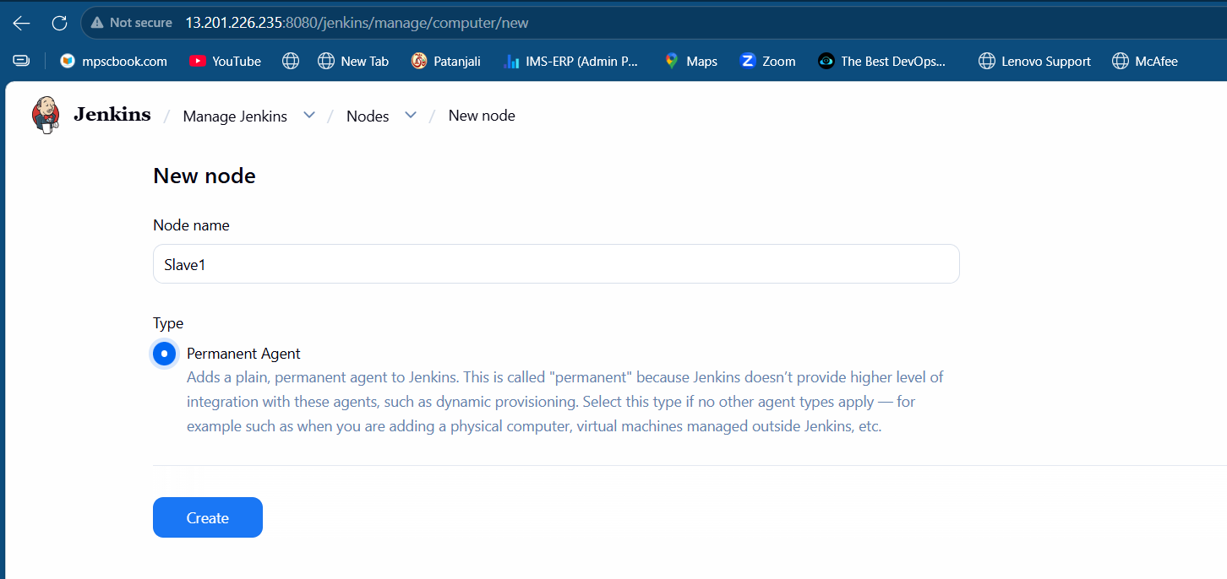

Jenkins Slave 1 Credentials :
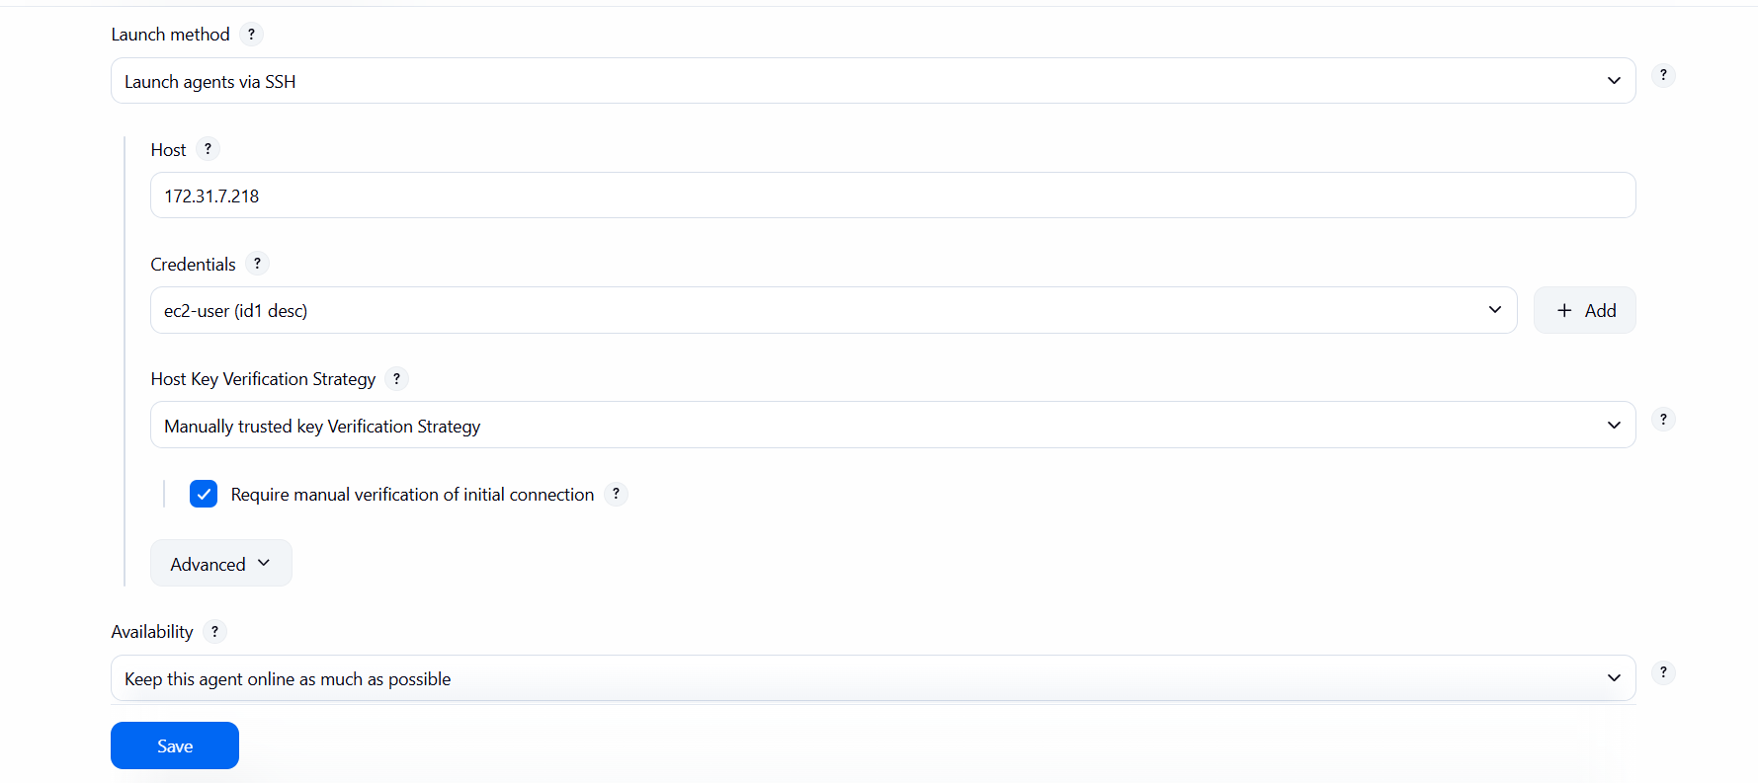

Jenkins Build Steps :

pipeline {
agent none

stages {
stage('Deploy Master Branch') {
agent { label 'slave1' }
steps {
script {
git branch: 'master',
url: 'https://github.com/onkarjadhao12/dock1.git'
sh '''
echo "Deploying Master Branch"
docker rm -f c1 || true
mkdir -p /mnt/oj1
cp ./index.html /mnt/oj1/
docker run -itd --name c1 -p 8071:80 -v /mnt/oj1:/usr/local/apache2/htdocs httpd
'''
}
}
}

stage('Deploy Q1 Branch') {
agent { label 'slave2' }
steps {
script {
git branch: 'Q1',
url: 'https://github.com/onkarjadhao12/dock1.git'
sh '''
echo "Deploying Q1 Branch"
docker rm -f c2 || true
mkdir -p /mnt/oj2
cp ./index.html /mnt/oj2/
docker run -itd --name c2 -p 8072:80 -v /mnt/oj2:/usr/local/apache2/htdocs httpd
'''
}
}
}

stage('Deploy Q2 Branch') {
agent { label 'slave3' }
steps {
script {
git branch: 'Q2',
url: 'https://github.com/onkarjadhao12/dock1.git'
sh '''
echo "Deploying Q2 Branch"
docker rm -f c3 || true
mkdir -p /mnt/oj3
cp ./index.html /mnt/oj3/
docker run -itd --name c3 -p 8073:80 -v /mnt/oj3:/usr/local/apache2/htdocs httpd
'''
}
}
}
}

post {
success {
echo "Deployment Successful on all branches"
}
failure {
echo "Deployment Failed in pipeline"
}
always {
echo "Pipeline execution completed"
}
}
}

Container 1 on Slave 1 :
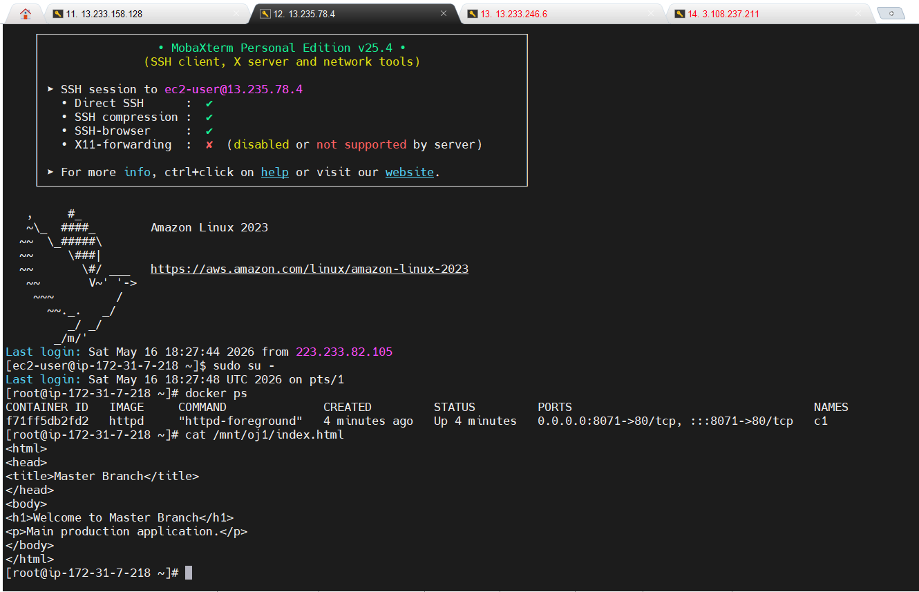
Container 2 on Slave 2 :
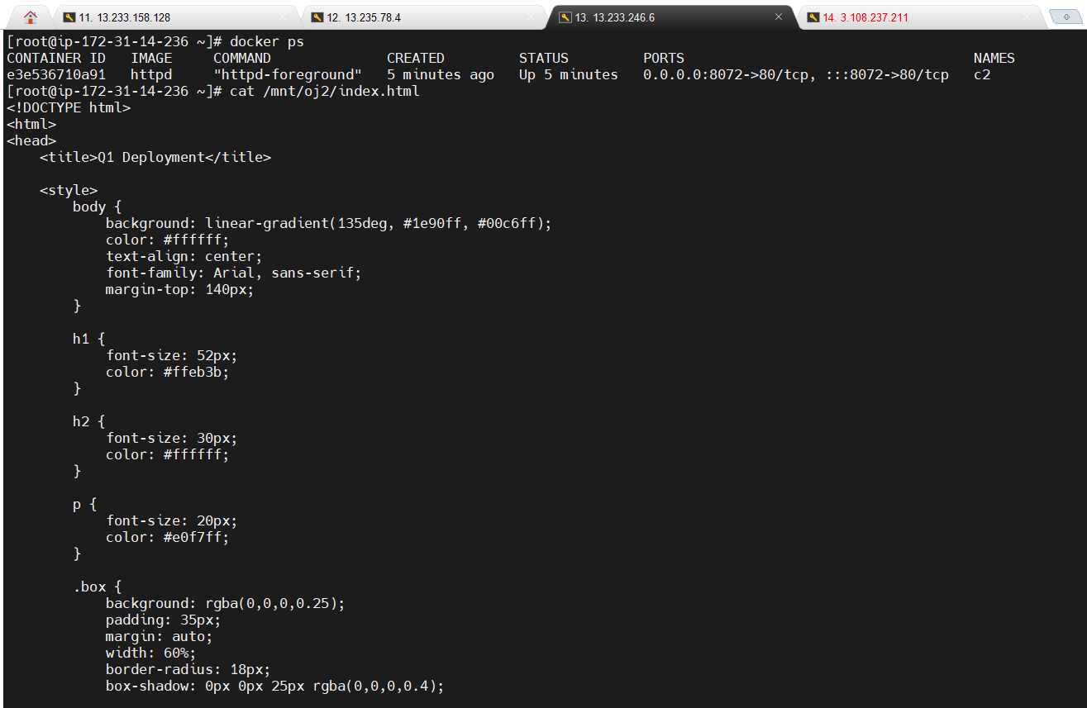
Container 3 on Slave 3 :
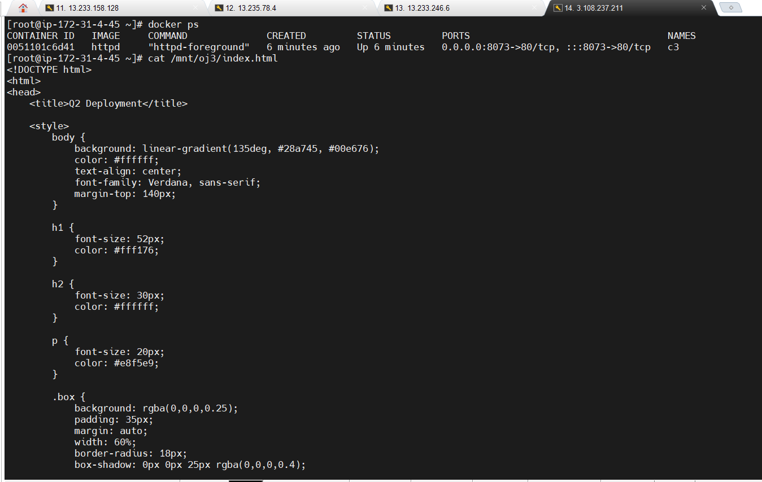

Jenkins index.html :
1. master branch
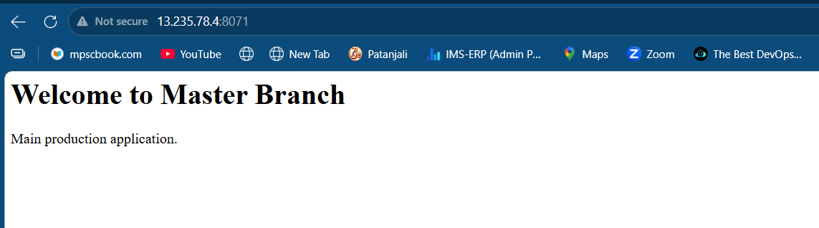
TBC..

2. Q1 branch
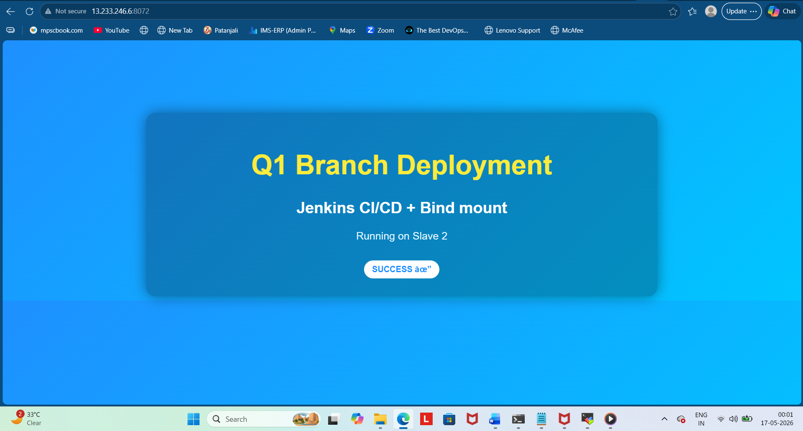
3.Q2 Branch
