HEALTHCARE ANALYTICS FOR DOCTOR VISITS
Complete Data Analytics & Machine Learning Project Report
Dataset: Healthcare Doctor Visits | 5,190 records | 13 columns

1. Project Objective
The objective is to analyze patient-related information and identify useful patterns associated with the number of doctor visits. The main analytical question is: Why do some people visit a doctor more often than others?

2. Dataset Overview
The dataset contains 5,190 records and 13 columns. The target variable is 'visits', representing the number of doctor visits during the period covered by the dataset. 'Unnamed: 0' is treated as a record identifier and is excluded from predictive modeling.

3. Feature Groups
Category | Columns
Personal Information | gender, age
Financial Information | income
Health Information | illness, health, reduced, nchronic, lchronic
Healthcare Support | private, freepoor, freerepat
Doctor Visit Information | visits
Record Identification | Unnamed: 0

4. Data Preparation
- Loaded the supplied CSV dataset using pandas.
- Checked dimensions, data types, unique values and missing values.
- No missing values were found in the supplied dataset.
- Treated 'Unnamed: 0' as a record identifier.
- Used an 80/20 train-test split with random seed 42.
- Applied preprocessing through a machine-learning pipeline.

5. Exploratory Data Analysis
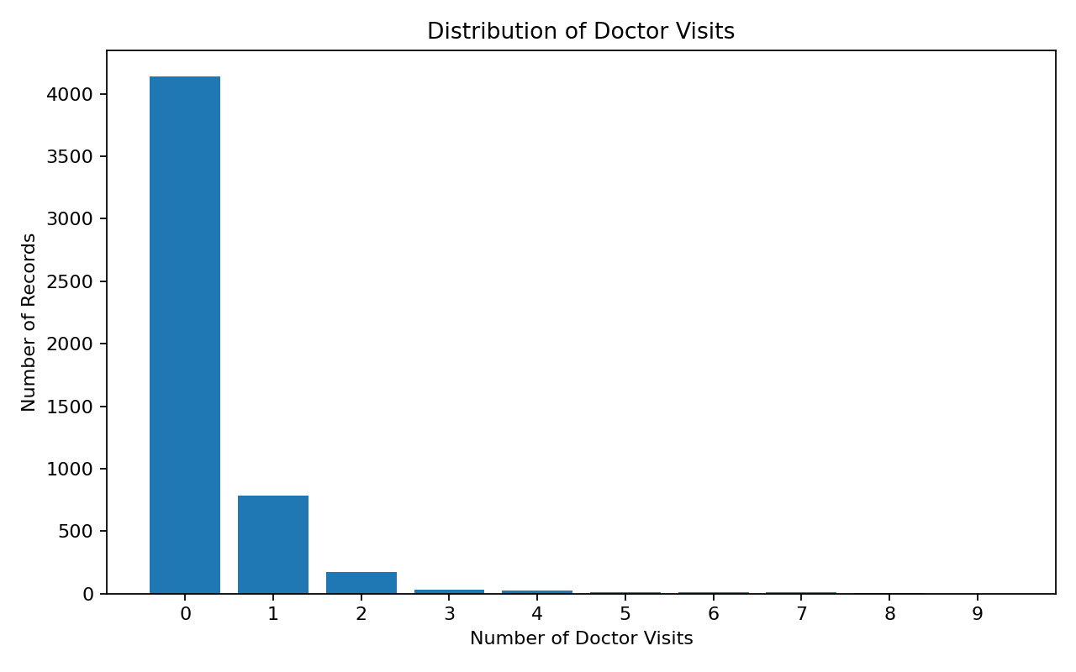
Figure 1. Distribution of Doctor Visits
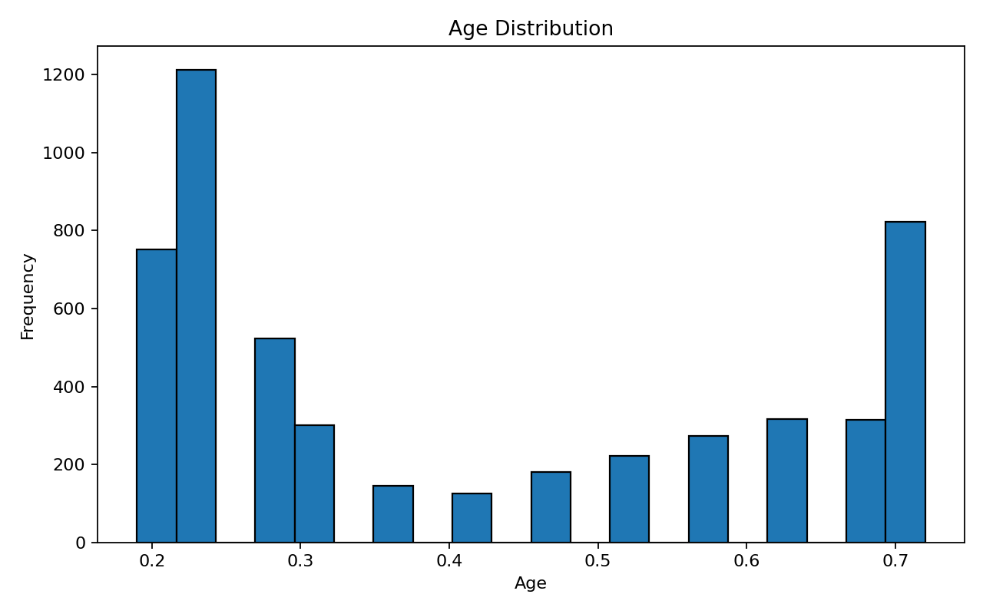
Figure 2. Age Distribution
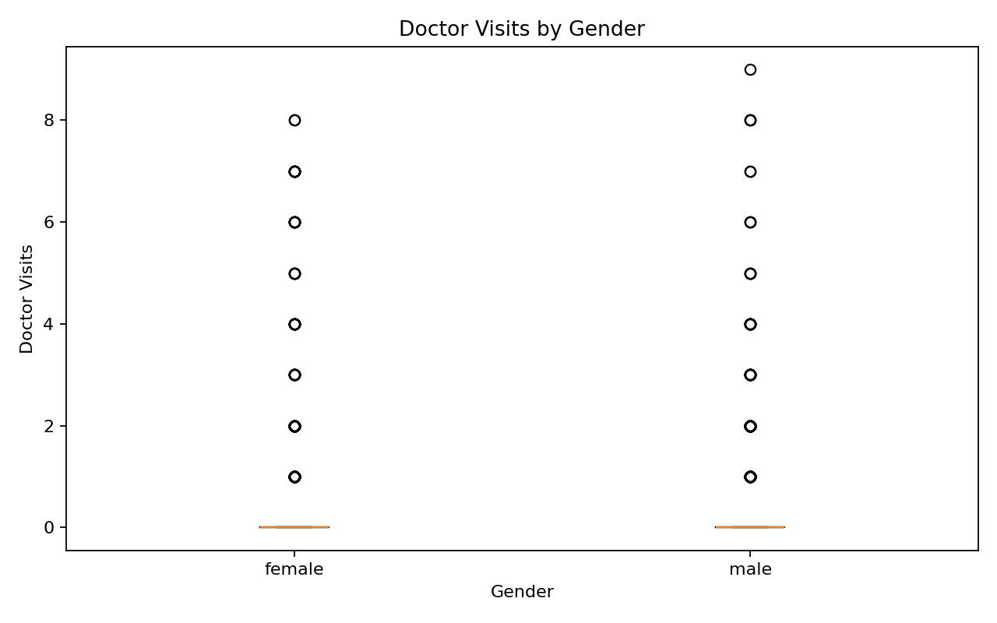
Figure 3. Doctor Visits by Gender
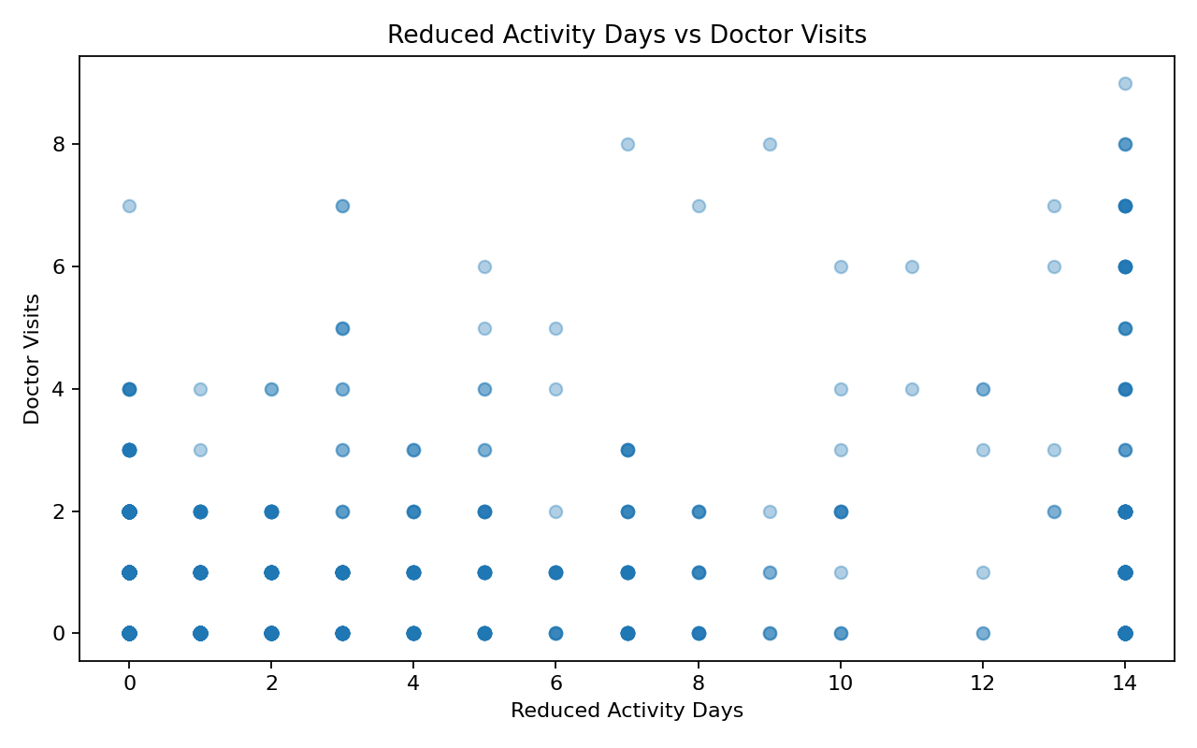
Figure 4. Reduced Activity Days vs Doctor Visits
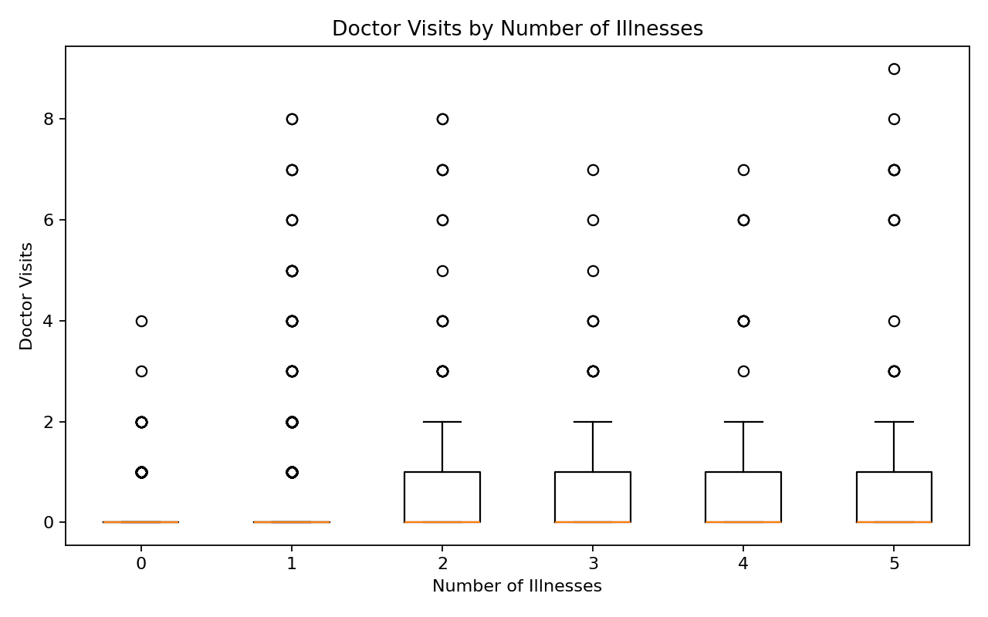
Figure 5. Doctor Visits by Number of Illnesses
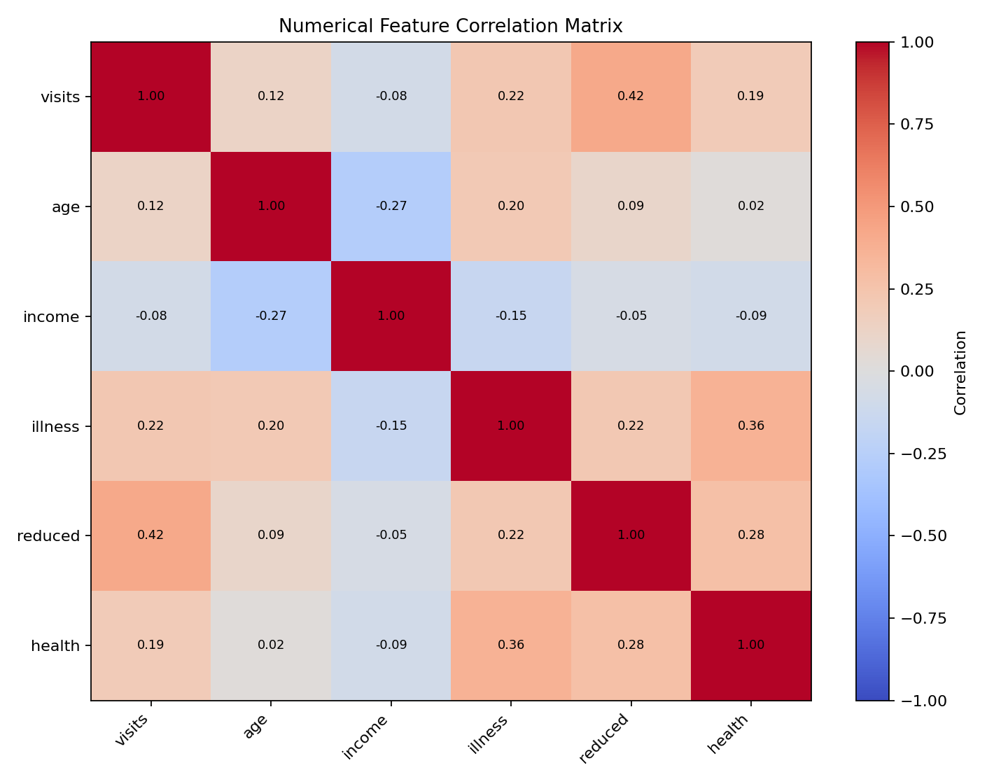
Figure 6. Numerical Feature Correlation Matrix

6. Key Observations
- The average number of doctor visits is approximately 0.30.
- Doctor visits are right-skewed, with many records having zero visits.
- In this dataset, reduced activity days show the strongest numerical association with doctor visits.
- Illness count and the health indicator also show meaningful numerical associations with visits.
- Doctor-visit distributions differ across gender groups.
- Chronic-condition and healthcare-support groups can be compared using their mean doctor visits.
These observations describe statistical associations in the supplied dataset and should not be interpreted as evidence of causation.

7. Machine Learning
Two regression models were implemented to estimate the number of doctor visits: Ridge Regression and Random Forest Regression.
Model | MAE | RMSE | R²
Ridge Regression | 0.4202 | 0.8348 | 0.2118
Random Forest | 0.4193 | 0.8589 | 0.1656

8. Dashboard
An interactive Streamlit dashboard is included in the project. It provides KPIs, filters, doctor-visit distributions, gender comparison, illness analysis, reduced-activity analysis, healthcare-support summaries, and filtered-data download.

9. Limitations
- The dataset is observational.
- Association does not establish causation.
- The project is an analytics exercise and does not diagnose patients or provide medical advice.
- Predictive performance depends on the supplied dataset and selected features.

10. Conclusion
The completed project provides an end-to-end healthcare analytics workflow covering data validation, exploratory analysis, group analysis, correlation analysis, predictive modeling, model evaluation, visualizations, and an interactive dashboard.

