|  |
| --- |
| Gosu CodeNarc++ External Report Generator  Codnarc++ Setup Implementation Readme Specification |

**AUTHORS**

|  |  |  |  |
| --- | --- | --- | --- |
| **Name** | **Role** | **Department** | **Date** |
| Onkar Prabhu | Infrastructure | GW Practice | 12/10/2018 |

**REVIEWER**

|  |  |  |  |
| --- | --- | --- | --- |
| **Name** | **Role** | **Department** | **Date** |
| Parikshith Keshavamurthy | Lead | GW Practice | 12/13/2018 |

**Table of Contents**

1. Step 1 3

2. Step 2 4

3. Step 3 5

4. Step 4 6

5. Step 5 7

6. Step 6 7

**Step 1 – Install Apache-ant-1.9.3 or any higher version in your system and give the path in environment variables**

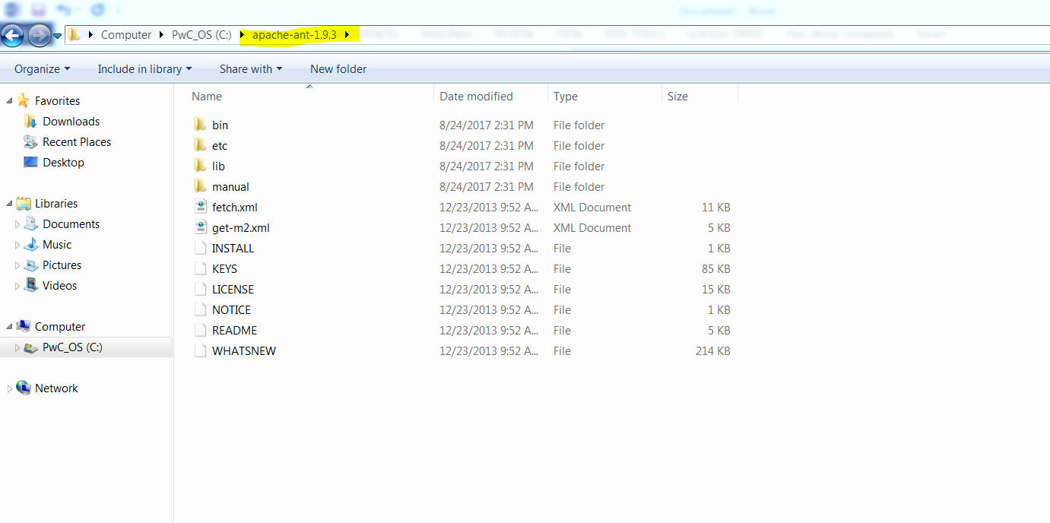

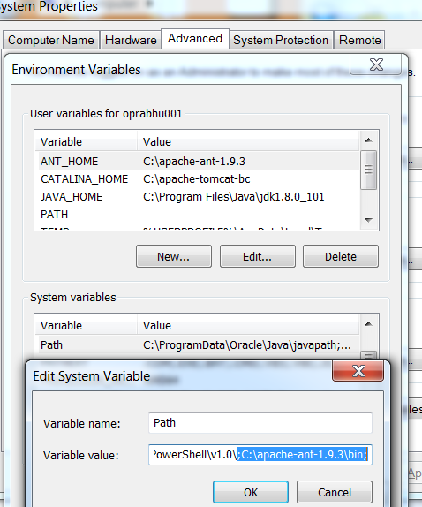

**Step 2 – Extract the codenarc++ folder (Custom Rules) inside the guidewire workspace (modules)**

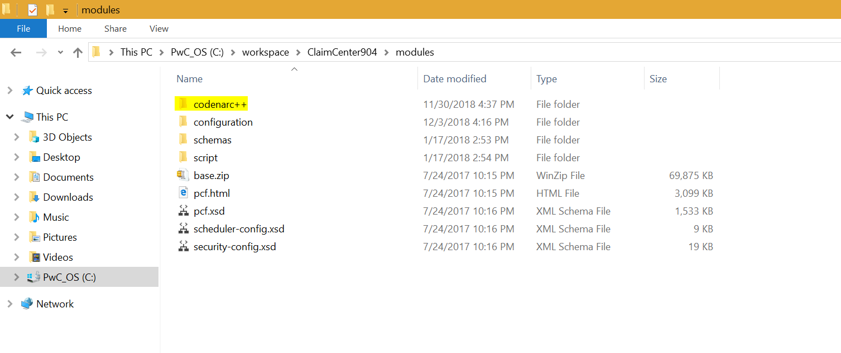

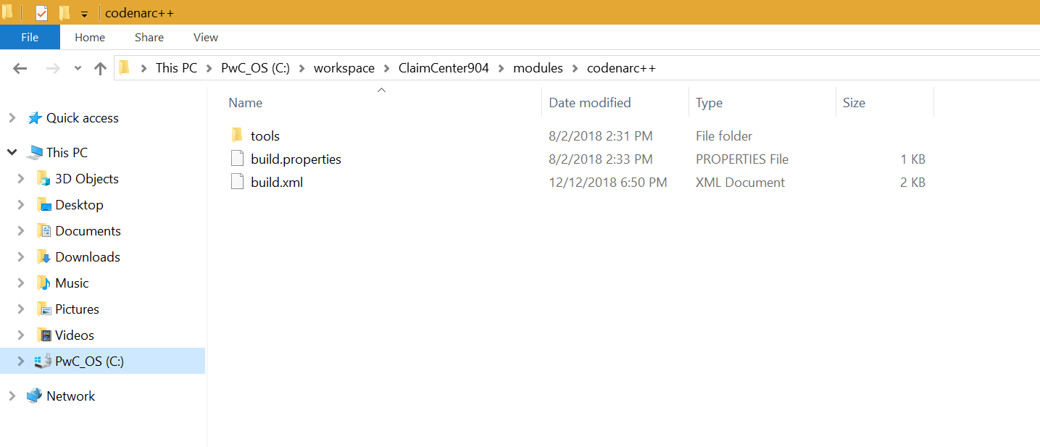

**Step 3 – Modify the build.xml and build.properties to point the path location as per workspace**

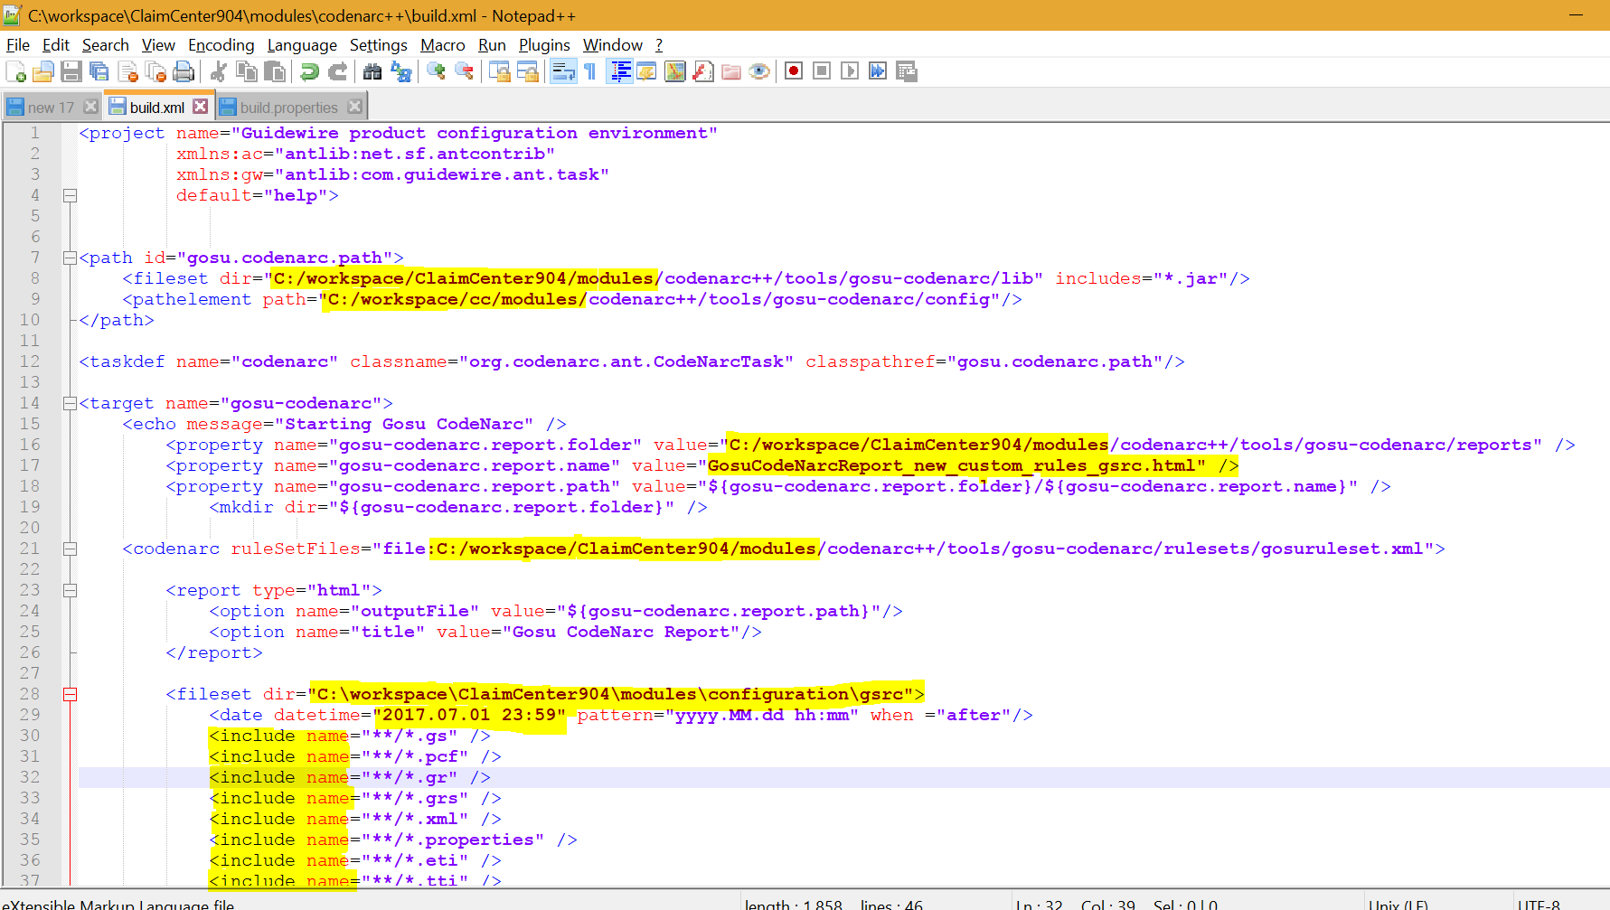

**Note - Include the .extensions from line number 30 as per the target folder and the files present in it**

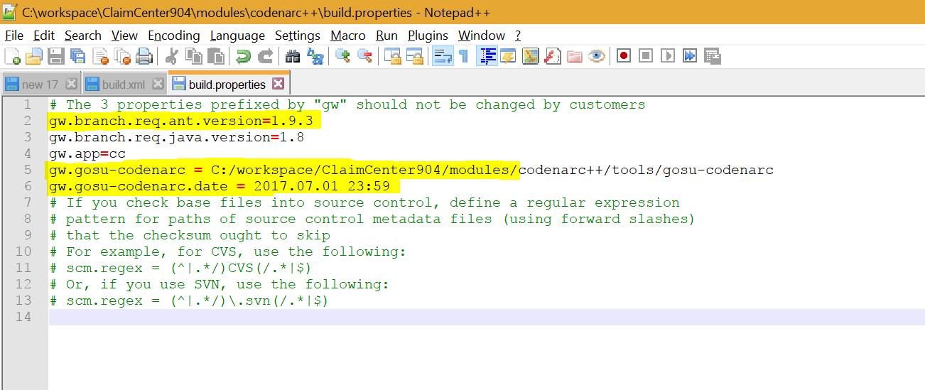

**Step 4 – Edit gosuruleset.xml to manually modify the priorities or properties of the value or even enable/disable the rules**

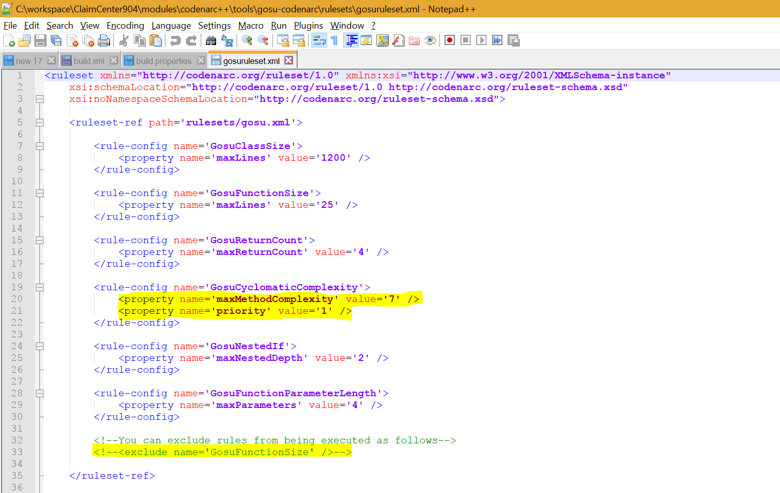

**Step 5 – Open cmd prompt at codnarc++ folder path and run the command - ant gosu-codenarc -f build.xml**

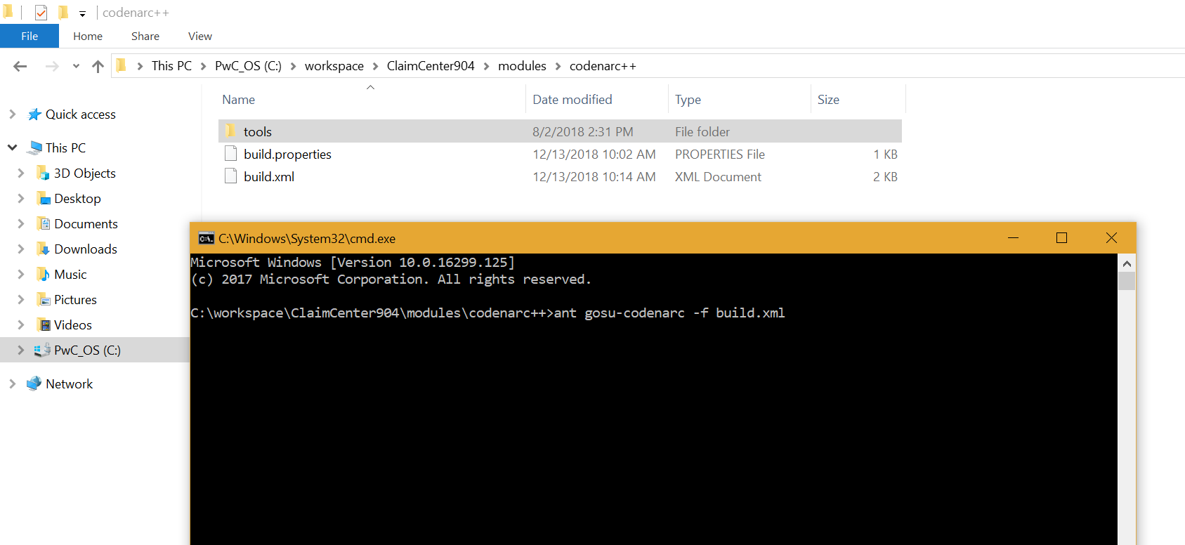

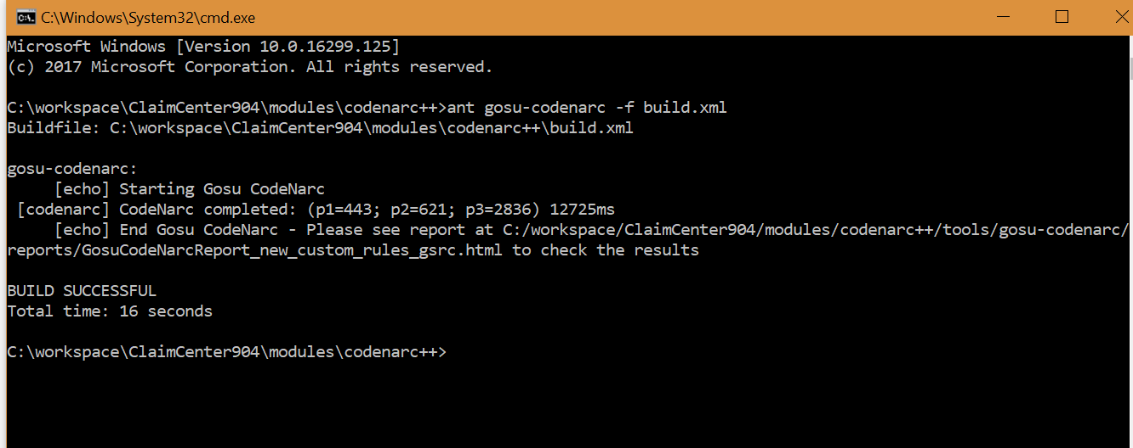

**Step 6 – Report is generated: codenarc++\tools\gosu-codenarc\reports**

