Software Requirements Specification (SRS) For Smart Student Routine Management System.

1. Introduction

1.1 Purpose

The purpose of this system is to help students manage their academic tasks, health habits, daily routines, and personal goals using intelligent planning, reminders, and behavior tracking. This Cyber-Physical System (CPS) aims to automate daily planning, prioritize tasks, and balance study and personal life efficiently using smart sensors, cloud-based analytics, and mobile interfaces.

1.2 Scope
The Remote Water Motor Control System provides the following functionalities:
- Smart scheduling based on priority, duration, and energy levels.
- Integration with physical sensors (like fitness bands or smartphone sensors) to track activity and sleep
- Automatic reminders for lectures, assignments, exercise, meals, etc.
- Progress tracking using calendars and productivity reports.
- Integration with academic portals for real-time updates on deadlines.

1.3 Definitions, Acronyms, and Abbreviations

1.3 Definitions, Acronyms, and Abbreviations
- CPS: Cyber-Physical System
- SRAMS: Smart Student Routine Management System
- IoT: Internet of Things
- UI/UX: User Interface/User Experience
- API: Application Programming Interface

1.4 References
- UML Diagrams: Use Case, Class, and Sequence Diagrams.
- Research papers on IoT-based automation in smart farming systems.
- Agricultural water management guidelines for optimized irrigation.

1.5 Overview
This document defines the functional and non-functional requirements, use cases, architecture, and interface designs for SSRMS. It includes UML diagrams and outlines the smart features that bridge the physical and digital routines of a student.

2. Overall Description

2.1 Product Perspective
SSRMS is a hybrid mobile/web-based system that integrates with physical sensors and cloud storage. It helps students plan, monitor, and adapt their academic schedules and daily habits dynamically.

2.2 Product Functions
- Smart Planner: Auto-generates daily routines based on task urgency and user preferences.
- Sensor Integration: Syncs with wearable or mobile sensors to track sleep, activity, and breaks.
- Productivity Reports: Visual dashboards with charts and daily/weekly insights.
- Academic Sync: Integration with Google Classroom, Moodle, etc., to fetch assignments and exam dates.
- Habit Tracker: Tracks consistency in tasks like meditation, walking, reading.

2.3 User Characteristics
- Students: Core users aiming to balance academics and personal growth.
- System Admins: Manage back-end operations, security, and analytics.

2.4 Constraints
- Requires permission to access device data (calendar, location, sensors).
- Requires reliable internet for cloud sync.
- Privacy of personal data must be maintained.

2.5 Assumptions and Dependencies
- Students have smartphones or smartwatches.
- Educational institutions allow integration with academic portals.
.

3. Specific Requirements

3.1 FUNCTIONAL REQUIREMENTS
- Routine Planner: Create and auto-adjust schedules based on task importance and available time.
- Sensor Monitoring: Detect sleep/wake cycles, movement, and idle time.
- Reminder System: Notify students of tasks with customizable alerts.
- Academic SYnc: Pull in academic deadlines and events from portals.
- Report Generation: Show productivity scores, time spent on activities, and routine health.

3.2 NON-FUNCTIONAL REQUIREMENTS
- Performance: Response time < 2 seconds; sync with cloud in < 5 seconds.
- Usability Simple UI for students of all age groups.
- Security: End-to-end encryption, biometric login (optional).
- Availability: 99.5% uptime.
- Maintainability: Modular codebase for easy updates.

4. User Interface Requirements
- Dashboard: Displays current time, next task, and routine overview.
- Calendar View: Visual schedule with drag-and-drop task management.
- Analytics Section: Bar and pie charts showing time usage.
- Settings Panel: Customize sleep goals, study time, and notification preferences.
- Motivation Zone: Quotes, music, and progress badges.

5. UML Diagrams

5.1 Use Case Diagram
A Use Case Diagram is a type of UML diagram that represents the functional requirements of a system by illustrating the interactions between actors (users or external systems) and use cases (system functions). It provides a high-level overview of how a system works from the user's perspective.
Actors:
- Student (Primary)
- System (Sensor Module, Task Manager, Notification Engine)
Use Cases:
- Track Physical Activity
- Sync Academic Calendar
- Receive Notifications
- View Productivity Report
- Adjust Schedule
Use Case Diagram:
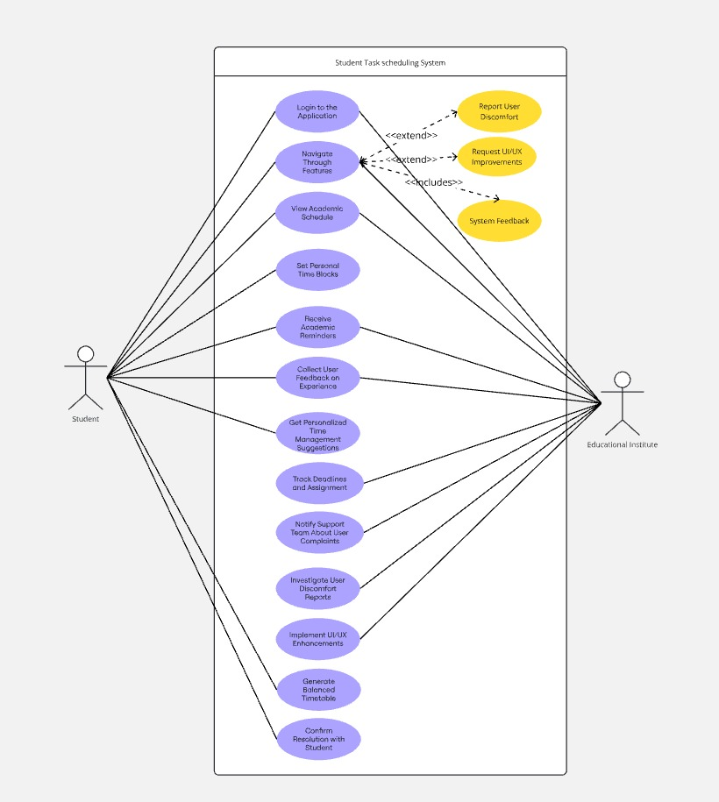

Figure: Use Case Diagram

5.2 Activity Diagram:
An Activity Diagram is a behavioural UML diagram that represents the flow of activities in a system or process. It shows the sequence of steps, decisions, and parallel processes in a system's operation.
In System, the activity diagram models Describes how a student interacts with the app to view their schedule, complete a task, or reschedule based on unexpected events (e.g., delay in college).
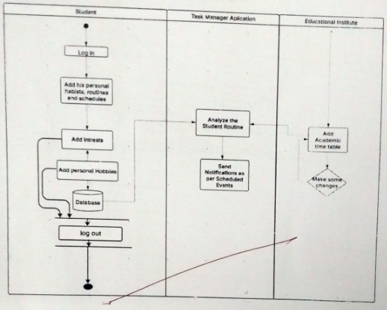
Figure: Activity Diagram

5.3 Class Diagram
A Class Diagram is a structural UML (Unified Modelling Language) diagram that represents the blueprint of a system by modelling its classes, attributes, methods, and relationships. It is used in object-oriented design to define the structure of a system before implementation.
In the Smart Student Routine Management System, the Class Diagram is used to represent different components, such as the student, Mobile App, Monitoring System and etc.
- Student
  - Attributes: id, name, age, preferred Wake Time
  - Methods:
    - +view_Schedule()
    - +update_Preferences()
- Task
  - Attributes: title, deadline, type (Academic/Personal), priority
  - Methods:
    - +setReminder()
    - +markComplete()

Class Diagram:
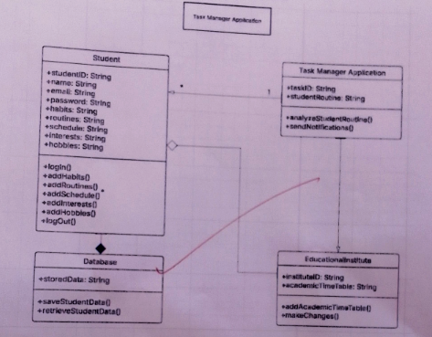

Figure: Class Diagram

5.4 State Diagram:
A state diagram is used to represent the different states of a system and how it transitions from one state to another based on events or conditions.
In the Smart Student Routine Management System, the state diagram helps visualize how the system behaves when the user interacts with it through a mobile or web interface to monitor his daily tasks.

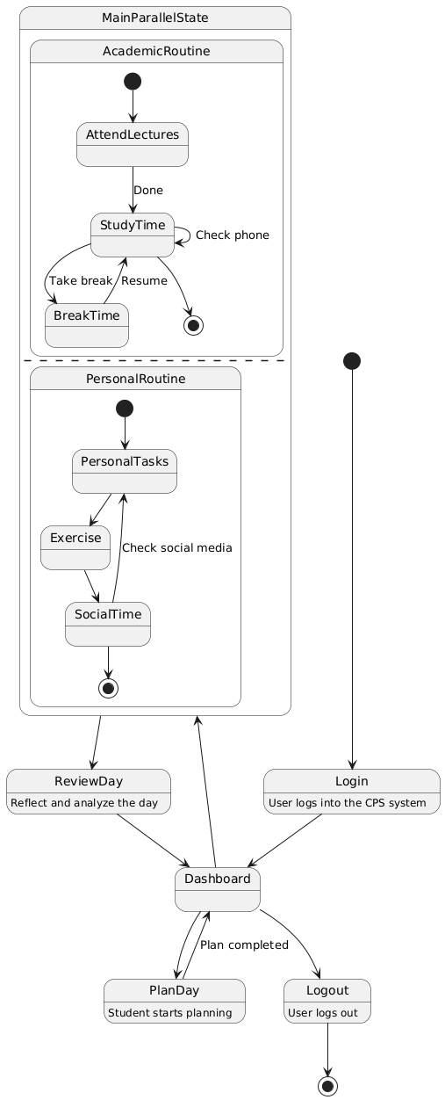

Figure: State Diagram

6. Additional Considerations

6.1 Reliability & Fault Tolerance
- Network Disruption Handling:
The system should be capable of gracefully managing internet outages. In the event of connectivity loss, it must cache the most recent control commands locally and automatically execute them once the network is restored, ensuring that essential operations are not interrupted.
- Power Backup Integration:
To mitigate the impact of power failures, battery-powered controllers or UPS (Uninterruptible Power Supply) systems should be incorporated. These will enable the system to continue operating critical functions during outages, providing a seamless experience to the user.

6.2 Cross-Platform Compatibility
- The system should be accessible through both web and mobile applications to accommodate users with different device preferences.
- The mobile application should support both Android and iOS platforms, ensuring a wider reach.
- The web interface should be optimized for desktop and mobile browsers to provide seamless usability.

6.3 Data Logging & Analytics
- Integrated Analytics and Smart Insights:
Future versions of the system should incorporate data analytics tools that can provide visualized insights and intelligent suggestions. These tools could help users identify patterns such as the most productive time of day, optimize study or work routines, track energy-saving opportunities, and even monitor device performance trends for predictive maintenance in the context of motor-based CPS systems.
- Users should be able to generate, download, and review detailed reports from the system. These reports can assist in agricultural planning (in irrigation systems) or academic goal setting (in student routines). Such documentation will be valuable for both short-term review and long-term strategy development.

6.4 Security & Data Privacy
- Secure encryption protocols (such as SSL/TLS) must be implemented to protect communication between the application and IoT controllers.
- Data storage should comply with privacy regulations to prevent unauthorized access to students’ usage data.
- Regular security audits should be performed to detect and mitigate vulnerabilities.

6.5 Scalability & Future Enhancements
- AI-Powered Recommendations:
Future updates could integrate Artificial Intelligence (AI) to provide smart academic suggestions — such as optimal time blocks for self-study, revision before exams, and break reminders — based on user behaviour, academic workload, upcoming deadlines, and personal productivity trends.
- Integration with Smart Assistants:
To offer a more seamless and hands-free experience, integration with voice assistants like Google Assistant, Alexa, or Sri can be explored. Students could simply ask things like “What’s my schedule today?” or “Remind me to study DBMS at 6 PM.”
- IoT and Environmental Awareness:
As an extension of the CPS concept, future iterations could include IoT devices that sense environmental factors like light, noise, and temperature to help students choose the best times and places for studying.

7. Conclusion
This Software Requirements Specification (SRS) outlines the foundational structure, purpose, and design of the Cyber-Physical System (CPS) designed to assist students in managing their academic responsibilities alongside their daily routines. In today’s fast-paced educational environment, students often struggle to maintain a balance between lectures, assignments, self-study, extracurricular activities, and personal well-being. This software aims to bridge that gap by offering an intelligent, automated, and user-centric solution that seamlessly blends time management with academic excellence.
In the long term, this system could be extended with AI-based learning pattern analysis, integration with college portals, and voice-assisted scheduling, ensuring adaptability and future readiness. Additionally, it can be customized for various educational levels, making it scalable and relevant for schools, diploma students, and even working professionals pursuing part-time education.
The development of this system represents a step forward in the evolution of educational technology and personal productivity tools. It not only contributes to academic improvement but also fosters discipline, stress reduction, and time-awareness among students, ultimately shaping more responsible and self-managed individuals.

