User Authentication System
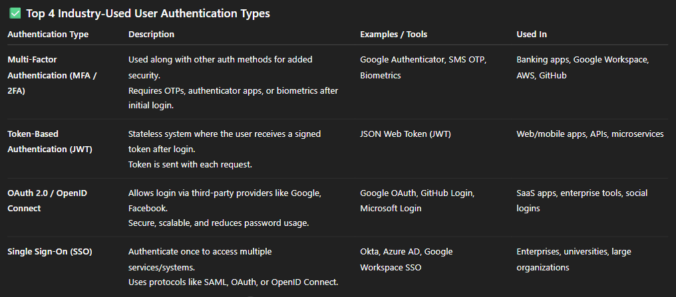

Token-Based Authentication (JWT) :
- Token-Based Authentication is a stateless authentication mechanism where, after a successful login, the server issues a token (commonly a JWT - JSON Web Token) to the user. The client then uses this token to access protected routes/resources.

