If kernel not recognized the python code :

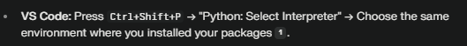
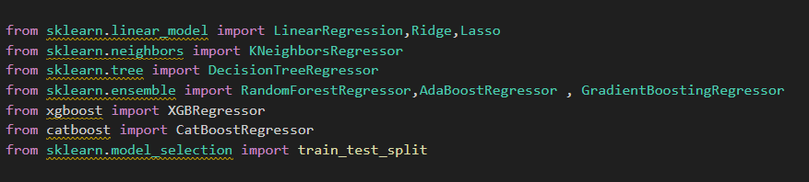
Problem :

Solution :

Text Not Highlight In Vs Code :
Problem :

Solution : In the VS Code command palette (Ctrl+Shift+P), search for "Python: Select Interpreter" and make sure the one with your .venv is selected
