Python Notes :
- Decorators :
- @dataclass
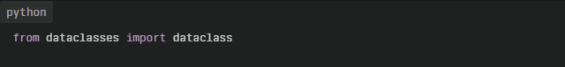
Why use @dataclass?
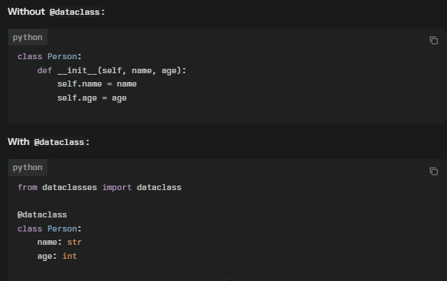
The @dataclass decorator provides a simple way to automatically add special methods like __init__, __repr__, __eq__, and more to your classes, so you don't have to write them yourself. It mainly helps you write cleaner and more concise code when defining classes that are mostly used to store data (sometimes called “data transfer objects” or “data containers”).

- Set virtual environment path to run files:
(Note : replace path with your root directory)
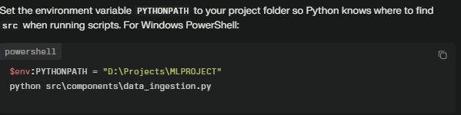
Another option to run file:
(Note : replace path with you want to run script/file)
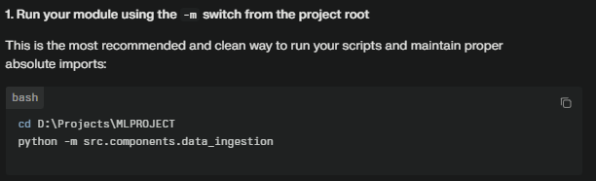
- Set parameters to selected model in dictionary:
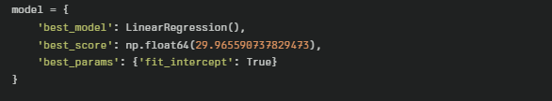
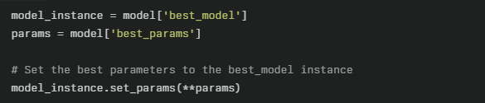

- Web Scrapping:
- If a website doesn’t provide an API, you can use web scraping to extract data directly from its HTML.
- The two most common libraries are:
  - requests → To fetch the page content.
  - BeautifulSoup (bs4) → To parse and extract elements from HTML.
Ex :
import pandas as pd
import numpy as np
import requests
from bs4 import BeautifulSoup

headers = {
"User-Agent": "Mozilla/5.0 (Windows NT 10.0; Win64; x64) "
"AppleWebKit/537.36 (KHTML, like Gecko) "
"Chrome/114.0.0.0 Safari/537.36",
"Accept-Language": "en-US,en;q=0.9", "Referer": "https://google.com"
}

url = "https://www.imdb.com/india/top-rated-indian-movies/"
try:
responce = requests.get(url=url,headers=headers)
soup = BeautifulSoup(responce.text,"lxml")
except Exception as e:
print(e)

print(soup.prettify())

movie = soup.find_all("span",class_="sc-29915307-7")
for i in range(len((movie))):
print(movie[i].text)

