Natural Language Processing (NLP):

What is NLP?
- NLP (Natural Language Processing) is a branch of Artificial Intelligence that enables computers to understand, interpret, and generate human language.
- It combines Linguistics (rules of language) + Computer Science + Machine Learning.
Example Applications:
- Google Translate
- Chatbots
- Sentiment Analysis
- Voice Assistants (Siri, Alexa, Google Assistant)

Why is NLP Needed?
- Human language is unstructured → computers understand numbers, not words.
- NLP helps convert text/speech → machine-readable format.
- Enables:
  - Communication between humans & machines.
  - Automation (customer support, summarization).
  - Information extraction from large text (news, social media).

Challenges in NLP
• Ambiguity (many meanings): A sentence can mean more than one thing.
Example: "I saw a man with a telescope" → Who has the telescope?
• Context dependency: The same word can mean different things depending on the situation.
Example: "Apple" → fruit 🍎 or tech company.
• Sarcasm/Irony (opposite meaning): Words say one thing but mean the opposite.
Example: "Great! My phone just died."
• Multilinguality: So many different languages exist in the world, making understanding harder.
• Spelling/Grammar errors: Real text often has mistakes that confuse machines.

Approaches of NLP

1. Heuristic Approach :
- A heuristic is a rule-of-thumb or shortcut method that helps solve problems quickly, though not always perfectly.
- In NLP, the heuristic approach means solving language tasks using handcrafted rules, patterns, or logic, instead of machine learning or deep learning.

Characteristics
- ✅ Simple & Fast → no training data required.
- ✅ Good for small problems or when domain knowledge is available.
- ❌ Not scalable → fails when data grows or language gets complex.
- ❌ Low accuracy compared to statistical or neural approaches.

When to Use Heuristic Approach?
- When data is scarce (no large training dataset).
- When task is well-defined and rules are easy to write.
- For prototyping before moving to ML/DL models.

2. Machine Learning Approach :
- Instead of writing manual rules (heuristics), the machine learning approach uses data-driven models to learn patterns from text.
- It converts text into numerical features (vectors) and then applies ML algorithms for prediction or classification.

Why Use ML in NLP?
- Rule-based systems are rigid → they fail with complex/ambiguous language.
- ML models adapt automatically when trained on large datasets.
- They generalize better across unseen text.

Workflow of ML-based NLP
- Text Preprocessing (cleaning, tokenization, stopwords removal, stemming/lemmatization).
- Feature Extraction (converting text into numbers):
  - Bag of Words (BoW)
  - TF-IDF (Term Frequency–Inverse Document Frequency)
  - N-grams
  - Word Embeddings (Word2Vec, GloVe)
- Model Training with ML algorithms.
- Prediction / Classification on new text.

Machine Learning Algorithms Used in NLP
- Naive Bayes Classifier
  - Based on probability (Bayes’ theorem).
  - Common in spam filtering, sentiment analysis.
- Logistic Regression
  - Simple yet powerful classifier for text classification.
- Support Vector Machines (SVMs)
  - Works well with high-dimensional data like text.
  - Used in topic classification, intent detection.
- Decision Trees & Random Forests
  - Not as common, but used for structured NLP tasks.
- Hidden Markov Models (HMMs)
  - Sequential models used in POS tagging, speech recognition.

Example Use Cases :
- Spam Email Classification (Spam vs Not Spam)
- Sentiment Analysis (Positive / Negative reviews)
- Topic Categorization (Sports, Politics, Technology)
- Named Entity Recognition (NER)

3. Deep Learning Approach in NLP :
- Deep learning uses artificial neural networks (like a brain with layers of neurons) to understand text.
- Instead of rules (heuristic) or manual features (machine learning), deep learning learns patterns automatically from big text data.

Key Features
- Learns on its own → No need to handcraft features.
- Understands context → Words have different meanings in different sentences, deep learning captures this.
- Works best with large data → The more text, the better.

Main Models Used in NLP
- Word Embeddings → Convert words into numbers with meaning.
  - Examples: Word2Vec, GloVe, FastText.
- RNN (Recurrent Neural Networks) → Good for sequences like sentences.
  - But slow and forgets long text.
- LSTM/GRU → Improved RNNs that remember long-term dependencies.
- CNN (Convolutional Neural Networks) → Also used for text (not only images).
- Transformers (Modern Era) → Powerful models that handle long text better.
  - Example: BERT, GPT, T5.

Advantages
- Learns automatically from data
- Captures meaning and context of words
- Very accurate for translation, chatbots, sentiment analysis

Disadvantages
- Needs a lot of data
- Requires high computing power (GPUs)
- Works like a "black box" (hard to explain how it makes decisions)

💡 Memory Tip:
Think of 3 stages in NLP evolution:
- Heuristic → Rules (teacher gives strict rules)
- Machine Learning → Features (student learns with notes + examples)
- Deep Learning → Neural Networks (student learns directly from reading books without extra help)

🌐 NLP Pipeline (Step-by-Step Process)
- Text Collection
  - Collect data (from websites, books, chats, etc.).
  - Example: Tweets, reviews, articles.
- Text Preprocessing
  - Clean and prepare the text for analysis.
  - Includes:
    - Lowercasing
    - Removing punctuation/stopwords
    - Tokenization (splitting into words)
    - Lemmatization/Stemming
- Text Representation
  - Convert text into numbers (since ML models only understand numbers).
  - Methods:
    - Bag of Words (BoW)
    - TF-IDF (Term Frequency–Inverse Document Frequency)
    - Word Embeddings (Word2Vec, GloVe, BERT).
- Feature Engineering
  - Extract useful features from text.
  - Example: word counts, sentiment score, part of speech tags.
- Model Building
  - Train ML/DL models on the processed data.
  - Examples:
    - ML: Naive Bayes, SVM, Logistic Regression
    - DL: RNN, LSTM, Transformers
- Evaluation
  - Check model performance.
  - Metrics: Accuracy, Precision, Recall, F1-score.
- Deployment
  - Use the trained model in real-world apps (chatbots, translators, recommendation systems).
Easy way to remember NLP pipeline : C → P → R → F → M → E → D
- Collection
- Preprocessing
- Representation
- Feature engineering
- Model building
- Evaluation
- Deployment
Aspect | Feature Engineering in ML | Feature Engineering in DL
Definition | Process of manually creating features from raw data to improve model performance. | Process is mostly automated, as neural networks learn features directly from raw data.
Role of Human | High involvement – humans design features based on domain knowledge (e.g., TF-IDF, n-grams). | Low involvement – deep models extract features automatically (e.g., word embeddings, CNN filters).
Complexity | Requires strong understanding of the problem domain and data patterns. | The model itself handles complexity, requiring less manual feature crafting.
Examples in NLP | Bag-of-Words, TF-IDF, POS tagging, handcrafted rules. | Word2Vec, GloVe, BERT embeddings, sequence representations.
Dependency on Data | Works well with smaller datasets if features are engineered properly. | Requires large datasets to learn meaningful features automatically.
Flexibility | Less flexible – features are fixed once designed. | Highly flexible – model can learn new feature representations during training.
Computation | Generally lower computation, but higher manual effort. | Higher computation, but less manual effort.

📌 Data Acquisition in NLP :

What is Data Acquisition?
- Data Acquisition means collecting text data that we will use for Natural Language Processing tasks like sentiment analysis, chatbot training, translation, summarization, etc.
- Without good and enough data, NLP models cannot learn patterns or understand language.

Sources of Data Acquisition
- APIs (Application Programming Interfaces)
  - Many websites provide APIs to access text data (e.g., Twitter API for tweets, NewsAPI for news articles).
  - Example: Getting tweets about "AI" using Twitter API.
- Web Scraping
  - If a website does not provide an API, we can extract data directly from its pages using libraries like BeautifulSoup or Scrapy.
  - Example: Scraping Amazon reviews.
- Open-Source Datasets
  - Kaggle, Hugging Face Datasets, UCI Machine Learning Repository, etc.
  - Example: IMDB Movie Reviews dataset for sentiment analysis.
- Databases & Logs
  - Text data can be collected from company databases, chat logs, customer feedback, emails, etc.
  - Example: Collecting customer support chats to train a chatbot.
- Manual Collection / Crowdsourcing
  - Creating your own dataset by surveys, forms, or platforms like Amazon Mechanical Turk.

📌 Text Preprocessing :
- Text preprocessing means cleaning and preparing raw text so a machine can understand it.
- Raw text (from books, websites, chats, etc.) is messy – it has punctuation, special characters, different cases (UPPER/lower), stopwords, and so on.So, preprocessing makes the text clean, consistent, and machine-readable.

Steps of Text Preprocessing (with Simple Examples)
- Lowercasing
  - Convert everything into lowercase.
  - Example: "I Love NLP" → "i love nlp"
  - Why? So machine doesn’t treat "NLP" and "nlp" as different.
text = "NLP is FUN"
text = text.lower()

- Remove html tags
- When we scrape data from websites, text often contains HTML tags (<p>, <div>, <br> etc.), so we need to remove them.
✅ Method 1: Using BeautifulSoup
from bs4 import BeautifulSoup

def remove_html_tags(text):
"""
Remove HTML tags from a given text using BeautifulSoup
"""
soup = BeautifulSoup(text, "html.parser")
return soup.get_text()

# Example
sample_text = "<p>Hello <b>World!</b> This is <a href='#'>NLP</a>.</p>"
clean_text = remove_html_tags(sample_text)
print(clean_text) # Output: Hello World! This is NLP.

✅ Method 2: Using Regex
import re

def remove_html_tags_regex(text):
"""
Remove HTML tags using regex
"""
clean = re.compile('<.*?>') # Pattern for HTML tags
return re.sub(clean, '', text)

# Example
sample_text = "<p>Hello <b>World!</b> This is <a href='#'>NLP</a>.</p>"
clean_text = remove_html_tags_regex(sample_text)
print(clean_text) # Output: Hello World! This is NLP.

- Tokenization

1. Split by Spaces (Basic Python)
text = "Hello world, this is AI."
tokens = text.split()
print(tokens)

o/p : ['Hello', 'world,', 'this', 'is', 'AI.']

2. Regex Tokenization
import re

text = "Hello world, this is AI."
tokens = re.findall(r"\w+", text) # only words
print(tokens)

o/p : ['Hello', 'world', 'this', 'is', 'AI']

3.NLTK Word Tokenizer
import nltk
from nltk.tokenize import word_tokenize

nltk.download('punkt')

text = "Hello world, this is AI."
tokens = word_tokenize(text)

o/p : ['Hello', 'world', ',', 'this', 'is', 'AI', '.']

4. NLTK Sentence Tokenizer:
from nltk.tokenize import sent_tokenize

text = "Hello world. This is AI. Tokenization is fun!"
sentences = sent_tokenize(text)
print(sentences)

o/p : ['Hello world.', 'This is AI.', 'Tokenization is fun!']

5. TextBlob Tokenization
from textblob import TextBlob

text = "Hello world, this is AI."
blob = TextBlob(text)
print(blob.words) # word tokenization
print(blob.sentences) # sentence tokenization

o/p : ['Hello', 'world', 'this', 'is', 'AI']

[Sentence("Hello world,"), Sentence("this is AI.")]

6. spaCy Tokenization
import spacy

nlp = spacy.load("en_core_web_sm")
text = "Hello world, this is AI."
doc = nlp(text)

tokens = [token.text for token in doc]
print(tokens)

o/p : ['Hello', 'world', ',', 'this', 'is', 'AI', '.']

7. Keras / TensorFlow Tokenizer (Deep Learning)
from tensorflow.keras.preprocessing.text import Tokenizer

text = ["Hello world", "This is AI"]
tokenizer = Tokenizer()
tokenizer.fit_on_texts(text)

print(tokenizer.word_index) # word → index mapping
print(tokenizer.texts_to_sequences(text))

o/p : {'hello': 1, 'world': 2, 'this': 3, 'is': 4, 'ai': 5}

[[1, 2], [3, 4, 5]]

8. WordPunct Tokenizer (NLTK)
from nltk.tokenize import WordPunctTokenizer

text = "Hello world, this is AI."
tokens = WordPunctTokenizer().tokenize(text)
print(tokens)

o/p : ['Hello', 'world', ',', 'this', 'is', 'AI', '.']

- Removing Punctuation
  - Delete symbols like .,!?;@#.
  - Example: "Hello!!! NLP??" → "Hello NLP"
  - Because punctuation usually doesn’t add meaning.
import string

text = "Hello!!! How are you?"
text = text.translate(str.maketrans('', '', string.punctuation))
Using regex :
import re

text = "Hello!!! How's everything going? Great, I hope."
clean_text = re.sub(r'[^\w\s]', '', text)
print(clean_text)
o/p : Hello Hows everything going Great I hope

- Removing Numbers (optional)
  - If numbers are not important, remove them.
  - Example: "I have 2 apples" → "I have apples"
import re

text = "I have 2 apples and 3 mangoes"
text = re.sub(r'\d+', '', text)

- Removing Stopwords
  - Stopwords = very common words that don’t add much meaning.
  - Example: "I love playing with the dog" → "love playing dog"
  - Words like "is", "the", "and", "with" are removed.
from nltk.corpus import stopwords
from nltk.tokenize import word_tokenize
nltk.download('stopwords')
stop_words = set(stopwords.words('english'))
text = "I am learning NLP"
tokens = word_tokenize(text)
filtered = [w for w in tokens if w.lower() not in stop_words]
print(filtered)

- Remove Duplicate/repeated word
text = "this is a test this is only a test"
words = text.split()
seen = set()
unique_words = []

for word in words:
if word.lower() not in seen: # case insensitive
unique_words.append(word)
seen.add(word.lower())

- Stemming
  - Cut words to their root form.
  - Example: "playing" → "play", "studies" → "studi"
  - Fast but sometimes not perfect.
from nltk.stem import PorterStemmer

ps = PorterStemmer()
words = ["playing", "played", "plays"]
stemmed = [ps.stem(w) for w in words]
o/p : ['play', 'play', 'play']

- Lemmatization
  - Smarter than stemming → gives real dictionary word.
  - Example: "playing" → "play", "studies" → "study"
- Example: "better" → "9good"
  - More accurate but slower.
from nltk.stem import WordNetLemmatizer
nltk.download('wordnet')

lemmatizer = WordNetLemmatizer()
words = ["playing", "better", "rocks"]
lemmas = [lemmatizer.lemmatize(w, pos="v") for w in words]
o/p : ['play', 'better', 'rock']

- Removing Extra Whitespaces
  - Clean up multiple spaces.
  - Example: " I love NLP" → "I love NLP"
text = " NLP is fun "
text = " ".join(text.split())

- Handling Special Characters / Emojis
  - Remove or replace them depending on task.
  - Example: "I love NLP 😊" → "I love NLP"
import emoji

text = "I am happy 😊"
text = emoji.demojize(text)

- Spelling Correction (optional)
- Fix wrong spellings.
- Example: "I lvoe NLP" → "I love NLP"

from textblob import TextBlob

text = " I lvoe NLP"
blob = TextBlob(text)
corrected = str(blob.correct())

- Text Normalization
Make words consistent.
- Example: "U.S.A" → "USA", "won’t → will not"
slang_dict = {"u": "you", "r": "are", "gr8": "great"}
text = "u r gr8 in NLP"
tokens = text.split()
normalized = [slang_dict.get(w, w) for w in tokens]
print(" ".join(normalized))
o/p : "you are great in NLP”

Regular Expression(Regex)

Definition
- Regular Expressions (regex) are a sequence of characters used to define a search pattern.
- They are mainly used for string searching, pattern matching, and text manipulation.
- In Python, regex operations are handled by the re module.
import re
# Search for a pattern in a string
pattern = r"hello"
text = "hello world"

result = re.search(pattern, text)
if result:
print("Pattern found!")
else:
print("Pattern not found.")

Examples

1. Match at the beginning :
import re

text = "Python is great"
result = re.match(r"Python", text)
print(result.group()) # Output: Python

2. Search anywhere :
text = "I love Python programming"
result = re.search(r"Python", text)
print(result.group()) # Output: Python

3. Find all matches
text = "cat mat bat rat"
result = re.findall(r"\b\w{3}\b", text)
print(result) # Output: ['cat', 'mat', 'bat', 'rat']

4. Replace text/Remove text :
text = "Hello 123, this is 456"
result = re.sub(r"\d+", "#", text)
print(result) # Output: Hello #, this is #

5. Split text :
text = "apple,banana;grape orange"
result = re.split(r"[,; ]+", text)
print(result) # Output: ['apple', 'banana', 'grape', 'orange']

- Remove links :
patt = r"http[s]?://\S+"
text = "playing https://chatgpt.com/c/68b8502d-eac8-832e-b167-88139ff600ce
parents & http://chatgpt.com/c/68b8502d-eac8-832e sfcsdvsd"
data = re.sub(patt,"",text)

Ex : Find this all possible mobile number from text.
Text = “My mobile number is 9309313335 and also (999)-(333)-4444”
Pattern = r“\d{10}|\(\d{3}\)-\(\d{3}\)-\d{4}”
all_phone_num = re.findall(Pattern,Text)

Some Important Pattern :
Pattern | Meaning | Example | Output
. | Any character except newline | re.findall(r"h.t", "hat hot hit") | ['hat', 'hot', 'hit']
^ | Start of string | re.findall(r"^Hello", "Hello World") | ['Hello']
$ | End of string | re.findall(r"world$", "Hello world") | ['world']
* | 0 or more repetitions | re.findall(r"ab*", "ab abb abbb a") | ['ab', 'abb', 'abbb', 'a']
+ | 1 or more repetitions | re.findall(r"ab+", "ab abb abbb a") | ['ab', 'abb', 'abbb']
? | 0 or 1 repetition | re.findall(r"ab?", "ab abb a") | ['ab', 'ab', 'a']
{n} | Exactly n times | re.findall(r"\d{3}", "123 4567 89") | ['123', '456']
{n,} | n or more times | re.findall(r"\d{2,}", "1 12 123 1234") | ['12', '123', '1234']
{n,m} | Between n and m times | re.findall(r"\d{2,3}", "1 12 123 1234") | ['12', '123', '123']
[] | Character set | re.findall(r"[aeiou]", "apple") | ['a', 'e']
[^] | Negation (not in set) | re.findall(r"[^aeiou]", "apple") | ['p', 'p', 'l']
\d | Digit (0–9) | re.findall(r"\d", "a1b2c3") | ['1', '2', '3']
\D | Non-digit | re.findall(r"\D", "a1b2c3") | ['a','b','c']
\s | Whitespace | re.findall(r"\s", "hi there") | [' ']
\S | Non-whitespace | re.findall(r"\S", "hi there") | ['h','i','t','h','e','r','e']
\w | Word character (letters, digits, _) | re.findall(r"\w", "hi_123!") | ['h','i','_','1','2','3']
\W | Non-word character | re.findall(r"\W", "hi_123!") | ['!']
`a | b` | re.findall(r"cat|dog", "cat dog rat") | ['cat', 'dog']
( ) | Group | re.findall(r"(ab)+", "ababab xyz") | ['ab', 'ab', 'ab']
\b | Word boundary | re.findall(r"\bcat\b", "cat scatter") | ['cat']
(?i) | Case insensitive | re.findall(r"(?i)hello", "Hello hELLo") | ['Hello', 'hELLo']

Text Representation:

1. What is Feature Extraction from Text?
- Converting raw text (unstructured data) into numerical features that a machine learning model can understand.
- Example: "I love NLP" → [0, 1, 1, 0, 0, ...]

2. Why do we need it?
- ML/DL models work with numbers, not raw words.
- Feature extraction helps capture:
  - Meaning of words
  - Frequency/importance
  - Context in sentences
- Without features, models can’t learn patterns from text.

3. Why is it difficult?
- Text is ambiguous (same word, different meaning).
- High dimensionality (huge vocabulary).
- Synonyms (different words, same meaning).
- Context dependency (“bank” in river bank vs money bank).
- Noise (stop words, spelling errors, slang).

4. What is the core idea?
- Represent text in such a way that:
  - Similar texts have similar representations.
  - Meaningful patterns are preserved.
- Core idea = Bridge between language (words) and math (numbers).

5. What are the techniques?
Here are the common techniques:
- Traditional Approaches
  - Bag of Words (BoW)
  - TF-IDF (Term Frequency–Inverse Document Frequency)
  - N-grams
- Distributed Representations (Word Embeddings)
  - Word2Vec
  - GloVe
  - FastText
- Contextual Representations (Deep Learning)
  - ELMo
  - BERT (and other Transformer models)
  - GPT embeddings

Some Common Term :

1. Corpus
- A large collection of text documents used for training or analysis.
- Example: A folder containing 10,000 news articles is a corpus.
- Think of it as the whole dataset of text.

2. Vocabulary
- The set of unique words present in a corpus.
- Example: In ["I love NLP", "I love Python"]
  - Vocabulary = {I, love, NLP, Python}

3. Document
- A single piece of text within the corpus.
- Example: One news article, one tweet, or one product review.
- If your corpus has 10,000 articles → each article is a document

4. Word
- The smallest unit of text (token).
- Example: "I love NLP" → words = ["I", "love", "NLP"]
📌 Hierarchy View:
- Corpus → Collection of documents
- Document → Collection of words
- Vocabulary → Set of all unique words across the corpus
- Word → Smallest element

Convert Text Data Into Numerical Data :

📌 Word Embedding Types in NLP

🔹 1. Frequency-based embeddings (Traditional)
- Use counts of words.
- Represent words based on occurrence in documents.
- Examples:
  - One-Hot Encoding → word = vector with 0s & 1 at position.
  - Bag of Words (BoW) → counts word frequency.
  - TF-IDF (Term Frequency–Inverse Document Frequency) → weights frequent words lower, rare words higher.

🔹 2. Prediction-based embeddings (Neural Network-based)
- Learn from context of words.
- Dense vectors, capture meaning & similarity.
- Examples:
  - Word2Vec (CBOW, Skip-Gram) → predicts words from context.
  - GloVe (Global Vectors) → combines co-occurrence + prediction.
  - FastText → considers sub-words (handles rare words better).

🔹 3. Contextual embeddings (Deep Learning, modern NLP)
- Word meaning changes by sentence context.
- Uses Transformers.
- Examples:
  - ELMo → embeddings from Bi-LSTM language model.
  - BERT, RoBERTa, DistilBERT → transformer-based contextual embeddings.
  - GPT embeddings → embeddings from large transformer models.

One-Hot Encoding in NLP

📌 Definition
One-Hot Encoding is the simplest way to convert words into numbers.
- Each word in the vocabulary is assigned a unique index.
- A word is represented as a binary vector with all 0s except one position marked 1.

📌 Example
Suppose our vocabulary is:
["dog", "cat", "apple", "barks"]
Vocabulary size = 4
Each word will be a 4-dimensional vector:
- "dog" → [1, 0, 0, 0]
- "cat" → [0, 1, 0, 0]
- "apple" → [0, 0, 1, 0]
- "barks" → [0, 0, 0, 1]
Now, sentence: "dog barks" → two vectors:
[1, 0, 0, 0]
[0, 0, 0, 1]

📌 Advantages
- Simple & Easy → Straightforward representation.
- No assumptions → Just unique identifiers for words.
- Good for small vocabulary tasks like text classification with very few categories.

📌 Drawbacks / Flaws
- High Dimensionality (Sparsity problem)
  - If vocabulary = 50,000 words → each word = 50,000-dim vector.
  - Most of the values are 0 → sparse matrix, wastes memory.
- No Semantic Meaning
  - "dog" = [1,0,0,0] and "cat" = [0,1,0,0] → they are equally far apart from all other words.
  - Model cannot understand that dog and cat are more similar than dog and apple.
- Vocabulary Dependent
  - New words (out-of-vocabulary) cannot be represented unless retraining is done.
- Ignores Word Order & Context
  - "dog bites man" vs "man bites dog" → both may have same words, but meaning changes. One-hot can’t capture this..

🐍 Python Code Example :
from sklearn.preprocessing import OneHotEncoder
import numpy as np

# Small vocabulary (dog, cat, apple, barks)
words = np.array(["dog", "cat", "apple", "barks"]).reshape(-1, 1)
# Create OneHotEncoder
encoder = OneHotEncoder(sparse=False)
# Fit and transform
onehot = encoder.fit_transform(words)
# Show vocabulary mapping
print("Vocabulary:", encoder.categories_)
print("\nOne-Hot Encoded Vectors:")
print(onehot)

Output:
Vocabulary: [array(['apple', 'barks', 'cat', 'dog'], dtype=object)]

# One-Hot Encoded Vectors:
[[1. 0. 0. 0.] # apple
[0. 1. 0. 0.] # barks
[0. 0. 1. 0.] # cat
[0. 0. 0. 1.]] # dog

Bag of Words (BoW) in NLP

🔹 Definition
- Bag of Words is a text representation technique that converts text into numerical vectors.
- It simply counts the frequency of each word in a document, ignoring grammar and word order.

📝 Example

Document (Sentence) | Label
good movie good acting | Positive
bad movie boring movie | Negative
excellent acting good movie | Positive
boring movie bad acting | Negative

Vocabulary Extracted
["acting", "bad", "boring", "excellent", "good","movie"]
Document | acting | bad | boring | excellent | good | movie
good movie good acting | 1 | 0 | 0 | 0 | 2 | 1
bad movie boring movie | 0 | 1 | 1 | 0 | 0 | 2
excellent acting good movie | 1 | 0 | 0 | 1 | 1 | 1
boring movie bad acting | 1 | 1 | 1 | 0 | 0 | 1

Prediction Example
Test sentence → "good good movie"
→ BoW vector = [0, 0, 0, 0, 2, 1]
→ Model prediction = Positive ✅
Behind the Math :

Idea: Cosine Similarity = Angle Between Vectors
When you use Bag of Words (BoW) or TF-IDF, each sentence becomes a vector.
To measure how similar a new sentence is to existing ones, we compute:
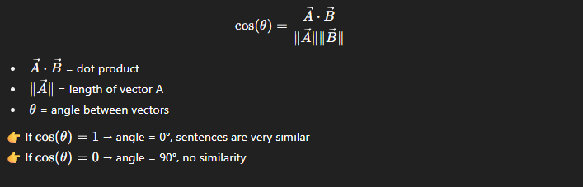

Example
Corpus:
- "good movie good acting" → Positive
- "bad movie boring movie" → Negative
Vocabulary = [acting, bad, boring, good, movie]

Step 1: Vectorize
- doc1: [1, 0, 0, 2, 1]
- doc2: [0, 1, 1, 0, 2]
- new sentence: "good good movie" → [0, 0, 0, 2, 1]

Step 2: Compute Cosine Similarity
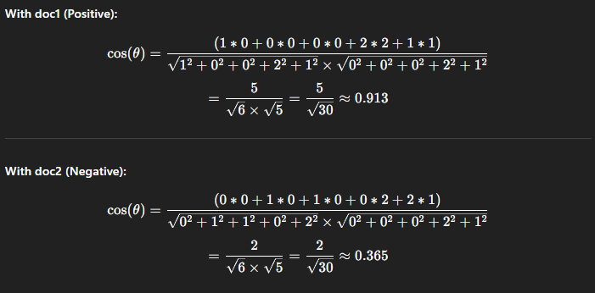

Step 3: Prediction
- Similarity with Positive = 0.913
- Similarity with Negative = 0.365
✅ New sentence is classified as Positive (closer angle with doc1).
👉 So yes — in vector-space models, prediction can be made using angle (cosine similarity) instead of probability.
Naive Bayes = probability multiplication
Cosine similarity = vector angle
- Read the all Hyperparamere in Details Link
Code Demo :
from sklearn.feature_extraction.text import CountVectorizer
from sklearn.metrics.pairwise import cosine_similarity

# Training data
documents = [
"good movie good acting",
"bad movie boring movie",
"excellent acting good movie",
"boring movie bad acting"
]
labels = ["Positive", "Negative", "Positive", "Negative"]

# New sentence
new_sentence = ["good movie excellent acting"]

# Fit BoW
vectorizer = CountVectorizer()
X = vectorizer.fit_transform(documents + new_sentence)

# Predict
similarities = cosine_similarity(X[-1], X[:-1])[0]
predicted_label = labels[similarities.argmax()]
print("Predicted Label:", predicted_label)

o/p : Predicted Label: Positive

Disadvantages (Cons) of BoW
• High Dimensionality (Sparsity Problem)
- Vocabulary size = number of features → huge and sparse matrices.
• Ignores Word Order
- "dog bites man" vs "man bites dog" → both look the same in BoW.
• Doesn’t Capture Semantic Meaning
- Words like "good" and "excellent" are treated as completely different, even though meanings are similar.
• Sensitive to Stopwords & Noise
- Common words like "the", "is", "a" increase dimensions but don’t add much meaning.
• Limited Generalization
- New words in test data not seen during training → ignored (zero vector).

⚡ In summary:
- Good for simple classification tasks (sentiment analysis, spam detection).
- Not good when you need to capture context, order, or meaning.

Feature | One-Hot Encoding (OHE) | Bag of Words (BoW)
Representation | Each word → unique vector (only 1 position = 1, rest = 0) | Each document → vector of word counts
Vector Size | Equal to vocabulary size (per word) | Equal to vocabulary size (per document)
Values | Binary (0 or 1) | Integer counts (0, 1, 2, …)
Captures Frequency? | ❌ No (just presence/absence) | ✅ Yes (word occurrence count)
Use Case | Word-level representation | Document-level representation
Limitation | Ignores frequency + produces very sparse vectors | Ignores order + leads to high dimensionality

N-gram

🔹 What is an N-gram?
An N-gram is a sequence of N consecutive words from a sentence or document.
- Unigram (1-gram): Single words
- Bigram (2-gram): Pair of consecutive words
- Trigram (3-gram): Sequence of 3 consecutive words
- … and so on.

🔹 Example Sentence
👉 "I love machine learning"
- Unigrams (1-grams):
["I", "love", "machine", "learning"]
- Bigrams (2-grams):
["I love", "love machine", "machine learning"]
- Trigrams (3-grams):
["I love machine", "love machine learning"]

🔹 Why Use N-grams?
- Captures word order & context (unlike BoW).
  - "not good" vs "good" are different bigrams.
- Improves prediction accuracy in NLP tasks like text classification, sentiment analysis, autocomplete.
- Common in language models (before deep learning, N-gram models powered Google Translate, speech recognition, etc.).

🔹 Drawbacks of N-grams
- High dimensionality (explodes with vocabulary size).
  - Example: 10,000 words vocabulary → 100M bigrams!
- Sparsity → Many possible N-grams never occur in the dataset.
- Computationally expensive for large corpora.

Code :
from sklearn.feature_extraction.text import CountVectorizer

# Example sentences
docs = ["I love machine learning", "machine learning is fun"]
# Use bigrams
vectorizer = CountVectorizer(ngram_range=(2,2))
X = vectorizer.fit_transform(docs)

print("Vocabulary:", vectorizer.get_feature_names_out())
print("BoW Matrix:\n", X.toarray())

👉 Output:
Vocabulary: ['i love', 'learning is', 'love machine', 'machine learning']
BoW Matrix:
[[1 0 1 1]
[0 1 0 1]]

Hyperparameter :
- ngram_range(1,1) → Only unigrams (single words).
- ngram_range(2,2) → Only bigrams (2-word sequences).
- ngram_range(1,2) → Both unigrams + bigrams.
- ngram_range(2,3) → Bigrams + trigrams.
👉 So (2,2) = extract exactly bigrams, nothing else.

🔹 TF-IDF (Term Frequency – Inverse Document Frequency)
It’s a statistical method to convert text into numerical vectors by considering:
- How often a word appears in a document (TF)
- How unique that word is across all documents (IDF)
This helps highlight important words while reducing weight of common words like the, is, movie.

✅ Formula
- Term Frequency (TF):
- Inverse Document Frequency (IDF):


- TF-IDF Score:

Example

Step 2: Example Dataset
We have 3 sentences (documents):
- good movie good acting
- bad movie boring movie
- excellent acting good movie

Step 3: TF (Term Frequency)
Let’s focus on document 1 → "good movie good acting"
- good = 2 times
- movie = 1 time
- acting = 1 time
- total words = 4
👉 Term Frequency (TF):
- TF(good) = 2/4 = 0.5
- TF(movie) = 1/4 = 0.25
- TF(acting) = 1/4 = 0.25

Step 4: IDF (Inverse Document Frequency)
Now check in how many documents each word appears (df):
- good → appears in doc 1 & 3 → df = 2
- movie → appears in doc 1, 2 & 3 → df = 3
- acting → appears in doc 1 & 3 → df = 2
- bad → appears in doc 2 → df = 1
- boring → appears in doc 2 → df = 1
- excellent → appears in doc 3 → df = 1
Total docs (N) = 3
👉 IDF = log(N / df):
- IDF(good) = log(3/2) ≈ 0.176
- IDF(movie) = log(3/3) = 0
- IDF(acting) = log(3/2) ≈ 0.176
- IDF(bad) = log(3/1) ≈ 1.098
- IDF(boring) = log(3/1) ≈ 1.098
- IDF(excellent) = log(3/1) ≈ 1.098

Step 5: TF-IDF for Document 1
Now multiply TF × IDF for document 1 (good movie good acting):
- TF-IDF(good) = 0.5 × 0.176 = 0.088
- TF-IDF(movie) = 0.25 × 0 = 0.0
- TF-IDF(acting) = 0.25 × 0.176 = 0.044
👉 So the vector looks like:
[good=0.088, movie=0.0, acting=0.044, bad=0, boring=0, excellent=0]
✅ Intuition:
- "movie" appears in every document → IDF = 0 → not important.
- "good" and "acting" are more unique → positive weight.
- Rare words like "bad", "boring", "excellent" get high IDF → if they appear, they are very important.

from sklearn.feature_extraction.text import TfidfVectorizer
import pandas as pd

docs = [
"good movie good acting",
"bad movie boring movie"
]

vectorizer = TfidfVectorizer()
X = vectorizer.fit_transform(docs)

df = pd.DataFrame(X.toarray(), columns=vectorizer.get_feature_names_out())
print(df)

o/p :
acting bad boring good movie
0 0.577 0.000 0.000 0.816 0.000
1 0.000 0.577 0.577 0.000 0.000

✅ Advantages of TF-IDF
- Reduces impact of stopwords (“the”, “is”, “movie”).
- Highlights important & unique words.
- Works better than plain BoW in many tasks.

❌ Limitations
- Still ignores word order (like BoW).
- Doesn’t capture semantic meaning (e.g., good ≠ excellent).
- Sparse representation for large vocabulary.
⚡ In short:
BoW says “word appears 3 times, so it’s important”.
TF-IDF says “but if the word appears in every document, it’s NOT important”.

Word2Vec

🔹 What is Word2Vec?
- Word2Vec is a word embedding technique created by Google in 2013.
- It converts words into dense vectors (numbers) such that similar words have similar vectors.
- Unlike one-hot or BoW, Word2Vec captures semantic meaning (king ≈ queen, walk ≈ walking).

🔹 Why Word2Vec is needed?
- Traditional methods (One-Hot, BoW, TF-IDF) only focus on word frequency.
- They cannot capture meaning or relationships between words.
- Example: "king" and "queen" are both royalty, but BoW treats them as unrelated.
- Word2Vec solves this by learning word meaning from context.

🔹 How Word2Vec works?
- Uses a shallow neural network (only 1 hidden layer).
- Input → word, Output → related/context word.
- During training, words that appear together frequently in text become close in vector space.

🔹 Two main architectures

1. Continuous Bag of Words (CBOW)
- Idea: Predict the current word using the surrounding words (context).
- Example sentence: "I love playing football daily"
  - Context window = 2
  - Input = ["I", "love", "football", "daily"]
  - Output = "playing"

⚙️ How it works:
- Takes multiple context words as input.
- Combines (averages) their embeddings.
- Predicts the target word in the center.

✅ CBOW is:
- Faster to train.
- Good for small datasets.
- Better for frequent words.

2. Skip-Gram
- Idea: Predict the surrounding context words from the current word.
- Example sentence: "I love playing football daily"
  - Context window = 2
  - Input = "playing"
  - Output = ["I", "love", "football", "daily"]

⚙️ How it works:
- Takes one center word as input.
- Predicts the words around it within the window.
- Each pair (center → context) is a training sample.

✅ Skip-Gram is:
- Slower to train (more pairs).
- Needs large datasets.
- Works better for rare words.
Feature | CBOW | Skip-Gram
Input | Context words | Center word
Output | Center word | Context words
Focus | Frequent words | Rare words
Speed | Faster | Slower (more training examples)
Best for | Small datasets | Large datasets
Accuracy | Less accurate for rare words | More accurate for rare words
Example | Predict "playing" from ["I","love","football","daily"] | Predict ["I","love","football","daily"] from "playing"

Analogy for easy memory
- CBOW = Guess the missing word → like a fill-in-the-blank puzzle.
- Skip-Gram = Guess the neighbors → given one word, find its surrounding friends.

Code
!pip install gensim
import os
import gensim
import nltk
nltk.download('punkt')
nltk.download('punkt_tab')
from nltk.tokenize import sent_tokenize
from gensim.utils import simple_preprocess

story = []
text = "suppose large data present"
for i in text:

with open( i,"r", encoding="latin-1") as f:
corpus = f.read()
raw_sent = sent_tokenize(corpus)
for sent in raw_sent:
story.append(simple_preprocess(sent))

model = gensim.models.Word2Vec(
window=10,
min_count=2,
)
model.build_vocab(story)
model.train(story, total_examples=model.corpus_count, epochs=model.epochs)

# similar words
model.wv.most_similar("daenerys")
# find old
model.wv.doesnt_match(['jon','rikon','robb','arya','sansa','bran'])
# perticular vector
model.wv["arya"]

Quick Summary
- most_similar → find related words
- similarity → check similarity between words
- doesnt_match → odd-one-out detection
- wv['word'] → get word vector
- index_to_key → vocabulary list
- save_word2vec_format & load_word2vec_format → save/load embeddings

Code Explanation
- vector_size=50 → dimension of word embeddings (you can change).
- window=3 → context window size.
- min_count=1 → include all words (otherwise rare words are ignored).
- sg=0 → CBOW model.
- sg=1 → Skip-Gram model.
- .most_similar("playing") → finds words with similar meaning.
- .wv["football"] → gives word embedding vector.

Text Classification :

1. What is Text Classification?
- Text classification is the process of assigning categories/labels to text.
- Example:
  - Email → spam or not spam
  - Movie review → positive or negative
  - News article → politics, sports, entertainment

2. Why is Text Classification Important?
- Helps in organizing and filtering large amounts of text.
- Automates tasks like:
  - Spam filtering (Gmail spam box)
  - Sentiment analysis (Amazon reviews, Twitter posts)
  - Topic categorization (news apps, blogs)

3. Steps in Text Classification Pipeline
- Data Collection – Gather text + labels (e.g., spam emails, movie reviews).
- Data Preprocessing – Clean text (remove stopwords, punctuation, tokenize).
- Feature Extraction – Convert text into numerical form (Bag of Words, TF-IDF, Word2Vec, BERT).
- Model Training – Train ML/DL model (Naive Bayes, SVM, LSTM, Transformers).
- Evaluation – Test model using accuracy, precision, recall, F1-score.
- Prediction – Use model to classify new unseen text.
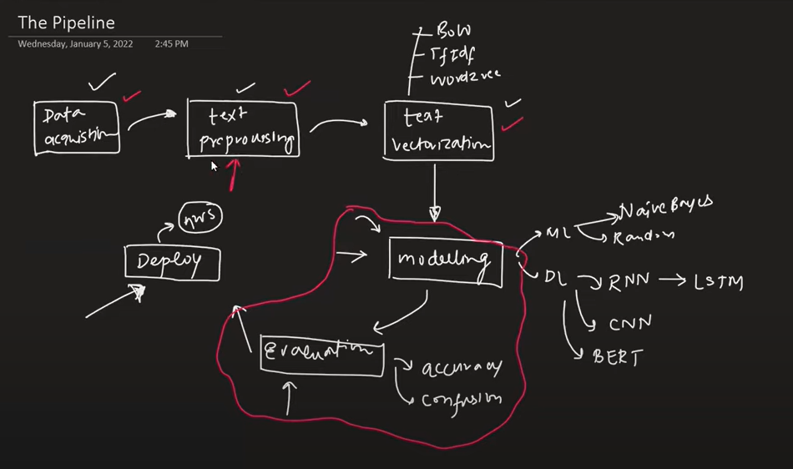

4. Types of Text Classification
- Binary Classification → Two categories (spam vs not spam).
- Multi-Class Classification → More than two categories (sports, politics, health).
- Multi-Label Classification → One text can belong to multiple categories (e.g., “AI in healthcare” → AI + Healthcare).

5. Algorithms Used
- Traditional ML: Naive Bayes, Logistic Regression, SVM.
- Deep Learning: LSTM, CNN, Transformers (BERT, RoBERTa).

📘 Applications of Text Classification

1. Spam Detection
- Classifies emails as spam or not spam.
- Example: Gmail filtering unwanted emails.

2. Sentiment Analysis
- Detects sentiment: positive, negative, neutral.
- Example: Analyzing customer reviews or tweets.

3. Topic Categorization
- Groups text into categories.
- Example: News articles → sports, politics, business.

4. Language Detection
- Identifies the language of a text.
- Example: Google Translate auto-detecting English, Hindi, Marathi.

5. Chatbot Intent Recognition
- Understands what a user wants.
- Example: “Book a flight” → intent = flight_booking.

6. Toxic Comment Detection
- Detects abusive, hateful, or offensive language.
- Example: Social media platforms removing hate speech.

7. Healthcare Text Mining
- Classifies medical records, symptoms, or research papers.
- Example: Grouping patient symptoms into disease categories.

8. Customer Support Ticket Classification
- Assigns tickets to the right department.
- Example: Bank queries → loan, credit card, account.

9. Search Engine Query Classification
- Classifies queries to improve search results.
- Example: Query “best pizza near me” → category = food.

10. Fake News Detection
- Classifies news as real or fake.

📘 Practical Advice for NLP :
- Use ensemple technique for better results
- Use Heuristic features for better result (handmade technique according to data)
- Don’t use direct deep learning because you don’t understand the data/feature engineering , and some time ML algorithm give the better result as compare to DL. After using ML then you can use DL.
- Data always balance . If data is inbalance then make it balance
- Imbalance data : 80% -true , 20% - false
- Balance data : like 55% -true , 45% - false etc

📘 Part-of-Speech (POS) Tagging in NLP :

1. What is POS Tagging?
- Definition: The process of assigning grammatical labels (tags) to each word in a sentence.
- Example:
"The cat is sleeping." →
  - The → DET (Determiner)
  - cat → NOUN
  - is → VERB
  - sleeping → VERB (present participle)
👉 POS tags tell us how each word is used grammatically in a sentence.

2. Why is POS Tagging Important?
- Helps in syntactic parsing (understanding sentence structure).
- Useful for information extraction (find names, places, dates).
- Improves text classification (knowing if a word is noun/verb matters).
- Used in machine translation, chatbots, and speech recognition.
- What is Word Sense Disambiguation (WSD)?
Many words in English have multiple meanings (polysemy).
Example:
  - “I went to the bank to deposit money.” → bank = financial institution
  - “He sat on the bank of the river.” → bank = river side
👉 POS tags help us guess which sense (meaning) of a word is correct.

3. Types of POS Tags (Common)
- NOUN (NN) → person, place, thing (e.g., "cat", "India").
- PRONOUN (PRP) → he, she, it.
- VERB (VB) → action/state (run, eat, is).
- ADJECTIVE (JJ) → describes noun (beautiful, tall).
- ADVERB (RB) → modifies verb/adjective (quickly, very).
- DETERMINER (DT) → the, a, an.
- PREPOSITION (IN) → in, on, at.
- CONJUNCTION (CC) → and, but, or.
- INTERJECTION (UH) → oh!, wow!
👉 POS tagsets vary (Penn Treebank is most widely used).

4. POS Tagging Approaches
- Rule-Based POS Tagging
  - Uses grammar rules + dictionary lookup.
  - Example: "ing" → likely a verb (running).
  - Simple, but limited for ambiguous words.
- Statistical POS Tagging
  - Uses probability models (e.g., Hidden Markov Models (HMMs)).
  - Chooses the most probable tag sequence based on training data.
- Machine Learning / Deep Learning
  - Uses ML algorithms (SVM, CRF, LSTM, BiLSTM, Transformers).
  - Modern NLP models (like BERT) perform POS tagging as sequence labeling.

6. Challenges in POS Tagging
- Ambiguity: "book" (Noun: "I read a book", Verb: "Please book a ticket").
- Unknown Words: Handling new words not in training vocabulary.
- Context Dependence: Same word can have different POS in different contexts.

7. Applications of POS Tagging
- Named Entity Recognition (NER)
- Text-to-Speech (deciding pronunciation)
- Sentiment analysis (adjectives often carry sentiment)
- Machine translation
- Grammar checking tools (like Grammarly)

📚 Python Libraries for POS Tagging

1. NLTK (Natural Language Toolkit)
- Most popular for beginners in NLP.
- Provides nltk.pos_tag() for POS tagging.
- Uses the Averaged Perceptron Tagger (statistical model).
- Works best on English text.
- ✅ Pros: Easy to use, good for learning.
- ❌ Cons: Not as powerful for large-scale or multilingual tasks.

2. spaCy
- Industrial-strength NLP library.
- Has a built-in POS tagger using deep learning.
- Provides universal POS tags + detailed dependency parsing.
import spacy
nlp = spacy.load("en_core_web_sm")
doc = nlp("The quick brown fox jumps over the lazy dog")
for token in doc:
print(token.text, token.pos_, token.tag_)

📌 Important Attributes & Methods of Docs
• doc.text → full text
import spacy
nlp = spacy.load("en_core_web_sm")
doc = nlp("The quick brown fox jumps over the lazy dog")
print(doc.text) # -> The quick brown fox jumps over the lazy dog
• doc[i] → ith token
for token in doc:
print(token.text) # print like list data
• doc.pos_ → named of POS to respective word
nlp = spacy.load("en_core_web_sm")
doc = nlp("The quick brown fox jumps over the lazy dog")
for token in doc:
print(f"{token.text:10} --> {token.pos_}")
• doc.sents → sentences
for sent in doc.sents:
print(sent.text) # The quick brown fox jumps over the lazy dog
• doc.noun_chunks → noun phrases
• doc.vector → document embedding
• doc.similarity() → similarity between docs
• doc.has_annotation() → check annotation availability
• doc.lang → language code
• doc.cats → classification labels
• doc.is_parsed / is_tagged / is_nered → pipeline status
✅ Pros: Fast, accurate, supports multiple languages.
❌ Cons: Models are larger, need installation (python -m spacy
download en_core_web_sm).

3. Stanford CoreNLP (via Stanza or NLTK wrapper)
- From Stanford NLP group.
- Provides very strong POS tagging (statistical + neural).
- Accessible in Python through stanza library or NLTK’s CoreNLP wrapper.
- Example with Stanza:
import stanza
stanza.download('en')
nlp = stanza.Pipeline('en')
doc = nlp("The cat is sleeping")
for sentence in doc.sentences:
for word in sentence.words:
print(word.text, word.upos)
• ✅ Pros: Very accurate, multilingual support.
• ❌ Cons: Slower, heavier to install.

from textblob import TextBlob
blob = TextBlob("The cat is sleeping")
print(blob.tags)
o/p : [('The', 'DT'), ('cat', 'NN'), ('is', 'VBZ'), ('sleeping', 'VBG')]

5. Transformers (Hugging Face)
- Uses pretrained deep learning models (BERT, RoBERTa, DistilBERT).
- POS tagging can be done using token classification pipelines.
- Very powerful for state-of-the-art accuracy.
- ✅ Pros: High accuracy, multilingual.
- ❌ Cons: Requires GPU for speed, heavier.

📌 Quick Summary for Notes
- NLTK → Beginner-friendly, fast demo, English only.
- spaCy → Best balance (fast + accurate + production ready).
- Stanford NLP (Stanza) → Research grade, multilingual.
- TextBlob → Super simple, but less accurate.
- Transformers → Cutting-edge, high accuracy, requires more compute.
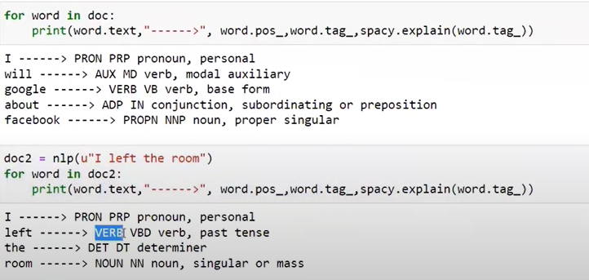
If you want to display the spacy :
import spacy
from spacy import displacy
# Load model
nlp = spacy.load("en_core_web_sm")
# Input text
doc = nlp("The quick brown fox jumps over the lazy dog")
# Visualize POS tags
displacy.render(doc, style="dep", jupyter=True)
like that :
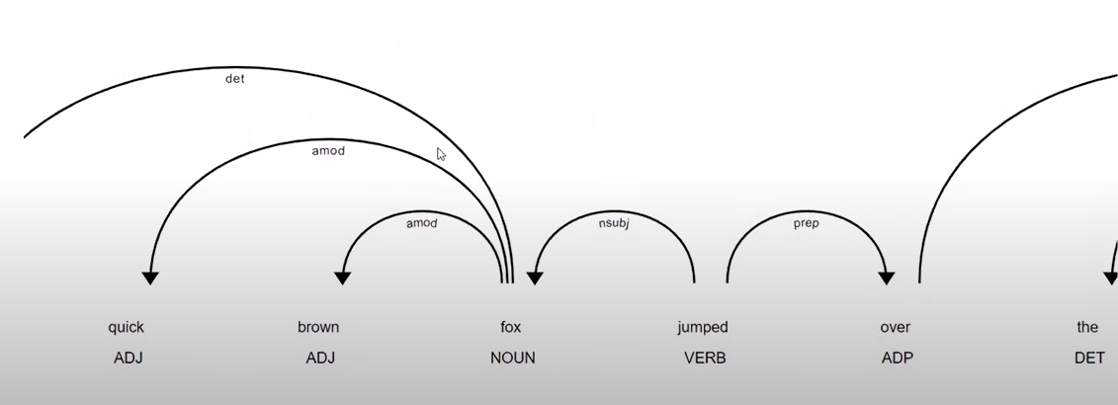
You can also customize it using option:
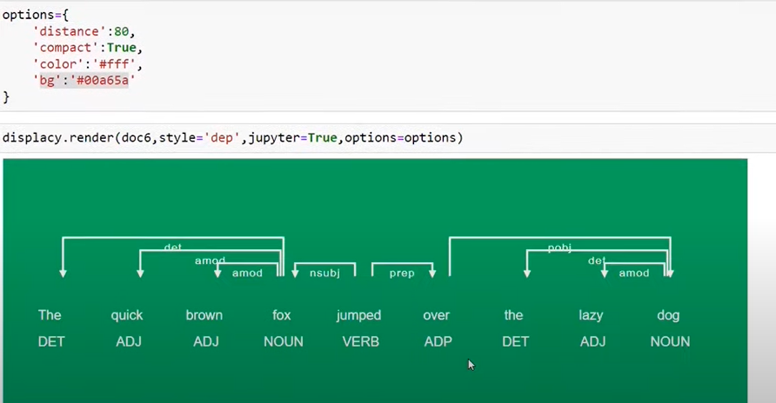

📌 Hidden Markov Model (HMM) :

Why Use HMM?
- 1. Sequence Modeling
  - HMM is made for sequential data (words in a sentence, sounds in speech, DNA bases).
  - It captures order and dependency between elements.
- 2. Simplicity
  - Easier to understand and implement than deep learning models.
  - Only needs probabilities (transition + emission).
- 3. Works with Small Data
  - Deep learning needs a lot of data.
  - HMM works even with limited datasets.
- 4. Interpretability
  - Probabilities are easy to explain.
  - Example: "Dogs bark" → Noun → Verb (you can see transition + emission clearly).
- 5. Used in Early NLP & Speech Systems
  - Before deep learning, HMM was the standard model for POS tagging, speech recognition, and sequence labeling.
- 6. Good for Hidden Structure
  - HMM helps find hidden patterns behind observed data (like POS tags behind words, or phonemes behind sound).

2. Components of HMM
HMM is defined by five elements:
- States (S) → Hidden variables (e.g., POS tags: Noun, Verb, Adjective).
- Observations (O) → What we see (e.g., words: “dog”, “runs”, “quickly”).
- Transition Probability (A) → Probability of moving from one state to another.
  - Example: P(Noun → Verb) = 0.4
- Emission Probability (B) → Probability of a word being generated by a state.
  - Example: P(“dog” | Noun) = 0.6
- Initial Probability (π) → Probability of starting in a particular state.
  - Example: P(Start with Noun) = 0.3
👉 Together, HMM = (S, O, A, B, π).

3. How does HMM work in NLP?
- For a given sentence → HMM tries to find the most likely sequence of states (POS tags).
- It uses algorithms like:
  - Forward-Backward Algorithm → to compute probabilities.
  - Viterbi Algorithm → to find the most likely hidden state sequence.
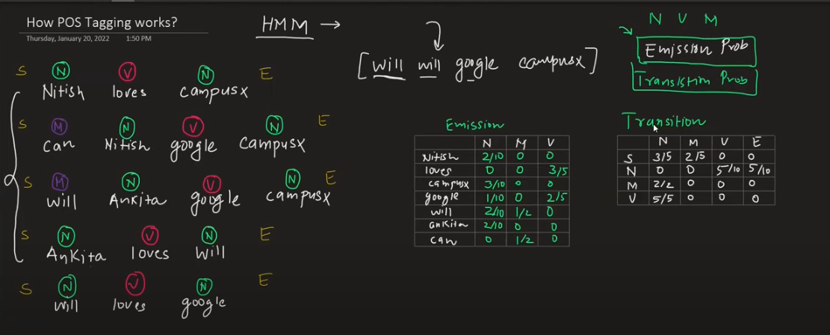

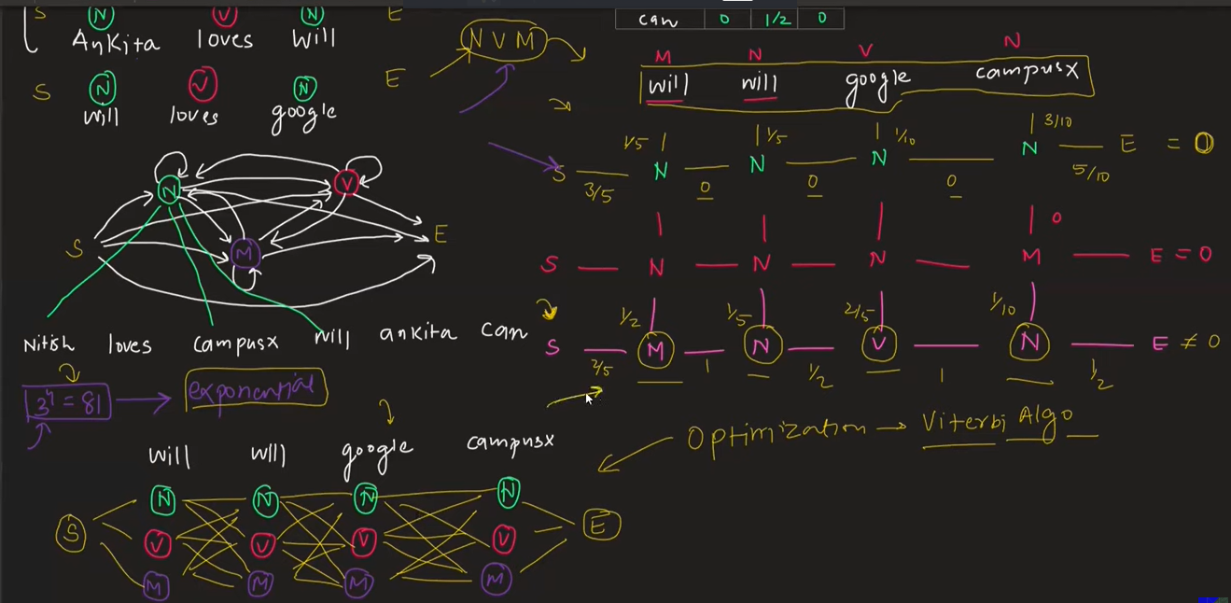

📌 Viterbi Algorithm (Easy Explanation)
👉 Definition:
The Viterbi Algorithm is a dynamic programming algorithm used in HMM to find the most likely sequence of hidden states (like POS tags) given a sequence of observations (like words).

🔑 Key Idea:
- Instead of checking all possible state sequences (which is huge),
- Viterbi finds the best path step by step, keeping track of probabilities.
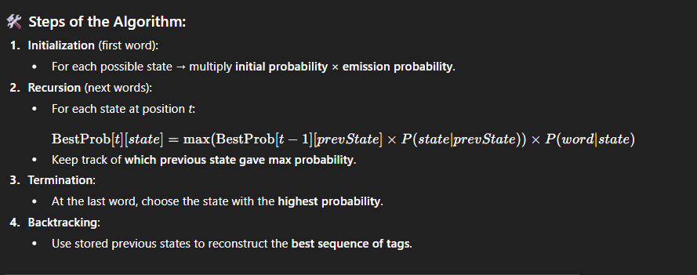

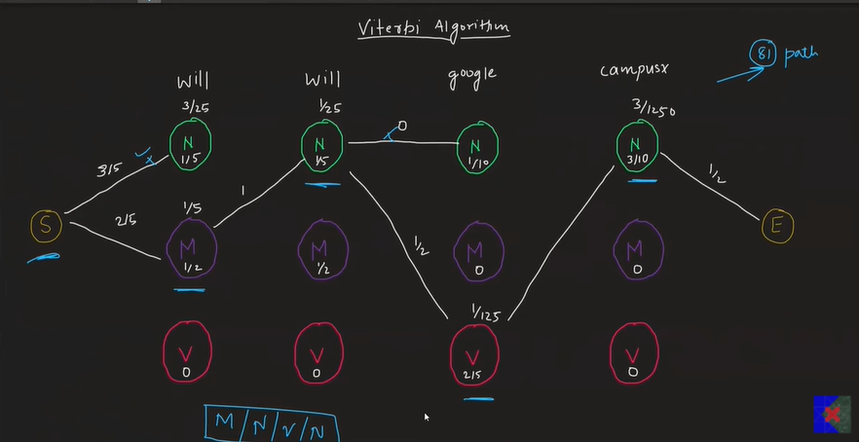

1. Collect and inspect data
- Gather labeled examples (CSV, JSON, text files).
- Inspect 100–500 random samples manually to understand noise, language style, slang, emojis, non-ASCII.
- Note class balance, missing labels, duplicated entries.
- Split data: train / val / test (common split: 70/15/15 or 80/10/10). Use stratified split for classification

2. Basic preprocessing
- Normalize text: lowercase (unless using cased models), remove control characters.
- Remove/handle metadata (timestamps, usernames) if not useful.
- For token-label tasks (NER), preserve token alignment when cleaning.
- Decide on handling emojis, URLs, emails, numbers (keep/replace with tokens <URL>, <NUM>).
- Optionally apply spelling correction, contraction expansion.

🔹 Steps to Train Your Own NLP Model (Deep Learning Approach)
- Collect Data
  - Get a dataset (text data like reviews, tweets, articles, etc.).
  - Example: IMDB movie reviews for sentiment analysis.
- Preprocess the Data
  - Clean text (remove special characters, punctuation, stopwords if needed).
  - Tokenize text → split into words or subwords.
  - Convert text into numbers (word embeddings like Word2Vec, GloVe, or pretrained like BERT).
- Prepare Input & Output
  - Define features (X) → text input.
  - Define labels (y) → category/target (e.g., Positive or Negative).
- Split Dataset
  - Training set (70–80%).
  - Validation set (10–15%).
  - Testing set (10–15%).
- Choose Deep Learning Model
  - RNN / LSTM / GRU → good for sequence data.
  - CNN for text → works well on local word patterns.
  - Transformer models (BERT, GPT, etc.) → best for context understanding.
- Build Model Architecture
  - Input Layer → takes embeddings.
  - Hidden Layers → LSTM/GRU/Attention/Transformer blocks.
  - Output Layer → classification/regression (softmax/sigmoid).
- Compile Model
  - Loss Function → Cross-Entropy (for classification).
  - Optimizer → Adam / SGD.
  - Metrics → Accuracy, F1-score, etc.
- Train Model
  - Feed training data into model.
  - Run for several epochs.
  - Use validation set to tune hyperparameters (learning rate, batch size, etc.).
- Evaluate Model
  - Test performance on unseen test data.
  - Check metrics (Accuracy, Precision, Recall, F1).
- Improve Model
- Try dropout, regularization, data augmentation.
- Use ensemble methods or pretrained embeddings.
- Fine-tune transformer models (like BERT).
- Deploy Model
- Save trained model.
- Use it in a web app, chatbot, or mobile app.

