** Motocross India Private Limited.**

*A DPIIT certified company*

3rd Main, Club Road, Basavnagar, Belagavi 590001

**EMPLOYMENT BOND OR CONTRACT CUM APPOINTMENT LETTER**

THIS AGREEMENT is made on the **14/10/2023** between **Motocross India Private Limited**, a company registered under the Companies Act, 2013 and having its registered office at 3rd main, Club Road, Basavnagar, Belagavi - 590 001 (hereinafter called the “company”) of the one part and **Denzel Alexander Panakkal** residing at Belagavi (Hereinafter called the “Employee”) of the other part.

**WHEREAS**

The company is desirous of appointing **Denzel Alexander Panakkal** as its Software Developer and the Employee has agreed to on the terms and conditions outlined here below.

**NOW THIS AGREEMENT WITNESSES AS FOLLOW:**

The said Vishnu Prabhakaran is hereby appointed as the Software Developer with Employee code **MOTO2305** of the company and he will hold the said office, subject to the provisions made hereinafter.

1. **Day of Commencement**

You are expected to report to your duties as from 1st November 2023. This employment bond is of one year(s) after which we may renew it based on your performance and mutual agreement.

1. **Reporting**

You will directly report to company’s CTO on the said date. You are required to comply with the company’s rules and regulations at all given times and should always act in a manner that protects the company’s interest.

1. **Allocated Place of Work**

You will be based at Company’s headquarters at Motocross India Private Limited, 3rd Main, Club Road, Belagavi, Karnataka, India. Company or you shall choose to work from home during any occasion/emergency with mutual agreement between you and your team manager.

1. **Roles and Responsibilities**

* Producing clean, efficient code based on specifications.
* Testing and deploying programs and systems.
* Fixing and improving existing software.
* Team work, obey the team leader and update day-to-day tasks in worksheet.
* Upskilling and upgrading to the technology when needed.

1. **Monthly Salary**

You are entitled to annual package amounting to INR 1,20,000/- including stay and other allowance, which will be subject to all statutory and company deductions with regards to the law. The pay will be credited directly to your salaried bank account twice a month (i.e., 25th & 10th of every month). Your salary shall be delayed by each day for every late in-time to the office with minimum debit of Rs.50/- .

1. **Increment or Incentives**

You will be getting promotion/increment/incentive on your work performance, upskilling and employee ratings which shall be reviewed every quarter.

1. **Working days & working hours**

* Your working time will be 9 hours per day including lunch & tea breaks.
* You shall work 6 days a week.
* Week off shall be decided by you and the HR accordingly.

1. **Work from Home**

The company shall welcome you with employee joining kit, Motocross employee application, visiting cards, ID card, company email ID and Insurance worth 2lach rupees as a complimentary. The company shall consider first fifteen days of your salary as deposit which shall be settled during the termination of this agreement with 6% annual interest. We shall offer you benefits of ESPOs and others only after 3 months from joining.

1. **Employee benefits, Deposits and settlements**

The company shall welcome you with employee joining kit, Motocross employee application, visiting cards, ID card, company email ID and Insurance worth 2lach rupees as a complimentary. The company shall consider first fifteen days of your salary as deposit which shall be settled during the termination of this agreement with 6% annual interest. We shall offer you benefits of ESPOs and others only after 3 months from joining.

1. **Leave**

* As per our company policy there are only 15 national & festival holidays annual on which the company shall give as paid holidays.
* Addition to it you will be entitled to 10 working days of mandatory paid leave annually, after you complete one-year term with the company.
* You are also entitled to up to 10 working days of sick leave at half pay in a year Company shall only pay you 25% or more during an Emergency/Natural-Disaster depending on the situation.
* As we fall in service tech sector, you can always adjust your leaves according to you and HR’s convenience. (Ex: if there are 30 working days in a month, then you can choose to work any 26 days)

1. ***Termination***

This contract can be terminated:

* By either party given a prior 90 working days written notice, failure to which a compensation of 90 working days salary shall be awarded.
* Or, By the Employer on grounds of indiscipline or under-performance or unlawful.
* Or, By the Employer on account of redundancy/retrenchment as per the law.
* The employee can only break this agreement after six months from the date of joining, failing which he/she shall compensate with 40 working days of salary.
* The employee shall get his/her deposit money only if the employee works for the company for at least eight months from the date of joining.
* Termination can lead to cancelation of ESOPs (if provided).
* He/she has to return all the property/facilities received by the company, Insurance and other bank facilities will no longer be applicable to them.

**Copyrights and Ownership**

You shall not work with any other company either full time or part-time without the consent of HR or the team manager in written format, in a capacity that would create a conflict of interest with the company. You agree to keep the information or any kind of internal data related to the company secured and confidential and shall not share it to any third party in or outside the company, failing which shall put you in legal problems.

**Documents to be submitted**

Copy of following documents to be submitted on the day of joining.

Aadhaar Card & PAN card

Active three months bank statement

Two passport sized photos

Xth/XIIth grade mark-sheet or Degree certificate, whichever is higher (Original)

Police verification certificate

Previous job pay slip (if applicable)

**Amendment and Enforcement**

Any alterations or amendment to this contract shall be duly communicated in writing taking into consideration both the employer’s and employee’s views.

Yours Faithfully

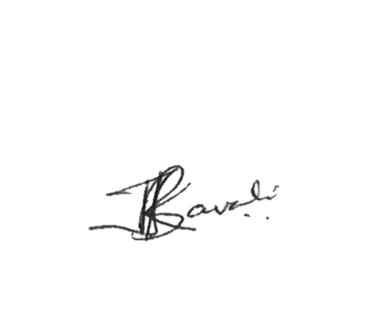

Karan Javali  
*Founder & CEO*

To affirm your acceptance to the terms and conditions laid out in this letter kindly sign below

|  |  |
| --- | --- |
| NAME | SIGN |
| (Witness-1) Bharati Javali |  |
| Denzel Alexander Panakkal |  |
| (Witness-2) |  |

8888 222 992 | www.Motocrossindia.in | info@motocrossindia.in