# TY B.Tech. (CSE) – II [ 2023-24]

**6CS371: Advanced Database System Lab**

Assignment No: 9

# Date: 20/03/2024

**Implementation of CRUD Operations in Python Desktop Application for MongoDB and Cassandra Databases**

**PRN:** 21510017  **Name:** Onkar Anand Yemul

**Title:**

Implementation of CRUD Operations in Python Desktop Application for MongoDB and Cassandra Databases

**Objective/Aim:**

The objective of this assignment is to install and deploy MongoDB and CassandraDB on a Windows platform. Additionally, the aim is to develop a Python desktop application to demonstrate CRUD (Create, Read, Update, Delete) operations using these cloud databases.

**Introduction:**

Cloud databases offer scalable and flexible storage solutions for modern applications. MongoDB and Cassandra are two popular choices for cloud-based database management systems. This assignment focuses on setting up these databases on a Windows platform and integrating them into a Python desktop application.

In modern application development, databases play a crucial role in storing and managing data. MongoDB and Cassandra are two popular NoSQL databases known for their scalability and flexibility. MongoDB Atlas and DataStax Astra provide cloud-based hosting solutions for MongoDB and CassandraDB databases, respectively. PyQt5 is a Python library used for creating GUI applications. This assignment explores how to connect PyQt5 GUI applications to MongoDB and CassandraDB databases to perform CRUD operations.

**Theory/Algorithms:**

* MongoDB: MongoDB is a document-oriented NoSQL database that stores data in flexible, JSON-like documents. It uses the BSON (Binary JSON) format to represent data. CRUD operations in MongoDB involve interacting with collections of documents using methods such as insert, find, update, and delete.
* Cassandra: Cassandra is a distributed NoSQL database designed for handling large amounts of data across multiple nodes. It uses a decentralized architecture based on a partitioned row store. CRUD operations in Cassandra involve interacting with tables of rows using CQL (Cassandra Query Language) statements.

MongoDB Atlas: MongoDB Atlas is like having your MongoDB database hosted on the internet instead of on your own computer. It's managed by MongoDB, so you don't have to worry about setting up servers or dealing with maintenance. You can easily scale your database as your needs grow, and it's available on different cloud platforms like AWS and Azure. With features like automated backups and security measures, your data is safe and accessible from anywhere.

Astra DB: Astra DB is a cloud-based database service based on Cassandra, a powerful database known for handling huge amounts of data. It's offered by DataStax, a company specializing in Cassandra technology. Astra DB is perfect for various applications, from websites to IoT devices. It's serverless, meaning you only pay for what you use, and it's easy to set up and manage. With global distribution and built-in security features, Astra DB ensures your data is always available and protected.

**Procedure:**

1. Install MongoDB and Cassandra on the Windows platform.
2. Set up the databases with appropriate configurations.
3. **Environment Setup:** Install the required Python libraries (pymongo for MongoDB and cassandra-driver for Cassandra) and set up a Python desktop application framework (such as PyQt5).
4. **Database Connection:** Establish connections to the backend MongoDB and Cassandra databases, either hosted locally or in the cloud (MongoDB Atlas and DataStax Astra).
5. **GUI Design:** Design the user interface using PyQt5, incorporating input fields, buttons, and other widgets to facilitate user interaction.
6. **CRUD Implementation:** Implement functions to handle CRUD operations for both MongoDB and Cassandra. This includes adding new records, fetching existing data, updating records, and deleting records.
7. **Integration Testing:** Test the CRUD operations within the desktop application to ensure they function as intended. Verify data integrity and the responsiveness of the application.

**Result / Observations:**

* The PyQt5 GUI applications successfully connect to both local and cloud-based MongoDB and Cassandra databases.
* CRUD operations can be performed seamlessly through the user-friendly interface of the applications.
* Testing demonstrates the effectiveness and reliability of CRUD operations with both MongoDB and CassandraDB.

**Screenshots:**

Screenshots of the Python desktop applications showcasing the GUI interface and the execution of CRUD operations on MongoDB and CassandraDB:

**For local MongoDB database instance:**

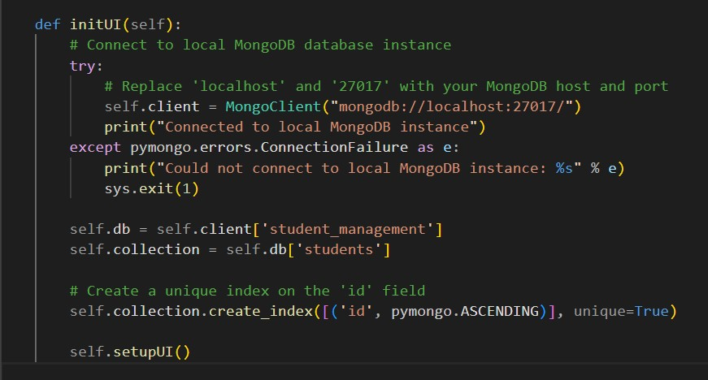

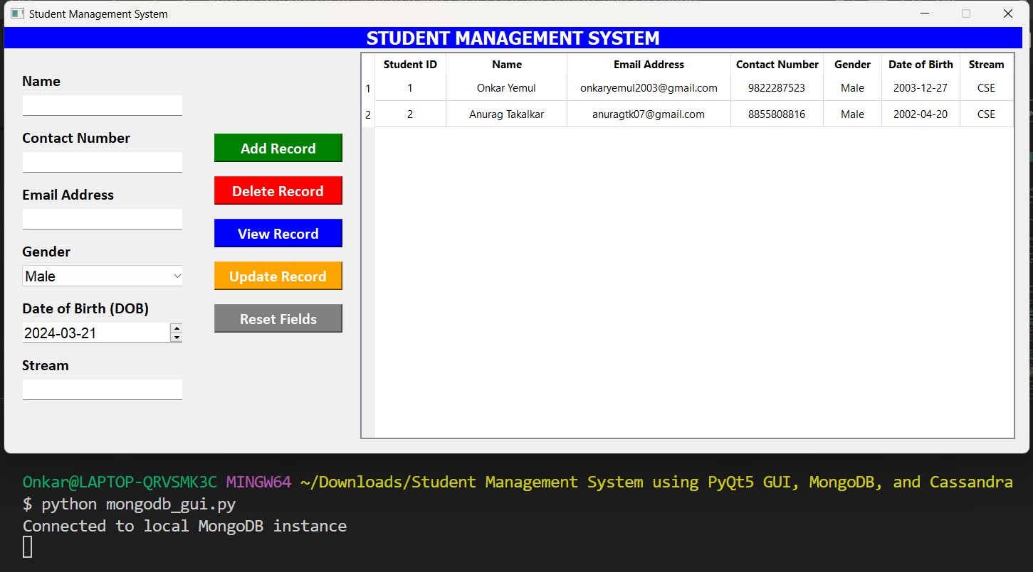

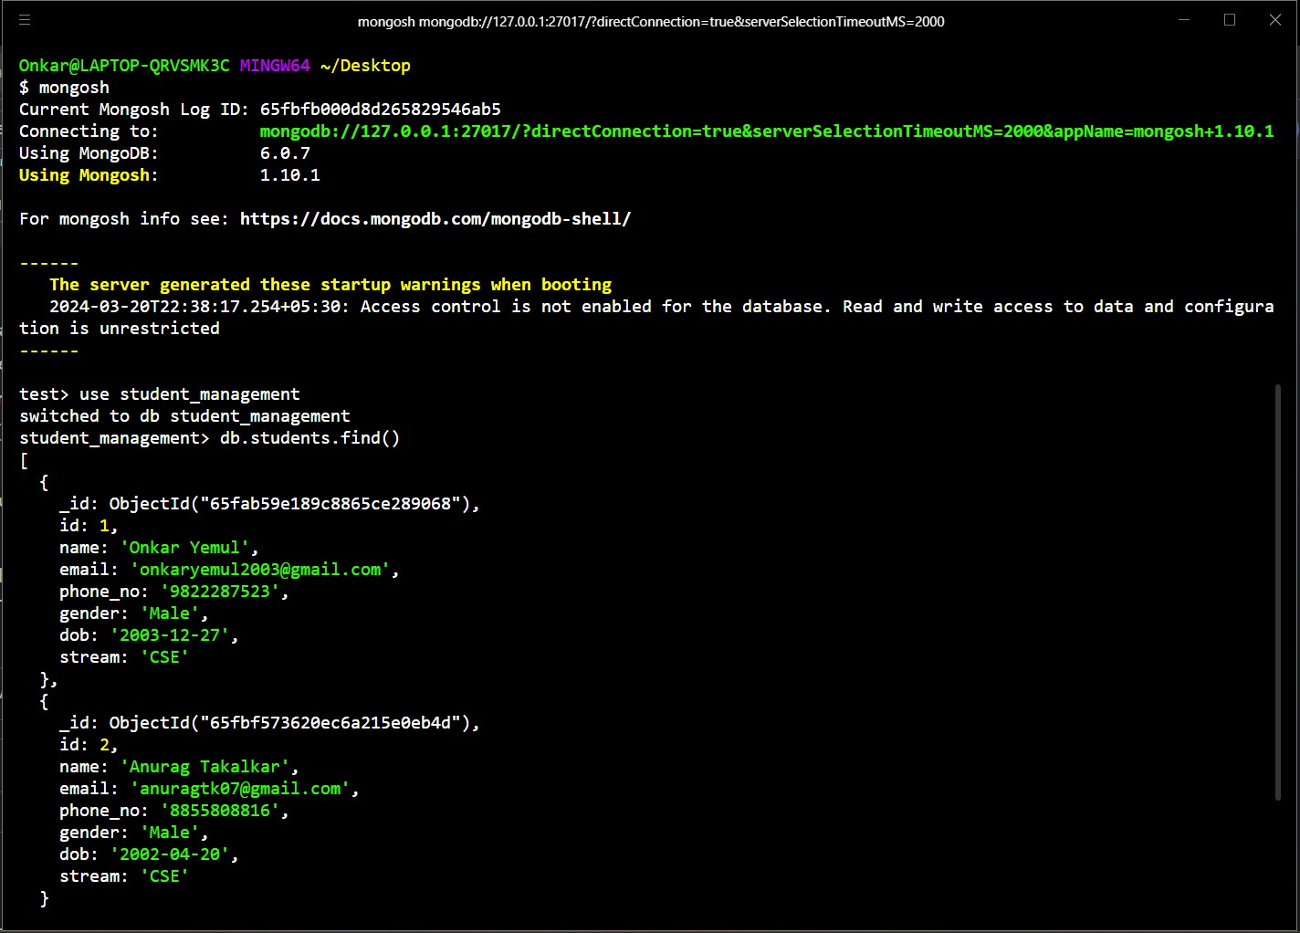

**For cloud MongoDB Atlas database instance:**

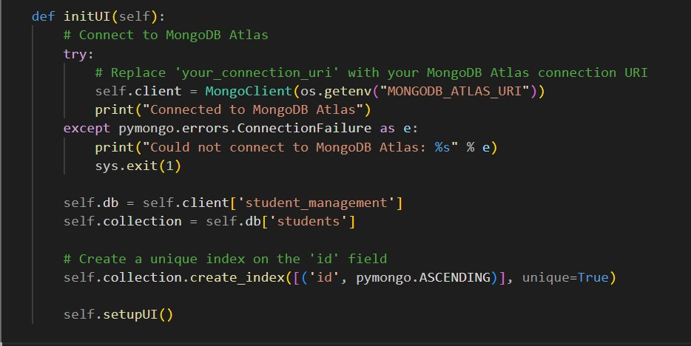

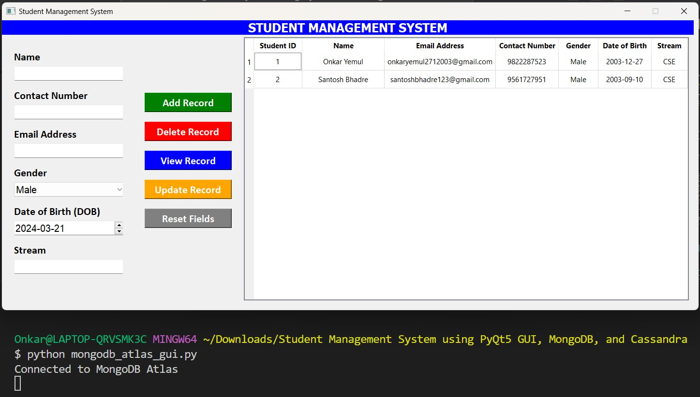

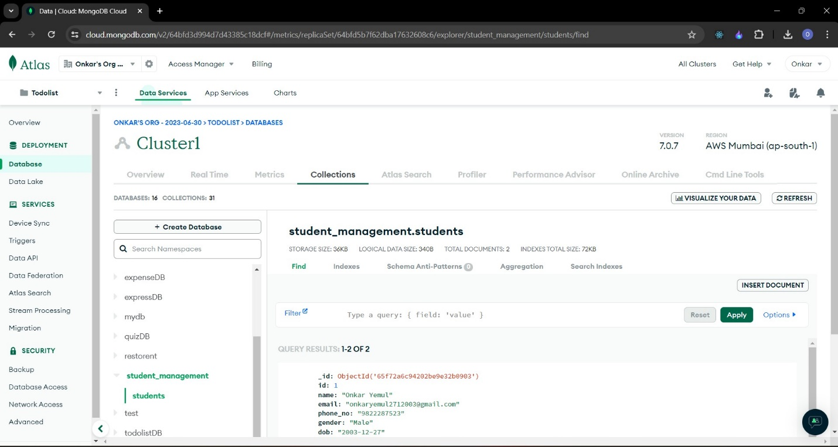

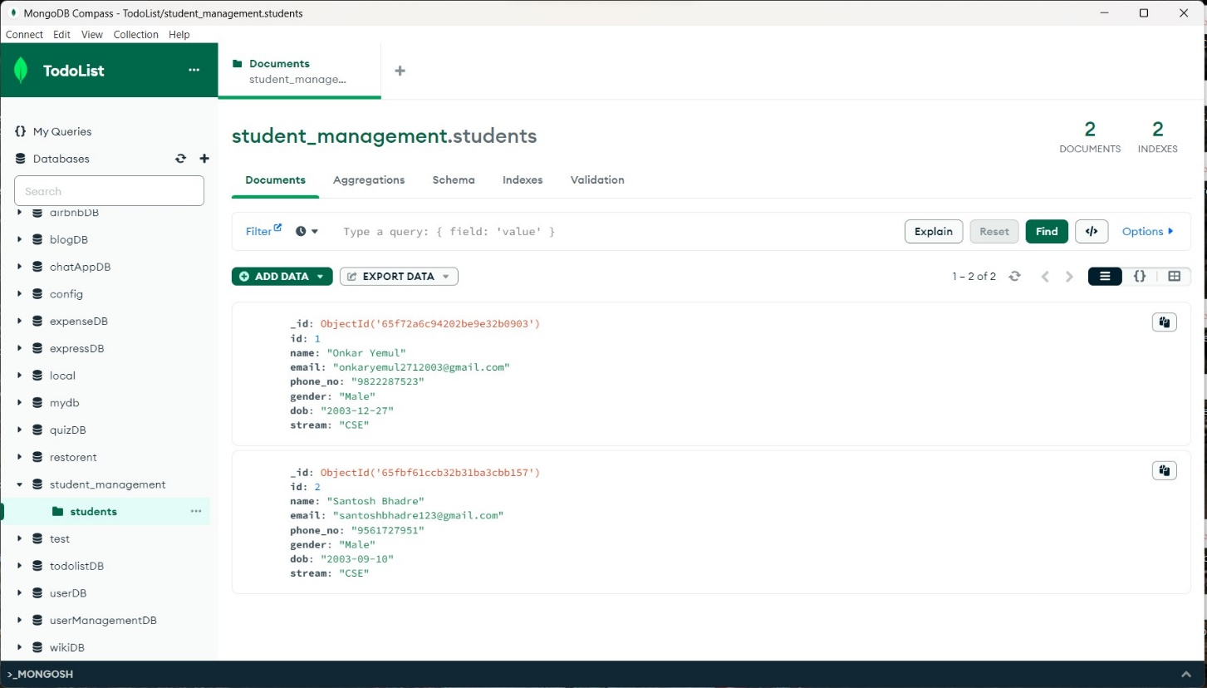

**For local Cassandra database instance:**

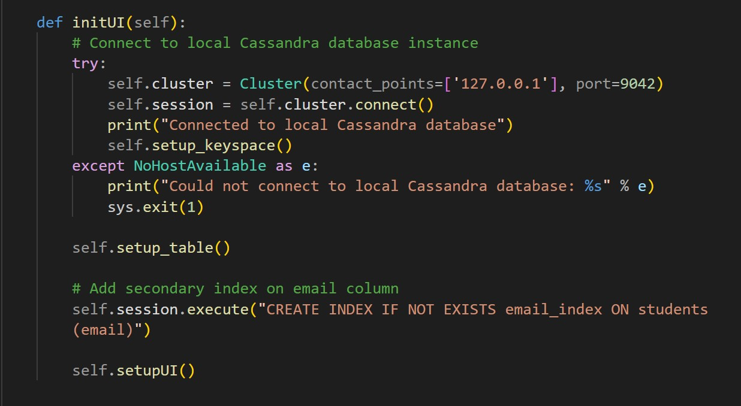

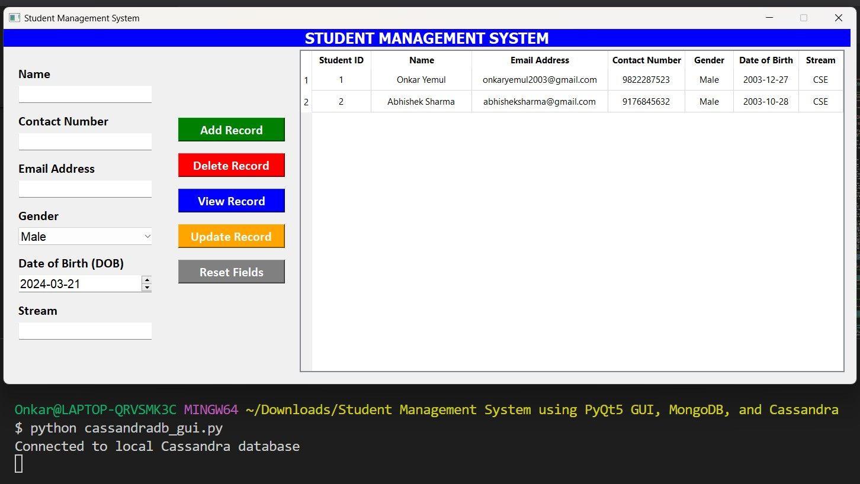

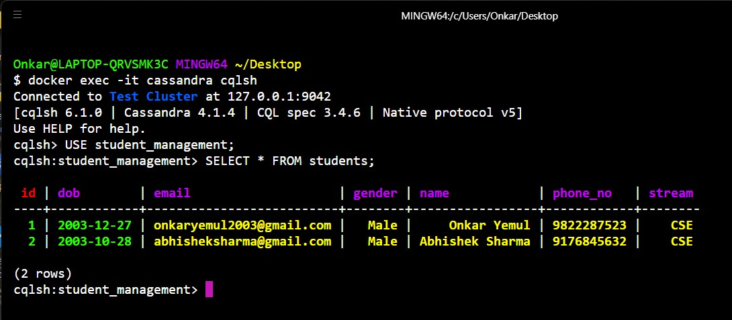

**For cloud-based DataStax Astra Cassandra database instance:**

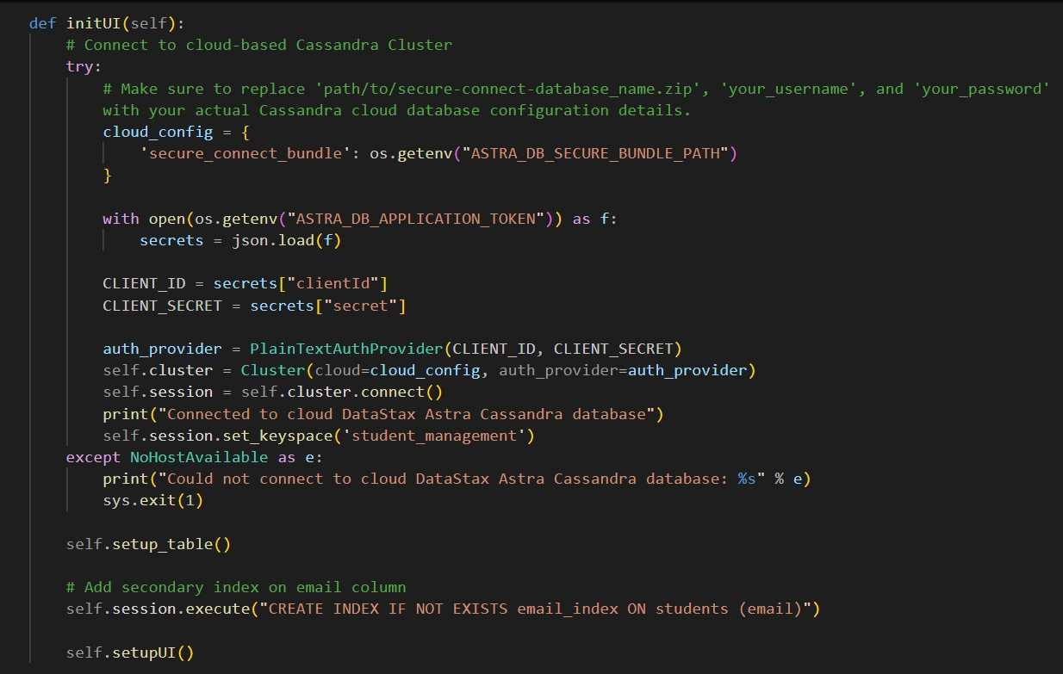

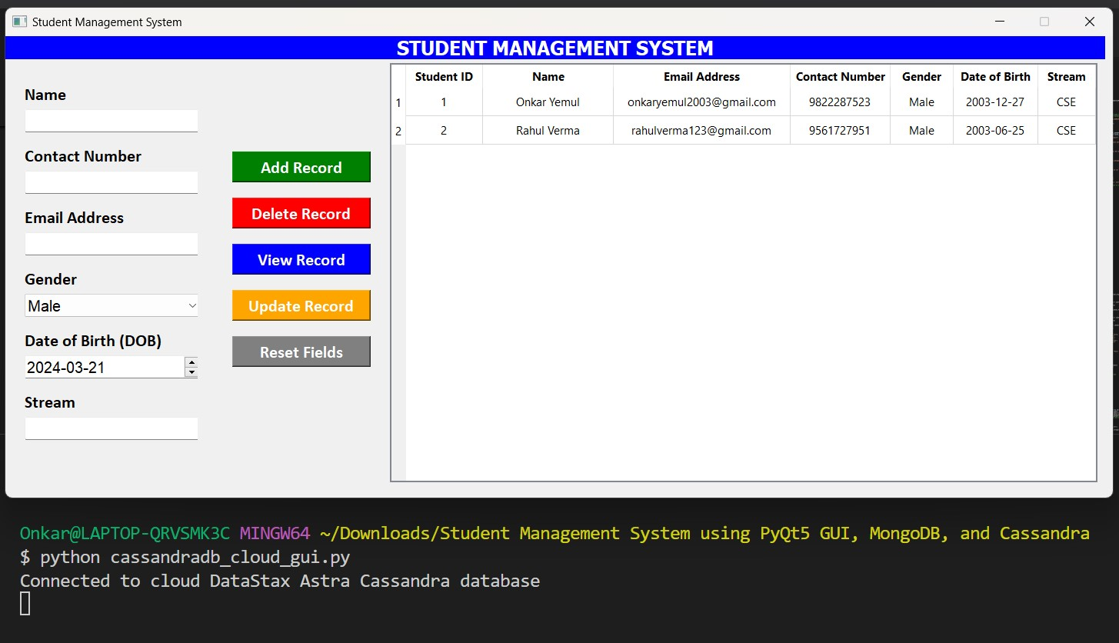

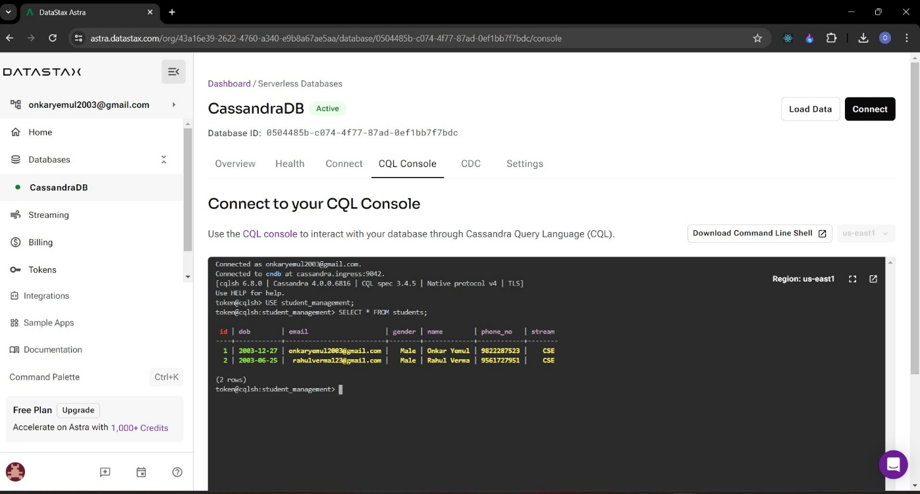

**CRUD Operations on local Cassandra database instance:**

**Adding new record:**

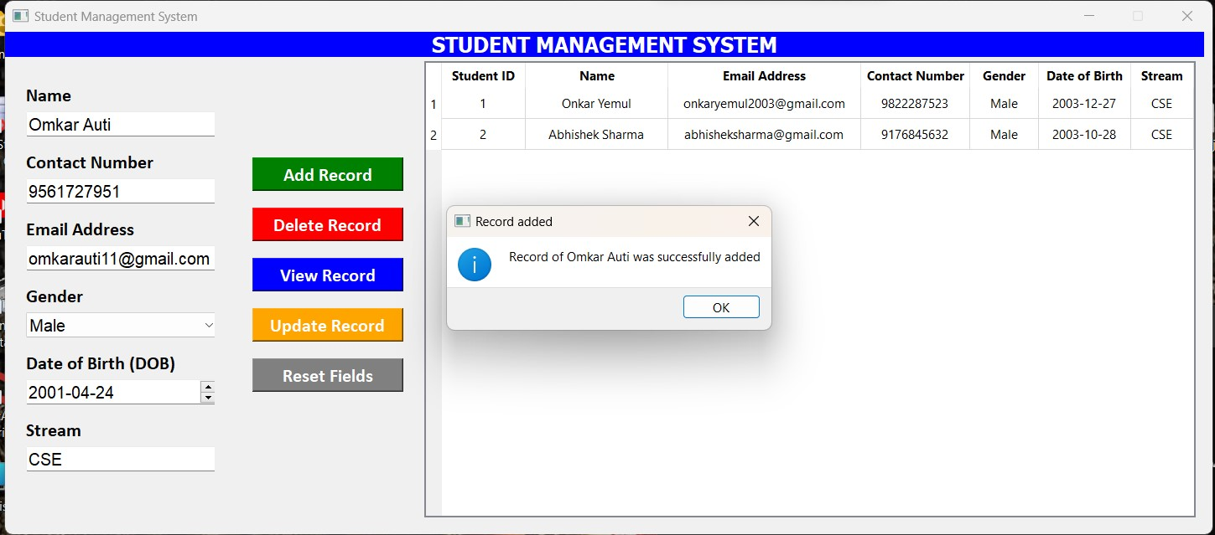

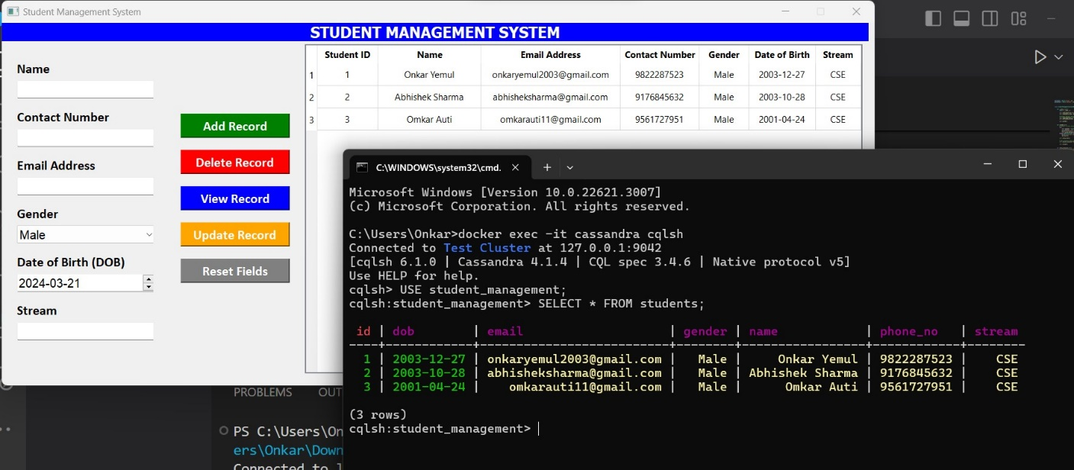

**Viewing and Updating existing record:**

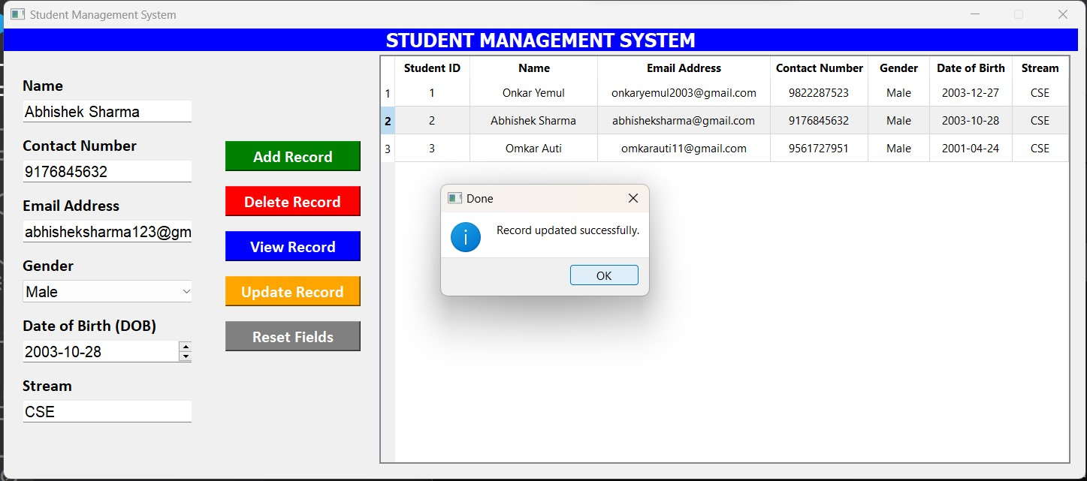

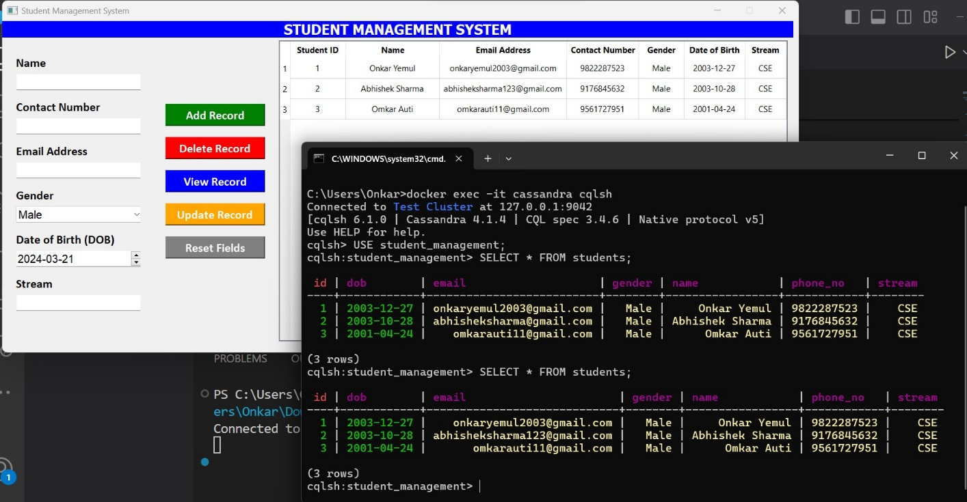

**Deleting a record:**

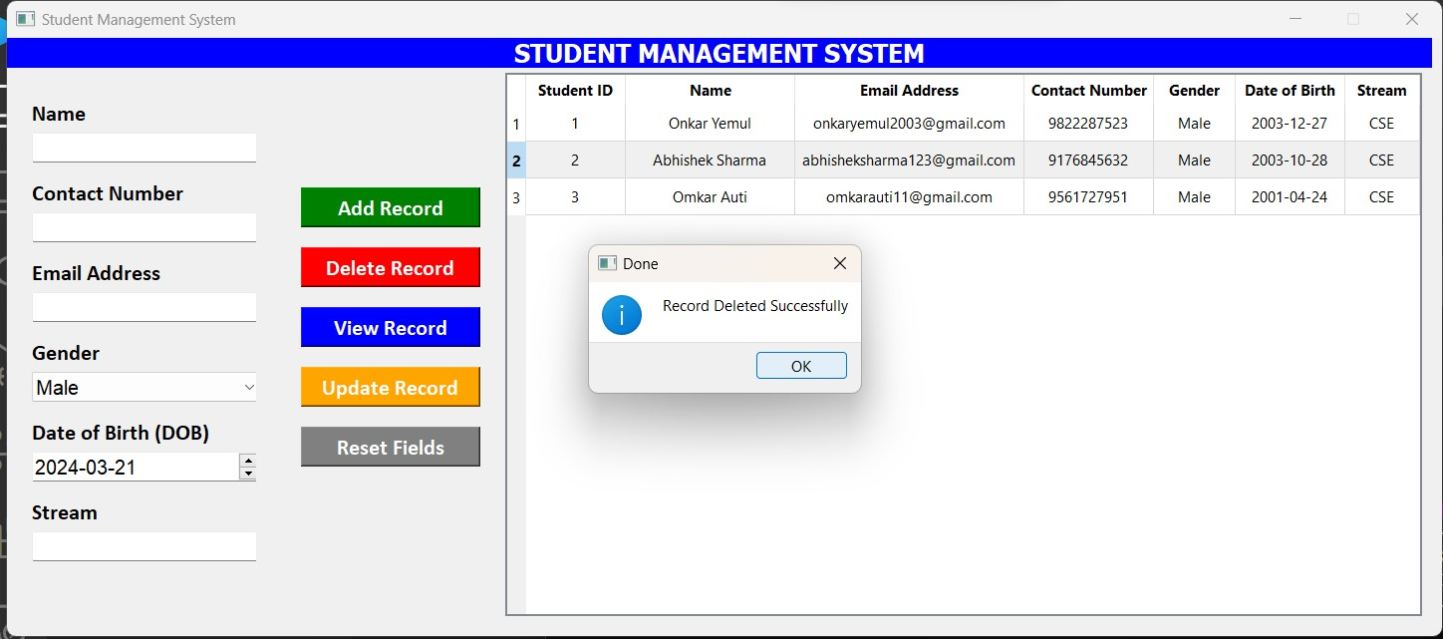

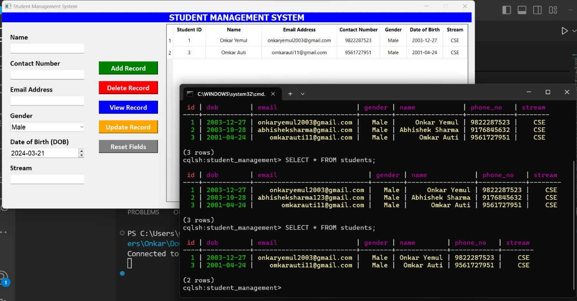

Through this assignment, we have demonstrated the implementation of PyQt5 GUI applications for CRUD operations on both MongoDB and Cassandra databases. We observed that PyQt5 provides a user-friendly interface for interacting with databases, and the choice between MongoDB and Cassandra depends on specific application requirements such as data structure, scalability, and consistency needs.

**Conclusion:**

Through this assignment, we have gained valuable hands-on experience in implementing CRUD operations with MongoDB and CassandraDB using Python desktop applications. This practical exploration has deepened our understanding of database interaction and provided insights into the strengths and characteristics of both MongoDB and CassandraDB.

**References:**

1. PyQt5 tutorial:

<https://www.tutorialspoint.com/pyqt5/index.htm>

1. MongoDB Documentation:

<https://docs.mongodb.com/>

1. CassandraDB Documentation:

<https://cassandra.apache.org/doc/latest/>

1. PyMongo Documentation:

<https://pymongo.readthedocs.io/en/stable/tutorial.html>

1. Cassandra Drive Documentation:

<https://docs.datastax.com/en/developer/python-driver/3.29/>