**Covert a tweet to speech and send it to an email or save it to OneDrive**

**Prerequisites**

Azure subscription

Twitter account

Email account

Optional OneDrive

**Setting up**

Create a new logic App

All services -> Integration -> Logic Apps -> Add

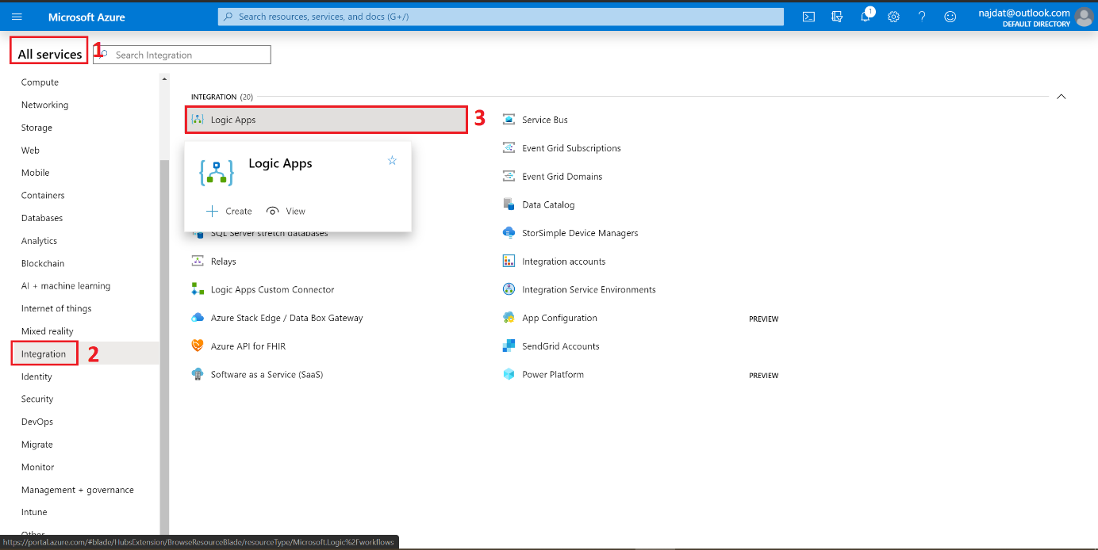

Chose the Subscription plan and the resource group (Click on Create new if needed) then enter the desired Logic app name, chose the location then click on Review + create -> Create -> Go to resource

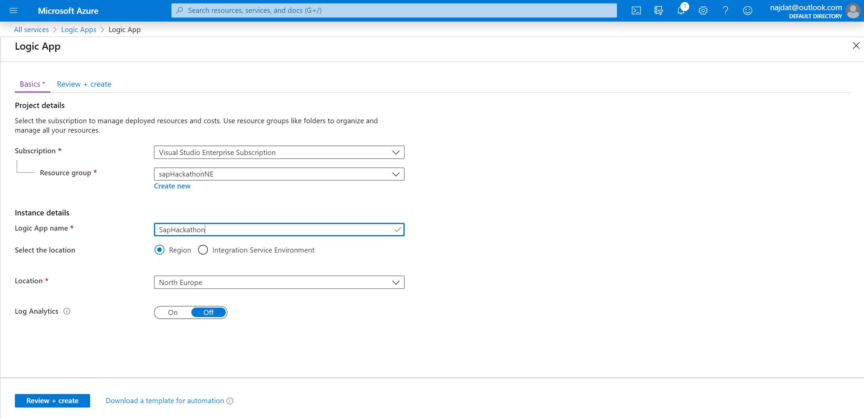

From the side bar click on Logic App designer

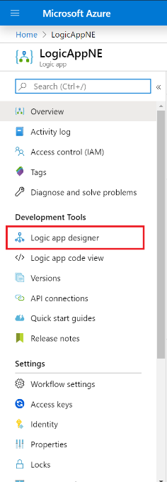

In the search bar type Twitter then chose ‘when a new Tweet is posted’

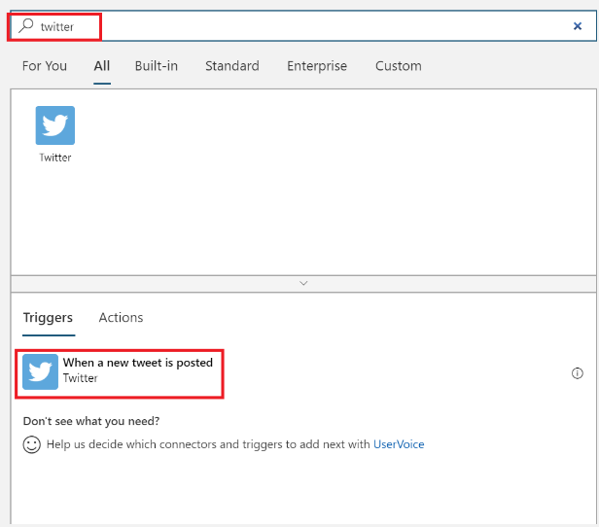

Fill in the needed search (case sensitive for the Hashtag # and name tag @ ) then click on New step

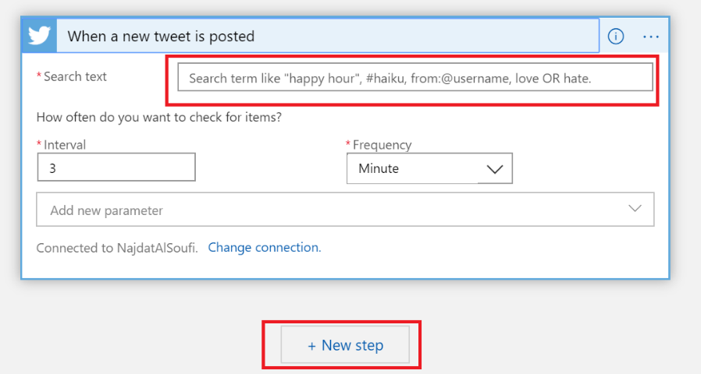

In the search bar type ‘speech’ then chose ‘text to speech’ (must have a Speech cognitive service ready)

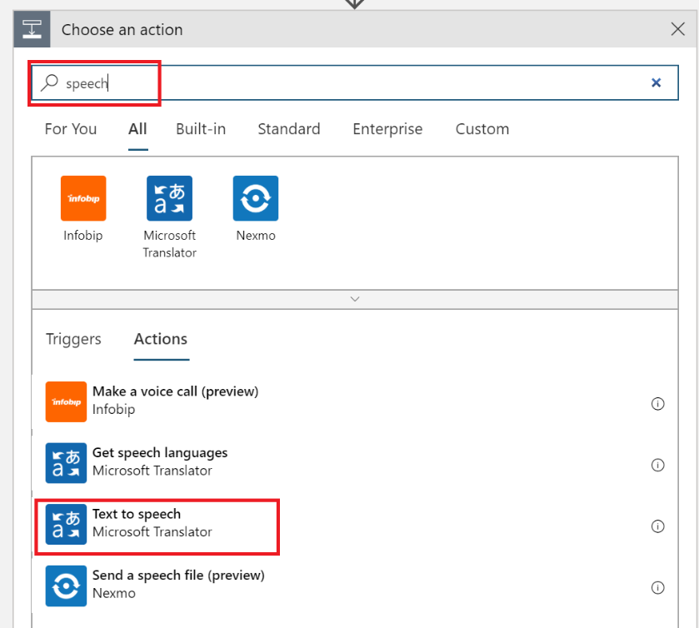

A new panel will open, chose the desired parameters for example

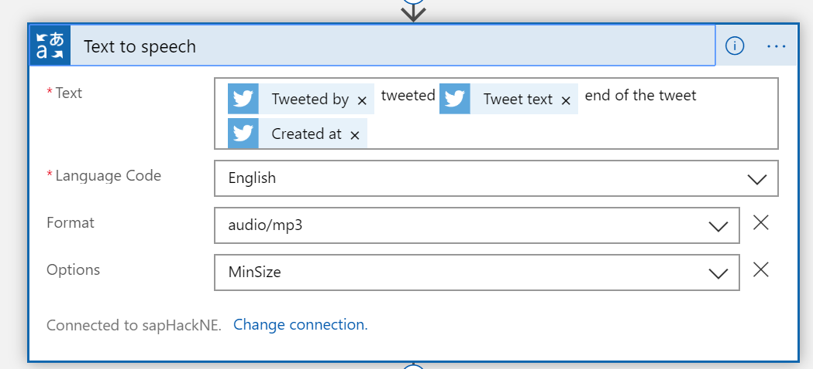

Then click on New step and either choose type ‘OneDrive’ or ‘Send to Email’

For one drive chose one drive connecter and log in to your account. Chose folder that you would like to add the generated audio files into and type the file name, in the file content chose Audio file

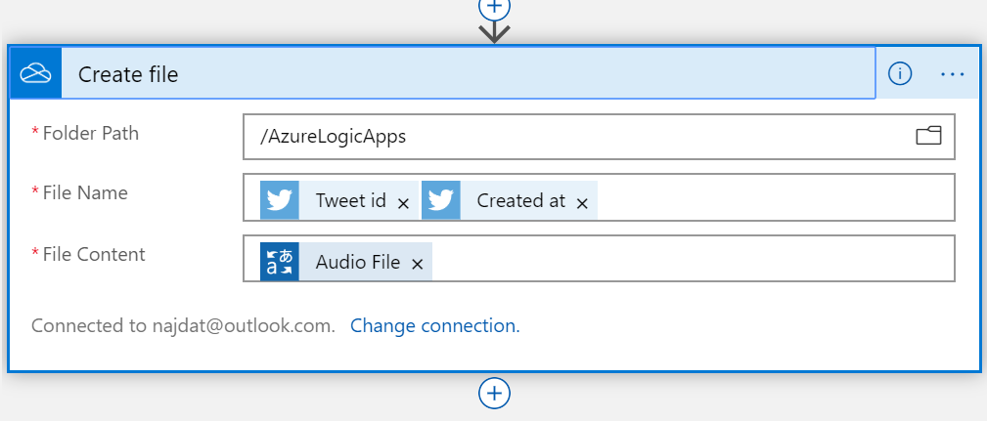

For email option chose Send an email and login to your email address then fill in the needed fields while adding the audio file as an attachment

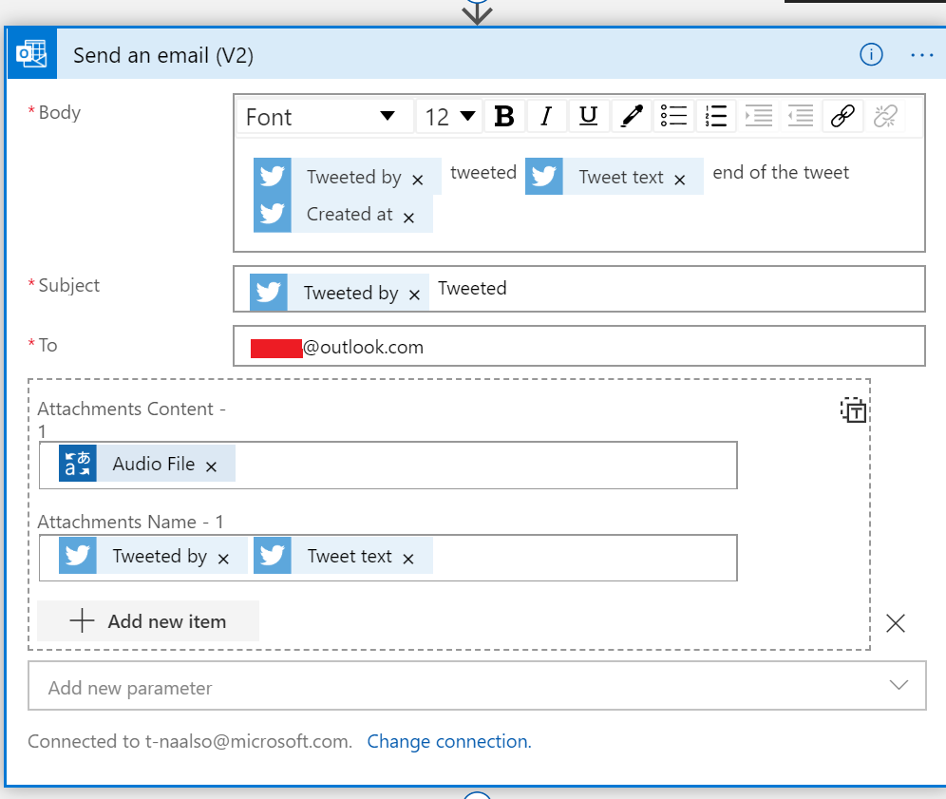

Full scenario

