SOFTWARE ARCHITECTURE
AND DESIGN SPECIFICATION
ONLINE QUIZ SYSTEM
Version 1.0 | 12 October 2026

Document information | Details
Project | Online Quiz System
Course / Department | Software Engineering
Prepared by | Avyukth KV (PES1UG24AM460)
Project team | Batchu Hari Nainika (PES1UG24AM461) — SRS | Avyukth KV (PES1UG24AM460) — SAD | Samvith Vaddiparthi (PES1UG24AM468) — STP
Faculty guide | Arpitha K
Baseline documents | Online Quiz System SRS v1.0; Software Test Plan v1.0
Status | Submission draft
Purpose: Describe the architecture, major components, interfaces, data model, security controls and design decisions for the Online Quiz System.

Document Control

Revision History
Version | Date | Author | Change summary
1.0 | 12 Oct 2026 | Avyukth | Initial architecture and design specification

Approvals
Role | Name | Signature / Date
Team representative | Batchu Hari Nainika | Pending
Faculty guide | Arpitha K | Pending

Contents
1. Introduction 3
2. Document Overview 3
3. Architecture 4
4. Design 6
5. Appendices 11

1. Introduction

1.1 Purpose
This Software Architecture and Design (SAD) document describes the proposed architecture and implementation design of the Online Quiz System, translating SRS requirements into components, interfaces, data structures, security controls and runtime flows.

1.2 Scope
The system supports student registration/login, quiz discovery, timed quiz attempts, single-attempt enforcement, automatic scoring, score history and quiz-specific leaderboards. Faculty and administrators manage quizzes; administrators manage roles and review feedback. The design also includes CI quality checks.

1.3 Audience
Student developers, QA/test engineers, faculty evaluators, maintainers and administrators.

1.4 Definitions and Acronyms
Term | Meaning
SAD | Software Architecture and Design
SRS | Software Requirements Specification
STP | Software Test Plan
REST API | HTTP interface exchanging structured data
JWT | JSON Web Token for authenticated requests
RBAC | Role-Based Access Control
CI/CD | Continuous Integration / Continuous Delivery
RTM | Requirements Traceability Matrix

2. Document Overview

2.1 How to Use This Document
Section 3 describes architecture goals, stakeholders, pattern, components, technology, risks, traceability and security. Section 4 describes runtime flows, API contracts, data model, error handling and UI design. Appendices list open decisions and references.

2.2 Related Documents
Document | Use
Online Quiz System SRS v1.0 | Requirements baseline
Online Quiz System STP v1.0 | Testing strategy, test cases and acceptance evidence
Repository README.md | Setup, configuration and developer workflow

3. Architecture

3.1 Goals and Constraints
Goal / constraint | Design response
Separation of concerns | Separate React UI, Express API, business logic and persistence.
Quiz fairness | Enforce attempt limits, deadlines and scoring on the server.
Confidentiality | Never return answer keys or explanations in student responses.
Maintainability | Use modular routes/controllers/services/models and automated tests.
CI/CD | Run lint, tests, coverage, build and dependency audit in GitHub Actions.
Constraints | Browser application; JavaScript ecosystem; no specialist hardware required.

3.2 Stakeholders and Concerns
Stakeholder | Primary concerns
Students | Clear quiz flow, accurate timer and score, privacy
Faculty | Quiz authoring, publication and reliable scoring
Administrators | Role management, feedback review and access control
Developers | Modular code, testability and maintainability
Faculty evaluator | SRS traceability, working CI and demonstrable acceptance tests

3.3 High-Level Component View
Component | Responsibility
React + Vite frontend | Pages, forms, routing, timer display and API calls
Express REST API | Routes, request validation, authentication and response formatting
Application services | Quiz lifecycle, attempt rules, scoring, ranking and role administration
Mongoose models | Schema validation and database access
MongoDB | Users, quizzes, questions, attempts and feedback
GitHub Actions | Install, lint, test, coverage, build, audit and report artifacts
Logical request path: Browser UI → REST API → authentication/validation middleware → application service → Mongoose model → MongoDB. The API returns a response to the UI.
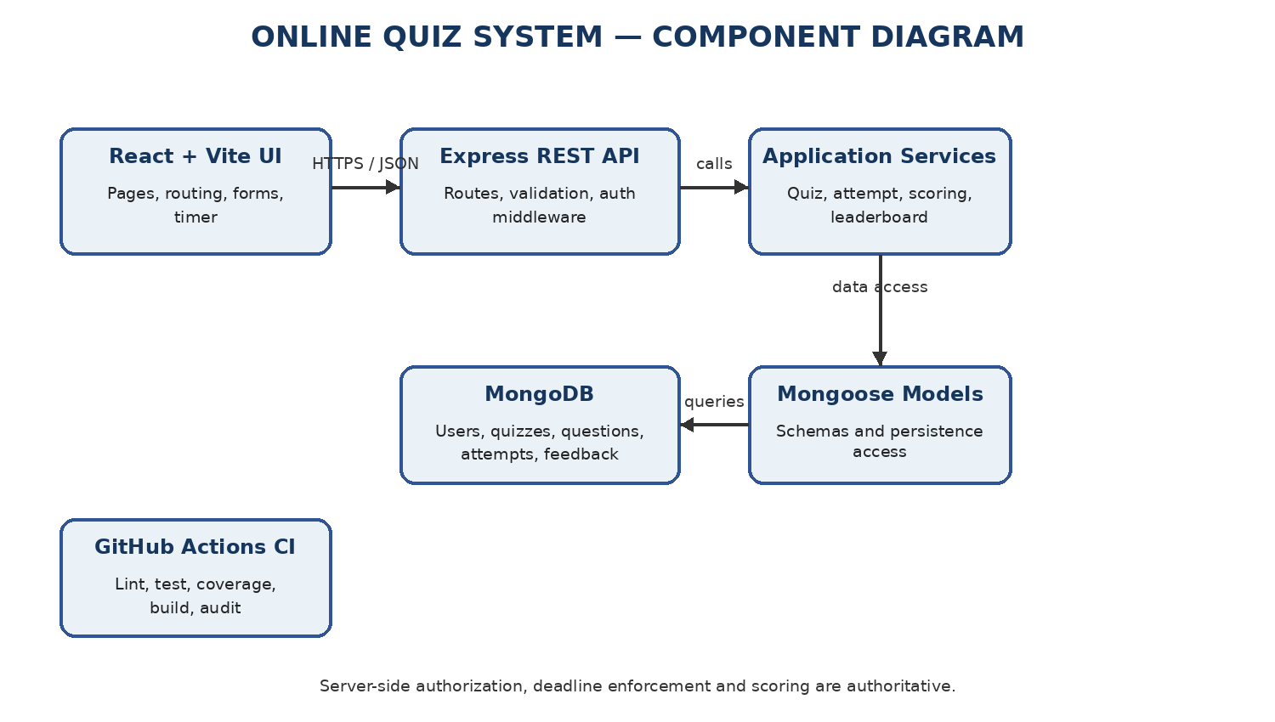
Figure 1. UML component view of the Online Quiz System.

3.4 Component Descriptions
Component | Responsibilities | SRS mapping
Authentication | Registration, login, password hashing, token validation and role checks | FR-001–004; SEC-001–002
Quiz module | Create/edit/delete/publish/unpublish and validate quizzes | FR-008–012
Discovery | List published quizzes and metadata | FR-005–007
Attempt | Create attempt, save answers, enforce deadline, prevent repeat attempts | FR-013–018; NFR-002–003
Scoring | Calculate score server-side; hide answer key | FR-019–020; SEC-003
History/leaderboard | Return own history and per-quiz ranking | FR-021–023
Feedback/admin | Store feedback, admin review and role changes | FR-024–026
CI workflow | Validate quality and package test evidence | FR-027–031; NFR-007; SEC-006

3.5 Architecture Pattern and Rationale
A layered modular monolith is proposed. React is a separate client; the backend exposes a REST API organized into routes/controllers, services, models and middleware. This is simpler for a student project than distributed microservices while preserving separation of concerns.

3.6 Technology Stack and Data Stores
Area | Proposed technology | Purpose
Frontend | React + Vite, React Router, Axios, plain CSS | Responsive UI and API calls
Backend | Node.js + Express | REST endpoints and business logic
Database | MongoDB + Mongoose | Persistence and schema validation
Authentication | bcryptjs + JWT | Password hashing and authenticated requests
Testing | Vitest, React Testing Library, Supertest | Unit, UI and API integration tests
Code quality | ESLint + Prettier | Lint and format checks
CI | GitHub Actions | Automated validation on push and pull request
Security | npm audit; optional CodeQL/gitleaks | Dependency and source/secret checks

3.7 Risks and Mitigations
Risk | Mitigation
Client manipulates timer | Use server deadline and validate every answer/submit request.
Duplicate attempts in concurrent requests | Use unique user/quiz constraint or atomic server-side check.
Answer key leaks | Use student-safe response objects that omit correct options and explanations.
Unauthorized changes | Apply role checks and resource ownership validation on API.
Test database unavailable | Use dedicated test DB or mongodb-memory-server.
Broken main branch | Require reviewed PRs and passing CI checks before merge.

3.8 Traceability to Requirements
SRS requirements | Component | Design evidence
FR-001–004; SEC-001–002 | Authentication | Auth routes, password hash utility, JWT/RBAC middleware
FR-005–007 | Discovery | Published quiz listing and metadata endpoint
FR-008–012 | Quiz module | Quiz/question models and protected authoring endpoints
FR-013–018; NFR-002–003 | Attempt module | Attempt model, server deadline, idempotent finalization
FR-019–023; SEC-003 | Scoring/history/leaderboard | Scoring service and safe response schemas
FR-024–026 | Feedback/admin | Feedback storage and admin-only routes
NFR-001 | Express API / MongoDB | Indexes on quizId and (userId, quizId); compact student DTOs; load test TC-PERF-01 in STP
NFR-004–005 | React frontend | Responsive layouts from 375 px; labelled forms with inline validation messages (Section 4.6)
SEC-004–005 | API middleware / configuration | Request validation middleware; secrets from environment variables, .env not committed (Section 3.9)
FR-027–031; NFR-006–007; SEC-006 | CI workflow | GitHub Actions, README and test artifacts

3.9 Security Architecture
The browser is not trusted to enforce roles, timers, scores or attempt limits. The API applies authorization and business rules on the server.
Threat / concern | Control
Spoofing | Password hashes, JWT validation and HTTPS if deployed
Broken access control | Role middleware and resource ownership checks
Answer-key disclosure | Keep answer keys server-side and omit from student API responses
Score/timer tampering | Calculate score server-side; validate deadline; reject post-finalization changes
Injection/malformed input | Validate IDs, types, ranges and request bodies
Secret exposure | Environment variables; do not commit .env or credentials
Dependency vulnerabilities | npm audit in CI with documented severity threshold
Use STRIDE as a review checklist: Spoofing, Tampering, Repudiation, Information disclosure, Denial of service and Elevation of privilege.

4. Design

4.1 Design Overview
React calls the Express REST API. The API validates requests, authenticates the caller, checks role and ownership, invokes a service and accesses MongoDB through Mongoose. The server is the source of truth for permissions, scoring, attempt status and deadlines.

4.2 Sequence Diagram Flows

4.2.1 Student Takes and Submits a Quiz
Step | Interaction
1 | Student opens a published quiz in React.
2 | Frontend requests quiz metadata; API returns details without answer keys.
3 | Student starts; API returns the student's active attempt or creates one with start time/deadline; a finalized attempt is rejected (409).
4 | Answer changes are sent; API checks attempt ownership and deadline before saving.
5 | Student submits or time expires; API finalizes the attempt once.
6 | Scoring service calculates score from the server-side answer key.
7 | API returns score/status only; UI hides correct answers and explanations.

4.2.2 Faculty Creates and Publishes a Quiz
Step | Interaction
1 | Faculty submits quiz metadata and questions.
2 | API validates JWT, role, fields and ownership.
3 | Quiz service validates options and correct-answer configuration.
4 | Quiz is saved as a draft in MongoDB.
5 | Faculty requests publication; required fields and questions are revalidated.
6 | Quiz is published and becomes visible in student discovery.
The formal UML sequence diagrams below show lifelines and message flows for both scenarios.
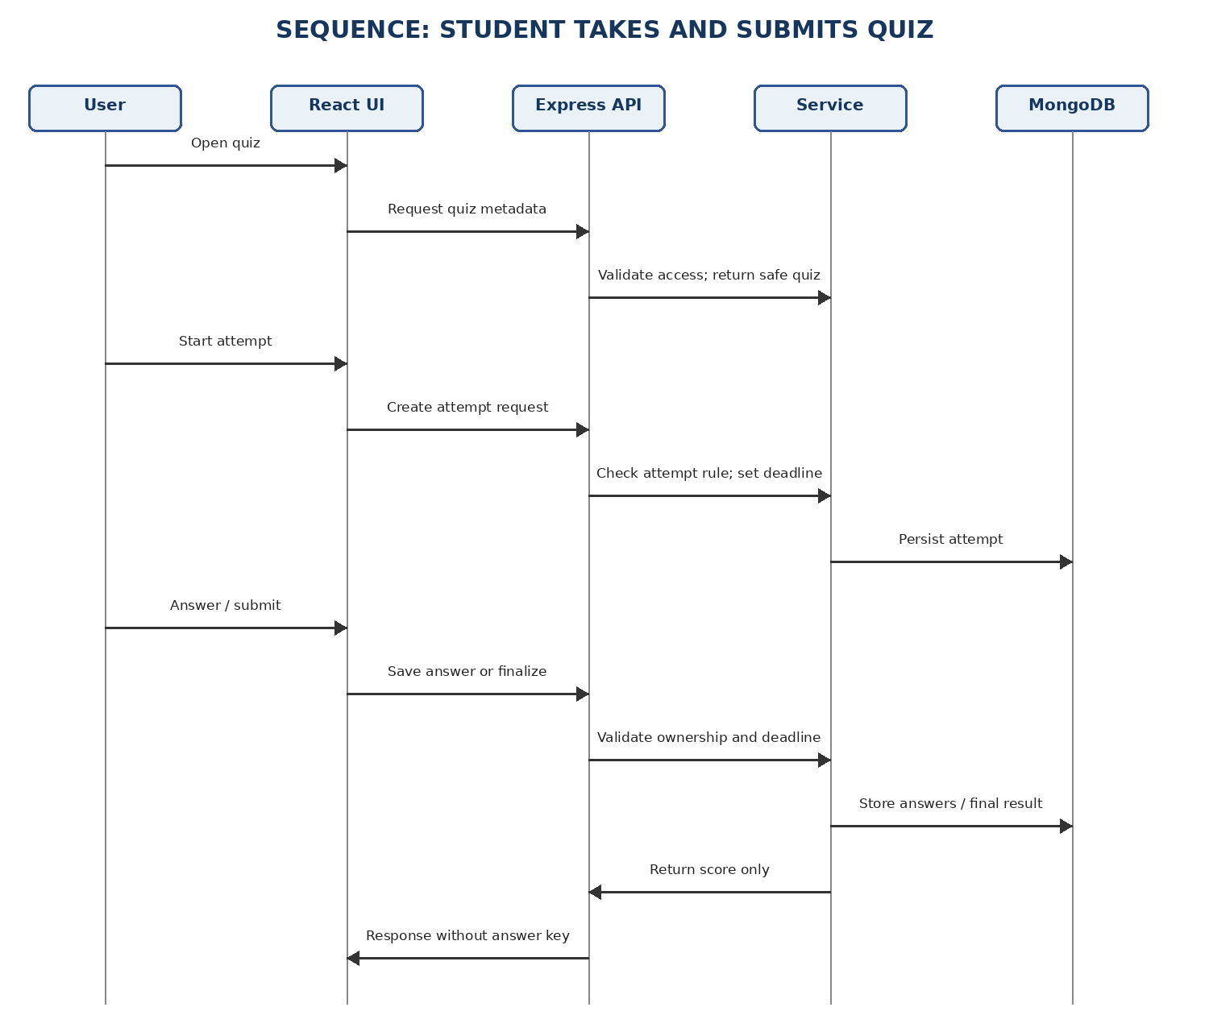
Figure 2. Student quiz-attempt sequence.
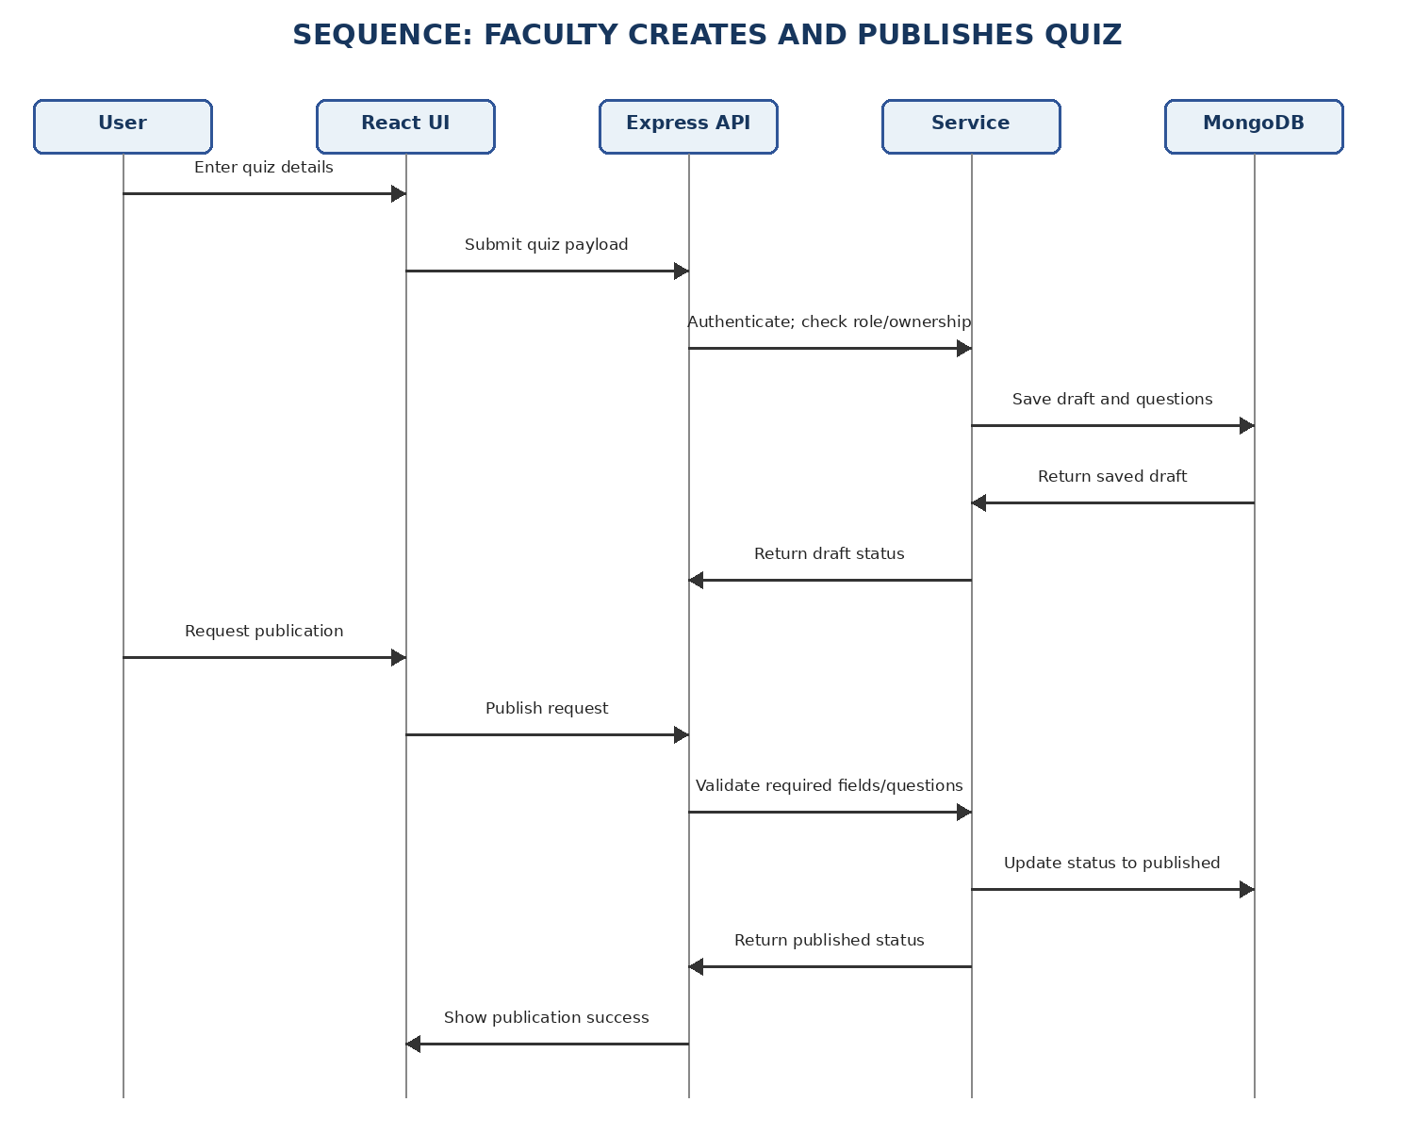
Figure 3. Faculty quiz-publication sequence.

4.3 API Design
The following REST contracts define the proposed API baseline. Any route or schema change made during implementation will be reflected in this table and in the README API documentation.
Method / endpoint | Access | Purpose
POST /api/auth/register | Public | Create student account; return safe profile or validation error
POST /api/auth/login | Public | Validate credentials and return token/session plus safe profile
POST /api/auth/logout | Authenticated user | Invalidate the caller's session so the logged-out token is rejected afterwards (FR-003)
GET /api/quizzes | Student | List published quizzes and metadata only
GET /api/quizzes/:quizId | Student | Quiz detail without answer keys/explanations
GET /api/manage/quizzes | Faculty/admin | List quizzes the caller may manage, including drafts
POST /api/quizzes | Faculty/admin | Create draft quiz
PATCH /api/quizzes/:quizId | Authorized faculty/admin | Edit quiz subject to ownership policy
DELETE /api/quizzes/:quizId | Authorized faculty/admin | Delete a draft quiz subject to ownership policy (FR-010)
POST /api/quizzes/:quizId/publish | Faculty/admin | Validate and publish complete quiz
POST /api/quizzes/:quizId/unpublish | Authorized faculty/admin | Remove a quiz from student discovery (FR-011)
POST /api/quizzes/:quizId/attempts | Student | Create an attempt, or return the student's active attempt; 409 if the attempt is already finalized
PATCH /api/attempts/:attemptId/answers | Attempt owner | Save answers while active and before deadline
POST /api/attempts/:attemptId/submit | Attempt owner | Finalize once and return score only
GET /api/me/scores | Student | Return current student’s attempt history
GET /api/quizzes/:quizId/leaderboard | Authenticated user | Return ranking for this quiz
POST /api/feedback | Authenticated user | Store feedback
GET /api/admin/feedback | Administrator | Review submitted feedback
GET /api/admin/users | Administrator | List users and their roles for role management
PATCH /api/admin/users/:userId/role | Administrator | Change a user's role (FR-026)

4.3.1 Example Request and Response
POST /api/quizzes/:quizId/attempts
Request body: {} (quiz ID is in the path; identity comes from the authenticated session).
Example response: { "attemptId": "…", "status": "in_progress", "startedAt": "…", "deadlineAt": "…" }
Typical errors: 401 unauthenticated; 403 insufficient permission; 404 resource not found; 409 conflicting attempt/state; 422 invalid input.

4.3.2 Standard Error Handling
HTTP status | Meaning
400 | Malformed request
401 | Missing, invalid or expired authentication
403 | Insufficient role or ownership
404 | Resource not found
409 | Conflicting state, such as an existing attempt
422 | Invalid fields or business-rule failure
500 | Unexpected error; do not expose stack trace

4.4 Data Model / Data Stores
Collection | Key fields | Notes
User | _id, name, email, passwordHash, role, tokenVersion, createdAt | Unique email; roles student/faculty/administrator; never return hash; tokenVersion invalidates tokens on logout
Quiz | _id, title, topic, durationSeconds, status, createdBy | createdBy references User; status draft/published
Question | _id, quizId, prompt, options, correctOption | Correct option is server-only and omitted from student DTOs
Attempt | _id, userId, quizId, answers, score, status, startedAt, deadlineAt, submittedAt | References User/Quiz; unique index on (userId, quizId) enforces one attempt record per user/quiz
Feedback | _id, userId, rating, message, createdAt | Admin-only review
Design decision: Questions are stored in a separate Question collection linked to Quiz by quizId. Index quizId for question lookup. Attempt creation must atomically enforce one attempt record per student/quiz; an active attempt can be resumed until deadline, while a finalized attempt cannot be restarted.
Session design: login issues a signed JWT containing the user ID, role and tokenVersion. Logout increments User.tokenVersion, so the authentication middleware rejects every token issued before logout (FR-003); tokens also expire after the configured lifetime.

4.5 Error Handling, Logging and Monitoring
- Return consistent JSON errors with safe messages; do not expose stack traces.
- Log request ID, timestamp, route, status and duration; never log passwords, tokens, secrets or answer keys.
- Track API errors, failed logins, submission failures, deadline rejections and CI status.
- Handle database errors and invalid IDs without crashing the server.

4.6 UX Design
Pages: Home, Register, Login, Quiz Topics, Take Quiz, My Scores, Quiz Leaderboard, About, Contact and Feedback. Faculty/admin users also access Quiz Management; administrators can review feedback and manage roles.
- Use consistent navigation, readable labels, validation messages and responsive layouts from 375 px upward.
- Show duration and countdown during an attempt; server deadline remains authoritative.
- After submission, display score/status only; never display correct answers or explanations.
- Provide loading, empty, success and error states for API-backed pages.

4.7 Open Issues and Next Steps
Open issue | Action required
Final API paths | Confirm routes against actual Express implementation.
Token lifetime and client storage | Agree the JWT expiry period and where the client keeps the token; document both in README.
Leaderboard privacy | Decide whether names or anonymized identifiers appear.
Editing published quizzes | Define behavior when attempts already exist.
Deployment | Optional unless course requires it; document HTTPS if deployed.

5. Appendices

5.1 Glossary
Term | Definition
Attempt | One student’s attempt at a particular quiz
Answer key | Server-side correct option data used for scoring
DTO | Data Transfer Object: explicitly shaped API data
Idempotent finalization | Repeated submits do not create or alter multiple finalized attempts
Middleware | Express function validating requests before route logic
Published quiz | Quiz available to students

5.2 References
- Online Quiz System SRS v1.0, 12 October 2026.
- Online Quiz System STP v1.0, 12 October 2026.
- OWASP Top 10 and OWASP Web Security Testing Guide.
- Official Node.js, Express, React, Mongoose and GitHub Actions documentation.

5.3 Tools
Tool | Use
draw.io / PlantUML | UML component and sequence diagrams
Swagger / OpenAPI | REST API documentation if adopted
GitHub | Version control, PRs, issues and CI evidence
Vitest / React Testing Library / Supertest | Automated unit, UI and API integration tests

