**Online shopping cart flow, functionality and no of modules**

**First Module: home page**

**Functionality:**

* **Login: as customer or admin(that will be two radio buttons in the login form after user clicks on login button on home page)**
* **Signup: for customer(that is only for customer if the user is new)**
* **Other functionalities: like the images, background so that home page will look more attractive**

**Flow:**

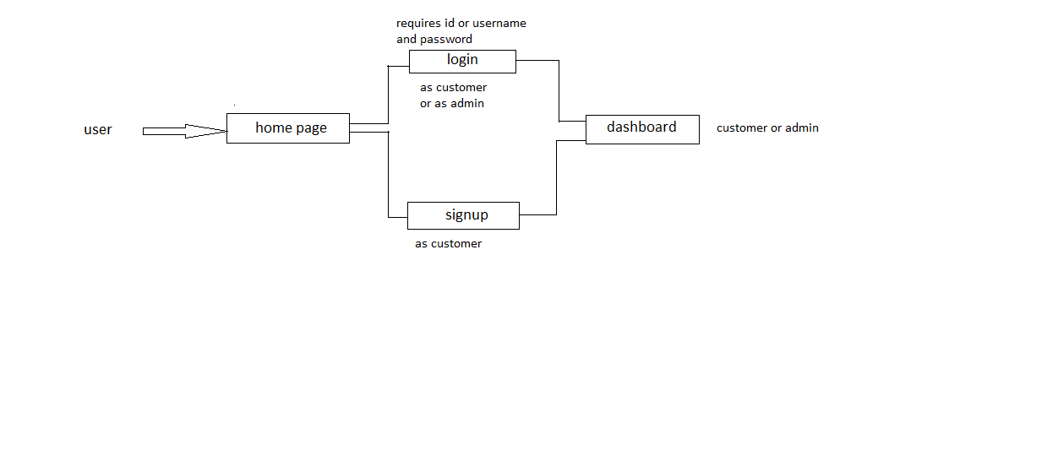

**Second Module: Dashboard**

**For customer:**

**Functionality:**

* **First user will be able to see all the products present in the online shopping cart**
* **Then user can buy single item or he can select multiple items and add them to cart to buy them all at once(that will require total price of all the items in the cart).It requires cart entity for that**
* **After buying user can give payment details on the payment page**
* **User can deselect all the items**
* **User can logout: that will take user to the home page**
* **User can change the password in the profile section and other details**
* **Ordered items should be visible in the your orders section(for all other functionalities we can make the dropdown like for to see the orders, go to profile etc)**

**For admin:**

**Functionality:**

* **Admin can add products for online shopping cart or remove them or can change the price of products(basically admin can perform crud operation)**
* **Admin can logout**
* **Admin can change profile details**

