**C:\wamp\www\Final Project\image\logo.png**

**TABLE OF CONTENTS**

**Brief Description 3**

**Nav Bar Section 4**

**Wireframe Section 5**

**Screen Capture Section 6**

**Potential Future Functionality 10**

**y**

**1.Brief Description**

The project is basically a CMS (Content Management System) of a survey. This system is made for only a survey purpose. Few of the tasks which are related to survey purpose are displayed as follows:

* Displaying the surveys.
* Retrieving details from registered user as well as anonymous user.
* Creating the survey and give the response to asurvey.
  1. **Purpose**

The main purpose of this project is that we can pay attention on creating surveys and responses the surveys. Also, we can get different responses to the from user.

* 1. **Scope**

In this section we get ourselves familiarized with the scope of the system. The system is a Content Management System which means it will manage different surveys. There are also some specifications or in simple terms a verity in the scope of this CMS, this CMS is specifically designed for a survey purpose.

**2.Nav Bar Section**



In this project, nav bar is horizontally created. The nav bar is located above the header tag. It has separate section from header tag. There are five lables include in nav bar: HOME PAGE, CREATE SURVEY, RESPONSE SURVEY, REGISTRATION, and GIT HUB. Nav bar has its border so that user can identify the portion of nav bar.When user move the cursor on the labels, the labels change its colour from black to grey by using hover function. Each label has its own portions. Also,each lables has its own separate file.Thus,when user click on the lables ,they will go to another page according to the lables.

**3.Wireframes Section**

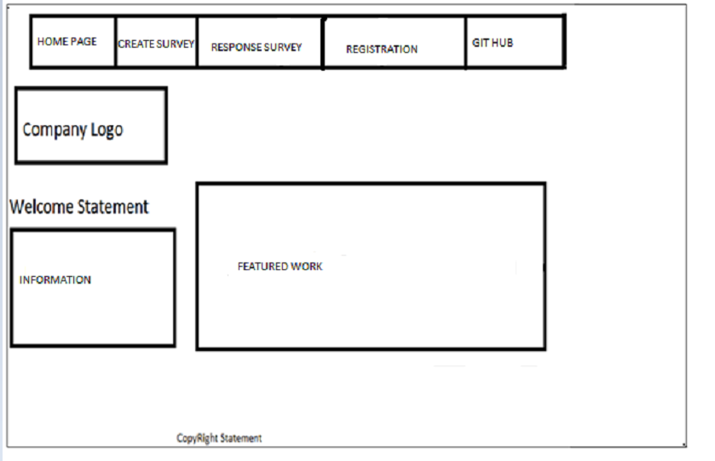

**4.Screen Capture Section**

**Screenshots :-**

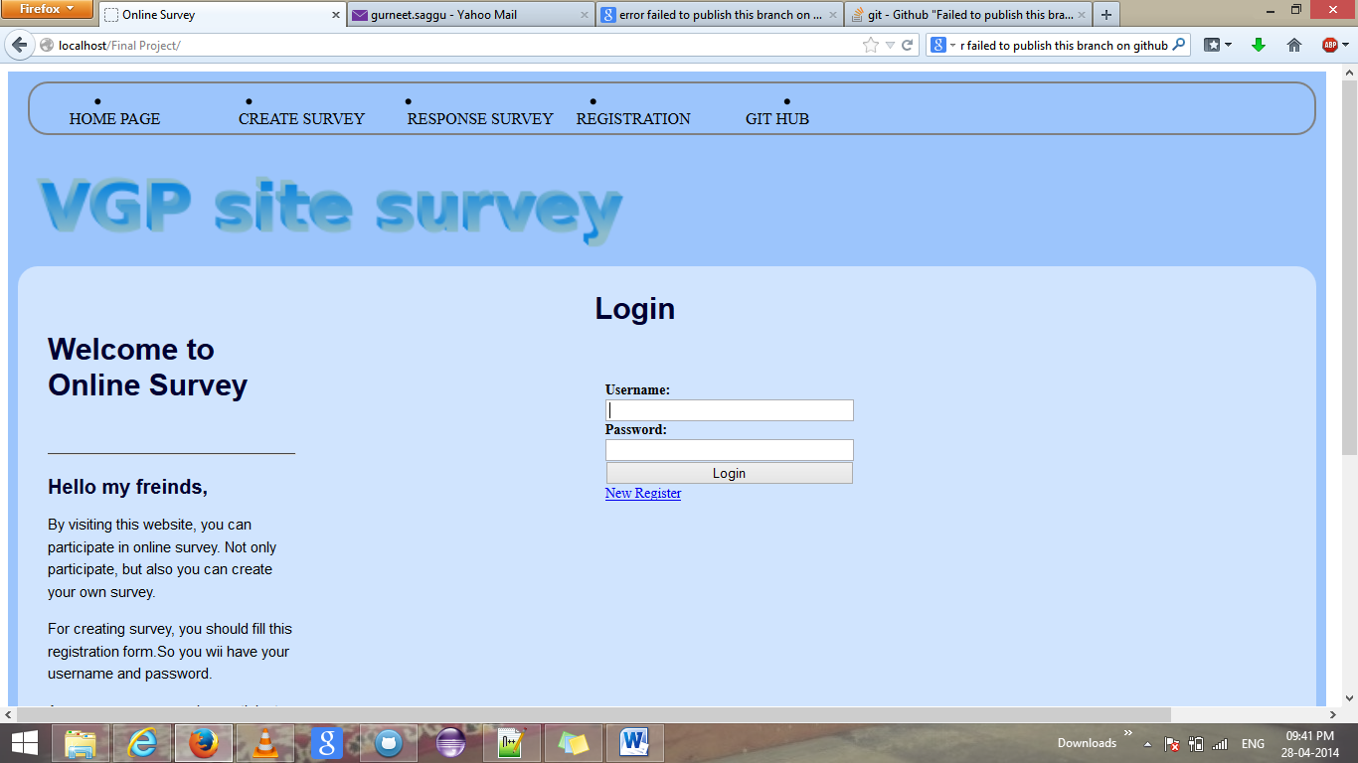 [Home page]

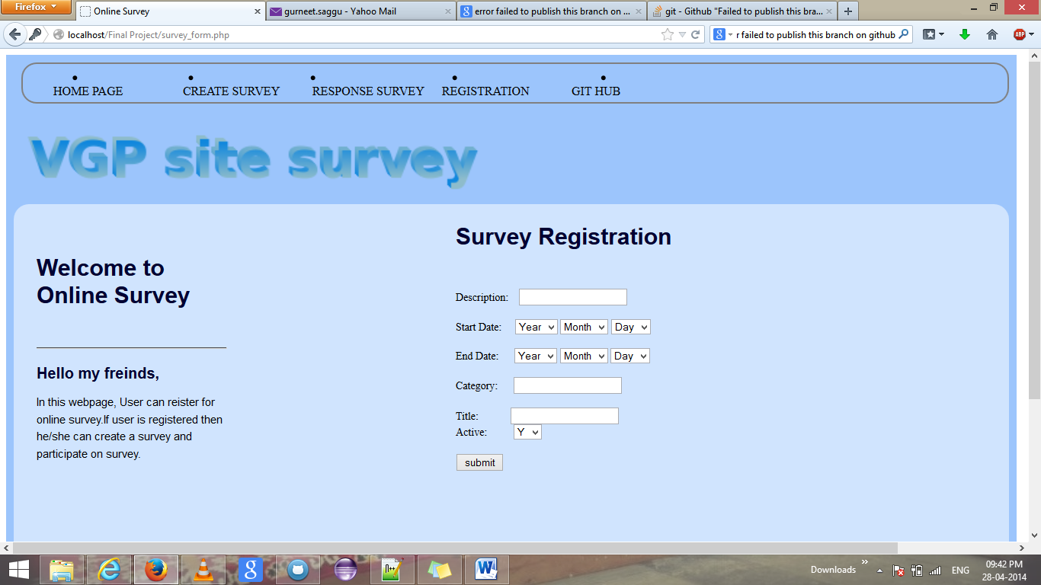 [Create Survey page]

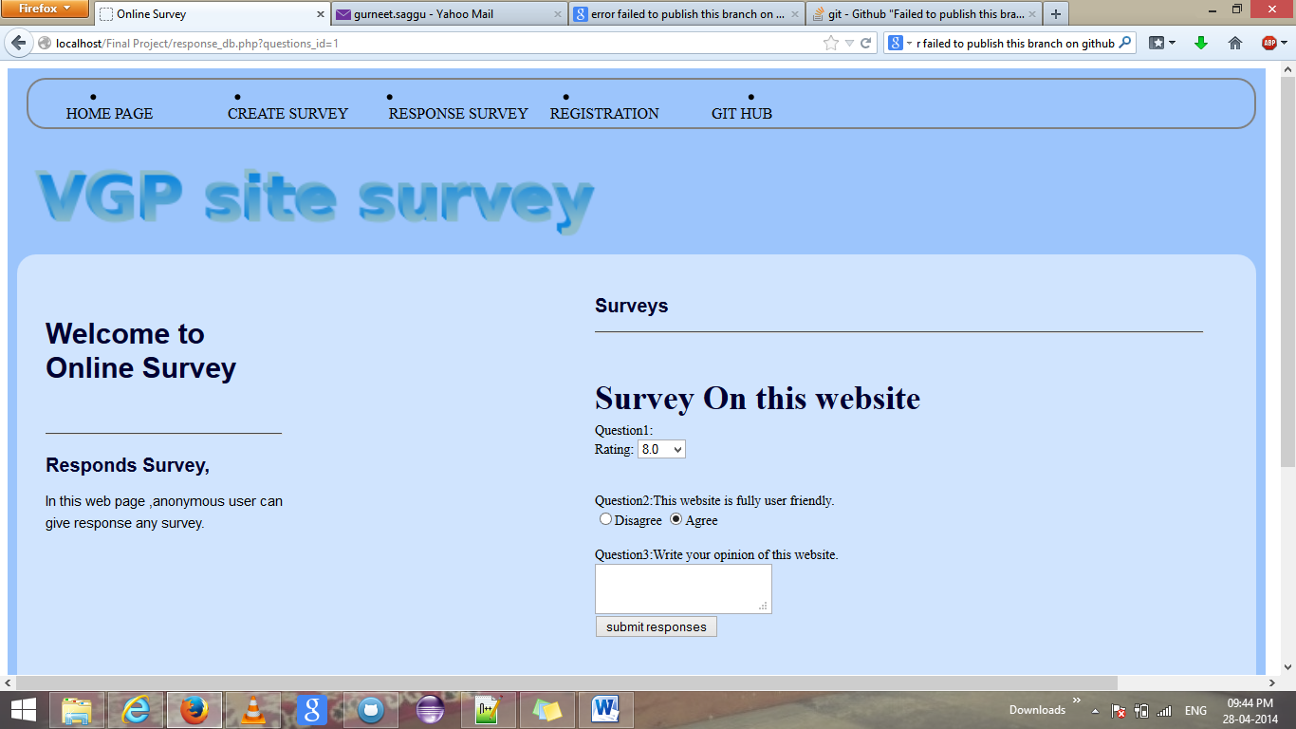 [Response Survey]

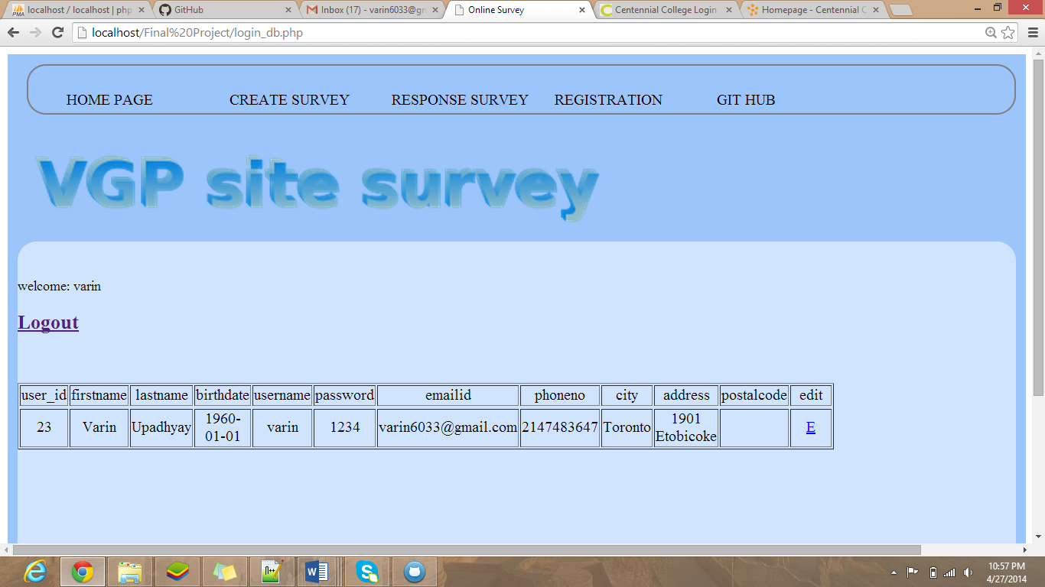 [User Modification Page]

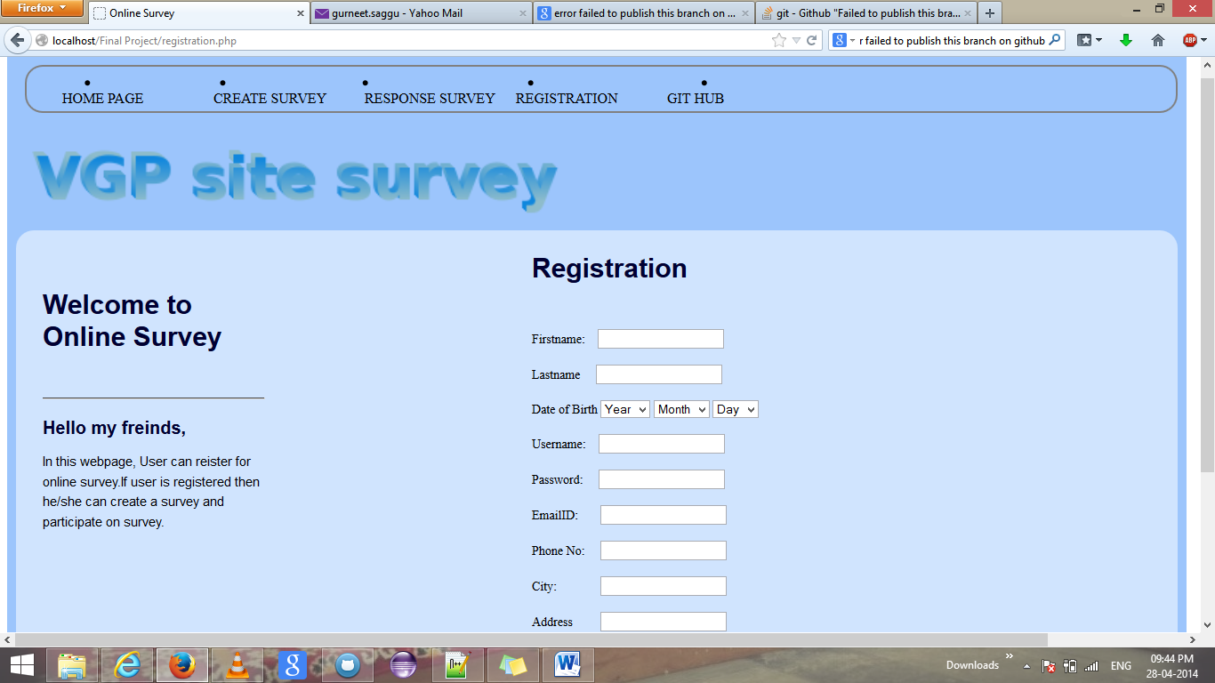 [Registration Page]

**5.Potential Future Functionality**

In future, we may use the slider question with images. Also, user may upload the attachment in the survey. Also , we may use the chat functionality for the registered user so that they can share their opinions with each other via chat functionality.