C.V(cirruculam vittae)

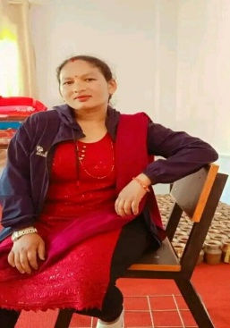

Photo

* Name:Apsara Sedai
* Age:31 years
* Adress:Sundarbazar-9,Bhotewodar Lamjung
* Email Adress:apsarasedai57@gmail.com
* Contact:+9846905388
* Proffesion:Teacher
* Hobby:Travelling
* Education:BED completed through Shree Bhakti Adarsha Multiple Campus
* Working Experience:4 yrs experience in teaching(Junior Level)on Global Vision English Boarding School
* Other Experience:Montesory traning by experts
* Teaching Lisence:Having Lisence to teach Secondary Level
* Job:Teaching in Global Vision English Boarding School