**INTRODUCTION:**

A blog is a discussion or informational website published on the World Wide Web consisting of discrete, often informal diary-style text entries. Posts are typically displayed in reverse chronological order, so that the most recent post appears first, at the top of the web page. Blogs are informal articles written for the purpose of showing thought leadership and expertise on a topic. They are a great way to generate fresh content on a website and provide a catalyst for email marketing, social media promotion to drive search traffic to your website. Technical blogging is a great way to share your expertise while building a potentially valuable readership. It can help you to document projects, or provide guidance to other web users. You can also monetize your content, or use your blog to market your services. While technical blogs have the same general characteristics as non-technical blogs, refining your blogging technique will help to make the technical content of your blogs more accessible.

**Importance of blog**

1. **Express Yourself and Share Your Passions**
2. **Make A Difference**
3. **Share Your Knowledge**
4. **Learn How To Make Money Online**
5. **Build Your Professional Network**
6. **Earn More Exposure**
7. **Become an Authority in Your Industry**
8. **Build an Online Portfolio**
9. **Market Your Business**
10. **Starting A Blog Today**

**LITERATURE SURVEY**

The other existing software are publicly accessible to anyone, there is no security for confidential data. In the past, students have generally written exclusively for their teachers. It’s hard for them to get excited about writing

something that they know no one else will see, on a subject that seems to serve no real purpose outside the classroom. The platform also has its darker side with some limitations on the enjoyment of its features and functionality. One of the major downsides of Blogger is that you cannot monetize it with ads other than Google’s. Google frowns over the competition thus it exercises exclusive ad service only for Google ads in Blogger.

Google owns the site as it exercises control on what ads you are allowed to post on your blog site. With this ownership issue, a blogger should realize that whatever content that they post on Blogger could disappear if Google decides to close down the platform. Therefore, anyone who is using Blogger should backup their content because their blog site could be deleted by Google even without notice to the blog site user.

Because there are only quite a few available template designs to choose from it is a challenge to create a professional-looking blog site. Most often than not, you will feel extremely disappointed to find another site using the same design as your blog site.

This blogging platform has formed an impressive Organization that resides in the online environment. What keeps this organization alive is the continuing interaction that is happening by regular postings, commenting, marketing, or just reading. This has been made livelier by the presence of businesses maintaining company blogs, although personal blogs still continue to lead in numbers.Blogs are already a mainstream media platform. It's interesting that the true growth of blogging is not coming from individuals using this empowered publishing platform to share their insights with the world. The credibility and growth from blogs moving forward seems to be coming from the mainstream media's desire to have a cheaper,faster and near-real-time platform to distribute their content. Blogging platform has so much earning and many other advantages many more people may start blogging and after it there will be more competition in the field of blogging too. Many companies are also looking forward to promote their products through blogs which get lot of visitors and this may help to increase the earning of bloggers. The scope of blogging is going to increase a lot and it may be the right time for you to start blogging. Blogging is often seen as a good way to get in touch with customers. Many businesses have found that using a forum or support ticket system for customer relations issues is a much smoother process. Unlike other websites, blogs need to be updated constantly. The consensus is a once a week update is the absolute minimum, and three times a week is even better. This means coming up with fresh topics and articles throughout the week, and finding the time to write them. For the casual blog user, this might be too big of a commitment. For Internet marketers, there are other easier solutions for getting the word out about your product or service.

**SYSTEM REQUIREMENT**

To run this project on various platform we need some hardware and software to support this project.

**HARDWARE SPECIFICATION**

Processor: Dual core

RAM: 512 mb

Memory: 10 GB

**SOFTWARE SPECIFICATION**

Technologies: HTML, CSS, JAVASCRIPT, BOOTSTRAP

Database: MYSQL

Language: PHP

Text editor: Sublime

Local server software: WAMP

**THEORETICAL CONCEPT AND IMPLIMENTAATION**

**HTML Documents**

* All HTML documents must start with a document type declaration: <!DOCTYPE html>.
* The HTML document itself begins with <html> and ends with </html>.
* The visible part of the HTML document is between <body> and </body>.

**HTML Paragraphs**

* HTML paragraphs are defined with the <p> tag:

**HTML Links**

* HTML links are defined with the <a> tag:

**HTML Images**

* HTML images are defined with the <img> tag.
* The source file (src), alternative text (alt), width, and height are provided as attributes:

**HTML Buttons**

* HTML buttons are defined with the <button> tag:

**HTML Lists**

* HTML lists are defined with the <ul> (unordered/bullet list) or the <ol> (ordered/numbered list) tag, followed by <li> tags (list items):

## What is CSS?

* **CSS** stands for **C**ascading **S**tyle **S**heets
* CSS describes **how HTML elements are to be displayed on screen, paper, or in other media**
* CSS **saves a lot of work**. It can control the layout of multiple web pages all at once
* External stylesheets are stored in **CSS files**

## External Style Sheet

With an external style sheet, you can change the look of an entire website by changing just one file!

Each page must include a reference to the external style sheet file inside the <link> element. The <link> element goes inside the <head> section:

### **Example**

<head>  
<link rel="stylesheet" type="text/css" href="mystyle.css">  
</head>

## Internal Style Sheet

* An internal style sheet may be used if one single page has a unique style.
* Internal styles are defined within the <style> element, inside the <head> section of an HTML page:

### **Example**

<head>  
<style>  
body {  
    background-color: linen;  
}  
  
h1 {  
    color: maroon;  
    margin-left: 40px;  
}   
</style>  
</head>

## Inline Styles

* An inline style may be used to apply a unique style for a single element.
* To use inline styles, add the style attribute to the relevant element. The style attribute can contain any CSS property.

The example below shows how to change the color and the left margin of a <h1> element:

### **Example**

<h1 style="color:blue;margin-left:30px;">This is a heading</h1>

## What is JavaScript?

Javascript is a dynamic computer programming language. It is lightweight and most commonly used as a part of web pages, whose implementations allow client-side script to interact with the user and make dynamic pages. It is an interpreted programming language with object-oriented capabilities.

JavaScript was first known as **LiveScript,** but Netscape changed its name to JavaScript, possibly because of the excitement being generated by Java. JavaScript made its first appearance in Netscape 2.0 in 1995 with the name **LiveScript**. The general-purpose core of the language has been embedded in Netscape, Internet Explorer, and other web browsers.

## Advantages of JavaScript

The merits of using JavaScript are −

* **Less server interaction** − You can validate user input before sending the page off to the server. This saves server traffic, which means less load on your server.
* **Immediate feedback to the visitors** − They don't have to wait for a page reload to see if they have forgotten to enter something.
* **Increased interactivity** − You can create interfaces that react when the user hovers over them with a mouse or activates them via the keyboard.
* **Richer interfaces** − You can use JavaScript to include such items as drag-and-drop components and sliders to give a Rich Interface to your site visitors.

# **JavaScript - Syntax**

JavaScript can be implemented using JavaScript statements that are placed within the **<script>... </script>** HTML tags in a web page.

You can place the **<script>** tags, containing your JavaScript, anywhere within your web page, but it is normally recommended that you should keep it within the **<head>** tags.

The <script> tag alerts the browser program to start interpreting all the text between these tags as a script. A simple syntax of your JavaScript will appear as follows.

<script ...>

JavaScript code

</script>

The script tag takes two important attributes −

* **Language** − This attribute specifies what scripting language you are using. Typically, its value will be javascript. Although recent versions of HTML (and XHTML, its successor) have phased out the use of this attribute.
* **Type** − This attribute is what is now recommended to indicate the scripting language in use and its value should be set to "text/javascript".

So your JavaScript segment will look like −

<script language="javascript" type="text/javascript">

JavaScript code

</script>

## JavaScript Datatypes

One of the most fundamental characteristics of a programming language is the set of data types it supports. These are the type of values that can be represented and manipulated in a programming language.

JavaScript allows you to work with three primitive data types −

* **Numbers,** eg. 123, 120.50 etc.
* **Strings** of text e.g. "This text string" etc.
* **Boolean** e.g. true or false.

JavaScript also defines two trivial data types, **null** and **undefined,** each of which defines only a single value. In addition to these primitive data types, JavaScript supports a composite data type known as **object**. We will cover objects in detail in a separate chapter.

**Note** − JavaScript does not make a distinction between integer values and floating-point values. All numbers in JavaScript are represented as floating-point values. JavaScript represents numbers using the 64-bit floating-point format defined by the IEEE 754 standard.

# **PHP**

The PHP Hypertext Preprocessor (PHP) is a programming language that allows web developers to create dynamic content that interacts with databases. PHP is basically used for developing web based software applications. This tutorial helps you to build your base with PHP.

**Common uses of PHP**

* PHP performs system functions, i.e. from files on a system it can create, open, read, write, and close them.
* PHP can handle forms, i.e. gather data from files, save data to a file, through email you can send data, return data to the user.
* You add, delete, modify elements within your database through PHP.
* Access cookies variables and set cookies.
* Using PHP, you can restrict users to access some pages of your website.
* It can encrypt data.

**Characteristics of PHP**

Five important characteristics make PHP's practical nature possible −

* Simplicity
* Efficiency
* Security
* Flexibility
* Familiarity

## Commenting PHP Code

A *comment* is the portion of a program that exists only for the human reader and stripped out before displaying the programs result. There are two commenting formats in PHP −

**Single-line comments** − They are generally used for short explanations or notes relevant to the local code. Here are the examples of single line comments.

## MySQL Database

MySQL is a fast, easy-to-use RDBMS being used for many small and big businesses. MySQL is developed, marketed and supported by MySQL AB, which is a Swedish company. MySQL is becoming so popular because of many good reasons −

* MySQL is released under an open-source license. So you have nothing to pay to use it.
* MySQL is a very powerful program in its own right. It handles a large subset of the functionality of the most expensive and powerful database packages.
* MySQL uses a standard form of the well-known SQL data language.
* MySQL works on many operating systems and with many languages including PHP, PERL, C, C++, JAVA, etc.
* MySQL works very quickly and works well even with large data sets.
* MySQL is very friendly to PHP, the most appreciated language for web development.
* MySQL supports large databases, up to 50 million rows or more in a table. The default file size limit for a table is 4GB, but you can increase this (if your operating system can handle it) to a theoretical limit of 8 million terabytes (TB).
* MySQL is customizable. The open-source GPL license allows programmers to modify the MySQL software to fit their own specific environments.

## Administrative MySQL Command

Here is the list of the important MySQL commands, which you will use time to time to work with MySQL database −

* **USE Databasename** − This will be used to select a database in the MySQL workarea.
* **SHOW DATABASES** − Lists out the databases that are accessible by the MySQL DBMS.
* **SHOW TABLES** − Shows the tables in the database once a database has been selected with the use command.
* **SHOW COLUMNS FROM *tablename:*** Shows the attributes, types of attributes, key information, whether NULL is permitted, defaults, and other information for a table.
* **SHOW INDEX FROM tablename** − Presents the details of all indexes on the table, including the PRIMARY KEY.
* **SHOW TABLE STATUS LIKE tablename\G** − Reports details of the MySQL DBMS performance and statistics.

**SNAPSHOTS**

Home page

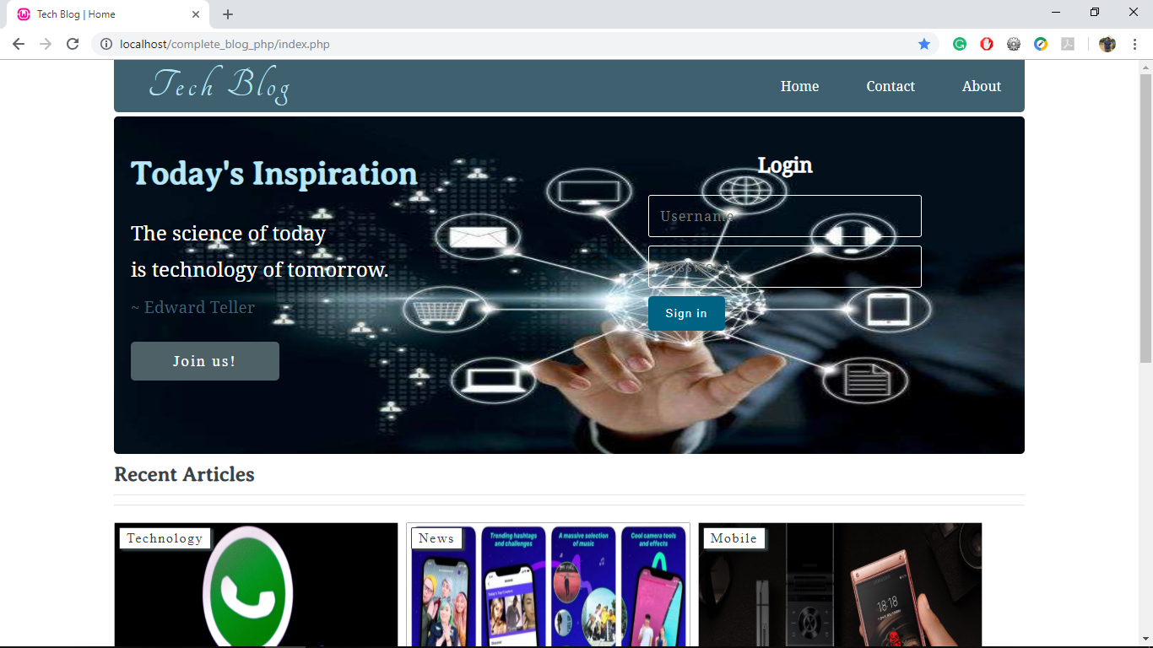

Admin page

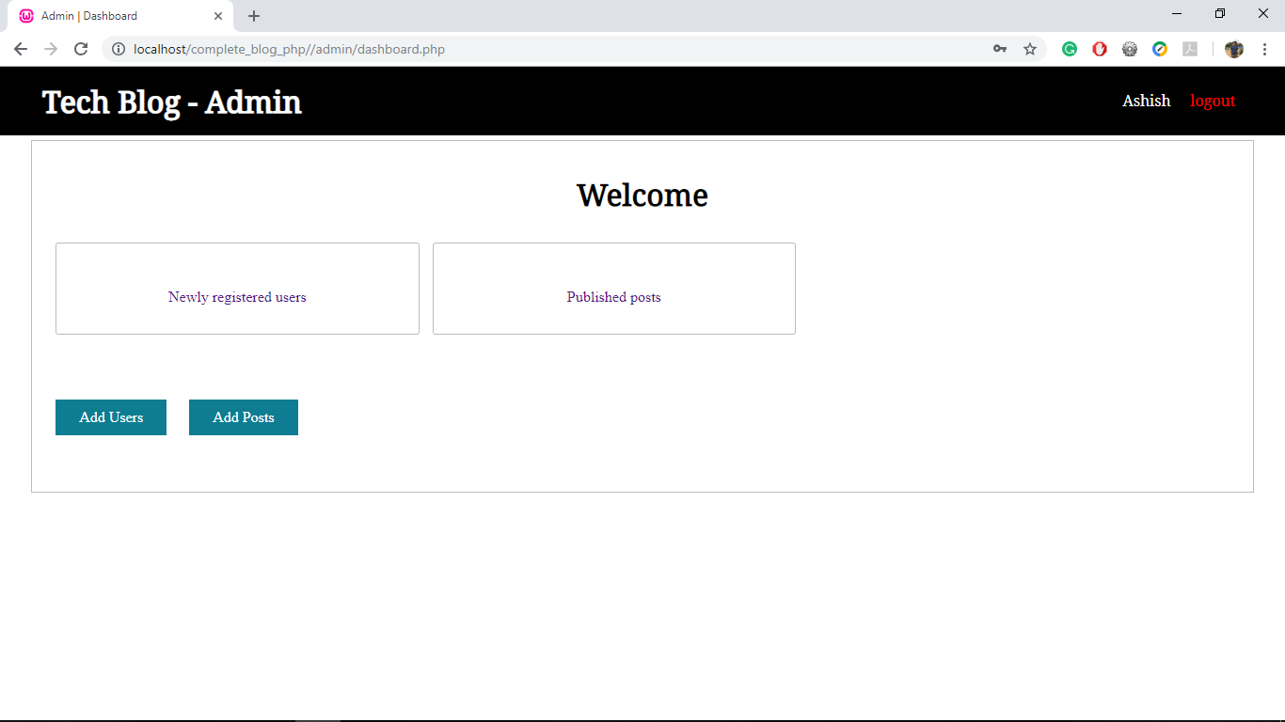

Create/edit user page

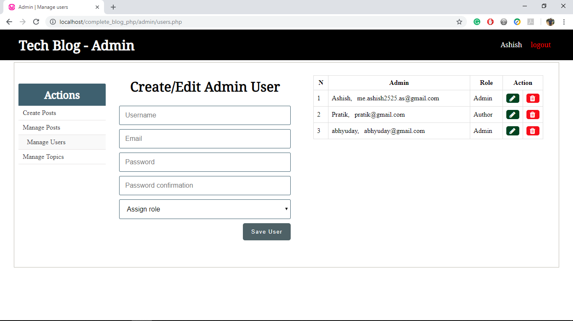

Create/edit post page

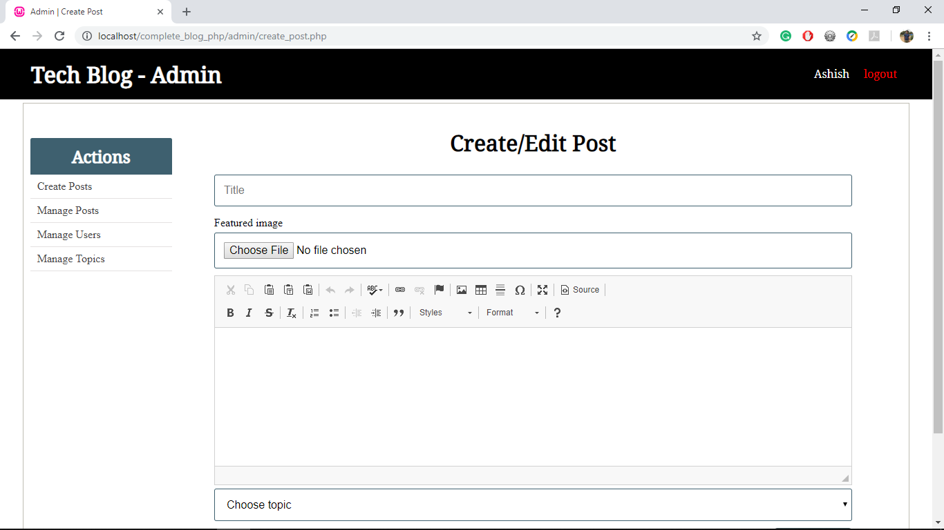

Manage post page

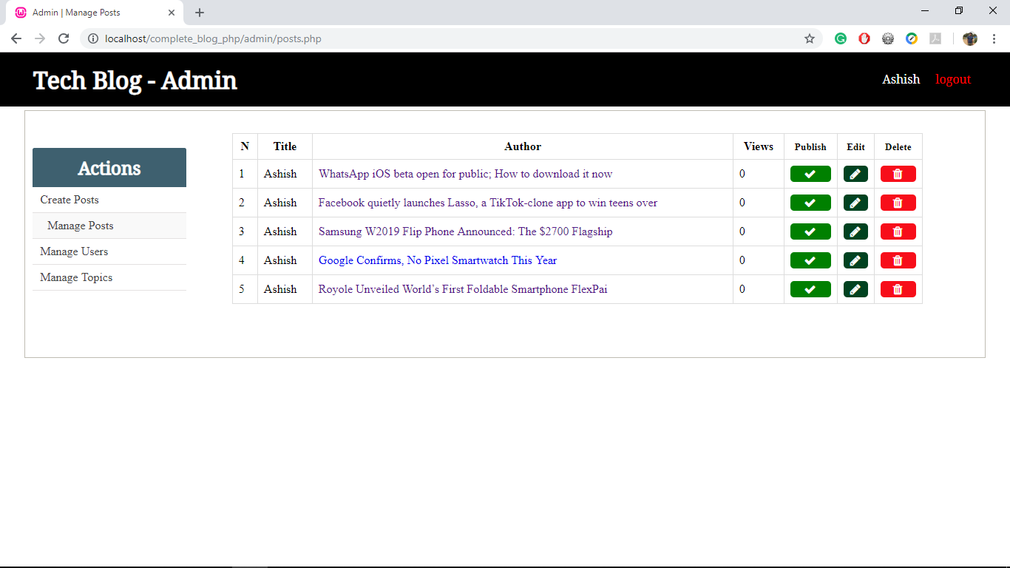

User registration form

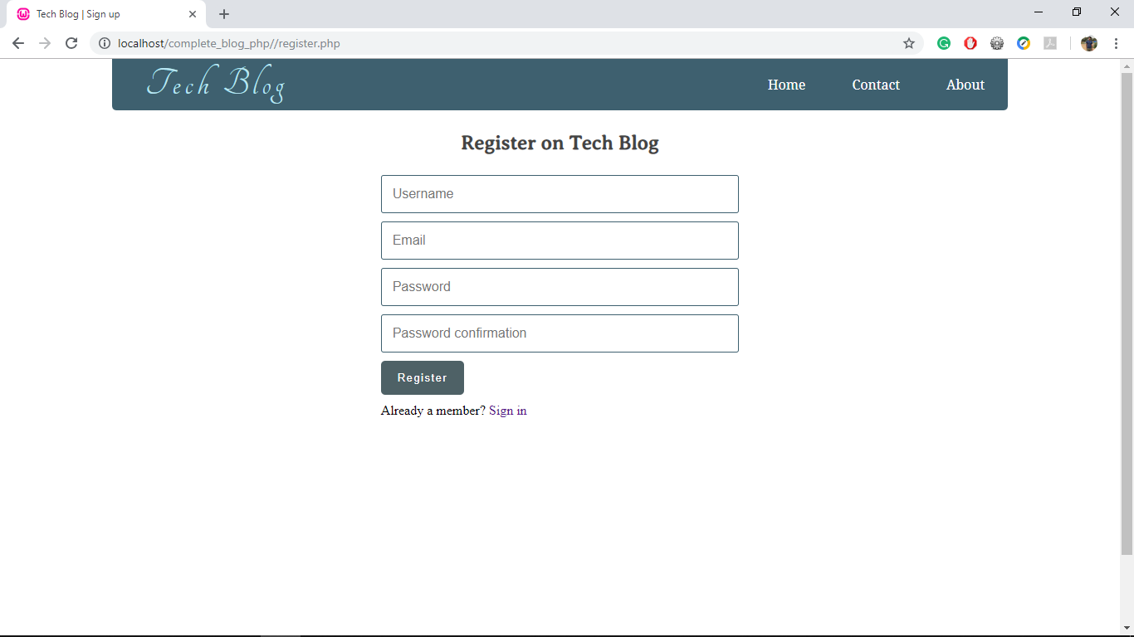

posts

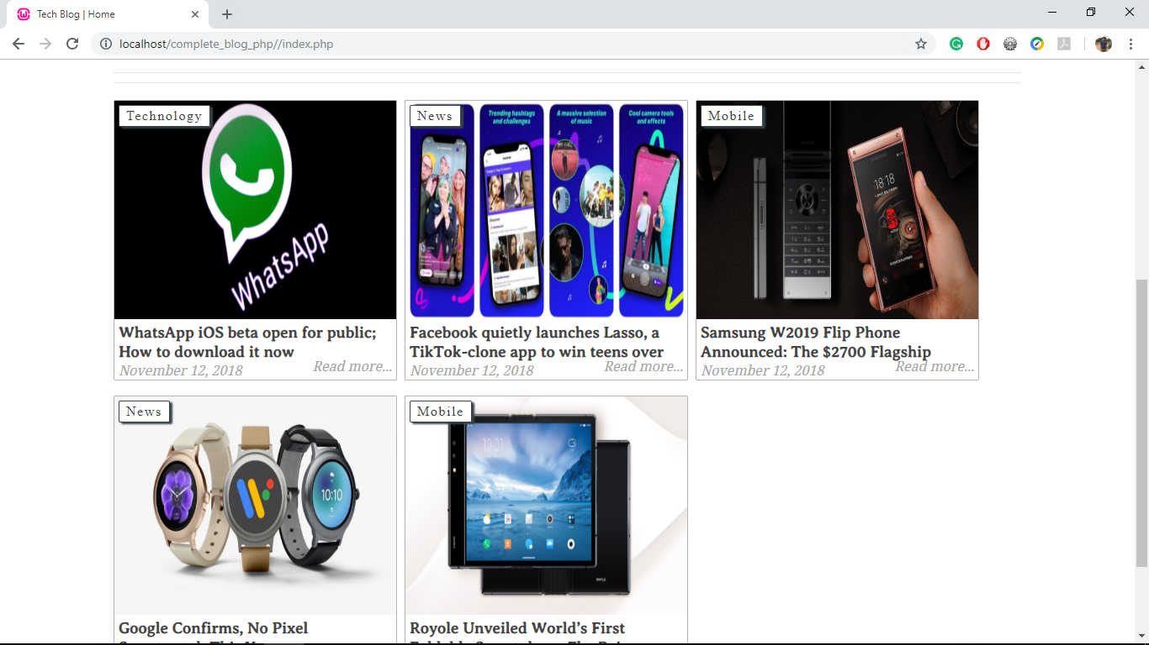

Individual post

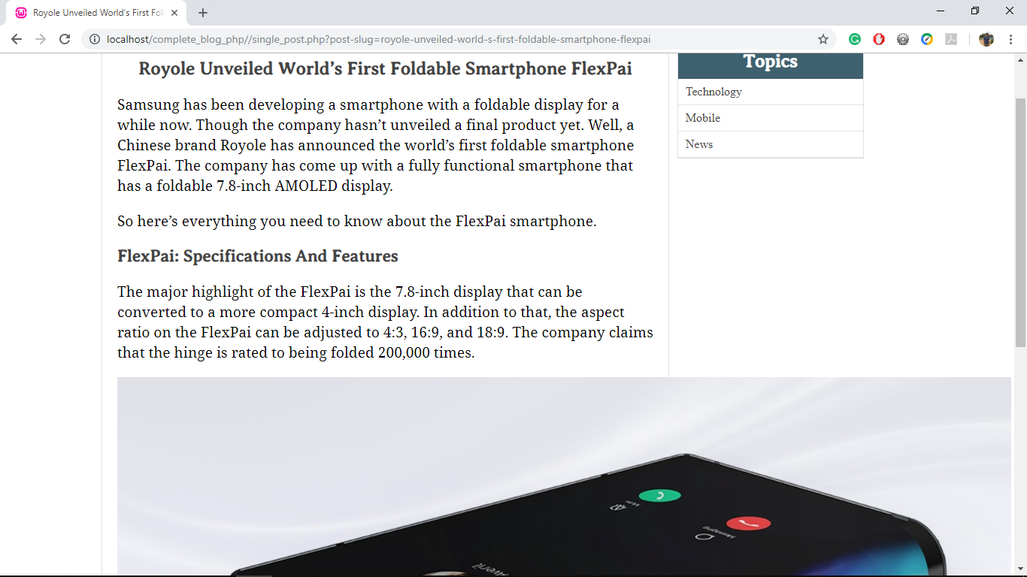

**CONCLUSION**

This web project uses html, css , javascript, mysql and php. It is about development of blog and have all admin as well as users section. Any admin can create a post, manage other users, delete a post , update a post and many others. This project have all the files written in PHP. Sublime text editor was awesome for the code editing purpose.

# **REFERENCES**

1. <http://www.tutorialspoint.com/>
2. <http://www.w3schools.com/>
3. Programming the World Wide Web (by Robert w. sebesta).
4. www.wikipedia.org