**NITTE MEENAKSHI INSTITUTE OF TECHNOLOGY**

(AN AUTONOMOUS INSTITUTION)

(AFFILIATED TO VISVESVARAYA TECHNOLOGICAL UNIVERSITY, BELGAUM, APPROVED BY AICTE & GOVT.OF KARNATAKA)



OOP COURSE-PROJECT REPORT

ON

**C++ Library**

*Submitted by:*

1. Ashish kumar sah1NT16CS188

In partial fulfillment of the requirements for the completion of *IV Semester Object-Oriented Programming Course-Project work* during the academic year 2017-2018.

Department of Computer Science and Engineering

NitteMeenakshi Institute of Technology,

Yelahanka, Bangalore– 560064

Academic Year 2017-18

**NITTE MEENAKSHI INSTITUTE OF TECHNOLOGY**

(AN AUTONOMOUS INSTITUTION)

(AFFILIATED TO VISVESVARAYA TECHNOLOGICAL UNIVERSITY, BELGAUM, APPROVED BY AICTE & GOVT.OF KARNATAKA)



**CERTIFICATE**

**This is to certify that the Project Report**

**C++ Library**

Is an authentic work carried out by:

1. Ashish kumar sah1NT16CS188

In partial fulfillment of the requirements for the completion of *IV Semester Object-Oriented Programming Course-Project work* during the academic year 2017-2018.

Name & Signature of the Guide Name & Signature of HOD

**ACKNOWLEDGEMENT**

I would like to express my special thanks of gratitude to my teacher **Mr. Ramesh Naidu** who gave me the golden opportunity to do this wonderful project on the topic **C++ library** which also helped me in doing a lot of Research and I came to know about so many new things I am really thankful to them. I would like to thank to our HoD sir as well for such opportunity.

Secondly I would also like to thank my seniors and friends who helped me a lot in finalizing this project within the limited time frame.

**ABSTRACT**

A library is a collection of pre[compiled](https://www.webopedia.com/TERM/C/compile.html) [routines](https://www.webopedia.com/TERM/R/routine.html) that a program can use. The routines, sometimes called [modules](https://www.webopedia.com/TERM/M/module.html)*,* are [stored](https://www.webopedia.com/TERM/S/store.html) in [object](https://www.webopedia.com/TERM/O/object.html) [format](https://www.webopedia.com/TERM/F/format.html). Libraries are particularly useful for storing frequently used routines because you do not need to explicitly [link](https://www.webopedia.com/TERM/L/link.html) them to every program that uses them. The [linker](https://www.webopedia.com/TERM/L/linker.html) automatically looks in libraries for routines that it does not find elsewhere.

In this particular program, we have included headers for subject such as physics, chemistry, mathematics. In particular, header <basic.h> is a library included which all these subject values. Constant values such as value for acceleration due to gravity(g), value for epsilon, value for gravitational constant(G) and many others for physics.

Similarly, the header consists of values such as value of gas constant(R), value of planks constant(h), value of Boltzmann constant(k) n many others related to chemistry. In the same way, header will include values for mathematical constants as well.

Moreover, there are some functions as well which will make the calculation simpler and easier. We can directly call those functions and pass the value for the output. We have made functions such as Areaofcircle(radius), Areaofrec(base,height), Areaoftriangle(base,height), and many others.

In this way, this program is made with C++ and is very helpful. This makes the calculation so simpler and even we don’t need to remember the values for constant terms.

**Table of Contents**

|  |  |  |
| --- | --- | --- |
| **Sl.No** | **Description** | **Page No.** |
|  | Introduction | 01 |
|  | System analysis | 02 |
|  | Requirement specification | 03 |
|  | Source code | 04-08 |
|  | User manual | 09 |
|  | Results & screenshots | 10-11 |
| 7. | Conclusion | 12 |
| 8. | Bibliography | 12 |

**1. Introduction**

A library is a collection of pre[compiled](https://www.webopedia.com/TERM/C/compile.html) [routines](https://www.webopedia.com/TERM/R/routine.html) that a program can use. The routines, sometimes called [modules](https://www.webopedia.com/TERM/M/module.html)*,* are [stored](https://www.webopedia.com/TERM/S/store.html) in [object](https://www.webopedia.com/TERM/O/object.html) [format](https://www.webopedia.com/TERM/F/format.html). Libraries are particularly useful for storing frequently used routines because you do not need to explicitly [link](https://www.webopedia.com/TERM/L/link.html) them to every program that uses them. The [linker](https://www.webopedia.com/TERM/L/linker.html) automatically looks in libraries for routines that it does not find elsewhere.

C++ is known to be very powerful language. C++allows you to have a lot of control as to how you use computer resources, so in the right hands its speed and ability to cheaply use resources should be able to surpass other languages. Thanks to C++’s performance, it is often used to develop game engines, games, and desktop apps. Many AAA title video games are built with C++.

**2. System Analysis**

**2.1 Scope of the project**

This is a generic type of project. This project includes header file consisting of many important and useful values for students as well as people who needs.

* User friendly.
* Long term use.
* Multiple use.
* Generic content.
* Useful for scientific coding.

**2.2 Aim of project**

The main aim of this project is to learn different features of C++. The aim is also to learn to create headers and libraries in C++ and use those headers in programs to get benefited of time and to write a lot of codes again and again.

**2.3 Project module**

The project is entirely in LINUX . We have used g++ compiler to compile this program and gedit editor is used to write a sample program to demonstrate our header.

**3. Requirement specification**

**3.1 Software requirement**

**Code::Blocks**

Code::Blocks isa free, open-source cross-platform IDE that supports multiple compilers including GCC, Clang and Visual C++. It is developed in C++ using wxWidgets as the GUI toolkit. Using plugin architecture, its capabilities and features are defined by the provided plugins. Currently, Code::Blocks is oriented towards C, C++, and FORTRAN.

**Windows 10**

Windows 10 is a personal computer operating system developed and released by Microsoft as part of the Windows NT family of operating systems.

**3.2 Hardware requirement**

* 512 MB RAM
* 1 GB Free HDD Space
  + 1 GHz CPU
  + Display Monitor
  + Keyboard

**4. Source code**

**Module for physics:**

#include<math.h>

double physics(char p)

{

double a;

int b;

if(p=='c')

{a=299792458; //Speed of light

return a;

}

if(p=='g')

{a=9.8; //gravity

return a;

}

if( p=='G')

{

a=(6.754/(pow(10,11))); //Gravitation constant

return a;

}

if(p=='k')

{

a=(1.3807/ (pow(10,23))); //Boltzman Constant

return a;

}

if(p=='F')

{

a=96485.33289; // Faradays constant

return a;

}

if(p=='s')

{

a=343; //Speed of Sound

return a;

}

if(p=='h')

{

a=(6.62607004/pow(10,34)); //plank Constant

return a;

}

if(p=='M')

{

a=(4*(22/7)/pow(10,7));//Magnetic Constant

return a;

}

if(p=='e')

{

a=(8.85418/pow(10,12));//Electric Constant

return a;

}

if(p=='m')

{

a=(9.1093/pow(10,31)); //electron mass

return a;

}

if(p=='x')

{

a=(2.067833/pow(10,15)); // Magnetic flux

return a;

}

}

**Module for chemistry:**

#include<math.h>

double chemistry(char t)

{

double a;

if(t=='a')

{a=(6.02214*(pow(10,23))); //Avogadro's Number

return a;

}

if(t=='M')

{a=(1.660538/pow(10,27)); //Atomic Mass Constant

return a;

}

if(t=='R')

{a=8.3144; // Molar Gas Constant

return a;

}

if(t=='r')

{a=(1.09737*(pow(10,7)));// Rydberg constant

return a;

}

if(t=='c')

{a=4.18; // Specific heat capacity of liquid water

return a;

}

if(t=='e')

{a=1.602176/pow(10,19);//Charge on a Electron

return a;

}

if(t=='B')

{a=(0.529/pow(10,10)); //Bohr radius

return a;

}

if(t=='N')

{a=(1.505/pow(10,10)); //neutron mass energy

return a;

}

if(t=='p')

{a=(1.503/pow(10,10));//proton mass energy

return a;

}

}

**Module for maths:**

#include<math.h>

double a=0;

double b,c,d,r=0;

double math(char t)

{

if(t=='p')

{

a=3.14;

return a;

}

}

double areaofrec(double b,double c)

{

r=b*c;

return r;

}

double areaofcircle(double b)

{

r=(3.14*pow(b,2));

return r;

}

double areaoftriangle(double b,double c)

{

r=0.5*(b*c);

return r;

}

double areaofsquare(double b)

{

r=pow(b,2);

return r;

}

double areaoftrapezoid(double b,double c,double d)

{

r=((0.5*(b+c)*d));

return r;

}

double areaofellipse(double b,double c)

{

r=3.14*b*c;

return r;

}

**5. User manual**

This is the user manual for corresponding work and symbols.

**Physics:**

**Use: physics(symbol)**

|  |  |
| --- | --- |
| **Name** | **Symbols** |
| Speed of light | c |
| Gravity | g |
| Gravitational constant | G |
| Boltzman constant | k |
| Faradays constant | F |
| Speed of sound | s |
| Planks constant | h |
| Magnetic constant | M |
| Electric constant | e |
| Electron mass | m |
| Magnetic flux | x |

**Chemistry:**

**Use: chemistry(symbol)**

|  |  |
| --- | --- |
| **Name** | **Symbols** |
| Avogadro’s number | a |
| Atomic Mass Constant | M |
| Molar Gas Constant | R |
| Rydberg constant | r |
| Specific heat capacity of water | c |
| Charge on a Electron | e |
| Bohr radius | B |
| neutron mass energy | N |
| proton mass energy | p |

**Mathematics:**

|  |
| --- |
| **Functions use** |
| Areaofcircle(radius) |
| Areaofrec(base,height) |
| Areaoftriangle(base,height) |
| Areaofsquare(length) |
| Areaoftrapezoid(base,length1,length2) |
| Areaofellipse(axis,axis) |
| Value of pie symbol-p |

**6. Results/screenshots**

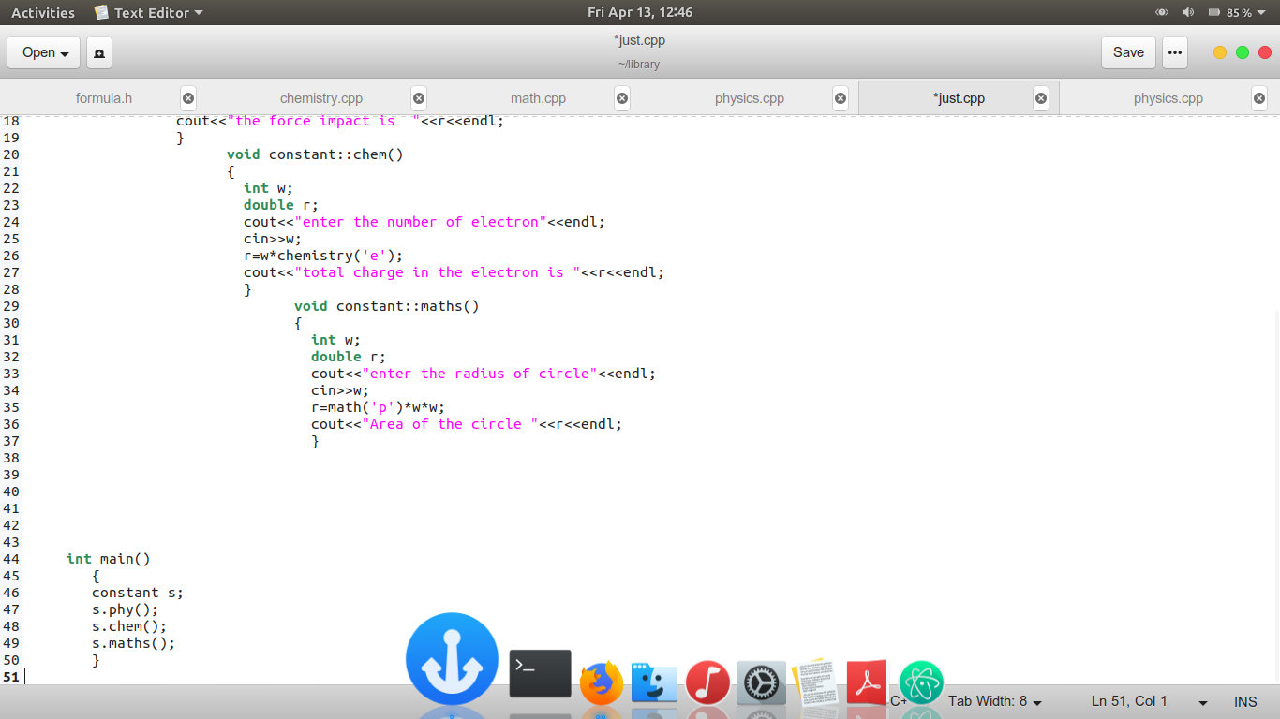



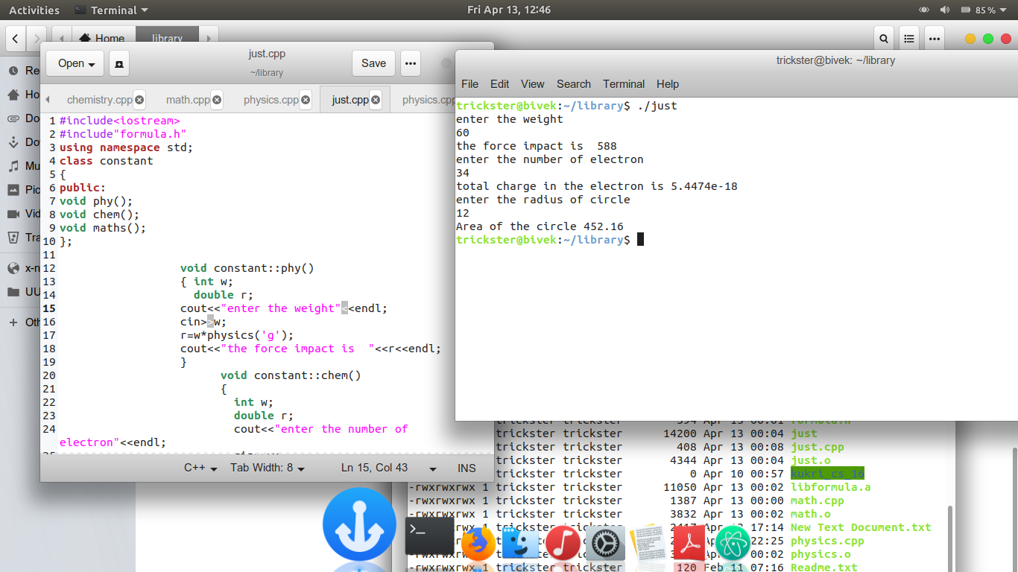

**7. Conclusion**

This project helps the user to work fast and efficient. It saves users time and memory to remember values for constants. It is a programmer friendly thing. A programmer in C++ knows its importance better.

This project helped me to analyze the complex situation and made me to debug it and taught me how to work in groups. It helped me to understand the concepts of and their implementations even more clearly and perfectly.

**8. References**

1. **BYRON GOTTFRIED**“ *Programming with C ”,*Third edition ,Tata Mc Graw Hill Education.
2. **YASHVANT KANETKAR** “ *Let us C ”,*13th edition ,BPB Publication
3. **H .K.Gundu Rao, N.S. Manjunath, M .N. Nachappa**  “*A New approach to Computer Science”* ,Revisited Edition March 2013,Sumukha Publication.
4. **A .M PADMA REDDY**  “*Computer Concepts &C Programming Techniques”,*Revised edition 2013.
5. **BALAGURUSWAMY** “*Programming in Basic”,*Third edition.