Rest end points currently supported:

[http://localhost:8080/products/{productId}](http://localhost:8080/products/%7bproductId%7d)

Description: Will retrieve product details for a given product id and respond back to the caller of the rest endpoint.

Ex rest endpoint with product id: <http://localhost:8080/products/13860428>

Response:

{

"id": "13860428",

"name": "The Big Lebowski (Blu-ray)",

"currency_price": {

"value": 13.49,

"currency_code": "USD"

}

}

HTTP Method: GET

HTTP Response code:

200 – Product details included

404 – Product detail not found.

500- Internal server error. For any unhandled exception occurred within application.

**Error handling:**

An error message will be send back to client containing error description and the product id. Here is sample error message for product information not found.

{

"errorMessage": "Product not found, please check product id 138604281"

}

**Supporting screen shots**:

Response 200

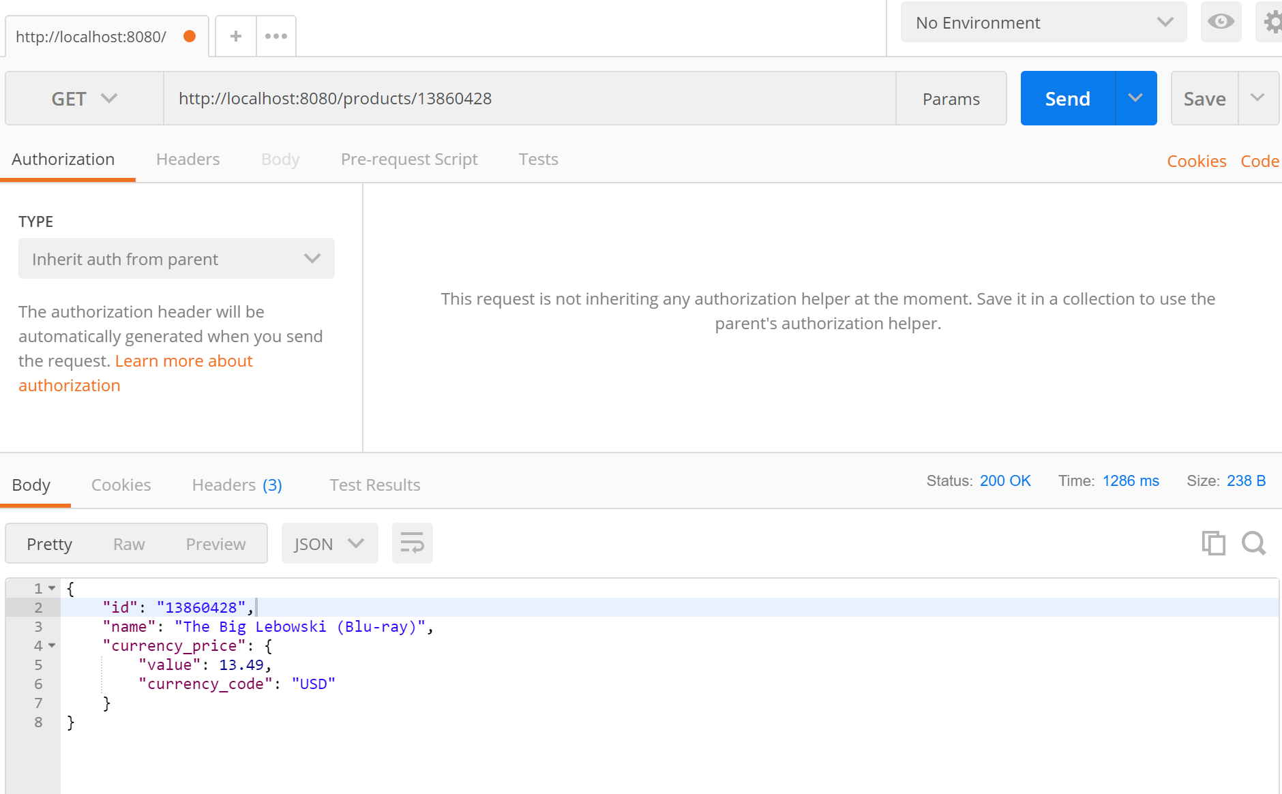

Response code: 404

