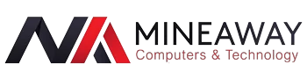

Mineaway is committed to being the leading Privately-owned IT retail store in South Africa, delivering exceptional client services and superior products at affordable pricing, with leading brands and a strong commitment to its customers gives us a competitive edge in the market. We are an established online computer and electronics store with a proven track record.

The knowledge and expertise we have acquired by dealing with bid or buy which is the worlds biggest and trusted online shop has forged us to be competitive at what we do. We use the same expertise in selecting our competitively priced range of established brands to serve our ever growing market, whether its building a computer from scratch or one that is ready to use. This includes hardware, software, accessories and more for business, personal or gaming applications. All our products are tested by out tech department to allow you to shop with confidence and trade carefully with your money

Unit F10, Corner Brand Rd & Swart Dr President Park, 1685 Midrand, South Africa