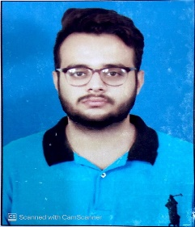**Muhammad Ans**

Ans50801@gmail.com

Contact +92 322 4203022

Address: St#7 House#7 Mohala Muradpurafateh Garh Lahore.

**OBJECTIVE**

I enjoy learning new skills and I am confident of working in different cultures. I have intuitive ability to learn new technologies quickly and want to utilize my abilities to the maximum by working for a reputed organization

**CORE FUNCTIONAL SKILLS**

* Effectively meet deadlines, achieve targets and work under pressure.
* Company success driven – passionate about company’s product line.
* Accounting-related computer literacy.
* Excellent communication skills, written and verbal.
* Effective presentation of complex issues.
* High level of negotiation skills.

**PROFESSIONAL EXPERIENCE**

* **Organization:** **KIA Motors SAMAA**

**Tenure:**  **Aug-2019 to Till Date**

**Designations: Senior Technician**

**Department: Service**

**Responsibilities:**

* Diagnosing Problems in Automobiles and Repairing Them As Quickly As Possible.
* Keeping Work Areas Clean, Organized and Safe from Hazards to Health and Safety.
* Advising Customers on Vehicle Faults.
* Diagnosing Vehicle Faults Using **KDS** (KIA Diagnostic System).
* Inspecting the Quality of Work Performed With Road Test to Ensure Customer Satisfaction.
* Taught Automotive Technical Matters To Trainees and Other Workshop Staff.
* Conducted Training Sessions For Technicians Acknowledgement.

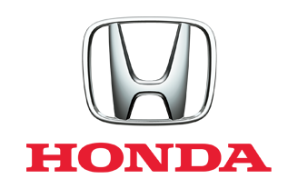

* **Organization:** **HONDA POINT**

**Tenure:**  **Sep-2015 to July-2019**

**Designations: Diagnostic Technician**

**Department: Service**

**Responsibilities:**

* Electrical & Mechanical Diagnostic Technician.
* Diagnosing Vehicle Faults Using **HDS** (Honda Diagnostic System).
* Servicing All Models of Vehicles Including Japanese.
* Replacing Worn or Broken Parts such as Piston Rings, Bearings, or other Engine Parts.
* **Organization:** **INH MOTORS**

**Tenure:**  **April-2015 to Aug-2015**

**Designations: Service Advisor**

**Department: Service**

**Responsibilities:**

* List Customer Concern and Ask Additional Questions to Diagnose Current Problems.
* Met Customers At Vehicle to Quickly Engage and Offer Assistance.
* Develop and Write up Repair Estimates and Keep Customer Informed of Charges.

**ACHIEVEMENTS**

* **TRP Level One** (Technician Recognition Program) Training from **KIA LUCKY MOTORS PAKISTAN.**
* Participated and Qualify **National Technician Contest** of **Honda Atlas Cars Pakistan Limited** in 2018.
* **RT** (Repair Technician) Training From **Honda Atlas Cars Pakistan Limited.**
* **MT** (Maintenance Technician) Training From **Honda Atlas Cars Pakistan Limited.**

**SOFTWARES**

Microsoft Word, Microsoft Excel, Microsoft PowerPoint, Google Apps, IOS Apps

**EDUCATION QUALIFICATION:**

|  |  |
| --- | --- |
| **Degree Title** | **University/Institute** |
| **D.A.E(Diploma Of Associate Engineer)** | Auto Mobile & Diesel  G.C.T Railway Road Lahore. |
| **Matriculation ( Lahore Board)** | Board Of Intermediate and Secondary Education with Science Subject. |

**PERSONAL INFORMATION**

Father Name Abdul Rasheed

Date of Birth Aug-03-1996

Nationality Pakistani

Religion Islam

**REFERENCE**

Will be Provided on Demand.