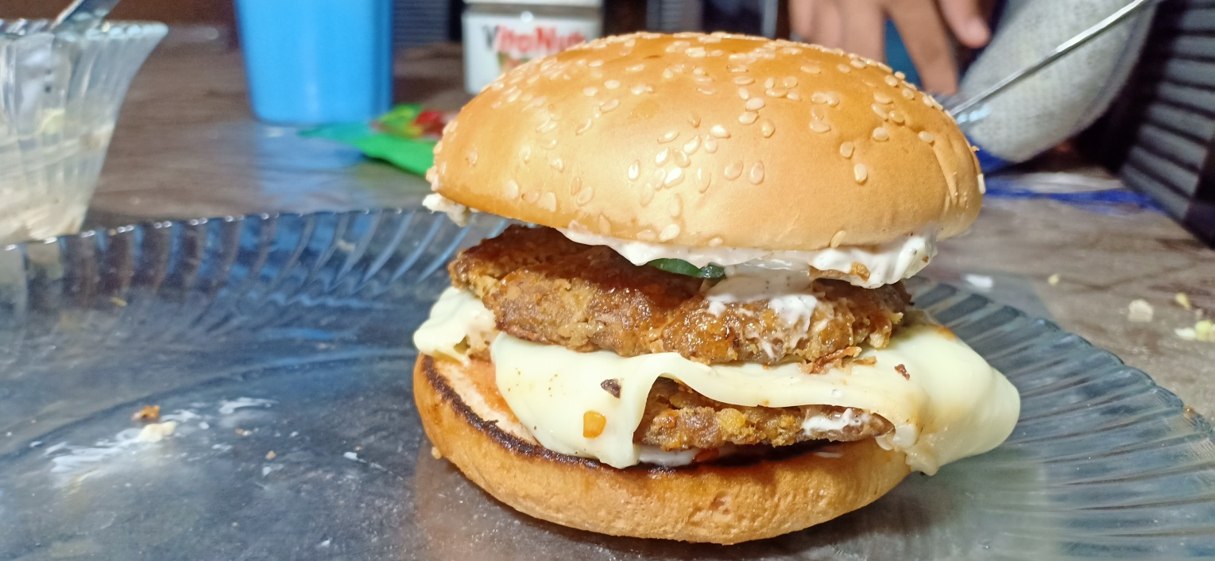**Ingredients**

**For sauce**

* ½ cup Mayonnise
* ½ cup cabbage
* 1 tablespoon black pepper / kaali mirch
* ½ tablespoon Salt

**For Burger**

* ½ kg beef qeema
* 1 tablespoon Red chilli powder
* 1 tablespoon Salt
* 1 tablespoon turmuric / haldee
* 1 tablespoon Corriander powder / khukh dhania
* 1 tablespoon garam masala
* Cheese slice
* Ketchup
* Burger bun

**Recipe**

* For sauce mix Mayonnise , cabbage , black pepper / kaali mirch and Salt .

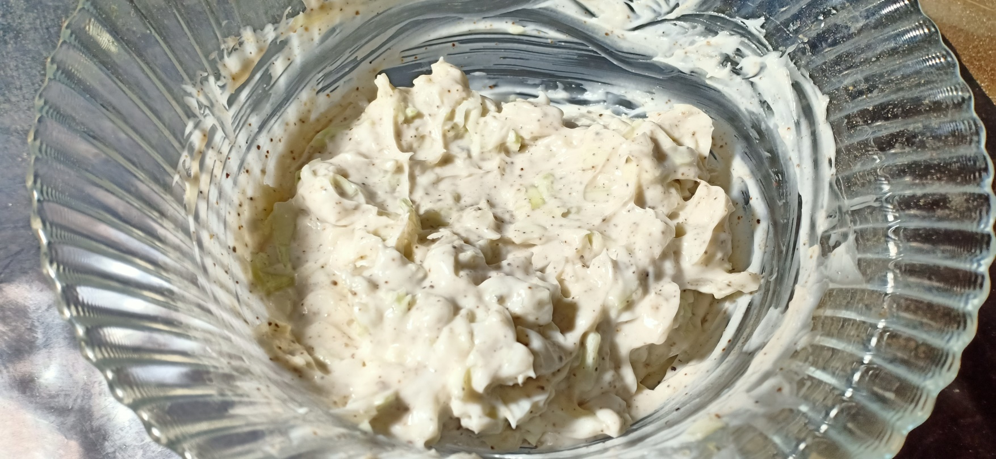

* For patty mix beef qeema , Red chilli powder , Salt , turmuric / haldee , Corriander powder / khusk dhania , garam masala and make 5- 7 patties . 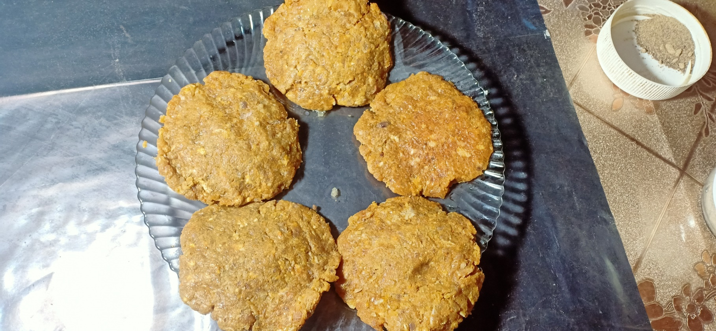
* Fry these patties and burger bun .
* Add sause , patty , cheese slice , patty , cucumber , ketchup on bun .
* Burger is ready to serve.