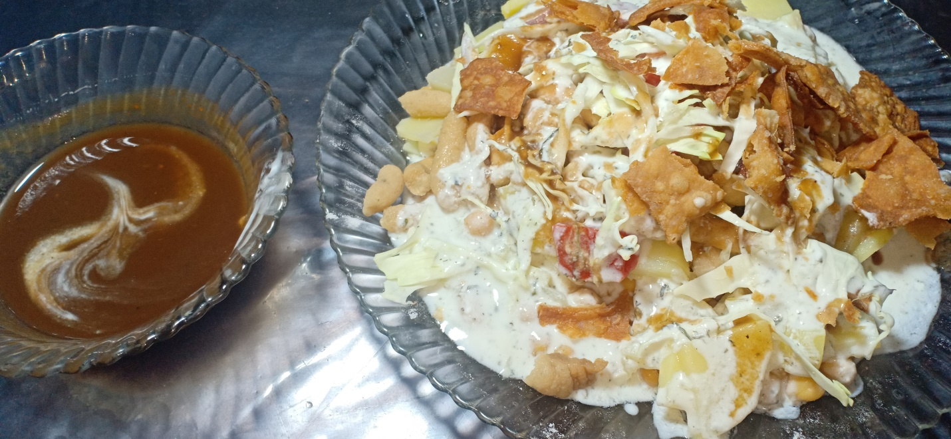

**Ingredients**

Serving 7- 10

* Aloo boiled 1 kg
* Safaid chana boiled 1 kg
* Dahi bhala soaked in water for 2 hours

**For papri**

* 1/3 kg maida
* ½ chamach namak
* 1 chamach oil
* Adha cup neem garam pani

**For Imli ki Chatni**

* 1/3 kg imli
* ½ chamach red chilli powder
* ½ chamach namak
* 1 chamach cheeni

**For mint chatni**

* 1 kg daahi
* 1 chamach podina pissa hua
* 1 chamach namak

**For Assembling**

* 1 darmayana pyaaz kata hua
* 1 darmayana tomatar kata hua
* 1 darmayana band goobi kaati hui
* Chat masala

**Recipe**

**For papri**

* namak , oil , paani ko maida ma daal kr acha sa goond layn phir us ki rooti bail kr usko choota choota kaat lyn .
* ab garam tail ma usko brown hna tk fry kryn

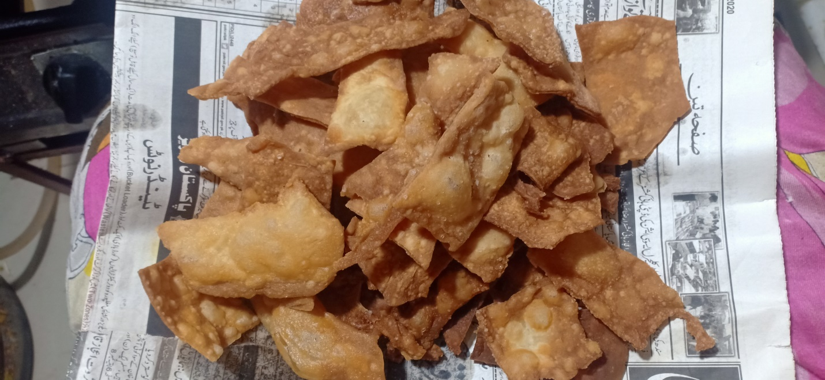

**For Imli ki Chatni**

* imli ko paani ma 1 ghanta beego k rkhayn phir us ka paani ko la k medium aanch pr pakayn .
* phir us ma namak , cheeni , laal mirch daal kr 5 minute pakayn or phir thanda hna k lia rkh dyn .

.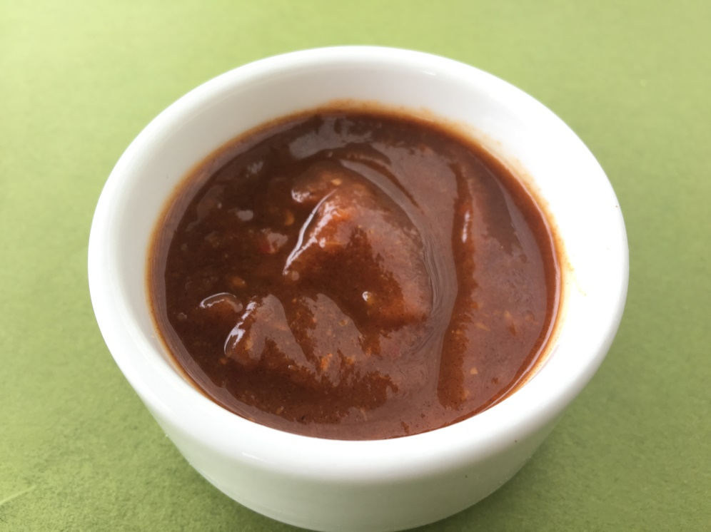

**For mint chatni**

* daahi ma namak aur podina mix kryn

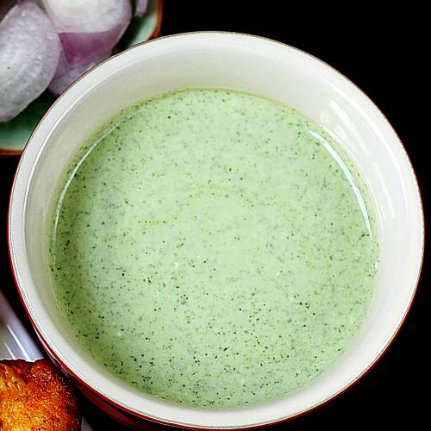

**For Assembling**

* aloo , chana , bhala , pyaaz , tamata , band ghoobi , poodina chatni , Imli chtni ,, papri , chaat masala daal k mix kryn aur usko serve kr dyn .