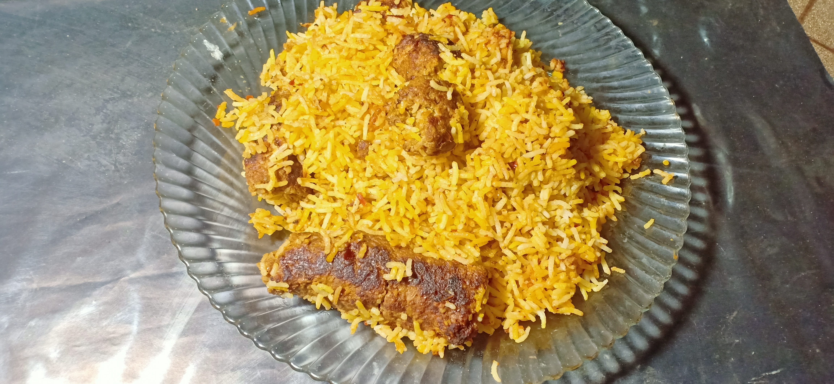

Ingredients

For rice

* 1 glass or 1/3 kg Rice
* 2 tablespoon oil

For qabab

* ½ kg beef qeema
* 1 tablespoon Red chilli powder
* 1 tablespoon Salt
* 1 tablespoon turmuric / haldee
* 1 tablespoon Corriander powder / khukh dhania
* 1 tablespoon garam masala

For gravy

* 1 tablespoon sheikh qabab masala
* 1 medium size onion
* 1 medium size tomato
* 1 tablespoon ginger garlic paste

Direction

For Rice

* Add 4 glass of water and 1.5 tablespoon of salt and bring it to boil then add rice when 80% of rice is done romove excess water
* Add 2 tablespoon of oil and mix it
* Place it under fan for 1 hourso max to its moisture absorbs

For qabab

* Add onion , salt , coriander powder / khukh dhania , garam masala ,turmuric / haldee ,Red chilli powder in qeema and mix it and make 8-10 qabab of it

For gravy

* Add onion chopped in 3 – 4 tablespoon of oil and sauté it .
* Add ginger , garlic paste to it then add tomato and sauté it .
* Add half cup of water and qabab to it then place it on low flame for five minutes

Assembling

* Add rice on gravy then add yellow food color .
* place it on low flame for 10 minutes .