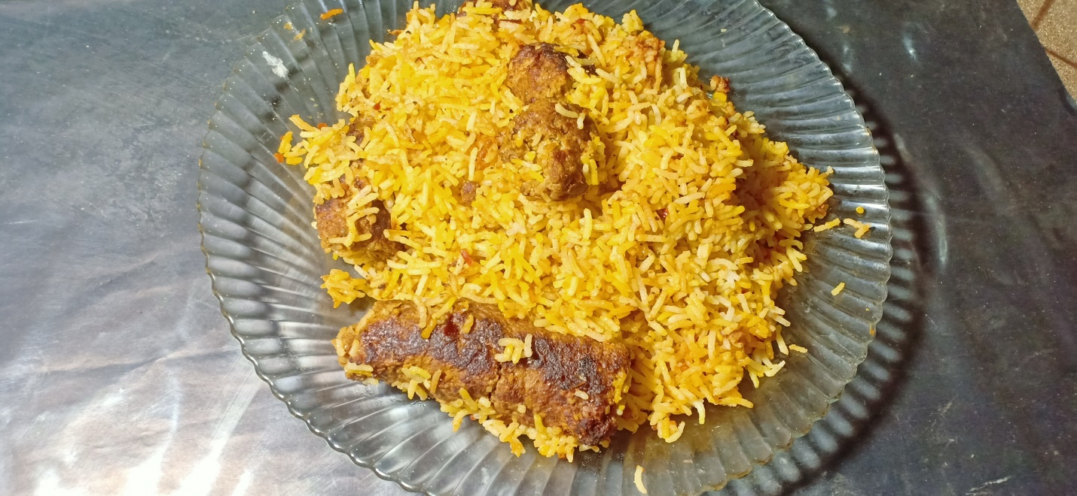

Ingredients

For rice

* 1 glass or 1/3 kg Rice
* 2 tablespoon oil

For qabab

* ½ kg beef qeema
* 1 tablespoon Red chilli powder
* 1 tablespoon Salt
* 1 tablespoon turmuric / haldee
* 1 tablespoon Corriander powder / khukh dhania
* 1 tablespoon garam masala

For gravy

* 1 tablespoon sheikh qabab masala
* 1 medium size onion
* 1 medium size tomato
* 1 tablespoon ginger garlic paste

Direction

For Rice

* 4 glass paani ma 1.5 namak daal kr ubalna tk ka intezar kryn phir us ma chawal daaal dayn jb chawal 80% tk paak jayn to uska izafi paani utaar kr side p rkh dyn
* 2 chamach oil daal kr mix kryn .
* Chawalo ko pankaa k neecha 1 ghanta rkhayn taaka uski naami jazb ho jy

For qabab

* pyaz ,namak , khukh dhania , garam masala , haldee ,laal mirch qeema ma daal kr mix kr lyn or 8 -10 qabab bna lyn

For gravy

* 3 – 4 chmach tail ma pyaaz daal k bhoonayn
* Phir adrak lehsan ka paste daal kr bhoon lyn
* Adha cup daani aur qabab daal ka 5 minute k lia daam dyn

Assembling

* Bhona hua masala p chawal aur food color daal dyn .
* Phir 10 minute k lia daam da dyn