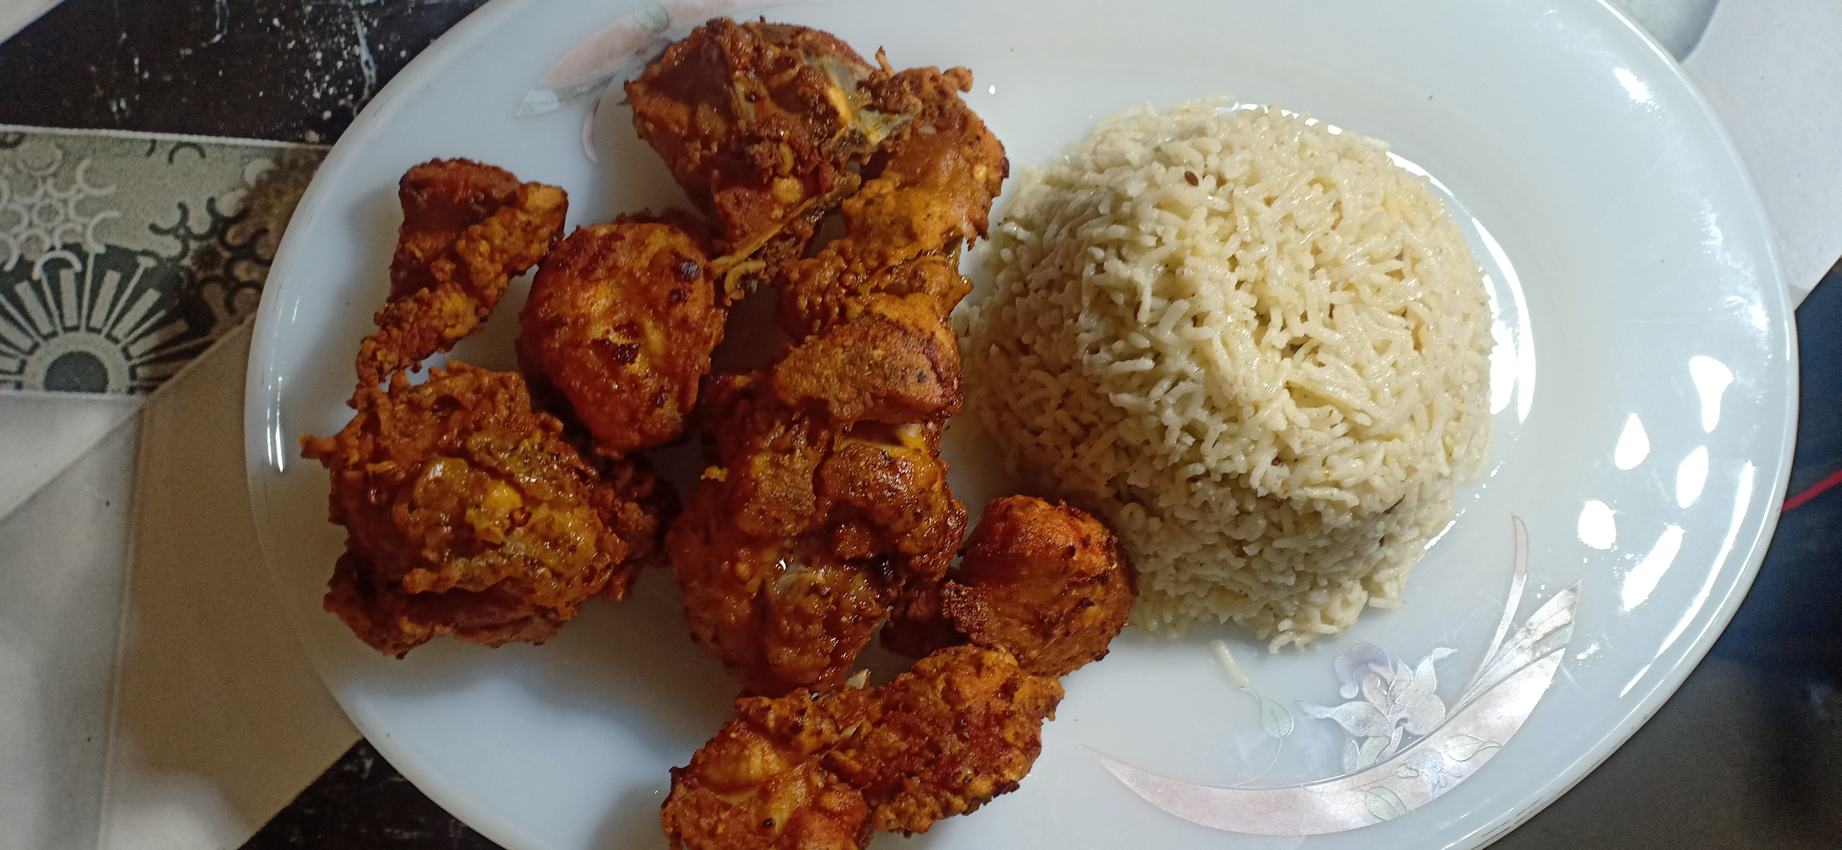

Ingredients

* 1 kg chicken
* 1 tbs red chilli powder
* ½ tbs chilli flakes
* ½ tbs zeera powder
* ½ tbs garam masala
* 1 tbs salt
* 1 tbs Dhania / Coriander powder
* 1 egg
* 2 tbs lemon juice
* 2 tbs basen powder
* 2 tbs All purpose flour

Directions

* Add red chilli powder , Chilli flakes , zeera powder , garam masala , salt , Dhania / Coriander powder , lemon juice to chicken and mix it .
* Then Add egg , basen powder , All purpose flour and mix it .
* Fry it and Serve it