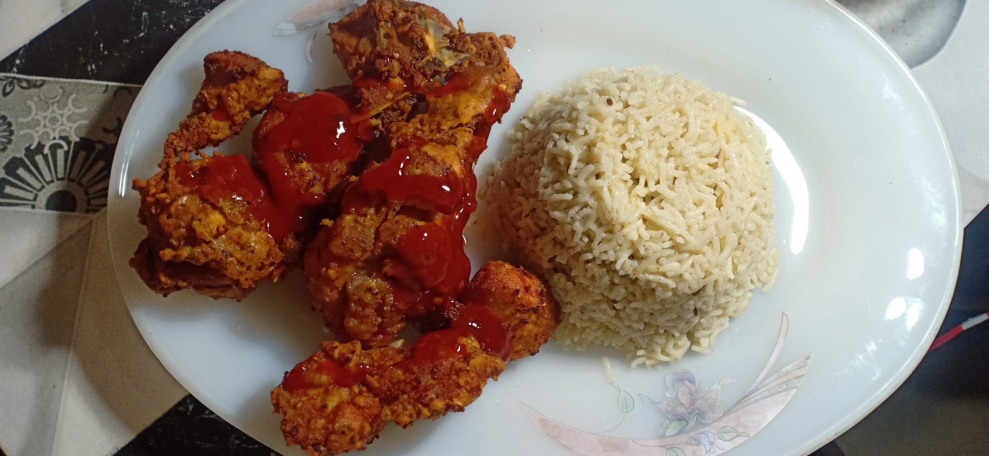

Ingredients

* 1 kg chicken
* 1 tbs laal mirch
* ½ tbs chilli flakes
* ½ tbs zeera powder
* ½ tbs garam masala
* 1 tbs salt
* 1 tbs Dhania powder
* 1 egg
* 2 tbs lemon juice
* 2 tbs basen powder
* 2 tbs maida

Directions

* Chicken ma laal mirch , Chilli flakes , zeera powder , garam masala , salt , Dhania powder , lemon juice daal k mix kr lyn .
* Phir egg , basen powder , maida daal k mix kryn .
* Ab fry kr k paish kryn .