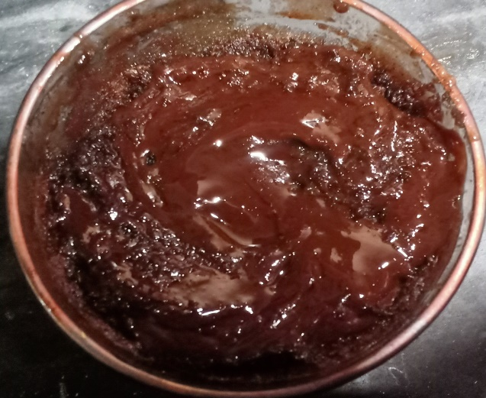 **Ingredients**

* 3 tablespoon Milk
* 1/4 cup chocolate bar
* 2 tbs maida/
* All purpose flour
* 2 tablespoon suger
* 2 tablespoon egg
* 2 tablespoon Cocoa powder
* 1/3 tablespoon Baking powder
* 1 drop Vanilla essence

**Recipe**

* Add 1 tablespoon Milk and 1/4 cup chocolate , microwave it for 1 minute then mix it
* Add 2 tbs maida/All purpose flour ,2 tablespoon milk ,suger , egg , Cocoa powder , cooking oil , chocolate paste
* , Baking powder , Vanilla essence in a mug
* Mix it well and Microwave it for 1 minute
* Add chocolate on top