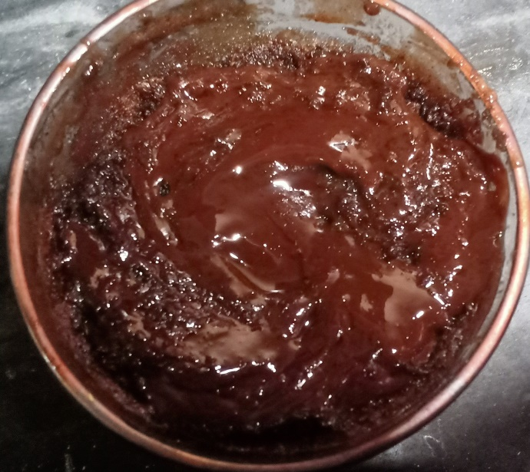**Ingredients**

* 3 Chamach dood
* 1/4 cup chocolate bar
* 2 Chamach maida
* 2 Chamach cheeni
* 2 Chamach anda
* 2 Chamach Cocoa powder
* 1/3 Chamach Baking powder
* 1 drop Vanilla essence

**Recipe**

* 1 Chamach dood , 1/4 cup chocolate ko oven ma rakh k aik minute tk garam kryn phir usa mix kr lyn .
* 2 Chamach maida ,2 Chamach dood, cheeni , anda , Cocoa powder , cooking oil , chocolate paste
* , Baking powder , Vanilla essence aik mug ma daal ka mix kryn
* phir oven ma rakh kr aik minute tk oven chalayn
* ab chocolate ko mug ka uper daal dyn